Individual Reflective Journal
EduGuardian AI: Early Risk Detection System
Emerging Trends | BSc Applied Computing

Student Name: | Mirela Balabanova-Kehayova
Student ID: | 2326292
Module: | Emerging Trends
Course: | BSc Applied Computing
University: | University of Wales Trinity Saint David
Date: | April 2026

Table of Contents
1. Introduction 2
2. Teamwork Experience 2
3. Personal Contribution and Skills Development 3
4. Limitations of the Design and Solution 3
5. Risk Factors Encountered 4
6. Critical Reflection and Future Development 4
7. Conclusion 5
Table 1: Team Member Contribution Evaluation 5
References 6

1. Introduction
This reflective journal evaluates my experience of working within a team during the development of EduGuardian AI, a desktop-based early warning system designed to detect student dropout and burnout risk in UK higher education. The system utilises rule-based analytics applied to synthetically generated behavioural data, with a Streamlit dashboard interface and an SQLite relational database backend. The purpose of this reflection is to analyse my personal contribution, evaluate how effectively the team performed, and identify the limitations and risks associated with the proposed design and solution. Reflective practice is widely recognised as an important learning process because it allows individuals to critically evaluate their experiences and improve their professional performance [1].
Team-based projects are an important part of computing education because they simulate real professional environments where collaboration, shared responsibility, and technical problem solving are required. Through this reflection, I analyse the effectiveness of our teamwork, the knowledge and skills I developed during the project, and how this experience contributes to my future academic and professional development.
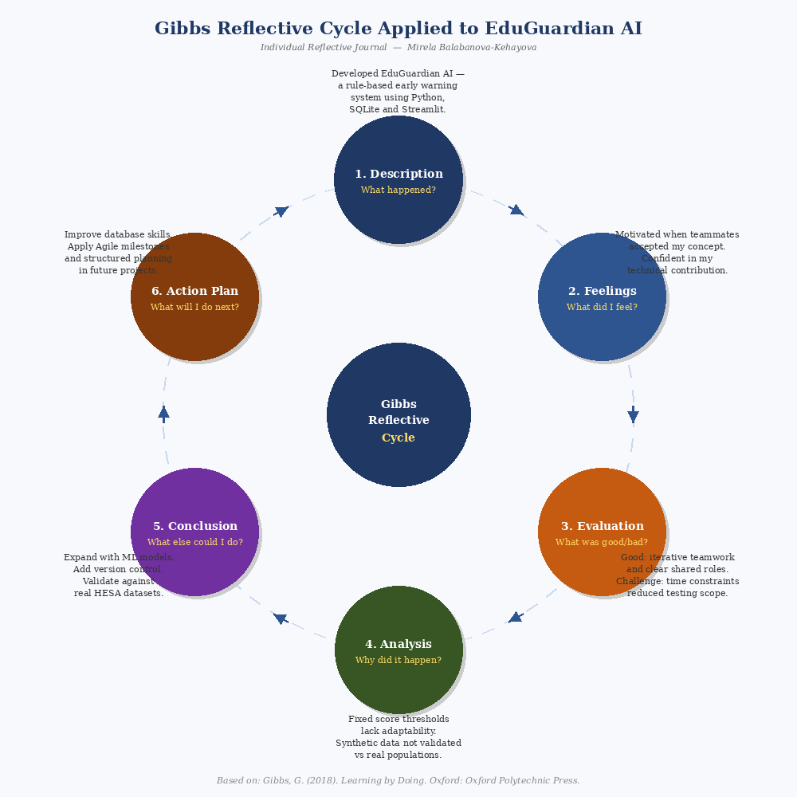
Figure 1 illustrates the application of Gibbs' (2018) six-stage reflective cycle to the EduGuardian AI project, mapping each stage to a specific aspect of the team experience — from the initial system description through feelings, evaluation, analysis, conclusion, and action plan. The diagram demonstrates how structured reflection can transform practical project experience into meaningful professional learning [1], [4].

2. Teamwork Experience
Working within a team environment during the EduGuardian AI project was both a valuable and motivating experience. At the beginning of the project, I proposed the idea that was later selected as the main topic for our group project. The concept was inspired by HESA retention data showing that a significant proportion of first-year students do not progress into their second year [6]. I was pleased that my teammates trusted my proposal and agreed that it represented a realistic and appropriate direction for the project. Their support demonstrated confidence in my judgement and encouraged me to actively contribute to the development of the proposal and the technical implementation.
Effective teamwork is widely recognised as a key factor in successful project development. Teams function best when members communicate clearly, collaborate effectively, and combine their individual strengths to achieve shared goals [2]. During the project, our team maintained regular communication and openly discussed ideas to improve the quality of the project.
An important element of our teamwork was the iterative development process. Instead of assigning completely separate tasks to individuals, the work evolved collaboratively. For example, I initially focused on structuring the proposal and implementing parts of the SQLite database and Python code. Other team members later reviewed this work and contributed improvements, optimisations, and refinements that enhanced the overall functionality of the system.
This collaborative approach reflects real software development environments where systems are continuously improved through teamwork and shared development practices [3]. Each member contributed to refining the work of others, which helped produce a more effective final solution.
Although the teamwork was generally successful, some challenges occurred. Coordinating schedules and ensuring tasks were completed within deadlines required careful organisation. However, through communication and cooperation the team managed to overcome these difficulties and maintain steady progress.
Overall, I believe the team demonstrated strong collaboration and commitment. Based on my experience, I would evaluate the overall team performance as 4 out of 5, as the teamwork was productive but could benefit from improved coordination and project planning.

3. Personal Contribution and Skills Development
My main contributions to the project were related to the development of the proposal and the technical implementation, particularly the work involving SQLite databases and Python programming. I contributed to structuring the proposal, designing the relational database schema for student activity tracking, and implementing parts of the system functionality using Python including the synthetic data generation module and the rule-based scoring engine.
Working with SQLite allowed me to gain practical experience in database design, query creation, and data organisation. I developed a stronger understanding of how relational databases operate and how they interact with programming environments such as Python via the Pandas library. At the same time, implementing the scoring engine strengthened my programming skills and improved my ability to design logical, rule-based solutions to technical problems.
Another important part of my contribution involved preparing the project proposal. This required research into UK student retention statistics, problem analysis, and presenting technical ideas in a structured academic format. Reflective learning theory suggests that analysing practical experiences enables students to connect theoretical knowledge with real-world application, which improves professional competence [4].
Through this experience, I also developed professional skills such as teamwork, communication, and collaborative problem solving. These skills are essential within modern computing environments where projects are usually developed by teams rather than individual developers.
One aspect of the project that I found particularly rewarding was observing how the initial idea gradually developed into a functional prototype system as different team members contributed their improvements.

4. Limitations of the Design and Solution
Although the project achieved its main objectives, several limitations became evident during development. One limitation relates to the scope of the system design. Because the project was developed within a limited timeframe, it was not possible to implement all advanced features that could further improve the system.
For example, the current scoring engine applies fixed penalty thresholds, such as deducting twenty points when attendance falls below sixty percent. While this approach provides transparency and explainability, it does not adapt to individual student circumstances or contextual factors. A more advanced implementation could incorporate machine learning models to learn variable risk patterns from real institutional data [3]. Additionally, the system currently relies entirely on synthetically generated data, which means its accuracy against real student populations has not been validated. Deploying EduGuardian AI in a live institutional environment would require integration with existing student information systems, compliance review under UK GDPR, and evaluation against real retention outcomes [7].
Another limitation concerns the extent of testing. Although the system was tested using scenario-based simulated cases to verify that the scoring engine and risk classification logic functioned as intended, more comprehensive testing using diverse synthetic profiles would be required to fully ensure reliability and consistency across different student risk patterns [5].

5. Risk Factors Encountered
Several potential risks were identified during the development process. One of the main risks involved the integration between the SQLite database and the Python application logic. Without proper optimisation and validation, inefficient database queries or incorrect data handling could affect system performance.
Another risk factor involved time constraints. Academic projects often have strict deadlines, which may reduce the time available for extensive testing and improvement. In hindsight, allocating more time to system testing and optimisation could have improved the robustness of the final solution. A further risk specific to EduGuardian AI relates to the validity of the synthetic data generation module. If the simulated student profiles do not accurately reflect real behavioural patterns observed in UK higher education institutions, the scoring engine may produce risk classifications that are not generalisable to real-world deployment scenarios [6]. This represents a key limitation that future development would need to address through validation against anonymised institutional datasets.
In future projects, adopting structured project management techniques such as milestone planning and regular progress reviews could help reduce these risks [5].

6. Critical Reflection and Future Development
Reflecting on the project helped me identify areas where I can further improve my technical and collaborative skills. While I contributed effectively to the proposal development and the implementation of SQLite and Python components, I recognise that continuous learning is necessary within the rapidly evolving field of computing.
In future projects, I would aim to expand my knowledge of database optimisation, software architecture, and collaborative development tools such as version control systems. These tools are widely used in professional software development environments to support teamwork and maintain code quality [3].
This experience also reinforced the importance of teamwork and iterative improvement. Successful systems are rarely developed by a single individual; instead, they evolve through collaboration and continuous refinement by multiple contributors.

7. Conclusion
In conclusion, this project provided valuable experience in teamwork, technical implementation, and reflective learning. I was particularly pleased that my teammates trusted my proposed project idea and supported its development. Their confidence encouraged me to contribute actively to the project and take responsibility for key aspects of the work.
Through my involvement in the proposal development and the implementation of SQLite and Python components, I strengthened my technical knowledge and programming skills. At the same time, working collaboratively with my teammates helped me develop essential communication and teamwork abilities.
Overall, this experience contributed positively to my academic and professional development. Reflecting on the project allowed me to better understand both my strengths and the areas where I can continue improving in future computing projects.

Table 1: Team Member Contribution Evaluation
Team Member | Key Contributions | Rating / 5
Member 1 (Myself) | Proposed EduGuardian AI concept, structured proposal, designed SQLite database schema, implemented Python scoring engine and synthetic data module | 4.5 / 5
Member 2 | Improved database queries and supported debugging | 4.0 / 5
Member 3 | Contributed to system design and scenario-based testing | 4.0 / 5
Member 4 | Assisted with research into UK retention statistics and documentation | 4.0 / 5
Member 5 | Reviewed implementation and suggested improvements to the Streamlit dashboard | 3.5 / 5
Overall Team | Collaborative development and iterative improvement throughout all project phases | 4 / 5

References
[1] D. Schön, The Reflective Practitioner. London: Routledge, 2017.
[2] S. Robbins and T. Judge, Organizational Behavior, 18th ed. Pearson, 2022.
[3] I. Sommerville, Software Engineering, 10th ed. Pearson, 2016.
[4] G. Gibbs, Learning by Doing. Oxford: Oxford Polytechnic Press, 2018.
[5] R. Pressman and B. Maxim, Software Engineering: A Practitioner’s Approach, 9th ed. McGraw-Hill, 2020.
[6] Higher Education Statistics Agency, Non-continuation: UK performance indicators, 2022.
[7] UK Information Commissioner’s Office, “Guide to the UK General Data Protection Regulation (UK GDPR),” 2023. [Online]. Available: https://ico.org.uk/for-organisations/guide-to-data-protection/guide-to-the-general-data-protection-regulation-gdpr/

