CASE STUDY



Student name: Luboia Barros
Student number: 2017955
Module code: BMHP4003_BIRM
Assignment Title: Case Study Report
Lecture name: Rebecca Kavanagh and Dushika Soundararajan

Table of content

Introduction 2
Discussion 3
Theories 4, 5
The importance of counseling 6
References 7

Introduction

In this report I will talk about the incident that occurred at your workplace and therefore, with theories I will indicate what led individuals to act in an inappropriate way, I will give examples of how the situation could be resolved without it reaching the point of complaint by your client and what can be done to prevent this problem from happening again. According to the facts, Attribution theory, social identity theory (SIT) and Frustration aggression hypothesis will be cited.

Discussion

The complaint about the member of your staff should be dismissed.

The reception is the first point of contact between the customer and the company, and it is from this communication that your customer has their first impressions of the company's operation. Therefore, the reception has a very important role to ensure that the company's image is transmitted in a positive way.
The staff member is new to this role but she must be verywell informed about the health status of the clients so she knew that the young boy suffers from Emery-Dreifuss Muscular Dystrophy (one of the muscular dystrophies. These are a group of rare, inherited muscle diseases (myopathies). EDMD' weakness causes in your child's shoulders, upper arms, and calves. The disease also causes stiff joints that can not move well) and he was there because he needed help to solve his mental and psychological problems.

Therefore, after reviewing the complaint made to your staff member, it is important to take into account that your receptionist acted according to the imposed measures by the Ministry of Health that we must all wear the mask, keep 2 meters distance from others and use hand gel to prevent COVID 19 and take care of the welfare of those who are around us. However, after raising her voice, she made the situation out of control.

Throughout our social environment, there are conflicts. After all, each person has a way of thinking, and this is enough to generate some disagreements. This kind of situation can be like a lit match in gasoline, which assumes proportions out of our control. That's why we must have cards up our sleeves to know how to mediate the case and avoid discomfort for both parties.
We are all human beings and we must position ourselves according to our life experience, the age gap between your receptionist and the teenager is very large, which already shows that her maturity should speak louder in this type of situation. Keeping calm and patience can be difficult for some people, as some events make us mad. However, it is essential for resolving disagreements.
As a manager and for being the person in charge to resolve this incident, I advise you that when

looking for what happened, listen to everything that both parties have to say and never interrupt them or act with irony. It is very important that during the meeting you listen to increase your communication as well as shows respect for the other person and gain their admiration. in this way will Transmit security and confidence that your collaborator needs, to have you as support point for this and any situation.
Be impartial when mediating situations, as much as you think one side of the story is righter than the other, do not take sides. Otherwise, it can cause even more discomfort and, what's worse, commit injustices with no intention. Listen to both parties and propose solutions to solve the problem without giving any verdict on who is right.

My concern now is to give her more training to help improve her customer service skills on a daily basis and to give a positive impression of the company so that next time she will handle the situation in a better way.
To avoid more incidents like this I propose that inside and outside of your establishment should have statements informing that During these exceptional times, safeguarding the well-being of you employees, partners and clients is your top priority and that means adapting to the new way of working in some areas. Doing everything possible to anticipate, and minimize any potential disruption that covid rules 19 may cause. Appreciating everyone's understanding and support.
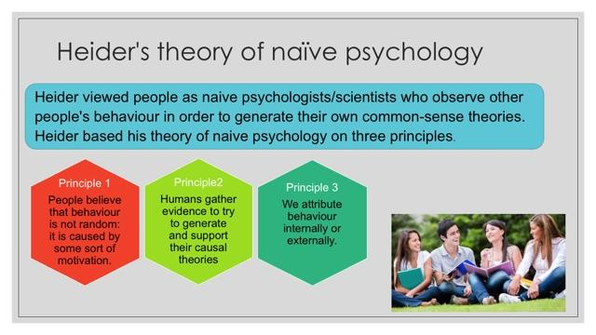
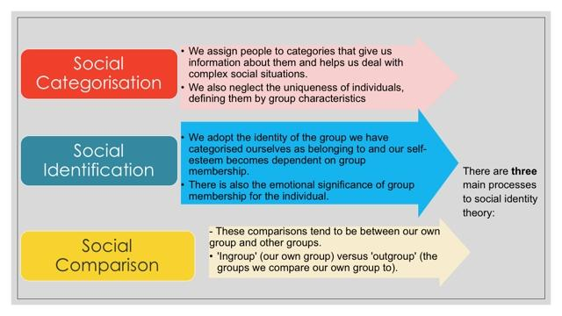
theories

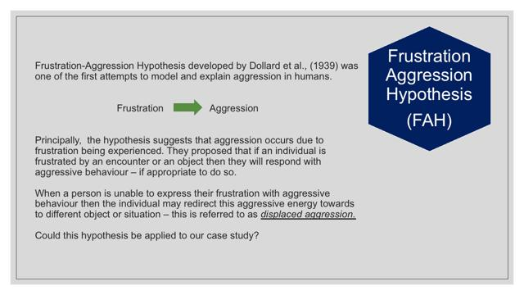

Staff member:

Social identity theory (SIT): she is a woman with 58 years old, with self-esteem but the way she behaved she is emotionally not well.
Attribution theory (Why did she do that): using Heider's theory I assume from principle 1 that she raised her voice when talking to the young man because she felt ignored after several unsuccessful attempts, principle 2 the company rules is to be followed, principle 3 she is a woman with 58 years old with personal problems with low experience, as she has been in this position for a short time.
Frustration aggression hypothesis (FAH): the receptionist was frustrated by asking the young man several times to put on the mask and follow company rules to prevent Coved 19 and turned to be aggressive.

Service user:
Social identity theory (SIT): he is a 15 years old boy with no self-esteem, who is emotionally unbalanced and has constant mood swings and loses control even in routine situations.
Attribution theory (why did he do that): due to his illness, he stopped with his physical activities, which leads to a depressive state. where he sees the world totally negative, principle 1 he felt abused by the receptionist because she did not take in consideration his health problems. principle 2 he is not capable to judge is own attitudes, principle 3 he is young and immature with mental problems.

The importance of counseling.
The main objective of counseling is to solve the patient's problems through emotional and intellectual empowerment. In other words, it is to enable the patient to solve their annoyances based on knowledge of their personality and their life experiences.
For it to be effective, the patient needs to feel capable of solving their behavioral mismatches and other problems that spread across different areas of their life (professional, family, social, love). He may not be able to resolve them in the desired way, but at least he should feel that it is possible because of the skills developed during counseling.

The counselor, in turn, sees the aspects that make up the patients' potential for change. It directs the most satisfactory standards of conduct, values and habits for each patient. In this way, individuals seeking psychological guidance also develop self-confidence, reduce anxiety, and re-establish emotional balance.

At the end of a well-done counseling, the patient must have become aware of his acts and ways of thinking, as well as of his possibilities for choices. Psychological counseling helps confused individuals to face their uncertainties without the stress load of external pressures. Thus, they are able to choose the best alternatives for their future and to satisfy their needs.
When you are emotionally involved with a problem, finding a solution to it is challenging. For those who observe from the outside, the way out can be very simple, but we cannot see it because we are immersed in emotions. That is why the advice of a mental health professional makes such a difference in resolving everyday impasses. They guide people to see them as they are, opening the way for emotional detachment and, finally, for possible solutions.

Statistical information relating to rates of suicide within this age group.

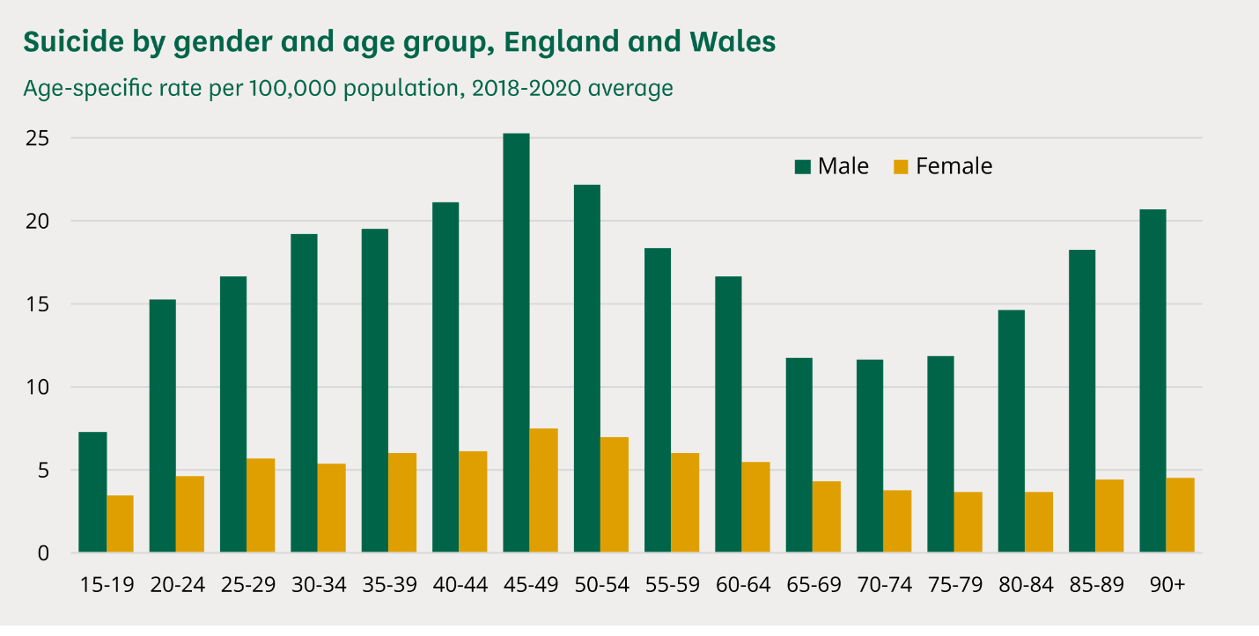

References

Buss, Allan R. "Causes and reasons in attribution theory: A conceptual critique." Journal of Personality and Social Psychology 36.11 (1978): 1311.

Hogg, Michael A. Social identity theory. Stanford University Press, 2020.

Stets, Jan E., and Peter J. Burke. "Identity theory and social identity theory." Social psychology quarterly (2000): 224-237.

Emery, Alan EH. "Emery–Dreifuss muscular dystrophy–a 40 year retrospective." Neuromuscular Disorders 10.4-5 (2000): 228-232.

Rowland, L. P., et al. "Emery‐Dreifuss muscular dystrophy." Annals of Neurology: Official Journal of the American Neurological Association and the Child Neurology Society 5.2 (1979): 111-117.

Miller, Neal E. "I. The frustration-aggression hypothesis." Psychological review 48.4 (1941): 337.

Dollard, John, et al. "Frustration and aggression." (1939).

Abrams, Dominic, Fanny Lalot, and Michael A. Hogg. "Intergroup and intragroup dimensions of COVID-19: A social identity perspective on social fragmentation and unity." Group Processes & Intergroup Relations 24.2 (2021): 201-209.

