Supportive Services
When you have no one to talk to..
Someone to talk to
If there is anything we have missed, or if you would like more information, please visit the websites listed below, or if you would like to talk to someone, please telephone any one of the numbers listed below, where someone will always be happy to talk to you.

Time To Change Wales
Website: http://www.timetochangewales.org.uk/en/
Telephone number: 02920 346598

Child and Adolescent Mental Health Services (CAMHS)
Website: https://youngminds.org.uk/find-help/your-guide-to-support/guide-to-camhs/
Telephone number: 0808 802 5544

Please remember that what you discuss with any professional will remain confidential unless, they have been given reason to be concerned for your safety, or the safety of others around you.

Human Brain (Letter Writing, 2018).
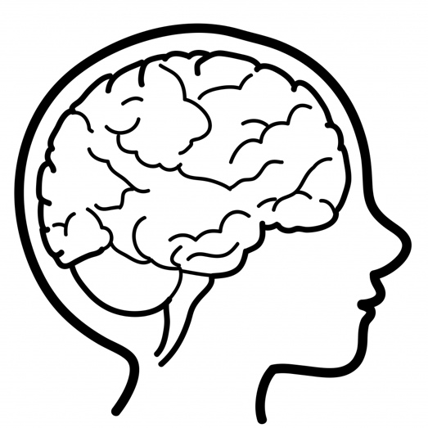

^{[1]}

A leaflet for children with mental health concerns and/or conditions

5.
Chloe Lewis – 1702405

What is Mental Health?

Time To Change (Wales) is a government funded campaign endorsed by 3 local, Welsh charities. All 3 charities, Gofal, Hafal and Mind Cymru specialise in providing support to those with mental health conditions and/or concerns.
Recently, Time To Change produced a campaign specifically aimed at children, #WeCanWeWill which aims to reduce the stigma and the discrimination that often surrounds mental health. The campaign encourages children to upload a positive image of their choice, for some children this is of the beach, or a favourite holiday destination, along with this image children have an opportunity to share their personal experience of mental health (Time To Change Wales, 2018). Regularly talking about your mental health can help to normalise it and prevent any discrimination you or any other child may be feeling.
If you would like more information about the services Time To Change (Wales) provides and the support they are able offer, please see page 5, where you will find their contact information.

Help Continued..

Mental health is something that you all have. It’s your overall emotional, social and psychological health (Mental Health.gov, 2017). Similarly, to your physical health it can range from good to poor, and it can change from time to time depending on your feelings and experiences. Good mental health helps you to maintain positive relationships with your family and friends. It helps you to handle the ups and downs, and generally enjoy all that life has to offer (Mental Health.gov, 2017).

However just because you have good mental health, that doesn’t necessarily mean you are constantly happy, with a big smile plastered across our face. As children, you are able to experience a wide and complex set of emotions, not all of which are positive (Dadds & Vasey, 2001 cited in National Scientific Council on the Developing Child, 2004; Centre on the Developing Child, 2013), and every now and then you can experience feelings of sadness, anger and upset but quite often those feelings will disappear in a day or two, or once you have had a chance to calm down. Sometimes those feelings can persist for longer than one or two days and become overwhelming and difficult to deal with.

You might feel like this because you are being pressured by your parents, your teacher, or even by yourself to do well in school and achieve good examination results, this pressure can have a negative effect on your mental health (McDonald, 2001; Owen-Yeates, 2005 cited in Connors et al, 2009).
Or you may have problems with other children at school. Often, children will treat somebody differently because they perceive them to be different. This is called othering, and it can have a lasting and negative impact on your mental health (Miller, 2008).

If you are experiencing feelings similar to these, please follow the steps on the next page, there you will find helpful advice and handy tips to help improve your mental health.

Child and Adolescent Mental Health Services (CAMHS) are provided by the National Health Service (NHS) and are free of charge. It is the responsibility of CAMHS to assess children like yourself and provide you with help and support should you need it.
Usually a parent, guardian, or teacher will contact CAMHS if they have reason to believe that you are displaying behaviours of poor mental health. However, if you believe this to be the case you can refer yourself for an assessment (NHS,2017). Once you have been assessed CAMHS can provide specialist treatment to help ease the symptoms of poor mental health and help to determine why such feelings were present in the first place. If you would like more information on mental health assessment please see page 5, where you will find their contact information.

4.
1.
1.
Steps you can take to improve your mental health

You can find help in many places, whether it’s online, over the phone or from professionals at school, but the first place you should look for help is at home. Parents/guardians are there to support you and provide you with the information you need. Talking to your parents/guardians may seem awkward at first but you must remember that they were children too, and the feelings you are experiencing, they might have experienced for themselves. If you are unable to talk to your parents/guardians, you should instead try talking to your friends. Often, children of similar ages go through similar learning experiences, and can experience similar feelings. Sharing your feelings with friends may encourage them to do so to. Mental health conditions affect 1/10 children (Task Force Wales, 2015), it could be yourself and it could be a friend. If you believe you, or a friend is suffering from poor mental health, please follow the steps provided on page 2, these can be done together and will have a positive effect on your mental health.

Where can you find some help?

When it comes to your mental health, communication is important. When you talk to your family and friends, you are helping to build a strong and meaningful relationship. It is within those relationships that you can share your thoughts and feelings, this will have a positive effect on your mental health (NHS, 2015). Why not speak to someone new in school and start a new friendship?
1.

It is believed that exercise causes a chemical change in your brain (NHS, 2015). By doing regular exercise you can positively change your mood and rid yourself of feelings of stress and anxiety. This doesn’t mean that you need to be in gym for hours a day, every day. All it means is that for a few days a week, you go for a long walk, or take part in an sporting activity, this can be alone or it can be with friends. Why not invite someone who is not one of your friends to join?
2.

Paying more attention to the present moment, your thoughts, your feelings and the world around you can have a positive impact on your mental health (NHS, 2015). This is known as mindfulness, it helps us to understand the feelings we are experiencing and out them in to perspective. Next time you’re walking to
school, take special care to identify the objects, sights and smells around you.

3.

If you are unable to talk to your family or your friends, you should consider talking to your teacher. Your teacher is someone you see the majority of the week, for the majority of the day. They know you more than you think, and you know them more than you think. You have both already established a line of communication, talking to your teacher can be surprisingly comforting and easy. Additionally, teachers have often received some form of mental health training and can offer guidance and support based on this training. If you do not feel comfortable talking to your teacher about your mental health or any concerns you may be having, you should try and talk to your school counsellor or school nurse. Again, both of those would have received training in mental health conditions and concerns, they are both able to offer support, guidance and referral to other services should you need it.

4.
Acts of kindness will not only impact you but will impact the recipient (NHS, 2015). Acts of kindness can be small, such a giving up your seat, or holding a door open, but both will positively impact your mental health, and improve the day of the person you have helped. Why not go the extra mile and help someone who may need it?

5.
Even learning can improve your mental health (NHS, 2015). By learning something new, you can boost your self-confidence and self-esteem, both of which will have a positive impact on your mental health. You could try learning to play an instrument, or learn to cook your favourite dinner, why not give one of these a go?

Reference List
3.
2.

