Najamus Sahar- 2428590

LCM 4006
Certificate in Higher Education Business Skills for the Workplace
Module- Enterprise and Entrepreneurship
Lecturer- Taonga Kaonga Sobere-Snithers

Individual Business Plan

Table of Contents

Overview of the business plan Pages 3-4
Legal format of the business Page 5
Pestle Analysis Pages 6-7
Marketing Plan Page 8
Funding and expenses Page 9
References Page 10

Overview of the Business idea

Name of the Business- Shirley Flowers and Gifts World
I am planning to open a florist/gift shop called “Shirley Flowers and Gifts.” This falls within the Horticultural or Florist industry. The florist/gift shop will sell fresh flowers including single roses as well as hand tied bouquets. We will also sell a variety of hand made gifts including personalised mugs, personalised candles, balloons, gift baskets and hampers, jewellery and chocolates. We will also supply bespoke Wedding and Funeral flowers/wreaths and gift wrapping supplies, such as cellophane and quality wrapping paper.
Customers will be able to place orders in person or via social media such as Tik Tok and Instagram. We will also accept telephone orders. In the future we also hope to open an online shop.
During Seasonal or special occasions such as Valentines Day, Mothers Day, Christmas, Eid, Diwali. Halloween etc we will be offering exclusive discounts as well as limited edition items.
The unique selling point is that we will offer a next day collection service including on Sundays. Initially we will not be offering a postal flower delivery service, however we will be expanding our services to facilitate this later on.
This shop will be based on the High Street Stratford Road, Shirley, Solihull. This is a main road with plenty of parking. It is also close to residential areas and schools. The customers I will be looking to attract are couples wanting to purchase flowers as gifts, young adults, families and older people. Some customers will become regulars whilst others will be more occasion based and purchase on specific occasions such as birthdays, mothers day and other annual events. There are no similar businesses which sell both flowers and gifts within 2.5 miles. The nearest flower and gift business is “Ever so Special” based in Sparkhill, Birmingham. (www.eversospecial.co.uk) There are however supermarkets which sell flowers nearby including M&S and Tesco.

I , myself will be running the shop. However, my husband will be assisting me in his free time from his employment. We will not be employing anyone unless necessary in order to save costs. The shop will be open 7 days a week from 10am-6pm, excluding Christmas Day.

Legal format of the business
The business will be trading as a Sole proprietorship in my name. “A sole proprietorship is an unincorporated business owned by one entrepreneurial individual. A sole proprietor assumes all the liabilities of the business and is responsible for all business debts. They also benefit from any business profits.” Indeed (n.d)
However, after the initial three months of opening, my husband will be ceasing his employment, and we will be operating as a General partnership. “Going into business with your partner is a great way to start running a company”. startuploans.co.uk (n.d)
“A Partnership is a relatively simple way for two or more legal persons to set up and run a business together with a view to profit.” BIS, a guide to legal forms for business, (2011)
“A general partnership is a business arrangement by which two or more individuals agree to share responsibilities, assets, profits, and financial and legal liabilities associated with a jointly owned business.” Bloomenthal A, (2025) General partnerships explained.
The main advantage of a general partnership is that it is not only will it mean that I have the extra help, but it also helps utilise the benefits of tax relief. “A spouse or civil partner is sometimes taken into partnership wholly or mainly to maximise the tax reliefs that are available. “ www.gov.uk (n.d)
The management structure of the business is shared between both partners, i.e myself and my husband. This means we are both equally involved in in all aspects of running the business and can act independently without any prior authorisation. Profit and loss will also be shared equally.

Pestel Analysis of “Shirley Flowers and Gift World”

PESTLE is an acronyms that stands for Political, Economic, Social, Technological, Legal and Environmental.

“PESTLE analysis enables a manager to identify the key macroeconomic factors that may have an influence on the future development of the business. The identification of future macroeconomic variables of interest and the construction of different scenarios allow the manager to better anticipate the strategic decisions needed to ensure the proper development and sustainability of the business.” Management and Marketing 50 mins.com.(n.d)
Political Factors affecting the business
Politics and the introduction of new laws and legislations can place a huge impact on the floral industry. This was evident when the government introduced new checks on plants and food from the EU as a result of Brexit. This caused significant delays with the transportation and delivery of the flowers. “John Heemserk, the co – founder of Klahee flowers, said his customers relied on timely orders for weddings and funerals, and that their longest delay had been nine hours. This was problematic for us and our customers”. Tapper, J, UK Flower industry thrown into chaos by new Brexit border checks (2024). Another factor is rising import costs, tariffs or instable trade relations between countries.
Economic Factors affecting the business
The economy plays a huge factor in how much people are likely to spend on gift giving. Rising food costs and household bills means people have less money to spend on buying flowers and gifts. Also, supermarkets are a cheaper alternative than a florist. Rising costs of importing will also affect the price of the goods we sell.
Social Factors affecting the business
Changing trends driven by social media influences can have an impact on sales. For example, there is a lot of demand for “everlasting flowers”, or dried flowers. These are low maintenance, aesthetically pleasing and long lasting as opposed to fresh flowers.
Technological factors affecting the business
Online flower ordering has surged in recent years. People prefer to order flowers digitally rather than in a florist shop as its quicker, easier and available 24/7. Flowers can be delivered nationally and internationally. Online platforms such as Tik Tok and Instagram also help boost sales and generate new trends.
Environmental factors affecting the business
Environmental factors include sustainability, climate change and agricultural damage. The use of plastic and cellophane wrapping is widely criticised and there is a call for more eco-friendly wrapping. Further, the effects of pesticides and fertilisers is causing environmental pollution. “When people come to learn about just how damaging the industrial farming of flowers is, it doesn’t feel like such as good gift.” Dubac, C (2022) The Flower industry has a thorny environmental problem, CBC News.
Legal Factors
Consumer Law, Health and Safety legislation, and Data protection are all important factors to consider. Especially, as recently there have been many reports of Cyber attacks and customers personal data theft.

Marketing Plan
“Given the massive potential audience available who are spending many hours a day using social media across the various platforms, it is not surprising that marketers have embraced social media as a marketing channel”. Appel, G et al, (2020) The future of social media in marketing, Journal of the Academy of Marketing science. I will mainly be utilising online platforms such as Instagram, Facebook and Tik Tok to show case my flowers and selection of gifts. Customers will be able to see the latest offers and seasonal promotions as well as place orders for collection. I will also be doing regular Tik Tok “lives” where I will have exclusive special discounts. Further, I will be running competitions where followers share my social media pages with their friends and family in order to win prizes. I will also be doing collaborations with local influencers to promote my content.
During the summer months, I will be joining with wedding planners and photographers to get more exposure.
Locally, I will be delivering flyers with a 10% discount for new customers for a limited time only. This will help us build up a client base.

Funding and Expenses
I will be using £10,000 from my own savings and borrowing £10,000 from family members to cover the initial costs. The main start up expenses are, covering the cost of the building rent, utilities, floristry supplies, tools and payment systems.
A breakdown of the cash flow is below. You will note the total cash flow for one month is approximately £5,350.
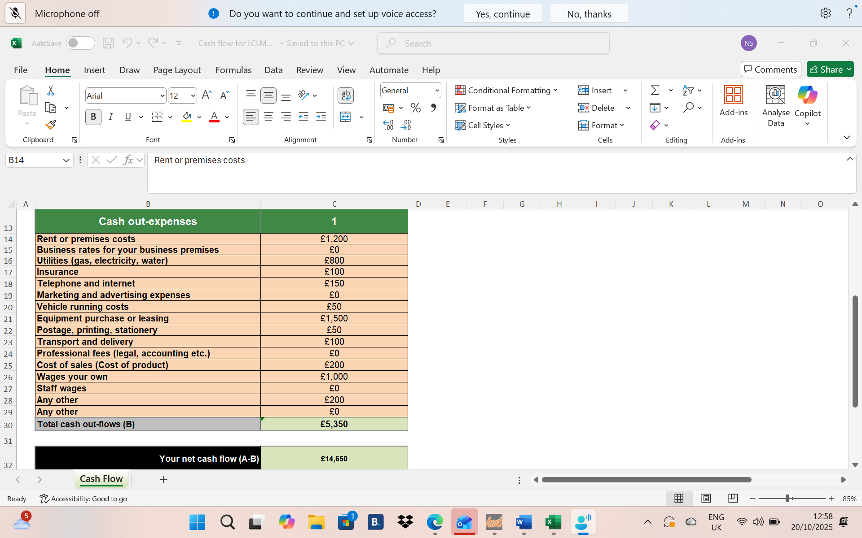
I will also be applying for a government start up loan of £25,000 within the first year of opening. The advantages of this is that not only is the loan free from application fees or early repayment fees, but it also comes with 12 months mentoring from a business advisor. It is also a good way for the business to build up good credit history for any future financial assistance.

References
Indeed.com
www.eversospecial.com
startuploans.co.uk
Guardian.com
www.gov.uk
Strengths, Weaknesses, Opportunities and Threats (SWOT )Analysis of China’s Prevention and Control Strategy for the COVID-19 Epidemic , International Journal of Environmental and Public Health.
The future of social media in marketing (Appel, G. et al., 2020) published in the Journal of the Academy of Marketing Science.

