Big Data model and warehouse for Pestron Foods

Author: Ion-Gabriel Matei
Organisation: University of Wales Trinity Saint Davis
City, Country: London, UK
E-mail: 1816251@student.uwtsd.ac.uk

Abstract
The rapid development and accessibility of data technologies has had a powerful impact in business success. Small business benefits from advanced management tools, effective marketing strategies and advised decision making process that reduce overall costs. Is nevertheless a trend in business development to adopt these technologies and to challenge the competitors which increase the benefits for customers and set up new, diverted, and accessible markets.

INTRODUCTION
Presented report is created based on a case study, related to Pestron Foods-supermarkets chain, an international retailer company with business from Asia to America and Europe.
Increasing volume of electronics attracted attention and the owners are willing to increase the sales in this domain.
Chief Executive Officer (CEO) is asking for a solution, using available technologies, that can demonstrate the business interest and growth capabilities over certain markets where their stores activate.
As possible solution will be presented a data warehouse and a big data model based on existing available data.
Data sets are delivered by the company and contain information about customers and business operation areas from Asia ant United States of America.

Small Business and Big Data
Small business concept is associated with the idea of limited company who deliver services and products at a small scale comparing with large business and is directly reflected on the revenue level, transaction volume, market coverage. Big data concept is defined as a large collection of data, divided in data sets, characterized by its complexity and analysis availability. [2],[4]
Big data analysis creates a transition from business domain of large enterprise into the small sized business according with [1]. Related studies revealed the impact of introducing big data analysis tools into small business comparing the emergent markets and the reported revenues. [2]
Information technology and cloud technologies are facilitating the access at big data collection and the development of data manipulation tools.
Procedural, data sets are created during the collecting process which is well controlled and predefined in order to measure information by variables of interests. Data sets are sorted and labelled for research, tests and evaluated by the potential outcome.
Research methods are common for any business area and includes sciences, humanity, and business. Data accuracy is the most important criteria associated with data collection and in association with appropriate data collection will determine the successful of analysis process.

Quantitative and qualitative data collection methods.
Research integrity is the key point for accurate data collection and in regards of our case study available data can be defined as quantitative data and qualitative data. Selecting from total amount of collected data only the appropriate data can be realised by targeted collecting data tools, specifically developed to correcting errors and filtering data.
Quantitative data collection must be more than numbers and statistics, must be able to deliver meaningful reflection of the market environment, customers, and competitors.[2],[4]
Analytical systems need to evaluate quantitative data reflecting the particularity of the targets and to suggest a certain behaviour.
Improperly data collected can determine several issues, such as:
- research objectives are inaccurately completed and generates wrong decisions
- analysis gets compromised and will be disabled from reproduction
- used resources are wasted and conduct to bad management
- wrong paths may conduct to others research study to fail
- public policy can be compromised based on wrong conclusions
- directly causing damage to participants
The main interest in data analysis is to grow the business, save capital and effectively manage the labour, and all may be possible only when the business learn about their potential customers needs and interests, according with [4]
Presented in [4] as a new idea of “democratization of big data”, data collection became a part of business activity with great efficiency in delivering tailored products and services for customers, building social networking around brands and locations, stimulating the innovation.
Big data tools are diverse and each one with its own particularity. Therefore, is essential for business owners to investigate, learn and chouse the right tool for their domain. Contracting a set of tools and explore before using one for their business strategy will be most recommended.[2],[3]

Customer trigger
Small business can obtain a complete overview about their customers using big data technologies and that means to know what trigger them to buy, to choose a certain shop, to change their preferences, to establish trending, and what satisfy their expectations. A new interaction can be established between customers and their favourite shops, and they can be directly questioned in order to discover what to improve. Customers feedback reports are essentials and can be obtained by using data sources including customer services logs, questionnaire, social media, browser logs, mobile data analytics, general market research.
Social network platforms are most valuable resources of data and result in very accurate research determining niche markets and customer feedback with almost no costs.[3], [4]
Social media platforms are collecting data for their own research and for commercial purpose. Spotting and monitoring behaviours and patterns allows social media companies to establish accurate predictability and to influence trending development by advertising customer targeted products or services. Social media platform can test the market response to a new product or service just before the business are bringing it into the shops.[3],[4]
Trendera and Trend Hunter, for example are specialised in trending and testing the answer of targeted customers and can offer specific answers for business. Online and offline customer behaviour evaluated in deep and detailed introspection down to physical moves inside the stores or time navigating the online shops. Customer data are analysed in context of social conditions, political background, weather, or economic conditions and that almost complete the perspective of well detailed customer with associated with a well recommended product or service.[3]
Google Trends is specialised in deep spectrum analysis and offer expertise in popularity of a brand or product, social media analysis and even can create rating for business. Twitter is particularly successful in offering big data services for business by introducing an innovative facility where accessed information from one brand can be directly compared with accessed information of competitors brands.[3]
Big data analysing is not only about customers and brands but also about data collected from other processes such as logistics, economics and financial systems, payroll, machinery on production line, sensors on delivery vehicles, customer ordering systems and many more others that can be improved, updated, and better managed.[3]
Big data analysis helps small business to find the most successful candidates and reduce the time and the costs with recruitment process, also helps to stimulate existing employees for better performance.
HR data analysis can refer, but not limited to:
- Attendance
- Productivity
- Personal development
- Annual review
- Staff satisfaction survey

Business model on big data
Business model adopted big data as a tool who works for generating revenue. Social media platforms constantly generate income for them and business partners by customizing advertising. Social media platforms collect worldwide data from its users and offer real time analyzing services, or raw data sets as products. Data collection and data analysis became a trading market where every business can buy accessible and most relevant data sets.
Business model gets automatically improved year after year as an impact of big data analytics implementation where dynamic adjustments are possible based on customer usage reports, performance reports, income vs costs balance monitor and many other process management tools.
Small companies must adapt and adopt big data technology in their business model because is the only way to compete with other competitors and the only opportunity to scale the organization and activities. Ignoring the big data means isolation and real thread in a global market as it is nowadays based on internet facility and cloud computing development. In social media era big data bring the solution for a better connectivity with the customers, trending and growing markets and open the company for innovation.
Business impact of big data can be but not limited to:
- Predictability and costs reduction
- Generate revenue and increase productivity
- Facilitate price control
- Competitive advantage
- Ease decision-making
Overall costs reduction is possible based on efficient allocation of resources. Resolving process-based issues is much easier or automatically executed with big data implementation.
Increased sales and revenue are obtained when data showing customers needs and interests are used by the business to tailor their offers.
Pricing decisions are now easier than ever before by integrating big data analytics. Data tools adopted in finance will help to establish the best value and to compare with competition prices. Keeping accessible prices means to control the market position over the competitors and availability for you customers but at the same time need a very accurate predictability and there is big data analysis to support the success.
Global market means very high competition and very dynamic conditions for business, and it can be dangerous if there is no tool to control this. Big data collection offers a great opportunity to address to local customers by their needs, to observe their behavior and then to gain competitive advantage by adding personalization to the products
Efficiency transforms small business in successful attendants to global business when big data a social media are used together in the business model. Social media mining is based on data mining and means to collect data, analyses, and draw advised conclusions about customers interests and trending and after to recommend adverts with personalized products and services for targeted individuals. Decision making process is almost automatized with data processing tools and company reduce the cost for marketing campaigns.
Analytic process of evaluating data sets will lead to valuable information ant that is the base of decision-making process. Customer loyalty and retention are most relevant behaviors that suggest how the business can be successful on a certain market and how sales can grow.
In our case study we need tools that analyses data and identify customer value and acquisition costs in Asian and American markets.
Provided data suggested that Pestron Food customers are not regularly using their money to pursue. This suggested a mathematic correlation between cost of storing the products and product acquisition price and may conclude to the idea that not all the products may worth it. This can be a very important conclusion for a small business and a limited salesforce.

F Big data tools for small business
Big data tools are affordable, ready to use and easy to customize in order to adapt to the business needs.
There are many tools available and can be classified in big data collection tools and data analytics tools but the most effective are integrated tools that provides both collection and analysis services.
In our case study we received data from multiple places and will be necessary multiple processes to select the most relevant. These processes are data integration, data preparation, data quality, data governance.
Data integration tool for small business with multiple stores facilitate interconnection between different data sources, transform all data sets into a unified data base in a single location. Interconnected data sources include management systems, marketing software, website traffic, shop sales systems.
Data preparation tool speed the analysis process by filtering data, correcting, and partitioning and combining data sets.[2], [3], [4]
Data quality tool perform essential actions of duplication detecting, data validation, and standardization. These facilitate accurate data, data integrity and relevance.
Data governance tool support business in processing and data management, regarding data availability, usability, integrity, and security. Is essential for understanding and valuate gathered data, improves data process quality, and speed up analysis.

Collecting Data
Collecting data was never that easy as it is today with the great contribution of internet-based applications and social media platforms.
Data delivered by mobile phones or other internet connected devices and synchronised by users are collected by operating systems providers, internet services providers, network administrators, websites, applications.
For marketing purpose small businesses have many options to collect data, such as:
Surveys-directly asking customer feedback. Quantitative or qualitative data or both can be obtained while the process consist in a list of questions and suggested answers for the participants. Online surveys are most popular but also can be obtained via email, over the phone or face to face. The fastest and most economical way is to create an online survey hosted on company website. Social media posting helps for advertising the survey as well email and SMS requests.
Online tracking- websites, applications, mobile platforms are constantly collecting user data. 40 data points are regularly determined by every website visitor and allows to determine visitor numbers, membership, navigation time, accessed content, etc. Analytics software are integrated in hosting platforms every device and data collected are available to directly collect by the business owner or indirectly by purchasing from third party data collector company. Known as cookies this are available to the websites to help tracking user behaviour.
Transactional tracking-in store selling, online selling became transactions and contained data can generates insights about the customer and more about shops and in general business activities are delivered. This data is essential in general for customer relationship management system and specific for online store functionality, e-commerce partner relationship, or local stores management system. Sell volume, products popularity, purchase frequency and many more information are contained in transactional tracking tool.
Multimedia analytics-marketing campaigns collects from online sources big data targeting key words from searching engines, selection buttons of webpages, subscriber email or mobile messages. Similar information can be collected offline and send when devices get back online. Metrics such as click on number, accessed time, used device, available software, location are relevant for these analytics.
Monitoring social media-collected data are gathered in systems and subsystems such as subscribers, friends, fallowers, regional users, global accounts, interest fields, etc. Advertising campaign always targeted a certain system and use the commune aspects to influence trending with forced, intensive, and repetitive content. These methods are cost consuming due to popularity of the social media platform but is essential to be part of this global network.[4]
Subscription and account registration-providing personal information are valuable customer data. In UK is mandatory for accessing public services or commercial contracts and that gives unlimited control over customers. Targeted advertising, rewards programs demonstrate the interest in commercial brands or build up new brands if necessary. The relation customer-company became very personal when these data collection methods are used and there is important to establish a decent limit of in-depth research, or the relation can break irreversible.
Store monitoring-foot traffic counter is used for tracking of how many people step inside, which hour, which days and these revealed data will help the business to adapt to busy days or busy hours and to regulate sales for better performance. Also, may be suggestive for what is triggering people to come in shop at certain hours or days. Shop high density areas can be better used based on monitoring data to advertise new products or to deliver high stocks or time-sensitive products. This information suggests products, services, or departments popularity as well.

Big data technologies
Data collection and data segmentation leads to a hierarchical organization based on multi-users business model.
An international company can be divided into different data warehouses containing local websites, data bases, or other data collection sources. Will be then possible to separate accounts per geographical area or country, individual markets or each and different brand separately, while also having an overall view of the data, a centralized monitoring system at the top.[2],[4]
Structured data helps to identify and personalize the customers, visualize what kind of audience grows around local business, determine campaign to increase the audience and customize the offers per customers interest. Local collected data reflects who are the best customers, what kind of content may be addressed to them and how to find the easiest way to reach them.
Introducing data management platforms (DMP) into business model can be possible by fallowing next 4 stages:
1. Data organization-it refers to actions of organizing collected data from first-party audience into data sets and “taxonomies”. Taxon categorizations are simply data reviled by users subscribed to the platforms, members of the staff. At this level data organization can be predefined by each level of understanding and extract specifically metrics before DMP start operating.[3], [4]
2. Data segmentation and growing audience-organized data moved from DMP into well-defined data sets and became segments with certain information used to define audience parameters personalized for marketing purpose. In our case study we can segmentate data from shops where can be targeted male customers and female customers with purchasing in a particularity such as WIC-women, infant and children product. Having positive feedback for sales regarding these targeted individuals the business can establish a marketing campaign to advertise more wic products or to expose more wic products into areas with regularly high volume of sales and can ignite audience growing around wic products, the quality and availability at their favorite shops.
3. Reporting- based on created profiles analysis may conduct to revealing in depth information about audience and compare these data with general business marker. Data analyses are busted up by completing previews two steps and determine customers intentions and set up business trending. Platforms build audience with a certain kind of interest and establish a trending evolution around a targeted product and this information are defining the future products or services that will address to this profiler and more than anything can suggest a certain kind of interest for other products.[3].[4]
4. Data activation-is the key point and the benefits of letting data to work for the business can get infinite possibilities and unlimited benefits. Once DMP deployment finished and data integration is available there is unconditional capability of connecting the business with other platforms or another sources of data or analysis tools which considerable increase the knowledge of the targeted customers, controlled markets, product development, market opportunities, finance sources, and may other benefits that guarantee the success.
A demand-side platform (DSP) may be connected to DMP and automatically correct or suggest actions to take at local content management system (CMS), in order to fallow the audience rating and to answer to their interest in real time or at least before their interest is lost.[3].[4]
Building up audience is one of the most successful method to advertise the products and to secure a strong connection with the customers and can be created using data management platform. DMP collect any kind of data originated at first, second or third-party sources, in many available formats and later breaking up to translate them into logical values true or false.
Data markers can refer but not limited at, [2]:
- Age
- Biological
- Ethnicity
- Religion
- Location
- Interest
- Browsing history
- Income
- Personal network
- Preferences
- Social network
- Payment methods
- Used devices
- Subscribed applications

Any data can lead to building a good audience, but data management platform can offer a better perspective when various sources are interconnected.[3]
Small business benefits using DMP are reflected by high level management and conduct to highly expertise and advised decision-making process. DMP offer a new structure of business, information-oriented to maintain and improve any aspects of the business from operational systems, marketing, advertising, to IT, media, globalization.
DPM is the short way to link the right audience with the targeted products or services, using the most accessible applications and running into the most accessible device.
As a business owner is important to select trained people to manipulate DMP activities and to learn and understand the process and be able to recognize the optimal profiler of existing customers and audience.
Marketing processes and strategies has never been much easier than now implementing DMP and helps businesses to resonate with their audience. Customer engagement will be then reflected directly in increasing sales and popularity of targeted brands.[3]
Data-driven marketing is a concept based on DMP capabilities and ensure business competitivity at high level on a global fast-growing market.[4]
When we talk about delivering personalized experience the content is the most significative:
- Customized video, audio for web and mobile users
- TV content with relevant information about locations and availability products
- Suggestive offers with similar products
- Brand loyalty and audience grow under specific circumstances and for that DMP is essential:
- Explore research companies with potential customers portfolio
- Driven audiences obtained by paid search campaigns with media partners
- Driven audience build up using social media platforms that provides customized audience solutions
Additional revenue can be obtained by selling customers data, a well-practiced method worldwide, see here Google, Facebook, Tweeter, Amazon, Apple, etc.[3],[4]

Benefits and weaknesses
Xplenty is one of the most popular platforms with integrated solutions to gather different data sources, specialized in data optimization, data quality and data analysis, most related to cloud technologies. The friendly presentation offers an intuitive framework and facilitate data replication, data modelling and implementing extract-transform-load process (ETL), and extract-load-transform process (ELT).[5]
In ETL process data transit the source to a new place called “data warehouse”. In comparation the ELT make data transition to another location called “data lake” [5].
With Xplenty, ELT use exiting for the best exploitation to create data warehouse while ETL secure data privacy before loading to data warehouse and verify compliance by filtering sensitive data.[5]
ETL support complexed transformations and that is more expensive than ELT. But securing data is more efficient and faster in ETL leading to a “stable data analysis”.[5]
According with regulatory institutions, GDPR -General Data Protection Regulation, HIPAA -Health Insurance Portability and Accountability Act, or CCPA -California Consumer Privacy Act private data must be excluded, encapsulated, or encrypted. In this matter ETL is the secure option to complete these actions because “it transforms the data before putting it into the data warehouse.” [5], [6]
Xplenty is a flexible and easy scalable cloud platform recognized in the market for complete solutions in advertising, sales, social media, and is offering technical support through multimedia devices. The platform use “rich expression language” technology to collect data.[5]
Identified weakness are regarding availability for annual subscription at a considerable price.
Adverity is other considerable solution recognized in the market for “flexible end-to-end marketing analytics” [7]
This platform is used for tracking marketing evolution and delivers complete reports with real-time automatic suggestions and in-depth analysis.
Marketing analyses are measured its value in ROI-return of investment and small business needs to monitories investments. Adverity helps small business in developing a set of affordable objectives based on organizational structure and determine clustering options for business plan execution.[7]
Build in predictive solution, fast data transformation, personalized reports and real time customer driven process are few of advantages of using Adverity. As previews platform cost of subscription may be the biggest inconvenient but performant ROI advisor can easily compensate the effort.
Next platform with potential for small business is Cloudera Data Platform (CDP).
As an open-source solution is presented as integrated platform with deployment facility for Apache Hadoop, Apache Spark, Apache Impala and support data collection, data optimization, data management, data discovery, data modelling, reporting, unlimited transfer.[8]
Viewed as IT solution and business tool in one simplified formula with great futures, secured and simplified design, user friendly environment and automatized processes, customization options, flexible and scalable, ready to use on premises or cloud compatible. [8]
Private cloud option, public cloud solution, CDP Hybrid Cloud platform is presented on the market ready to run in any environment with any analytics and any data formats.[8]
For our case study will be used KNIME which stands for Konstanz Information Miner.
An open-source tool supported by Linux, Windows, OSX operating systems that can be used for business reports, model integration, data research, CRM, data mining, analytics, and business intelligence.
One of the best characteristics of these platform represented visual workflows for data analytics. Simplified drag and drop style interface with visualization the working environment is designed to deploy models with graphic suggestive hub elements such as nodes connections and components.[9]
ETL operations are simplified and compatible with other available technologies. Variate languages are recognized and can support complex algorithms.
The platform is setting up easily high standards for accessibility and organizational workflow, confer stability and improve automatization process.
Weakness may be into limited data capacity than reduces systems RAM to zero availability.[6],[8]
Other inconvenience is that comparing with previews platforms is not capable to provide graph databases and any add on facility will bring an extra cost.

Data Warehouse Modelling
Bill Inmon has the inventor of data warehousing, and his aim was to design a whole company model that integrates entire business model under entity-relationship (ER) model.
Small business benefit from this idea by using business model as reflection of its targets and not targeting objects in business domain.
Data warehouse model in ER modelling combine data from various systems, selected from the perspective of the business model. Data consistency, data quality and organization determine analysis and decision-making process.
ER modelling is structured as fallow:
- High level modelling-is the abstract model where we can identify detailed relationship established between CRM and business organization.
- Middle level modelling-reflect which data sets may be established based on high level modelling.
- Underlying model-is the section where can be identified physical characteristics describing storage units, performance markers, platform capability, data partitioning.
Similar model is Financial Services Logical Data Model (FS-LDM) released by Teradata design financial warehouse models.[10]
R. Kimball introduced in [11] data warehouse modelling associated with data warehouse engineering where user data are first analyzed. Dimensional star model and the snowflake model for example includes few steps:
1. Finding specific application that generates analysis and decision-making and if is there an interest to evaluate “single business event, the state of an event, or a process containing a series of inter-related events.” [11]
2. Regarding analysis introduced “the granulation” which refer to “sub-division for all analysis” at different dimensions.[11]
3. Once granularity is determined a “dimension table” is created, with dimensional attributes where will be executed “grouping and screening during analysis.” [11]
4. “Facts identification” is the last step to identify markers that take measures during analysis. [ 11]
Dan Linstedt extends data models from ER model to the Data Vault Model.
The new model introduced audit targeting data history, traceability, and consistency without integration. Using different thematic the model establishes structures and normalization process and request changes to the source system when necessary.[12]
Data Vault Model structure contains:
The hub-is the business center and integrates entity keys, data warehouse serial key, access time, and data sources.[12]
Links-hubs relations are abstracted as independent units which determines high scalability of the model.[12]
Satellites- refer to detailed interconnection of hubs and subscriptions. A satellite contains “surrogate keys, loading time, source types, and detailed hub descriptions.” [12]
In Data Vault Model the ETL processing is configurable.[12]
According with [13] the Anchor Model is developed by Lars Rönnbäck in his intention to highly normalize the Vault model with great scalability. Anchor model is known also as “K-V structural model” and is structured as fallowing:
Anchors-are similar with hubs and represents business entities containing only primary keys.[13]
Attributes-the same as satellites in the Data Vault Model are better normalized structures known as K-V and contain only one anchor attributes.[13]
Ties-are the relationships between anchors, structured in tables, similar with links from Vault model and facilitate growing capabilities.[13]
Knots-like nodes where attributes are shared between connected anchors.[13]

Pestron Foods and Big Data
Pestron Foods provided data from various locations and because of the complexity of this case study will be recommended to use data mining process where we will be able to create a combination between shop activities, transactions, events, shop location, customers personal and financial data in correlation with time, date, frequency, and others suggestive markers.
Data sources are presented in plain text, xml formats and contain next information:
Fig1. First data source 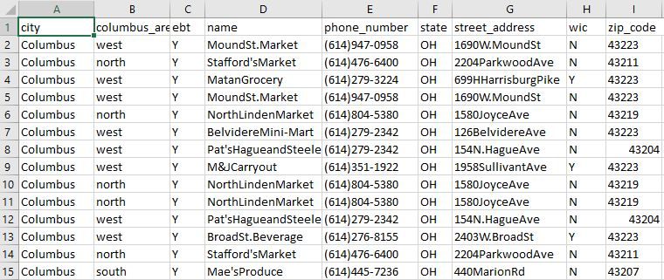
First data source provides stores information located in Columbus, USA area.
Second data source listed below, contain more information about shops and customers from Asia.
Fig2. Second data source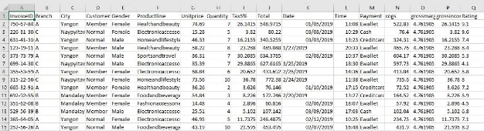
KNIME platform facilitate working with plenty types of data formats and connect with any available sources such as databases (Oracle, Microsoft SQL, Apache Hive, Snowflake) and data warehouses (Avro, Parquet, or ORC files from HDFS, S3, or Azure)”.[14]
According with [14] platform compatibility extends to logistics, financial, accountability and management software environments such as Salesforce, SharePoint, SAP Reader (Theobald Software), Twitter, AWS S3, Google Sheets, Azure.
Using KNIME platform we can open and combine both sources that at very first moment contains unstructured data types.

Files are evaluated and related values are selected and separated in different data sets.
Fig.3 Nominal value splitter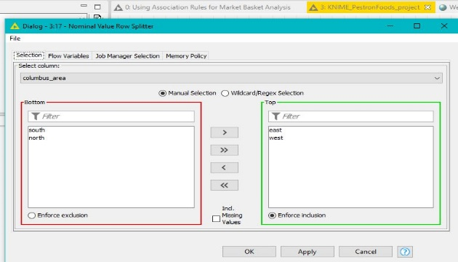
Fig4. Data combining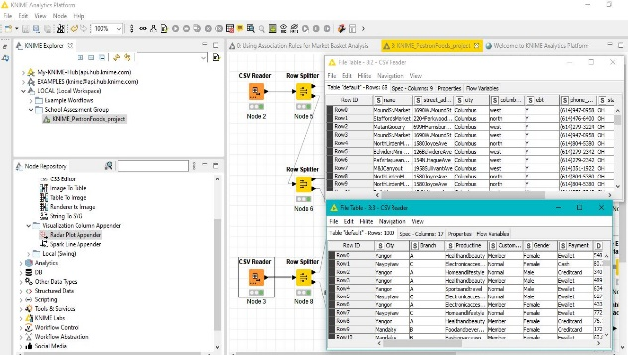
After data access is established nest stage is to create data transformation for a better manipulation and these actions include secondary steps such as aggregate, sort, filter, and join data.[14]
Fig5. Data filtering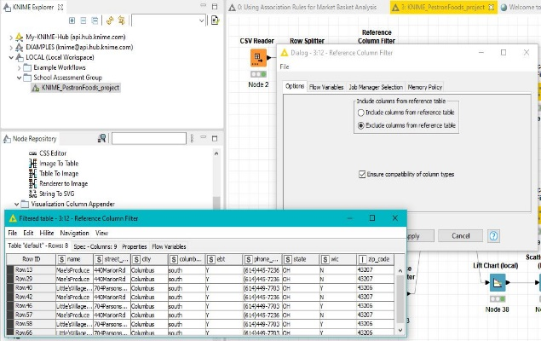
Raw data must be filtered, selected, eliminated errors and null values, executed data type conversion and that is possible trough normalization process.
Extract, select, construct features are available to prepare dataset for machine learning.[14]

Fig6. Reference filter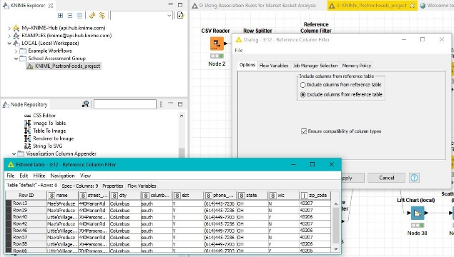
“Machine learning” model is revolutionary feature that KNIME successfully delivers and contain a set of predefinitions such as: data classification, dimension reduction, or clustering.[14]
Advanced algorithms are used for automatic learning, creating tree-based methods, expanding to forest models when network expand considerable and logistic regression. [14]
According with [14] quality data are obtained with hyperparameter optimization, with available boosting methods and stacking, or building complex ensembles.
Fig7. Mining process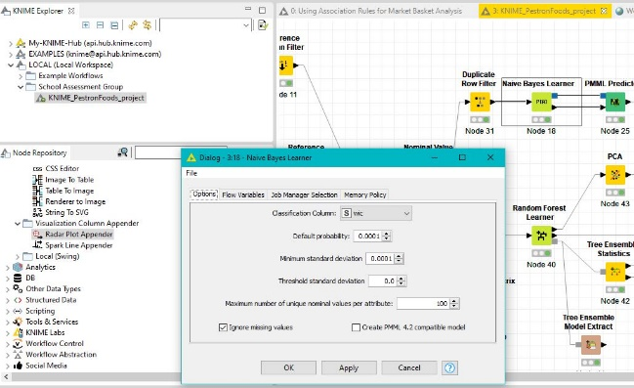
Next stage is data analysis and process mining from where will generate statistics.
Fig.8 Statistics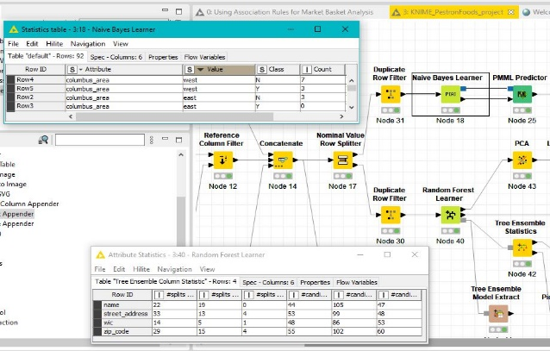

Summary statistics reflects essential data from filtered tables and statistical tests increase quality and secure hypothesis, suggest dimensions reduction, corelate analysis, ensure [14].
Fig9. Analysis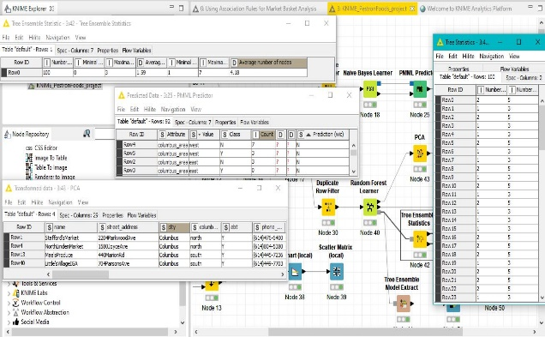
Graphic features are offering a large scale of reproductions with deep introspection and customized as it need.
Fig10 Histogram view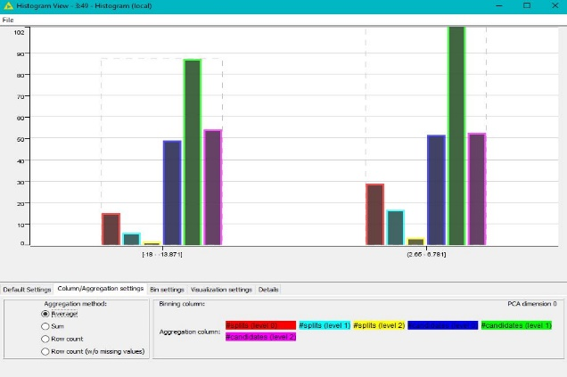
Advances charts, bar chart, metrics view, matrix, colons to image translations, scatter plot, parallel coordinates, networks, graphic map and many more.[14]
Fig11. Chart view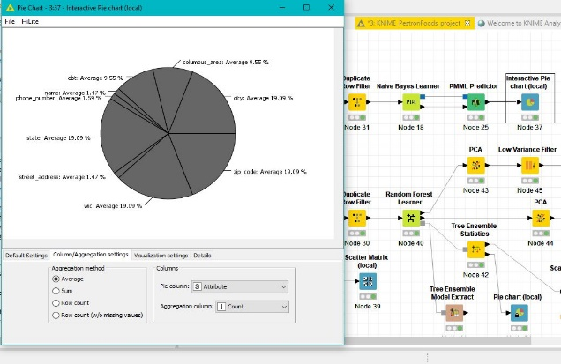

Fig.12 Matrix view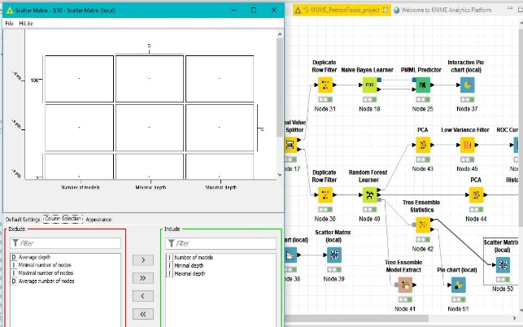
Pestron Foods needs to build up a data base in order to use data warehouse facilities, which KNIME is ready to provide. SQL knowledge are necessary to implement and connect data base with KNIME nodes.
Customized export reports with different formats are available for management.
Fig13. Workflow view
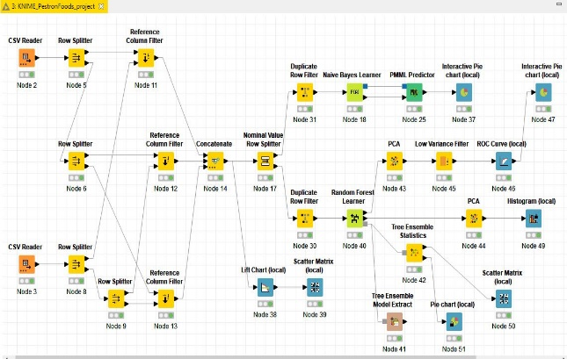
The platform present capability to connect, write and read from database. ETL process is easy and data manipulation is secured with a variate range of models and analysis, statistics, and business-focused outputs.[14], [5]

Conclusions
Pestron Foods is a small business that has immense potential to grow from two markets to a global available market and the solution for that is to adopt in their business model big data technology. In order to succeed the company needs improvements: optimizing stocks, increase predictability, open to social media platforms with their advertising, manage a better relationship with their customers by understanding their needs and promoting own products to generate more income.
Data analyses help the business to eliminate unwanted stocks and to customize their offers according with customers preferences.[1],[3]
In store work can be optimized by connected big data platform at local monitoring systems which includes logistics, delivery, access, security, payroll, cashing, storage temperature control, etc.

FIGURES and TABLES
Fig1. First data source
Fig2. Second data source
Fig.3 Nominal value splitter
Fig4. Data combining
Fig5. Data filtering
Fig6. Reference filter
Fig7. Mining process
Fig.8 Statistics
Fig9. Analysis
Fig10 Histogram view
Fig11. Chart view
Fig.12 Matrix view
Fig13. Workflow view

References

[1] Accounting Today, Big Data, [Online], 2021, Available: https://www.accountingtoday.com
[2] Intuit, Study of big data, [Online], 2021, Available: https://http-download.intuit.com/http.intuit/CMO/intuit/futureofsmallbusiness/intuit_2020_report.pdf
[3] Zdnet.com, Intuit aims to give small business spin to big data, 2021, [Online], Available: https://www.zdnet.com/article/intuit-aims-to-give-small-business-spin-to-big-data
[4] Intuit, The new data democracy, 2021, [Online]. Available: https://www.slideshare.net/IntuitInc/intuit-2020-report-the-new-data-democracy
[5] Xplenty, ETL vs ELT, 2021, [Online], Available: https://www.xplenty.com/blog/etl-vs-elt
[6] Pentasecurity, Data compliance, 2021, [Online], Available: https://www.pentasecurity.com/blog/4-data-compliance-standards-gdpr-hipaa-pci-dss-ccpa
[7] Adverty.com, Platform presentation, 2021, [Online], Available: https://www.adverity.com
[8] Cloudera, Cloudera data platform, 2021, [Online], Available: https://www.cloudera.com/products/cloudera-data-platform.html
[9] KNIME, Analytics platform, 2021, [Online], Available: https://www.knime.com/knime-analytics-platform
[10] Teradata, Financial data model, 2021, [Online], Available: https://www.teradata.co.uk/Industries/Financial-Services/Financial-Services-Data-Model
[11] R. Kimball., R. Margy,,The Complete Guide to Dimensional Modelling, Second edition, John Wiley & Sons, 2002, New York
[12] DanLinstedt.com, Data vault basics, 2021, [Online], Accessed: https://danlinstedt.com/solutions-2/data-vault-basics
[13] Anchormodeling.com, Anchor model, 2021. [Online]. Available: http://www.anchormodeling.com
[14] KNIME.com, Process mining, 2021, [Online], Available: https://www.knime.com/sites/default/files/2021-03/process-mining-knime.pdf

