
Student Name: | Gias Ahmed
Student Number: | 1709681
Module No: | BMSK4003
Module Title: | Digital Skills and Research Methods
Assessment: | 2
Date of Submission: | 30/08/2018
Skills for the Workplace
Module Assignment Submission

Abstract
The research is pointed out the gender pay gap of UK and use different methodologies for this research that finds out the huge effect of the pay gap among women. The research founds 88% of women in the UK workforce deprived of their main payment and pays less. Also, 11% male is deprived of their standard payment. The gap is decreasing at a very small rate throughout many years. Men are engaging in the full-time workforce and lead the field where women are less in the full-time workforce because of most of the reason for having children. Education of people also makes the pay gap more vital though nowadays the rate of education in people is increasing. Ages of male and female effect the wage rate sometimes. Where men are paid higher than women at older ages, where many women do not carry their jobs. Many rules and regulations are forced in the UK to control and maintain the equality but in most of the cases, it fails to control the discrimination. Different factors show the reason for the gender pay gap in the UK in the assessment. Analysis of different articles shows different solutions, but their main concern is the gender pay gap effect and resolving.

Table of Contents
Abstract 2
Introduction 4
Literature Review 5
Analysis and Findings 6
Conclusion 11
Recommendation 12
References 13

List of Illustrations
Figure 1: Gross median income of Men and Women 7
Figure 2: Hourly wage and wage gap 7
Figure 3: Work characteristics 8

Introduction
The gender pay gap is a most common matter in the UK and concerning the issue of the employees. About 90% of women in the UK is facing this problem and gets less than men in the workplace. The issue is serious because it is increasing poverty and many other problems also. The assessment is focusing on the topic and research the impact and situation of the gender pay gap. Also focuses on different issues and effect of this problem.

Literature Review
As the gender pay gap is a widely concerned topic in the UK, the law of Equal Pay Act is not maintained strictly thought the organisations in the country. According to the Ons.gov.uk (2018), focuses on the equal pay and raising awareness among the people and the organisation about the gender pay gap. The articles show that the wages among men in 2011 are 13 $ per hour whereas 11.50 $ per hour to women. The discrimination is continued to grow and in 2017 it is 15 $ per hour to men and 13 $ per hour to women which is a huge gap in the wage rate. Women are not only losing their rights but also, they are deprived and demotivated sometimes for that. Also, women are deprived in all ages from men by a larger proportion of their earnings. Sometimes these gap is occurred because of their occupation and types of post in the organisation. But in some organisations, women also paid higher than men.
According to Costa Dias, M., Joyce, R. and Parodi, F., (2018), in their article named the gender pay gap in the UK: children and experience work stated that gender pay gap is remained large in the UK. They stated that the low payment in jobs increases poverty and the gap between men and women in their salary is a matter of their human rights. They focused on the payment of different types of people according to their standards. They mainly focus on drivers as a sample of their research and find out the differences between them. According to their research, BHPS men 5667 women 6667, Usoc men 11346 women 12563, both of them men 1279 women 1450-person sample size results in the different level of people working age.
According to the Assets.publishing.service.gov.uk (2018), Prof. Wendy Olsen, Dr Vanessa Gash, Sook Kim, Dr Min Zhang stated that drivers of the gender pay gap are education 5%, occupational segregation 10%, industrial sector 12%, unexplained 36% and labour market 37%. Also, their research shows that 80%-part-time worker are women and they are paid low than male. About 56% of full-time workers are male and having a higher pay rate. They also show that full-time pay gap is 12.10%.
According to Times (2018), Aleksandra Wisniewska, Billy Ehrenberg-Shannon, and Sarah Gordon stated that UK companies pay less to females than males in 9 sectors out of 17 sectors. Also, males are paid 10% more than females in different sectors. 90% of women were paid less in their workplace and only 10% of women earn equal or more money in their work. But males are paid around 88% equal or in favor of their rights. They have also found out the highest pay gap around 88% in an organisation. They found that 1470 companies pay more females and 8090 companies pay males more which is a huge gap.

Analysis and Findings
From the data found in the articles, the pay gap in the UK seems to be a burden. Analysing these data is needed for the recovery of this system and find the way out of the problem.
From the data of Ons.gov.uk (2018), all the data has been considered and analysed so that the gender pay gap of UK can be realised. By analysing the data, the research found that the pay gap is a matter of concern in the UK. Most of the organisations in the UK used to pay less to women and does not pay equal to them. The research shows that men are dominated in the payment facilities. Full-time work is around 95% in favour of men rather than equal to women. The occupational system is also responsible for that. Moreover, the highest wages move around the age of 30-50 workers and thus gap incurred by these strategies. Female pay growth rate is also not so much growing in respect of male and according to 2017, the rate is too lower and not growing at all in the young age. Men are paid 21% more when working in the same company more than 20 years than males who are less than one year in work and females are 17.5% in these cases where pay rate is higher for a male(Drolet and Mumford, 2011). Also, men working in higher post earn 4 times more where females are 3.5 times more. Women are working much on part-time jobs for in many times having children and many other reasons, that’s why men are dominated in the field of full-time job. Their median gross hourly income is also different and shown in the following figure-
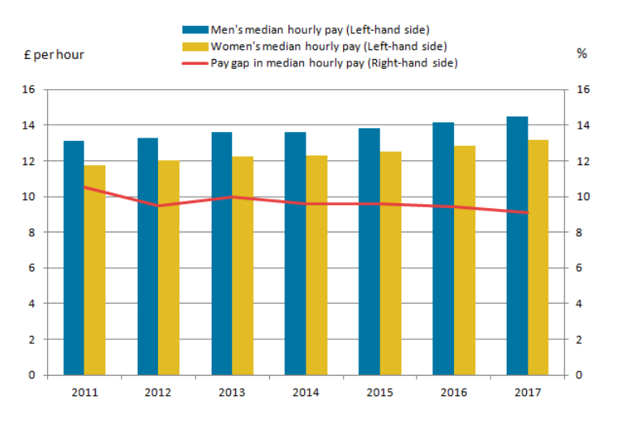
Figure 1: Gross median income of Men and Women
(Ons.gov.uk, 2018)
The figure shows that men are paid higher per hour than women through all the years and there is always 1 – 2 % difference between men and women wage rate per hour. In 2011, their men were paid 13 and women are 11.80 $ per hour where in 2012 men were paid 13.20 and women were paid 12 $ per hour. In these circumstances, in 2017, men paid 14.30 and women were 13.10 which show that difference is still in the workplace and there is a pay gap.
From analysing the data of Costa Dias, M., Joyce, R. and Parodi, F., (2018), there are two kinds of data. One is the British Household Panel Survey (BHPS) and another is the Understanding Society (USoc). The total sample of BHPS is 12334 individuals of which 5667 men and 6667 women. Of the total USoc 23909, men are 11346 and women are 12563 individuals. The number of observations of BHPS was 84258 of which men was 37241 and women was 47017. Where the number of observations in USoc was 87067 of which men was 41538 and women was 45529. The median duration of observation spells was BHPS men 5 and women 6 where USoc men 2 and women 2. Where distribution of education among the sample men in High school .456, A-level .406, and degree.137 where women passing high school .438, A-level .434 and degree.126. From the sample analysis, it seems the wage gap and the hourly wage is high for males in 23 years. The hourly wage and wage gap is shown in the following figure-
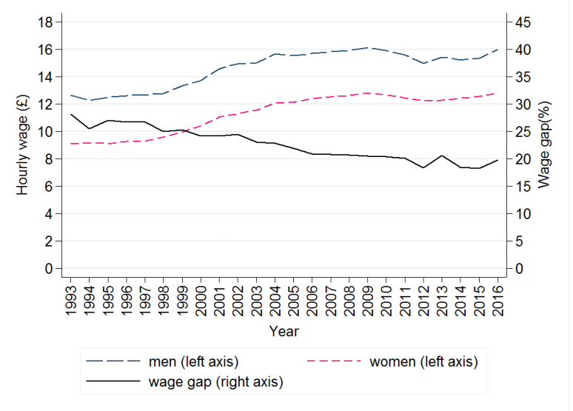
Figure 2: Hourly wage and the wage gap
(Costa Dias, M., Joyce, R. and Parodi, F., 2018)
The figure shows that men wage is increasing throughout the years where women wage is also increasing but the difference between them is not so much lessening (Gregory, Sales and Hegewisch, 2009). The rate of the wage gap is decreasing over time but nowadays fluctuating. Where educational factors also dominating the wage gap and wage. Overall gender pay gap is clear in the research and needs to be controlled by proper maintaining.
From analysing the data of Assets.publishing.service.gov.uk (2018) by Prof. Wendy Olsen, Dr Vanessa Gash, Sook Kim, Dr Min Zhang found that the pay gap of the mean of ASHE is 17.7% and BHPS is 13.4% where the median of ASHE is 19.3% and 5.8% BHPS. The research observed key characteristics of the employees in the UK such as follows-
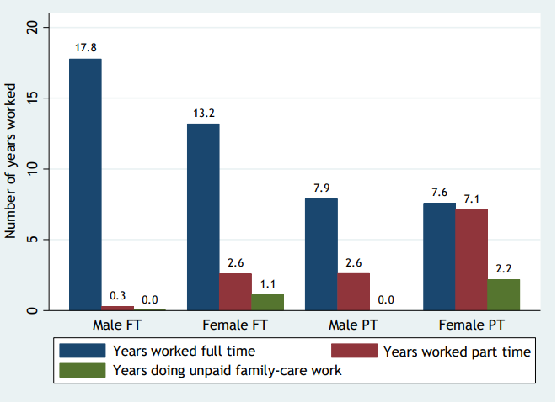
Figure 3: Work characteristics
(Assets.publishing.service.gov.uk, 2018)
The figure shows that male is dominated in all the fields and earn much more than women. Women also do unpaid family care work, which is around 0% for men. Also, the male is not so interested in part-time jobs where women are very much comfortable in that field. Thus, the characteristics also influence the gender pay gap. The research found that the pay rate of female per hour is 10.85$ in full time 9.77 in part-time and all employees are 10.47$. but the male pay rate hourly full time is 12.34$, 10.07$ in part-time and all employees is 12.09$. overall, the full-time pay gap is found at 12.1%.
Analysing the data of Times (2018) by Aleksandra Wisniewska, Billy Ehrenberg-Shannon and Sarah Gordon found that the gender pay gap is 18.4% in part-time and full-time work. The analysis found different pay gap in the different sector such it found 23% pay gap in the construction sector, 22% in financial and insurance sector, 20% in the education sector and 1% in accommodation and food sector (Times, 2018). The research shows that 30% of women are paid lowest in every kind of company in the UK. The gap is devasting in day by day.
So, all the research found that the gender pay gap in the UK is a matter of concentration and need to be evaluated (Chichilnisky, 2009). For removing discrimination and this gap, the government should be effective enough to control it. The study found that educational improvement is also effective to lessen this gap. The pay gap is a discriminatory activity where people are not equally treated. Thus, it also increases poverty.

Conclusion
The gender pay gap is one of the vital problems in the UK and still this thing need to be controlled. Many laws like the Equal Pay Act, Gender Discrimination Act etc. are in force in the UK but is not maintained properly. Thus, employees are treated not equally, many women around 80% are deprived of their actual payment and paid less of that. The gap is not so much lessening overtimes but fluctuating. Proper maintenance is needed for the gap to be removed. There must be strict laws and regulations to be maintained and controlled. So, the gender pay gap requires to be slow down for the equality among people.

Recommendation
The research of the gender pay gap founds many limitations of the employees mostly women that they are deprived in the workforce. The problem is not resolving throughout the times but for removing this there need some initiatives. For this some recommendations are given below:
- Relevant laws and regulations should be controlled and maintained strictly.
- Equal Pay Act should be enforced properly.
- Ensure punishment for gender pay gap because most organisations do not pay women according to their rights.
- Raising awareness among people so that they can be aware of their rights.
- Must emphasis on the education of people because education helps to reduce the gap.
- Proper supervision must be in force for the maintaining strategy.
- The government must be conscious of this matter.
- Every organisation must be a focus on the matter of gender pay gap so that anyone cannot pay less for the same level of work.
- If necessary, there must ensure new laws for the removal of the gender pay gap.

References
Ons.gov.uk. (2018). Understanding the gender pay gap in the UK - Office for National Statistics. [online] Available at: https://www.ons.gov.uk/employmentandlabourmarket/peopleinwork/earningsandworkinghours/articles/understandingthegenderpaygapintheuk/2018-01-17 [Accessed 25 Aug. 2018].
Costa Dias, M., Joyce, R. and Parodi, F., 2018. The gender pay gap in the UK: children and experience in work. Institute for Fiscal Studies. https://www. ifs. org. uk/publications/10356
Assets.publishing.service.gov.uk. (2018). [online] Available at: https://assets.publishing.service.gov.uk/government/uploads/system/uploads/attachment_data/file/706030/Gender_pay_gap_in_the_UK_evidence_from_the_UKHLS.pdf [Accessed 25 Aug. 2018].
Times, T. (2018). Gender pay gap: how women are short-changed in the UK. [online] Ig.ft.com. Available at: https://ig.ft.com/gender-pay-gap-UK/ [Accessed 25 Aug. 2018].
Drolet, M. and Mumford, K. (2011). The Gender Pay Gap for Private-Sector Employees in Canada and Britain. British Journal of Industrial Relations, 50(3), pp.529-553.
Gregory, J., Sales, R. and Hegewisch, A. (2009). Women, Work and Inequality. Basingstoke: Palgrave.
Chichilnisky, G. (2009). Gender Pay Gap. SSRN Electronic Journal.

