
REFLECTIVE REPORT ON EMPLOYABILITY SKILLS

Student Name: Samuel Filipe Torres da Silva
Student ID: 2107485
Module Code: BMSW 4001
Assignment Title: Task 2 Reflective review on Employability skills (report)
Lecturer Name: Giridhar Katti
Table of content
1. Contents 3
2. Abstract 3
3. Introduction 3
4. Discussion 4
4. 1 Time Management Skill 4
4. 2 Written Communication Skill 6
4. 3 Presentation Skill 7
5. Conclusion 8
6. Action Plan 9
7. References 10
8. Bibliography 12
9. Appendices 12
Appendices 9. 1 12
Appendices 9. 2 13
Appendices 9. 3 14
Appendices 9. 4 Feedback from Lecture: 15
10. Lectures Draft 16

1. Contents
This reflective report will talk and observe the definition of employability skills and how some of the employability skills help nurture self-evolution.

2. Abstract

Examining Employability skills
What abilities do companies seek? ‘Employability skills are defined as skills required not only to gain employment but also to progress within an enterprise to achieve one’s potential and contribute successfully to enterprise strategic directions.
Today, despite the degree, companies are paying more attention to the employability skills of the graduates, but there is no uniform standard of employability skills. What employability skills the graduates should have, depending on the company’s actual operating conditions and different companies have different standards (Cottrell, 2019). Through a wide range of literature research, the result of the employability skills needed by companies are almost the same, and can be roughly divided into the following nine basic skills: Time Management skill, Written Communication skill, Presentation skill, Digital skill, Note Taking skill, Finding Information/Research skill, Critical Thinking skill, Team Working skill and Planning/Organisation skill.

3. Introduction

In this reflective review, I will explain what employability skills are and why they are necessary.
Employability Skills are a series of capabilities, notions, and individual qualities that increase an individual's chances of obtaining work and succeeding in their chosen professions.
According to McQuaid (2005), the term "employability" refers to two job-related characteristics: aptitude or training, and work attitude.

Your career will most certainly entail a variety of work responsibilities and employers, and even if you stay in the same career, its nature will most likely vary over time. As a result, employability skills are valuable since they are transferable and you can apply them to any circumstance you find yourself in.
Follow on to use Gibb’s reflective cycle to be applied to this report.

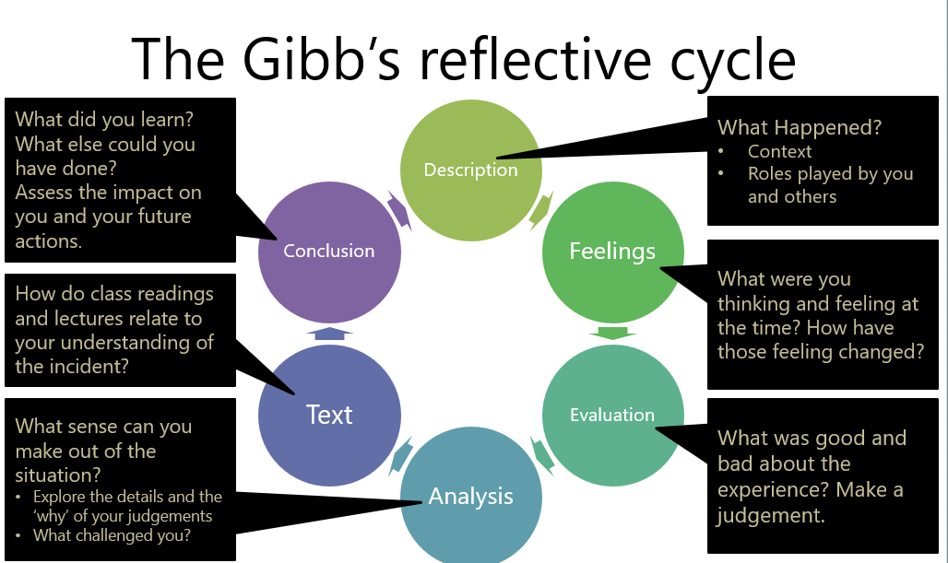
Gibbs, G. (1988)

4. Discussion

In this report, I will just focus on the first three employability skills (Time Management, Written Communication and Presentation skills) and go throw the challenges encounter along the way.

4. 1 Time Management Skill

Time Management skills let me improve the capacity to set aside a fair amount of time each day to carry out various tasks based on my life obligations, such as learning, working or exercising. I must strike a balance in order to devote enough time to each of my life commitments. Setting things up so that I am on time for work, studies, school runs, and so on. Waiting till the last minute to try or finish anything is an example of poor time management.
Making a strategy for how I will spend my day to get things done is excellent time management. There may be instances when compromises must be made in order to maintain outstanding time management. Whether I have a hectic schedule or not, prioritising it is needed to retain appropriate time management.
Planning ahead of time can help me succeed in the long term since tasks that need more time and energy are better accomplished while I am full of energy and awareness. Activities that need less time can be completed later in the day.

Agreeing to Darshanand, (2011) highlights the need of working without distractions and employing effective tactics such as cancelling our inclinations to do other things instead of studying and commenting on performance.

Distracting factors must be eliminated. Distractions such as social media, SMS, phone calls, television, and so on may consume a significant amount of time; I can go from being distracted for 10 minutes to 2 hours without realising it.
Multitasking may also have an impact on time management; it is best to focus on one activity at a time in order to maximise my potential.
One way to be able to organise my tasks is to use the 4Ds list, with this method I could organize my tasks in a way I could see it and analyse it in 4 ways; Do, Delegate, Delay and Dump.
On the first D (Do list) I would choose the tasks I need to prioritise that need to be done straight away.
- On the first D (Do list), I would choose the tasks I need to prioritise that need to be done straight away.
- On the second D (Delegate list), I would organise with people that I can ask to help me with some tasks on the list that can be done by another friend, colleague, service provider, family member etc…
- On the third D (Delay list) I would put those tasks that are still important but do not have the same priority as the first D.
- On the fourth and last D (Dump) I would not necessarily dump those tasks but would be tasks that can take less priority to do it or would assign just a little amount of time to do them or even split the tasks into several parts to doing it after I did the First and third list tasks.

According to Ramdass and Zimmerman, (2011), there was a favourable association among homework activities and self-efficacy, self-reflection, responsibility for learning, sustaining attention, regulating the environment, blocking distractions, postponing gratification, and time management. The experimental investigation with elementary students showed that these self-regulation abilities may be taught to learners.
This simple list method helped me to take my time management skills to another level.

4. 2 Written Communication Skill

Globally Written Communication skills, I have to add that was for me a challenge especially because English is not my first language but nevertheless, a less important skill, right the opposite, the humanity never used this ability more now than in all history of mankind.
Especially with the increased need for better education, new technologies and social networks this skill take a great part of our daily time agreeing to Chu, et al, (2021 p 39).
Agree to Maguire (2002), communication education is critical for the growth of the full person since it improves certain skills and abilities such as critical thinking, media literacy, and critical thinking.
For this reason, a skill I found the need to improve and assure that is from reliable sources as for me is important to know the sources I rely on, can make a big effect on the decisions, plans I would take or commitments I can possibly have.
For that reason, one of the tools that I use to have a reliable written communication skill is to make use of a CRAAP test.
CRAAP is an acronym that stands for Currency, Relevance, Authority, Accuracy and Purpose.
- Currency: I learn to research the majority of the cases for the most up to date information available.
- Relevance I look for the importance of the information that was researched and if relates to the topic I am writing on together with a comparison between more sources of the same topic if available.
- Authority: I search for the author of the information that they researched, as nowadays anyone can write anything on the web but that does not mean it is a credible person or fact that should be taken into consideration if it is only an opinion without any groundwork over the facts.
- Accuracy: I chase the source of the information where the author got his point of view from and in my case because English is not my first language, I detect grammar, spelling or other errors that can appear when I am writing.
- Purpose: it is important to identify why the information major target is and for which purpose as I need to base my research on opinion/propaganda free and limit it to a single, obvious, and direct goal.

According to Julien (2009), there is a link with Warren (2001) across his research in that he emphasises that the information we acquire must be very carefully appraised and that students must prepare themselves properly, such as ensuring that they have the credibility to know what we use in our learning.

4. 3 Presentation Skill

A presentation may be done in a variety of ways, but how should I present it effectively? Giving a presentation puts me in the spotlight. An audience responds not only to my ideas but also to how I use tone and posture. A well-written presentation alone will not suffice to make an impact. I must also provide it in an engaging, adaptive, and captivating manner.
To begin, I need to imagine myself as a member of the audience for my presentation. What may happen: spark my curiosity, invigorate my creative spirit or enhance my understanding?
Morreale, et al, (2000) shows that the most dramatic areas of improving communication skills are self-confidence, familiarity with others' perceptions, discussions with others, and proper use of language.
There are several approaches to making an excellent presentation:
Exercise
Standing in a room and making my presentation to the surroundings. Experiment with the loudness of my sound. Understand the terms and topics that will be utilised in my presentation. The more at ease I am with my speech, the more probable it is that I will inspire my audience. Examine how the various components of my presentation fit together to become connected with the main point of the topic. This will help to keep engaged on the objectives and prevent disruptions during the delivery process.

Make my case
It is necessary to convey in a strong, rather than aggressive, manner. There are two important things to remember.
Body language - It is critical to have confident conduct at all times.
Appearance - Being self-assured enough to occupy my space in front of a crowd.
Maintaining eye contact helps to maintain an audience's attention and enables them to believe I am genuinely engaged in communicating with them. To connect with my listeners, I can employ visual contact, gestures and words as per Verderber, et al, (2011).
Utilize my voice
My voice is a powerful and versatile instrument. By adjusting the volume, pace, and tone, I may use it in a multitude of situations.
Breathing
If I am nervous about giving a presentation, my respiratory rate might be compromising my ability to communicate effectively. I need to remember to be calm and breathe deeply. This improves the quality of my tone and allows me to make my message more effectively.
Drinking If I am going to be talking for a long amount of time, it's a good reason to take some fluids around to quench my thirst.
According to Forbes, et al, (2008), I found that a SWOT analysis would help me to analyse my presentation skills in order to improve them.
- Strengths: Identify my presentation strengths and make good use of them.
- Weaknesses: Identify my weaknesses to work on them so that they do not interfere with my presentation.
- Opportunities: Identify the opportunities I can pass to the audience.
- Threats: Identify the threats that may jeopardise the audience's understanding of the presentation message.
Throughout my colleagues’ feedback while practising my presentations I could be more aware of my flaws and where I can improve. Hughes and Jones, (2011) state that without effective supportive action from individual team members, effective collective team skills could not be obtained. (See Appendices 9.1 -9.2 – 9.3)

5. Conclusion

In the enclosure of this reflective report, I must conclude that many of my first tasks were very weak, as per time management I should have prioritised more the most important tasks instead of distractions.
Leaning to the writing communications I should have been more thorough in regards to my ability to spot grammar and spelling errors.
To finalise, the presentation skills I should have worked into my voice projection as I tend to have a low tone of voice which makes it very difficult for the audience to understand the message.

6. Action Plan

Looking into the future I should learn from my experiences and put to practice the methods that I learn and try to expertise myself in each of the tools that I used to identify and improve my employability skills to use them in favour of my employers, employees or into the community.

7. References

- Forbes, D., Smith, S., & Horner, M. (2008). Tools for selecting appropriate risk management techniques in the built environment. Construction Management and Economics, 26(11), 1241-1250. Available from; https://www.tandfonline.com/doi/abs/10.1080/01446190802468487 (Accessed on 10/11/2021)
- Hughes, R. L., & Jones, S. K. (2011). Developing and assessing college student teamwork skills. New Directions for Institutional Research, 2011(149), 53-64. Available from: https://peerassessment.com/wp-content/uploads/2020/01/developing-and-assessing-college-student-teamwork-skills-2011.pdf ( Access on 10.11.2020)
- Julien, H., & Barker, S. (2009). How high-school students find and evaluate scientific information: A basis for information literacy skills development. Library & Information Science Research, 31(1), 12-17. Available from: https://d1wqtxts1xzle7.cloudfront.net/13694541/julienandbarker.pdf? . Access on 08.11.2021
- Julien, S. K. W., Reynolds, R. B., Tavares, N. J., Notari, M., & Lee, C. W. Y. (2021). 21st-century skills development through inquiry-based learning from theory to practice. Springer International Publishing. Available from: http://dspace.vnbrims.org:13000/xmlui/bitstream/handle/123456789/4207/21st%20Century%20Skills%20Development%20Through%20Inquiry-Based%20Learning%20From%20Theory%20to%20Practice.pdf?sequence=1 Access on 23.11.2021.
- Maguire, P., & Pitceathly, C. (2002). Key communication skills and how to acquire them. BMJ, 325(7366), 697-700. Available from:https://www.ncbi.nlm.nih.gov/pmc/articles/PMC1124224/ ( Access on 10.11.2020). [Google Scholar]
- McQuaid, R. W., & Lindsay, C. (2005). The concept of employability. Urban Studies, 42(2), 197-219. Available from: https://eprints.whiterose.ac.uk/50721/1/Concept_of_Employability_FINAL.pdf Access on 22.11.2021.
- Morreale, S. P., Osborn, M. M., & Pearson, J. C. (2000). Why communication is important: A rationale for the centrality of the study of communication. JACA-ANNANDALE-, 1, 1-25. Available from: https://d1wqtxts1xzle7.cloudfront.net/49426190/PDF-ATD-JACA-Why_Communication_is_Important__Rationale_for_Centrality_of_the_Study_of_Communication.pdf? (Access on 10.11.2021)
- Ramdass, D., & Zimmerman, B. J. (2011). Developing self-regulation skills: The important role of homework. Journal of advanced academics, 22(2), 194-218. Available from: https://citeseerx.ist.psu.edu/viewdoc/download?doi=10.1.1.978.3879&rep=rep1&type=pdf Access on 25.11.2021.

Bibliography

- Cottrell, S. (2019). The study skills handbook. Macmillan International Higher Education. Available From: https://www.researchgate.net/profile/Vathsala_Wickramasinghe/publication/235296645_Graduates'_university_lecturers'_and_employers'_perceptions_towards_employability_skills/links/566d336208ae430ab4fe9b05/Graduates-university-lecturers-and-employers-perceptions-towards-employability-skills.pdf Access on 28 .11.2021

- Verderber, R. F., Verderber, K. S., & Sellnow, D. D. (2011). The challenge of effective speaking. Cengage Learning. Available from: https://books.google.co.uk/books?hl=en&lr=&id=GdM8AAAAQBAJ&oi=fnd&pg=PR4&dq=related:lOBFRhySmz0J:scholar.google.com/&ots=x3Mv06U3Pw&sig=lwZvUAQPfBsFemGa-ee8pAKdCX0&redir_esc=y#v=onepage&q&f=false Access on 26.11.2021.

Appendices

Appendices 9. 1

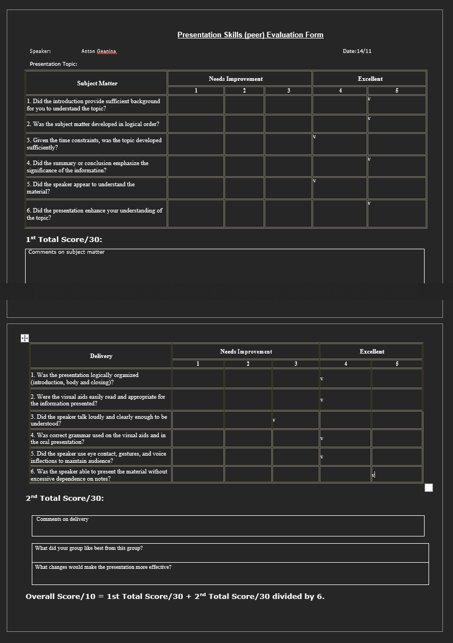

Appendices 9. 2
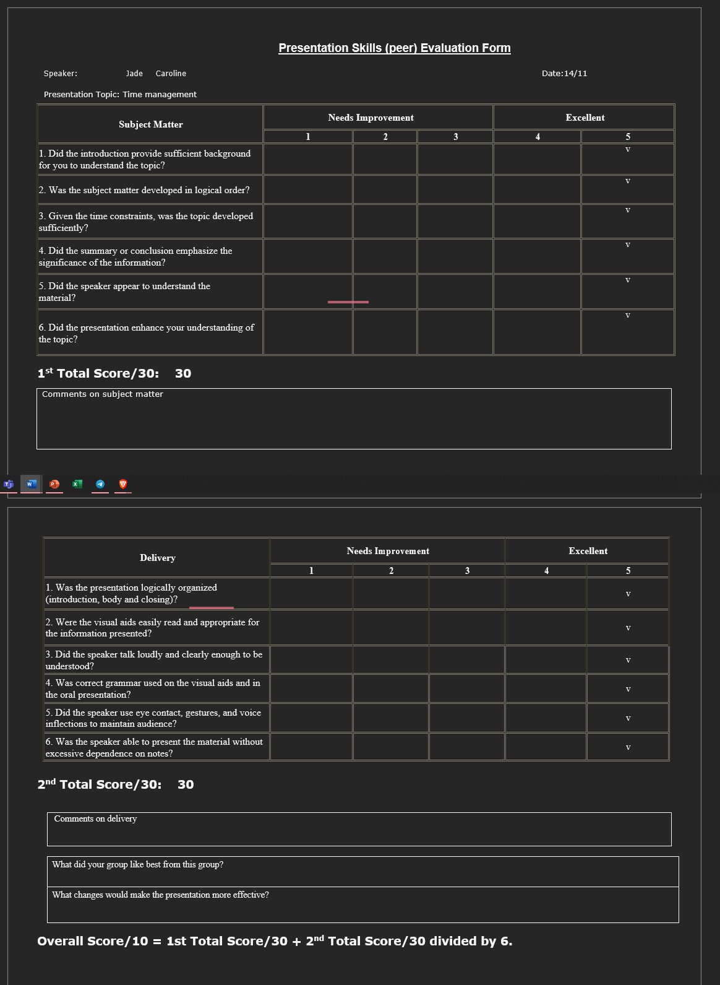

Appendices 9. 3
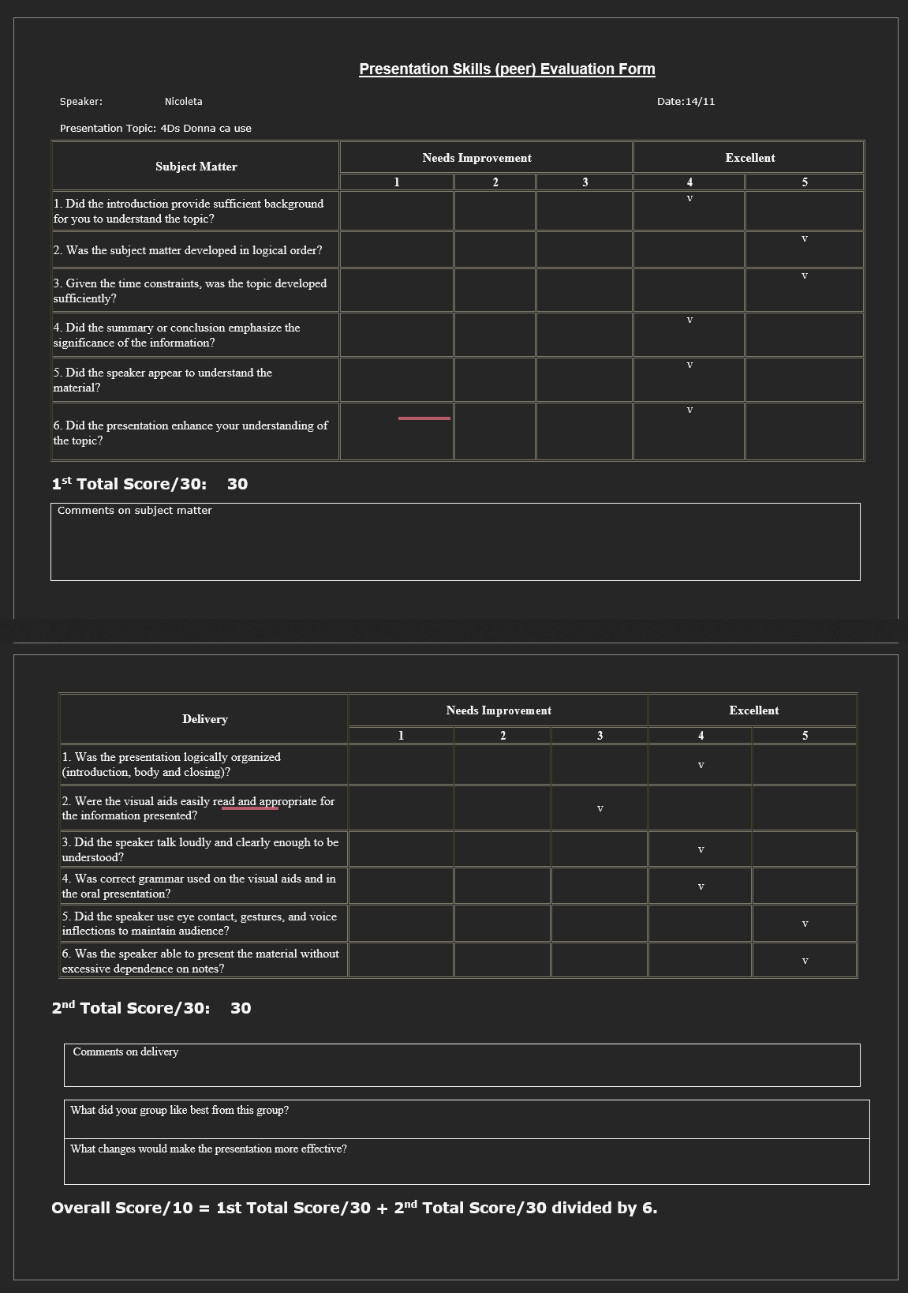

Appendices 9. 4 Feedback from Lecture:

Cohort 10 Skills and Cohort 5 HSC -BMSW 4001- Feedback Template.

Student name: Samuel Filipe Torres da Silva Student ID: 2107485

Activities | Lessons learnt | Areas To Improve on
Week 7: Group Homework activity- Teamwork and Presentation skill | Donna Case. 4D’s Presentation. We acquire how to establish the time management priorities. | Speak more emphatically and loudly.

Lectures Draft
I did not receive a draft form but my lecture sent me an email with the task 1 feedback.

