

Student Name: Bhaumik Rakeshkumar Trivedi

Student ID: 2430320

Module Name: International Business Concepts

Module Code: LCMB7034

Lecturer’s Name: Akshay Narayanan

Assignment Title – International Business Consultancy Report On Coca-Cola’s Market Entry Into India
Table of contents
1. Introduction 3
2. Benefits and challenges of international operations 3
2.1 Coca-Cola As a TNC 3
2.2 Global Value Chain analysis 5
2.3 Entry modes in different markets 7
2.4 Key benefits of international operations 8
3. Critical Discussion of OLI Factors' Impact on Entry Mode for Coca-Cola in India 9
3.1. Ownership Advantages 9
3.2. Location Advantages (India) 10
3.3. Internalisation Advantages 11
3.4. Overall evaluation of the impact on the entry mode 11
4. Critical Evaluation of Cultural Differences Between the USA and India and Impact on Market Entry 12
4.1. Cultural contrasts (USA vs. India) 12
4.2. Impact on Coca-Cola’s market entry strategy: 13
4.3. Impact on operational success 14
4.4. Critical evaluation 14
5. Standard Operating Procedures Adjustment for India 16
5.1 Adjustment 1: Sustainable And Localised Production 16
5.2 Adjustment 2: Diversifying Products And Marketing To Suit Local Preferences 18
5.3 Adjustment 3: Implementing Culturally Adaptive Human Resource And Governance Practices. 20
6. Conclusion 21
References 22

1. Introduction
The Coca-Cola Company, which was established in 1886 in Atlanta, Georgia, is the world's largest beverage company with a presence of more than 200 countries and a portfolio of more than 500 brands ranging from sparkling soft drinks to bottled water and juices (The Coca-Cola Company, 2024). Being a typical multinational corporation (MNC), Coca-Cola has exhibited a powerful global strategy that combines centralised brand management with localised market flexibility. This report critically reviews the international business of Coca-Cola, focusing on its performance and strategic changes in India, a rapidly growing market for the company. The study discusses the positives and negatives of going international, the company's market entry strategy through the OLI (Ownership, Location, Internalisation) model perspective, and the cultural aspects that impact the operations. The report ends with suggestions for changes in Coca-Cola's Standard Operating Procedures (SOPs) to be able to maintain the success and competitiveness in India's socio-economic environment.

2. Benefits and challenges of international operations

2.1 Coca-Cola As a TNC
A Transnational corporation (TNC) is defined as a firm that owns as well as controls value-creating activities in multiple countries (Knutsen et al., 2025). Coca-Cola exemplifies this definition through its extensive transnational operations, which span production, distribution, marketing and management systems across diverse markets. With headquarters in the United States and regional offices in over 200 countries, Coca-Cola operates through a decentralised “Coca-Cola system” that integrates global strategy with local execution (Nair et al., 2021). The firm’s structure allows for strategic control over brand consistency while leveraging local bottlers’ and distribution to adapt to specific market needs.
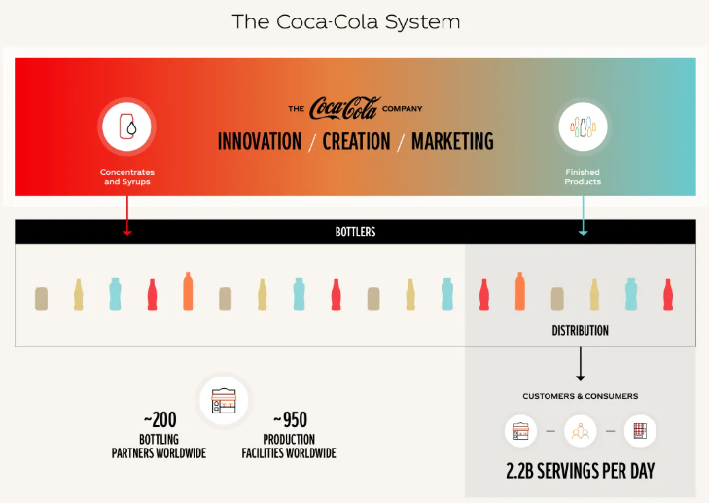
Figure 1: The Coca-Cola System
Source: (The Coca-Cola Company, 2025)
Coca-Cola’s international model aligns with a transnational strategy, which combines global efficiency and local responsiveness (Nair et al., 2021). On the other hand, corporate decisions are made through a centralised management structure and local subsidiaries enjoy autonomy in operations, which reflects the ability to host-country conditions such as customer preferences, regulation and cultural values. Furthermore, The Coca-Cola Company runs a distinctive "franchise" model, through which it mostly manufactures and sells concentrates and syrups to local bottling partners. These partners together create a huge network named the "Coca-Cola System" that comprises around 200 bottling partners, roughly 950 bottling plants worldwide, and a total of more than 700,000 employees who are all on the same team to produce and distribute finished Coca-Cola beverages (The Coca-Cola Company, 2025).

2.2 Global Value Chain analysis
Understanding the nature of Coca-Cola's Global Value Chain, it is found that Coca-Cola's capability to penetrate deeply into international markets is largely owing to its intricate worldwide supply chain, which was established so as to ensure not only production efficiency but also brand standardisation and local responsiveness. Coca-Cola's along with its arch-rival, still remains at the top position in the global beverage and snacks industry (Vrontis, 2023). This has been contributed by consistent R&D in developing new products which are locally fit. The R&D operation has been largely conducted in the U.S., Belgium, and Japan, with a specialisation in the areas of product formulation, packaging, and sustainability (Pascall et al., 2022). Coca-Cola’s R&D projects are currently highly concentrated on the area of sugar controlling technology, plastic-free, eco-friendly packaging, and environmentally friendly bottling systems. This series of initiatives across these areas helped the company become capable of adapting constantly to changes in consumer demands, such as health-oriented beverages and eco-friendly practices.
In terms of Marketing and Sales, internationally, Coca-Cola employs a glocalisation marketing strategy - "think global, act local." The company has championed the formula of uniform look but assimilated with local culture to become an inseparable part of the people in the areas where it is operating. In India, the ads like "Thanda Matlab Coca-Cola" and "Share a Coke with India" are examples of localised marketing that fit the national identity and feelings. The association of Coca-Cola with the biggest sporting events and the film industry (Sharma, 2023).
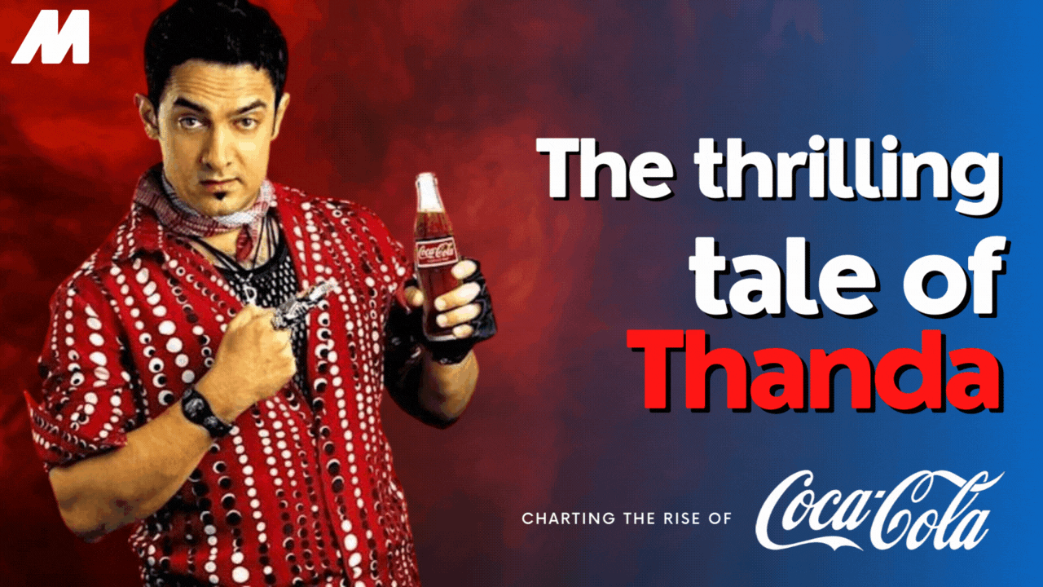
Figure 2: The Thrilling Tale of Thanda: Charting the Rise of Coca Cola
Source: (Sharma, 2023)
In turn, lets the brand be visible to different customer segments. With a distribution and logistics perspective, Coca-Cola is known for cutting-edge logistics technology and collaboration with local partners. Coca-Cola operates one of the most complicated and far-reaching distribution networks worldwide. The distribution network of the company in India is spread across more than 2.6 million retail outlets with the use of district-level distributors and rural penetration programs (Shekhar and Rai, 2025). This tactical coverage is the means of ensuring the availability of the product in both the urban and rural areas.
Thus, the market is maximally covered. In terms of the financial setup of Coca-Cola, it is capable of supporting the company on a worldwide scale through a series of strategic reinvestments and worldwide financing operations. The company uses its financial power as a lever to gain a higher market share, to make investments in sustainability initiatives, and to go for purchase expansion. The investment in capital has gone well beyond 3 billion USD since 2011 in India. Thus, the local market is witnessing a long-term growth commitment (The Coca-Cola Company, 2012).

2.3 Entry modes in different markets
The multinational company Coca-Cola employs a wide array of entry strategies in different countries to support its market expansion globally. Besides adjusting its policy according to the host country, it also considers the level of economic development and the regulatory environment. The company primarily uses franchising, joint ventures, FDI and acquisitions and strategic alliances to sustain operations across different parts of the world. Through franchising, the company grants permission to local bottlers to produce and distribute its drinks. The venture has enabled the company to stimulate growth across different markets with less capital. This can be exemplified by Coca-Cola FEMSA's operation across different Latin American countries, while HCCB oversees the bottling operation in India (Gómez, 2023).
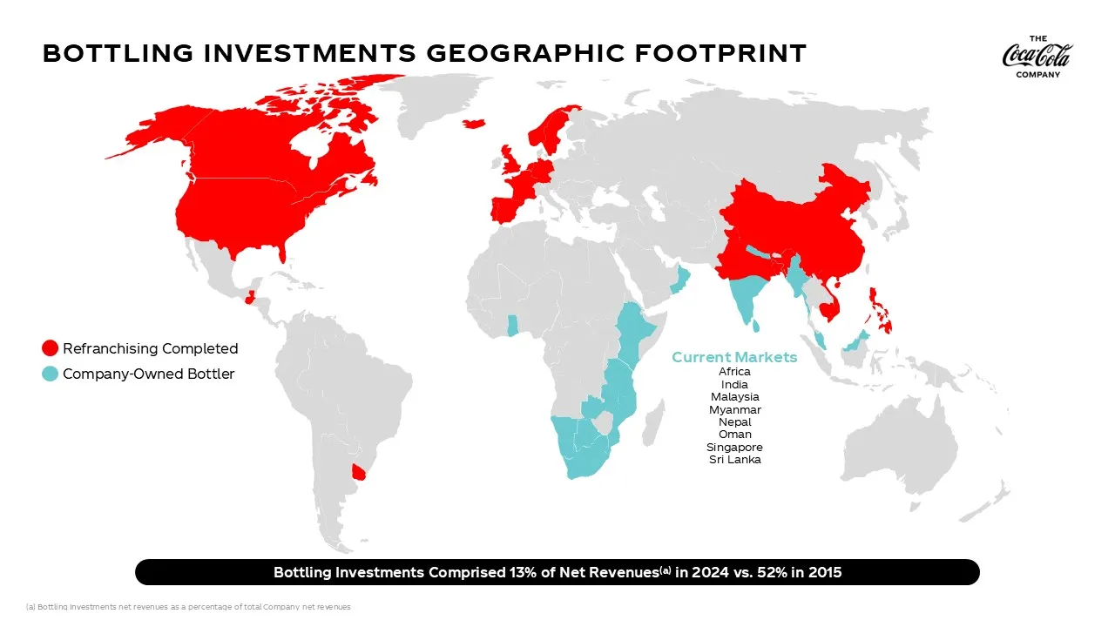
Figure 3: Bottling Investments Group
Source: (The Coca-Cola Company, 2025)
The multinational company Coca-Cola uses such ventures in its approach to the target market in order to follow the local rules concerning FDI and gain knowledge of the local market. The best example of joint ventures by Coca-Cola was with Parle Bisleri, which led to Coca-Cola’s re-entry into the Indian market in 1993 (Gupta, 2018). These kinds of collaboration help the company lessen their exposure to market risks and establish a good relationship with the stakeholders. In markets with liberal investment policies, Coca-Cola establishes fully owned subsidiaries (Collier and Whitehead, 2023). The firm's wholly owned operations in the U.S. and Western Europe demonstrate high control and long-term commitment. In India, Coca-Cola transitioned from a joint venture to a wholly owned subsidiary following economic liberalisation, allowing full operational control.
To expand product offerings, Coca-Cola frequently acquires or collaborates with local beverage firms. Examples include the acquisition of Thumps Up. In India, partnerships with local brands like Maaza enhance its regional portfolio and appeal to local tastes.

2.4 Key benefits of international operations
Coca-Cola’s internationalisation brings a lot of strategic advantages that make the company more competitive and have more global influence. In terms of market diversification, Coca-Cola has an active presence in more than 200 countries, and it mitigates the risk of a single market. This spread of the company protects it against regional economic changes and geopolitical risks (EZE et al., 2022). For instance, revenue cuts in North America can be compensated for by the growth in Asia-Pacific and Africa. In terms of economies of scale and scope, Coca-Cola enjoys the benefits of large-scale production and global procurement efficiencies. The production of concentrate is kept standard and marketing is done globally, which helps in reducing the unit costs, while the diversification of product lines allows the company to share the resources between the brands, such as Sprite, Fanta and other brands. Emerging markets such as India are full of consumers with increasing disposable income (Roy et al., 2021).
The company targets various market segments by implementing multi-pricing strategies, thus making rural consumers able to afford products through the introduction of 10 Rs bottles and at the same time, premium variants continue in the urban market (Olausen, 2024). Coca-Cola has been viewed as a universal icon of delight and refreshment. The brand’s equity is the main source of customer loyalty and a competitive advantage, with Coca-Cola being ranked as one of the most valuable brands in the world (Godspower and Ego, 2025). The brand is also extensively involved in knowledge transfer, where it continues to operate in diverse markets, which also increases the learning process of the company. Exposure to different regulatory, cultural and consumer contexts enables Coca-Cola to innovate both in products and processes. Generalising lessons from emerging markets, including India, where low cost distribution models are helping to overcome the challenges of last-mile delivery.
The multinational activities of Coca-Cola are a source of the development of multicultural leadership and the global workforce mobility of the company (Alsabe and Alsharif, 2025). The firm employees are based on regional to regional exchanges. Thus, employees not only develop cross-cultural competencies but also leadership skills and innovative thinking, which ultimately results in the firm becoming more agile in change.

3. Critical Discussion of OLI Factors' Impact on Entry Mode for Coca-Cola in India

3.1. Ownership Advantages
Coca-Cola’s ownership benefits can be generated from various aspects. Its net revenues have demonstrated the steady development in recent years which extending to $47.06 billion in 2024 and a trailing twelve months (TTM) revenue of $47.66 billion as of September 30, 2025(Macrotrends, 2024). Moreover, its advantages generated from its worldwide brand image, proprietary product formulas, marketing abilities and economical resources. It has been noticed that its robust brand recognition has enable it to transfer its reputation for quality, trust and lifestyle for the new and emerging marketing such as India. Coca-Cola’s ownership advantages also generated from its vast recognition, unparalleled distribution network and emerging collaborative system for bottling partners which enable it to obtain significant economies of scale, emotional branding and product accessibility globally which making the robust competitive advantage and attracts long-term investors (Min et al., 2023). Moreover, this intangible resources has delivered Coca-Cola the significant competitive benefits against local brands such as Thumbs Up during its re-entry into India in October 24, 1993. Moreover, its global marketing professionals and economies of scale in production and distribution has solidified it ability to maintain brand persistence along with personalising local tactics. However, its ownership of advanced technologies of bottling and concentrate production integrated with the global R&D resources has encouraged the effective implemented with the local customer demand (Kioufi and Chen, 2024). This company’s economical strength and managerial expertise allowed it to undertake high-risk investments and acquisitions such as purchase of Thumbs Up, Maaza, and Limca, to regenerate market share. Lastly it can stated that these ownership benefits has justified the organisation’s decision for pursue foreign direct investment and a wholly owned subsidiary model assures control over strategic assets and long-term brand positioning in the Indian market.

3.2. Location Advantages (India)
The emerging market of India and its unique market setting offers various locatioanl benefits which made it a tactical position for Coca-Cola. Initially, the country’s large and youthful population integrated with increasing disposable incomes has offered a vast consumer base for non-alcoholic beverages. The increasing urbanisation and developing middle class has improved Coca-Cola’s chances to target diverse market aspects from the rural customers seeking accessible refreshment to urban customers preferring premium products. Moreover, India’s favourable climate defined by long summers and high temberatures enhaced the requirements for cold-bevearges. These aspects has solidified Coca-cola’s business landscape. It can be stated that Indian government’s economic liberalisation policies in 1990s also have a signifcant role in capturing Coca-Cola back into the market. Moreover, its primary location advantage in India generated from its extensive, strategic network of local bottling plans. Moreover, it has employs an effective “hub-and-spoke” distribution model to reach remote rural market by moving products from bottling plants to central warehouses (hubs) and the disturbing them via smaller outlets (spokes) to retailers(icmrindia, 2025). However, India’s well-developed agricultural sector has delivered chances for Coca-Cola to regenerate raw materials locally assisting its localisation strategy and cost effectiveness. Moreover, the affordability of low-cost labour and extending logistics networks can improve its decision-making for investing heavily in local bottling operation system. Although India’s location delivered difficulties such as complicated regulatory structures, water scarcity and socio-political responsiveness in the resource utilisation (Sharma, 2025). These factors require Coca-Cola to implement a glocalised strategy for tackling global brand persistence with sensibility to local economic and environmental realities. Hereby, India’s locational benefits integrated with market potential and assistive policy reforms, were the main components impacting its entry through FDI and joint ventures.

3.3. Internalisation Advantages
Coca-Cola’s strategy and inclination for internalisation rather than licensing or depending on external partners highly mirror its tactical requirements to safeguard proprietary assets and maintain operational control. Its core competitive benefits effectively depending in its secret syrup formula, advanced production methods and worldwide standardised marketing practices which are challenging to protect in a licensing arrangement. Internalisation assures quality consistency, brand ethics and protection of intellectual property overall markets (Bonadio and Solanki, 2025). Moreover, its internalisation benefits depend on its innovative “glocal” system which is also focus on centralising concentrate production, brand management and marketing while also depending on local bottling partners for manufacturing, distribution and sales making strong economies. Moreover it can be stated that this transformation has mirror the sustaining dedication to internal governance allowing it to harmonize supply chains and marketing campaigns without reliance on third parties(Bonadio and Solanki, 2025). Additionally, the internalisation enable Coca-Cola to attain full value from its operations and incorporates India into its global value chain efficiently. Moreover, the internalisation has been optimum for Coca-Cola’s ability to mainatin its competitive position and safeguard its intangible assets along with expanding its Indian operations.

3.4. Overall evaluation of the impact on the entry mode
From the overall aspect, it can be noticed that the OLI (Ownership, Location, and Internalisation) framework has effectively delivers the inclusive exploration of Coca-Cola’s selected entry mode into India. It can be stated that Coca-Cola's ownership benefits such as brand equity, marketing abilities, research and development facilities and economic power, have made it effectively suitable for direct investment rather than a contractual prospect such as licensing. Additionally, its robust worldwide brand and managerial prospects has mitigated the risk and uncertainty, which has assisted it to invest effectively in forming local infrastructure and acquiring existing brands (Sharma et al., 2020). India’s locational benefits has promoted this strategic fit. Additionally the integration of a broader customer market, favourable climatic conditions and government liberalisation policies have made a proactive business setting.
Furthermore, India socio-economic diversity has led the Coca-Cola organisation to robustly localise its offerings and pricing while maintaining the global image. Additionally, challenges such as bureaucratic difficulties, lack of infrastructure system and environmental challenges have demanded flexible tactics such as robust community involvement and local collaboration(Sharma et al., 2020). However, the safeguard of proprietary assets, maintenance of brand development and the capability to collaborate with global and local operations effectively are incorporated with a wholly owned subsidiary structure. Moreover, this company's transformation from a joint venture with Parle to full ownership has highlighted its long-term strategic intention for developing the economy over terms of decision-making, product innovation and marketing strategy. Lastly, it can be highlighted that the incorporation of OLI factors has resulted in Coca-Cola's favouring a foreign direct investment mode. This strategy has enabled the organisation to maintain the global effectiveness with local strategy competitive benefits and manage India as a strategic development market (Hassan et al., 2022). This model has critically investigated not only Coca-Cola's primary decision but also its transformation into India's leading beverage organisation.

4. Critical Evaluation of Cultural Differences Between the USA and India and Impact on Market Entry

4.1. Cultural contrasts (USA vs. India)
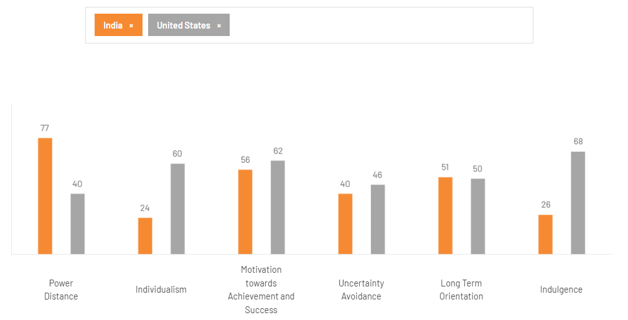
Figure 4: Comparison between the USA and India
Source: (Hofstede Insights, 2025)
The cultural differences between the United States and India are substantial and have effectively impacted the business operations. By using Hofstede’s cultural dimensions, the US has score high in individualism as 60, and India scores low 24. Moreover it scores low on power distance as 40 and relatively high as 46 in uncertainty avoidance(Hofstede Insights, 2025). This prospect highlighted the culture which focuses on valuing personal autonomy, equality and effective innovation. On the other hand, India has highlighted the hierarchical social standard, authority respect and a robust family and community-driven system. The American business culture focuses on direct communication merit-driven decision making and task oriented collaboration. However the Indian culture highlighted indirect communication, relationship development and long term trust. Time orientation also differs as Americans obtain time as linear and efficiency-driven, while Indians prefer to adopt a more flexible, relational approach. Moreover, the U.S. has a low-context communication style, where clarity and precision are valued, whereas India’s high-context culture relies on implicit understanding and contextual cues (Levitt, 2022). Additionally the religion and tradition has improved the Indian customer behaviour with the robust impact from Hindu values which is fostering the collectivism. In contrast American management style has concentrating on assertiveness and individualistic prospect which can approach culturally inclusive in India. This cultural differences has made different advantages and difficulties for the organisations as Coca-Cola which needs proper adaptation strategy for marketing Kama leadership and employee involvement in the market for obtaining operational success.

4.2. Impact on Coca-Cola’s market entry strategy:
Coca-Cola's market entry into India needs various cultural flexibility for incorporating with American corporate ethics and Indian values. Primarily, Coca-Cola's global standardisation techniques have focused on marketing strategy of individualism and faced challenges in incorporating with Indian customer who prefers community and local identity (Liu, 2023). Recognising this, Coca-Cola adopted a localisation approach emphasising collective experiences and emotional appeal through campaigns such as “Thanda Matlab Coca-Cola”, which incorporated the brand within local language and cultural context. Cultural adaptation also extended to product and pricing strategies. In contrasting the premium range US market landscape, the Indian customers mainly focused on robust price sensitivity and regional diversity (Arunachalam et al., 2020). Here, Coca-Cola highlighted smaller and accessible packaging and regionally customised beverages as Maaza and Limca for a wide range of customers. Internally, it had to adapt with the Indian Management practices for its hierarchical standards for fostering local leadership while maintaining rooted global principles. This cultural incorporation has enabled Coca-Cola to develop its brand reputation and overcome early challenges and obtain the desired market penetration.

4.3. Impact on operational success
It has been noticed that the cultural adaptation of Coca-Cola is the main prospect for the operational success in India. Its ability to incorporate global systems with local practices has enable to balance diverse stakeholders such as suppliers and work forces along with customers and regulators. By incorporating Indian cultural values of relationship-building and community engagement, Coca-Cola strengthened its reputation and social legitimacy (Marschlich and Ingenhoff, 2021). From the operational prospect it can be highlighted that the collectivist and hierarchical system of India has allow Coca-Cola to customise the management system that properly values team collaboration and respect for authority. The local leadership roles has assisted Indian managers to better recognise the regional market and make more suitable decisions for increasing employee motivation(Marschlich and Ingenhoff, 2021). From the human resource prospect, it can be highlighted that identifying the rooted culture of India has assisted this company to invest in employee well-being, diversity and local career growth (Malik et al., 2021). This culturally focused HR practice has enhanced customer retention and employee morale. Lastly, Coca-Cola's success in India is mainly focused on the incorporating cultural intelligence and localisation, which helps them to mitigate challenges and obtain strategic benefits.

4.4. Critical evaluation
Coca-Cola’s market entry into India reflects a dynamic interaction of ownership, location, and internalisation factors, as well as significant cultural adaptation challenges. While the OLI model effectively explains Coca-Cola’s decision to re-enter India through foreign direct investment (FDI) and establish a wholly owned subsidiary, a deeper critical analysis highlights both the strategic strengths and the areas of concern within this approach.
From an ownership perspective, Coca-Cola leveraged its strong global brand equity, financial strength, and proprietary assets to dominate the Indian soft drink market (Wood et al., 2021). These resources gave Coca-Cola a clear competitive advantage over local competitors, such as Thums Up and Parle. However, the company’s heavy reliance on its global brand identity initially limited its responsiveness to India’s socio-economic and cultural complexities. During its re-entry in the 1990s, Coca-Cola underestimated the significance of indigenous consumer behaviour, local flavour preferences, and rural affordability, which initially hindered widespread acceptance beyond urban areas(Wood et al., 2021). Over time, the adoption of localisation strategies, such as acquiring Thums Up and launching India-centric marketing campaigns, demonstrated Coca-Cola’s ability to balance global brand consistency with cultural integration a critical success factor in emerging markets.
Location factors further reinforced India’s strategic importance to Coca-Cola. The country’s vast population, youthful demographic, and climate-driven demand for cold beverages provided a large market potential. Yet, these advantages were tempered by infrastructural and environmental challenges. Issues such as water scarcity, political activism, and regulatory complexity forced Coca-Cola to reassess its production and environmental management practices. The controversies in Kerala and Tamil Nadu, where Coca-Cola faced accusations of groundwater depletion and pollution, exposed weaknesses in its initial sustainability framework. These challenges underscore the need for a more context-sensitive approach where corporate strategies are not merely economically efficient but also socially and environmentally accountable (Dehama, 2025). In this regard, Coca-Cola’s later commitment to water stewardship and local sourcing initiatives represents a corrective evolution rather than a proactive strategy.
The internalisation dimension ensured Coca-Cola’s control over its proprietary technology and brand quality through vertical integration and a “glocalised” system of bottling partners. While this model protected its intellectual property and maintained global standards, it also generated tensions between centralised control and local flexibility. For instance, bottling partners sometimes faced constraints in adapting to regional logistics or community needs due to rigid corporate procedures. Thus, although internalisation strengthened brand uniformity and quality assurance, it occasionally hindered responsiveness to local market volatility and social expectations.
Culturally, Coca-Cola’s initial entry reflected a Western-centric orientation that clashed with India’s collectivist and relationship-oriented business culture. The adaptation of communication strategies such as using Hindi taglines (“Thanda Matlab Coca-Cola”) and associating with Bollywood and cricket, gradually bridged this cultural gap. Nevertheless, Coca-Cola’s long-term success depends on institutionalising cultural intelligence across its managerial hierarchy and embedding local leadership in decision-making processes.
Overall, Coca-Cola’s internationalisation in India demonstrates both effective global integration and critical learning through local adaptation (Deliceırmak, 2022). The company’s strategic flexibility, investment in sustainability, and cultural localisation have enhanced its legitimacy and market penetration. However, persistent socio-environmental scrutiny and operational standardisation challenges indicate that Coca-Cola’s global dominance must be continually reconciled with ethical, ecological, and cultural sensitivity to sustain its competitive advantage in India’s evolving market landscape.

5. Standard Operating Procedures Adjustment for India
The OLI analysis illustrates how crucial it is to use the global strengths of Coca-Cola and make the most of India’s market potential while keeping internal control over the key operations. The cultural comparison between the United States and India also indicates that local sensitivity, stakeholder involvement and community engagement are very important. Hence, three major changes in the Standard Operating Procedures of the Coca-Cola area needed to be aligned with India for continued performance and market leadership.

5.1 Adjustment 1: Sustainable And Localised Production
India is an ecologically diverse country with a great number of environmental problems and social issues that affect its economy. Among such problems are water scarcity, pollution, and resource management. In order to mitigate the situation, local communities have gone on to rally and protest against Coca-Cola, releasing reports of how the company is depleting groundwater in different places of Kerala and Tamil Nadu, which are already dealing with water scarcity (Mathews, 2011). Coca-Cola has been involved in legal battles throughout this period as it faces accusations that, after the opening of the plant, local wells around the South Indian plantation wells have been drying up, and the available water has become contaminated and toxic
Water stewardship and circular use
As water is the most important element in the Coca-Cola production process, the company need to go beyond the concept of water neutrality and strive for water positivity, which gives back to the environment and communities more water than it takes. Among the SOPs, there should be a compulsory requirement for watershed assessment before installation of a new plant as well as the promotion of rainwater harvesting and the use of state-of-the-art water recycling machines (Raimondi et al., 2023). Besides, the company should also join hands with the local government as well as NGOs in the work of aquifer recharge, installation of water facilities for communities, and encouragement of efficient irrigation in farming in the regions around the plant.
Renewable Energy and Green Manufacturing
To lessen the impact of the release of carbon dioxide on the environment, manufacturing SOPs at Coca-Cola should need to be revised by the company by focusing on the renewable energy sources procured from solar and wind energy to power the plants where bottling activities are carried out. Besides that, the integration of energy efficiency compressors can be used for waste heat recovery systems into Coca-Coca India will be in line with the global environmental goals as well as the India National Decarbonisation agenda. Part of Coca-Cola’s environmental audit shall include the inclusion of carbon reduction KPIs from production units (Senay et al., 2022).
Local Sourcing and Supplier Partnerships
The localisation of supply chains provides the company with various economic and social benefits. Coca-Cola should not only keep on growing its cooperative relations with Indian farmers through its Fruit Circular Economy project that supports the local sourcing of mangoes, oranges, and lichis for the production of Maaza and Minute Maid products, but also diversify the activities under this program (Okuthe, 2024). Standardised SOPs ought to require supplier framing through a focus on quality control, environmental sustainability and good trade practices such as fair trade.
Waste and Packaging Management
In terms of waste and packaging management, Coca-Cola is known for using plastic bottles for delivering its products to the masses to serve billions of people. Coca-Cola is responsible for creating a million plastic bottles over the years. In terms of Extended Producer Responsibility (EPR) into operational SOPs need to be part of Coca-Cola India via an increase in the rPET bottle usage and the setting up of a closed-loop waste management system (Peter John. and Mishra, 2025). The waste management system can be part of the circular economic model to remain forefront as an eco-friendly international corporation. These activities not only solve the environmental problem but also put the company in line with the India PWM Regulations.

5.2 Adjustment 2: Diversifying Products And Marketing To Suit Local Preferences
India's beverage market is a diverse one, heavily influenced by regional habits, weather, and even income levels as well as a growing health-consciousness. Based on the OLI and cultural analyses, Coca-Cola is required to intensify its location-specific adaptation to have comprehensive leverage of the Indian market potential.
Expanding Health-Conscious and Traditional Offerings
The trend of Indian consumers is turning toward health and conscious living. The factors responsible for this trend are the awareness of lifestyle diseases and government campaigns aiming to improve nutrition. Therefore, Coca-Cola should rethink its R&D and product innovation SOPs that would lead to the production of more low-sugar, natural, and functional beverages (Zaidel et al., 2021). The middle class of the urban areas and health-conscious youth will be attracted to the variants of beverages with reduced sugar content, natural sweeteners (like stevia), and nutrients. Besides that, the company should also start producing and marketing beverages that are deeply rooted in Indian food culture-such as fruit-based drinks, herbal infusions, or dairy alternatives as to get the rural people and regional taste groups on their side.
Multi-Tiered Pricing and Packaging Strategies
Tiered pricing SOPs, which are aimed at both affordability and aspirational value, should be the next SOPs to be institutionalised by Coca-Cola if it wants to attract a larger consumer base. Thus, the 200 ml and ₹10 packs for the rural and low-income consumers will be the means through which mass reach will be ensured (Roy et al., 2021). At the same time, premium and functional beverages will focus on the urban segments. Packaging SOPs should be suitable for the regional logistics. For example, the rural distribution and sustainability can be facilitated by lightweight, recyclable materials.
Regional Branding and Cultural Integration
Coca-Cola​‍​‌‍​‍‌​‍​‌‍​‍‌ would derive more value from the application of cultural embedding beyond surface levels in its marketing SOPs to resonate with Indian audiences at a comparable level. One such campaign is “Thanda Matlab Coca-Cola” which is done by employing common language and feeling to communicate the brand ethos of the global brand very effectively. Future marketing SOPs should have the detailed steps for language adaptation, festival-based advertising, and regional celebrity endorsements clearly outlined (Chan, 2022). For example, the coordination of promotional themes with Diwali, Holi, and local harvest festivals would not only heighten the emotional involvement but also the brand would become more ​‍​‌‍​‍‌​‍​‌‍​‍‌relevant.
Digital Transformation and Consumer Engagement
The digitally advanced ecosystem of India that is changing very fast offers quite a few new ways of interaction with consumers. Coca-Cola's marketing and customer engagement SOPs should be in line with the integration of such technologies as data analytics, mobile marketing, and the personalisation of social media, which can help them develop a strong relationship with younger consumers. The use of artificial intelligence for predictive analytics, consumer feedback, and the integration of online sales can be a tool for the brand to become more agile and responsive. The campaign "Share a Coke India" and "Coke Studio Bharat" are just a few examples of how digital engagement can be a vehicle for brand loyalty (The Coca-Cola Company, 2024).

5.3 Adjustment 3: Implementing Culturally Adaptive Human Resource And Governance Practices.
India is demographically young country with a large number of youth are in their working age, and firm leadership management is extremely important for establishing proper governance practices.
Localised Leadership and Decision-Making
One way Coca-Cola India can achieve this is by elevating the level of local leadership in decision-making processes (Huse et al., 2022). With the help of local empowerment modules, Coca-Cola not only legitimises local managers to have the authority to adapt equipment strategies to local realities but also makes the company more agile in responding to consumer trends, regulatory changes, and socio-political factors.
Employee Engagement and Well-being
The Indian labour force includes youth and a demographic variety and they are chiefly driven by the mission rather than the power. SOPs should turn into a medium that facilitates employee engagement through various well-being programs and other initiatives such as gender diversity and career ​‍​‌‍​‍‌​‍​‌‍​‍‌progression. Besides increasing retention, by participating in leadership styles and using inclusive HR policies, Coca-Cola's employer branding will get a lift in India's competitive labor market.
Community Relations and Corporate Social Responsibility (CSR)
In the Indian perspective, community relations are at the core of business sustainability. The governance program of Coca-Cola should comprise obligated CSR impact evaluations that revolve around rural development, water access, education, and women's empowerment (Patil and Verma, 2025). Apart from this, through its programs Support My School and Parivartan, Coca-Cola has gone a considerable way to positively engage the community.
Ethical Governance and Transparency
By far, the most important undertaking is for Coca-Cola to establish clear and ethical governance processes as a response to issues in public perception. The contingency plan should make provision for the anti-corruption programs, ethical supply chain audits, and whistleblower assistance mechanisms.

6. Conclusion
Coca-Cola​‍​‌‍​‍‌​‍​‌‍​‍‌ worldwide can succeed mainly as a result of its strategy of harmonising the global standardisation aspect with the local adjustment aspect. This balance is still very important for the company to keep growing in India. The firm’s three strong ownership advantages its brand equity, capacity for innovation, and global expertise, are like a solid rock on which to build competitive strength in the market. Nevertheless, in order to take full advantage of India’s location benefits, Coca-Cola has to carefully plan its adaptation of the company to the social-cultural and environmental aspects of the country. The Standard Operating Procedures (SOPs) for Coca-Cola, centered on environmentally friendly production, locally tailored product diversification, and socially compatible human resource practices provide a complete guide for achieving such harmony. Water stewardship, use of renewable energy sources, and ethical governance being deeply ingrained in the company’s operational framework will make Coca-Cola more trustworthy in the eyes of the community and help it comply with regulations. At the same time, making products and advertising more suitable to Indians’ tastes will lead to a larger customer base and the brand becoming more relevant. In addition, ensuring cultural inclusiveness and local leadership will lead to a higher level of organizational unity and more brilliant ideas. In the end, these strategic moves will help Coca-Cola to stay at the top of the list of companies that are socially responsible, flexible, and forward-looking in nature. This will guarantee the firm’s growth and sustainability for a very long time in one of the world’s most vibrant emerging ​‍​‌‍​‍‌​‍​‌‍​‍‌markets.

References
Alsabe, A.A.A. and Alsharif, R.A.B., (2025). The Impact of Globalization on Business Administration and the Adaptation to International Markets and Diverse Workforces. International Journal of Academic Publishing in Educational Sciences and Humanities (IJAPESH), pp.69-78.https://easrjournals.com/index.php/ijapesh/article/view/31
Arunachalam, S., Bahadir, S.C., Bharadwaj, S.G. and Guesalaga, R., 2020. New product introductions for low-income consumers in emerging markets. Journal of the Academy of Marketing Science, 48(5), pp.914-940.https://papers.ssrn.com/sol3/Delivery.cfm?abstractid=3460736
Bonadio, E. and Solanki, A., 2025. Intellectual Property and the Freedom to Conduct a Business under the EU Charter of Fundamental Rights in Paul Torremans (ed.), Intellectual Property and Human Rights (Wolters Kluwer forthcoming 2026). Intellectual Property and Human Rights (Wolters Kluwer forthcoming 2026).https://papers.ssrn.com/sol3/Delivery.cfm?abstractid=5390965
Chan, F. (2022). A Study of Social Media Influencers and Impact on Consumer Buying Behaviour in the United Kingdom. International Journal of Business & Management Studies, [online] 03(7), pp.2694–1449. Available at: https://ijbms.net/assets/files/1659111546.pdf [Accessed 12 Nov. 2025].
Collier, W.G. and Whitehead, M., (2023). Corporate governmentality: building the empirical and theoretical case. Territory, politics, governance, 11(5), pp.1029-1048.Available at:https://www.tandfonline.com/doi/abs/10.1080/21622671.(2022).2153159
Dehama, S., 2025. Corporate Social Responsibility and Lessons Learned from Some Countries. Public Administration and Law Review, (1 (21)), pp.65-74.https://public.scnchub.com/palr/index.php/palr/article/download/243/218
Deliceırmak, F.D., 2022. The glocal marketing strategies of global brands: Coca-Cola and McDonald’s. Journal of International Business and Management, 5(7), pp.1-22.https://rpajournals.com/wp-content/uploads/2022/07/JIBM-2022-06-5414.pdf
EZE, F.O., UGWU, F.I., ORGA, C., ASOGWA, J., OKECHUKWU, E. and NNAMANI, E., (2022). Effect of Research and Development Funds on Managing Sales Leads: The case of Commercialisation of Completed Research Project in Enugu State, South-East Nigeria. Solid State Technology, 65(1), pp.185-196.Available at:https://www.academia.edu/download/88939825/Effect_of_Funds_Intended_for_Research_and_Development_on_Managing_Sales.pdf
Godspower, O. and Ego, O.I., (2025). BRAND POSITIONING AND CONSUMERS LOYALTY IN COCA-COLACOMPANY BENIN CITY. INTERNATIONAL JOURNAL OF FINANCE, ACCOUNTING AND MANAGEMENT STUDIES, 1(5), pp.112-121.Available at:http://www.ijfams.com/index.php/ijfams/article/download/75/71
Gómez, E.J., (2023). Government response to ultra-processed and sugar beverages industries in developing nations: The need to build coalitions across policy sectors.Available at:https://library.oapen.org/bitstream/handle/20.500.12657/85666/9780198882237_WEB.pdf?sequence=1#page=150
Gupta, R. (2018). ‘COCA COLA COMPANY AND BRAND-A CASE STUDY AND ANALYSIS OF A MARKET LEADER IN SOFT DRINK SEGMENT TO TRACK ITS EVOLUTION, GROWTH TRAJECTORY, AND FUTURE PROSPECTS’ ABOUT COCA COLA HISTORY OF THE COCA-COLA COMPANY THE ADVENT OF BOTTLING. International Journal of Transformations in Business Management (IJTBM, [online] (8). Available at: https://ijtbm.com/admin/upload/03%20Rizul%20Gupta.pdf [Accessed 12 Nov. 2025].
Hassan, Y., Pandey, J., Varkkey, B., Sethi, D. and Scullion, H., 2022. Understanding talent management for sports organizations-Evidence from an emerging country. The InTernaTIonal Journal of human resource managemenT, 33(11), pp.2192-2225.https://www.researchgate.net/profile/Yusuf-Hassan-4/publication/353972692_Understanding_Talent_Management_for_Sports_Organizations-Evidence_from_an_Emerging_Country/links/6523ddc2d717ef1293dd9f1a/Understanding-Talent-Management-for-Sports-Organizations-Evidence-from-an-Emerging-Country.pdf
Hofstede Insights (2025). Country Comparison Tool. [online] Theculturefactor.com. Available at: https://www.theculturefactor.com/country-comparison-tool?countries=india%2Cunited+states.
Huse, O., Reeve, E., Bell, C., Sacks, G., Baker, P., Wood, B. and Backholer, K., (2022). Strategies used by the soft drink industry to grow and sustain sales: a case-study of The Coca-Cola Company in East Asia. BMJ global health, 7(12), p.e010386.Available at:https://gh.bmj.com/content/7/12/e010386.abstract
icmrindia (2025). Coca Cola India’s Thirst for the Rural Market | Free Management Articles | Free Management Case Studies. [online] Icmrindia.org. Available at: https://www.icmrindia.org/free%20resources/casestudies/CocaCola.htm.
Kioufi, N. and Chen, W., 2024. Exploring IoT adoption and operational efficiency within the international chilled beverages industry. Journal of Industrial and Production Engineering, 41(2), pp.158-181.https://bura.brunel.ac.uk/bitstream/2438/27534/3/FullText.pdf
Knutsen, H.M., Hansen, A., Wethal, U. and Potapohn, M., (2025). Brewing the Global Shift: Variegated Capitalism, Firm Strategies, and the Restructuring of the Southeast Asian Beer Industry. Journal of Contemporary Asia, 55(1), pp.74-95.Available at:https://www.tandfonline.com/doi/abs/10.1080/00472336.(2023).2254774
Levitt, S.R., 2022. Intercultural competence in international teamwork: Understanding high-and low-context communication styles. Communication and Media in Asia Pacific, 5(1), pp.1-13.https://so01.tci-thaijo.org/index.php/CMAP/article/download/252438/170953/959617
Liu, H., 2023. Cultural Influence on Consumer Behavior: Strategies for Adapting Marketing Campaigns in a Globalized World. International Journal of Education, Humanities and Social Sciences, 1(1), pp.10-70088.https://papers.ssrn.com/sol3/Delivery.cfm?abstractid=5038476
Macrotrends (2024). CocaCola Revenue 2006-2020 | KO. [online] www.macrotrends.net. Available at: https://www.macrotrends.net/stocks/charts/KO/cocacola/revenue.
Malik, A., Budhwar, P., Patel, C. and Laker, B., 2021. Holistic indigenous and atomistic modernity: Analyzing performance management in two Indian emerging market multinational corporations. Human Resource Management, 60(5), pp.803-823.https://discovery.dundee.ac.uk/files/139383231/201012_Revised_Manuscript_HRM.pdf
Marschlich, S. and Ingenhoff, D., 2021. Stakeholder engagement in a multicultural context: The contribution of (personal) relationship cultivation to social capital. Public Relations Review, 47(4), p.102091.https://www.sciencedirect.com/science/article/pii/S0363811121000849
Mathews, R. (2011). The Plachimada Struggle against Coca Cola in Southern India. [online] ritimo. Available at: https://www.ritimo.org/The-Plachimada-Struggle-against-Coca-Cola-in-Southern-India [Accessed 12 Nov. 2025].
Min, W., Zhou, P., Xu, L., Liu, T., Li, T., Huang, M., Jin, Y., Yi, Y., Wen, M., Jiang, S. and Jain, R., 2023. From plate to production: Artificial intelligence in modern consumer-driven food systems. arXiv preprint arXiv:2311.02400.https://arxiv.org/pdf/2311.02400
Nair, R.K., Reddy, L.S., Verma, P., Pandey, R., Yuwono, S., Sin, L.G., Qi, W.Y., Kee, D.M.H., Gee, O.X., Ing, T.W.S. and Yu, T.P., (2021). The impact of COVID 19 towards international business strategy: A study of coca-cola company. International Journal of Accounting & Finance in Asia Pasific (IJAFAP), 4(2), pp.73-92.Available at:https://www.academia.edu/download/94596204/1014.pdf
Okuthe, G., (2024). Valorizing fruit and vegetable waste: The untapped potential for entrepreneurship in sub-saharan africa—A systematic review. Recycling, 9(3), p.40.Available at:https://www.mdpi.com/2313-4321/9/3/40
Olausen, P., (2024). COMPARATIVE ANALYSIS OF MARKETING STRATEGIES AIMED AT ACHIEVING RESILIENCE AND AGILITY OF COMPANIES: A CASE SUDY OF COCA-COLA AND PEPSI. Journal of Entrepreneurship and Business Resilience, 7(1), pp.115-124.Available at:https://jebr.fimek.edu.rs/index.php/jebr/article/view/122
Pascall, M.A., DeAngelo, K., Richards, J. and Arensberg, M.B., (2022). Role and importance of functional food packaging in specialized products for vulnerable populations: Implications for innovation and policy development for sustainability. Foods, 11(19), p.3043.Available at:https://www.mdpi.com/2304-8158/11/19/3043
Patil, M.V. and Verma, M.K., (2025). Empowering women through corporate social responsibility: a pathway to sustainable development. Journal of East-West Thought (JET) ISSN (O): 2168-2259 UGC CARE I, 15(1), pp.201-208.Available at:https://jetjournal.us/index.php/journals/article/view/257
Peter John, A. and Mishra, U., (2025). Optimizing Sustainable PET Plastic Supply Chain Model with Reverse Logistics Waste Tracking System. Process Integration and Optimization for Sustainability, pp.1-22.Available at:https://link.springer.com/article/10.1007/s41660-025-00534-7
Raimondi, A., Quinn, R., Abhijith, G.R., Becciu, G. and Ostfeld, A., (2023). Rainwater harvesting and treatment: State of the art and perspectives. Water, 15(8), p.1518.Available at:https://www.mdpi.com/2073-4441/15/8/1518
Roy, G., Debnath, R., Mitra, P.S. and Shrivastava, A.K., (2021). Analytical study of low-income consumers’ purchase behaviour for developing marketing strategy. International Journal of System Assurance Engineering and Management, 12(5), pp.895-909.Available at:https://link.springer.com/article/10.1007/s13198-021-01143-6
Roy, G., Debnath, R., Mitra, P.S. and Shrivastava, A.K., (2021). Analytical study of low-income consumers’ purchase behaviour for developing marketing strategy. International Journal of System Assurance Engineering and Management, 12(5), pp.895-909.Available at:https://link.springer.com/article/10.1007/s13198-021-01143-6
Senay, E., Cort, T., Perkison, W., Laestadius, J.G. and Sherman, J.D., (2022). What can hospitals learn from the Coca-Cola company? health care sustainability reporting. NEJM Catalyst Innovations in Care Delivery, 3(3), pp.CAT-21.Available at:https://catalyst.nejm.org/doi/abs/10.1056/CAT.21.0362
Sharma, A., 2025. From active collaborators to source of new regulatory politics: regulatory intermediaries in India. Policy and Society, p.puaf033.https://academic.oup.com/policyandsociety/advance-article-pdf/doi/10.1093/polsoc/puaf033/65224658/puaf033.pdf
Sharma, P., Leung, T.Y., Kingshott, R.P., Davcik, N.S. and Cardinali, S., 2020. Managing uncertainty during a global pandemic: An international business perspective. Journal of business research, 116, pp.188-192.https://pmc.ncbi.nlm.nih.gov/articles/PMC7247500/pdf/main.pdf
Sharma, P. (2023). Coca Cola’s advertising journey in India has been a fascinating one. From starting its operations in 1950, to withdrawing it in 1977, and finally making a comeback by acquiring Thumbs Up from Parle, Coca Cola’s marketing and advertising strategies have evolved over time. [online] Linkedin.com. Available at: https://www.linkedin.com/pulse/thrilling-tale-thanda-charting-rise-coca-cola-peeyush-sharma/ [Accessed 12 Nov. 2025].
Shekhar, C. and Rai, P., (2025). Rising Strong: How Indian MSMEs Are Adapting and Thriving in a Post-FY2025 Landscape Study. Available at SSRN 5338943.Available at:https://papers.ssrn.com/sol3/papers.cfm?abstract_id=5338943
The Coca-Cola Company (2012). The Coca-Cola Company. [online] The Coca-Cola Company. Available at: https://investors.coca-colacompany.com/news-events/press-releases/detail/554/coca-cola-targeting-additional-us3-billion-investment-to-support-long-term-sustainable-growth-in-india [Accessed 12 Nov. 2025].
The Coca-Cola Company (2024). Coke Studio Bharat. [online] Coke2home.com. Available at: https://cokestudio.coke2home.com/bharat [Accessed 12 Nov. 2025].
The Coca-Cola Company (2025). The Coca-Cola System. [online] www.coca-colacompany.com. Available at: https://www.coca-colacompany.com/about-us/coca-cola-system [Accessed 12 Nov. 2025].
Vrontis, D. (2023). (PDF) The Strategic Positioning of Coca-Cola in their Global Marketing Operation. [online] ResearchGate. Available at: https://www.researchgate.net/publication/233658633_The_Strategic_Positioning_of_Coca-Cola_in_their_Global_Marketing_Operation [Accessed 12 Nov. 2025].
Wood, B., Baker, P., Scrinis, G., McCoy, D., Williams, O. and Sacks, G., 2021. Maximising the wealth of few at the expense of the health of many: a public health analysis of market power and corporate wealth and income distribution in the global soft drink market. Globalization and Health, 17(1), p.138.https://link.springer.com/content/pdf/10.1186/s12992-021-00781-6.pdf
Zaidel, D.N.A., Muhamad, I.I., Hashim, Z., Jusoh, Y.M.M. and Salleh, E., (2021). Innovation and challenges in the development of functional and medicinal beverages. In Functional Foods and Nutraceuticals for Human Health (pp. 137-198). Apple Academic Press.Available at:https://www.taylorfrancis.com/chapters/edit/10.1201/9781003097358-6/innovation-challenges-development-functional-medicinal-beverages-dayang-norulfairuz-abang-zaidel-ida-idayu-muhamad-zanariah-hashim-yanti-maslina-mohd-jusoh-eraricar-salleh

