

Alina Ionela Ghinea- 2020634

University of Wales, Trinity Saint David
Teacher: Adesewa Ajayi


BMSW4001

REPORT

Contents

I. Time management 4
10 steps to effective time management 7
Set goals correctly 7
II. Paraphrasing 8
Definition 8
Step-by-step paraphrasing 9
Example of paraphrasing 10
III. Summarising 10
Steps for summarising 11
11
Example of summarising 11
IV. Public speaking and giving presentations 12
Definition 12
Conclusion 13
Reference list 14

introduction

University is about preparing you for the beginning of your profession and the rest of your life by broadening your knowledge, talents, and perspective on the world. (Morgan, 2017, p. 9)
In this test, I'll discuss how I improved my skills in class and what I've learnt so far this academic year.I'll go through some of the topics that helped me figure out how to split my time according to my priorities. To know in which category to put them, by priority, important and less important, they taught me to be a more open person when I spoke in front other people, how to speak, how to express myself, to reflect before, and as well to realizing how I can improve my skills, to know how to highlight a text and the main ideas in it.

Time management

The process of organising and planning how I would split my time between various tasks is known as time management. When time is short and pressures are strong, good time management allows me to work smarter, not harder, to get more done in less time.
Failure to manage my time reduces my effectiveness and increases stress. Effective time management allows me to accomplish more in less time, reduces stress, and leads to career success.
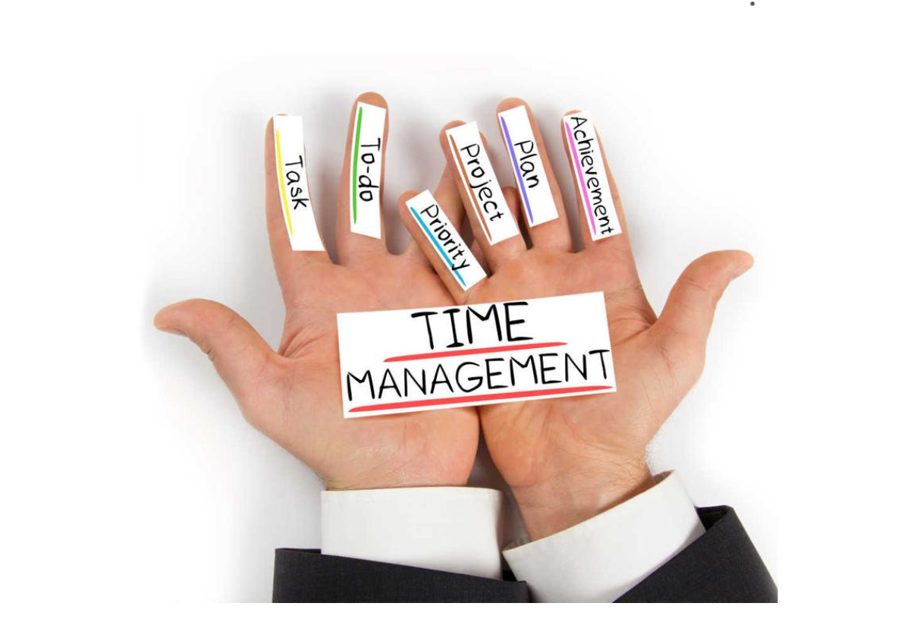
Figure.2
There are three abilities that divide success from failure in time management:
- Awareness: Consider my time realistically, keeping in mind that it is a finite resource.
- Arrangement is the process of establishing and organising your goals, plans, timetables, and responsibilities to make the most use of my time.
- Adaptation is the monitoring of my time utilisation while executing activities, such as adjusting to interruptions or shifting priorities. (Dierdorff 2020)


The importance of time management
It is very important to know how to divide my time, to set my priorities and to organize myself so that I can complete everything I set out to do. Although my weekly schedule is very busy, I manage to organize my free time and set my priorities.
Time management as a student

As a student on the topic of ‘time manager’, I set out to analyze the style in which I organized my priorities towards the university and everything that includes it, from the calculation of the hours I allocate to study – to how many should actually be, reflecting on the result by using Kolb’s Learning Cycle (1984) after which I can create a well-structured diary to help me achieve my student goals.
I started with the question; ‘How well do I divide my time at the moment?’ See table 1. (Cottrell, 2019a, p. 124)
For each of the items below, I circled the answers which fits me better.

No. | Items DO I… | RESPONSE
1. | have good sense of why my time management is important for students? | Yes | No | Don’t know
2. | usually know where I should be and at what time? | Yes | No | Don’t know
3. | usually turn up on time to where I need to be? | Yes | No | Don’t know
4. | keep good track of all the things I need to do? | Yes | No | Don’t know
5. | have an accurate sense of where my time goes? | Yes | No | Don’t know
6. | use breaks and blocks of study time creatively, to help me to study efficiently? | Yes | No | Don’t know
7. | know how many study hours are expected for my course? | Yes | No | Don’t know
8. | know how many hours I am expected to spend across the year in different kinds of study? | Yes | No | Don’t know
9. | prioritise effectively the things I most need to do? | Yes | No | Don’t know
10. | use a planner or diary effectively? | Yes | No | Don’t know
11. | know when all assignments deadlines and/or exams fall? | Yes | No | Don’t know
12. | map out my planner how I will organize my work so as to meet all deadlines? | Yes | No | Don’t know
13. | use my online time effectively? | Yes | No | Don’t know
14. | know how to manage distractions? | Yes | No | Don’t know
15. | use time management strategies effectively? | Yes | No | Don’t know
16. | have time for myself and relax? | Yes | No | Don’t know

Table1. (Cottrell, 2019a, pp. 124)
From Table1. I can clearly say that even if I have convinced myself that I’m using my time efficiently, the truth is that I need to practice more on:
- managing distraction-to identify the factors and to minimalize them
- using time management strategies more effectively by using time management tools( a timer)
- creating and respected a planner or diary
- recharging batteries

10 steps to effective time management

- Be systematic in your time management
- Find out your time requesting
- Clarify how you’re using your time currently
- Decide how do you want to spend your time
- Prioritise what is most important
- Plan what you will do/ when
- Do it, keeping to your plan
- Apply time management techniques
- Manage distractions and procrastination
- Monitoring keep checking it is all working
(Cottrell, 2019b, p. 127)
For example, my main goal is to finish this course, to learn a lot and after enrolling in the profession that I will practice in the future, this plan remains unchanged, and I know that it is future and requires a lot of time and I am aware that it takes a lot of involvement on my part.

Set goals correctly
. When setting goals, I use the SMART technique and, SMART is a well-known approach for goal planning and achievement. While the abbreviation's meaning may be construed in a variety of ways, the most frequent interpretation is that objectives should be specific, measurable, achievable, relevant, and time bound.
- Specific (significant, precise)
- Measurable (motivating)
- Achievable (attainable)
- Relevant (realistic and resourced)
- Time bound (time limited/cost limited) (Mayer, 2003)


Set a time limit to complete a task
Setting a time limit for finishing activities allows me to be more focused and efficient. Making the tiny extra effort to determine how much time I need to devote for each work will also assist me in identifying potential difficulties before they arise. That way, I'll be able to devise strategies for dealing with them. (Hook, 2018)

Take a break between tasks
It's more difficult for me to stay focused and motivated when I'm performing a lot of things without a break. I take some time between activities to clear my mind and recharge my batteries. I think about taking a quick rest or going for a short walk outside the house or in the garden.
Plan ahead

I am confident that I begin each day with a clear understanding of what I need to do — what must be completed THAT DAY. Consider making it a habit to write out my "to-do" list for the next weekday at the end of each workday. That way, I'll be ready to go the next morning.

Paraphrasing

Definition
Paraphrasing is the process of putting another person's ideas into my own words. When I use the work of others to support my own point of view, I use paraphrasing. When paraphrasing, I must adjust the words and structure while maintaining the meaning. (Smith, 2021)
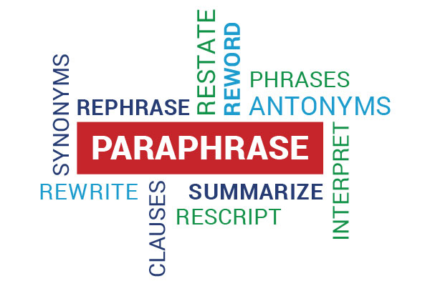

Step-by-step paraphrasing
- For the purposes of my discussion, determine what the most important information is.
- Rearrange the concepts and words in a different sequence. This will allow me to emphasize my take on the original text.
- If required, I will change the word form or grammatical form of the sentence in question.
- Whenever possible, I will use synonyms, but I will not alter any specific phrase.
- If three or more consecutive words remain the same in the same order, I must use quotation marks around these terms.
- Repeat the author's name or a pronoun throughout the paragraph to indicate that I am still reading a paragraph.
- I'll provide a note about where the data comes from.
- Keep track of the author's name as well as the page number. Although I may have been instructed that I do not need the page number for a paragraph, it is still useful to mention it if the idea came from a certain page. That way, if I need to, I can double-check the information.

Example of paraphrasing
- Original text:
“In the Sopranos, the mob is beset by both internal infidelity and the federal authorities. The greatest threat to Tony's Family early in the series is his biological family. One of Tony's closest colleagues testifies to the FBI, his mother conspires with his uncle to arrange a hit on Tony, and his children use the Internet to keep up with the government crackdown on Tony's gangland.”
- Paraphrased: 
“In the first season of The Sopranos, Tony Soprano's mob activities are endangered more by members of his biological family than by federal authorities. This family betrayal is multifaceted. Uncle and mother are plotting to assassinate Tony, and his children are searching the Web for information about him. Tony's closest buddy and colleague is an FBI agent.”

Summarising

A summary, on the other hand, is a condensed version of a complete debate or argument. For example, I might explain an entire research paper or conversation in a single paragraph or with a series of bullet points, using my own language and style.
Summaries remove material or instances that may divert the reader's attention away from the most relevant information, and they simplify complex arguments, syntax, and vocabulary. Summarizing, when done well, may save time, boost understanding, and lend authority and credibility to my work. When the phrasing of the original communication is less crucial than its overall meaning, this tool comes in handy.

Steps for summarising
- If I'm reading a longer article, I'll skim through the material. Take note of the subheadings, the opening and last paragraphs, and the topic phrases.
- I attentively read the material while utilizing a dictionary.
- Several times through a challenging text.

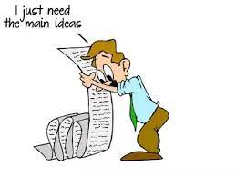

- I take notes in the style of bullet points, using significant words and ideas.
- I lay my text aside and begin writing my summary from my notes.
- I go back to the original to ensure that my version accurately reflects the writer's thoughts and point of view.
- I always provide an in-text citation at the beginning and end of my summary. (Bauer, 2006)

Example of summarising

Original text:
“Writing is a difficult undertaking for most people when they are trying to wrestle in their language with new ideas and new ways of looking at them. Sitting down to write can be a painful experience that does not necessarily improve with the passage of time and the acquisition of experience. As a result, you must reflect on and analyse your personal reactions to the writing work. That is to say, the task will become more bearable if you learn how to deal with your own unique ways of dealing with it, rather than postponing the moment when you must put pen to paper” (Taylor 1989, p. 3).
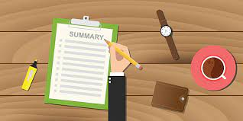
Summarised text:
“When faced with writing assignments, inexperienced and even skilled writers might experience a considerable lot of anguish; nevertheless, this response can be mitigated by recognizing and coping with personal avoidance methods (Taylor, 1989, p. 3).”

Public speaking and giving presentations

Definition
Giving an oral presentation in front of a class or another group of people is a unique type of contact that is widespread in education. As part of my exam, I will be asked to deliver a power point presentation in this exam, being half of my note, and my future employment may also need public speaking. It's essential to develop my communication abilities in this area. (Anderson, 2013)
Participating in class and expressing my thoughts, ideas, and questions with the rest of the class is public speaking. Public speaking, on the other hand, is significantly different in other aspects. Instead of speaking from my customary seat, I stand in front of the class, which alters the psychology of the scenario for most students.
I also have time outside of class to prepare my presentation, which allows me to meticulously plan it—and gives me more time to worry about it, causing me even more anxiety!


Conclusion

In this exam I write a structured academic report in which I reflect on what I've learnt in this module so far. I picked four chapters that caught my interest from the viewpoint of my development, which I did not grasp very well, but with the guidance of teachers and class participation, I learned to identify my priorities, not be afraid to speak in front of people, and express my own and others' ideas.
This report includes a list of required or advised reading from the faculty, as well as the lessons covered in class. Without a doubt, I've frequently pondered how my 2,000-word mission could incorporate all these materials that are meant to inform my writing while also letting the reader know that I knew what I needed to do and that I thoroughly comprehended the lessons.

Reference list

- Anderson, C. (2013), “How to Give a Killer Presentation,” [Online]. Available: https://hbr.org/2013/06/how-to-give-a-killer-presentation. [Accessed 26 July 2021]
- Bauer, R. (2006) ‘Guidelines for writing a SUMMARY with IN-TEXT CITATIONS’ . [Online]. Available: http://academics.smcvt.edu/cbauer-ramazani/AEP/EN104/summary.htm. [Accessed 26 July 2021].
- Cottrell, S. (2019a) The study skills handbook. 5 ^{th} end. Red Globe Press: London pp. 124, illus
- Cottrell, S. (2019b) The study skills handbook. 5 ^{th} end. Red Globe Press: London pp.127
- Dierdorff, E. C. (2020) “Time Management Is About More Than Life Hacks,” Harvard Busimess Revire
- Mayer, P.J (2003) Attitude Is Everything: If You Want to Succeed Above and Beyond. Paul J. Meyer Resources: United States
- Morgan, P. (2017) The business student’s guide to study and employability. London: Sage pp. 9
- Smith, S. (2021), “Eapfoundation.com,” [Online]. Available: https://www.eapfoundation.com/writing/paraphrase/. [Accessed 26 July 2021].
- Hook, J. (2018), ‘Set a time limit for your tasks.’, [Online]. Available: https://joshuanhook.com/2018/05/11/set-a-time-limit-2/. [Accessed 26 July 2021].

