University of Wales Trinity Saint David

Combustion and Emission study:
Modelling fuels and emissions

Alex David Jones
2200239
BEng Motorcycle Engineering

ACHA6006
Contemporary Powertrain Design
2025/2026

Task 2:
Ricardo WAVE set-up:
The following fuels tests were performed using the given WAVE model for the Ducati Panigale 1199. The following operating conditions and assumptions were used for the testing of each fuel:
- The RPM set points at which data is calculated for remained constant.
- The throttle/load control for the engine remained constant for each fuel type
- Combustion was modelled using a predefined burn profile.
- Knock limits were not explicitly modelled.
- Injector and fuel system constraints were assumed sufficient.
- Heat transfer correlations may not capture real wall effects.
- Lambda control was idealised as stoichiometric.

The fuels that have been selected to test are E85, methanol and propane.
This selection of fuels will give a good range of results as methanol is a pure alcohol fuel, E85 is a blend of ethanol, an alcohol, and octane, with 85% ethanol by volume. Propane is another alkane comparable to isooctane, the main component of regular E10 petrol. The have a varying range of ideal stoichiometric ratios which should give detail on how the engine reacts to fuels that require a larger volume of fuel per combustion event.

Fuel property table:
 | Propane | E85 | Methanol
Stoichiometric AFR | 15.57 | 9.78 | 6.43
LHV (MJ/Kg) | 45.35 | 29.7 | 22.7
Stoichiometric equation | C3H8 + 5(O2 + 3.76N2) --> 3 CO2 + 4H2O + 18.81N2 | C2.35H6.7O0.94 + 3.56(O2 + 3.76N2)  --> 2.35 CO2 + 3.35H2O + 13.38N2 | C1H4O1 + 1.5(O2 + 3.76N2)  --> 1 CO2 + 2 H2O + 5.64N2

In order to apply these fuels correctly in WAVE, the model was set with the desired fuel under the model properties tab, and the injector’s fuel ratio was changed to match the stoichiometric air/fuel ratio for each fuel. All other settings not related to the fuel properties remained constant throughout to maintain accurate and comparable results.

WAVE results and graphs:
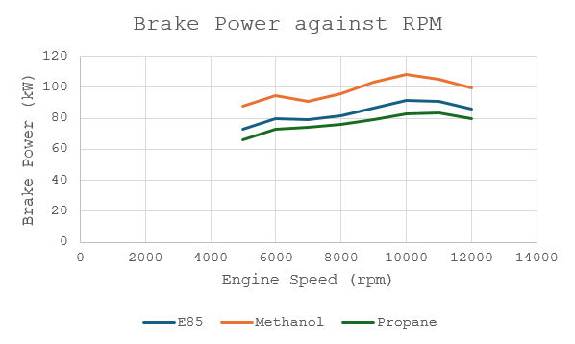
Brake Power:
Methanol produces the highest brake power with 108kW at 10000rpm, E85 produces 92kW at 10000rpm and Propane produces 83kW at 11000rpm. The alcohol based fuels created greater peak power 1000rpm lower than the alkane fuel. This is due to the fact that methanol and ethanol within E85, although having lower calorific values per kilogram than alkanes such as propane and octane, it is offset by their air/fuel ratios requiring more fuel to be injected into the cylinder, more than double in the case of methanol. This results in a higher overall amount of fuel energy within the cylinder with the alcohol fuels, leading to higher power, more so with methanol than E85 as it is pure. Methanol and the ethanol within E85 also carry oxygen within the fuel allowing the fuel to burn more completely, maximising the output. Methanol and ethanol also have greater heat of vaporization than alkane fuels, meaning they absorb more heat as it vaporizes, resulting in cooler and therefore denser air filling the cylinders.
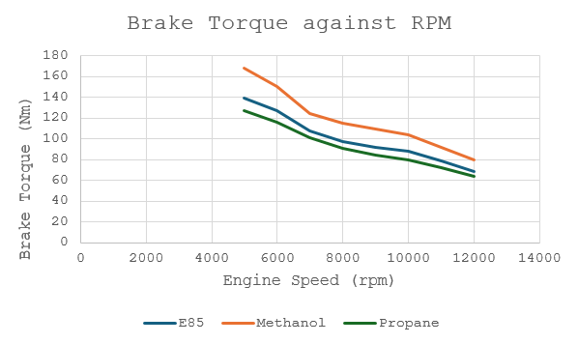
Brake Torque:
The torque and horsepower produced by an engine are directly related by rpm, such the reasons for the increased torque produced by methanol and ethanol are much the same as stated above under brake power, however it can be noted that at 10 000rpm the alcohol fuels drop off quicker than propane proportionally. This is likely due to the 1199 Panigale engine being specified for petrol, which more closely resembles propane than the alcohols and as such the compression ratios are intended for that. Typically it would be expected that an engine appropriately designed to run on methanol or E85 would maintain torque even higher in the rpm range than propane or octane.

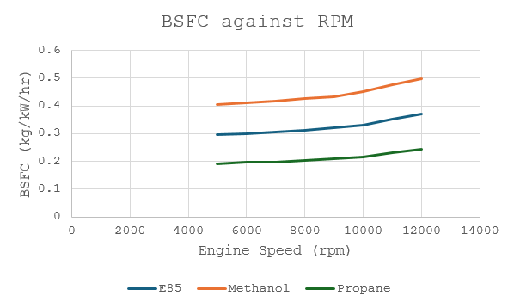
Brake Specific Fuel Consumption
The brake specific fuel consumption is a measure of how much fuel by mass (kg) is required to produce a unit of power, in this case one kilowatt for an hour duration. Although methanol creates the most power of the 3, it has the lowest lower heating value (LHV) of 22.7MJ/kg and its air fuel ratio of 6.43:1 means that to produce the same amount of power as a fuel with a higher LHV such as propane with 45.35MJ/kg it will require a greater fuel mass and so these results are expected. E85 sits in the middle with an LHV of 29.7 MJ/kg and 9.78 air to fuel ratio. BSFC is measured based on fuel mass and not volume so the density of each fuel will also play a factor in the results, with propane being the least dense fuel.
There is a distinct ramp up in BSFC for Propane and E85 at 10000 rpm, however for methanol this occurs at 9000rpm, thus indicating at higher rpms methanol requires increasing amounts of fuel to continue running at the desired air/fuel ratio.

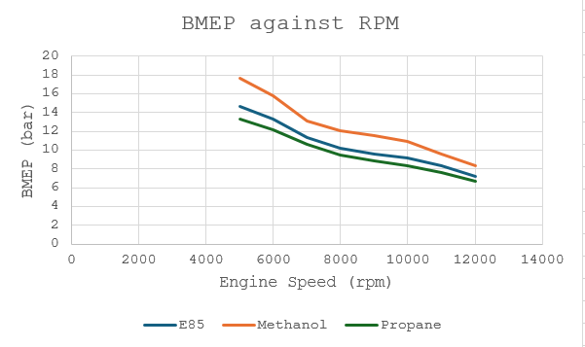
Brake Mean Effective Pressure
Brake Mean Effective Pressure is a measure of the average pressure on the piston that would produce the measured engine torque. This is a great way to compare completely different engines regardless of capacity, number of cylinders or engine layout. In this example the methanol produces the highest BMEP followed by ethanol and then propane, as we would expect to see since this is the same order the 3 fuels have been in for power and torque. Since cylinder pressure has a direct effect on the torque produced, and in this example the engine specifications are identical, these results seem reasonable.

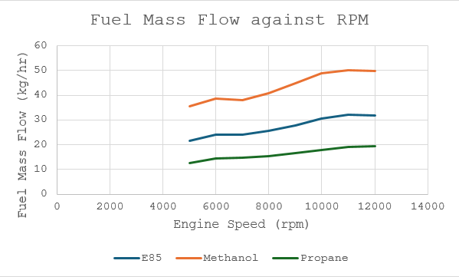
Fuel Mass Flow:
This graph is similar to the BSFC with the difference being that it power output is not factored in, it is based only on the fuel mass flow. As a result of this the gap between E85 and methanol is larger as the factor of methanol creating more power does not make any effect in this case. These results are expected based on the stoichiometric air/fuel ratios of the fuels.

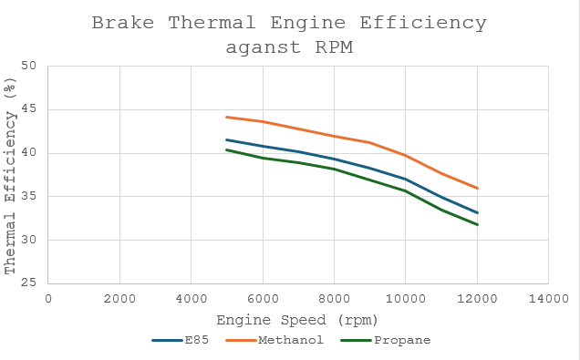
Brake Thermal Engine Efficiency:
Brake thermal efficiency is a measure of how well an engine converts the chemical energy in the fuel into mechanical work at the crankshaft. It is calculated by the ratio of power output to energy input from the fuel. These thermal efficiency results appear to be overestimated as the typical results for a naturally aspirated gasoline engine are in the range of 25-30%, with these results reaching over 40% at 5000rpm. It is expected that methanol and E85 have a higher thermal efficiency than the alkane fuel propane, due to their higher latent heat of vaporisation. Methanol has 1100KJ/kg, E85 920KJ/kg and propane 360KJ/kg latent heat of vaporisation. This means methanol and E85 are going to absorb more heat within the intake charge, results in cooler, denser air entering the combustion chamber. Combined with the fact that methanol and E85 being alcohol based fuels contain oxygen within the fuel (methanol more so than E85) results in a much cleaner, more complete and faster burn in the combustion chamber. These factors lead them to have greater thermal efficiency than propane.

Direct fuel comparison summary:
To summarise the fuels:
Methanol is the best of the 3 when it comes to outright performance. It produced the highest BMEP, torque and power and has the capability of this being further increased in an engine modified to be optimised to run on Methanol, such as increasing the compression ratio and advancing the ignition due to the aggressive fast burn during combustion. As a downside it has the worst BSFC so it uses a significant amount of fuel and would quickly be very costly to run.
E85 is a great performance fuel with improved BMEP, torque and power compared to standard petrol. It has potential for further modification to improve performance further but can also be run in most vehicles with just a few modifications, such as swapping out rubber fuel lines, making it far more versatile than methanol. The ethanol in E85 is also renewable as it is made from fermenting sugars such as corn, sugarcane and wheat. It has an increased fuel usage but not to the same effect as methanol.
Propane, being an alkane fuel in terms of performance is most similar to regular petrol. It uses the least fuel of the tested fuels. It is not used in vehicles due to its boiling point of -42C making it gas at room temperature which is why heptane and octane are preferred for petrol due to the boiling point of 98C – 125C making it a liquid at room temp which is much more convenient for use in vehicles.

