8 Reference List  Child Mind Institute. (no date) Social Anxiety: What to look for https://childmind.org/guide/social-anxiety-disorder/social-anxiety-disorder-what-to-look-for/ (Accessed: 16th April 2018).  Freedman, J. (2011) Integrated Emotions: Rethinking the way we evaluate our feelings http://www.6seconds.org/2011/07/26/integrated-emotions/ (Accessed: 15th April 2018).  Gines, A.C., Dizon, P.B, Obias, P, H, Uriarte, G, G, Vendivel, F, G. (1998) Developmental Psychology. Book Store: Philippines.  Lyness, D. (2014) Kids Health https://kidshealth.org/en/parents/anxiety-disorders.html (Accessed: 15th April 2018).  Moyses, K. (2013) Michigan state University Extension http://msue.anr.msu.edu/news/help_young_children_identify_and_express_emotions (Accessed: 15th April 2018).  Mental Health Foundation. (no date) The Anxious Child. Victoria Street: London.  NHS (2016) Anxiety in children https://www.nhs.uk/conditions/stress-anxiety-depression/anxiety-in-children/ (Accessed: 15th April 2018)  Oakley, L. (2004) Cognitive Development. Routledge: London.  Images  Anas Alam Faizli. (no date) Management Theories: Human Relations Movement. [Online]. Available at: http://aafaizli.com/management-theories-human-relations-movement/ (Accessed: 16th April 2018).  Choices 4 Children. (no date) Acknowledge Children’s Feelings. [Online]. Available at: http://choices4children.blogspot.co.uk/2013/02/acknowledge-childrens-feelings.html Accessed: 16th April 2018).  Natty. (no date) How to cope with children under 10 with anxiety. [Online]. Available at: http://www.mommyedition.com/how-to-help-children-under-10-cope-with-anxiety (Accessed: 16th April 2018).  Pinterest (no date) [Online]. Available at: https://www.pinterest.co.uk/pin/171347960799604691/ Accessed: 16th April 2018).  Popescu, R. (2014) [Online]. Available at: http://beingraluca.com/help-child-express-release-emotions-drawings/ (Accessed: 16th April 2018),  Theories of Mind: Representations of Consciousness in Fiction and Theory. (no date) [Online]. Available at  http://www.reed.edu/english/courses/eng333theoriesofmind/syllabus.html (Accessed: 16th April 2018). | 1 Student Number- 1500740  A fun feelings map for schools / nurseries to use with children who have Social Anxiety  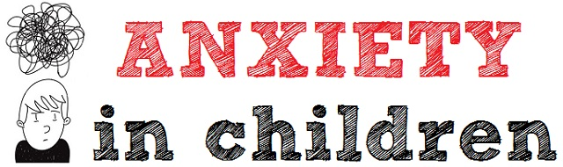  This leaflet is an instruction guide for schools and in therapy to use who work with children who suffer with Social Anxiety. The resource is a feelings map that has 6 types of feelings. The chart starts from happy, calm, sad/disappointed, anxious and scared, frustrated and to angry. However, each number explains each feeling to help the children chose how they are feeling on that day, they could even feel more than one feeling. For instance, each number will have a sentence ‘this makes me feel nervous...’ or ‘this makes me feel sad...’. Moreover, the leaflet is aimed at schools but parents can also use it at home when they have children who are unable to communicate or express how they are feeling.
2 Instruction guide on how to use  A feelings map can be used with different types of children who have communication needs, it can be used with Autistic children as well as children who have Social Anxiety which this instruction leaflet is aimed at. Supporting children with emotion issues have become a priority in schools / therapies and it is an effective way to help children who have social anxiety express their feelings.  However, this feelings map is a fun way to get the children to express how they are feeling. The feelings map has six different faces expressing their feelings and in the middle, there are also six different words such as; happy, calm, sad/disappointed, anxious/scared, frustrated and angry. Each word will have an explanation underneath so the children can understand what each one means. To make it fun for the children, they must draw a line from each word to the face that they think matches the word they have chosen. Therefore, it’s more of a spider diagram but using faces and words. Moreover, they children can chose more than one word and face if they have more than one feeling.  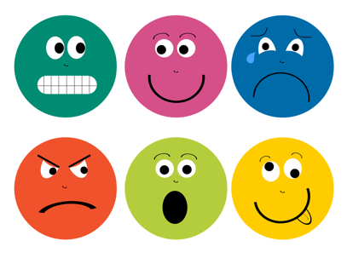  As children who suffer with anxiety and find it hard to communicate and to express how they are feeling, it is also hard for staff in schools and therapists who work along the children understand what the children are feeling without communicating with them. Therefore, making this feeling map a more fun and colourful it will draw the children’s attention. Moreover, every child can have one feelings map each and through having it laminated it means they can use a marker pen each day to express their feelings and can still rub it out to use the next day and so on. | 3 Advantages  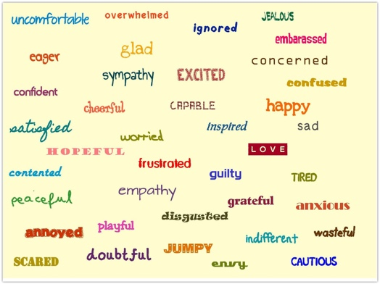  There are a variety of advantages of using this feelings map. As it has become a priority for schools to acknowledge how children are feeling, but with children who find it hard to express how they are feeling it can then be difficult for teachers/therapist to know what is wrong with them or why they feel upset/angry. However, children often ‘hit out of frustration’ or they may find it difficult calming down and as previously discussed this can be difficult for school teachers or therapist who are trying to help and communicate with them.  Freedman (2011) explains how emotions are signals. However, the key advantages of using this feelings map is 1. It helps children to ‘name’ their feeling, by giving them words to choose from it helps them to ‘label’ the way they are feeling. 2. It helps the children ‘identify’ the feelings in ‘themselves’ and other people. This helps them express the feelings the feel in themselves and what they feel from other people. 3. It helps the children talk about how ‘feelings can be expressed’. This helps them know when someone is feeling sad or happy or to acknowledge their own feelings and how to communicate through expressing their feelings (Moyses, 2013).  Mental Health Foundation (no date) suggests how ensuring children with anxiety can make decisions on their own as it helps with their confidence. Therefore, by using this feeling map it helps them to choose on their own how they are feeling.
4 What is Anxiety?  Anxiety is overall a ‘form’ of stress. Anxiety can be experienced in numerous ways such as ‘emotionally, physically’. Lyness (2014) suggests how anxiety is a ‘natural human reaction’. However, there is also ‘normal anxiety’. This can be a feeling of ‘mild uneasiness’ to ‘full panic attack’. It is normal for a ‘unfamiliar’ or a ‘challenging situation’ to cause anxiety. Types of anxiety disorders that children usually develop are:  - Generalized Anxiety  - Obsessive Compulsive disorder  - Phobias  - Social Anxiety  - Panic Attacks  - Posttraumatic stress disorder  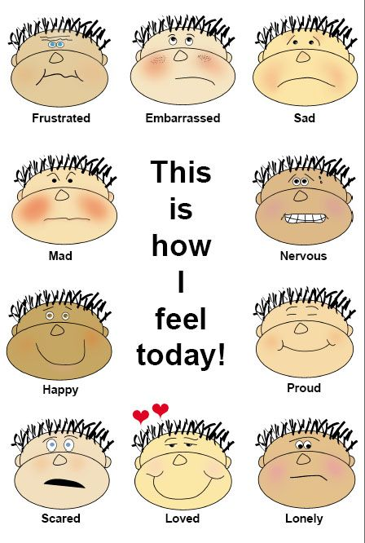  (Lyness, 2014).  Social Anxiety is considered by the feeling of ‘self-consciousness’ and the dread of ‘embarrassment’ which leads of shyness and this leads the children to avoid ‘social interactions’. Children with social anxiety also have the fear of ‘criticism’. Most children will often respond to their anxiety by asking questions such as ‘what if I do something wrong…’ However, there is also two types of ‘social anxiety disorder’, the first one is the performance which means the fear of ‘speaking in public’, the second one is ‘social interactional’ this portrait the ‘social situations’ children who have ‘social interactional’ have the fear of going to school, and the fear of expressing themselves with others (Child Mind Institute, no date). | 5 How Anxiety affects children  Children can start to experience anxiety from about ‘eight months to three years’. They often start to feel ‘anxious’ about a variety of things at different stages of growing up. Moreover, it is also common in young children to develop ‘fears’ or ‘phobias’. Also, the anxious feeling of starting school and they tend to feel nervous in ‘social situations’ and find it hard to show their feelings and to communicate (NHS UK, 2016).  When does, Anxiety get too much for children?  Anxiety becomes a big problem for children when it starts affecting their ‘day to day life’. Therefore, this instruction leaflet explains how a feelings chart can help schools / nurseries or parents use with their children who find it hard to express how they are feeling. However, ‘severe’ anxiety can have a big impact on a Childs’ well-being and ‘confidence’ (NHS, UK, 2016).  
6 Cognitive Development Theory  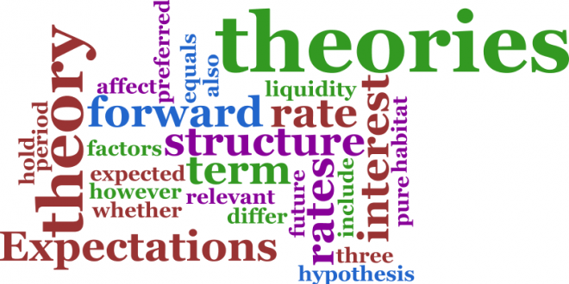  Looking at Jean Piagets’ theory on cognitive development, it explains how a child creates a ‘mental model’ of the world they live in. Piaget disagreed that a child’s intelligence was a ‘fixed trait’. Moreover, Piaget also claimed that the ‘cognitive development’ is an ‘inevitable process’, what this means is when the ‘brain matures the thinking matures’ so then the ‘understanding increases’ (Oakley, 2004) Moreover, Piaget thought that the ‘cognitive development’ came in stages and that each stage became achievable as the brain matured. However, this theory can be understood based on a ‘staircase’. The stages in the theory signifies each step and the steps ‘represent’ a further ‘development’ and an increased level of ‘cognitive ability’. That said, it is important to know that each ‘stage’ are set in ‘sequence’. Furthermore, the stages are from ‘0-2 years’ it’s called the ‘sensorimotor’ which means the ‘rapid development’. ‘2-7 years’ is called the ‘pre-operational’ stage, this stage is the ‘development of imaginative play’. ‘7-12 years’ is called the ‘concrete operational’ this stage is the development of ‘strategies’ and exploring the child’s world. The last stage is the ‘formal operational stage 12-16 years’, this stage focuses ‘hypothetical problems’ or imaginary ‘problems’ that the child is unable to see (Oakley, 2004). To support this theory with this instruction, leaflet on social anxiety, although the theory describes a child’s ‘cognitive development’ but it discussed their ability, and how they see the world through their own development along with how their brain matures and understands which links in with children who have anxiety as they have the abilities and maturity but not the ability of communicating the way they should or want. | 7 Erik Erikson Psychological Development theory  Another theory that focuses on the development of children is the Erikson Psychological Development. In this theory, Erikson developed an eight stage that goes from ‘infancy’ to ‘adulthood’. The stages focus on an individuals’ experiences on ‘psychosocial crisis’ which can either have a ‘positive’ or a ‘negative’ effect on the aftermath of the persons’ ‘personality development’. That said, Gines et al. (1998) states how Erikson said that ‘individuals’ develop a ‘healthy personality’ through overcoming ‘life’s outer and inner dangers’. The first stage in the theory is the ‘trust versus mistrust’, life is a ‘social endeavour’ and this contains ‘linkages and interactions’ amid other people. This results in whether children come to trust or mistrust people depending on their ‘early experiences’. The second stage of the theory is the ‘Autonomy versus Shame and Doubt’ this stage focuses on when children start to crawl, walk and begin to discover what ‘confronts them’. Moreover, Gines et al (1998) states how the theory explains when parents have patience, ‘supportive’ and encourage the children it gives them a feel of ‘independence’ and ‘competence’, in comparison to that, when parents are ‘over-protected’ of the children it gives them the feel of ‘shame and doubt’. The next stage which is the ‘Initiative Versus Guilt’ during this stage it looks at the ‘mental abilities’ available to children, parents who give their children the independents to go ‘bike riding, skating’ it allows the children to ‘develop initiative’. However, parents who ‘curtail’ their children doing so, it gives the children the feel of themselves as ‘nuisances’ and gives them the feeling of ‘intruders in adult world’ instead of being confident and determining their own behaviour. Although, this theory discussed children from infancy to adulthood it links in with anxiety as individuals who suffer with anxiety often have experienced issues in early life that affects it, or as the last two stages discuss if parents are too controlling it doesn’t give the children the chance to live independently or to gain confidence therefore, starting school on their own will prompt a sense of anxiety and finding it hard to confront in people and express their emotions.

