Observational Analysis – Game
Physical | Technical | Tactical | Psychological
C5- good strength to win the ball back by the red midfielder, then releases a powerful shot at the keeper that cant save it due to the power. | C3- defender doesn’t look or take any time just clears the ball in panic. | C7- good shape when setting up from a goal kick. Midfielder needs to be in front of the blue player to give keeper another option. | C10- poor communication and mentality from green defender and positioning from goal keeper is very poor cutting off options.
C6- Blue defender needs to have a better defensive shape to be able to make a stronger tackle and not get bumped off by winger. | C4- Great ball into the box (area wise) drops front post, defenders need to do better though as the balls dropped into an area and not a player.  C8- great pass by midfield red to split between the 2 defending players. | C8- Red striker needs to drop back to be inline/between the blue defenders. This is due to being offside in the older age groups and would benefit the player from learning it at a young age.  C9- blue teams defending position in poor and not spread enough. | C14- red right wing tries a skill, poor execution, gives away possession then doesn’t even bother to track back and press the ball.
 | C6- good ability to dribble with the ball and good physicality to beat the defender off. | C12- poor execution of skill when playing out from the back from green team, loses ball around goal area and concede.
 | C13- ball lost by green team when in possession as the players aren’t scanning and just passing wherever.
Overall Review and Link to Session Planner:
Thought the games played were at an okay level. Could be better when on the ball and stay more composed. The main focus in the sessions to follow for me would to look at the tactical aspect of their game. This would link to their positioning off goal kicks and when the balls in open play as I found they were poor at times which lead to goals. But both the attacking and defensive side need looking at.

UWTSD Session Planner
Venue: Britton Ferry training ground |  |  | Age group: u10  Number Attending:
Date: 20/01/2026 |  |  | Start time: 18:00  Finish time: 19:00
Equipment: Goals, balls, cones

Nearest Telephone:  Coaches pocket | 1st Aid bag:  On site
Risk Assessment completed: | Additional Hazards and actions taken:
Learning from Observational Analysis:  Listen within template above |  | Personal action points Observational Analysis:  Listed in template above
Goals for the session:

To be able to identify defensive and attacking positioning. Looking at the tactical aspect of why were in that position

.
Introduction and warm-up

Stuck in the mud get the players moving around and running into wider positions to stay away from taggers.

Main Content/Game  The defensive team has to communicate and move in a line trying to win the ball back from the attacking team. Focus for the defence is to try break down the attack without breaking as a line.  Focus for the attacking team is to spread out wide and create options making it harder for the defence and try make them unlink. |  | Organisation/diagram  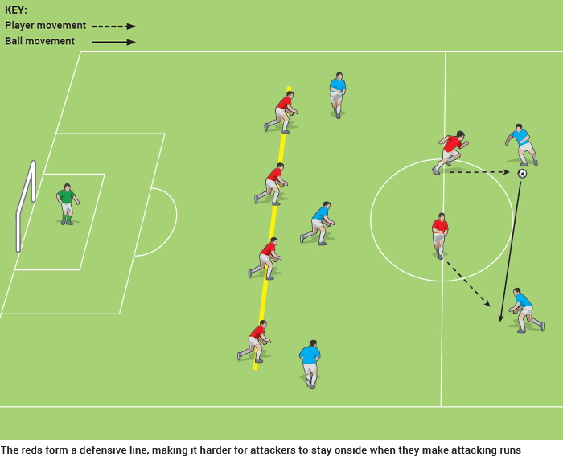
Ideas for Development (progression / regression):  To develop this can the defending team work in a U like shape with the full backs working in a pendulum where there’s always at least 3 defenders in a straight line at a time. |  | Diagram for activity  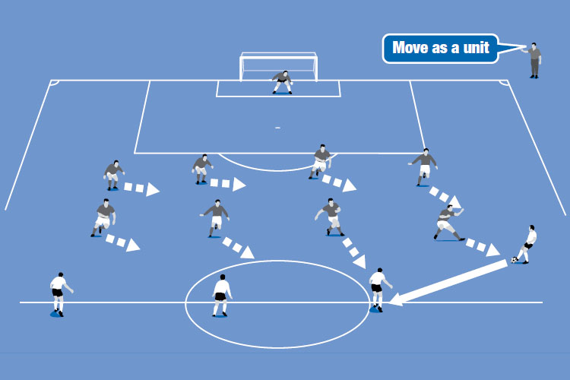

5Cs to be included in this session | Select 2 of the 5 and apply to session  HOW?
Competence

Confidence:

Connection: | Lead within a defensive line and be able to communicate to keep the link between all 4 of the defenders.
Character and caring:

Creativity:

Cool-down:
Small game of 5 a side and then end with stretching.

Observational Analysis – Game
Physical | Technical | Tactical | Psychological
C13- red team needs the bigger players to mark the corner threats in the box, they didn’t and attacking player gets a header off. | C6- striker has really touch from the goal kick, loss of possession. | C5- Black left wing shoots while still on the touch line, really poor shot and really poor decision making. | C19- poor comms from keeper and defender
C16- goalkeeper too slow in decision making may be down to his size. | C10- red player poor pass, could have used weak foot just to tap it back inside, had 2 options.  C15- good clearance from black defender. Poor control and makes things harder for themselves black midfielder. | C8- Another elusive shot by the black team, take about 3 long shots which are nowhere near the goal.  C9- poor attacking corner, ball goes front post and no attacking threat to meet it.
 | C17- poor through ball from black player just passes it straight to opposition team.  C18- red player could have played a through ball to cut between 2 defenders instead takes them on and gets blocked. | C12- red goal keeper picks to go long yet all left side is open with 2 players unmarked.  C14- poor defensive position black team broke apart very easily.
 | C20- another through ball moment but wrong option chosen.
Overall Review and Link to Session Planner:
Game was scrappy, a lot of poor decisions when coming to attacking and taking on players. My main focus for the session would be looking at how the team can break between a defensive line by using through balls and having multiple running options to pick rather than take a 2 on 2 situation into a 2 on 1 favouring the defenders.

UWTSD Session Planner
Venue: Ponty Rec |  |  | Age group: U13  Number Attending:
Date 22.01.26 |  |  | Start time: 18:00  Finish time: 19:00
Equipment: Goal posts, Bibs, Balls, cones, football pitch

Nearest Telephone:  Coaches pocket | 1st Aid bag: onsite/ side of pitch
Risk Assessment completed: | Additional Hazards and actions taken:  Check pitch before session picking up any rubbish.
Learning from Observational Analysis:  Listed within template above |  | Personal action points Observational Analysis:  Listed within template above
Goals for the session:

For the players to identify where to play the ball to break a defence and select a better

.
Introduction and warm-up
Start with 3 in a row (tik tac toe) to get the players moving and running/changing direction. Also a great game as It gets the players to think about how to with the game.

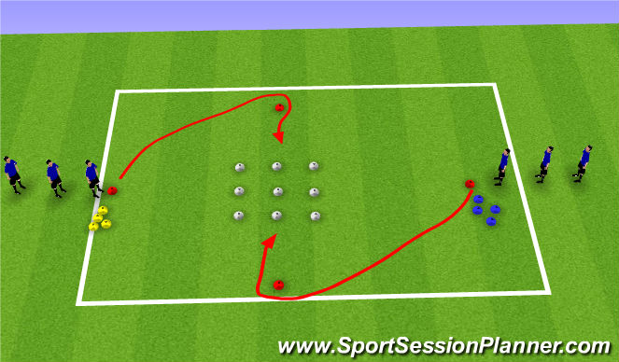

Main Content/Game  Start off by 2 players passing to each other, one player plays the ball and the other makes a diagonal run. This practices our through balls. |  | Organisation/diagram  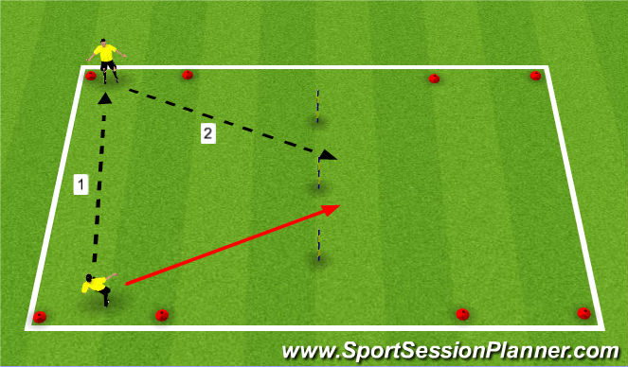
Ideas for Development (progression / regression):  Pro: make the player standing with their back to goal. They will receive ball from player 1 then play the ball to player 2. Player 2 plays a through ball forward and player 3 makes a run then takes a shot on goal. Add a defender.  Reg: take the defender out and go back to step 1 but just use 2 players instead of 3 |  | Diagram for activity  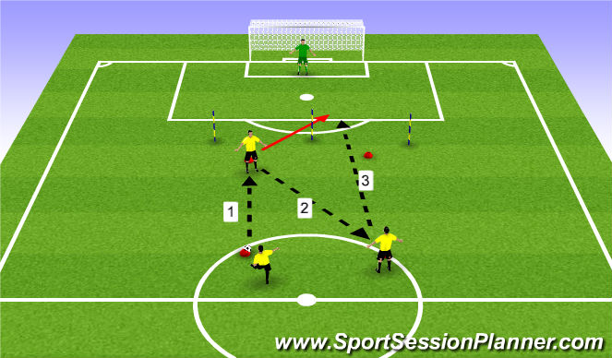

5Cs to be included in this session | Select 2 of the 5 and apply to session  HOW?
Competence

Confidence:

Connection: | The players will be developing their connection and communication in the attacking third.
Character and caring:

Creativity: | Players will be able to identify where to play the ball and create an attacking focus.
Cool-down: Play a reduced game of walking football and end with some stretches.

Observational Analysis – Game
Physical | Technical | Tactical | Psychological
Overall Review and Link to Session Planner:

UWTSD Session Planner
Venue: |  |  | Age group:  Number Attending:
Date |  |  | Start time:  Finish time:
Equipment:

Nearest Telephone: | 1st Aid bag:
Risk Assessment completed: | Additional Hazards and actions taken:
Learning from Observational Analysis: |  | Personal action points Observational Analysis:
Goals for the session:

.
Introduction and warm-up

Main Content/Game |  | Organisation/diagram
Ideas for Development (progression / regression): |  | Diagram for activity

5Cs to be included in this session | Select 2 of the 5 and apply to session  HOW?
Competence

Confidence:

Connection:

Character and caring:

Creativity:

Cool-down:

