
Skills for the Workplace
Module Assignment Submission
Student Name: | Ana Maria Arcila Rengifo
Student Number: | 1714416
Module No: | BMSK4004
Module Title: | Problem solving and decision making
Lecturer:  Date: | Yajesh kumar  29 April 2019

Table of Contents
EXECUTIVE SUMMARY 3
INTRODUCTION 3
DISCUSSION 4
DEFINING PROBLEM WITH ITS SCOPE AND IMPACT 4
MODEL OF PROBLEM SOLVING: 4
ANALYSIS 10
DEVELOPING A PLAN FOR IMPLEMENTING THE SOLUTION 10
DECISION-MAKING TECHNIQUE FOR EVALUATING A RANGE OF SOLUTIONS TO IDENTIFY THE MOST APPROPRIATE OPTION 16
ALTERNATIVE SOLUTIONS TO THE PROBLEM 19
DEVELOPMENT OF A PLAN FOR IMPLEMENTATION OF THE SOLUTION 20
CONCLUSION AND RECOMMENDATIONS 22
REFERENCES 23

EXECUTIVE SUMMARY
The report has been carrying out for finding the issues facing by the McDonald and the activities laid down for solving the problems. This report carries the basic details and information of the company which also shows the issues facing by the company. This laid down the critical issues and recommendations to solve the problem focus by the manager of the company and implemented successfully. The problems related to the poor management and strong competition in the market which had a great impact on the McDonald shown in the report. The problems also impacted on the decision-making process of the company which laid emphasis by the managers and the positive attitude of them towards solving the problem of the company.

INTRODUCTION
This report carries the problems facing by the McDonald. McDonald’s is an American fast food which was founded by Richard and Maurice McDonald on 15th May 1940 and its headquarters are in Chicago, Illinois, United States. The company is famous for fast food all over the world and mainly serves the hamburgers and French fries to the customers, other breakfast items which include soft drinks, wraps, milkshakes, cheeseburgers etc. McDonald has the world largest chain of restaurants over the world more than in 100 countries. The company serves more than 68 million customers per day (McDonald, 2015).
This report laid out the issues facing by McDonald which affects the decision making of the company. This will tell about the issues and the problems in the company with its scope and impact and analyse the information to solve the problem of the company. This report will focus on the range of alternative solutions to the problem which will help in decision making and implementation on the development of a plan that will also communicate to the stakeholders of McDonald. The report will also carry the appropriate maintaining and reviewing the techniques for implementing successfully the solution to the plan.

DISCUSSION

DEFINING PROBLEM WITH ITS SCOPE AND IMPACT
A business acquires benefits with a tough organizational structure by a well-defined hierarchy, improved communication and the capability to create a combined business message (Reder, 2016). An organizational structure can be effective, but it can create problems which lead to the conflicts and the loss of productivity. The issues facing McDonald are poor management and strong competition (Reder, 2016). McDonald has the strongest chain of restaurants all over the world and the stock prices sluggish rising by 7% after the joining of McDonald CEO don Thompson over 2012.
According to Reder (2016), for maintaining a healthy business framework, the manager must have to identify the issues within the organizational structure and have the capability to fight with them. For diversification, at the workplace, the organization must identify the problems and the opportunities for solving the problems help in reducing the conflicts between the management and the workers (McDonald, 2015).

MODEL OF PROBLEM SOLVING:
The problem of poor management and strong competition get managed by following the simple steps of the problem-solving model.
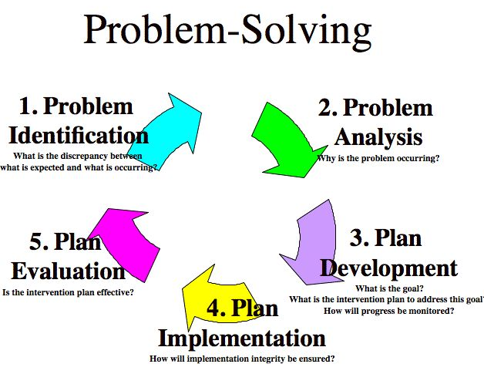
Figure 1: Problem-solving model
(Source: Brodbeck and Guillaume, 2015)
- Problem identification: The first step is to determine the problem that the McDonald is facing. The McDonald is facing the problem of poor management and strong competition prevailing in the market. It can be identified by collecting the data from the market research and the reasons behind the problem that McDonald has facing (Brodbeck and Guillaume, 2015).
- Problem analysis: This measures the level of the problems of poor management and competition. The managers and the team need to decide the solution for the problem in context to solve it effectively and efficiently (Brodbeck and Guillaume, 2015).
- Plan development: This includes the vision and the direction which helps the team and the managers to make a choice for taking the best option to solve the problem (Brodbeck and Guillaume, 2015). This can be getting evaluated by the managers in development towards the goal.
- Plan implementation: The process of selecting the best way to solve the problem and implementation of the plan, which developed by the managers and the team. This includes how and when to implement the right plan at the right place (Brodbeck and Guillaume, 2015).
- Plan evaluation: This step evaluates the changes implemented on the problem have affected positively or not. This includes the evaluation of the performance and monitoring control over the plan that gets implemented for solving the problem (Brodbeck and Guillaume, 2015). The evaluation of problems resulting from taking feedback from the customers about the services offered to them.
PERCEIVED PROBLEMS AND POTENTIAL CAUSES:
According to, the identification of issues and determining the causes reflect the perceived problems. The problems are facing by McDonald are related to poor management, lack of motivation in staffs and competition in the market (Katzenbach and Smith, 2015). The selection and identification of the problem should be get solved by understanding its causes. The possible causes can arise by the process of clarifying the causes of the problems.
ACTION PLAN:
The action plan quantifies and defines the actions for the improvement of the problem by processing and by change management. McDonald needed an action plan to solve the problem of poor management and strong competition (McDonald, 2015). The issues got solved by using these methods of the action plan which includes brainstorming and smart goal.
- BRAINSTORMING
According to Rawlinson (2017), this approach combines an informal approach to solve the problem with different thinking. This encourages managers and teams to come up with thoughts and ideas that can be crafted in creating a solution to the problem (Rawlinson, 2017). Brainstorming provides an open and free environment that encourages people to participate in the problem-solving process by sharing ideas and solutions.
- SMART
Specific: This includes a target that set for an area for the implementation of the plan.
Measurable: This quantifies the suggestions provided for implementation on the plan.
Attainable: This includes who will perform the task of solving the problem (Rawlinson, 2017).
Realistic: This includes the realistic achievement of the results within the provided resources.
Time-bound: This includes the specific time provided to achieve the results (Rawlinson, 2017).
PERFORMANCE OBJECTIVE:
- Quality: Businesses must quantify by meeting specifications and standardization leads to a higher level of conformance. Quality must be compared before it has any real meaning and helps in reducing the cost such as less wasted materials, fewer problems to fix, less wasted time (Katzenbach and Smith, 2015). It also helps in increasing the revenue for higher sales volume, less price competition and brand image
- Speed: This is the time between the customer and the requested product, these include internal speed and external speed where internal speed reduces in-process inventory, reduces risk and speed the demands on the nature of the business. It considered the layout and flow of the process (Katzenbach and Smith, 2015).
- Dependency: It means different things in different parts of the organization. it includes internal dependency of reliable machinery and consistent processes and external dependency of receiving orders of customers on time which saves time and money which provides flexibility in the organization (Katzenbach and Smith, 2015).
- Flexibility: It includes the flexibility of introducing new products and services with high variation and high customization. This provides a wide range of products includes similar products having low skilled staff and greater flexibility allows variations. This also includes the volume flexibility in delivering and flexibility of queuing, flexible contracts, good supplier relations and backward integration (Katzenbach and Smith, 2015).
- Cost: Increasing quality can increase cost and keeping cost low gives business a competitive advantage. It keeps costs low and provides 2 pricing strategies which involve setting the price at low to increase sales and keep prices the same and receive a higher profit margin. It is important to maintain the balance in the performance and the objective (Katzenbach and Smith, 2015).
ORGANIZATIONAL STRUCTURE OF MCDONALD:
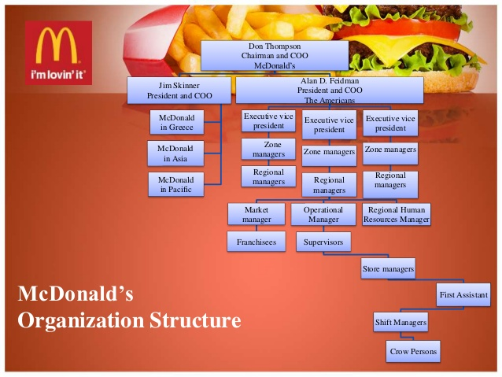
Figure 2: Organizational structure of McDonald
(Source: McDonald, 2015)
McDonald is the most popular and has the largest chain of restaurants all over the world and serves almost 58 million people a day. This is supported and manages by the effective staff members, supporting staff and senior administration (McDonald, 2015). The company follows the top to bottom hierarchy structure which includes the top-level executives, CEO, chairman, directors, senior-level managers including the departments of finance, marketing, sales and restaurant level executives (Warrick, 2017).
ORGANIZATIONAL CULTURE OF MCDONALD:
The organizational culture of McDonald follows the facts, symbols, norms, traditions and rituals for the benefit of the organization as well as the development of the employees (Warrick, 2017).
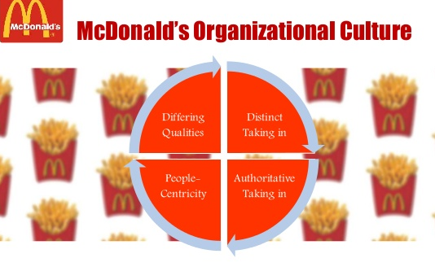
Figure 3: McDonald’s organizational culture
(Source: Warrick, 2017)
- People-centricity
The organizational culture of McDonald gives priority to the employees’ needs and focus on their development. The business gives emphasis on the values and the standards of business in consideration of that McDonald is the business of service providing (Warrick, 2017).
- Individual learning
The company highlights the lifelong learning importance and the belief is for individual learning which promotes quality, productivity and effectiveness to business. For this, the company offers training and development programs for the employees (Warrick, 2017).
- Organizational learning
The organizational culture supports the learning in the organization and McDonald aims to use the learning of individual to the benefit and development of the organization (Warrick, 2017). McDonald’s applies this on its organizational culture by programs, policies and gatherings which inspire worker feedback and awareness of sharing.
- Diversity and inclusion
For supporting diversity and inclusion McDonald ensures the organizational structure which encourages the employees, franchisees, customers and suppliers for receiving their feedbacks and communicates with them to improve the business (Warrick, 2017).

ANALYSIS

DEVELOPING A PLAN FOR IMPLEMENTING THE SOLUTION
STP-Segmentation, targeting, positioning
McDonald’s uses the marketing strategy of segmentation, targeting and positioning as its integral components (Schlegelmilch, 2016). Segmentation involves the dividing of the population into groups based on the characteristics and the targeting involves choosing the targeted people that identifies by the segmentation (Schlegelmilch, 2016).
Positioning refers to selecting the best marketing mix suitable for the segment of the targeted customers. McDonald has adopted this type for positioning of products and the company engaged in the positioning of the products and the services according to the segment (Schlegelmilch, 2016).
CHANGE OF TECHNOLOGY COMPETITION
According to (2018), McDonald is bringing up with the technologies that are beneficial to the growth of the company and making the organizational digital including its employees by Customization that the company has placed its restaurants all over the world and plan to expand “create your taste” in the year 2015. The company experiences that there will be more different ways of ordering and delivering the products to its customers (Wu, 2018).
Change in technology affects McDonald and increasing the competition due to the lack of employees, cash flow problems, employee’s empowerment etc.( Mumford, 2015) Leadership also affects the McDonald due to change in the technology and the employees get less motivation which affects the production of the company and decrease in the profit and customer satisfaction (Mumford, 2015). The managers must keep insights on the employees to serve and perform better in the organization to increase its growth and adopt the changes in the environment.
The problems get identified by the Pestel analysis of McDonald.
POLITICAL FACTORS
McDonald gets affected by the political factors of political laws and influences on the health and hygiene regulations (Dey, 2016). The food industries are under government pressure and get affected by the government tensions between the countries like the United States and the United Kingdom.
ECONOMIC FACTORS
It took a financial hit from the economic recession and the economy affect the success of the McDonald. The tariffs are imported resources and foreign incorporation taxes played an important role in the decision making of McDonald (Dey, 2016). The brand image of the McDonald has success due to an increase in the health consciousness in between the customers.
SOCIAL FACTORS
The customers are complaining about the high sugar in the drinks. People are becoming health conscious which affect the McDonald. People in Asian countries are supposed to eat local cuisines like hamburgers and French fries (Dey, 2016). The company wants to survive among other fast food companies then McDonald must reshape the menu according to their customer.
TECHNOLOGICAL FACTORS
The technological factors impact the McDonald as it has needed to develop its technology. The technology the company is using must improve for benefit of the staff in communication, productivity and production of food quickly based on customer expectations (Dey, 2016).
ENVIRONMENTAL FACTORS
McDonald has focused on protecting the items from the air and water pollution and reduce the waste of packing on the environment (Dey, 2016).
LEGAL FACTORS
Regulation is constantly the main concern for a company. The fast food industry, McDonald’s must follow many legal requirements, such as the discrimination law, corporate law, labour and employment law and taxation to remain in the market (Dey, 2016).
The SWOT analysis of McDonald
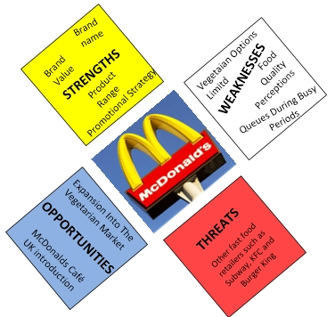
Figure 4: SWOT analysis of McDonald
(Source: Dey, 2016)
Strengths
- The company has the market power over the suppliers for demanding minor prices from them (Dey, 2016)
- Second largest network of serving customers in 120 countries
- Its network allows the chain of restaurants can reach to the customers all over the world
- The company has brand loyalty and a large range of products (Dey, 2016)
Weaknesses
- The company has a limited range for vegans and vegetarians
- Customers consider food unhealthy
- Delay in providing services due to long queues (Dey, 2016)
Opportunities
- To manufactures and sell the products aiming vegetarian market
- It is an opportunity for the company to expand the business internationally after the testing of burger in vegan was successful (Dey, 2016)
- The opportunity to diverse market into the coffee market by introducing McDonald café
Threats
- Threats are the competitors like subway, burger king and KFC
- Changing customer preferences in context to stay healthy which was influenced by the government (Dey, 2016)
DATA ANALYSIS
This data is conducted by analysing the feedbacks of the employees and the managers on the discussion of the problem of poor management and competition.
Analysis of employees
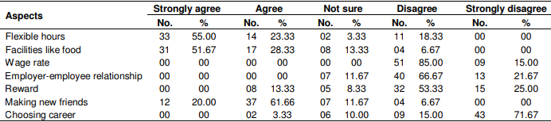
A study was conducted by Nawaz (2011), to find out the issues in the management by different perspective of the employees and the manager at McDonald. The study shows that out of 100 employees 60% are men and 40% are women that reveal most of the employees are men. The study was conducted regarding the working hour that strongly revelled 55% of the employees out of them only 3.33% are not sure. The facilities like food, 51% of employees are strongly agreed on the facility of food and other things that they are not working in McDonald for food. This all the data carried in context to the employees (Nawaz, 2011).

Analysis of managers
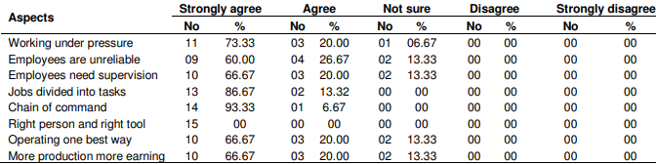
A study was conducted by Nawaz (2011), to show the relationship between the employer and the employees where the good relationship stands for 66.67% and 11.67% were not sure about their relationship. In managers view the employees are working hard under pressure that is strongly true at 73.33%. The managers realize that the employees need to be motivated for working well for the company and need more to be supervised that results in strongly agree of 66.67% and rest of the managers were not sure about this (Nawaz, 2011). The managers think to divide the jobs into the tasks where the managers agreed at 83.67%.
KPIS
According to the annual report of McDonald (2017), Key performance indicators of McDonald help in analysing the business trends and the reviews of management results based on the currency and the variety of performances of financial measures and non-financial measures. The market leads to high growth in 2017 which was accounted for 35% and the revenues by 24%.
FINANCIAL
The company’s financial performance proves that the velocity of growth plan is working by focusing on the pillars of the growth which company can achieve in 2017 with an increase in 5.3% of global sales and 1.9% of positive results. Similar sales in the United States increased by 3.6% and similar guest amounts increased by 1.0%. (McDonald, 2017)

NON-FINANCIAL
McDonald's is able to recognize, implement and measure concepts that meet customers' varying needs and preferences. The velocity plan for growth outlines the actions of the sustainable growth count and reliable for long terms measures which are important for the growth of the sales and the value of shareholders. In 2018, McDonald has raised customer preference and start an online business for the benefit of them and increasing the number of customers (McDonald, 2017).

DECISION-MAKING TECHNIQUE FOR EVALUATING A RANGE OF SOLUTIONS TO IDENTIFY THE MOST APPROPRIATE OPTION
DECISION-MAKING TECHNIQUE
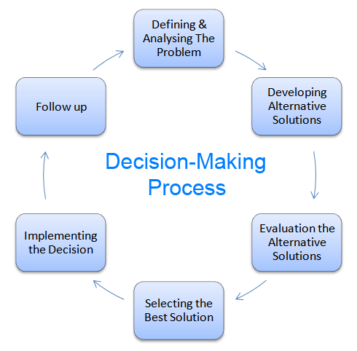
Figure 6: Decision-making process
(Source: Zavadskas, 2019)
- Identification of the problem
It includes what is the problem, why should solve the problem, effect of the problems. In this way, the problems get identified and analysed before decision-making (Zavadskas, 2019).
- Gathering information
McDonald has many stakeholders and divided work in between them and a dozen of problems can affect them. Information gathering is related to the factors and stakeholders who involved in the problem and the process uses the tool of check sheet (Zavadskas, 2019).
- Evaluation of alternative solutions
The solutions can be considered on the criteria of the organizational objectives along with the corporate culture (Zavadskas, 2019). The solutions are based on the decision-making process which results to gain profit for McDonald.
- Selecting the best solution
This is based on idea generation and before generating idea the company needs to identify the cause of the problem and give priority to the problem. Making many solutions and choosing the best solution by the managers to solve the problem effectively (Zavadskas, 2019).
- Implementation of decision
After deciding and planning the solution there is a need to judge the principles and criteria od decision making by evaluating the alternatives (Zavadskas, 2019).
- Evaluate the decision and results
This is the outcome of the implemented decision and shows the results of implementing the solution positive or negative for future decision making (Zavadskas, 2019).
THEORIES OF MOTIVATION
Herzberg two factor theory
According to this theory, Herzberg observed that employees not only want job satisfaction also on work motivation. He concluded that the employees need job satisfaction as well as motivation and he set two factors theories of motivation (Alshmemri, 2017).
- Hygiene factors: These are needed to be present in the environment of McDonald for removing the discomfort of the employees as well as the customers in support of mental and physical health (Alshmemri, 2017). The hygiene factors result in job dissatisfaction after providing instant pay, promotion, job security, quality of supervision etc.
- Motivation factors: These factors are directly related to the job and the rewards for performing well at the workplace. The managers need to motivate employees for their welfare and growth as well as for the benefit of McDonald. This belief that the employee’s motivation and job satisfaction and lead to perform well to improve the productivity of McDonald (Alshmemri, 2017).
Equity theory
According to Lazaroiu, (2015), this theory emphasis on the equal working pays to the employees which enhance their working conditions and job satisfaction to improve the performance of McDonald (Lazaroiu, 2015). This also helps in solving the issues of poor management which cause by the unhealthy relationship between employees and employer.
The analysis of the marketing mix of 4 P's
- Product: McDonald serves varieties of burgers, French fries, milkshakes etc.to bring the customers. There is no competition on the McDonald on serving the taste of the McDonald (Meyer, 2015). The problem of changing customer preferences results in shifting to healthy products affects the company and McDonald suffers from strong competition.
- Price: The objective of increasing price is to increase the market share, and this can be done by creating a marketing strategy. McDonald set a menu of affordable price which brings in customers constantly and this balance the income which helps in increasing market share in comparison of the competitors (Meyer, 2015).
- Place: It consists of a distribution channel place so that the products can reach to the customers at the right time, right quality and right place (Meyer, 2015). They manufacture products based on targeted segments. It designs the place for kids where they can play and serves better to them what they like to eat and drink which decreases the completion in the market.
- Promotion: McDonald uses many ways to promote their products in the world of marketing such as direct marketing, advertising, public relations and sales promotion. The company mainly use advertising for promotion by involving celebrities for parsing quality, affordability and value of the product (Meyer, 2015).

DEVELOPMENT OF A PLAN FOR IMPLEMENTATION OF THE SOLUTION
Following are the plan which is developed for implementing on the solution:
- The first step for implementing a plan is to make a strategy by identifying the reason for the problem facing by the McDonald (Duggal and Alexander, 2018)
- Every plan gets communicated with the members of the team before executing the plan. The plan to solve the problem by communicating with the customers and the employees about the issue to solve it
- The third step is to help to solve the dilemmas of every individual
- The fourth exercise is to breakdown the strategy along with 4 perspectives includes the financial, customer, internal process and learning growth perspective (Duggal and Alexander, 2018)
- The last exercise is to show others about the success of the implementation
System | Title
Project name | Development of a plan for implementation of the solution
Business unit | The plan is developed by McDonald
Sources of problem identification | Customers and employees’ feedbacks
Results | Positive after implementing the plan

The plan that is to get implemented on the problem must be shared with its stakeholders. The stakeholders of McDonald are the CEO, director, senior executives, different departments, employees etc. (Duggal and Alexander, 2018) The decision making of problem-solving should get communicated with the stakeholders before implementing. The plan is to solve the problem of poor management and the strong competition and the solution is to take the feedback from the customers about the problem to solve the competition and feedback from the employees and the managers for the reason of undesirable performance in the organization (Duggal and Alexander, 2018).

CONCLUSION AND RECOMMENDATIONS
This report concluded that McDonald was facing the problems and the plans are maintained to solve the problem of poor management and competition prevailing in the market. The report has laid down the problems and the solutions also shared with its stakeholders before implementation of the plan. This report stated that the problem was critical and much needed to solve as it was impacting on the brand image of McDonald and the company was losing their customer's cause of the increase in competition.
This report has recommended that the company should focus on the customers as well as its employees because the employees are the stakeholders and the workers who work for the customers. The managers should provide training to the employees for performing well for the benefit of the organization as well as for their growth. This report has carried the models and techniques for solving the problems.

REFERENCES
Alshmemri, M., Shahwan-Akl, L. and Maude, P., 2017. Herzberg’s two-factor theory. Life Science Journal, 14(5), pp.12-16.
Brodbeck, F.C. and Guillaume, Y.R., 2015. Effective decision making and problem-solving in projects. In Applied Psychology for Project Managers (pp. 37-52). Springer, Berlin, Heidelberg.
Coccia, M., 2018. The Fishbone diagram to identify, systematize and analyze the sources of general-purpose Technologies. Journal of Social and Administrative Sciences, 4(4), pp.291-303.
Dey, K., 2016. The fast food industry in the UK. Analysis of McDonald's with PESTEL, VRIN and Porter's Five Forces. GRIN Verlag.
Duggal, R. and Alexander, P., 2018. Staff management training in McDonald's.
https://corporate.mcdonalds.com/content/dam/gwscorp/investor-relations-content/annual-reports/McDonald%27s%202017%20Annual%20Report.pdf
Katzenbach, J.R. and Smith, D.K., 2015. The wisdom of teams: Creating the high-performance organization. Harvard Business Review Press.
Lazaroiu, G., 2015. Employee motivation and job performance. Linguistic and Philosophical Investigations, 14, p.97.
McDonald, J.F., 2015. Chicago: An economic history. Routledge.
Meyer, P., 2015. McDonald’s Marketing Mix: 4Ps Analysis. Panmora Institute.
Mumford, M.D., Steele, L., McIntosh, T. and Mulhearn, T., 2015. Forecasting and leader performance: Objective cognition in a socio-organizational context. The Leadership Quarterly, 26(3), pp.359-369.
Nawaz, A.S., 2011. Employee motivation: A study on some selected McDonalds in the UK. African Journal of Business Management, 5(14), pp.5541-5550.
Rawlinson, J.G., 2017. Creative thinking and brainstorming. Routledge.
Reder, M.D., Gonzalez, E. and Melero, J.J., 2016, September. Wind turbine failures-tackling current problems in failure data analysis. In Journal of Physics: Conference Series (Vol. 753, No. 7, p. 072027). IOP Publishing.
Schlegelmilch, B.B., 2016. Segmenting Targeting and Positioning in Global Markets. In Global Marketing Strategy (pp. 63-82). Springer, Cham.
Warrick, D.D., 2017. What leaders need to know about organizational culture. Business Horizons, 60(3), pp.395-404.
Warrick, D.D., 2017. What leaders need to know about organizational culture. Business Horizons, 60(3), pp.395-404.
Wu, Y., Zhang, K. and Padmanabhan, V., 2018. Matchmaker competition and technology provision. Journal of Marketing Research, 55(3), pp.396-413.
Zavadskas, E.K., Antucheviciene, J. and Chatterjee, P., 2019. Multiple-Criteria Decision-Making (MCDM) Techniques for Business Processes Information Management. Multiple-Criteria Decision-Making (MCDM) Techniques for Business Processes Information Management, p.1.

