

University of Wales Trinity Saint David
School of Engineering
BEng Manufacturing systems

DARRYL EVANS
1904051

Manufacturing Systems and Quality
M5X01177

01/10/2020

Abstract
This assignment is a work-based project that has enabled me to put into practice the tools and techniques that I have learnt during the quality systems module at university.
The management team at work allowed me to set aside some time every week which was dedicated to completing a DMAIC project which would help me complete my module and be a vested interest for the company in an ever-important continuous improvement business culture.
There is a continuous improvement department in work which has a black belt six sigma leader who overseas any Lean and Six sigma project and who will also be my mentor for the following project at work.

Contents

Introduction 1
Define phase 5
Measure Phase 10
Conclusion 17
Work Cited 19

Table of Figures

Fig 1 Spectrum 2 Instrument Page 1
Fig 2 Spectrum 2 Main base Page 2
Fig 3 Spectrum 2 Top cover Page 2
Fig 4 5S Survey Page 3
Fig 5 DMAIC Acronym Page 4
Fig 6 Project charter Page 6
Fig 7 SIPOC Page 8
Fig 8 Project team Page 8
Fig 9 Action register Page 9
Fig 10 Monthly review Page 9
Fig 11 Trolleys in current use Page 10
Fig 12 Timings and spaghetti diagrams Page 10
Fig 13 Voice of operator Page 11
Fig 14 L1605266 scrap Page 12
Fig 15 L1605208 scrap Page 12
Fig 16 L1605208 returns Page 13
Fig 17 L1605266 returns Page 13
Fig 18 Risk assessment Page 14
Fig 19 Presentation to Newcom Page 14
Fig 20 Cause and effect diagram Page 15
Fig 21 5 Whys Page 16
Fig 22 Timeline Page 16
Fig 23 Supermarket trolley Page 17
Fig 24 Rough concept Page 18
Fig 25 Monthly review Page 18

Introduction

I am an employee at PerkinElmer in the Llantrisant manufacturing site. PerkinElmer is an American owned worldwide corporation with 13,000 employees.
PerkinElmer is a healthcare supplier and critical manufacturer for many industries including the healthcare, pharmaceutical, environment and agricultural.
Our products are important for our customers as they are used by scientists and researchers in drug discovery and applications, which is critical now with Covid-19.
One of the analytical instruments manufactured in Llantrisant is a Spectrum 2 Near infrared (NIR) spectrometer. The Spectrum 2 falls into the IR department of the company. It is classed as high-volume instrument and has a production cell of 12 dedicated technicians. The production line manufactures all the sub-assemblies in-house before the instrument finally has the cases put on them for final test and shipping.
The current Sales Inventory Operations Planning (SIOP) demand is to manufacture 49 of the spectrum 2 instruments per week which get installed at the customers site by the service department.
One of the capabilities of the spectrum 2 is to analyse alcohol content in liquids and this has seen an increase in demand during the Covid-19 pandemic as there are many companies producing their own sanitiser which needs to have the exact amount of alcohol before it can be legally sold.

Fig. 1 Spectrum 2 Instrument

As a company we are trying to stop using cardboard for storage and where possible stop having any cardboard on the production workshop. This will help the environmental waste. The high-volume production cell of the Spectrum 2 has lots of parts in the bill of materials and many are still delivered to the site in cardboard. The smaller parts aren’t a concern as they can easily be decanted lineside and stored in the relevant bins. There are two parts for the spectrum 2 which are the main base and the top cover that are too large to be kept lineside and are stored in cardboard boxes with a Kanban system until they are required.
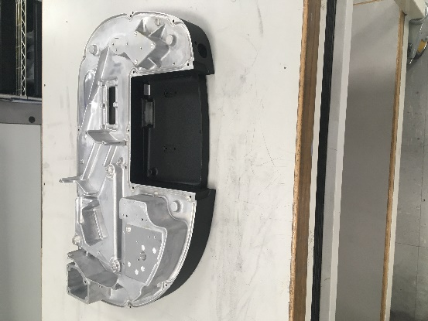

Fig. 2 Spectrum 2 main base

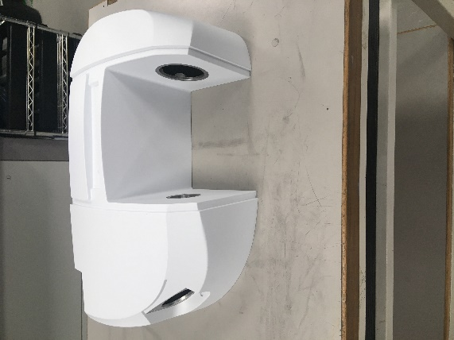

Fig. 3 Spectrum 2 top cover

The area that the boxes for the covers and bases are stored have been brought to the attention to team leaders through 5S surveys. As the following survey shows the boxes are stored in an unsightly way, the boxes are damaged which are exposing the internal packaging which will ultimately wear and not protect the parts. Some of the boxes are taped together and are torn which could lead to an accident. The boxes are stored above height level and are not secure in any way so this a health and safety concern.

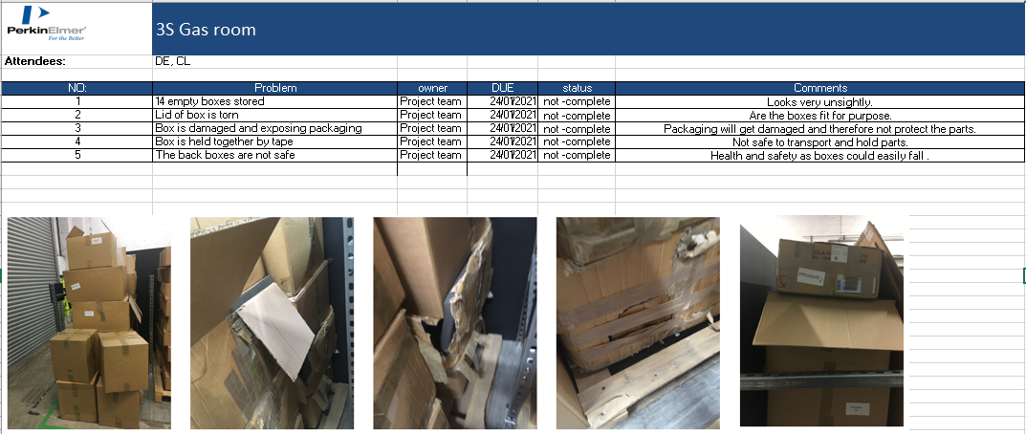
Fig. 4 5s survey

Six sigma has a system called 5S which organises work areas. It will enable operators to do their processes effectively and safely. The system focuses on quality and productivity being too high standards.
(McFadden, 2020)

The leadership team had decided that the spectrum 2 parts were a concern and asked me and a fellow colleague if we would like to lead a six-sigma project looking at this problem. We both work as technicians in different departments and do not normally get the opportunity to broaden our skills and work with different departments so it would be a challenging project. When it was agreed we had a briefing with the project sponsor and the project mentor who quickly discussed what the DMAIC project involved.
The senior management involvement in six sigma is essential for activities to be successful. The black belts from the management team mentor the project leaders.
(Truscott , 2002)

A DMAIC is a five-letter acronym that stands for Define, Measure, Analyse, Improve and Control. DMAIC are carried out to improve processes and to reduce variables and inefficiencies. The process is driven through quantifiable data sets.
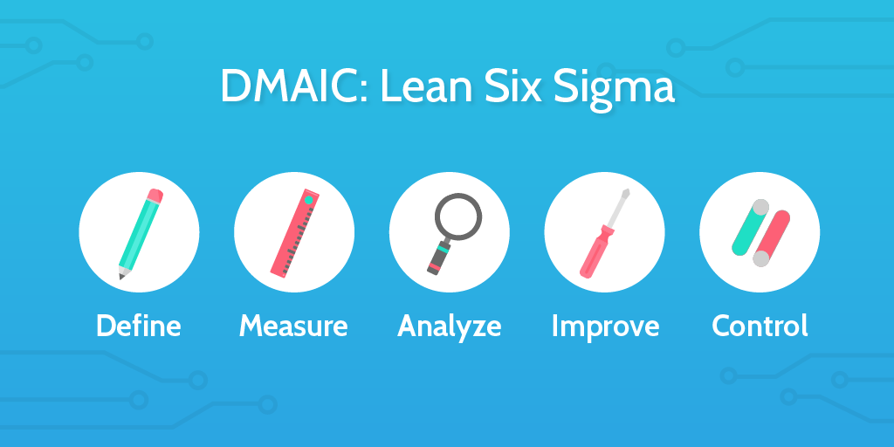

Fig. 5 DMAIC acronym
(Henshall, 2017)
Continuous improvement is essential for businesses today to compete with competitors and survive with the times. The overall performance of any six sigma activities need the people involved to be engaged.
(Truscott , 2002)

Define phase
Define is the first phase of the six sigma. It is here that project gets fully defined. The deliverables of the define phase include the Business scenario and project charter. The project charter encompasses the problem statement, goal statement and the objectives.
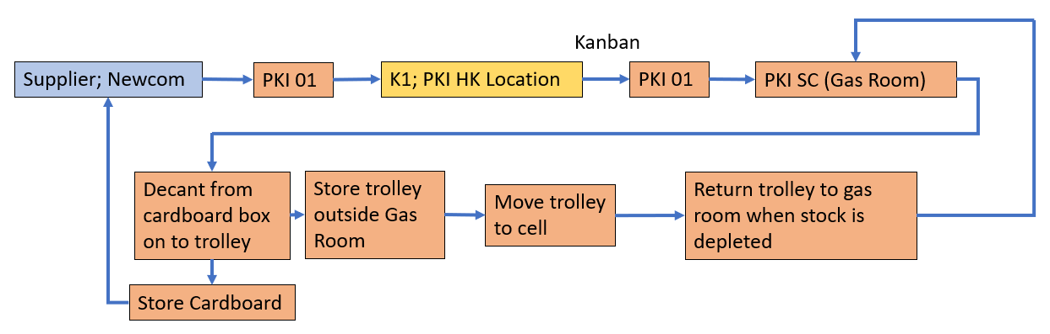
(Sarkar, 2004)

The first task was to truly understand how the current process operates. We walked through the process with the logistics team leader who was involved in all aspects and very eager for a change. The parts are supplied and delivered by a company called Newcom to PerkinElmer. They are then picked up and moved straight to K1 which is a dedicated external storage facility. The parts are called back from K1 to PerkinElmer on Kanban system This would be dependent on the daily output targets. The parts are taken to SC which is the storage location (also known as the gas room) it is here that the parts are decanted from cardboard boxes and placed onto trolleys. The trolleys are stored outside the gas room and are moved into the Spectrum 2 production cell when the technician requires them for the build stage. When the trolley is depleted it gets moved back to the gas room for the next set of parts. After the parts have been decanted onto the trolleys the empty cardboard boxes get stored in the gas room and get returned to Newcom to be used again.
The parts that we are looking at have the following parts numbers and descriptions
L1605208 MAIN COVER L1605266 OPTICAL CHASSIS
After the initial discussions a project charter was written up with our mentor who is Dr Tatnell and a black belt. The charter was sent to the project sponsor for the approval to start. The project was given a name in this case it was called Supply of materials from vendor to the line. The business case was a new process as it hadn’t been attempted before. The business scenario had to be established as the project had to beneficial for the company and any downtime wouldn’t be under scrutiny by the leadership team if the project wasn’t useful.
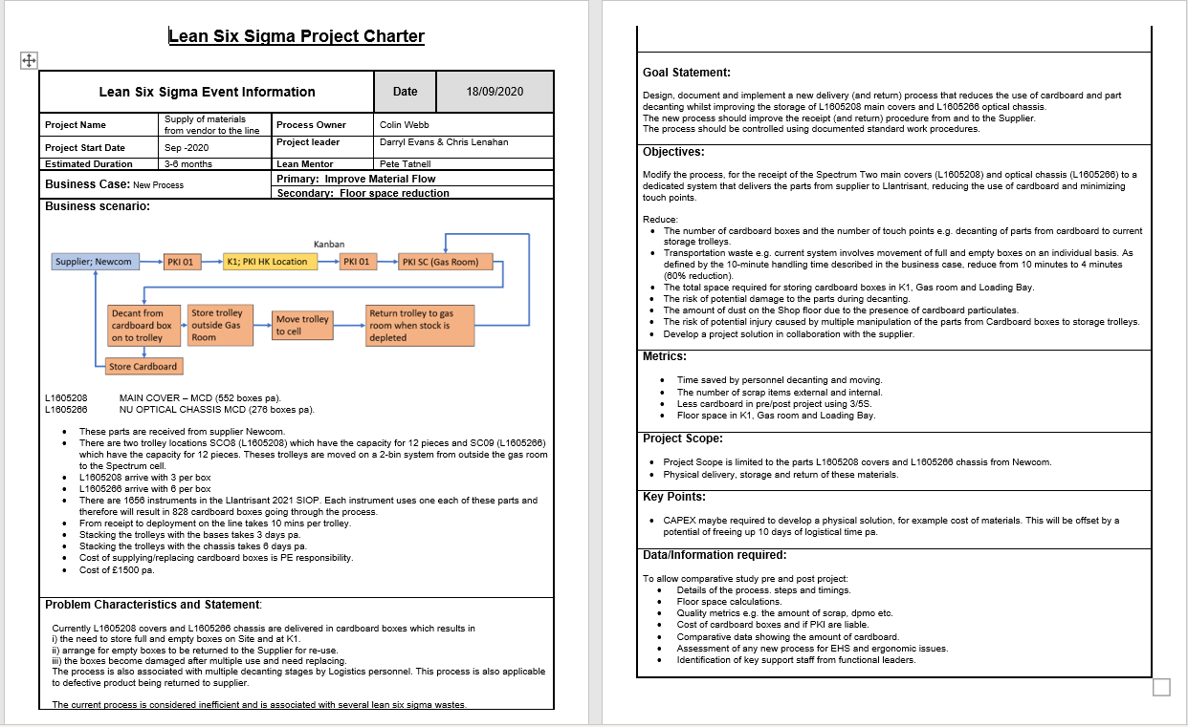
Fig. 6 Project charter.

After carrying out a gemba walk through the process and talking to the relevant personnel who work in various departments, we were able to understand where improvements could be made and find out what steps hadn’t been considered or were overlooked.

The Business scenario.
There are two trolley locations SCO8 which store part (L1605208) and have the capacity for 12 pieces and SC09 which store (L1605266) and has the capacity for 12 pieces. Theses trolleys are moved on a 2-bin system from outside the gas room to the Spectrum 2 cell either by the technician who will use them or by the stores personnel who is feeding the line with parts.
The main cover (L1605208) gets delivered with three in each cardboard box and the chassis gets delivered with six in each cardboard box.
After looking at 2021 SIOP it shows there are 1656 spectrum 2 instruments that need to be manufactured in Llantrisant. Each instrument uses one each of these parts and therefore will result in 828 cardboard boxes going through the process. Some rough estimates of the timings were generated from the boxes being delivered to the warehouse and booked into deployment on the line takes roughly 10 mins per trolley.
It was also realised that stacking the trolleys for the logistics department was quite a long-winded process. Stacking the trolleys with the bases takes three days per annum and stacking the trolleys with the chassis takes six days per annuum. So, nine days a year was lost through stacking the trolleys. The supplying of the cardboard boxes was the responsibility of PerkinElmer and the cost of the boxes was £1500 per annuum.

The Problem Characteristics.
There L1605208 covers and L1605266 chassis are delivered in cardboard boxes which results in
i) the need to store full
and empty boxes on Site and at K1.
ii) arrange for empty boxes to be returned to the Supplier for re-use.
iii) the boxes become damaged after multiple use and need replacing.
The process is also associated with multiple decanting stages by Logistics personnel. This process is also applicable to defective product being returned to supplier. The current process is considered inefficient and is associated with several lean six sigma wastes.

The Goal Statement.
The goals are set out so that everyone knows what the project consists off to keep the project on track and stop any deviation and input that is not relevant. The project is to design, document and implement a new delivery (and return) process that reduces the use of cardboard and part decanting whilst improving the storage of L1605208 main covers and L1605266 optical chassis. The new process should improve the receipt (and return) procedure from and to the supplier. The process should be controlled using documented standard work procedures.

The Project Scope.
The project scope is limited to the parts L1605208 covers and L1605266 chassis from Newcom and the physical delivery, storage and return of these materials.

The Objectives.
The objectives of the project are to modify the process, for the receipt of the Spectrum Two main covers (L1605208) and optical chassis (L1605266) to a dedicated system that delivers the parts from supplier to Llantrisant, reducing the use of cardboard and minimizing touch points.

The number of cardboard boxes that get delivered to PerkinElmer containing the spectrum 2 covers and chassis should be reduced if possible, eliminated as there is transportation waste with the current system involving movement of full and empty boxes.
There is a lot of space required for the storage of the boxes as they are reused so they get stored in K1 warehouse the gas room and the loading bay. There are also non-value added steps and motion waste in the process with a number of touch points to decant the parts, the amount of handling of [parts could be a risk to damaging the parts and also could be a potential injury through the multiple manipulation of the parts from cardboard to the trolleys. There should be a less dust on the shop floor with the amount of cardboard this will also have less electrostatic discharge with cardboard boxes being opened on the shop floor.
There will be several metrics that will need to be looked at for the project these need to be mentioned so they are available for viewing throughout the project and can be used to compare pre and post DMAIC. The timings of the logistical personnel involved in the decanting and moving of the parts will need to be measured. The historical data of the parts that have been scrapped and returned will need to be traced of the system. A 5S survey of the amount of cardboard can be used for the pre and post project for reference. The floor space that has been taken up by the boxes In K1, Gas room and the loading bay need to be measured.

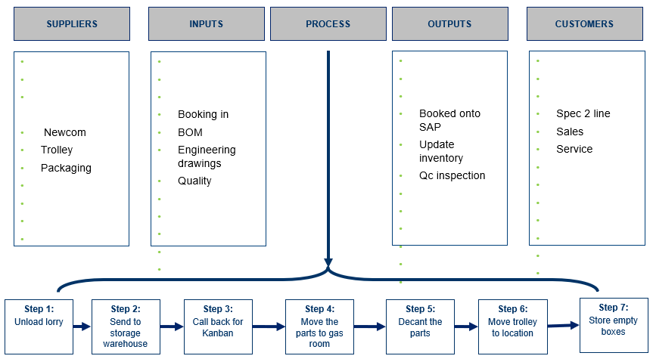
Fig. 7 SIPOC
The SIPOC has been drawn up with the process.
The critical to quality (CTQ) were then derived from the project charter. They were to reduce the amount of cardboard associated with the process and to reduce the floor space used to store the parts. The customer that will be using the parts will be internal as the parts are passed onto the spectrum line and to the sales and service departments.
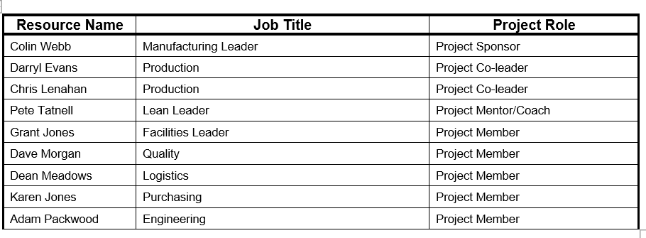
Fig. 8 Project team
As the project would encompass input and support from various departments. The leadership team were asked which personnel they would have readily available for support. The team was then established, and introductions and briefing were started. Management get their employees involved as they become committed and help with project and decisions.
(Rayner & Adam-Smith, 2005)
Now the project charter had been approved by the project sponsor, the project had the go ahead to continue. An action registered was developed with a simple visual management of the status complete for the team to see.
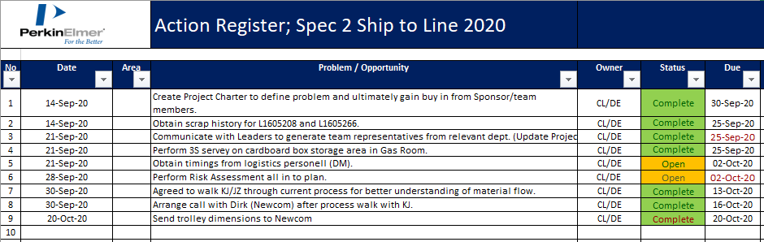
Fig. 9 Action register
The project sponsor asked for a monthly update of the project, so the company standard template was used. The monthly updates were vital so that any costs that will be needed could be raised through a company Capex and the project sponsor was aware. The costs would be offset by the logistics personnel who would have potentially days freed up through a new process. Health and safety considerations needed to be raised in the updates as the new process could have ergonomic issues and possible environment health and safety standards would need to be checked.
The Project Sponsor has the responsibility for keeping the project focussed and making sure the goals are achieved. The required resources and financial constraints are arranged with the project sponsor’s agreement with senior management.
(Young, 2016)
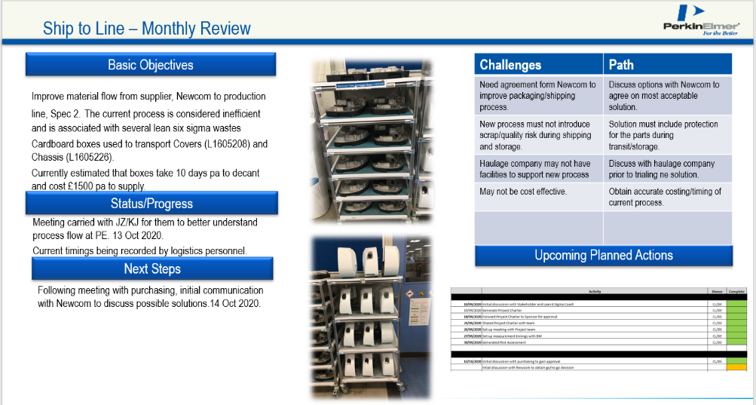

Fig. 10 Monthly review

Measure Phase

In the second stage of Measure phase of the project data needs to be gathered. The process needed to be fully understood along with the extent of the problem. It is during the measure phase that brainstorming techniques are carried out.
(Sarkar, 2004)
The trolleys that the parts were decanted onto were custom made from flow tube.
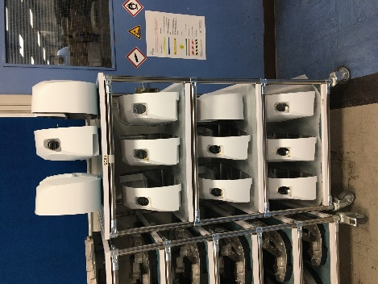
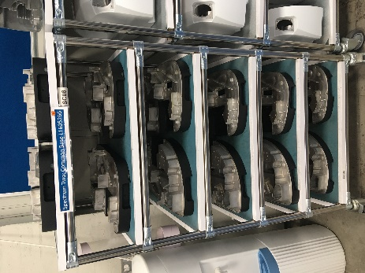

Fig. 11 Trolleys in current use
These trolleys are then stored in the dedicated locations and will be moved using a 2-trolley system into the spectrum two cell when needed and the empty trolleys will be left ready to be populated.
 | Time
1st | 21.58
2nd | 20.04
3rd | 23.01
4th | 20.10
5th | 20.47
6th | 26.34
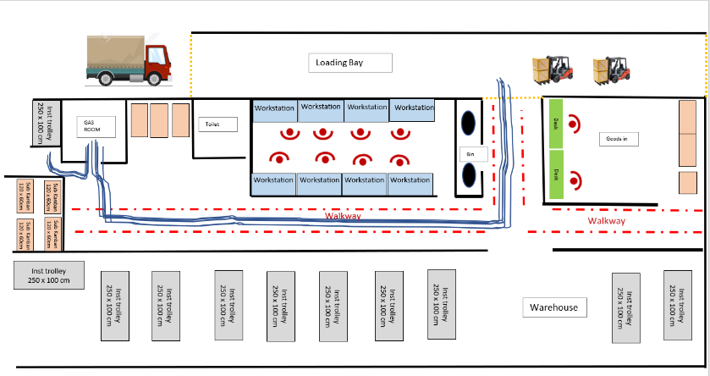
Fig. 12 Timings and spaghetti diagrams

The logistic personnel carried out the process and was timed from the same start position each time. The same stopwatch was used, and the time of day was also consistent to keep the warehouse and the corridors being busy to avoid stopping for people to pass. The quickest time of 20.04 minutes was the time that was used to work out how long the decanting process would take over the year.
The time to decant L1605266 onto the trolleys was calculated. There are 6 parts delivered in a box and 12 parts are needed to fill a trolley
1656 ÷ 6 = 276 boxes
276 ÷ 2 = 138 per trolley
138 x 20 = 2760 mins
2760 ÷ 60 = 46 hours
46 ÷ 7.5 = 6 days
The time to decant L1605208 was calculated. There are 3 parts delivered in a box and again 12 parts are needed to fill a trolley.

1656 ÷ 3 = 552 boxes
552 ÷ 4 = 138 trolleys
138 x 20 = 2760 mins
2760 ÷ 60 = 46 hours
46 ÷ 7.5 = 6 days
The time taken to decant and populate the trolleys with the chassis and covers takes 12 days per annuum.
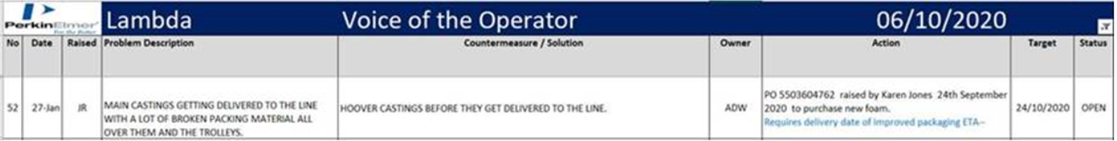

Fig. 13 Voice of operator

There has also been a voice of the operator complaint which hadn’t been closed. This was from the technician who had to hoover all the dust from the castings before use. The time hasn’t been captured for this, but it is a step that is nonvalue added and could be eliminated with the new process.
The quality department looked at any historical defects for the chassis and lids which have been damaged in the process. Some of them have had to be scraped while others have been sent back to the supplier for rework. The scrap and rework have been captured on PerkinElmer SAP program.
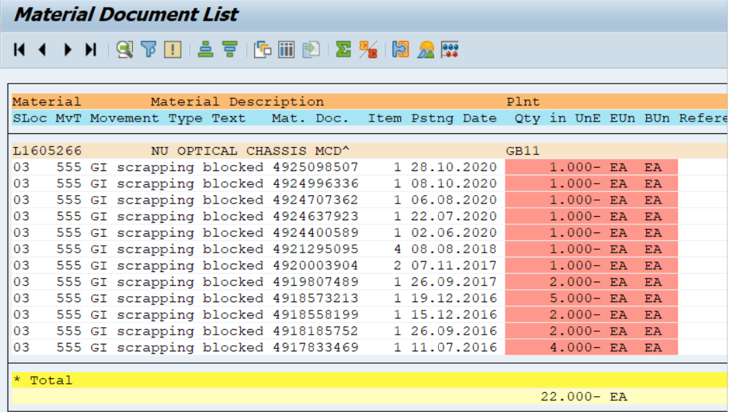

Fig. 14 L1605266 scrap
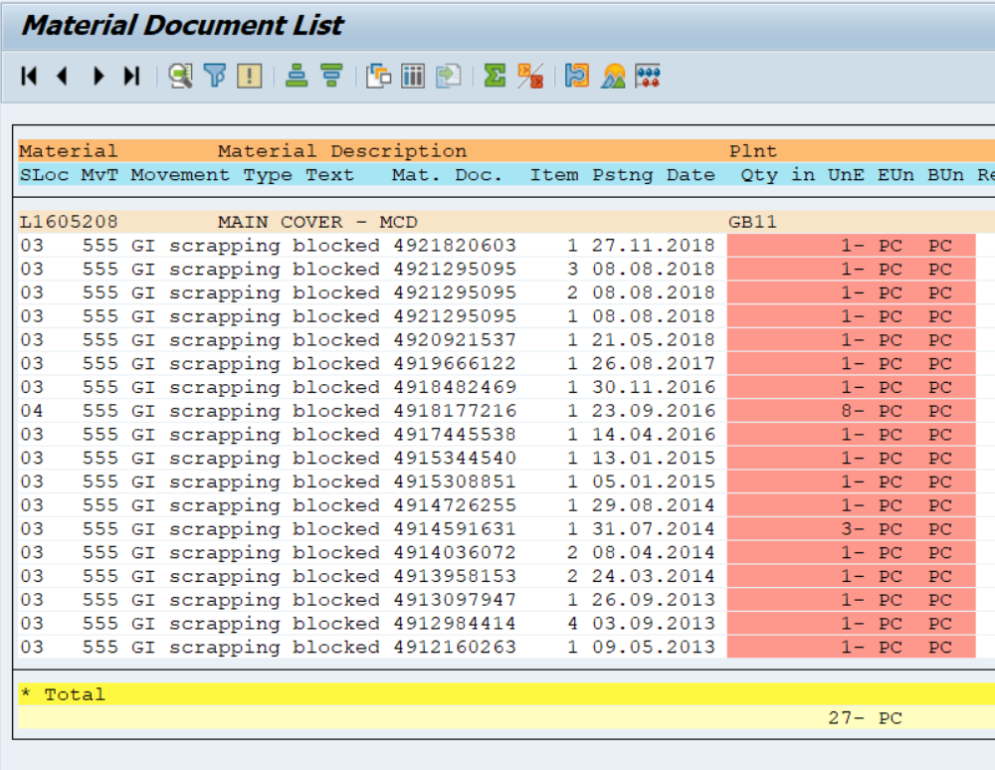
There have been 22 L1605266 scraped off in the last 4 years.

Fig. 15 L1605208 SCRAP
There have been 27 L1605208 scraped of in the last 7 years.
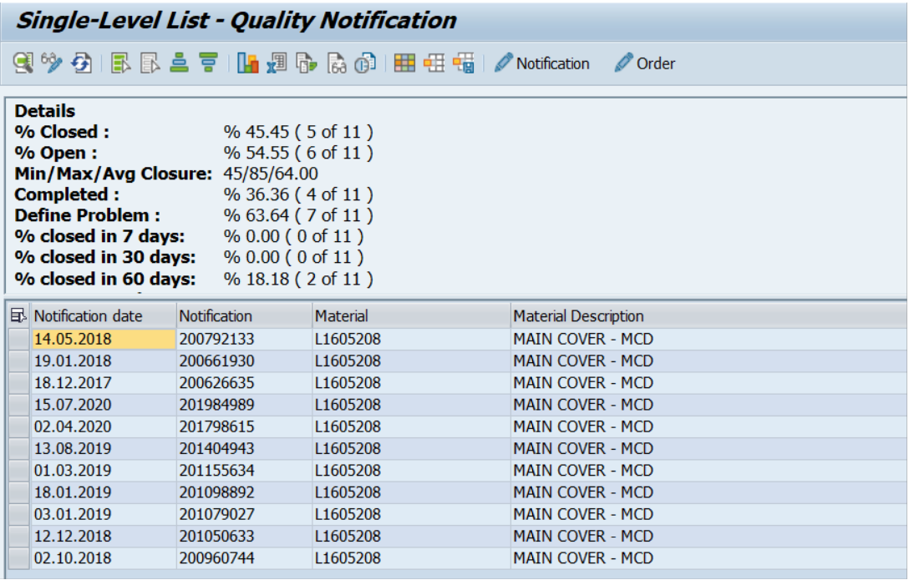

Fig. 16 L1605208 returns

In the last 3 years 11 L1605208 have had to be returned to supplier.

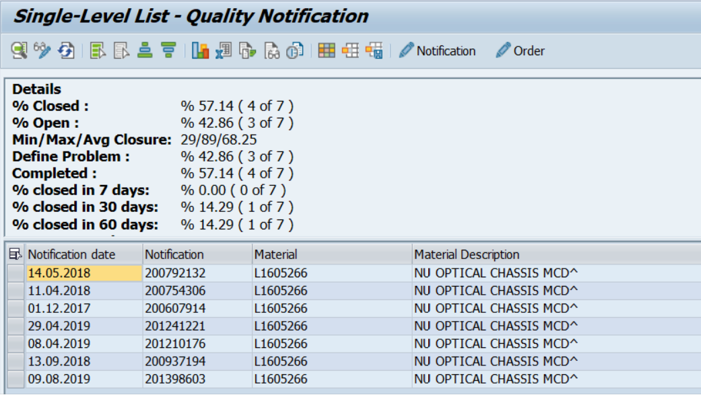
Fig. 17 L1605266 scrap

In the last 3 years 7 L1605266 have been returned to the supplier.
A DMAIC is a structured approach that uses collected data to reduce waste and to get the maximum profits.
(Gygi, 2006)

A risk register was set up and is kept as a live document to raise any concerns about the project and the product concerns.

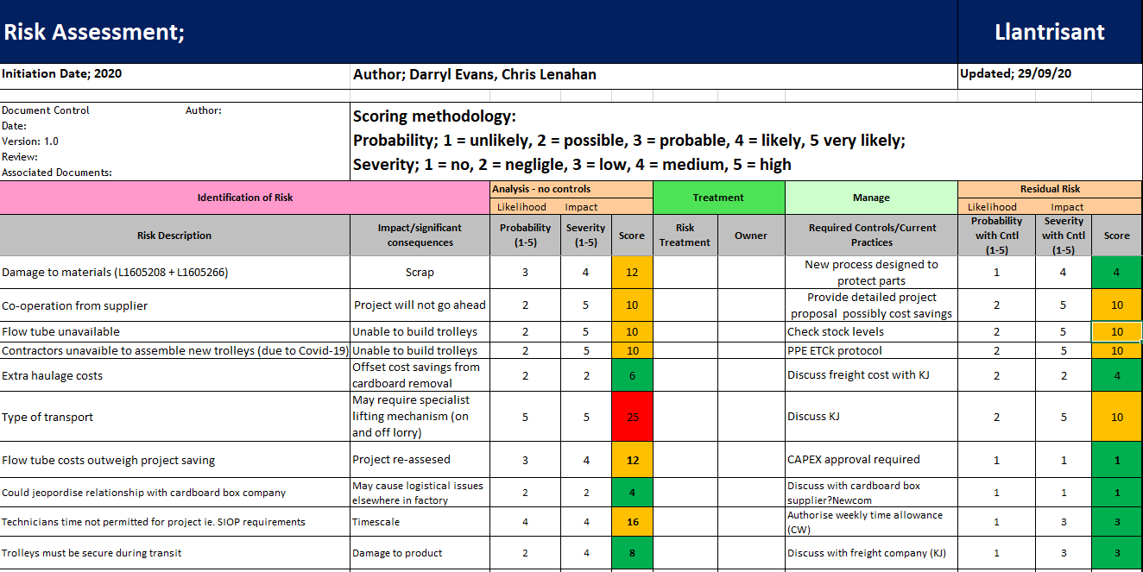
Fig. 18 Risk assessment

The main risk of the project not being achievable was if the suppliers weren’t happy for the process to change or if the ideas just wouldn’t be viable for their company.
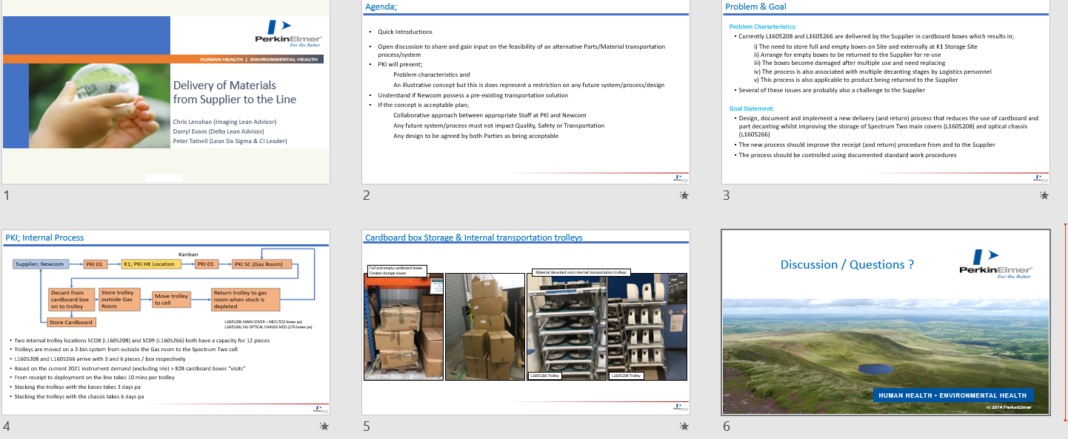
Fig. 19 Presentation to Newcom

A meeting was set up with introductions and for a presentation about the current process. The team had a brainstorming session and invited the key personnel from the suppliers to join us on Microsoft Teams as their input was just as valuable and they would need to be on board with any decisions and changes.
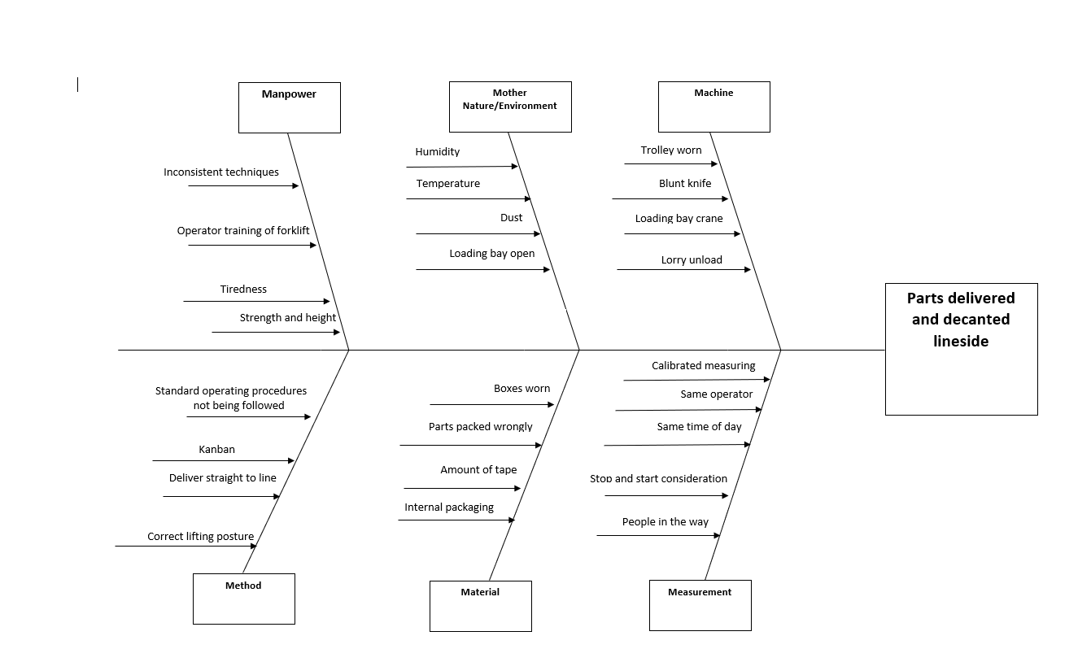
Fig. 20 Cause and effect diagram

A cause and effect diagram was the easiest way to carry out the discussions as it was informal, and the subcategories had already been decided. There were some very good points raised through the brainstorming that had been overlooked previously. The parts are sent to the sprayer in the cardboard boxes before they get delivered to PerkinElmer. The way the boxes are packed on a pallet fit into the suppliers’ own van as they don’t use a generic courier.

Meetings were regularly set up from both parties with many questions and answers resolved. The meetings along with a timeline kept the momentum of the project moving and to communicate any deadline. It was important to take minutes from the meetings as these could be looked at by the non-attendees to see the progress and see what was decided as traceability.
(Gutmann, 2016)

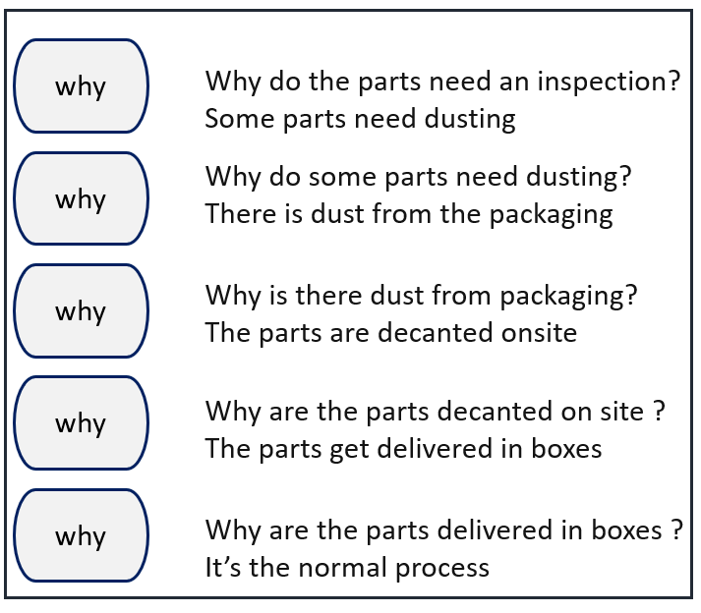

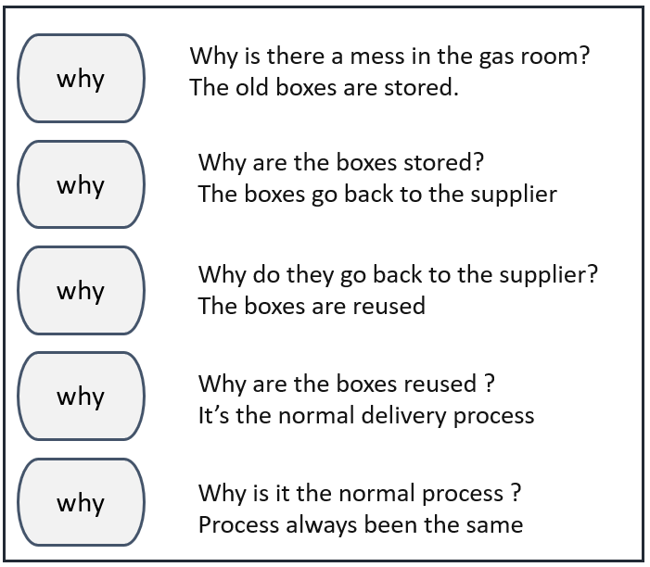
Fig. 21 Whys
After the brainstorming the team were able to use the 5 whys to understand the root cause of the problem. It was clear that the problem was the process has always been used and no one had ever looked at the problems or felt the need to try and improve anything.
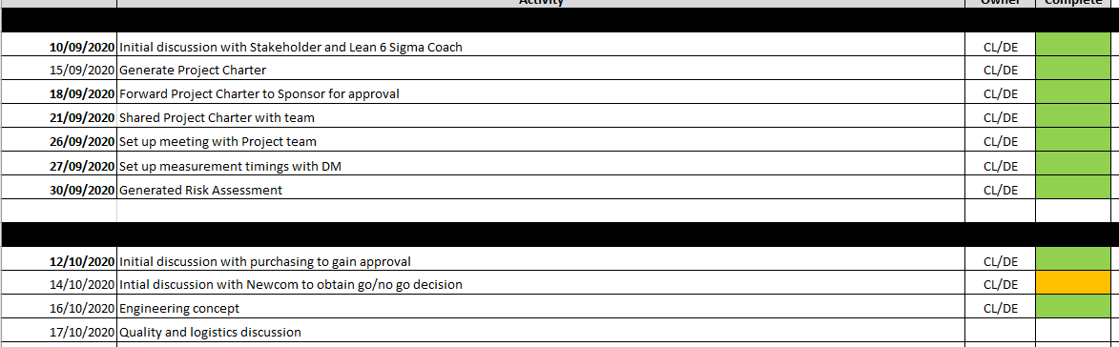
Fig. 22 Timeline

Conclusion

The project was at risk if Newcom was not prepared to change the current process. If they had said no or just dismissed any change then ultimately the project would have been viable. After initial discussions with Newcom, their manufacture manager was keen to listen to any ideas. The new process had to be sold in such a way that in would benefit themselves and there wouldn’t be any cost incurred. As we did in PerkinElmer asking the personnel who carried out the process of moving and decanting the parts, we were introduced to the appropriate personnel at Newcom. The warehouse manager and the tool maker were at the fore front of the day to day activities. It soon became apparent that after brainstorming sessions there were aspects of the process that hadn’t been considered and there were steps that could be improved or omitted. Both parties are now looking at the idea of using the system that supermarkets use for their milk and bread deliveries. All decanting and filling shelves as well as stock rotation has been removed from their shelf replenishment staff by using trolleys. The trolley arrives from the supplier all loaded with milk and will go straight to the supermarket floor. This works in a 2-trolley system with the empty trolleys being sent back to the supplier to load.
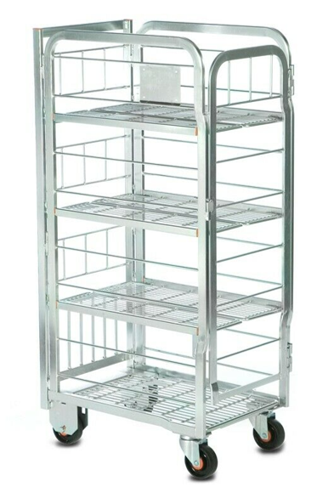
Fig. 23 Supermarket trolley

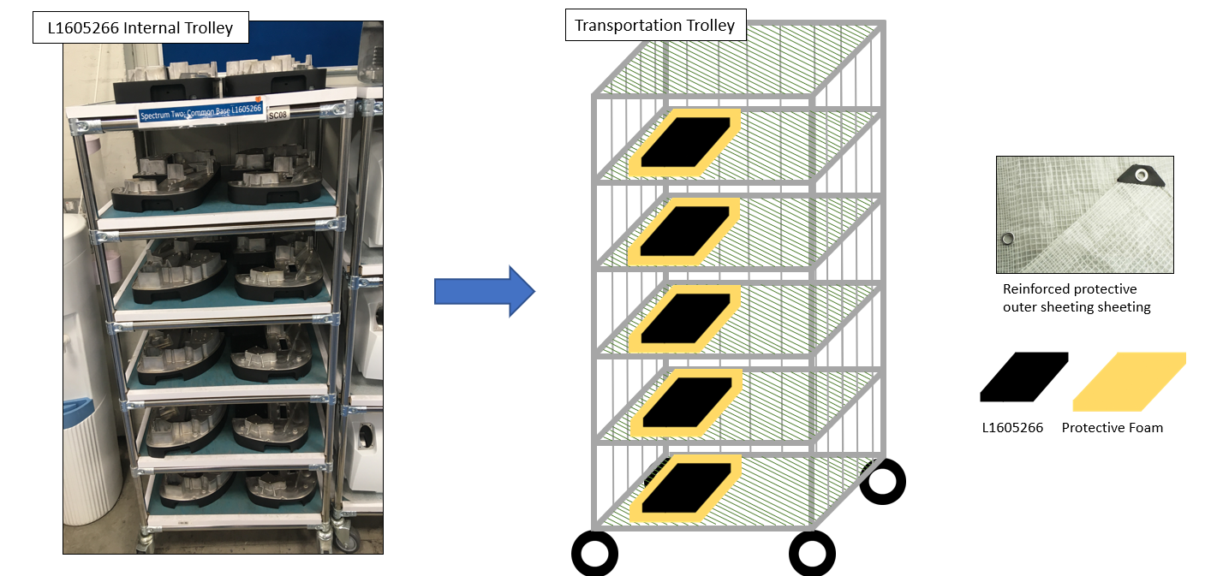
Fig. 24 Rough concept
Rough concepts were drawn up just for discussions so all parties could visualise the parts on the potential new design. The measurement of the lids and trolleys was looked at next to make sure that space is left between shelves for decanting. Newcom have agreed to trail a prototype trolley to see how it fits in the process as there is a concern about the transporting and how the trolley will fit into transit. The prototype trolley is being designed out of flow tube and should be ready for trail at the start of December 2020.
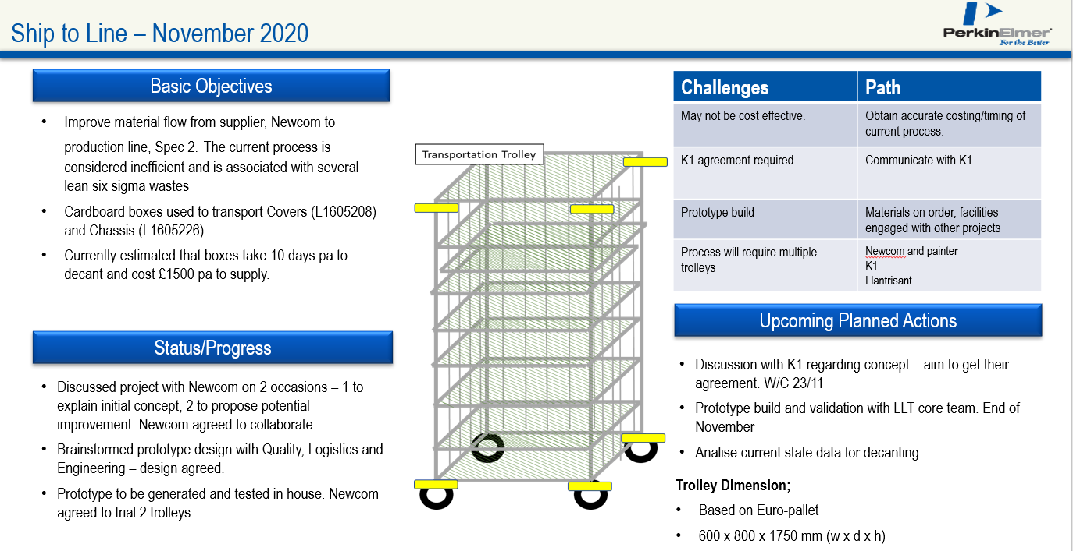
Fig. 25 Monthly review

The project will now proceed to the Analyse phase.

Work Cited

Gutmann, J., 2016. Taking minutes of meetings. 4th ed. London: Kogan Page.
Gygi, C., 2006. Six Sigma Workbook For Dummies. 2nd ed. Hoboken: John Wiley & Sons Inc.
Henshall, A., 2017. DMAIC: The Complete Guide to Lean Six Sigma in 5 Key Steps. [Online]
Available at: https://www.process.st/dmaic/
[Accessed 10 2020].
McFadden, B., 2020. Graphic product. [Online]
Available at: https://www.graphicproducts.com/articles/what-is-5s/
[Accessed 02 March 2020].
Rayner, C. & Adam-Smith, D., 2005. Managing and Leading people. London: Chartered Institute of Personnel Development.
Sarkar, D., 2004. Lessons in Six Sigma : 72 Must-Know Truths for Managers. Thousands oaks: SAGE Publications Inc.
Truscott , W., 2002. Six sigma: Continual Improvement for Businesses. Abington: Routledge.
Young, T. L., 2016. Successful Project Management. 5th ed. London: Kogan Page.

