Leadership and Decision—Making in Complex Environments


Blog 1: Leadership dilemmas interview
I interviewed Alex, one of our classmates. He has been working for 15 years and has more than 10 years of experience leading teams. So, I think he has a lot of leadership experience. I interviewed him for a total of 5 questions, which were sent to Alex in advance. The recording part is his answer.

Question 1: what do you think is leadership?
A: I think in the business world, it's more about results. Results-oriented is leadership.

Question2: what do you think are the leadership dilemmas?
A: I think there are internal conflicts within the team, such as conflicts in various aspects (between the lower level, between the lower level and the middle level, between partners). External pressures such as political factors (China-US trade war, Huawei), COVID-19 and other non-human influences.

Question 3. What is the most difficult part of your leadership team?
A: I think it is the handling of the relationship between employees because they are the people who directly affect the interests of the company.

In the management team, I divide it into external and internal. Externally, everything is based on the interests of customers. Internally: employees should not have open conflicts -- because open conflicts between employees will damage the interests of the company.

Case: Employees A and B have been feuding for various reasons. Once A accidentally spilled milk on B's laptop, and the computer shut down. B asked A to compensate 6000 yuan, but A thought it was not so expensive. In order to calm the situation, I took out 6000 yuan to compensate B in the name of A and told A that the money was paid by A himself. Some may feel that it is in my own interest to do so, but it is only a small part of the overall good. If the two lost tens of thousands of businesses because of the 6,000 yuan, that would be the biggest loss.

Question 4. How to manage employees effectively?
A: The standards are different for different sizes and industries. For example, there are some results to see (KPIs). I think the ultimate goal of employee management is employee self-management. Let employees themselves have better growth and development. This is the most effective management. Among them, I think service leadership can better manage employees. Because they will provide more demand for employees. For example, Tencent in China encourages employees to start their own businesses and provides various platforms for employees to better develop themselves. In this way, employees' enthusiasm in work can be improved and the company can be better served. Finally, the effectiveness of managing people needs to be measured by both the process and the results.

Question 5. What do you think is leadership？
A: I think the first one is charisma. It's how many people you can get to do what you want to do. There is an old saying in China: "Take the lead", which means that a leader should have the role of leading, and his own action force can better make his employees follow him. The second is confidence and infectivity. Leaders need to be full of confidence, only full of confidence can let the team have confidence to complete a thing. Inspiration is the ability to let employees be influenced by their leaders. Finally, influence, such as Jack Ma. When a leader has a certain influence, employees will naturally follow him
Blog 2:

How to manage people?

Introduction
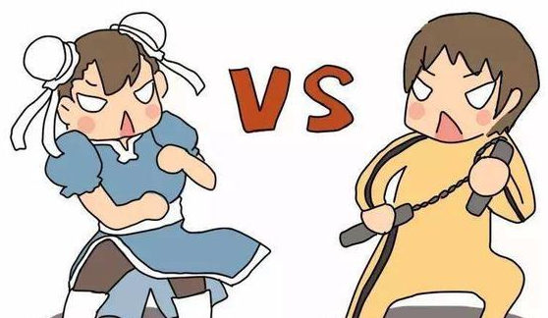
Recently, there has been some friction between me and my colleague. The other side thinks I work not seriously, I think the other side's work requirement is too harsh, did not start from the actual situation. As a result, the two of us argued for a long time about the content of our work. Finally, when neither of us reached a compromise, we reported the situation to our leader.

Our leader has a lot of experience in managing a team and he knows exactly what kind of problems everyone has. So he took a different approach to managing us. For me, he would first calm me down, then tell me what problems the other side might have and ask me to actively cooperate if reasonably requested. Finally, my leader provided us with an effective solution.


Due to the occurrence of this incident, I deeply feel that managing employees is a very difficult thing. Because everyone thinks they are right, as an old Chinese saying goes, " all people have their own way of saying things". How to balance the ideas of both sides, keep personal opinions without affecting the work, and finally complete the task together. This is a leader's problem.

In the interview, Alex also said that how to balance the relationship between employees is a matter that directly affects the interests of the company. In dealing with problems among employees, he gave an example: “Employees A and B have been feuding for various reasons. Once A accidentally spilled milk on B's laptop, and the computer shut down. B asked A to compensate 600 pounds, but A thought it was not so expensive. In order to calm the situation, I took out 600 pounds to compensate B in the name of A and told A that the money was paid by A self. Some may feel that it is in my own interest to do so, but it is only a small part of the overall good. If the two lost tens of thousands of businesses because of the 600 pounds, that would be the biggest loss.”

The above two examples are good proof that the effective management of employees to complete work tasks is a daily problem that leaders need to solve. So, I think the main leadership dilemma is how to effectively manage people. First, because the employee is the most uncertain factor, he may work today and quit tomorrow (Crane, 1996). Secondly, employees may not work hard and thus have low efficiency. Finally, there will be friction between people in daily communication, let alone between employees who need to cooperate. They will appear in the communication with colleagues and cause friction, which will affect the mood and make the work less effective.

Leadership dilemmas have more complexity and diversity due to turbulence. Turbulence is referring to ‘situations where events, demands, and support interact and change in highly variable, inconsistent, unexpected or unpredictable ways’ (Ansell and Trondal, 2018). The turbulence environment is divided into external and internal directions. Internal has staff turnover, conflicting rules, internal reform, or complex operations. External has legal rulings, accidents, wars，(Ansell and Trondal, 2018) and environment（Corvid-19）.

“We shall not cease from exploration, and the end of all our exploring will be to arrive where we started and know the place for the first time.” (T.S. Eliott, 1943).

Even though leaders keep saying, we need to have a way of managing people. Because of the complexity of people and the complexity of leadership (Uhl-Bien, el at. 2007). We have been exploring how to effectively enable better cooperation between employees, so that employees have a higher efficiency in their work. The above quote expresses that we think we know a thing, but different experiences will make us see it with different eyes the next time we encounter it. Therefore, coping with the complexity of leadership requires us to refine it through different experiences and approaches. When too little information or too much complexity affects our thought process, adequacy and rationality will take precedence over accuracy (Ancona, 2012).

I think it's thinking the problem in terms of reality, not thinking about the problem itself. Simply, we are need to thinking about why it's happening and how we can effectively fix it. Instead of thinking about what the question is, how do we answer the question. There is a clear distinction between the two. For example, if we publish an article online, the first thing we want to do is publish the content, and the title needs to be attractive. Rather than thinking about what font to use in the text, what number the paragraphs should be, and things like that. Solving a problem requires anticipating what the outcome will be. Rather than the immediate problem without thinking about the consequences.

“Wise executives tailor their approach to fit the complexity of the circumstances they face.” (Snowden and Boone, 2007) In managing employees in a team, leaders react differently to each individual's situation.

People are different, the method will be diverse!

Blog 3:

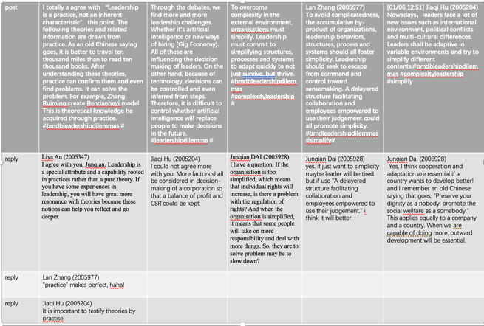

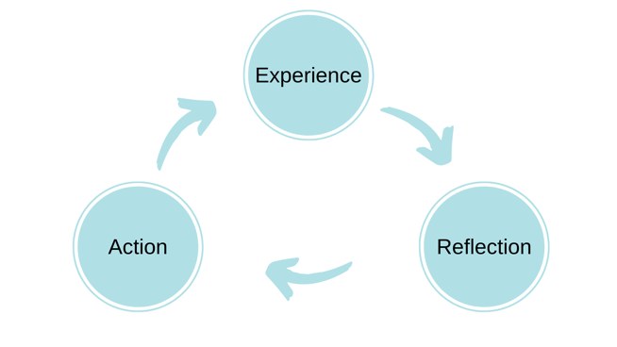
I will use Era Cycle (shown in the figure below) to reflect on this task.
The ERA cycle (Jasper, 2013) include three stages: Experience，Reflection ，Action.

Experience
In the team, I have sent a total of 3 posts, and the reply to my classmates is 8 posts. I find that because it's a proposition, everyone's thoughts are focused on one topic. Posts are around 200 words, and the number of replies varies. I find that the later the date, the fewer words people reply. People began to express their opinions in one simple sentence. At the same time, with the increase in the number of posts, the previous posts are more difficult to browse.

Reflection
Since posts require no more than 240 words each, that means we do not get a lot of our ideas across. And our personal ideas are limited after all, so the content coverage of our personal posts will not be very wide. On the other hand, as the number of posts increases. The earliest posts get overwritten, and people ignore them.

In ANT, connections between human and non-human characters need to be established in order to create a social. The establishment of connection requires a medium (institution), which connects me with others and forms a society (Mallory, 2018). I create a small society in which what I post needs to be seen and someone to reply on teams.

Social media platform (Teams) is a hub that connects the two sides. Only through TEAMS can we get more information. Without social media, our thoughts might not have been known. Therefore, social media provides a platform (medium) for us to post our idea (Law, 1992). It's a platform where everyone can see what we think. It is because of the emergence of the Internet and social media that the information explosion has emerged in this world (Friedric, 2013). However, we can influence the world around us through language, while social media does not have this ability (Mallory, 2018). The platform has to rely on us to make it work. Since we are not in the same region as each other and come from different countries. Most of us only communicate in class. This will weaken the bond between us. However, it is precisely because of this "weak tie" that the scope of information transmission becomes larger (De, et al., 2014). The good thing about "weak ties" is that communication with each other is limited to social media, and we do not have any interaction with each other after we posts. This will have less impact on our own lives.

Action
Nowadays, knowledge is a core commodity. And our knowledge and ideas are also shared through social media. It is not easy to control our own ideas from being plagiarised. In the new economy, creating an environment where knowledge is accumulated and shared at low cost is a challenge and a complex competitive environment. We want to share our ideas, but we need to protect our own idea. In this case, it is necessary to raise the overall environmental level. Rather than simplifying the whole structure. (Mary, Marion & McKelvey, 2007.)

Blog 4:
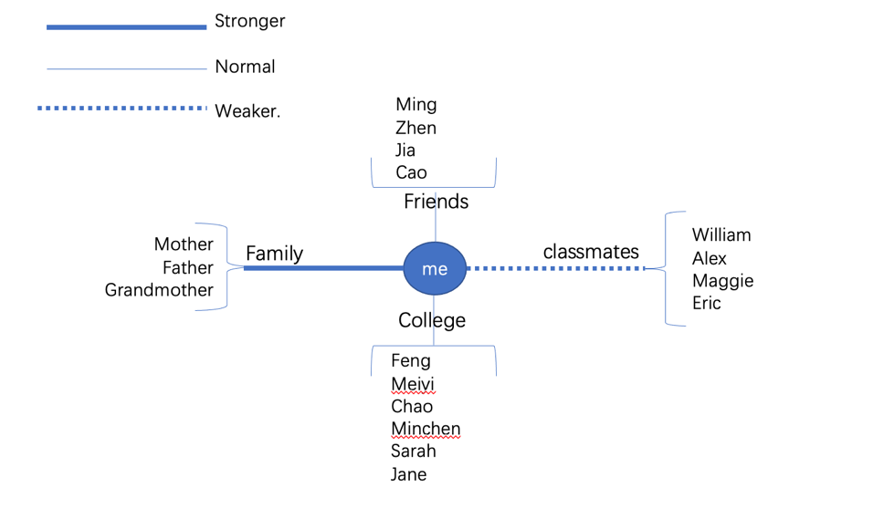
Above is my recent network relationship map. I simply divide it into four parts: family, friends, colleagues, and classmates. Within a group there will be connections between each other. But across the entire network, there was almost no communication between the groups. The people listed above are mainly those who will play a role in my research.

Although network analysis can lead to direct conclusions, it requires careful analysis of people, organisation, and goals to make reasonable improvements. The network perspective is the key to achieving the goal (Kristin, et al, 2014). Through the above network, I found that I did not make a breakthrough in crossover. Not making resources interact to create new connections. Today's world is increasingly complex but interdependent. This requires every leader to be able to make a critical shift from managing and protecting borders to crossing them. Crossing boundaries is to create a goal direction, to have the ability to coordinate, and to achieve higher goals (Jeffrey, Chris, and Michael, 2011). A team needs to communicate in a variety of ways. Leadership can be concentrated around one or several leaders, or applied in the whole organisation (Kristin, et al, 2014).

In my network map, the regions are clearly divided. When I need resources, I can quickly reach out to individuals and ask for help. However, because there is no connection between groups, hidden relationships are not revealed. There are some information and opportunities may be missed. In China, we have a word “guanxi”, which like network. “Guanxi” means knowing a lot of people, having a lot of connections, and not necessarily doing things through formal channels. Kristin (2014) and other researchers also mentioned that a lot of work would be done through informal channels. Therefore, leaders must discover and make good use of their social networks to achieve their goals (Ibarra and Hunter, 2007). The obstacles to linkage information and decision-making can be clearly found through the interpersonal network (Cross & Thomas, 2008). So, in the map above, my network needs to push beyond the boundaries of each group. I also need to expand my personal contacts. For example, seek common interests with others to gain more contacts through professional associations, alumni associations, clubs, or personal interest communities (Ibarra and Hunter, 2007). In China, we ask each other where are from. If people are from the same place, it will increase the feeling of intimacy and lay the foundation for making friends in the future. This is especially prominent in an unfamiliar environment (Jin, 2006). A good leader is one who cultivates personal networks, expands his or her capabilities, and helps him or her learn and develop in the workplace. Because leaders need to know how to use relationships, to see the whole better -- to have the holistic view. Leaders can hear different information early on through interpersonal relationships and integrate the information to leverage different expertise and insights to produce better solutions (Cross & Thomas, 2008).

In China, work is generally people-oriented (Lovett et al). Leaders are more concerned with team harmony. A study (Ewing, 2000) shows that it takes great effort to maintain and cultivate relationships, and that taking respect and care as the basis, taking long-term development as the orientation, and paying more attention to the interests of the whole network members are the keys to achieving leaders' goals. In addition to the above information about expanding my network, integrating resources, and paying attention to the interests of my collaborators, I also need to learn to accept new ideas, challenges, and different opinions. In this way, I could broaden my vision and obtain more favorable information for my research direction.

Blog 5:

Our group discussed Gig economy. I'm on the side of the gig economy. I will use Gibbs' Reflective Cycle Framework to reflect on this debate. Gibbs’ reflective cycle includes 6 stages of reflection. This is below as cited in Dye (2011, p. 230).
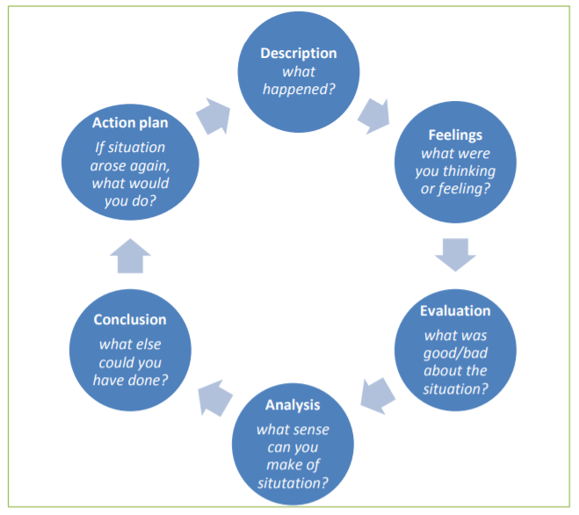

Description
This debated our group talk about the gig economy is reasonable or not. Eric, William, and I support the existence of the gig economy. Two other members (Alex and Lucius, who opposes the gig economy). First, I use the data to demonstrate the rationality and necessity of the gig economy. To provide better proof of my support. Second, I set out my three arguments in favor of the gig economy.

When I get the questions and I choose to support the side. So, I started thinking about the benefits of the gig economy. And when searching for information, they will also deliberately look for favourable information. I ignore the bad news about the gig economy.

Feelings
Before the formal debate, I made full preparations. Because, my English speaking ability is not good. I was well prepared and did not let myself get so nervous. I have some weaknesses in the stress response. Therefore, I need to make adequate preparation for whether Chinese or English speeches. Otherwise, I might be too nervous to say a word. However, there is evidence that speaking nervously in public is a natural reaction (Jiménez and Pinazo，2001). I hope I can relax myself first and then speak slowly, perhaps so, there will be no incoherent situation (Khusnia, 2017).

Evaluation
The debate of our group is in the last one, which means that we have limited time for discussion. During the discussion, our debate did not finish because the time was up. And because of the online discussion, some student's microphones are not on. This tricked the teacher into thinking we were finished and moving on to the next section. In this situation, I really want to interrupt the teacher and tell her that we are not finished, but due to my timidity, and in Chinese culture, it is impolite behavior to interrupt others (Huang, 2008). So, I gave up objecting. After class, I reflected on myself many times. I should be brave to say: "we are not over". In fact, a lot of things is to have the courage, bold to express themselves. In this way, I will have a chance to show myself and exercise my ability.

Analysis
In the whole debate, I think I have been well prepared. However, this is more like a presentation than a debate. This may be due to my English ability is not good, which to make myself timid and afraid to express. I feel anxious when I need to speak English. Khusnia (2017) described how people behave before expression：“Many of us have been in situations as language learners when we are asked a question and our minds mysteriously go blank.” So that's what happens to me. So, I need to be fully prepared before every speech. Otherwise, I would have been afraid to speak. Therefore, I dare not interrupt the teacher.

Conclusion
Through this debate, I deeply realized that to improving my English-speaking ability. I also need to learn how to express myself bravely and not be afraid of being embarrassed on the crowd. For example, when I found that our group had not finished the task and student's microphone has no sound. In that time, I should have been brave enough to say, "We are not finished, can we continue?”. It's not about looking back and blaming myself after class. I should also be brave to speak up in class. Only by constantly forcing myself to express in front of others can I overcome my fear (Dong, Jinwei, 2007).

Action Plan
In the future study, I will be braver. And I will try my best to improve my English speaking. I will train more and communicate more with my classmates and teachers. If I have the chance, I will make more British or without chinses friends, so that I will not be afraid to speak English. I accumulate words every day, however this only seems to help my reading significantly. I wish teachers would talk slowly in class. (Caroline and Steve's speaking speed is very appropriate.) I hope teachers could give us enough time to react after asking questions. PePa has done a good job before.

Blog 6:

Slide: 1: Question: How to effectively manage employees? So that they can achieve their goals together, without being influenced by each other.

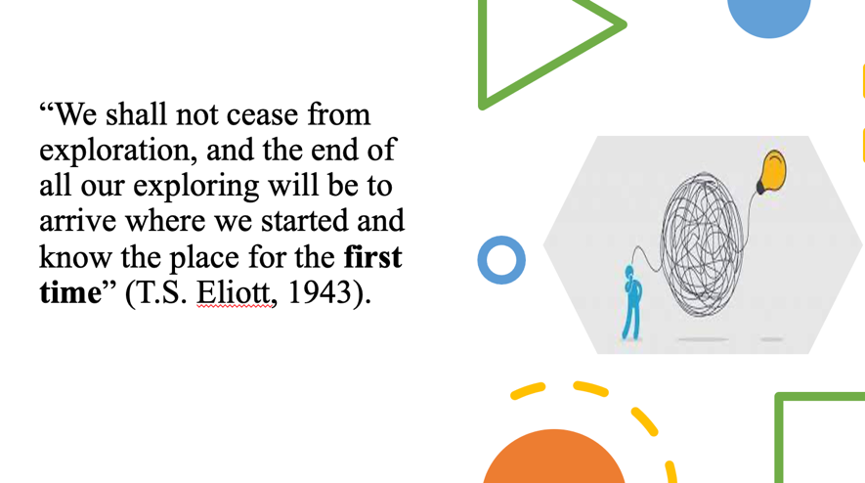
Slide 2: This sentence explains very well about sensemaking. We think we know something, but experience allows us to see it with different eyes when we come across it again. Sensemaking can not only help us see the same thing through different experiences, but also help us find solutions when facing unfamiliar things (Ancona, 2012).

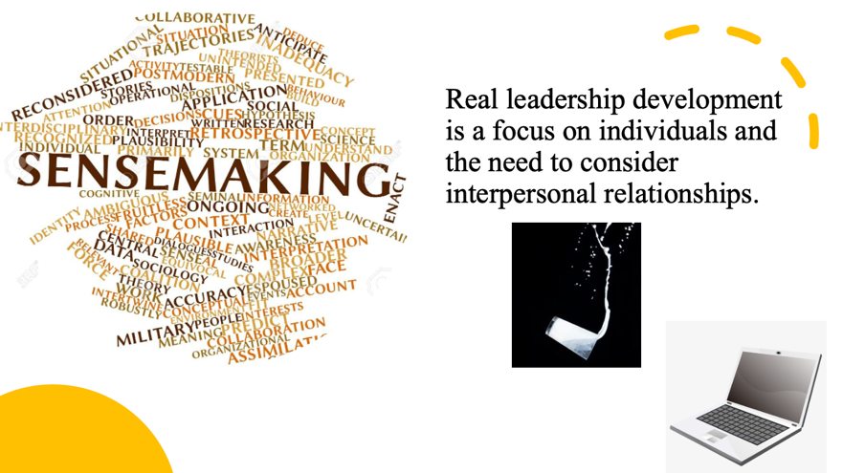
Slide 3：According to research, the two biggest factors that make leadership effective are creating meaning and creativity. Due to the increasing complexity and uncertainty of leadership, sensmaking is the key thing that leaders need to do (Moore, 2013). Real leadership development is a focus on individuals and the need to consider interpersonal relationships (Day,et al., 2014).

In the interview, Alex mentioned how to deal with conflicts and relationships among employees. In this case, he's thinking first of what's good for the company, given that premise. He then went to find a solution to the contradiction between the two employees.

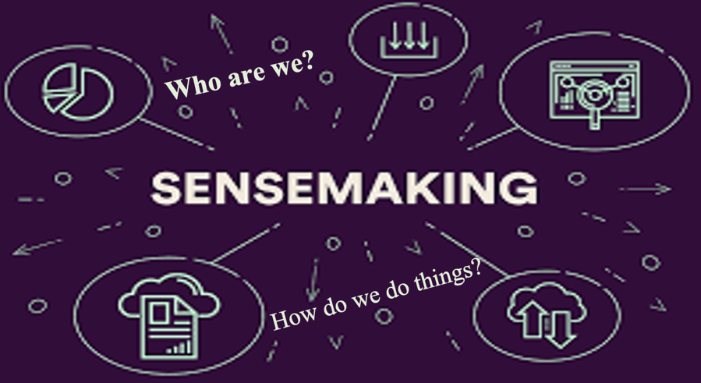
Slide 4: In sensemaking, the first thing to think about is identity construction. "Who are we?" and "How do we do things?" In this process, individuals (or organisations) connect clues (events, ideas, etc.) with frameworks (cognitive frameworks, mental models, etc.) to seek solutions (Mills et al. 2010). For example, in the case of Alex, he would think that he is the leader of the team, and he needs to ensure the harmony of the team and the interests of the company. However, in this process may also be affected by other factors. For example, the rules of the company, the impact of behavior on employees (Mills et al. 2010). When faced with conflicts of interest, people tend to answer with questions of identity (Lise, 2013). For example, as a leader, there may be the phenomenon that I am talking about rules. In Alex's case, is the act of giving money. He will think that the reason behind this move is that he is the leader, and he needs to take responsibility.

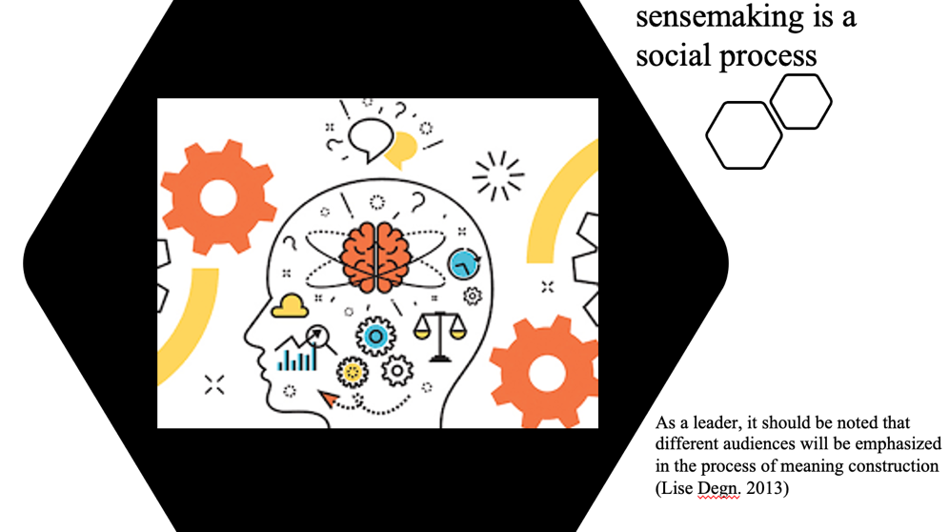
Slide 5: Second, sensemaking is a social process. It takes into account the reactions of others in certain situations. As a leader, it should be noted that different audiences will be emphasized in the process of meaning construction (Lise Degn. 2013). In Alex's case, there was a difference in the way he treated the two employees. Instead of accusing them at the same time, he explained to each other separately. And as a leader, he took on the role of middleman. Compensate employee B in the name of employee A out of his own pocket. This behavior will stop employee B from complaining about employee A. Employee A will work harder because the leader has taken responsibility for her.

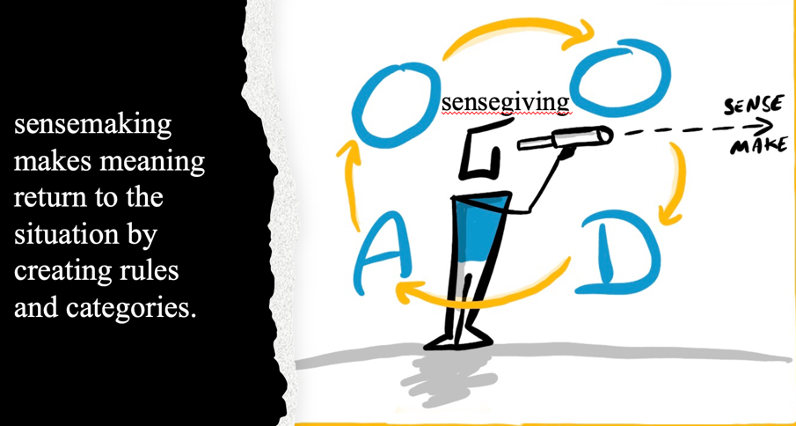
Slide 6: Thirdly, sensemaking makes meaning return to the situation by creating rules and categories. In the future, similar situations can be used to extract useful information from these orders and categories. There is a kind of activity in this -- sensegiving. It is a form of behavior that attempts to influence other people's thinking in order to achieve a leader's goals. Sensegiving is the behaviour of leaders who provide explanations to their employees and thus influence them. The way leaders try to "sell" a message and gain influence after communicating with others (Lise Degn. 2013). In Alex's case, he made Employee A agree to pay Employee B in her name by influencing Employee A. Let Employee A be grateful to Alex in her heart and regard Alex as A close person. Alex influences A's behaviour in A sensegiving way. Finally, Alex solved the contradiction between Employee A and B well. Alex also brings benefits to the company.


Slide 7: When something happens, we lack rationality for a variety of reasons. That's where perceptual knowledge comes in. In such cases, rationality will trump accuracy. When faced with more complex forms, previous experience can help us. However, if we just wait for more information without taking action, we will be in trouble (Ancona, 2012). Therefore, sensemaking can motivate us to take action to solve problems.

Blog 7

I created this model which I called "co-development." It means that the employee and the company are expected to grow together. The following diagram is a model of the theory. There are four quadrants, and each quadrant and axis correspond to a different target. The upper right quadrant is when the problem is related to the interests of the company, the goals and the development of the company, the interests of the company will be the top priority, and this is the choice within the company. When it comes to customer problems, the principle of "customer first" is in the lower right quadrant. That is, when external conditions appear, customers' interests will be the priority. On the left is employee development. In the team, employees' conflicts should not be intensified, and peace should be emphasized. When the goal is not clear, it will focus on the interests of the employees. Uphold the "people-oriented" principle.
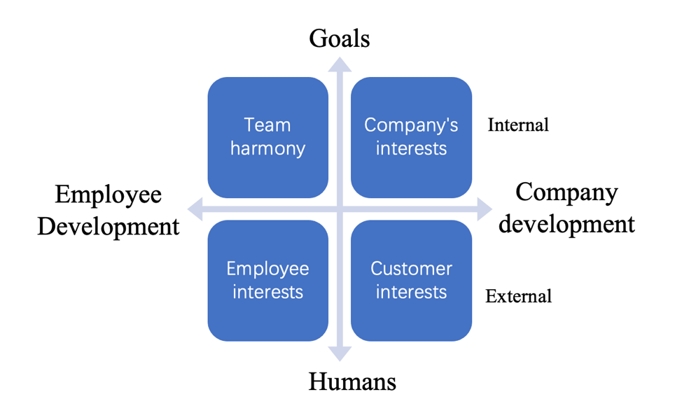

This model is mainly based on Alex's example and Zhang Ruiming's model theory of "Rendanheyi". Zhang Ruiming once stressed the need to treat employees: "Trust them to be better than you and give them power." At work, it's easy to have conflicting interests, so you need to set priorities. The division under a big framework can effectively solve the contradictions of all parties.

"People-oriented" has always been the hallmark of Chinese society. While emphasizing the concept of "humanism", we should not compromise our interests. Zhang Ruiming once said: "When you encounter problems in starting your own business, you do not rely on reports to solve them. To start a business, the first is money, the second is people." What we need to solve is the conflict between people and money. And often, it's about people and people in the end.

Therefore, when there are conflicts between people and companies, conflicts between people can be dealt with according to the division of the above model. The above model gives a clear indication of whether to focus on goals or company development, and whether to focus on people or staff development.

References

Blog 1:

Blog 2:
Ansell, C. and Trondal, J., 2018. Governing turbulence: An organizational-institutional agenda. Perspectives on Public Management and Governance, 1(1), pp.43-57.

Ancona, D., 2012. Sensemaking: Framing and Acting in the Unknown. In: S. Snook, N. Nohria & R. Khurana, eds. The Handbook for Teaching Leadership. Thousand Oaks: Sage, pp. 3-18.

Crane, 1996.The Influence of Uncertain Job Location on Urban Form and the Journey to Work.Journal of Urban Economics. 39(3). pp. 342-356. [online] Available at: https://www.sciencedirect.com/science/article/abs/pii/S0094119096900182 [Accessed 1 July 2021].

Snowden and Boone, 2007. A Leader’s Framework for Decision Making. Harvard business review. [online] Available at: https://centerforcommunityinvestment.org/sites/default/files/media/a_leaders_framework_for_decision_making.pdf [Accessed 28 June 2021].

Uhl-Bien, Mary, Marion, Russ & McKelvey, Bill, 2007. Complexity Leadership Theory: Shifting leadership from the industrial age to the knowledge era. The Leadership quarterly, 18(4), pp.298–318.

Blog 3:
De et al., 2014. On Facebook, most ties are weak. Communications of the ACM, 57(11), pp.78–84.

Dwiartama, A. and Rosin, C., 2014. Exploring agency beyond humans: the compatibility of Actor-Network Theory (ANT) and resilience thinking. http://www.ecologyandsociety.org/vol19/iss3/art28/ [Accessed 2 July 2021].

Friedrich H. Kohle, 2013. (PDF) The Social Media “Information Explosion” Spectacle: Perspectives for Documentary Producers. [online] Available at: https://www.researchgate.net/publication/297766948_The_Social_Media_Information_Explosion_Spectacle_Perspectives_for_Documentary_Producers [Accessed 2 July 2021].

Jasper, M. (2013). Beginning Reflective Practice. Andover: Cengage Learning. [online] Available at: http://mis.kp.ac.rw/admin/admin_panel/kp_lms/files/digital/SelectiveBooks/Nursing/Foundations%20in%20Nursing%20and%20Health%20Care%20[Wigens,%20Lynne].pdf [Accessed 2 July 2021]

Law, J. (1992) ‘Notes on the Theory of the Actor Network: Ordering, Strategy and Heterogeneity‘, Available at: http://www.comp.lancs.ac.uk/sociology/papers/Law-Notes-on-ANT.pdf [Accessed 2 July 2019]

Mallory Reed 2018, The Classification of Artificial Intelligence as "Social Actors”. Thesis, Georgia State
University. [online] Available at: https://scholarworks.gsu.edu/cgi/viewcontent.cgi?article=1059&context=rs_theses [Accessed 2 July 2019].

Mary, Marion & McKelvey, 2007. Complexity Leadership Theory: Shifting leadership from the industrial age to the knowledge era. The Leadership quarterly, 18(4), pp.298–318.

Blog 4:
Cross, Rob & Thomas, Robert J, 2008. How Top Talent Uses Networks and Where Rising Stars Get Trapped. Organizational dynamics, 37(2), pp.165–180.

Ewing, Michael, 2000, “Some consequences of Guanxi: A Sino-Singaporean perspective,” Journal of International Consumer Marketing, Vol. 12, Issue 4, pp.75-89.

Ibarra, Herman & Hunter, Mark, 2007. How leaders create and use networks. Harvard business review, 85(1), pp.40–124.

Jeffrey Yip, Chris Ernst, and Michael Campbell， 2011. Boundary Spanning Leadership Mission Critical Perspectives from the Executive Suite，[online] Available at: https://cclinnovation.org/wp-content/uploads/2020/02/boundaryspanningleadership.pdf [Accessed 2 July 2021].

Jin, 2006. Guanxi Networks in China： Its Importance and Future Trends. China & world economy, 14(5), pp.105–118.

Kristin L. Cullen, Charles J. Palus, and Craig Appaneal 2014. Developing Network Perspective Understanding the Basics of Social Networks and their Role in Leadership. [online] Available at: https://cclinnovation.org/wp-content/uploads/2020/03/developingnetworkperspective.pdf [Accessed 2 July 2021].

Lovett, Steve, Simmons Lee and Raja Kali, 1999, “Guanxi versus the market: Ethics and efficiency,” Journal of International Business Studies. No. 2, pp. 231-247.

Blog 5:
Dye, V. (2011) ‘Reflection, Reflection, Reflection. I’m thinking all the time, why do I need a theory or model of reflection?’, in McGregor, D. and Cartwright, L. (ed.) Developing Reflective Practice: A guide for beginning teachers. Maidenhead: McGraw-Hill Education (pp. 217-234).

Dong, Jinwei, 2007. Valerie Pellegrino Aveni, Study abroad and second language use: Constructing the self. Language in Society, 36(1), pp.140–141.

Huang, 2008. Politeness Principle in Cross-Culture Communication. English Language Teaching, [online] Available at: http://files.eric.ed.gov/fulltext/EJ1082589.pdf [Accessed 3 July 2021].

Jiménez and Pinazo，2001. “I FAILED BECAUSE I GOT VERY NERVOUS”.ANXIETY AND PERFORMANCE IN INTERPRETER TRAINEES:AN EMPIRICAL STUDY

Khusnia 2017. Students’ Speaking Anxiety in English Foreign Language. Journal of Education and Learning. Vol. 11 (1) pp. 83-90. DOI: 10.11591/edulearn. v11i1.4301

Mbopartners.com, 2019: The Changing Nature of the American Workforce
https://www.mbopartners.com/state-of-independence/mbo-partners-state-of-independence-in-america-2019/ [Accessed 18 June 2021].

Blog 6:
Ancona, D., 2012. Sensemaking: Framing and Acting in the Unknown. In: S. Snook, N. Nohria & R. Khurana, eds. The Handbook for Teaching Leadership. Thousand Oaks: Sage, pp. 3-18.

Day, D. V. et al., 2014. Advances in leader and leadership development: A review of 25 years of research and theory. The Leadership Quarterly, Volume 25, pp. 63-82.

Lise Degn. 2013. “Sensegiving and strategic management in HEIs:
the sensemaking and sensegiving processes of top-level managers”
[online] Available at: https://www.uv.uio.no/english/research/groups/hedwork/publications/Working-paper-series/docs/HEIKwp201302_degn.pdf [Accessed 4 July 2021].

Moore, D.T., 2013. Sensemaking: A structure for an Intelligence Revolution. Government Printing Office.

Michael T. Mitchell， 2017. 3 Crucial Behaviors for Successfully Leading Innovation.
[online] Available at: https://cclinnovation.org/wp-content/uploads/2020/02/3-crucial-behaviors-successfully-leading-innovation.pdf [Accessed 4 July 2021].

Mills, J.H., Thurlow, A. & Mills, A.J. (2010). Making sense of sensemaking: the critical sensemaking approach, Qualitative Research in Organizations and Management: An International Journal 5(2), 182–195.

T.S. Eliott, 1943. https://notablesofthe1920stevlin.weebly.com/ts-eliot.html [Accessed 4 July 2021].

