Portfolio

Module: The learning journey: developing skills for academic success (ECEY4012)
Student: Elena-Diana Pintle (2509353)
Lecturer: Paul Darby
Glenda Finney

Contents
Contents
Part 1. Study timetable 2
Part 2. Utilised Microsoft 365 Copilot to Research Learning Technique 3
Part 3. Poster Study Skills 11
Part 4. Link to Poster Presentation 12

Part 1. Study timetable
Amser /Time | Llun  Monday | Mawrth  Tuesday | Mercher  Wednesday | Iau  Thursday | Gwener  Friday | Sadwrn  Saturday | Sul  Sunday
00:00 - 00:59 | Sleep | Work | Work | Work | Work | Sleep | Sleep
01:00 - 01:59 | Sleep | Work | Work | Work | Work | Sleep | Sleep
02:00 - 02:59 | Sleep | Work | Sleep | Sleep | Sleep | Sleep | Sleep
03:00 - 03:59 | Sleep | Sleep | Sleep | Sleep | Sleep | Sleep | Sleep
04:00 - 04:59 | Sleep | Sleep | Sleep | Sleep | Sleep | Sleep | Sleep
05:00 - 05:59 | Sleep | Sleep | Sleep | Sleep | Sleep | Sleep | Sleep
06:00 - 06:59 | Sleep | Sleep | Sleep | Sleep | Sleep | Sleep | Sleep
07:00 - 07:59 | Personal care &Breakfast | Personal care &Breakfast | Personal care &Breakfast | Personal care &Breakfast | Personal care &Breakfast | Sleep | Sleep
08:00 - 08:59 | School prepare | School prepare | School prepare | School prepare | School prepare | Personal care &Breakfast | Personal care &Breakfast
09:00 - 09:59 | English course | Study/ Homework’s | English course | Study/ /  Homework’s | Study/ Research | Sport (walking/  running) | Church
10:00 - 10:59 | English course | Study/ Research/ | English course | Study/ Research | Study/ Research | Groceries& Shopping | Church
11:00 - 11:59 | English course | Study/ Research/  Writing | English course | Study/ Research/  Writing | Study/ Research/  Writing | Groceries& Shopping | Family  time
12:00 - 12:59 | Personal Time/care | Personal Time/care | Groceries& Shopping | Personal time/care | Personal time/care | Household tasks | Family  time
13:00 - 13:59 | Cooking/ | Cooking | Cooking | Cooking | Cooking | Cooking | Family  time
14:00 - 14:59 | Household tasks | Household tasks | Household tasks | Household tasks | Household tasks | Lunch | Lunch
15:00 - 15:59 | School pick-up | School pick up | School pick-up | School pick-up | School pick-up | Social Time | Personal  &Family time
16:00 - 16:59 | Lunch | Lunch | Lunch | Lunch | Lunch | Cooking | Cooking
17:00 - 17:59 | University Course | Cooking&  Dinner | Cooking&  Dinner | Cooking&  Dinner | Cooking&  Dinner | Dinner | Dinner
18:00 - 18:59 | University Course | Work | Work | Work | Work | Personal time | Personal time
19:00 - 19:59 | University Course | Work | Work | Work | Work | Rest&  Relax | Rest&  Relax
20:00 - 20:59 | Work | Work | Work | Work | Work | Bedtime  Routine& Story | Bedtime  Routine& Story
21:00 - 21:59 | Work | Work | Work | Work | Work | Sleep | Sleep
22:00 - 22:59 | Work | Work | Work | Work | Work | Sleep | Sleep
23:00 - 23:59 | Work | Work | Work | Work | Work | Sleep | Sleep

Part 2. Utilised Microsoft 365 Copilot to Research Learning Technique
Microsoft Copilot was accessed to explore two study techniques to support progression through the BA (Hons) Early Years Education and Care. Two prompts were used to create this information.
- Initial prompts
Prompt 1: Hi Copilot, I am a level 4 student in a UK University studying a BA in early years education and care. What study techniques can help university students plan and organise their study time more effectively while improving concentration and productivity?
Prompt 2: Hi Copilot, I am a level 4 student in a UK University studying a BA in early years education and care. What study techniques can help university students maintain a healthy balance between studying and wellbeing while still being productive?
Original output
As a Level 4 university student, effective study habits are not only about working harder but also about planning your time well and maintaining concentration. Several evidence-based techniques can help improve organisation, productivity, and academic performance.
1. Time Blocking
Time blocking involves dividing your day into specific periods for studying, attending lectures, completing assignments, and taking breaks.
How it works:
- Schedule study sessions in a diary or digital calendar.
- Assign each session a clear task, such as reading articles or writing an essay section.
- Include regular breaks to avoid fatigue.
Benefits:
- Reduces procrastination.
- Creates a structured routine.
- Helps balance study and personal commitments.
2. Creating SMART Goals
SMART goals are:
- Specific
- Measurable
- Achievable
- Relevant
- Time-bound
Example: Instead of "revise child development," set a goal such as: "Read and summarise Chapter 3 on cognitive development by Friday."
Benefits:
- Provides clear direction.
- Makes progress easier to monitor.
- Increases motivation.
3. The Pomodoro Technique
This technique uses short periods of focused work followed by breaks.
How it works:
- Study for 25 minutes.
- Take a 5-minute break.
- Repeat four times, then take a longer break.
Benefits:
- Improves concentration.
- Prevents mental fatigue.
- Makes large tasks feel more manageable.
4. Weekly Study Planning
At the beginning of each week:
- Review deadlines and upcoming lectures.
- Break assignments into smaller tasks.
- Decide when each task will be completed.
Benefits:
- Reduces last-minute stress.
- Improves organisation.
- Helps maintain steady progress throughout the semester.
5. Prioritisation Using a To-Do List
List tasks in order of importance and urgency.
Example:
- Complete assignment due next week.
- Read lecture notes.
- Organise references.
Benefits:
- Focuses attention on the most important work.
- Prevents time being spent on less urgent tasks.
- Increases productivity.
6. Reducing Distractions
Create a study environment that supports concentration.
Strategies:
- Turn off phone notifications.
- Use website blockers if needed.
- Study in a quiet space such as the library.
Benefits:
- Improves focus.
- Helps maintain attention for longer periods.
- Increases the quality of study time.
Conclusion
University students can improve concentration, productivity, and organisation by using techniques such as time blocking, SMART goals, the Pomodoro Technique, weekly planning, prioritised to-do lists, and distraction management. Combining these approaches can help students use their study time more effectively, reduce stress, and make consistent progress towards their academic goals.

- Refined and stronger prompts
Prompt 1: Explain in more detail how the Time Blocking technique works and how university students can use it to organise their study time and reduce procrastination.
Prompt 2: Explain in more detail how the Pomodoro Technique works and how it may help university students improve concentration, productivity and manage study breaks.
- Prompts to identify sources
Prompt 1: Find reliable academic sources that support the use of Time Blocking for university students, particularly for time management, organisation and reducing procrastination.
Prompt 2: Find reliable academic sources about the Pomodoro Technique and its effects on concentration, productivity and study breaks among university students.
- Discussion of the Two Techniques
Effective study techniques are essential for academic success. Managing study time is important for university students because it can help them complete their work, meet deadlines and reduce stress. Two useful techniques are time blocking and the Pomodoro technique. Both can help students manage their time, but they work in different ways.
First, time blocking is a time-management technique where students divide the day into specific blocks of time, and each block is used for one task (Mubango and Ngirande, 2024). For example, a student can plan on hour for reading, another hour for research and another for writing an assignment. Cottrell (2024) explains that good time management skills are essential in higher education because students have more responsibility for managing their own study. Baykara Mat (2026) included time blocking alongside task prioritisation and daily planning in time management training programme. After the programme, students showed improved time management and reduce academic procrastination. Time blocking may therefore help students create a clear study plan and manage their academic task.
Secondly, the Pomodoro Technique is a study technique based on short periods of focused work followed by regular breaks. It usually involves studying for 25 minutes followed by a five-minute break (Ogut, 2025). Biwer et al. (2023) found that students using systematic breaks reported better concentration and motivation than students using self-regulated breaks. However, Smits, Wenzel and de Bruin (2025) found that Pomodoro had similar results to other break-taking approaches for productivity and task completion. This shows that Pomodoro can be one option students may choose to structure their study sessions and for tasks that require concentration, such as academic reading or assignment writing.
In conclusion, both Time blocking and the Pomodoro Technique can be used to support students in managing their study time. Time blocking can help students plan and organise their workload, while the Pomodoro technique can support concentration by using focused study periods and planned breaks. Students can choose the technique that best suits their needs or combine both to develop more effective study habits in the future.
References
Baykara Mat, S.T. (2026) ‘The effects of Slavin model-based time management training on procrastination in nursing students: a quasi-experimental study’, Frontiers in Psychology, 17, article 1756887. Available at: https://doi.org/10.3389/fpsyg.2026.1756887
Biwer, F., Wiradhany, W., oude Egbrink, M.G.A. and de Bruin, A.B.H. (2023) ‘Understanding effort regulation: Comparing “Pomodoro” breaks and self-regulated breaks’, British Journal of Educational Psychology, 93(S2), pp. 353–367. Available at: https://doi.org/10.1111%2Fbjep.12593
Cottrell, S. (2024) The Study Skills Handbook. 6th edn. Bloomsbury Academic. Available at: https://ebookcentral.proquest.com/lib/trinity/reader.action?docID=31357862&c=RVBVQg&ppg=41
Mubango, H. and Ngirande, H. (2024) ‘Self-regulated learning: Time management in a blended learning environment for student academic performance’, in Mistretta, S. (ed.) Self-Regulated Learning – Insights and Innovations. IntechOpen. Available at: https://doi.org/10.5772/intechopen.1006068
Ogut, E. (2025) ‘Assessing the efficacy of the Pomodoro technique in enhancing anatomy lesson retention during study sessions: a scoping review’, BMC Medical Education, 25, article 1440. Available at: https://doi.org/10.1186/s12909-025-08001-0?urlappend=%3Futm_source%3Dresearchgate.net%26utm_medium%3Darticle
Smits, E.J.C., Wenzel, N. and de Bruin, A. (2025) ‘Investigating the effectiveness of self-regulated, Pomodoro, and Flowtime break-taking techniques among students’, Behavioral Sciences, 15(7), article 861. Available at: https://doi.org/10.3390/bs15070861
- Reflection on Using Microsoft 365 Copilot for Academic Study
Using Microsoft 365 Copilot fort this task was an interesting experience, mostly positive, but I also found some challenges. At first, I asked Copilot to suggest study techniques that could help university students manage their time and study more effectively. It gave me different ideas, and I decided to focus on Time blocking and Pomodoro Technique. I found this helpful because it gave me a starting point my research.
I also learned that the way I write a prompt is important. My first prompts were quite general, so Copilot gave me a lot of information. When I refine my prompts and asked more specific questions, the answers were more useful. For example, I asked how each technique could help university students with organisation and productivity. This helped me find information that was more relevant to my task.
The biggest challenge for me was checking the sources. At first, I thought that the sources suggested by Copilot would be suitable for my work. However, when I checked them more carefully, I noticed that some were about general time management and not specifically about time blocking. I had to read the original sources and decide for myself which ones were truly relevant. This clearly demonstrates that I cannot trust on what artificial intelligence provides. Bearman and Ajjawi (2023) discuss the importance of students using their own judgment when working with artificial intelligence (AI), which relates to my experience of checking the information before using it.
In my opinion AI can be useful for students because it can give ideas, explain topics and help with starting research. Johnston et al. (2024) found that students used generative AI for different learning activities, including understanding concepts, planning and summarizing information, However, their study also showed concerns about using AI to produce complete academic work. This relates to my experience helped me understand how to use Copilot as a learning support, but I still needed to check the information and do my own work.
In my future work, I will focus on the use of AI as a support tool to help me understand topics, explore ideas and improve my study skills. I would continue to use reliable academic sources for my research and follow university guidance when using AI. Most importantly, I would use my own judgment and make sure that my final works reflect my own understanding. In conclusion, from this experience, I learned that AI is a useful tool, but it needs to be used carefully and responsibly.
References:
Bearman, M. and Ajjawi, R. (2023) ‘Learning to work with the black box: Pedagogy for a world with artificial intelligence’, British Journal of Educational Technology, 54(5), pp. 1160–1173. Available at: https://doi.org/10.1111/bjet.13337
Johnston, H., Wells, R.F., Shanks, E.M., Boey, T. and Parsons, B.N. (2024) ‘Student perspectives on the use of generative artificial intelligence technologies in higher education’, International Journal for Educational Integrity, 20, article 2. Available at: https://doi.org/10.1007/s40979-024-00149-4?urlappend=%3Futm_source%3Dresearchgate.net%26utm_medium%3Darticle

Part 3. Poster Study Skills
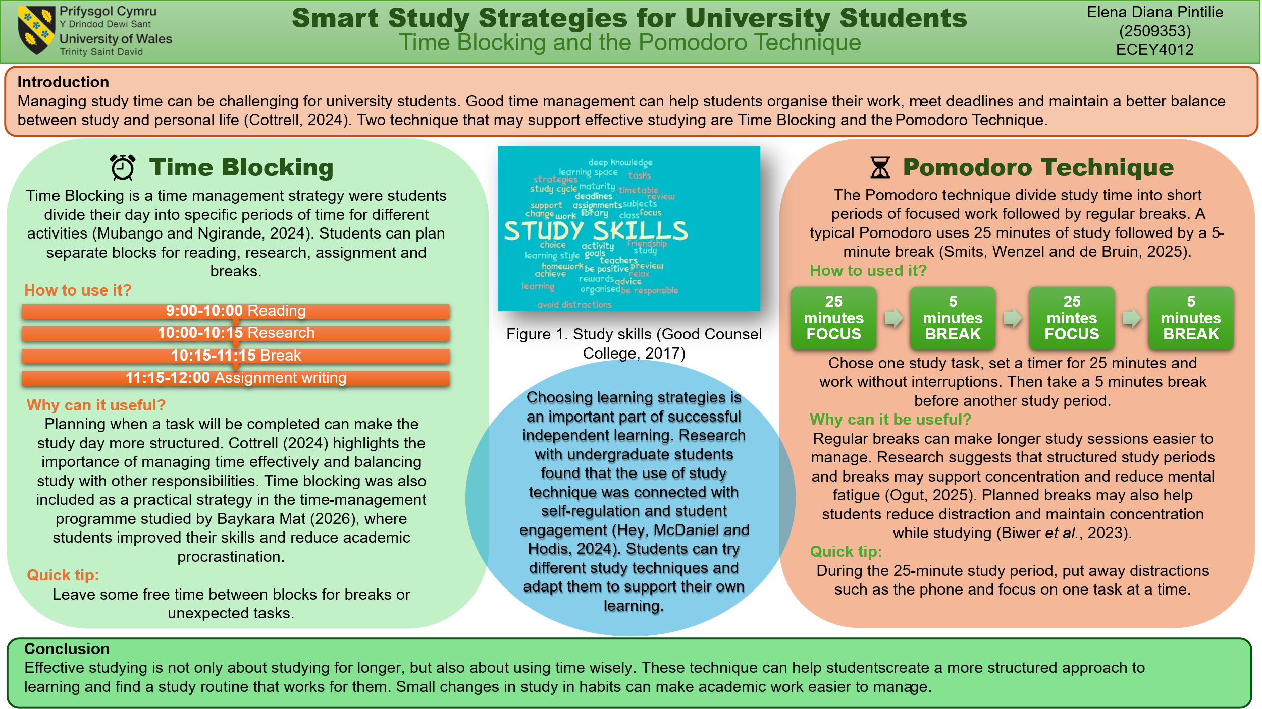

References:
Baykara Mat, S.T. (2026) ‘The effects of Slavin model-based time management training on procrastination in nursing students: a quasi-experimental study’, Frontiers in Psychology, 17, article 1756887. Available at: https://doi.org/10.3389/fpsyg.2026.1756887
Biwer, F., Wiradhany, W., oude Egbrink, M.G.A. and de Bruin, A.B.H. (2023) ‘Understanding effort regulation: Comparing “Pomodoro” breaks and self-regulated breaks’, British Journal of Educational Psychology, 93(S2), pp. 353–367. Available at: https://doi.org/10.1111%2Fbjep.12593
Cottrell, S. (2024) The Study Skills Handbook. 6th edn. Bloomsbury Academic. Available at: https://ebookcentral.proquest.com/lib/trinity/reader.action?docID=31357862&c=RVBVQg&ppg=41
Good Counsel College (2017) ‘Study Skills Week’ [online image]. Available at: https://goodcounselcollege.ie/study-skills-week/
Hey, R., McDaniel, M. and Hodis, F.A. (2024) ‘How undergraduate students learn: uncovering interrelationships between factors that support self-regulated learning and strategy use’, Metacognition and Learning, 19, pp. 743–772. Available at: https://psycnet.apa.org/doi/10.1007/s11409-024-09389-8
Mubango, H. and Ngirande, H. (2024) ‘Self-regulated learning: Time management in a blended learning environment for student academic performance’, in Mistretta, S. (ed.) Self-Regulated Learning – Insights and Innovations. IntechOpen. Available at: https://doi.org/10.5772/intechopen.1006068
Ogut, E. (2025) ‘Assessing the efficacy of the Pomodoro technique in enhancing anatomy lesson retention during study sessions: a scoping review’, BMC Medical Education, 25, article 1440. Available at: https://doi.org/10.1186/s12909-025-08001-0?urlappend=%3Futm_source%3Dresearchgate.net%26utm_medium%3Darticle
Smits, E.J.C., Wenzel, N. and de Bruin, A. (2025) ‘Investigating the effectiveness of self-regulated, Pomodoro, and Flowtime break-taking techniques among students’, Behavioral Sciences, 15(7), article 861. Available at: https://doi.org/10.3390/bs15070861
University of Wales Trinity Saint David (n.d.) University logo [online image]. Available at: https://www.uwtsd.ac.uk/

Part 4. Link to Poster Presentation

