Creative writing dates back to the very beginning of human existence. From cave paintings that convey stories, or documentation, to the ballads of Ancient Greece, and the myths told through the Epic poems of Homer, but it also has great promise in the future. Creative writing has been an ever-present thing, all throughout history, from the very beginning of time, through the Medieval period, through the Renaissance, and the Victorian times, everything from news to novels and poetry, to plays and hymns. Creative writing is a strong pillar of what it means to be human, and though the name of the discipline may seem silly, it is entwined with so much of humanity’s history, and even so much of it you may have yet to notice.
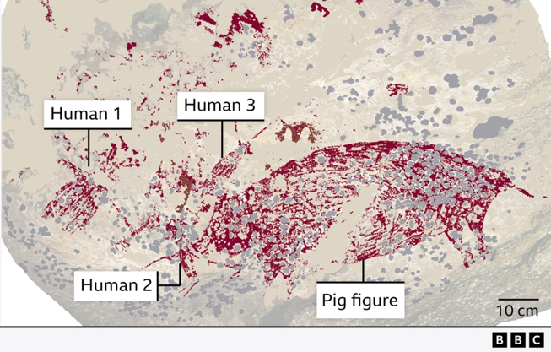
A recently published article from BBC News documents the findings of this “figurative cave art” discovered in the Indonesian Island of Sulawesi and has been depicted as a painting of a pig and three “human-like figures” dated at “51,200 years old.”
A similar article discussing the same piece in The Smithsonian Magazine suggests the piece may be “the earliest known example of visual storytelling.” And later goes on to quote an Indonesian rock art specialist, who stated “storytelling is a hugely important part of human evolution, and possibly even it helps to explain our success as a species.” Truly stressing the integral role that creative writing has played and continues to play within the evolution of the humanities.
Similarly, Will Storr introduces his book, ‘The Science of Storytelling’ by explaining to the reader, “it’s story that makes us human.” Further explaining that “Recent research suggests language evolved principally to swap ‘social information’ back when we were living in the Stone Age tribes.” Essentially implying that creative writing as a discipline is, for the majority, the reason language has evolved to what we know it as today. Stories were told, performances enacted, or reenactments of daily life performed, and such can be seen through cave paintings many historians and archaeologists will analyse within their disciplines in the coming years, much like the aforementioned Indonesian cave painting. While it may not have been considered creative writing then, it was performed as storytelling, an act, which in itself related to creative writing. They may have used performance or art on a cave wall to interpret it, but the point remains the same, they told stories, and communicated through the act of storytelling, and in Will Storr’s words “we’d gossip.” And thanks to that, humanity’s language evolved from handprints on a wall, to written word, to typewriters and computers. Creative writing may often appear as an art, but in its basic structure, it is not simply an artistic endeavour, but an expression of human nature and a way for others to relate their own humanity.
Creative writing is also a large part of ancient history and is a major part of the reason students are able to study the subject today. This is because of poets such as Sappho, and Homer, or playwrights such as Euripides and Sophocles, and especially Greek Philosophers such as Aristotle and Hypocrites. All of these people documented what it was like to live in Ancient Greece, and the Classical Period, and all of them did so by using some form of creative writing medium, be it poetry, theatre or non-fiction. Even philosophical debate can be seen as creative since it engages you with an argument.
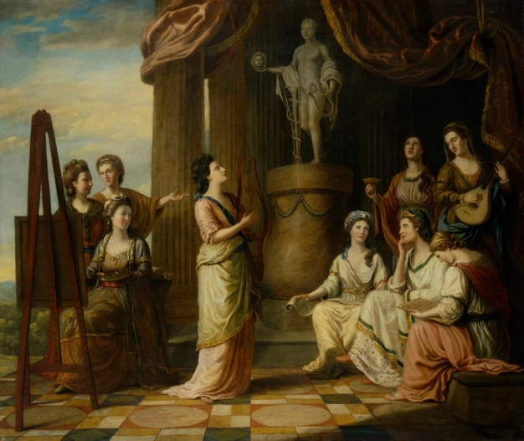
Furthermore, in Ancient Greece, people would evoke the favour of the Muses, such as Homer did at the beginning of The Odyssey and The Iliad. And according to an article in Breathe Magazine, “Writers and artists in Greece called upon the Muses when embarking on creative work” much like Homer. This was because the Muses were considered the foundation of human knowledge, and once again, a large part of that, was due to creative writing. While Homer invoked the favour of Calliope, the Muse of epic poetry, she was not the only one of her sisters to have a specialty in this discipline. There was also Euterpe, who represented music and lyrical poetry, Erato, who stood for love and erotic poetry, Polyhymnia, who was the Muse of sacred poetry and hymns, and finally Melpomene and Thalia who stood for tragic and comedic drama. These goddesses took up a large portion of what was considered important to human knowledge in the time of Ancient Greece, because stories and songs would have been how they communicated and entertained, spreading ballads and poems of great heroes of faraway lands, defeating monsters and travelling great distances. They represent both theatre and poetry, two of the several major aspects of creative writing. Of course, they will have evolved over time, from ballads, to sonnets to freeform, from street plays, to Shakespeare, to modern television. Of course, the Muses did not only stand for this discipline, but they also represented other aspects of key human intelligence, such as Astrology and Astronomy, represented by Urania, which would have been the Ancient Greeks’ major sciences of the time, as well as Clio, who stood for history. And though all of these subjects have expanded and evolved, they still remain key pillars of humanity.
In more recent history, the famous novel, The Handmaid’s Tale, flips this idea, instead proving that history builds upon creative writing, and that we cannot exist without it. Margaret Atwood wrote the novel around true historical events, suggesting that both disciplines can support one another, since writers wrote the history, but writers would not have much to write if not for history. Atwood told students in an online class she taught for creative writers, that “nothing went into it [The Handmaid’s Tale] that had not happened in real life somewhere at some time.” This novel is a great example of a modern piece of literature that had a significant impact on not only the readers, but also the people who watched the television series, because that, too, while not technically literature, was still written in script. This novel had a massive impact, especially in a post-modern environment, with it being taught in schools, becoming required reading for many students in colleges and universities across the United Kingdom. While the novel is meant to be set in a dystopian theocracy, it does have alarming similarities to today’s society, which caused an uproar with many people, even so far as being banned in several states of America, as well as multiple other countries. It is a testament to the importance of creative writing, that novels such as Atwood’s ‘The Handmaid’s Tale continues to have such a massive impact on society.
It just goes to show how much creative writers are such an integral piece of the humanities, as we are so imbedded within humanity. Much like Margaret Atwood, so many other writers have influenced history, or become major factors in movements and literary eras. Thanks to Mary Shelley, we now have the science fiction genre, and a classical tale that continues to be used within schools and a character that has influenced so much literature and television. Think of Shakespeare, and how much the English language has evolved thanks to him and his plays, and how his works have become a requirement for learning in English Literature GCSEs, a mandatory qualification to be able get many jobs or continue education. The movements of the Romantics, the Decadents, the Renaissance era, and all the Literature we gained from it. Similarly, the roles could be reversed again, for example with war poems, or Shakespeare’s more historical plays, once again, creative writing using major historical events as inspiration. You could look to someone like Oscar Wilde, a great influence within the LGTBQ+ community, who authored a famously queer novel in a time when homosexuality was illegal, a novel that was later to be used as evidence against him in his own trial. You could even begin to venture into how Grimm’s Fairytales have shaped and influenced the modern world, inspiring all of the Disney Princess films, and recently, the live action remakes, as well as both Disneylands, that still remain as popular as ever. BBC Culture conducted a poll to help determine the most influential “stories that shaped the world” with Homer’s The Odyssey ranking at number one. The article is meant to study how literature and creative writing have affected humanity, and “why sharing those stories is a fundamental human impulse: one that can overcome division, inspire change, and even spark revolutions.”
Within English Literature studies in GCSE and A-Level, it is required that you study one work of fiction, one work of drama, as well as one poetry anthology. These three are some of the main literary mediums, alongside journalism and non-fiction. It is required that most people have just the basic understanding, as the literature would influence one's language and understanding of English history. Creative writing is still so embedded within society, that many would not even begin to notice. Think of the television you watch, or the films, that had to have been written by someone, or a group of someones, working together on the the script, or had to have been inspired by books, adapted to the screen. Think of plays, musicals, or theatre, which had to have the creative minds behind it, writing. Think of documentaries, or biographies, all written within creative writing mediums. Human lives are surrounded by writers, from the bedtime stories and nursery rhymes you are told as a child, to the textbooks you study in schools, to the television you watch. And then of course there are the authors of today, such as Carol Ann Duffy, who’s work is used alongside authors and poets of the Romantics and Renaissance writers in GCSE and A-Level examinations. Creative writing in modernity has become so much more diverse, now that the world is a freer place, more and more novels are written in support and awareness of black history and LGBTQ+, more black and female authors can put their messages out into the world, and possibly the very creative writers about to begin their journey will carve a new piece into history.
Creative writing is an important piece of the humanities because it is so intertwined with society, have had such a strong influence on humanity, and can even be traced back to the very origins of it. It still remains a strong piece of modern society, such as across social media, specific corners of Instagram and TikTok have been appointed ‘Booktok’ and ‘Bookstagram’ a place where like minded readers or writers can go to find inspiration, promote books, find new reads or news about books and authors they like. Writing and reading are two of the very first things you are taught in primary school, because they are so important to functioning within modern society. Creative writers have existed from the dawn of time, so do not let the cute name fool you, this discipline is just as important to the humanities as any other course.

Bibliography.

- Ghosh, Pallab (2024) ‘World’s oldest cave art found showing humans and pig’ BBC News, 3rd July 2024.
Available at: https://www.bbc.co.uk/news/articles/c0vewjq4dxwo (Image)
- Ghosh, Pallab (2024) ‘World’s oldest cave art found showing humans and pig’ BBC News, 3rd July 2024.
Available at: https://www.bbc.co.uk/news/articles/c0vewjq4dxwo
- Sullivan, Will (2024) ‘Indonesian Cave Painting Is Oldest-Known Visual Storytelling’ Smithsonian Magazine, 5th July 2024.
Available at: https://www.smithsonianmag.com/smart-news/indonesian-cave-painting-is-oldest-known-visual-storytelling-180984660/
- Storr, W. (2019) The Science of Storytelling. London: William Collins, p.2.
- Samuel, Richard, (1778) ‘Portraits in the Characters of the Muses in the Temple of Apollo’ National Portrait Gallery, 1778.
Available at: https://www.npg.org.uk/collections/search/portrait/mw00328/Portraits-in-the-Characters-of-the-Muses-in-the-Temple-of-Apollo (Image)
- D’Silva, Beverley (unknown) ‘Why are Muses important in art history?’ Breathe Magazine.
Available at: https://www.breathemagazine.com/2023/08/09/why-are-muses-important-in-art-history/
- Matyszak, P. (2010) The Greek and Roman Myths, A Guide to The Classical Stories, reprinted 2022, London: Thames & Hudson LTD, p. 117.
- Evans, Greg (2018) ‘’Handmaid’s Tale’ Author Margaret Atwood Tells Online Writing Class Those “Bad Things” Really Happened’ Deadline, 11th July 2018.
Available at: https://deadline.com/2018/07/handmaids-tale-margaret-atwood-masterclass-writing-class-bad-things-really-happened-1202424424/
- BBC Culture ‘The 100 Stories That Shaped the World’ BBC Culture.
Available at: https://www.bbc.com/culture/article/20180521-the-100-stories-that-shaped-the-world

Ghosh, Pallab (2024) ‘World’s oldest cave art found showing humans and pig’ BBC News, 3rd July, 2024. Available at: https://www.bbc.co.uk/news/articles/c0vewjq4dxwo (Image)
Ghosh, Pallab (2024) ‘World’s oldest cave art found showing humans and pig’ BBC News, 3rd July, 2024. Available at: https://www.bbc.co.uk/news/articles/c0vewjq4dxwo
Sullivan, Will (2024) ‘Indonesian Cave Painting Is Oldest-Known Visual Storytelling’ Smithsonian Magazine, 5th July, 2024.
Storr, W. (2019) The Science of Storytelling. London: William Collins, p.2.
Samuel, Richard, (1778) ‘Portraits in the Characters of the Muses in the Temple of Apollo’ National Portrait Gallery, 1778. Available at: https://www.npg.org.uk/collections/search/portrait/mw00328/Portraits-in-the-Characters-of-the-Muses-in-the-Temple-of-Apollo (Image)
D’Silva, Beverley (unknown) ‘Why are Muses important in art history?’ Breathe Magazine. Available at: https://www.breathemagazine.com/2023/08/09/why-are-muses-important-in-art-history/
Matyszak, P. (2010) The Greek and Roman Myths, A Guide to The Classical Stories, reprinted 2022, London: Thames & Hudson LTD, p. 117.
Evans, Greg (2018) ‘’Handmaid’s Tale’ Author Margaret Atwood Tells Online Writing Class Those “Bad Things” Really Happened’ Deadline, 11th July 2018. Available at: https://deadline.com/2018/07/handmaids-tale-margaret-atwood-masterclass-writing-class-bad-things-really-happened-1202424424/
BBC Culture ‘The 100 Stories That Shaped the World’ BBC Culture. Available at: https://www.bbc.com/culture/article/20180521-the-100-stories-that-shaped-the-world

