
Title: Entrepreneurship
Assessment 2.

Course Name: Master of Business Administration
Course Code: LCMB7004
Student: Errol Malcolm
Student Number: 1709503
Lecturer: Dr Nandish Patel

Content:

Introduction:
The purpose of part 1. of this assignment is to analyse perspectives that contribute to entrepreneurial motivation, such as individual drivers, the way in which gender, age, and theories all play a significance in motivation. The purpose of part 2. of this assignment is to gauge the success of business start-up support systems and their overall effects on these business.

Part 1.
Individual Drivers of Entrepreneurial Motivation:
According to Kusa, et al., (2021) In order for entrepreneurs to start a new business it is necessary for these individuals to be driven and motivated. Furthermore, according to studies on entrepreneurial motivation, motivation is the key factor for several start-up businesses and also a significant reason for individuals to follow the entrepreneurial pathway. In addition, according to Barba-Sanches, and Atienza-Shauquillo, (2017) entrepreneurial motivation has the ability to assist individuals to focus and invest time and finances to create their business plans, furthermore, connected to these matters are strategies to build a business. In other words, here we are able to suggest that motivation is a key factor applied by individual entrepreneurs as a steppingstone to start a business (Kusa, et al., 2021).
In addition, according to Eliyana et al., (2020) individuals will tend to adopt mannerisms or characteristics which enables them to act in a particular way, this is due to the feeling of being highly motivated. Basically, entrepreneurial motivational behaviour is governed by the desire to acquire improved results. In addition, highly motivated individuals are believed to adopt three main characteristics which are: 1.) a partiality to work encompassed in a defined area of personal responsibility, 2.) the capacity to put-down practical objectives whose probability of achievement can be roughly calculated, and 3.) a requirement for self-satisfaction and continual assessment (Stainewski and Awruk, 2019; Ruiz – Palomino and Zoghbi- Manrique-de-Lara, 2020). Besides, when individuals absorb the feeling of being motivated, this is the moment individuals attain cognitive pliability, and accessibility as a result of widening one’s aperture for expansion to current plans, and the processes of solving problems. Also, individuals can put to use the business procedures that accomplish development towards the pathway of entrepreneurship (Eliyana et al., 2020).
The three characteristics above can be seen in entrepreneurs such as Bill Gates, Steve Jobs, and Richard Branson, “which have turned their dreams and their vision into reality” (Tantau and Fratila, 2021).

Gender:
According to Dilli and Westerhuis, (2017) the female of Europe represent 52% of the whole population in regard to entrepreneurial workforce and starting business in Europe (Eurostat 2007; 2016a,b,). In most cases women that run their own businesses, however, there believed to be smaller, and seen as fewer financial gains by members of the financial sector, which includes a customary routines, and chores that are thought of as being fairly vulnerable. Furthermore, if women were to get involved with ambitious entrepreneurship, this maybe significant as a governmental tool to bring about the improvement of the entrepreneurial temperature over countries and areas, that has advantages and competitiveness. In addition, women entrepreneurs provide employability that creates economic wealth by applying participation as well as adding diversity and a degree of excellence to entrepreneurship and the economic climate.
Furthermore, according to Mersha and Sriram (2019), different factors motivate women and men entrepreneurs when starting their own businesses. Male entrepreneurs are driven by income improvement, opportunity to flaunt talent, improve social status, and gain greater life control. Whereas women entrepreneurs intend to be driven by the opportunity to engage within the family business and to continue the family legacy. There are also differences between women and men entrepreneur’s personality traits. Mail entrepreneurs intend to be enthusiastic, more confident, have inner driven success, more creative, more energetic, and more persistent. Whereas women entrepreneurs intend to believe luck controls success and fear. However, according to Huffington, (2019) who adopts the view of being fearless in business, and relating it to a mussel that requires exercise, and the more exercise you get, the stronger the mussel gets. Furthermore, according to Into The Minds, (2021), women entrepreneurs are said to have less experience than their male counterparts, statistics reveal that (37.5%. less for women, compared to 25.7% for men). Additional statistics also uncovered that 82.5% of women are inclined to start businesses on their own in comparison to men at 69.8%.
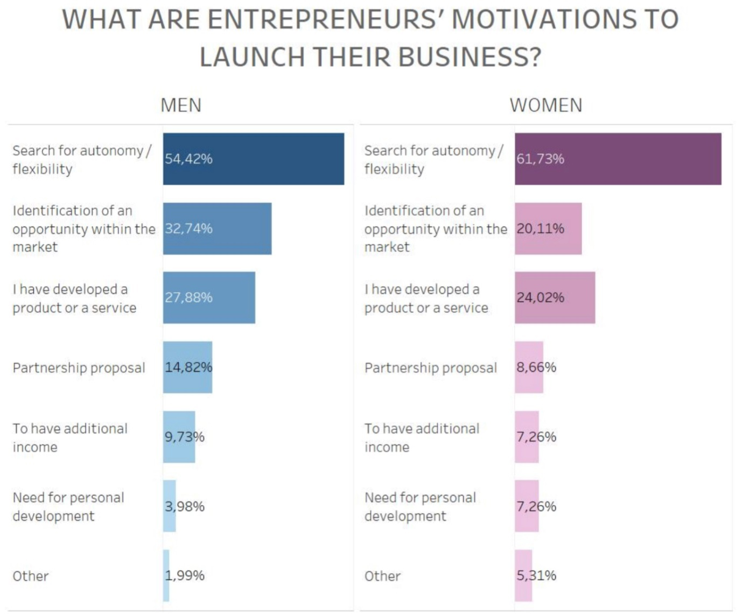
Diagram above sourced from Into the Minds: https://www.intotheminds.com/blog/en/entrepreneurship-diffeerences-women-men/

Age:
According to Geilnik, et al., (2018) academics, scientists, and politicians, have given thought to the question of whether “older or younger entrepreneurs have the greater advantage”. Alternatively, on one hand, older individuals have acquired human, social and financial capital for many years, that will have benefits in being able to start a business. And on the other hand, older individuals could lose the appeal to engage in the challenges of entrepreneurship. These debates can be merged into a lifespan, which puts-forward gains in human capital and losses in motivation which are two opposing age-relating forces which increase or decrease the plausibility of entrepreneurship. In view of these forces combined, analysts have put-forward that relations amongst the age and entrepreneurship adopts the path of an inverted U-shape (Levesque and Minniti, 2011; Minola, Criaco and Obschonka, 2016).
According to Geilnik, et al., (2018) as a matter of fact, analysis has uncovered that the relations amongst age and entrepreneurship is curvilinear and represents a maximal possibility of an age of about 45 years. The investigation into entrepreneurship through the lifespan has advanced a compelling and deeper understandings, even so, the lifespan view-point leaves out the theoretical aspects, which is both just as significant to comprehend the purpose of age entrepreneurship. They put forward their argument that inspecting not only entrepreneurship covering the lifespan, the age of which dissimilar steps of the entrepreneurial proceedings can move forward in a purposeful way, their theoretical apprehension of the path age play’s within entrepreneurship.
Furthermore, the analysis’s focus will theorise the age path in which are the entrepreneurial proceedings as well as the current hypotheses that merge the lifespan viewpoints of entrepreneurship. Additionally, the procedure viewpoint of entrepreneurship, is that entrepreneurship encompass stages which link opportunity identification, opportunity evaluation, also opportunity exploitation. In addition, making the transfer from one stage to another, entrepreneurs must carry-out various tasks. e.g., they must first highlight an opportunity, construct entrepreneurial objectives to take advantage of the opportunity, then in due course act on the opportunity. By merging the lifespan viewpoint, and the procedure viewpoint in entrepreneurship, we untwine the path of entrepreneurship and in the process link the progression between paths of entrepreneurship with various age-related attributes acquired through the lifespan development (Geilnik, et al., 2018).

Theories of Entrepreneurship Motivation:
According to Barba-Sanchez and Atienza-Shuquilla, (2017) linked to the theory of research on entrepreneurial motivation, their view is that the theory which effect this situation is known as (content-based motivational theories) furthermore, omitting all the required processes which connects how individuals make decisions links connections to (processed-based motivation theories). In addition, there are several theories for instance Expectancy Theory, which have tried to make sense in relation to an individual’s work performance, however, there are very few theories that connect entrepreneurship to employers. Furthermore, these studies normally address the psychological profiling that separates certain individuals from others. However, the research has revealed that entrepreneurs possess characteristics such as: a need for independence, a capacity to take risks, they are also ambitious, goal-focussed, and adopt a liking to innovation.
In addition, according to Barba-Sanchez and Atienza-Shuquilla, (2017) who explain in more detail about the Expectance Theory, which had also been called the Theory of Motivation, or the Rational Intention Theory, which are viewed as having great importance in view of how rational prioritisation stimulates the behaviour, in conjunction with the effects of individual purpose in regard to, motivation and gathering information and assessing alternative resolutions. Consequently, this situation sees individuals behaviour turn towards anticipation than towards impoverishment, which has been suggested by earlier theory that the basic needs of individuals are catered for. (word count 1263)
According to Xiaohua, et al., (2020) Mahto, et al., (2018) Staniewski and Awruk, (2019) Przepiorka, (2017), entrepreneurship is not just a major force for economic growth and industrial evolution, it is also for growth linked to employment possibilities, and the way in which individuals can accomplish growth particularly for economies that are in a state of transformation e.g., China. In addition, startups are usually the significant sources of economic growth in connection to emerging economies; hence, the support for entrepreneurship within developing countries are governed by strategic policies. Nonetheless, according to the Global Entrepreneur Monitor 2017- 2018 reports that in China, new startups survival rates are listed at being 5-25% or lower; and it is also noted that over half fall flat within a three-year period. Additionally, startups that are situated in developed countries, for instance the UK and others such as the US suffer similar fates, in which 7% of startups have yielded turnovers in-excess of £10,000.
Seemingly, entrepreneurship is surrounded by great unpredictability and is faced with increased failures. Furthermore, the unreliability to produce incomes and a heavy workload will witness many entrepreneurs quitting along the journey. Therefore, leaving only a relatively small amount, of newer entrepreneurs who will endure the journey to find success. Surviving or abandoning entrepreneurship is a predicament for newer entrepreneurs. Consequently, this leads to the fascinating conversation of: why do newer entrepreneurs pursue and last the test of time of entrepreneurship, even-though they face an unpredictable future, and in addition, how economic advantages are not that clear or obvious?
However, considering what the UK and the entire global community have all experienced with lockdowns, economic factors that have impacted on entrepreneurs in recent years are Brexit and the Corona virus lockdowns. According to .Gov (2021), lockdown prevented shipping of products overseas, but, allowed entrepreneurs to connect with a wider community of individuals due to the increase of internet usage, and start up businesses were also offered funding from the government to keep afloat. According to Terpan and Saurugger (2021), Brexit embedded new laws and regulations that have an effect on entrepreneurs and start-ups, such as the currency fluctuations, contracts, taxes, and cost-benefits, conventional economics, producing entrepreneurial actions with economic rationality, for start-up’s that managed to survive during the lockdown. (Xiaohua, et al., 2020; Mahto, et al., 2018; Lee and Kim, 2019).
In addition, there are non-economic motivational concerns that have an influence on entrepreneurial behaviours, according to various analysis. Scholars agree that emotions play a significant responsibility in regard to entrepreneurial cognition and mention, the way in which emotions influences entrepreneurial behaviour purpose. The entrepreneurial procedure is supported to a certain degree by positive and negative emotions; hence, emotions influences individuals confidence, therefore deciding entrepreneurial motivation (Xiaohua, et al., 2020; Sanchez and Sahuquillo, 2018; Alum et al., 2019).
According to Gundolf et al., (2017) the entrepreneurs motivations to start-up a business is very much likely to effect, their entrepreneurial behaviour, analysts on the subject seem to agree that entrepreneurship alongside innovation are interconnected, which has been so since the times of Schumpeter, (1934, 1942). Furthermore, because of these factors they are interconnected to one another, and are viewed as innovative and a significant factor of entrepreneurial behaviour, and in addition, a possible source which links competitive advantage, facilitating market entry, competitive positioning, also lastly business survival. In addition, there have also been suggestions that there are positive connections concerning innovation and entrepreneurial performance. Besides, a large segment of innovation is believed to be advanced through the smaller entrepreneurial businesses, this highlights their importance in connection to economic growth.

Part 2.
Support Systems for Start-Up Businesses:
According to Lee and Kim, (2019) the world-wide trend in start-ups has been around since the middle of 2005, and the fad is forecasted to remain this way. Furthermore, in 2018 start-up financial investments to the value of 99.5 billion USD have been amassed in the United States, and it is recorded to be the largest amount ever made, which equates to a 30% growth in 2017. In addition, global organisations in particular Google, Facebook, Uber, Airbnb, and others have initiated innovation for the transportation as well as the housing sectors, furthermore, the likes of Dropbox have made popular Cloud services, and Xiaomi and is mainly alluded to as the Apple of China. These organisations have all begun life as start-up’s and have gone on to increase their value considerably, to tens of billions of dollars, this has all taken place in a relatively short amount of time, and at the same time these organisations are all world renowned.
However, start-ups are known for their creation of current job’s. additionally, from the moment of the economic depression back in 2009, small and medium sized enterprises (SME’s) are said to have accumulated nearly 95% of businesses in OECD countries, (Organisations for Economic Co-operation and Development), and start-up’s bringing about the creation of nearly 60 to 70% of current jobs. Which is in line with current trends globally, and is the significance of start-up’s, to anchor new growth and to create jobs in this fashion. Furthermore, areas and countries such as Silicon Valley in the United States; Tel Aviv, Israel; also, London, UK all focus attention on highly developed start-up environments, and are viewed by other nations for being the start-up ecosystems (Lee and Kim, 2019: van Weele et al., 2018).
In addition, Japan have brought in laws that protect SME’s by reducing the minimum capital of incorporation, which was JPY 10 million to now JPY 1, which has initiated an increase for start-ups in 2002. In addition, angel investments for early-stage start-up’s, have risen notably to JPY 2.5 billion for 2015, also venture capital (VC) investment has also witnessed a rise of JPY 90 billion in 2016. Furthermore, when China began the economic development policy of “Widespread Entrepreneurship and Innovation” in 2015, this start-up frenzy snowballed right through China, which left the Chinese government to highlight the importance of “innovation through entrepreneurship” as the new growth engine. Besides, start-up’s, are generating an environment which makes matters that much easier for the obtainability of external finances, e.g., from venture capitalists, private individual investors, and governments, by way of subsidies, and grants etc, furthermore, when acquiring capital for expenses, in preference to utilising the owners own capital (Lee and Kim, 2019).
However, because of the global fad in connection to low growth, an increased social consensus which supports the growth of larger organisations, also SME’s are deemed inadequate to anchor new growth engines for economic development. Consequently, therefore, vital nations for instance the USA, Japan, also China are executing plans to put-in-place entrepreneurial alongside start-up development policies, in accordance with their own state of affairs. The United States, and the Obama administration have put-in-place a Start-up America initiative, that assists innovative entrepreneurs linked to the private sector and are continuously seeking out start-ups along-side venture capitalist investment, by introducing the 2012 JOBS Act (Jumpstart Our Business Start-ups Act) to assist finances for start-ups. Furthermore, the Trump administration have also issued administrative orders on deregulation and are continuously performing duties to support policies through the creation of the Office of American Innovation, within the White House Office. Also, many entrepreneurial ecosystems (state governments, universities, large corporations, investors, incubators, etc.) which are initiated in larger cities for instance, Silicon Valley, San Francisco, Silicon Alley, New York, Silicon Beach, Los Angeles, this significantly reinvigorates and furnishes the economic urban development (Lee and Kim, 2019).
However, according to Weele et al., (2018) who discuss the topic of technology start-up’s that are based in Europe, additionally, these start-ups play a tiny part of the actual entire population in consideration to small businesses, economic policy-makers and strategic thinkers, view these as relevant and significant drivers of employment already mentioned earlier, Furthermore, they are increasingly suffering with high failure rates, and it has been noted that at least one in three of western start-ups do not last beyond two years. Therefore, to counterbalance the risk connected with this challenge that start-up’s face, European governments are supporting new start-up’s through incubators: in addition, organisations which give start-up’s a wide range of services or resources required for ongoing growth potential. Furthermore, it has been calculated that at present there is over 1000 European incubators, 85% is said to be situated in Western European countries, and there has been a rise of fivefold. Appropriately, incubators are viewed as ‘the mainstays of high-technology industrial development in Europe’, and an institutionalized segment of Europe along with the other member states national innovation systems.
The determined attempts of Western European policy makers in the assistance towards start-up’s with incubators are in-line with current measures on the global stage, in terms of fads, furthermore, incubators have been on the rise, speedily so, on a global scale, which has witnessed a diverse worldly population of incubators, connected with start-up support initiatives, which dispenses a ‘humongous opportunity’ with incubators globally to acquire knowledge through one another and assist with the ability of self-help. This knowledge requires immediate attention, due to questions being raised in connection to the constructiveness of incubators, in Western Europe (van Weele et al., 2018).
Therefore, demonstrating countries on a global scale most definitely appreciate start-up businesses, and have all put systems in place to assist these businesses because of the growth they bring to all these countries mentioned above.

Recommendations for New Entrepreneurs:
Recommendations for new entrepreneurs, challenge yourself. According to Richard Branson, he believes the biggest motivator for him is the way he keeps challenging himself on a daily basis, he also approaches life as a learning educational event, in which he is able to increase his education (Patel, 2021).
Have a connection and care about the work you do, as a lot of time is needed running a business. For example, Steve Job’s believes that entrepreneurs are satisfied in life when they commit to work they believe in (Patel, 2021).
At all times a clear vision should be kept. e.g., David Karp (CEO of Tumblr) believes anyone with a vision and desire to develop something can be an entrepreneur (Patel, 2021).
To overcome fear, which is not easy, but must be faced. e.g., Arianna Huffington believes fearlessness can be related to a muscle due to, the simple fact that the more it is exercised, the stronger it grows and becomes (Patel,2021).
Word count in section 2 (1088)
Conclusion:

References:
Alam, M.Z., Kousar, S. and CH, A.R., (2019) Role of entrepreneurial motivation on entrepreneurial intentions and behaviour: theory of planned behaviour extension on engineering students in Pakistan. Journal of Global Entrepreneurship Research, 9(1), pp. 1-20.
Barba-Sánchez, V. and Atienza-Sahuquillo, C., 2017. Entrepreneurial motivation and self-employment: evidence from expectancy theory. International Entrepreneurship and Management Journal, 13(4), pp.1097-1115.
Eliyana, A., Rohmatul, S., Rohmatul, S., Sridadi, A.R., Razaq, A. and Gunawan, D.R., (2020) The role of motivation on attitudes and entrepreneur achievement. Systematic Reviews in Pharmacy, 11(8), pp.335-343.
Gielnik, Michael M, Zacher, Hannes & Wang, Mo, (2018) Age in the Entrepreneurial Process: The Role of Future Time Perspective and Prior Entrepreneurial Experience. Journal of applied psychology, 103(10), pp.1067–1085.
Gundolf, K., Gast, J. and Géraudel, M., (2017) Start-ups’ Innovation Behaviour: An Investigation Into The Role Of Entrepreneurial; Motivations. International Journal of Innovation Management, 21(07), p.1750054.
.Gov (2021) part of covid-19 business support. Available at: https://www.gov.uk/coronavirus/business-support (Accessed: 26. 08. 2021).
Hyuk, K.H. and Park, W., (2019) Impact of Entrepreneurial Business Start-up Motivation, Entrepreneurial Spirit, and Entrepreneurial Competence Characteristics on Start-up Companies' Sustainability: Focusing on the Mediating Effect of the Start-up Companies' Business Performance. Asia-Pacific Journal of Business Venturing and Entrepreneurship, 14(3), pp.59-71.
Into the minds (2021) entrepreneurship: 7 key differences between women and men. Available at: https://www.intotheminds.com/blog/en/entrepreneurship-diffeerences-women-men/ (Accessed: 26. 08.2021).
Kusa, R., Duda, J. and Suder, M., (2021) Explaining SME performance with fsQCA: The role of entrepreneurial orientation, entrepreneur motivation, and opportunity perception. Journal of Innovation & Knowledge.
Lee, W., and Kim, B., (2019) Business Sustainability of Start-Ups Based on Government Support: An Empirical Study of Korean Start-Ups. Sustainability, 11(18), pp. 4851.
Mahto, R.V. and MC Dowell, W.C., (2018) Entrepreneurial motivation: a non-entrepreneur’s journey to become an entrepreneur. International Entrepreneurship and Management Journal, , pp. 1-14.
Marijn, Rijnsover, F.,J., Eveleens, C.P., Steins, H., Niels, V.S. and Groen, M., (2018) Start-EU-up! Lessons from international incubation practices to address the challenges faced by Western European start-ups. Journal of Technology Transfer, 43(5), pp. 1161-1189.
Mersha, T. Sriram, V. (2019). ‘Gender, entrepreneurial characteristics, and success: Evidence from Ethiopia’, Thunderbird International Business Review, 61 (2), pp. 157-167.
Przepiorka, A.M., (2017) Psychological determinants of entrepreneurial success and life-satisfaction. Current Psychology, 36(2), pp.304-315. In Staniewski and Awruk, (2019).
Sánchez, V. B., and Sahuquillo, C. A. (2018, p. 4) Entrepreneurial behavior: Impact of motivation factors on decision to create a new venture. Investigaciones Europeas de Dirección y Economía de la Empresa, 18(2), 132–138. In Alam, et al., (2019).
Staniewski and Awruk, (2019) Entrepreneurial Success and Achievement Motivation – A Preliminary Report on Validation Study of the Questionnaire of Entrepreneurial Success. Volume. 101, p. 433 – 440.
Su, Xiaohua et al., (2020) To Be Happy: A Case Study of Entrepreneurial Motivation and Entrepreneurial Process from the Perspective of Positive Psychology. Sustainability (Basel, Switzerland), 12(2), p.584.
Tantau, A. D. Fratila, L. C., (2021) ‘Entrepreneurship, Start Up, and Corporate Entrepreneurship in Renewable Energy Industry, Anthology on Small Business Strategies for Success and Survival, pp.132-155.
Terpan, F. Saurugger, S. (2021) ‘Soft and hard law in times of crisis: budget monitoring, migration and cybersecurity’, West European Politics, 44 (1), pp. 21-48.
van Weele, M., et al. (2018) Start-EU-up! Lessons from international incubation practices to address the challenges faced by Western European start-ups. The Journal of technology transfer. [Online] 43 (5), 1161–1189.
S. Patel, (2021) 21 Success Tips for Young and Aspiring Entrepreneurs. Available at :https://www.entrepreneur.com/article/247540 (Accessed: 26. 08. 2021).
Arianna Huffington, (2019) Twitter. Available at :https://twitter.com/ariannahuff/status/1130444368740012033?lang=en (Accessed: 26. 08. 2021).
Murnieks, C.Y., Klotz, A.C. and Shepherd, D.A., 2020. Entrepreneurial motivation: A review of the literature and an agenda for future research. Journal of Organizational Behavior, 41(2), pp.115-143.

Appendix: 1.
Entrepreneurial motivation, linked to emotions:
Additionally, scholars have highlighted the fact that positive emotions (for instance, happiness) towards entrepreneurial behaviour. Happiness determines entrepreneurial actions, in conjunction with individual entrepreneurial keenness provides to opportunity identification and fruitful utilisation of opportunities. However, current analysis on the topic of subjective benefits of entrepreneurship, in-particular the effects of positive emotional knowledge on entrepreneurship tenacity, are non-existent. Thus, to comprehend the motivation and continual power source of entrepreneurship, the techniques selected in dealing with the increased risk of failure of entrepreneurship and the systems of positive emotions in dissimilar entrepreneurial moments require immediate attention (Xiaohua, et al., 2020; Sanchez and Sahuquillo, 2018; Alum et al., 2019).

References & Appendix word count totals (714)

