PROJECT CONTROL & CONTRACT ADMINISTRATION

ALTERNATIVES TO TRADITIONAL PROCUREMENT

The senedd and holyrood

KERRI FARMER 2100037

CONTENTS

Introduction pg.3
THE SENEDD PG. 5
HOLYROOD PG. 7
conclusion PG. 9
references PG. 11

INTRODUCTION
Procurement in construction, is no different to procurement in other industries. Procurement is “the process of obtaining goods or services, typically for business.” In construction this process is securing all the services and goods required for a project to complete it. The success of the project is dependent on how the procurement process is overseen.
Typically, there are four procurement methods used in construction, traditional contracts, design and build contracts, management contracts and contractor led contracts (Pagabo, n.d).
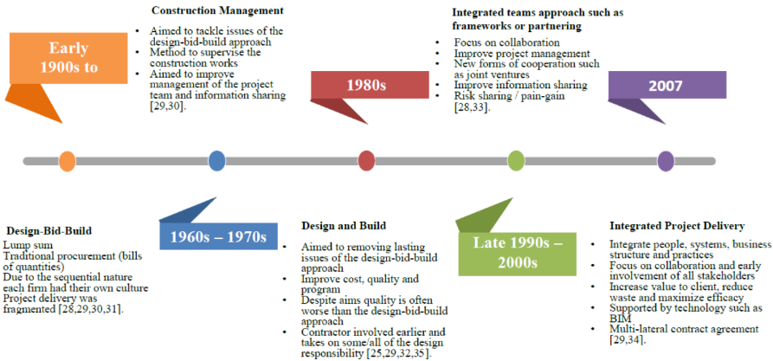
Below is a graphic showing how the different procurement routes have developed in the construction industry.

Figure 1 Timeline on Procurement in Construction (A Case Study of a Negotiated Tender within a Small-to-Medium Construction Contractor: Modelling Project Cost Variance, 2021)
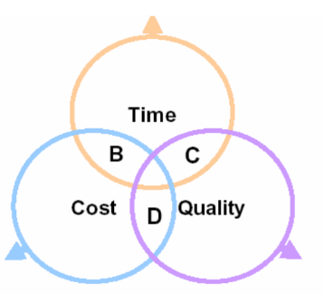
Developing a procurement strategy in construction, is based on risks, the risks include a project that does not meet the client’s needs, delivered late and over budget. The risk evaluation therefor is based on three objectives which need to be balanced: time, cost, and quality.

Figure 2 Two of the three criteria identified as most important B, C or D (Constructing Excellence, 2004)

We will be looking at two iconic buildings in this essay The Senedd (Wales) and Holyrood (Scotland) their procurement processes and failures within the process and construction.
The Senedd Wales parliamentary building was opened by Queen Elizabeth II on St David’s day in 2006, it cost almost £70million and one of the most environmentally friendly parliament buildings in the World, rainwater collection from the roof is used to flush the toilets, it has a biomass boiler and has a design life of 100 years. The design was completed by Rogers Stirk Harbour and Partners (ITV News, 2015).
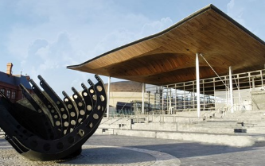

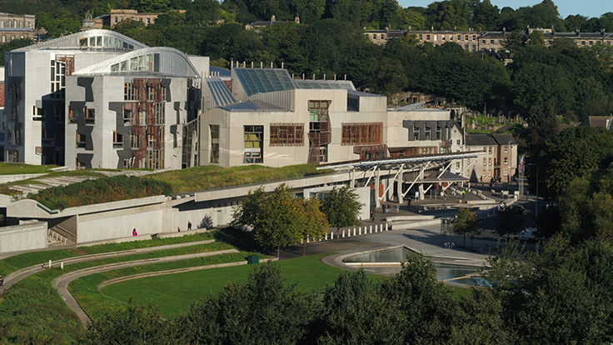
Figure 3 The Senedd (Senedd Cymru Welsh Parliament, 2021)

Figure 4 Holyrood Scotland (The Scottish Parliament, n.d)
The new parliament building Holyrood is situated at the lower end of Royal Mile, next to Holyrood Park. The Holyrood was designed by architect Enric Miralles, who never got to see the completed plans as he passed away. It was a very controversial design due to its modern style which does not match the Edinburgh’s Old Town. The Holyrood was completed 3 years late and ten times over budget with a total completion cost of £400 million. (City Explorers, n.d)

THE SENEDD
The Senedd was procured on a design and build contract. The project timeline was as follows 1998-2001 - A decision was made to locate the Senedd in Cardiff Bay this was made by The Right Honourable Ron Davies MP; the land was acquired for a nominal fee of £1 on a 150-year lease. Following this decision there was a competition to design the building which was won by Sir Richard Rogers. In 2001 - groundwork began, after an approval on the revised design. 2002 – an invitation to tender was issued for a design and build contract. 2003 – work on the Senedd’s foundations began after Taylor Woodrow consortium won the design and build contract, by 2004 work commenced on the plenum slab and by the close of that year the roof was assembled. 2005 – IT installations began after the large windows were fitted and in 2006 works were completed (Senedd Cyrmu Welsh Parliament, 2021).
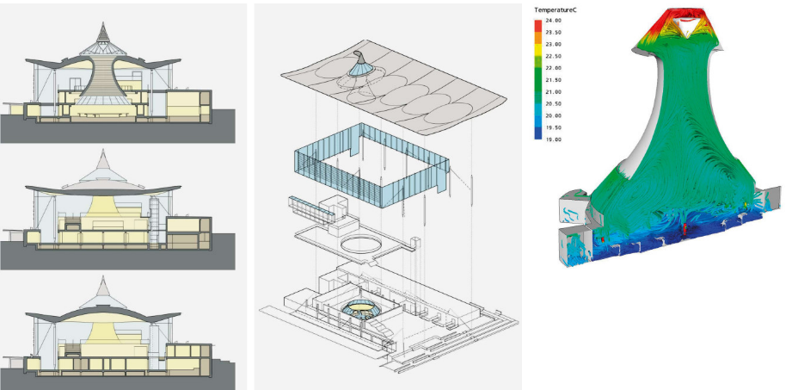
Due to the Senedd being a public funded project cost certainty is of utmost importance when evaluating the risk and procurement method. The project was originally a project management procurement route, but this does not give any cost or time certainty therefor the procurement method was reviewed and commissioned under a design and build fixed price contract (RSHP, n.d).
Figure 5 Design features the Senedd natural airflow (RSHP, n.d)
Some controversy came with the Senedd construction where contributing architect Lord Richard Rogers was fired by the Welsh Government and then re-hired due to works not commencing for two years. The construction of the Senedd was delivered in two phases by two contractors and it had concerns over the rising costs. The architects were rehired in 2003 the same year the original operational dates of the building were set for. The Welsh Government withheld fees at one point, the Welsh finance minister Edwina Hart tried to claim £6.9 million in damages, this case was eventually dismissed, Cardiff Bay politicians had grossly underestimated the complexity and cost for the show piece Senedd building.
The original budget for the showpiece Senedd building was £12 million (1997), the project completed and delivered at £69 million (The National For All Of Wales, 2021).
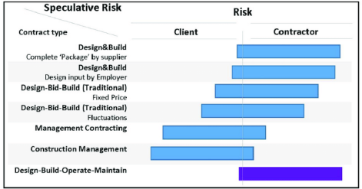
The original budget for the Senedd was a total of £27 million, Richard Rogers Partnership was contracted to manage the £13.8 million estimate on building costs. Confusion came in where the architect understood that the consultant’s fees and fit out were not part of the sum. When preliminary costs were reported to the assembly it raised alarm bells. The assembly then hired quantity surveyor Symonds Group to report on the project with a conclusion of the project costing £40 million plus (Gardiner, 2001).
Figure 6 Indicative Risk (Research Gate, 2015)
Design and Build procurement is a lump sum agreed price where the main contractor is responsible for the design and construction of a project. This can vary depending on the the amount of initial design that would be included in the employers requirements and initial design input. The contractor requires adequate time to submit their tender price and proposal (JCT, n.d).
In the end after the procurement method was changed to fixed price design and build in 2003 with the total cost estimated at £66 million the Senedd was eventually completed and delivered. The previous estimates in the original estimates were due to a number of factors which included robustness in estimates, changes in specifications, (increased security measures required after 2001 attacks in the USA) incomplete designs, and cost increases.
The project when it restarted again there were sufficient measures now in place to control the costs of the project. However when the re-tendering went to market there was an extremely poor response with only two companies submitting formal tenders, Taylor Woodrow and David McLean, to add to the complications David McLean did not comply with some stipulated requirements.
Other delays on the re-start of the project was damaged information and communications techonology equipment, this caused a 6 month delay.
Another factor affecting the additional uplift in costs was the time between initial esitmates and the signing of the contract with the contract Taylor Woodrow. Due to the risk mostly being allocated to the contractor in Design and Build procurement, with cost certainty the contractor is likely to seek cover for any cost overruns it incurs, these risks are factored into their cost. The pre-2002 phase of the Senedd project took time as the most important risk and consideration, and not the complexities and cost of the project (National Assembly for Wales Audit Committee, 2008).
In summary looking at figure 6 on page 6, indicating the risk allocation depending on the procurement route chosen oringally all the risk lay on the client, with the main issue being the rising costs of such a landmark building, this did not make any sense to use this procurement route, originally time was the only factor or risk, but this procurement route could lead to extensive uplift in costs on the project as there is no definite figure from the outset, there was just an estimated total budget. The re-evaluation on the procurement route and design and build lump sum procurment for the way forward was the correct decision to make with a building of this maginitude and new sustainability technologies used. After the initial mistakes and lessons learnt the project came in more or less on time and within budget. Which is the aim of the design and build lump sum route. The choice of contracts chosen was the NEC3 family of contracts design and build, this type of contract is more collabertive management tool which means even though the risk allocation under design and build was on the contractor the entire project team including the client would work collabortively.

holyrood
A basic summary of the timeline of the construction of the Holyrood Scottish Parliament building went as follows; 1997 – December shortlisting of possible sites, and a exhibition of shortlisted sites in Edinburgh and Glassgow. 1998 - January a site was selected and designer competition was launched, by March there were 70 submissions received for the desing competition and 12 were selected for interviews. April archeological works began on site and cost consultants were appointed a first draft was also issued. May that year 5 practices were preparing and submitting their conceptual ideas. July Designers were selected and appointed Enric Miralles y Moya and RMJM (Scotland) Limited architects, in September the site was officially purchased 1998 – October demolition works began. 1999 – The main construction works began on the site. 2000 – Death of the architect Enric Miralles. 2003 – June an investigation began into the costs of the Holyrood building project. 2004 – October the official opening of the Holyrood Scottish Parliament building (The Scottish Parliament, n.d).
On the 21st April 1997 there was an estimated overall capital cost of £24.5 and £34 million for the purchasing and refitting the New Parliament House. See figure 7 of the original figures that were given to the first Ministers.
The origins of the initial figures could not be verified and there was no evidence on what the £10 million figure was intended to cover exactly. Please see tabled extract from the enquiry below.
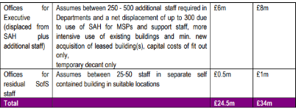
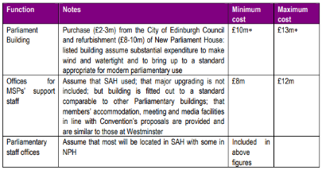
Figure 7 tentative figures briefing provided to first Ministers tabled above
There was then a figure of £40 million from Mr Wyllie in 1997 this clearly indicated the inclusion of professional fees, fit out plust furniture, and VAT but this was also contradicted where he had claimed does not include site works, fit out and VAT.
August and September of 1997 Doig & Smith Chartered surveyors were commissioned to produce costings at the various sites. Indicative estimates ranged from £54 - £71.2 million.
After the selected architects were appointed, there were no legal arrangements in place, therefor the proposed joint adventure between both parties had no contractual validity. The project moved forward without any due dilligence and collatoral warranties undertaken.
There were also miscalculation errors made in the breif on the area of the building.
The procurement route chosen for the Holyrood was construction management. Using traditonal design the design is almost complete prior to construction work being issued for tender. With construction management procurement route the design, tendering and construction work can overlap. The client appoints a management contractor separate from a designer, the management contractor manages work packages with subcontractors and programe of works. This form of procurement can be advantagous with time but there is no price certainty. As shown in figure 6 page 6 construction management procurement the entirety of the risk almost lays all on the client.
It is clear within the Holyrood inquiry none of the risks identified in construction management were evaluated and mitigated. The construction manager is a consultant and co-ordinator it is important to note they are not the main contractor.
There is evidence that too much consideration was placed on the site selection rather than the actual procurement route analysis. The choice to use construction management is minuted by Mr Brown on the 6th February 1998 as using a traditional procurement route would delay completion to around the end of 2002.
Initial draft estimates, although produced with inadequate information by the quantity surveyor concluded that the £50 million budget would be significantly exceeded.
There was a major decision made that to seek additional budget risk allowances would be irrisponsible and cause for fee increases and delays.
The project manager was handed over a completely new design in March 1999 and had to start again. There were difficulties attaing the amended layout drawings (Fraser, 2004).
The Holyrood opened its doors three years later than planned and ten times over the original budget planned. There were endless issues and contraversy from the start from the location of the site, the architects appointment, the project manager, and evidently the budget and procurement routes chosen. In conclusion there does not seem to be one specific pin point to lay blame on the failure of the Holyrood but an accumulation of factors going wrong, one of the biggest factors was the choice of procurement method, this left the entire risk on the client and no risk management and mitigation was completed prior to selecting the procurement method. It was done without much thought and due deligence, this is a major error in a project that was very complex.

conclusion
Choosing the correct procurement route is of great importance right from the outset of a project, as evidenced in the Senedd project, had the correct procurement method been used right from the start, there would never have been such a delay in completion and other complications that arose. The fact that they could identify that this route was not going to work and re-evaluated, and opted to change procurement route, effectively saved the project and the Senedd was built on time and within budget in the end. With regards to the Holyrood project, it is a clear example of how badly things can go wrong without following the correct methods and selecting procurement based on proper evaluated risks, not much was investigated with regards to the risks and best procurement route to select. It was based on almost one statement alone without looking at any mitigation, advantages and disadvantages. Should the Scottish Parliament had taken on a different approach and due to their lack of experience within the parliament had they employed other more experienced consultants, they could of completed this project with much better end results.
Although traditional design led procurement method could of worked for both parliament buildings, due to the lack of expertise and experience within both the Welsh and Scottish led teams, this method is suitbable for complex projects where you are looking for quality design development with cost certainty but time would have been the risk factor. The risk lays mostly on the contractor and not the client. This also seperates the design completely from the construction (which is the main disadvantage), and the architect and design team are appointed to the client directly, this method is well known with contractors and how the process works. The architect is the lead consultant therefor the quality of the project is at the forefront.
With design and build procurement this method is aimed at collaboration of the teams involved in the project. Where the contractor takes the main role being the one point of contact. This method leaves all the risk on the contractor and not the client, as they are the only appointed party to the client. This route makes payment easier and simple due to you only having to make one payment. However there is a risk of reduction in quality.
Contract management is the type of method used for developers who have a wide selection of in house or experienced teams on board, the main advantage is cost to this method due to there not being a main contractor, this method however is extremely risky due to the complexity of the route and most of the management and risk lay on the client (Vita Architecture, 2020).
Selecting a procurement method is not a simple task to and can not be decided on a whim, there are various risks and objectives to take into account and evaluate. There needs to be essentially enough time for the planning and design stages, especially considering big complex designs and projects. Risk management and mitigation is extremely important as well as good record keeping and paper trails for auditing purposes. This became evident in the Holyrood inquiry report conducted. There was no control from the client side in managing the risks and with construction management this is vital as the risk lays almost soley on the client. Complete lack of experience also played a role in the failure of the Holyrood project. When there is a lack of knowledge and experience it is essential to adjust your risk strategy to lay risk with more qualified personnal that can deal with the risks.
In conclusion, the Senedd possible failure was identified and averted in turn making a success of the construction project, while the Holyrood although choosing the wrong procurement method let it roll and instead of dealing with the risk and managing the risks as they arose, they accepted the cost of the risk being over run on budget and delivered late. A traditional lump sum procurement would have probably averted all the failures.

Word count: 2774

references

A Case Study of a Negotiated Tender within a Small-to-Medium Construction Contractor: Modelling Project Cost Variance (2021).
City Explorers, n.d. City Explorers Tours. [Online]
Available at: https://cityexplorerstours.com/edinburgh-travel-guide/scottish-parliament
[Accessed 10 December 2022].
Constructing Excellence, 2004. Constructing Excellence. [Online]
Available at: https://constructingexcellence.org.uk/wp-content/uploads/2015/03/procurement.pdf
[Accessed 10 December 2022].
Fraser, T. R. H. L., 2004. Scottish Parliament Archives. [Online]
Available at: https://archive2021.parliament.scot/SPICeResources/HolyroodInquiry.pdf
[Accessed 11 December 2022].
Gardiner, J., 2001. What went wrong?. [Online]
Available at: https://www.building.co.uk/news/what-went-wrong/1012731.article
[Accessed 10 December 2022].
ITV News, 2015. Senedd awarded Trip Advisor Certificate of Excellence. [Online]
Available at: https://www.itv.com/news/wales/update/2015-06-12/ten-facts-about-the-senedd/
[Accessed 10 December 2022].
JCT, n.d. Corporate JCT Ltd. [Online]
Available at: https://corporate.jctltd.co.uk/products/procurement/design-and-build/#:~:text=Design%20and%20Build%20procurement%20works,an%20agreed%20lump%2Dsum%20price.
[Accessed 10 December 2022].
National Assembly for Wales Audit Committee, 2008. Senedd Wales. [Online]
Available at: https://senedd.wales/media/55gnbpbl/cr-ld7285-e-english.pdf
[Accessed 11 December 2022].
Pagabo, n.d. Pagabo. [Online]
Available at: https://www.pagabo.co.uk/guide-to-construction-procurement#:~:text=Procurement%20is%20simply%20the%20process,a%20construction%20project%20to%20completion.
[Accessed 10 December 2022].
Research Gate, 2015. Research Gate. [Online]
Available at: https://www.researchgate.net/figure/Indicative-risk-allocation-Source-Davis6-2008_fig3_284096467
[Accessed 10 December 2022].
RSHP, n.d. RSHP. [Online]
Available at: https://rshp.com/projects/civic/senedd-cymru-welsh-parliament/
[Accessed 10 December 2022].
Senedd Cymru Welsh Parliament, 2021. Senedd Wales. [Online]
Available at: https://senedd.wales/visit/our-estate/the-senedd-a-landmark-building/
[Accessed 10 December 2022].
Senedd Cyrmu Welsh Parliament, 2021. Senedd Wales. [Online]
Available at: https://senedd.wales/visit/our-estate/senedd-at-15/
[Accessed 10 December 2022].
The National For All Of Wales, 2021. The National. [Online]
Available at: https://www.thenational.wales/environment/19795023.architect-richard-rogers-designed-senedd-died/
[Accessed 10 December 2022].
The Scottish Parliament, n.d. Parliament Scotland. [Online]
Available at: https://www.parliament.scot/
[Accessed 10 December 2022].
The Scottish Parliament, n.d. Parliament Scottland. [Online]
Available at: https://archive2021.parliament.scot/visitandlearn/16333.aspx
[Accessed 11 December 2022].
Vita Architecture, 2020. Vita Architecture. [Online]
Available at: https://vitaarchitecture.com/journal/the-3-main-procurement-routes-explained/
[Accessed 7 January 2022].

