
APPENDIX GA36a

LEVEL 4 ASSESSMENT SPECIFICATION

Student name: | Sarah Louise Hoffmann | Student ID number: | 2315599
Programme: | BA Business Management
Module: | Marketing Fundamentals
Module code: | BMBM4005
Assignment Title: | Essay: An Evaluation of Marketing | Word count (or equivalent): |  | 1,500

Module Learning Outcomes
(from module syllabus)
- Identify the elements of the marketing mix and apply them to satisfy customer needs;
- Evaluate the role and function of marketing in driving success and delivering results;
- Identify factors and trends in the marketing environment and how they affect marketing planning.

Content Page
Contents

Figures 1 and 2..…………………………….……..…………………………………………………………………1.
Introduction ..…………………..………………………… 2
An Evaluation of Marketing ………………... 3
Conclusion ..…………………………….……..………………………………………………………………… ….6
References ………………………………………………. 7

List of Figures

Figure 1 - SMART model - 1 -
Figure 2 - SMART model - 1 -

Figures 1 – The 7Ps of the Marketing Mix

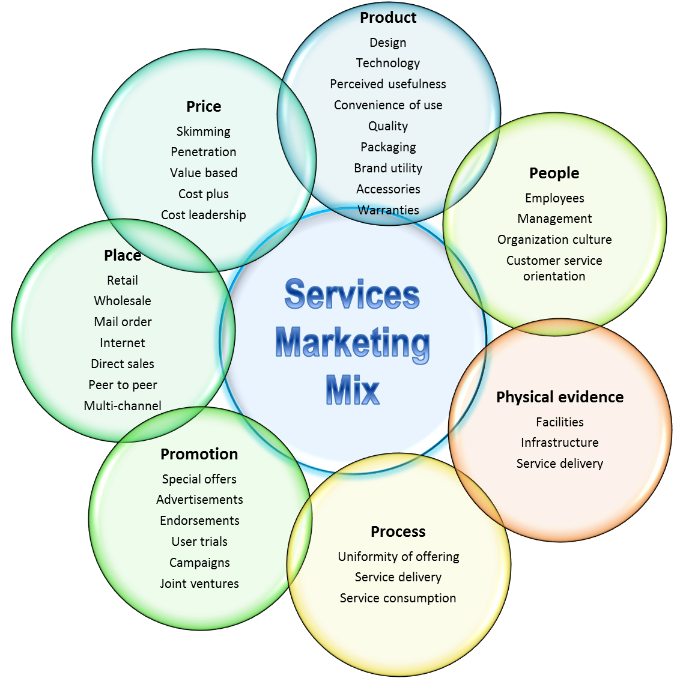

Figure 2 – The PESTLE Analysis

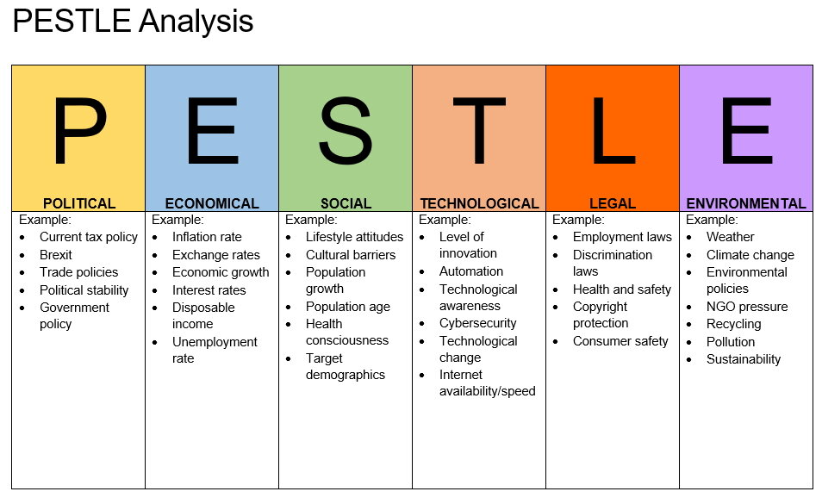

Introduction

Whether we agree with it or not, marketing is all around us. There are multiple forms of advertising which have developed over time. By far the most successful form of marketing is digital. According to Kotler and Armstrong 2021 Principles of Marketing, p.42, more than four billion people which is equivalent to 55% of the world’s population are now online. Digital and social media marketing includes tools such as websites, social media platforms, mobile ads, pops ups, online videos and blogs. Almost every company is reaching out to customers in order to successfully engage with their customers with multiple websites, Facebook and Instagram posts, tweets and blogs. A company that has been successful with engaging with their consumers online is beauty giant Sephora known as “the world’s largest beauty forum”. They have created an online community where costumers can ask questions, share their makeup and beauty ideas and tips, post reviews, post before and after photographs from using the Sephora products as well as receiving inspiration from other enthusiasts using the brand. Even influencers on TikTok create powerful videos promoting the brand using a hashtag or tagging the company into the posted videos and blogs.

Before digital marketing, this would not have been able to have been achieved as there would be no instant engagement from leaving a review in a magazine or newspaper. Nowadays you would struggle to find a brand or company who do not feature links to their social media outlets such as Facebook, Instagram, X (formerly Twitter). Facebook alone has over 2.3 billion active monthly users with Instagram just behind with more than one billion.

An Evaluation of Marketing

Previous generations will remember nostalgic tv adverts. For companies this was the most successful form of advertising. According to Kotler, P. 2021 p.42, latest trends will now show that the most successful form of advertising is social media. The likes of Facebook, Instagram, YouTube, TikTok and Twitter posts are able to reach out to such a wide audience and unless sponsored or paid advertising, then these can be posted/listed for free. Social media influencers also play a huge part of advertising. A successful influencer will post or blog about a certain product which could then go viral within minutes. Such marketing strategies were not available years ago.

When a company posts online using social media, they have on their platforms such functions to assist companies evaluate how successful their marketing campaign is. Functions such as signing up to the website to receive a percentage discount is an order is placed, signing up with an email address to receive regular updates about the company or product.

Using the PESTEL analysis, companies must ensure that their marketing posts are relevant Brands will plan as strategy around where they are now and where do they want to be and how do they get. One way to describe this process is to illustrate how is can be implemented into an everyday scenario. For example, if a person wanted to start a healthy lifestyle plan and their goal would be to lose weight, reduce their cholesterol intake then using the best possible strategy to optimise their progress would be to track with regular updates and keep a record up to date with weigh gain or loss and keep track if they are on target to achieve their weight gain. Use always the SWOT analysis with PESTEL

Digital marketers would use the SWOT analysis (strength, weakness, opportunities, and threats to evaluate how best to advertise a brand or product within the PESTEL analysis. A SWOT analysis is designed to facilitate realistic, fact-based, data-driven look at the strengths and weaknesses of an organisation or initiatives in this case Tesco.

For example, Tesco are one of the top supermarket leaders. So using the SWOT analysis as follows:-

Category | Description
Strengths | Characteristics of a business that give it a relative advantage over its competition which is the clubcard. Tesco would use the data collected from usage of the clubcard to monitor and keep track of the cardholder’s purchases, their buying habits, when they shop how much they spend etc. Valuable data which can then be tailored to suit each individual customer and Tesco can use this as a way of capturing data.
Weaknesses | Characteristics of a business that put it at a relative disadvantage compared to its competition being Aldi or Lidl. These supermarkets are considerably cheaper and sell non-branded products but do not have a loyalty scheme in place.
Opportunities | Elements of the external macro environment that management can scan upon to improve their business performance. Examples of this can be seen from how Tesco adapted quickly and put in place measure during the covid pandemic. Additional drivers were employed to delivering customers; shopping to them during the covid lockdowns. Click and collect was expanded. Tesco and the main leading supermarkets were quick to implements these measures.
Threats | Elements of the external macro environment that may endanger a firm’s competitive advantage. These can be seen can by other supermarkets having deliveries direct to your house or click and collect facilities. Tesco have tried to stay ahead by promoting their clubcard promotions. Yellow clubcard sticker prices can be seen around the store promoting the fact that if customers use their existing or sign up to a clubcard then they are able to purchase products at a cheaper price. This are all time based and can change from week to week. All the while in the background Tesco are storing marketing data to keep on to of the market space and segmentation in order to gain a competitive advantage over other supermarkets. This element can also be affected by the PESTEL analysis paying close attention to the legal aspect of the model. Tesco and indeed all supermarkets are bound by law so when regulations were put in place on the selling of cigarettes, increasing age restrictions, limiting amount of alcohol purchased, sugar tax on fizzy drinks then supermarkets have no control over this and have to comply with the law. They have no control over outside threats.

Conclusion

Marketing attributes to all aspects of a business from product development, distribution of products, sales, and advertising. Marketing is a process of getting people to notice and remain interested in your business. Through market research, businesses have a better understanding of customer’s needs and interests.

Digital marketing has rapidly grown over the years and has revolutionised the way companies promote their brand, products, and services. Involving the use of electronic media to reach their customers and promote new and existing products.

Digital marketing has become increasingly important in recent years particularly through lockdown as people were at home and online more than ever before. Companies are able to reach a far wide target audience and pint point specific demographics more effectively than what ever could have been achieved through TV advertising making it the most cost-effective form of marketing which is an appealing option for businesses regardless of their size or budget. Digital marketers are able to capture in real-time the effectiveness of marking campaigns as soon as social media post is uploaded.

Once a social media post is uploaded, digital marketers can then monitor the feedback from the post and in turn advise if the business needs to change their strategy if they need to improve their results. Being able to track their customer’s behaviour and preferences, business can tailor their marketing posts to specific audiences. For example, if a post is uploaded late in the evening, would it capture more of a target audience as opposed to if the post were submitted earlier in the day after the work/school commute?

In conclusion then, it can be agreed that digital marketing is a very powerful tool that can assist businesses to reach new customers, retain their loyal customers and grow their sales. To be successful, businesses must stay up-to-date with the latest trends and technologies so that they can stay competitive and achieve their goals effectively.

References

Adam, S., Mulye, R., Deans, K.R. and Palihawadana, D., 2002. E‐marketing in perspective: a three country comparison of business use of the internet. Marketing Intelligence & Planning, 20(4), pp.243-251.

Armstrong, G., Adam, S., Denize, S. and Kotler, P., 2014. Principles of marketing. Pearson Australia.

Baines, P. and Fill, C., 2014. MARKETING 3E P. Oxford University Press, USA.

Baker, M. and Hart, S., 2008. The marketing book. Routledge.

Brown, D. and Hayes, N., 2008. Influencer marketing. Routledge.

Campbell, C. and Farrell, J.R., 2020. More than meets the eye: The functional components underlying influencer marketing. Business horizons, 63(4), pp.469-479.

Jaswal, R., 2021. Augmented Reality's Effect on Online Cosmetics Consumer Purchasing Patterns: A Study on Virtual Artists at Sephora. Turkish Journal of Computer and Mathematics Education (TURCOMAT), 12(12), pp.730-737.

Jin, S.V., Muqaddam, A. and Ryu, E., 2019. Instafamous and social media influencer marketing. Marketing Intelligence & Planning, 37(5), pp.567-579.

Kotler P., Armstrong, G., Oprensnik, M,. 2021. Principles of Marketing. Pearson Education Essex.

Kotler, P., Burton, S., Deans, K., Brown, L. and Armstrong, G., 2015. Marketing. Pearson Higher Education AU.

Kotler, P., Kartajaya, H. and Setiawan, I., 2021. Marketing 5.0: Technology for humanity. John Wiley & Sons.

Kotler, P. and Lee, N., 2008. Social marketing: Influencing behaviors for good. Sage.

Kotler, P., Lee, N., Farris, P.W., Bendle, N., Pfeifer, P., Reibstein, D., Light, L., Kiddon, J. and Reece, M., 2010. Marketing Strategy from the Masters (Collection). FT Press.

Kundu, S., 2021. Digital Marketing Trends and Prospects: Develop an effective Digital Marketing strategy with SEO, SEM, PPC, Digital Display Ads & Email Marketing techniques.(English Edition). BPB Publications.

Leung, F.F., Gu, F.F. and Palmatier, R.W., 2022. Online influencer marketing. Journal of the Academy of Marketing Science, pp.1-26.

Melewar, T.C. and Gupta, S., 2017. Strategic international marketing: an advanced perspective. Bloomsbury Publishing.

Skålén, P., Fougère, M. and Fellesson, M., 2007. Marketing discourse: A critical perspective. Routledge.

Strauss, J. and Frost, R., 2014. E-marketing. Pearson.

Wang, C.L. ed., 2023. The Palgrave handbook of interactive marketing. Springer Nature.

Wilson, R.M. and Gilligan, C., 2012. Strategic marketing management. Routledge.

