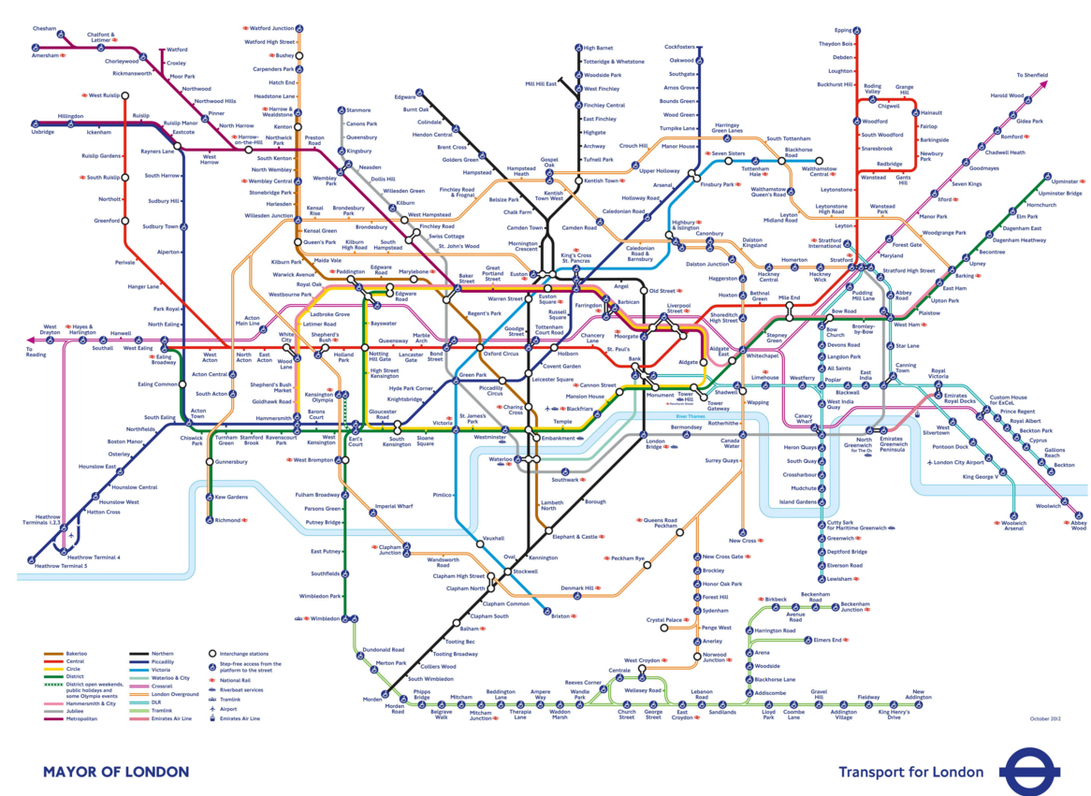

Strategic Travel and tourism management -
the impact of crossrail
25-11 2017
By Jessica Harrison – P140704

1.0 Executive Summary
1.1 Introduction………………………………………………………………………………………...1
2.0 The impact of crossrail in London………………………………………………………….....1
2.1 The threat of Entry………………………………………………………………………………..2
2.2 The threat of substitutes………………………………………………………………………...3
2.3 The bargaining of power buyers……………………………………………………………….3
2.5 The bargaining power of supplier……………………………………………………………...4
2.6 The extent of rivalry between existing competitors………………………………………..5
3.0 Value………………………………………………………………………………………………...5
3.1 Rarity………………………………………………………………………………………………..6
3.2 Inimitability…………………………………………………………………………………………6
3.3 Organizational Support…………………………………………………………………………..7
4.0 Case study on how the cross-rail has an effect on Wembley Stadium…………………7
4.1 The threat of entry within the Wembley Stadium……………………………………………7
4.2 The threat of substitutes from cross-rail to Wembley Stadium………….……………….7
4.3 The bargaining of power buyers from cross-rail to Wembley Stadium….……………..7
4.4 The bargaining power of suppliers from cross-rail to Wembley Stadium……………...8
4.5 The extent of rivalry between existing competitors for cross-rail linking to Wembley Stadium………………………………………………………………………………………………….8
5.0 The Value within cross-rail to the Wembley Stadium………………………………………8
5.1 The rarity of the cross-rail within Wembley Stadium………………………………………9
5.2 The Inimitability of cross-rail within Wembley Stadium…………………………………...9
5.3 The Organizational support from cross-rail to Wembley Stadium………………………9
6.0 Recommendations………………………………………………………………………………10
7.0 Conclusion………………………………………………………………………………………..10
8.0 References………………………………………………………………………………………..11


THE ELIZABETH CROSSRAIL LINE AND CASE STUDY OF WEMBLEY STADIUM

Executive summary
Throughout the report it will show porters 5 summaries and a VRIO summary on how cross-rail is effecting travel and tourism within London and then a summary of the 5 porters point and the VRIO summary on how Wembley stadium is being affected.
1.1 Introduction
Crossrails aim is "To deliver a world-class railway that fast-tracks the progress of London" (Crossrail, 2017)
First described by Michael Porter in his classic 1979 Harvard Business Review article, Porter’s insights started a revolution in the strategy field and continue to shape business practice and academic thinking today. A Five Forces analysis can help companies assess industry attractiveness, how trends will affect industry competition, which industries a company should compete in Porter. M (2017)

2.0 THE IMPACT OF CROSSRAIL IN LONDON
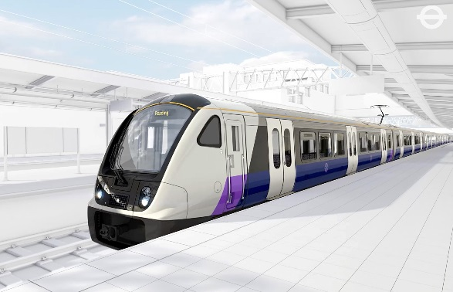
The new Elizabeth Cross rail line is going to have both a negative and positive outcome on London itself within the travel and tourism industry and it will affect people and places within London a lot. In Porters five forces, threat of new entrants refers to the threat new competitors pose to existing competitors in an industry. Therefore, a profitable industry will attract more competitors looking to achieve profits. (Wilkinson.J, (July 24, 2013)
PAGE 1
2.1 The threat of entry
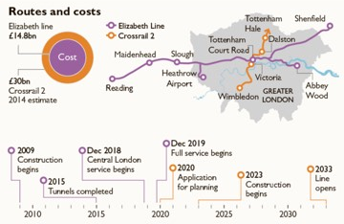
The threat of entry within the cross rail is quite low due to the fact that it is the only line made in the UK and it would take a lot for other distributes to have an effect on this. By having the new cross rail it is going to have a price tag of £14.8 Billion just to make and have it running. This is a huge cost and the cost has been split into a third where a third is paid by the central government, another third from Transport for London and the other third is split up between their sponsors. The cross rail had to go through many procedures before it could have the go ahead to start building this line, they allowed local people to put in proposals of their views on the cross rail so this is where they had to meet the needs of local people and do an alternative for them to make sure that they could still go ahead with the cross rail, but also make the local people happy at the same time. The cross rail had to have a Hybrid bill from the parliament and to be granted it by the Queen before going ahead. By having cross rail they have come across some damage along the way to places in the areas they are working underneath or have come across such as some flats or houses and shops the damage of them have come to around £5000-£10,000, but they have also had to pay out from their insurance to places up to £1Million due to a massive crack in the ceiling of a historical church that they had damaged while building the Elizabeth Line. Within the network for the cross rail it is the sponsor of Network Rail that so all the surface work for the new line. To do the new line they had 23 interfacing contracts that they had to do. (CGMA, (2017).

PAGE 2
2.2 The threat of substitutes
The threats of substitutes are quite low for the new Elizabeth Line due to they are in company with most the lines running and for the cross rail to work to its potential it will benefit the other lines along with itself due to the new line having the capacity of 1,500 per train and along with that there are a total of 900 trains under the Transport for London so this brings a huge impact and relief for London and visitors. The other substitutes that visitors have are buses that there are 9,200 of under the Transport for London and most people use these for the short journeys that they need to get to or for people that are not confident enough to use the tubes and rails but it’s never had an impact on the new line, the new line will just benefit more people as it will be quicker and a lot more space for people within the other lines. By having the new Elizabeth line it’s going to give people a new satisfaction as they know they can be in their destination within that running line much quicker than they normally would so they wouldn’t have to wait for a packed tube to have space or worry about not getting onto the train as it has much more space and a lot more carriages to make sure they can get as many people on without any hassle. The cost should be running the same as what the tubes are now nothing has been launched as of yet so the prices are waiting to yet be said but if they want to be having a great affect they need to have reasonable pricing to make people to want to end up using the line or they will find a cheaper alternative for themselves.
2.3 The bargaining of power buyers
The cross-rails buyers are the local people within London as they have to make amends with the local people that they are bothering when in process of building the cross-rail along with the consumers of all the materials they have used are joint in with this, the lines they are using, the would have to have a consumer for the signal lines and Wi-Fi underground, within the consumers they are trying to be as green as possible so have classed themselves as a green transport as most the materials used have been reused to fit everything they have needed to build it. There have been at least 75,000 opportunities for current businesses to generate enough work to support the equivalent of 55,000 full time jobs in London, Cross-rail has firms right around the country and all are from award winning businesses that they have put into cross rail, 95% of the contracts have been awarded to companies based within the UK they also have 61% that are outside of London, 58% are small/medium sized businesses and 44% of the small/medium sized businesses said they had new customers due to cross-rail.
PAGE 3
Crossrail's Sponsors are the Mayor of London, through Transport for London, and the Secretary of State for Transport through the Department for Transport. Heathrow Airport Network Rail City of London Canary Wharf Group Berkeley Homes Co.

2.4 The bargaining power of supplier
Following the Royal Assent some 48 funding agreements were set up:
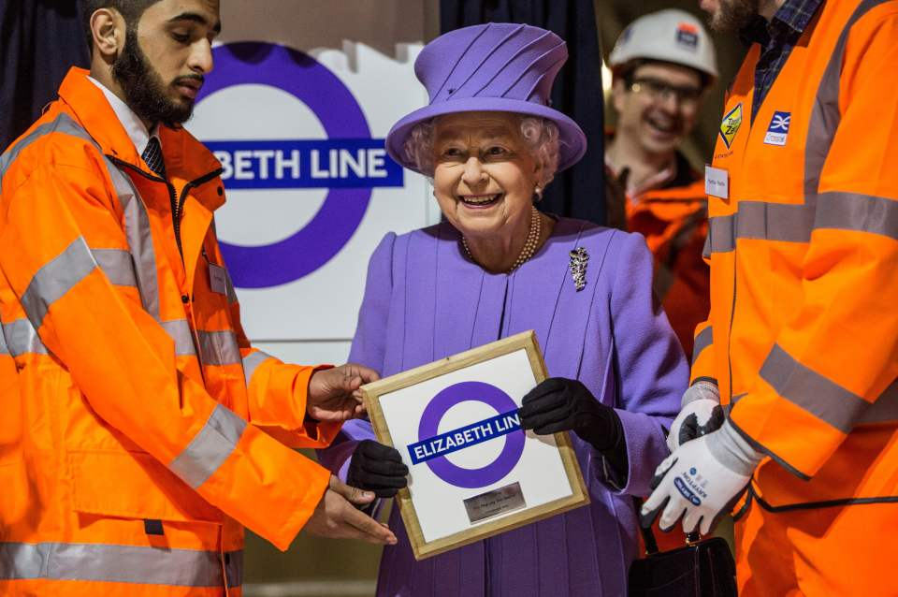
• City of London– £350m – £200m contribution plus a further £150m from London businesses
• Canary Wharf Group - £150m – This will be part of the cost of Canary Wharf Station
• Heathrow Airports Ltd - £230m towards the cost of construction of an extension to the Stockley viaduct to provide more capacity on the link to Heathrow
• Berkeley Homes – agreed to construct the station box at Woolwich as part of the Royal Arsenal Development.
• Network Rail - £2.3bn out of own funding for all works on the surface section of the railway.
In April 2010, the Mayor introduced a levy of 2p on non-domestic properties with a ratable value of over £55,000 in London. In addition The GLA is expected to contribute around £4.1bn of its agreed contribution using income generated from a new business rates supplement. Powers were gran ted to the GLA to introduce this under the 2009 Business Rates Supplements Act.
PAGE 4
- 84 per cent of construction machinery in the central section were fitted with pollutant reducing emission controls;
- 98 per cent of material excavated from sites was beneficially reused.
(Crossrail in numbers, (2016)
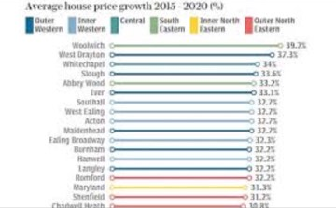
2.4 The extent of rivalry between existing competitors
There is no extent of rivalry between existing competitors as all the lines will be used. Cross-rail has been made to help out all the other tubes and rails, it’s also going to help bring bless cars within London to help stop the traffic being so bad within London so people can then use the buses and taxis comfortably and also all the cyclists can feel more safe when on the road as more people will go and use the new cross-rail to save time and know that will be the better option to save money now and in the future and will be easier for them to get around so rather than having competitors they don’t really have anyone to compete against as they usually work under the same network together.
3.0 Value
Cross-rail has taken up a great opportunity of what people want within London and when visiting London and that is to get around quickly and in a calm relaxed environment they have taken this from their original tubes to put less pressure on them and to make more people happy by doing so and giving them all these new lines but mainly the Elizabeth Line as its more space, has air con, more seats for people, bigger train, it has given a massive job growth within London and the rest of the UK, it provides signal and Wi-Fi/4G underground and much more, so the cross rail holds its value as its helping out the economy as well as itself being there it provides so much more than transport for people it has changed London as a whole.
PAGE 5
3.1 Rarity
Cross-rail is very rare as nowhere else in the UK has a design like this they have managed to cut down times so far the most being cut down my 23minutes from the original time it would of taken them to get to their chosen destination and the lowest change being 11 minutes, but even 11 minutes quicker benefits people much more and this is what the customers are very happy with as they are not traveling to their destination for long, with the Wi-Fi and signal being available underground this had made customers want to use this system and brings more people in as they always have access to their phones to want to make calls and look online and now they can but on the other tubes and trains you will not be able to do this so it is rare. Sheldrake.B, (24 August 2017).
3.2 Inimitability
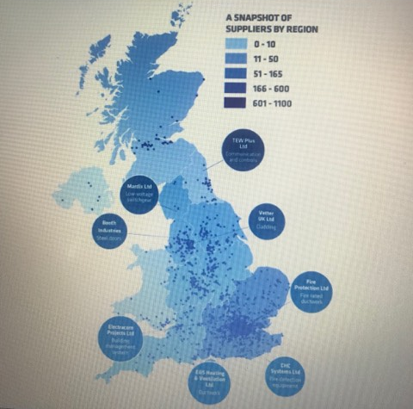
Cross-rail do have a competitive advantage as it is going to be very hard for someone to copy what has been built, it would have taken 14 years to get to the stage of completion as it started with the bill in 2005 and will end on December 2019.They have come across many problems along the way of all of the years they have been through already to get to where they are now, they also had to find a route that they could fit the cross-rail under and had to make sure that they could put stations in places to fit these routes so for someone to take the plan and place it in any destination it will not work as it is very hard to make a replica of it as you would need to know every fine detail and with this they are making their own Cross-rail 2, but this may take much longer and would also cost a lot more than the original cross-rail that is in process now.
PAGE 6
3.3 Organizational support
It shows that over all the Elizabeth Line cross-rail has the value, rarity and inimitability with all the systems in place so that they have a big organizational support that will make this sustainable for the future and has met more than their needs. It has been very organized from the start and finish.

4.0 Case study on how the cross-rail has an effect on Wembley Stadium
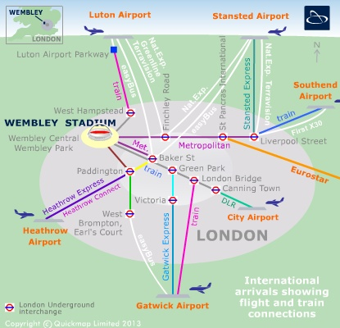
4.1 The threat of entry within the Wembley Stadium
The threat that cross-rail causes for Wembley stadium is that more people will be turning up at the same time so instead of having a spread out divide of people going through the gates they will have more people to deal with in one go as it has more space for people to go on for the day compared to what they have now.
4.2 The threat of substitutes from cross-rail to Wembley Stadium
The Wembley stadium is not going to be a threat to crossrail like it has been over the years by filling the trains to the max that can get on there during events it will be less of a threat towards crossrail as they have a lot more space to come with days like this so it will minimize it a lot as there will be a lot of trains that will be used on the day so it will be spread across but if more people are going to come to games because of the new access to Wembley then it could be a threat to where the trains are not big enough to fit the capacity going to Wembley.
4.3 The bargaining of power buyers from cross-rail to Wembley Stadium
By Wembley being so close to the crossrail it is going to make the profit for crossrail to go very high especially on the game day events as people will go to the games from all locations using the rail and would have to get back and then people usually find a destination on the way to go out for a drink or a night out and then back home so situations like this helps bring the revenue in very fast. The main buyers will then be seeing that the money they have put into the crossrail was a good buy as it is bringing more revenue and people in and helping their businesses as well as their own.
PAGE 7
4.4 The bargaining power of suppliers from cross-rail to Wembley Stadium
The suppliers for crossrail is meeting the needs of Wembley stadium by having the new rail all together as fans are always complaining by how long they have to end up waiting to get onto the trains due to them being so packed so this will put a relief to them to get there much quicker so by the suppliers having a faster line and by having all the products and services they have it will be very useful towards the people going to Wembley.
4.5 The extent of rivalry between existing competitors for cross-rail linking to Wembley Stadium
The rivalry that cross-rail has is all the other transport that people use to get to Wembley knowing how packed it gets by having the new rail they need to meet the customers’ needs in providing a quick and easy service with enough space to fit thousands of people before and after the events. So the rivalry on the days are very high when it comes to Wembley as people plan in advance for things like this so they need to meet what they can offer to get the profit coming in for both Wembley and the cross-rail.
5.0 The Value within cross-rail to the Wembley Stadium
With the value of cross-rail it could bring more money into the stadium for when matches and events are on due to the new access of transport being quicker and more room to access so more people will look for a quicker service knowing they can get there or close to the destination to get food or do something before they attend or to make sure they are there in time to start queuing up so this will bring more money into the Wembley stadium as more people will now have a way that they can get there and wouldn’t have to think twice about the times so this could benefit them by bringing more money and visitors in for different things.
PAGE 8
5.1 The rarity of the cross-rail within Wembley Stadium
There is not much rarity within the connection to the cross-rail compared to getting to Wembley stadium as most their tubes and trains are always full with fans and people going to events so it will just be another benefit for Wembley rather than something rare for them to have.
5.2 The Inimitability of cross-rail within Wembley Stadium
The Cross-rail is going to be hard to copy from any system no matter what so it’s already being places close enough to the Wembley so they wouldn’t need to have another rail in the area as they have enough coming to the area using the Jubilee line.
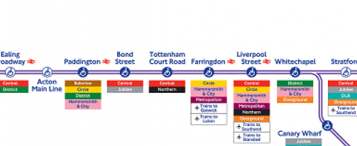
5.3 The Organizational support from cross-rail to Wembley Stadium

The organizational support is all linked to many places including the Wembley stadium it’s going to have a massive effect on the stadium now with the new line having the jubilee line that runs to the stadium. By having the value of it being benefited to Wembley and again being on the rare side of what the line has to offer people and for a line not being able to copy this it is something that fans will very much appreciate or even tourists that are going to Wembley for the day people will now see the difference from how more affective it is for them and will being more people and money in.

PAGE 9
6.0 Recommendations
The recommendations could be to make the line a bigger line and start on the cross-rail 2 as soon as possible as even though it is so much money the tickets pay back out they will be making their money back quicker than they think with the affect they have already had from the new Elizabeth line.
Another recommendation could be that they limit the tickets that are sold for each train keeping count of how many are on and go off allowing people to be comfortable and to have that space but it may have an effect on some people most days but to make sure you have more trains running for the busy days with events on.
7.0 Conclusion
It shows that overall crossrail is going to have a huge impact in a good way to everything around and outside of London, some people may not like it at first with the costs of homes and other products and services rising but this is a huge step into the future for the UK not only London and this is going to bring a lot of revenue into the business and bring more people that will want to sponsor the next crossrail.

PAGE 10

8.0 References
- CGMA, (2017), https://www.cgma.org/resources/tools/essential-tools/porters-five-forces.html
- Christmas.W (22 August 2017) London’s New Lizzy Line, The Sun https://www.thesun.co.uk/living/1924011/elizabeth-line-crossrail-project-new-trains-route/
- Colliers International, (2017), http://www.colliers.com/en-gb/uk/services/destination-consulting/sectors/sport-and-events/london-wembley-success-story
- Crossrail in numbers, (2016) www.crossrail.co.uk/news/crossrail-in-numbers
- Crossrail, (2017) http://www.crossrail.co.uk/
- file:///D:/Crossrail%20presentation%20(1).pdf
- file:///D:/Impact-of-Crossrail-briefing-paper%20city%20of%20london.pdf
- Grafton-Green.P, (22 June 2017), Crossrail First Elizabeth Line, Evening Standard https://www.standard.co.uk/news/transport/crossrail-first-elizabeth-line-train-comes-into-service-on-liverpool-street-line-a3570566.html
- Harvard Business School, Porter. E (2017) http://www.isc.hbs.edu/strategy/business-strategy/Pages/the-five-forces.aspx
- http://moodle.uwtsd.ac.uk/pluginfile.php/117321/mod_resource/content/1/Class%206.pdf
- http://www.crossrail.co.uk/news/articles/crossrails-final-shipment-of-earth-arrives-at-wallasea-island
- http://www.crossrail.co.uk/route/maps/route-map
- http://www.crossrail.co.uk/route/safeguarding/affected-properties
- http://www.crossrail.co.uk/sustainability/economic-sustainability/suppliers/
- http://www.crossrail.co.uk/sustainability/economic-sustainability/
- https://tfl.gov.uk/travel-information/improvements-and-projects/elizabeth-line
- https://tfl.gov.uk/travel-information/visiting-london/
- https://tfl.gov.uk/tube-dlr-overground/status/
PAGE 11
- Hughes. A, (29 August 2017), New crossrail Elizabeth line, getwestlondon http://www.getwestlondon.co.uk/news/west-london-news/new-crossrail-elizabeth-line-see-13528970
- New Elizabeth Line, BBC, (4 July 2017), http://www.bbc.co.uk/news/uk-england-london-40493290
- Porter. M (2017) http://www.isc.hbs.edu/strategy/business-strategy/Pages/the-five-forces.aspx
- Rail News, (2017), https://www.globalrailnews.com/2017/10/31/elizabeth-line-train-hauled-into-crossrail-tunnels-for-first-time/
- Sheldrake.B, (24 August 2017), Take a look inside London’s new £15 billion Elizabeth Line, Independent http://www.independent.co.uk/news/business/london-new-fifteen-billion-elizabeth-line-europe-biggest-infrastructure-project-a7910811.html
- The Week, (2017) http://www.theweek.co.uk/81688/the-elizabeth-line-everything-you-need-to-know
- Thomas.N (22 September, 2012) Cross Rail opens doors for rare one-off viewing, The Telegraph http://www.telegraph.co.uk/finance/newsbysector/industry/engineering/9559935/Crossrail-opens-doors-for-rare-one-off-viewing.html
- Wilkinson.J (July 24, 2013) Threat of New Entrants https://strategiccfo.com/threat-of-new-entrants-one-of-porters-five-forces/
- Wright. E, (1 November 2017) Home & Property https://www.homesandproperty.co.uk/property-news/buying/new-homes/where-to-buy-along-the-elizabeth-line-crossrail-effect-boosts-house-prices-in-abbey-wood-and-a115071.html

PAGE 12

