Ychwanegwch eich targedau o’ch aseiniad diwethaf (Ond yn berthnasol os yr ydych wedi cwblhau aseiniad) / Please add your targets from the previous assignment (Only relevant if you have completed an assignment)
Targed/Target 1 | Increase the level of criticality in your writing – look for areas where there is disagreement in the literature.
Targed/Target 2 | Review your referencing – ensure the publications dates are correct, and you are including a ‘last access’ date.
Targed/Target 3

How a school develops one aspect of its SDP: a report that critically reflects on the actions, impacts and evidence base.
The aim of this report is to view the School Development Plans (SDP) and reflect in a critical manner the different aspects which effect the SDP; looking at the actions which have be taken place, the impact of these and the evidence/ theory to support the reasons why the school decided to focus on the chosen aspect. Within this report, the main focus from the SDP will be around Pupil voice; looking further into the use of RAP (Reflect and Plan). The school which the writer will be focusing this report around will be known as School X in order to keep the anonymity and confidentiality of the school and its pupils. School X is a pioneer school which has a total for 482 children on their role; 75 of these children are enrolled part-time at nursery, according to Estyn (2018a). School X identifies 21% of the children as eligible for free school meals, this is above the average for Wales of 19%, and 34% of the children identified as having an additional learning need, this is higher than the national average of 21% (Estyn, 2018a).

The School Development Plan, which can also be known as the School Improvement Plan (SIP), is a plan for improvement which sets out actions for the school to complete in order to improve learner outcomes (Welsh Government, 2014). School Development plans are used to bring together the priorities of the school and which measures will be taken to raise the standards (Department of Education, 2021). The use of a School Development Plan can be used to develop the teamwork of the staff; this could be intentional or unintentional, as the plans are typically used to unite the work of both the staff and teachers (Lofthouse et al., 1990). This in turn brings together the ideas and collective views from the staff in regard to what should be improved/ developed within the school (Lofthouse et al., 1990). Resilient Educator (2021) supports the use of School Development Plans as they state that the use of this cyclical approach can increase parental involvement as well as promote the professional development of the teachers; including a teacher mentor program which allows the teachers to share their experiences, opinions and potential improvements in order to make the school a better place for the children.

The School Development Plan is broken down into four significant phases; including ‘self- evaluation’, ‘strategic planning’, ‘making improvements/ action’, ‘reviewing impact’ (Diagram available to evidence this in Figure 1) These four stages work in a cyclical motion which allows the school to carry out evaluations of performance, identify strengths and areas which can be improved. This cyclical approach, according to One Education (2016) allows the school to continue to develop strategies through the use of implementing the aspect, monitoring its effectiveness within the school and then evaluating its strengths and limitations; encouraging the school to discover a new way in which they could attempt this aspect to make it more beneficial for the school (One Education, 2016)

Figure 1:
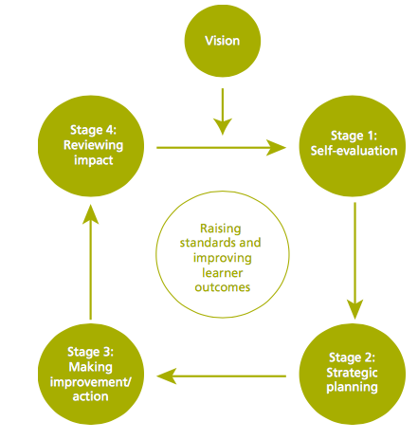

(Welsh Government, 2014)

The first stage is ‘self-evaluation’ which consists of looking at the strengths and areas for development within the school; allowing the school to celebrate what they are good at and the most important ways to improve the school (School Leaders, 2019). This stage also encourages the school to identify the areas of strength, notice how they may be performing as a school, look at the things which need improvements and work out what actions are needed to make these improvements, as stated by the Welsh Government (2014). The use of ‘self- evaluation’ is important as it allows the school to clearly decide where their priorities need to be as well as allowing the school to address new and previous ideas as well as allowing the school to look at the recommendations made by Estyn (Welsh Government, 2017). Within this stage of the SDP process, it is important that the school looks at a range of tools in order to ensure that the evaluation is complete to its fullest potential. Some of the tools which the school need to look at include workshops and interviews with stakeholders, looking at the current focus of the school and using a variety of sources, including documentation and data analysis (Winter, 2016). This data allows the school to explore the key aspects and analyse the benefits; potential limitations within the development of the aspect.

The second stage of completing a School Development Plan is ‘strategic planning’. The process of ‘strategic planning’ is completed through assembling information from a range of stakeholders; such as the pupils, staff and governors, and evaluating the options to discover which strategies are appropriate (Davies and Ellison, 2000). Asking the stakeholders to input into the strategic planning is beneficial as it allows for a different perspective on the things which need improving (Crowe, 2017). Frick (2019) also believes that involving stakeholders has quite a few benefits; from providing new insights and consolidating their own opinion to saving time and money. Davies and Ellison (2000) suggest that the ‘strategic planning process consists of three interlinking components. These components are:
‘1. The learning outcomes: pupil progress and achievement
2. Support for the quality of learning and teaching processes
3. Managing arrangements: physical and financial resources, school structures organisations’ (The diagram of this can be seen in Figure 2)
Figure 2:
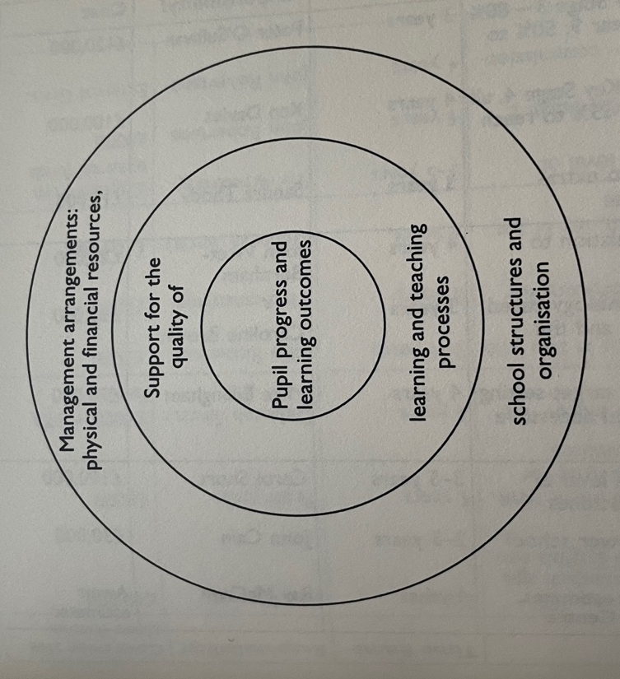

(Davies and Ellison, 2000)

The third stage of the SDP process is ‘making improvements/ actions’, this could also be known as the implementation process. Within this stage, the teachers are putting in place the strategies/ actions discussed and summarised in the School Development Plan. It is important in this stage of the SDP process that the teachers are supported by each other through encouraging, advice and support teams if they are needed, these types of support are encouraged by Martin (1999). Martin (1999) continues to explain that within this stage, there should be a way to figure out if the aspects inside the plan are working and assessing how effective these strategies are. Some of the procedures which can be completed include review meetings, discussions (formal as well as informal), observations and formal reviews (Martin, 1999). The Welsh Government (2014) supports Martin (1999) and further discusses that th SDP should include clear details of actions and timescales so that confusion is avoided.

The fourth stage in the process of completing a School Development Plan is ‘reviewing impact’. Within this stage, the school completes a formal evaluation in order to assess any improvements made and to refocus the plan, if necessary, in order to further achieve the goal, set within the School Development Plan (Education Improvement Commission, 2000). The Education Improvement Commission (2000), also states that once there is a new or revised strategy, the school would need to re-evaluate the existing SDP in order to ensure further development within the chosen aspect. Typically, in this stage, the stakeholders have another discussion so that the new goal or plan can be set up.

The particular aspect of School X’s SDP which will be focused on is the use of Pupil Voice within lessons and the planning process. Using the aspect of pupil voice, the school was able to start the cyclical process of the SDP. School X decided to develop this particular aspect as Estyn (2018b) states that every child’s voice is significant when it comes to shaping the curriculum therefore they need to be aware that their contributions are valued. The use of developing pupil voice and ensuring that the children know that their voice is valued is supported by SSAT (2021) as they state that a school that ensures pupil voice is embedded and valued, the impact on the school and learning will be transformational. SSAT (2021) continues to explain that using pupil voice could be difficult as it requires a balance between planning and resourcing. Roxburgh agrees with the benefits of pupil voice as they state that in their own practice they noticed that the children were more engaged with the lesson which they had played a role within the planning process.

As well as this, School X completed a survey and discussing with the children, as stakeholders, in regard to their pupil voice. It was discovered that a minority of students from Key Stage 2 were able to identify ways that they were able to get involved with pupil groups to have pupil voice. Unfortunately, the survey was not accessible, however, if this data was accessible I would expect that the children would not notice the pupil voice used in the lessons/ planning process. If the school was going to complete this survey and discussion again after the actions were completed, it would be expected that the children would be more aware of their pupil voice being incorporated into planning as they would complete the RAP (Reflect and Plan) strategy.

After deciding to focus on the aspect of developing the voice of the pupils, School X had to involve stakeholders and school partners to ensure that there is a commitment to the agenda surrounding the school’s improvement (Welsh Government, 2014). This aspect of the process also allows the school to construct a range of plans which will determine how the improvements will be improved. The plans which School X put in place were getting the children to be more involved in the designing of the lessons that they learn as this encouraged them to have an input into the new curriculum and support the children into becoming ‘ambitious, capable learners who are ready to learn throughout their lives’ (Welsh Government, 2015).

Next, School X will put the different aspects and plans into practice. In School X, the teachers have used the RAP (Reflect and Plan) strategy to encourage pupil voice throughout planning. The use of this strategy is supported by Potter (2008) as he states that allowing children to participate in planning increases the motivation of the children as well as their confidence to contribute towards any class or group discussions. Although the school states the benefits of the RAP strategy, Greenwood (2019) believes that the use of KWL grids is a beneficial method of sharing pupil voice since they allow the children to ‘activate prior knowledge’, ‘ask questions’ and ‘review their learning’. School X decided to not complete KWL grids since they wanted the children to recognise that the points which they were displaying on the RAP board were being used to guide their learning.

The final stage of the SDP process which was completed by the school was reviewing the impact of the newly implemented strategy. Although this was not observed, it would be expected that the school would complete the survey and discussion with pupils, as they did at the beginning, so that they could successfully see the differences in the children’s opinions. It would be anticipated that from doing this survey and discussion again that the pupils would be able to identify several examples of when they felt their voice was being heard and inputted into their lessons since the school implemented the Reflect and Plan strategy; allowing the pupils to see the things which they wanted to learn through the topic while they complete them.

Overall, the strategy which School X decided to develop within this aspect of the School Development Plan was beneficial as the children were able to see that the information which they placed on the RAP board would directly translate into the things that they will learn. This use of pupil voice was also beneficial as it allowed the children to feel their voice was valued and aided them to understand the new curriculum more effective since they had thought about what they wanted to learn in the topic being taught.

School X’s use of RAP time to encourage pupil voice being implemented throughout planning is beneficial as the children were all able to write on their post it notes what they already knew and what they would like to learn. This in turn showed the children that their opinions were being considered and also allowed the teacher to use children as the more knowledgeable other with certain lessons, if they already had the knowledge. The more knowledge other strategy is supported by Vygotsky (cited in McLoed, 2020) as states that people develop through using the aid of someone who may understand the topic better than the individual who is struggling.

To conclude, the pupil voice aspect of the School Development Plan used in School X was successfully improved throughout the four-stage process as it allowed the teachers to ensure the children were aware that their voice was being considered within the planning process. The RAP time strategy was beneficial for enforcing this as it allowed the children to see what the already knew at the beginning of the topic and out forward ideas of things which they want to learn about; this being displayed in the class also allowed the children to be able to constantly refer back to it.

References

Crowe (2017), ‘The importance of stakeholder engagement’, available at:
https://www.crowe.com/ie/insights/the-importance-of-stakeholder-engagement (Accessed: 05/05/2021)

Davies, B. and Ellison, L. (2000), ‘Strategic Direction and Development of the School’. London: Routlage

Department of Education (2021), ‘School Development Planning’, available at:
https://www.education-ni.gov.uk/articles/school-development-planning (Accessed: 05/05/2021)

Estyn (2018a), ‘A report on Pontarddulais Primary School’, available at:
https://primarysite-prod-sorted.s3.amazonaws.com/pontarddulais-primary/UploadedDocument/b066256de6c949b3b975e556ea2366b0/pontarddulais-primary-school.pdf (Accessed: 04/05/2021)

Estyn (2018b), ‘Pupil voice shapes the curriculum’, available at:
https://www.estyn.gov.wales/effective-practice/pupil-voice-shapes-curriculum (Accessed: 06/05/2021)

Frick, J.C. (2019), Six benefits of Stakeholder engagement’, available at:
https://www.npstrategy.com/highlights/six-benefits-of-stakeholder-engagement/ (Accessed:05/05/2021)

Greenwood, R. (2019), ‘Pupil involvement in planning topics using KWL grids: opinions of teachers, student teachers and pupils’, available at:
https://www.stran.ac.uk/wp-content/uploads/2019/11/Greenwood-2019-Pupil-Involvement-in-Plannint-Topics-Using-KWL-Grids-OA-PDF-AM.pdf (Accessed: 06/05/2021)

Lofthouse et al (1990), ‘The study of Primary Education: a source book/ Vol. 3 School organisation and management 2nd edition. Complied by Geoff Southwest with Brenda Lofthouse., London: Falmer

Martin, M. (1999), ‘School Development Planning’, available at:
http://www.sdpi.ie/blue_book/SDPI_Book.pdf (Accessed: 05/05/2021)

McLoed, S. (2020), ‘Lev Vygotsky’s Sociocultural Theory’, available at:
https://www.simplypsychology.org/vygotsky.html (Accessed: 06/05/2021)

Potter, C. (2008), ‘How does involving children in classroom planning affect their learning?”, available at:
http://www.curee.co.uk/files/publication/1230895917/How_does_involving_the_children_in_classroom_planning_affect_their_learning.pdf (Accessed: 06/05/2021)

Resilient Educator (2021), ‘What is a School Improvement Plan?’, available at:
https://resilienteducator.com/classroom-resources/what-is-a-school-improvement-plan/ (Accessed: 06/05/2021)

Roxburgh, ‘Pupil Voice in Planning’, available at:
http://www.in2teaching.org.uk/Blogspot/View/5749Pupilvoiceinplanning.aspx (Accessed: 06/05/2021)

School Leaders (2019), ‘Tips for writing your school self- evaluation form (SEF)’, available at:
https://schoolleaders.thekeysupport.com/school-evaluation-and-improvement/self-evaluation/departmental-sefs/tips-for-writing-your-school-self-evaluation-form-sef/ (Accessed: 04/05/2021)

SSAT (2021), ‘The Power of Pupil Voice’, available at:
https://www.ssatuk.co.uk/blog/the-power-of-pupil-voice/ (Accessed: 06/05/2021)

Welsh Government (2014), ‘School development plans’, available at:
https://gov.wales/sites/default/files/publications/2018-03/school-development-plans.pdf (Accessed:05/05/2021)

Welsh Government (2015), ‘The 4 core purposes of the curriculum for Wales’, available at:
https://gov.wales/new-curriculum-poster (Accessed: 06/05/2021)

Welsh Government (2017), ‘SDP Support and Information’, available at:
https://www.gwegogledd.cymru/wp-content/uploads/2018/03/GwE-School-Development-Plan-Guidance-1.pdf (Accessed: 05/05/2021)

Winter, H. ‘A guide to self-evaluation of Business Analysis skills’, available at:
https://www.businessbullet.co.uk/business-analysis/a-guide-to-self-evaluation-of-business-analysis-skills/ (Accessed: 05/05/2021)

