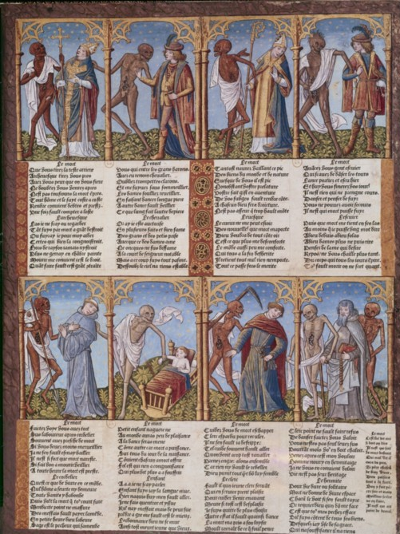
Danse Macabre print by Pierre le Rouge, 1491-1492
The time that the danse macabre was created was the same time as the 100-year war and the plague (Oosterwijk, nd, 131-162). The idea of these sort of images and texts was so that people could confront their own idea of death and mortality to help comfort them amongst all the death (atlas obscurer 2017). It was created at a time of major political upheaval (Oosterwijk, nd, 131-162). When the original danse macabre was created France was divided (Oosterwijk, nd, 131-162 ). The original images were supposed to show the stereotypical ideal of what a medieval society should be based on hierarchy, however this is a false representation of what was happening in France at the time (Oosterwijk, nd, 131-162). The order of the people in the original image was, the pope, the emperor, the cardinal, the king, the infant, the clerk, the hermit and another king (Oosterwijk, nd, 131-162). However, in France at the time they had no crowned king and no single constable in fact they had two (Oosterwijk, nd, 131-162). The danse macabre is depicted as a series of images and a poem that shows a dialogue between death and the living in different stages of life, and it combines a message about mortality and sin with social satire (Oosterwijk, nd, 131-162). By just looking at the picture without understanding the words it is difficult to state what the skeletons are doing as it just looks like happy skeletons next to living beings, however the skeletons are leading the living to their graves (atlas obscurer 2017).
As you can see in the image there is a verse underneath each section, these verses explain the persons status in life (atlas obscurer 2017). The different sections are also arranged according to the persons social status, from the pope and emperor to the Shepherd and farmer (atlas obscurer 2017). Although to tell who is who or who is of what status you do not need to know what it says, the accessories that the people have can tell you (atlas obscurer 2017). An example of this would be the pope as he is given a cross shaped staff and robes, whereas the farmer has a hoe and a simple tunic (atlas obscurer 2017).
When you look at the skeletons they appear to be smiling, this can be interpreted to mock the dead and even social status of the hierarchy. Because death takes everyone and smiles while doing it is almost as if it is saying enjoy the wealth of life while you can because it will not last long, death comes for everyone (atlas obscurer 2017). In all but two of the sections death is looking directly at the person this could be to do with the medieval view of the senses where sight is a very important aspect of it, and those where death is not looking at the person death is touching them instead. In the part where death is leading the pope he is holding the popes cross shaped staff almost as if death is leading the pope with the staff and the rest follow. Since medieval people where very religious it could also be interpreted as the people following God or the divine plan for all humans even if that plan includes death.
Death appears to have a hole in its stomach that makes it look like rotting flesh, this could be linked to the idea of death appearing before the living to show them that this is what they will become it does not matter if you are rich or poor, young or old all will end up as nothing but skin and bones with just a shawl to cover themselves with. The rot could be a way to show that the worms will come for everyone to eat the dead flesh or it could just be a way to show that everyone will rot (Oosterwijk, nd, 131-162 ).
In the section where death is with the infant he is the most covered. This sign of modesty in front of a child could be linked to the idea of innocence. A child is pure and that pureness should be protected even in death. By death showing modesty, it could be interpreted as death respecting the pureness of the child. It could also be a reference to the fact that a child has not had chance to do much sin so should be treated as a creature without sin. This idea would also explain why the child would have a higher ranking than the people who come after, because if the child has no sin it will be more holy or just have a higher status compared to those who have sinned.
In all the sections the living people seem reluctant to go with death, and it almost looks like death is forcing them to go with him rather than gently leading. Each person seems to be showing some form of resistance towards death. For example, in the second section the living looks to be pushing death away rather than blindly following, and in the last section the guy has two skeletons one pulling him and one pushing him. The fact that he has two skeletons could show how the older the people are the more they fight death to try and hang onto life, but death in return is proving showing to anyone seeing it that age does not matter if it is your time then death will come no matter what.
The faces of the living on the top row are all like each other, they are different to the faces of the people below. This could be another way to show status by having the faces different from the ones of the bottom emphasises their richness or higher class, but at the same time it does not separate them from the others in their class showing that they are the same and will end up in the same place. The people on the lower row also appear to have similar faces this again could be to show that we are all the same both young and old.

Bibliography
Gotschall, B, 2017. A brief History of the Danse Macabre. Atlas obscurer. Available from https://www.atlasobscura.com/articles/danse-macabre-david-pumpkins-art-history [accessed on 5/11/2017]
Oosterwijk, s. nd. Of Dead Kings, Dukes and Constables: The Historical Context of the Danse Macabre in Late Medieval Paris. pg 131-162

