POPULATION HEALTH AND DIGITAL HEALTH PROMOTION
(LCHS7007-LON)

Table of Contents
Task 1: Blog entries 3
Blog 1: Can PET CT scan machines help detect and monitor cancer in new ways? 3
Blog 2: Sonography machine (new concept sonography machine which can be connected through digital services and mobile phones as well) 5
References 8
Task 2: Poster design 9
Background: 9
Health promotion values and principles: 10
Expected Outcomes: 12
Conclusion: 13
References 14

Task 1: Blog entries

Blog 1: Can PET CT scan machines help detect and monitor cancer in new ways?
Public health problem and its concern
Cancer is one of the most significant public health issues that is having a far-reaching impact on individuals’ communities’ families as well as society as a whole. In recent years due to aging population changes in lifestyle, tobacco use, environmental exposures, pollution, and many other factors, the rate of cancer is drastically increasing in recent times. Additionally, it has become one of the leading causes of mobility and mortality all over the globe and poses a considerable burden on both the healthcare systems and economies. Statistics show that with the aging population, cancer contributes to a higher number of dates every year. In 2020 nearly 10 million days have been recorded for cancer worldwide which is expected to be 16 million by 2014 (Statista, 2023).
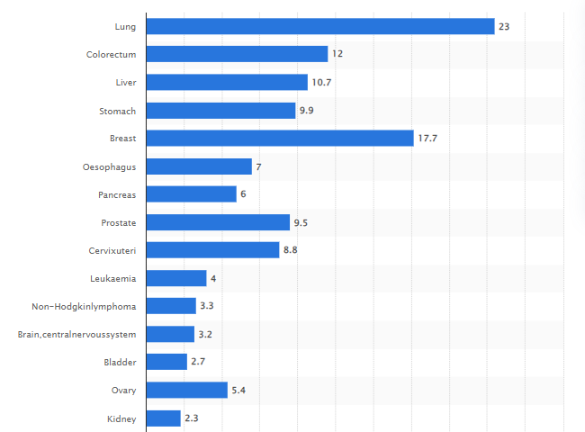
Figure 1: Cancer worldwide death rate in 2020
(Source: Statista, 2023)
After seeing all these statistics and significant reasons for the increasing growth of cancer one might probably think that a genuine solution and a revolution in the healthcare system is highly required to decelerate the spread of this deadly disease. Well, statistics reveal that prostatectomy, chemotherapy, and radiotherapy have been quite good diagnosis options available that can cure 80% of people with cancer types which are easier to diagnose (Sajja, Devarapalli and Kalluri, 2019). However, the main solution for the treatment of this disease is to detect it at the early stages. Computer tomography scan also known as PET CT scan is an imaging procedure that uses advanced computer technology and X-rays to create cross-sectional images of the body. In recent times PET CT scan machines are being used worldwide which takes a huge burden off the healthcare sector by providing easier and more advanced cancer-detecting options. During a PET CT scan X-ray beams are directed through the body from multiple angles. Cancerous tumours and normal tissues have different densities, which mean they absorb X-rays differently. In CT imaging, tumours often appear as masses or areas of abnormal density compared to the surrounding healthy tissues. As per the statistics, the overall success rate of PET CT scan machines is ranged between 63% and 64% (Sajja, Devarapalli and Kalluri, 2019).
Moreover, PET CT scan machines have tailored the cancer detection and monitoring process at a significant level. CT scans are relatively quick to perform and are considered non-invasive, as they do not require any surgical incisions. Patients only need to lie on a table while the scanner rotates around them. PET CT scans can detect various types of cancer in different parts of the body, making them a versatile imaging tool (Ozdemir, Russell and Berlin, 2019). However, PET CT scans can produce false-positive or false-negative results. A false positive might indicate the presence of cancer when there is none, leading to unnecessary additional tests or procedures. Conversely, a false negative might miss a cancerous lesion, delaying diagnosis and treatment. In Addition, a single PET CT scan increases the chances of developing a fatal tumour from 20 to 20.05 percent.

Blog 2: Sonography machine (new concept sonography machine which can be connected through digital services and mobile phones as well)

People have been suffering from Kidney disease since the 16th century as it was discovered by a Polish King named Stefan Bathory in 1576. As of 2020, about 68.2 thousand patients have been receiving RRT (Renal Replacement Therapy) in the UK.
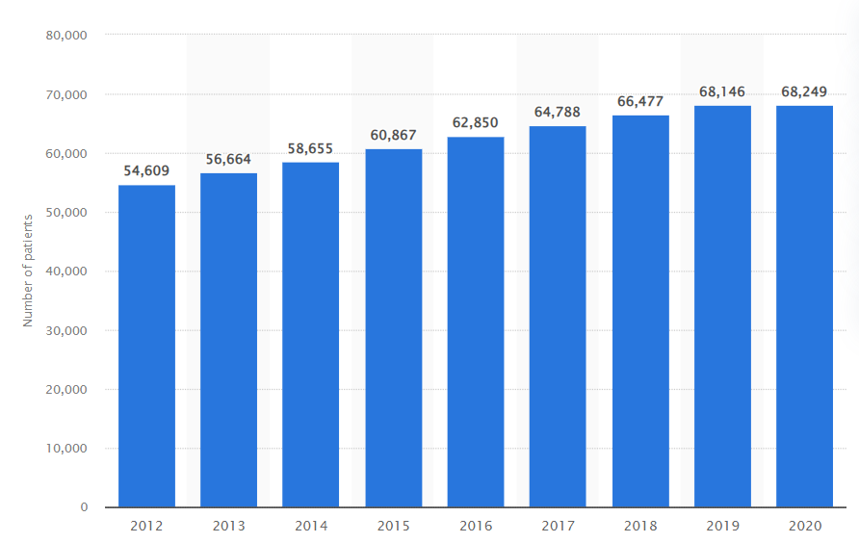
Figure 2: Total number of patients receiving RRT in the UK (2012-2020)
(Source: Stewart, 2023)
There have been around 9 thousand cases recorded of kidney cancer in the UK in 2020. and the mortality rate for men was 8.6 deaths per 100,000 people and for women it was 5.5.
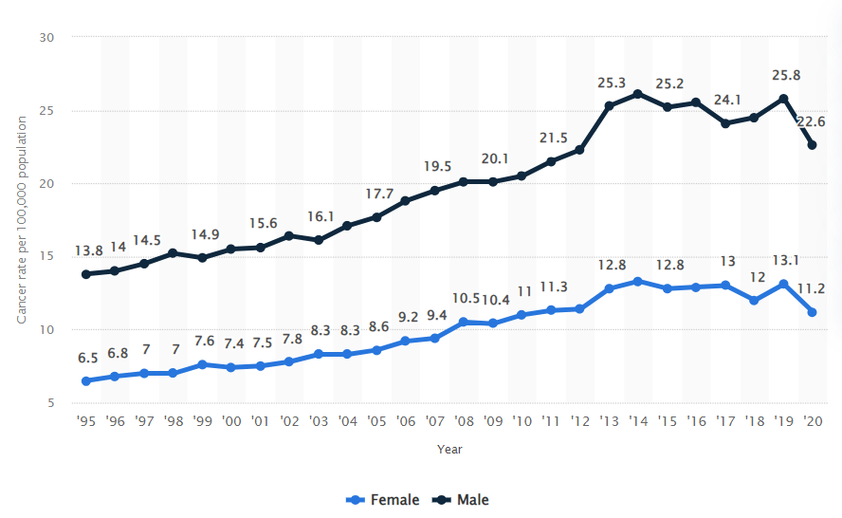
Figure 3: Kidney cancer cases for both males and female in the UK from (1995-2020)
(Source: Stewart, 2023a)
Kidney diseases in the UK have been a major concern because people in the country suffer from high blood pressure and diabetes. It is a main concern because around 40% of the UK people take unhygienic food and they consume it daily. This gives rise to kidney diseases and heart disease as well as fatty deposits clogging and hardening arteries.
Considering this, I have designed a sonography machine which is a modified version of the Doppler Ultrasound Machines. The name of this machine will be Doppler Ultrasound Machine 2.0 and this machine will be almost identical to others can detect the restricting flow of blood, monitor heart rate, diagnosing cardiovascular diseases, and kidney problems as others (Jiang et al. 2019). However, I have added certain functions to this machine series like connecting the machine with mobile phones and other digital services like laptops, cameras, and others. Now, I can say this will help the treatment of kidney or any other disease to be detected by sitting at home or anywhere else. Long queues for check-ups can get reduced and patients can understand their conditions with just a click of digital devices. The design of this modification is through a digital application that any individual can install on their device (Kimura, Kono, and Rekimoto, 2019). People with this application can get results without going to the healthcare institutions and know-how critical their problem is. There is a process through which the application reads the report and conveys it to the patient in 2mins. All the necessary information will be conveyed digitally and through voice messages as well.
This technology will have both advantages and disadvantages and these are:

Advantages:
a. Patients will be able to self-understand the report as it will be translated to them in their language with proper graphical presentation.
b. Physical tracking will become easy as it will remind the patients of the things that need to be done.
c. Notification will be provided if there will be any change in the physical attributes or check-up date.

Disadvantages:
a. Use of high-priced smartphones is required as it might get lagged in low-end devices.
b. It might not be possible for some elderly aged people who have no idea of social networking.
Overall, these above challenges can be countered by making some adjustments in the application like not using high graphics which can lead anybody to use it. The application will automatically connect to a doctor or nurse if the people are unavailable to social networking.

References
Jiang, L., Yang, Y., Chen, R., Lu, G., Li, R., Xing, J., Shung, K.K., Humayun, M.S., Zhu, J., Chen, Y. and Zhou, Q., 2019. Ultrasound‐induced wireless energy harvesting for potential retinal electrical stimulation application. Advanced Functional Materials, 29(33), p.1902522.
Kimura, N., Kono, M. and Rekimoto, J., 2019, May. SottoVoce: An ultrasound imaging-based silent speech interaction using deep neural networks. In Proceedings of the 2019 CHI Conference on Human Factors in Computing Systems (pp. 1-11).
Ozdemir, O., Russell, R.L. and Berlin, A.A., 2019. A 3D probabilistic deep learning system for detection and diagnosis of lung cancer using low-dose CT scans. IEEE transactions on medical imaging, 39(5), pp.1419-1429.
Sajja, T., Devarapalli, R. and Kalluri, H., 2019. Lung Cancer Detection Based on PET CT scan Images by Using Deep Transfer Learning. Traitement du Signal, 36(4), pp.339-344.
Statista. (2023). Cancer worldwide - Statistics & Facts Worldwide. Available at https://www.statista.com/topics/8292/cancer-worldwide/#topicOverview (Accessed on 26 July 2023)
Statista. (2023). Rate of cancer deaths worldwide in 2020, by type of cancer. Available at https://www.statista.com/statistics/1031260/cancer-death-rate-worldwide-by-type/ (Accessed on 26 July 2023)
Stewart, C. (2023) Number of patients receiving KRT in the United Kingdom (UK) 2012-2020, Statista. Available at: https://www.statista.com/statistics/950044/number-of-patients-receiving-rrt-in-the-united-kingdom/ (Accessed: 26 July 2023).
Stewart, C. (2023a) Kidney cancer rate in England 1995-2020, by gender, Statista. Available at: https://www.statista.com/statistics/313129/kidney-present-past-cancer-cases-rate-england-gender/ (Accessed: 26 July 2023).

Task 2: Poster design

Background:

Why intervention is necessary:
Given the size of the public health problems, immediate action is required. Due to the rising demand for sophisticated diagnostic tools, some medical conditions, such as cancer, that require an accurate and speedy diagnosis are now more prevalent. Inadequate utilization of medicines and lack of expertise with superior medical imaging equipment can lead to delayed or missed diagnoses which jeopardize patient health outcomes and possibly a life risk for the patient also. To accelerate the decrease of cancer disease and achieve long-term health outcomes, larger initiatives that address structural determinants are required (Brown et al 2019). The PET CT scan machine is a game-changing innovation in determining and help in making proper treatment in the world of medical imaging. Its capacity to generate precise cross-sectional images of the human body allows healthcare practitioners to detect cancer and diagnose the cancer cells with proper scanning and save a wide range of cancer patients’ nowadays.

Examples of Public health interventions:

Telemedicine:
During the COVID-19 pandemic, telemedicine became a popular digital public health strategy (Bitar, and Alismail, 2021). Telemedicine nowadays also provides remote medical treatments, and consultations, and monitoring through digital communication technologies. Telemedicine allows healthcare practitioners to contact patients in underserved or remote locations, lowering obstacles to care and eliminating the need for in-person visits. Many cancer patients order their medication online during a pandemic to ensure a constant supply and that no doses can be missed.

Vaccination:
Vaccination initiatives are critical to control and eliminate infectious diseases all over the world. Over a long period, vaccines have played an important role in defending against many outbreaks, and it is proven that this is the only option to control and eradicate disease outbreaks (Dhama et al 2021). Through vaccines, individuals or communities can immunize themselves from diseases like polio, influenza, etc. Additionally, some vaccines are used to treat cancer as well.
Chosen Digital Health Intervention:
For public health issues, the chosen digital health intervention is a Computerized Tomography or PET CT scan machine. PET CT scan machines employ sophisticated X-ray technology to provide precise cross-sectional pictures of the cancer cells, which helps in the proper diagnosis of cancer or any other medical disorders with pinpoint accuracy.

Health promotion values and principles:
Values and Principles:
The ideals and principles of health promotion are key notions that govern the creation and execution of good public health initiatives (Parker, and Fleming, 2020). These values and principles are founded on a comprehensive view of health that prioritizes the overall health of people, communities, and society as a whole. Health promotion prioritizes fairness and justice, striving to decrease health inequities and guarantee that everyone, regardless of socioeconomic class, ethnicity, or other variables, has an equal opportunity to attain optimal health outcomes. Also, health promotion emphasizes the need for early identification, mitigation of risks, and health maintenance to avoid sickness and enhance well-being. Health promotion promotes strengthening people as well as communities by offering them the information, resources, and skills that they need to make informed health decisions and take responsibility for their health. Sustainable health promotion efforts aim to make long-term positive changes by taking into account all aspects of the economy, society, and environment.

PET CT scan machine aligned to health promotion values:
The use of digital health technology, particularly PET CT scan equipment, is strongly aligned with health promotion objectives and concepts, thereby increasing the effectiveness of public health campaigns. Digital health technology, such as PET CT scan equipment, increases the availability of advanced diagnostic tools, guaranteeing that people from all walks of life are eligible for timely and accurate diagnoses, thereby eliminating health disparities regarding cancer. Also, PET CT scan equipment enables healthcare providers to make informed decisions and engage people in their medical choices by delivering detailed imaging data, encouraging patient autonomy. PET CT scanners aid in the early detection of cancer, allowing for preventive interventions and lowering the impact of illness on individuals and society (Manoharan, and Sathesh, 2020). The use of PET CT scanners is scientifically supported, guaranteeing an accurate diagnosis that supports evidence-based treatment strategies.

Behavioural change theory used to deliver the digital technology intervention:
The use of Social Cognitive Theory (SCT) in the delivery of a technological program that promotes health, namely the usage of PET CT scan machines. The intervention can effectively address behavioural change issues while motivating individuals to embrace and sustain the use of PET CT scan equipment for health monitoring and diagnosis by exploiting key aspects of SCT.

Environmental Factors:
SCT recognizes the environment's tremendous influence on behaviour modification. The introduction of PET CT scan equipment into healthcare settings has the potential to change the cultural standards surrounding health monitoring practices. The measure sets the stage for a cultural shift towards proactive health management by normalizing the usage of this digital technology within the community and providing access to the equipment in medical institutions.

Personal Factors:
SCT emphasizes the importance of individual cognition in driving behaviour change. Individuals who are educated on the positive aspects of using PET CT scan equipment and their usefulness in early disease diagnosis are better able to make health-related decisions. The intervention fosters a sense of individual agency and the drive to incorporate PET CT scan equipment into health routines by disseminating knowledge and creating positive attitudes towards technology.

Behavioural Factors:
The relevance of improving abilities and self-efficacy is emphasized in SCT. The intervention boosts participants' trust when operating the technology by giving sessions of instruction as well as chances for hands-on practice with the machines. This hands-on approach supports good behavioural change by building confidence and proficiency in using CT scanners for health monitoring.

Expected Outcomes:
Using behavioural change theory or SCT principles to implement the digital health intervention is predicted to result in several outcomes. Because of SCT's emphasis on behavioural modelling and observational learning, digital health technologies such as PET CT scan machines will see an upsurge in use. Also, individuals will be driven to adopt these technologies as critical tools for detecting cancer and early diagnosis. The intervention would enable people to grow as educated health consumers by concentrating on personal characteristics such as knowledge diffusion and self-efficacy. They are going to be better equipped to make key decisions regarding their health and well-being if they have a thorough understanding of the benefits and functions of digital health technologies. On the other hand, SCT's focus on behavioural elements, such as skill development and practice, will result in better healthcare results (Thomas et al 2020). Individuals will gain the essential skills to use digital health technology such as PET CT scan equipment efficiently with sufficient training and assistance, allowing for early disease identification and timely medical attention. The intervention will also drive a cultural revolution in healthcare practices by targeting external variables and social norms. Integration and incorporation of electronic health records into medical institutions will become the norm in the coming years.

Conclusion:
The digital technology treatment, which uses the Social Cognitive Theory to encourage the use of PET CT scan scanners for monitoring one’s health, will have far-reaching ramifications for healthcare legislation, education, and research.
Policies:
The execution of this intervention has an impact on healthcare policies at multiple levels. The benefits of electronic medical devices may be recognized by health authorities, who may prioritize their incorporation into healthcare systems. Policymakers may contribute resources to improve PET CT scan machine accessibility and affordability, ensuring that people from all socioeconomic backgrounds can benefit from this technology.

Education:
The digital health intervention will require a focus on teaching healthcare professionals and people about the benefits and proper usage of PET CT scan machines. Although, training will be required for healthcare providers to successfully interpret and incorporate PET CT scan results into patient treatment. Public education initiatives will also communicate information about the benefits of health monitoring via PET CT scan equipment.

Research:
Researchers will look at the intervention's effectiveness, assessing its effects on behavioural modification, medical results, and cost-effectiveness. Also, some comparative studies may be conducted to investigate the advantages of digital health technology over traditional healthcare techniques. Furthermore, medical technology evaluation studies may evaluate the general importance and benefits of incorporating CT scanners into healthcare settings.

References
Bitar, H. and Alismail, S., 2021. The role of eHealth, telehealth, and telemedicine for chronic disease patients during COVID-19 pandemic: A rapid systematic review. Digital health, 7, p.20552076211009396.
Brown, A.F., Ma, G.X., Miranda, J., Eng, E., Castille, D., Brockie, T., Jones, P., Airhihenbuwa, C.O., Farhat, T., Zhu, L. and Trinh-Shevrin, C., 2019. Structural interventions to reduce and eliminate health disparities. American journal of public health, 109(S1), pp.S72-S78.
Dhama, K., Sharun, K., Tiwari, R., Dhawan, M., Emran, T.B., Rabaan, A.A. and Alhumaid, S., 2021. COVID-19 vaccine hesitancy–reasons and solutions to achieve a successful global vaccination campaign to tackle the ongoing pandemic. Human Vaccines & Immunotherapeutics, 17(10), pp.3495-3499.
Manoharan, D.S. and Sathesh, A., 2020. Early diagnosis of lung cancer with probability of malignancy calculation and automatic segmentation of lung PET CT scan images. Journal of Innovative Image processing, 2(4), pp.175-186.
Ndousse, K.K., Eck, D., Levine, S. and Jaques, N., 2021, July. Emergent social learning via multi-agent reinforcement learning. In International conference on machine learning (pp. 7991-8004). PMLR.
Parker, E. and Fleming, M.L., 2020. Health promotion: Principles and practice in the Australian context. Routledge.
Seneviratne, K., Hamid, J.A., Khatibi, A., Azam, F. and Sudasinghe, S., 2019. Multi-faceted professional development designs for science teachers’ self-efficacy for inquiry-based teaching: a critical review. Universal Journal of Educational Research, 7(7), pp.1595-1611.
Thomas, J.G., Goldstein, C.M., Bond, D.S., Hadley, W. and Tuerk, P.W., 2020. Web‐based virtual reality to enhance behavioural skills training and weight loss in a commercial online weight management programme: The Experience Success randomized trial. Obesity Science & Practice, 6(6), pp.587-595.

