
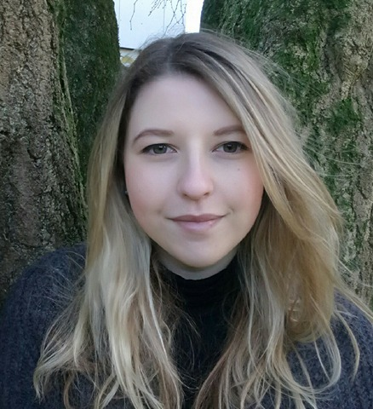
Nicole Murphy
Tel: 07539600333
Email: collimurphy@Gmail.com
Location: Carmarthen
Height: 5’7”
Weight: 11st. (70kg)
Playing age: 18 – 27 years
Appearance: white
Eye colour: Dark Green
Hair colour: Mousy Blond
Hair length: Long

Credits:
2013, Stage, Lorriel, Crime of your Life, Merlin Theatre, Simon Haslam
2017, Film, Skylar Wilson, A week in the life of, Media to Motion uwtsd, Lloyd Grayshon & Keiron Self
2017, stage, Narrator, ME, ME, ME, University of Wales Trinity St David, Andrew Sterry

Skills:
Accents & Dialects: West Midlands*, RP, Welsh-south, Northern
(* =native)
Languages: English*
(* = Native/Fluent)
Music and dance: Ballroom, Latin, Folk dancing
Sports: Horse Riding*, Shooting, Archery
(* = highly skilled)
Vehicle Licences: Clean UK Driving Licence
Other skills: Sowing, Drawing
Training: University of Wales Trinity St David, Level 2 Stage Combat

