

LCBB5010
Management Accounting for Managers
BA (Hons) Business Management

Component 1: Coursework: Individual Report
on
Management Accounting Tools and Financial Decision-Making: A Case Study on Netflix Inc.

Student Name: Carmen Caraman
Student ID: 2213756

Table of Contents
Introduction 3
Cost Analysis and Business Model of Netflix 4
Fixed vs Variable Costs 5
Budgeting and Financial Planning at Netflix 7
Sustainability and Ethical Considerations 11
Ethical Considerations in Cost Management and Pricing Strategy 12
Conclusion 12
RECOMMENDATIONS 13
REFERENCE: 14

Introduction
Netflix is one Technology and Entertainment for company based in the digital media and subscription video on demand (SVOD) industry sector. Launched in 1997 and headquartered in California, Netflix started its trajectory as a DVD rental business but has since become one of the largest streaming services worldwide, with more than 300 million paid memberships across over 190 countries (Netflix, 2025). As evidence to the strong market position of the company, its revenue was about USD 39 billion in 2024 (Macrotrends, 2025). Its major products and services include the streaming of movies, TV series, documentaries and interactive games via online like subscription-service called Netflix Originals (Global Data, 2025).
The role of management accounting in strategic decisions of modern organizations: the case Netflix. It requires the collection and use of financial and non-financial information to support planning, control and investment decision (CIMA, 2023). Netflix can effectively account managing its business which allows them to evaluate ROI on their content, maintain control of production spending, project subscriber for recast and efficiently allocate resources (Chang et al. 2023). Therefore, management accounting connects operational execution to strategic direction and helps firms stay competitive in a dynamic digital economy.

Cost Analysis and Business Model of Netflix

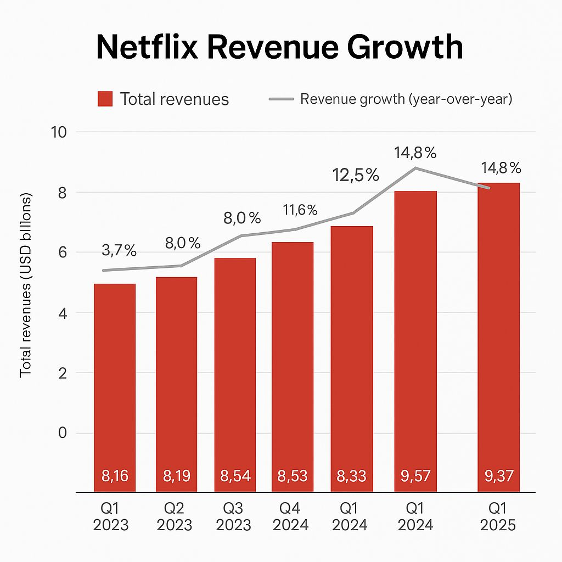

Netflix’s main source of revenue comes from subscriptions. 4.2 Time period Users subscribe to a decisive month price (In tiered plans e.g. basic, standard, premium and based on some market players to support ad) due to unlimited streaming of contents such Film, shows interactive content (Marketing91, 2025; The Business of..., 2025). Just recently, Netflix also launched an ad-supported tier to expand its monetization, leveraging incremental advertising revenue while tapping into a lower price point for users (Parrot Analytics, 2025) in some market’s ad subs grew 35 % quarter on quarter as Netflix strategically expands its sources of revenue (Parrot Analytics, 2025). Due to the subscription-based nature, revenue is sensitive to customer adds, retention, and price changes (price hikes or plan mix adjustment) (The Business of… 2025; Analysis of Netflix Strategic Issues 2025).
Apart from subscriptions, sales can also be optimized by upselling or cross-selling (i.e. premium offerings or add-ons), partnership with Telcos via bundling offers and sometimes licensing rights (albeit licensing is more often on the cost side) (Business Strategy Analysis of Netflix, 2025). The subscription model offers somewhat more stable and predictable cash flows than transactional or ad-only models and is naturally conducive to power-law economy of scale dynamics.

Fixed vs Variable Costs

Netflix’s cost structure is characterized by high fixed costs and comparatively low marginal (variable) costs, which is typical in digital platform businesses with content and infrastructure intensity (Business Model Analysis of Netflix, 2025).

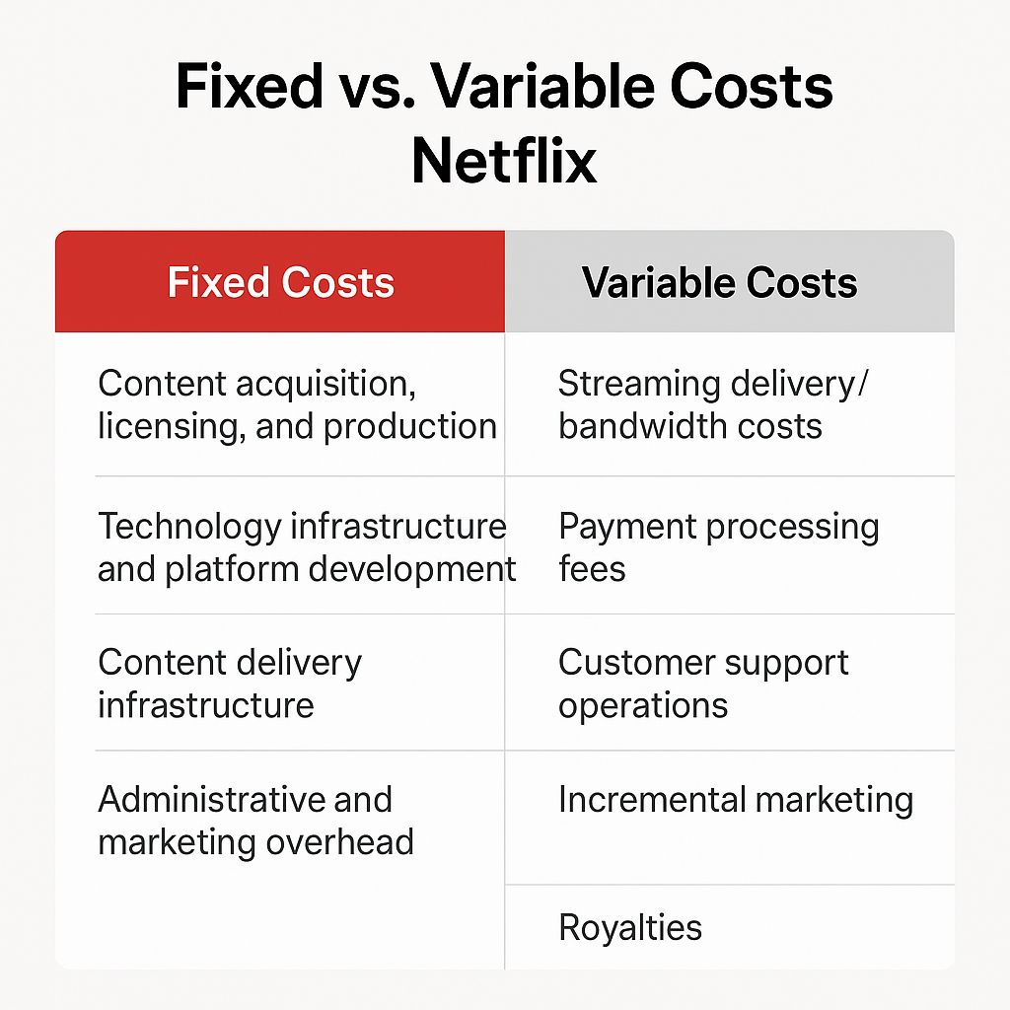

Fixed Costs
- Content acquisition, licensing, and production Netflix spends billions upfront to create original and/or license provider content for a fixed period under agreements. Most of these costs are termed sunk and therefore should be expensed as they are traced to the useful life of the content (Business Strategy Analysis on Netflix, 2025).
- Deep tech infrastructure, R&D and Platform building the investment into the software, algorithms (e.g. recommendation engine), user interface development, streaming architecture and machine learning systems is constant against marginal growth in subscribers (ResearchGate, 2025).
- Content delivery and distribution infrastructure Netflix owns and runs a CDN (Open Connect), while also using caching to mitigate the costs of serving from third parties; building this infra is very capital intensive & fixed, quite opposite to AWS.
- General and administrative, marketing and overhead costs Other operating costs Salaries, corporate functions, administration, long-term branding (brand advertising), and overhead costs are primarily fixed or semi-fixed (Investopedia on Netflix’s income statement, 2025; Macrotrends, 2025).
Variable Costs Streaming bandwidth and Data transfer charges the more subscribers there are, the greater the network traffic (on Netflix’s internally managed Open Connect CDN or on cloud providers) cost and/or external content distribution costs. These increase as people use them (Investopedia, 2025). Payment processing and transaction costs Payment processing fees are incurred for every subscription sign up or renewal, and scale along with the number of transactions. Customer support and service operations User requests for assistance (either support or customer service) are also likely to increase with the number of subscribers, making these costs semi-variable. Incremental marketing / user acquisition Baselined marketing spend is course, but additional campaigns (promos, discounting, targeted user acquisition) varies with growth targets, thus behaving in a non-linear fashion. Royalties or performance-based compensation Content partnerships or license contracts may also contain variable elements (such as revenue shares, per-stream remuneration), so they can be considered partly variable.

Because of this cost profile, Netflix benefits from economies of scale: as the subscriber base grows, fixed costs are spread over more users, reducing average cost per user and improving margins (Prep Lounge discussion; Business Model Analysis, 2025). Indeed, the incremental cost to serve an additional user is often minimal. Prep Lounge notes that Netflix’s fixed cost base is large, and “one additional subscriber costs them cents in terms of variable costs.” (Prep Lounge, 2025)

However, rising scale does not indefinitely guarantee lower average costs; recent empirical studies suggest diseconomies of scale may arise in very large SVOD providers like Netflix, where per-user costs begin increasing non-linearly (Szalkowski & Johansen, 2024) due to increasing complexity, localization, licensing inefficiencies, and content cost escalation.

From a management accounting perspective, Netflix must monitor contribution margins (subscription revenue minus variable costs) to decide which markets to enter, which content to commission, and how to allocate marketing expenses. Investment in new content must be justified by expected incremental revenues exceeding variable and allocated fixed cost burdens. Moreover, forecasting fixed and variable costs with precision is vital for long-term sustainability, especially given the high capital requirement and competitive pressures in the streaming industry.

Budgeting and Financial Planning at Netflix

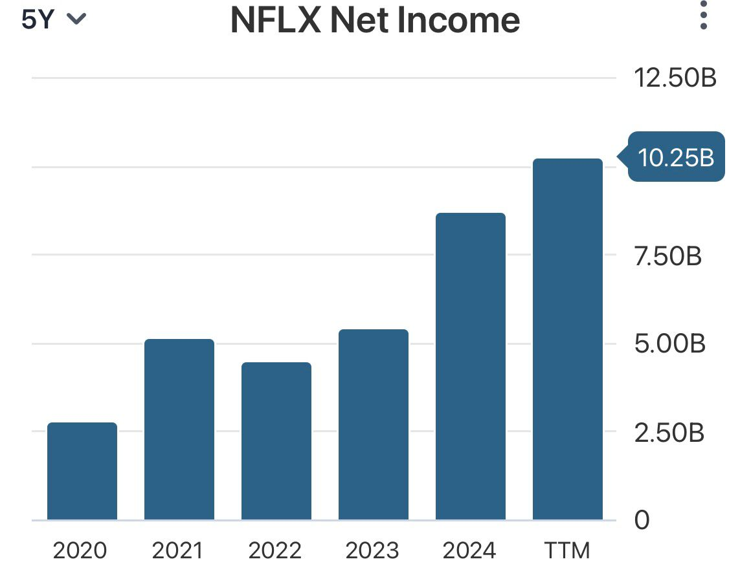

Budgeting is a key aspect of Netflix’s internal financial planning, cost management and strategic resource allocation. In a high-investment industry, like streaming media, budgets are plans, communications devices, standards and performance progress tools (Horngren et al.; 2018). For Netflix, budgets serve to forecast cash flows for content creation, IT infrastructure needs, marketing campaigns and R&D; to co-ordinate between functional departments (content operations, technology dive technology development and marketing) towards corporate strategy; and to monitor actual against budgeted cash flows via variance analysis (Drury 2020). By implementing rolling forecasts and zero-based budgeting methods, Netflix can reallocate its investments based on the performance of its content and the dynamics in the market, as well as subscriber behaviours (Christensen, 2021). As implemented at Netflix, the budget regime is a hybrid model where top-down management establishes broad targets and bottom- units submit their cost proposals and forecasts, which are iterated on in (Deadline.com, 2025) ESM 25 these boundaries there is alignment.
According to recent data, Netflix’s annual operating expenses for the twelve months ending June 2025 were approximately USD 29.389 billion, representing a 6.27 % increase year-on-year (Macrotrends, 2025). Quarter-level filings show that for the quarter ending June 2025, operating expenses stood at around USD 7.3 billion (Trading Economics, 2025). However, in public statements, Netflix’s management has described that operating expenses were “essentially unchanged” in certain periods, signaling disciplined cost control and margin focus (Seeking Alpha, 2025).

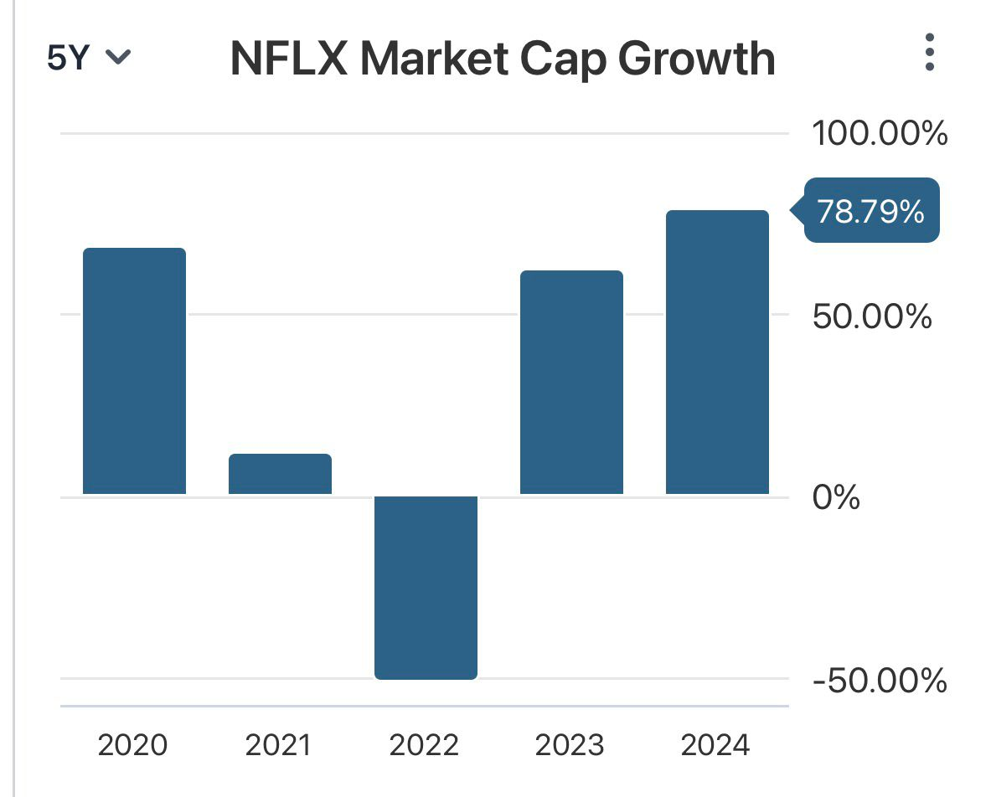

To support these goals, Netflix management has made specific budgeting and financial planning decisions. First, they have capped content cash spending in relation to revenue growth planning content budget of about USD 18 billion in 2025, with content spend growth slower than revenue to expand margins (Variety, 2025; Economic Times, 2025). CFO Spencer Neumann described the approach as combining top-down and bottom-up processes to set content budgets rigorously (Deadline, 2025). This implies that each content division must justify incremental investments against expected returns and against alternative priorities.
Second, Netflix wants to grow expenses at a slower pace compared to revenues management anticipates expenses to increase ~9 % vis-à-vis 12-14 % revenue growth over the FY19-FY21 period (Economic Times, 2025). This spread helps widen the operating margins. Management is thirdly choosing to invest selectively in live content, advertising capabilities and product engineering and interface improvements but only pushing localized or experimental content budgets where return is expected reflects capital prioritization inside of the budgets (Economic Times, 2025).
From a management accounting perspective, Netflix employs variance analysis, flexible budgeting and rolling forecasts to keep track of deviations and redistribute resources, in the middle of the year. Budget not only limits over-spend but enables strategic flexibility management that reallocates budget from underperforming content to higher-return projects. As such, Netflixs budgeting and financial planning serve as levers to manage opex growth, demonstrate margin discipline, and drive scalable growth in a turbulent media landscape.

Netflix employs a balanced scorecard of financial and non-financial key performance indicators (KPIs) to inform strategy and evaluate performance. Key financial metrics include free cash flow (FCF), which reflects operational liquidity after content and capital expenditures (Netflix, 2024a), and operating margin, indicating efficiency and cost discipline. Non-financial KPIs such as average revenue per membership (ARM), net subscriber additions, and content engagement (e.g., hours viewed) offer insights into user behaviour and growth potential (Netflix, 2024b; Content Technologist, 2024). These metrics are interdependent: user engagement drives retention and ARM, which in turn supports profitability.
More recently, Netflix has made a tactical transition “from growth at any cost to more profitable and capital-efficient growth. Three drivers enable this margin expansion: tiered pricing (including ad-supported plans), disciplined content investment, and operating leverage (Netflix, 2024a). Content spending is evaluated based on contribution margin and engagement projections that allow for an investment-returns correlation (Vitrina AI, 2024). Data-driven insights have also influenced our international content strategies and inspired us to expand into live events and advertising enabling us to grow ARM and mitigate churn. Using a combined KPI framework, Netflix adjusts its approach on the fly to optimize for subscriber growth, content returns and long-term shareholder value.

Sustainability and Ethical Considerations

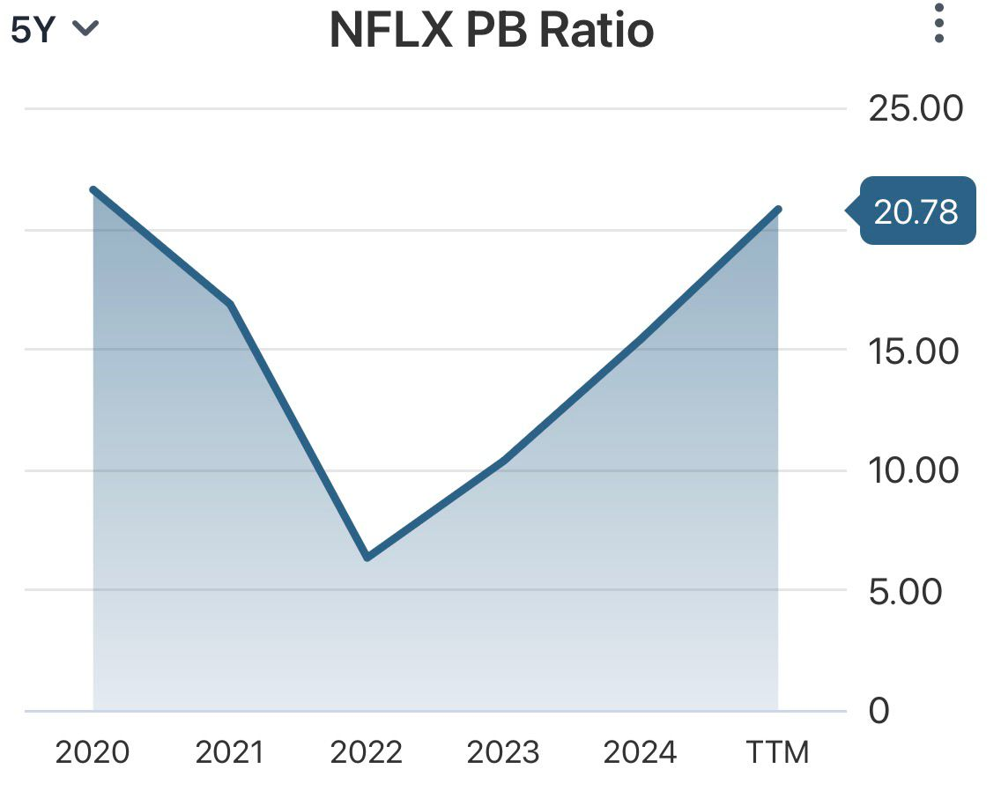
In the past several years, Netflix has crystallized sustainability into a strategic priority, integrating environmental factors in execution and capital allocation (Netflix, 2024 ESG Report). During 2021, Netflix established climate goals consistent with the Science Based Targets initiative (SBTi) including a net zero greenhouse gas emissions target and a goal to lower Scope 3 emission intensity by 55% per million USD of value added by 2030. The company’s quest to decarbonize its productions and studios has involved the investment in clean power (hydrogen-powered units, electrification) as well as replacing fossil-fuel-based gear (generators, vehicles) with low emission equivalents. projects with higher initial capital expenses but lower carbon operational liabilities in the long term. Netflix also buys high-integrity carbon credits to counterbalance the emissions that can’t yet be eradicated and has entered a 15-year contract to finance afforestation projects through the American Forest Foundation, which spreads out the expensive obligations of carbon neutrality over years to come.
In financial planning, these sustainability decisions impact Netflix’s capital budgeting decision (investments in green production technologies), cost of capital (investor expectations around ESG performance), and risk management (avoiding stranded assets, or regulatory fines). Finally, Netflix’s demand-side approach is also related to content: the platform advocates for climate storytelling and invests in sustainable-themed original content as part of its brand positioning and stakeholders’ engagement (“Clean Mobile Power Initiative,” 2015).

Ethical Considerations in Cost Management and Pricing Strategy

On the ethical front, Netflix must balance cost efficiency with fairness to consumers and creators. Cost management in content production raises questions of labor practices, diversity, and equity: Netflix has engaged with the USC Annenberg Inclusion Initiative to publish studies on diversity in its U.S. original production pipeline and commit to inclusive representation in creators and crew, reflecting an ethical stance beyond mere cost cutting.
Regarding pricing, Netflix is employing tiered to locally differentiated pricing models that have raised ethical considerations of affordability and equity. The latter operating style is its global pricing strategy, which often pushes for price raises in mature markets (especially with Standard and Premium plans) but has been kept somewhat on the down low with cheaper subscription options to avoid discouraging fewer wealthy consumers. The introduction of ad-supported or mobile-only tiers in certain markets is also further evidence for democratizing access (cheaper options), while protecting revenue (“Basic with Ads”). But aggressive pricing can make people feel Angies or gouged, especially in lower income where that's the case (as found with subscription services studies).

Conclusion

In conclusion, Netflix’s financial strategy increasingly embeds sustainability as a determinant of long-term value creation. The company’s investment in low-carbon production technologies and its transparent ESG reporting indicate a shift from reactive compliance to proactive sustainability governance (Netflix, 2024). Ethical considerations in cost management and pricing reflect its attempt to balance profitability with social equity and consumer fairness (Hermes Investment, 2023). Nonetheless, tensions remain between maintaining affordable global access, controlling escalating content costs, and satisfying investor expectations.

RECOMMENDATIONS

In the future, Netflix must work to better incorporate sustainability and responsible governance into its financial and operational planning.
The company should establish an SMAS (“Sustainability Management Accounting System”) to integrate CO2 metrics – specifically, the reporting of social impact indicators and carbon costs/ benefits into budgeting and performance assessment. Such a model would improve accountability and increase the consistency in translating operational decisions into long-term ESG goals (Bebbington & Larrinaga, 2014).
Second, Netflix must practice strategic cost management and activity-based costing to determine the environmentally friendly cost cutting across its production and streaming platform for an informed decision making on investment in renewable energy and efficient data centres (Drury, 2018).
Thirdly, the organisation must incorporate ethical pricing governance that is both transparent and affordable to buyers in global markets -especially those based in emerging economies (Smith & Nagle, 2020). If Netflix can embed these practices it will be able to sustain competitive advantage, reaffirm stakeholder confidence and improve long-term profitability in an increasing ESG led media environment (Eccles and Kruz’s, 2018).

REFERENCE:

- Bebbington, J. and Larrinaga, C., 2014. Accounting and sustainable development: An exploration. Accounting, Organizations and Society, 39(6), pp.395–413.
- Drury, C., 2018. Management and Cost Accounting. 10th ed. Andover: Cengage Learning.
- Eccles, R.G. and Kruz’s, M.P., 2018. The Nordic Model: An Analysis of Leading Practices in ESG Disclosure. Boston, MA: Harvard Business School Press.
- Global Data, 2025. Netflix Company Profile - SWOT Analysis and Financials
- Hermes Investment, 2023. Responsible Pricing in the Digital Economy.
- Macrotrends, 2025. Netflix Revenue 2010-2025.
- Netflix, 2024. Environmental, Social and Governance (ESG) Report.
- Netflix, 2024a. Top Investor Questions.
- Parrot Analytics, 2025. Netflix’s Ad Tier Strategy and Market Growth.
- Smith, T. and Nagle, T.T., 2020. The Strategy and Tactics of Pricing: A Guide to Growing More Profitably. 6th ed. New York: Routledge.

