

Project Management

Module Code: LCLM5003_LON

LECTURER`S NAME: Sukhpreet Grewal

Table of content

Part A: Project Portfolio Poster ……………………………………………………..……….………1
Part B: Reflection on the feedback…………………………………………….……………………..2
Part C: 1. Introduction and 2. Project Description………………………………….………..4
3. Scope…………………………………………………………………………………………..…….5
3.1 In Scope Activities ……………………………………………………………………...…………6
3.2 Out of Scope Activities ……………………………………………………………………………6
3.3 Project Objectives…………………………………………………………………………………6
4. WBS………………………………………………………………………………………………….7
4.1 Assessment Phase………………………………………………………………………………….7
4.2 Clearance Phase…………………………………………………………………………………...8
4.3 Repair and Reconstruction Phase………………………………………………………………..8
4.4 Final Inspections and Reopening Phase………………………………………………………….9
5. Quad Chart……………………………………………………………………….………………10
5.1 Purpose………………………………………………………………………….……………….10
5.2 Desired Outcomes……………………………………………………………….………………10
5.3 Schedule………………………………………………………………………….………………10 5.4 Resources and Cost…………………………………………………………...…………………10
5.5 Key Risk………………………………………………………………..…………….…………..11
6. Gantt Chart……………………………………………………………….………….……...……12
7. Stakeholder Involvement …………………………………………………………….…….……13
8. Allocation of Resources………………………………………………………..……………..…..14
9. Risk Analysis………………………………………………………………………………..…….15
9.1 Continued Flooding…………………………………………………………………………..…15
9.2 Structural Instability …………………………………………………………………..……….15
9.3 Resource Shortages………………………………………………………………………..……15
9.4 Public Safety Risks ………………………………………………………………………………15
9.5 Budget Overruns…………………………………………………………………………………15
10. Conclusion…………………………………………………………………………………….….16
11. Reference…………………………………………………………………………………………17

Part A: Project Portfolio Poster:
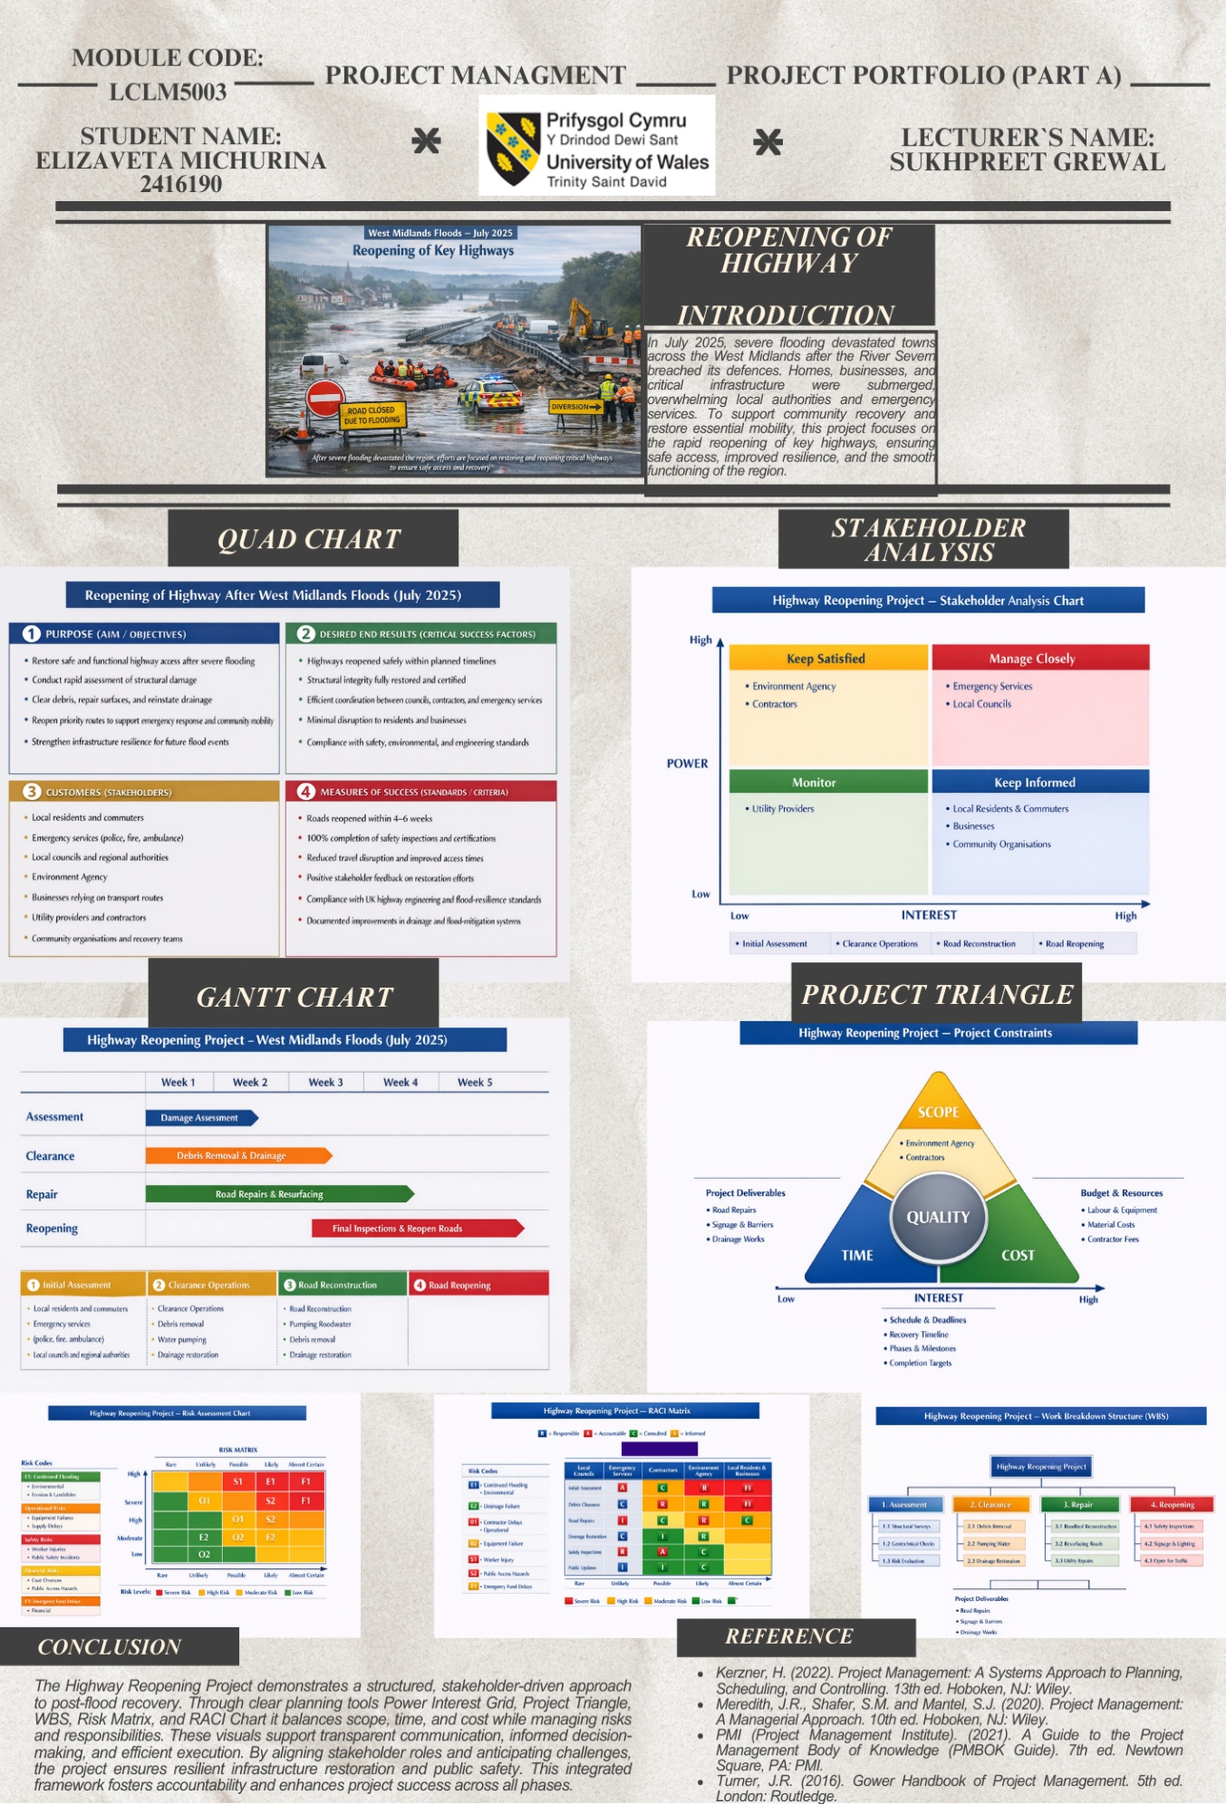
PART B:
Reflection on Feedback from the lecturer and students:
The feedback received from both my lecturer and students on the Highway Reopening Project portfolio was constructive and valuable in identifying both strengths and areas for improvement. Overall, the feedback highlighted that the project demonstrated a strong understanding of project management principles, particularly in terms of structure, clarity, and the use of key tools such as the Quad Chart, Gantt Chart, Stakeholder Analysis, Risk Matrix, RACI Matrix, and Work Breakdown Structure (WBS). It was noted that the visual presentation was clear, professional, and logically organised, making the project easy to follow. The alignment of the project with the real-world flood scenario was also positively recognised, as it showed an ability to apply theoretical knowledge to a practical and relevant situation.
One of the main strengths identified was the effective use of project management frameworks established within 4 to 5 weeks to support the project and project managerial process. The stakeholder analysis, in particular, was praised for correctly categorising stakeholders based on their level of power, interest and involvement. Similarly, the Gantt chart was considered realistic and appropriate for an emergency infrastructure recovery project, demonstrating an understanding of time constraints and sequencing of activities. The inclusion of multiple tools also reflected a comprehensive approach to project planning, which is essential in complex and high-risk environments such as post-flood recovery.
However, the feedback also indicated that the project was largely descriptive and could be improved by incorporating more critical analysis. While the tools were correctly applied, there was limited explanation of why certain decisions were made or how trade-offs between time, cost, and scope were managed. For example, the project could further explore the implications of accelerating the reopening timeline, such as increased costs or potential safety risks. In this context, the estimated project cost expenditure of approximately £2–5 million becomes particularly relevant, as fast-tracked recovery efforts often require additional labour, specialised equipment, and emergency procurement processes, which significantly increase overall costs. This highlights the need to justify financial decisions more clearly within the project plan.
The risk management section was also identified as an area that could be strengthened. During my presentation, it was mentioned that we will use managers for all the process stages, which obviously will be cost-effective; however, in the case of the increasing water levels, we had to act promptly. While the risk matrix visually presented potential risks, it lacked a detailed explanation of their impact and specific mitigation strategies. In response to this feedback, I plan to expand on the most critical risks, such as continued flooding and resource shortages, and clearly outline how these risks will be managed in practice.
In conclusion, the feedback has provided clear direction for improving the quality of the final project plan. While the current work demonstrates strong organisation and application of project management tools, the next stage will focus on enhancing critical analysis, strengthening academic integration, and providing more detailed justification of decisions, including financial considerations such as the £2–5 million estimated cost.

Part C: PROJECT MANAGEMENT PLAN: REOPENING OF HIGHWAY AFTER WEST MIDLANDS FLOODS (JULY 2025)

- Introduction
Severe flooding events present significant challenges to infrastructure systems, particularly transport networks that are critical for emergency response and economic recovery. In July 2025, extreme rainfall across the West Midlands caused the River Severn to breach its defences, resulting in widespread flooding across towns such as Worcester, Shrewsbury, and Kidderminster. Key highways were submerged, damaged, or rendered unsafe, severely disrupting mobility and access for residents, emergency services, and businesses.
The reopening of highway following such events is a complex, high-risk project requiring effective coordination, rapid decision-making, and adherence to safety and engineering standards. This project management plan outlines a structured approach to the reopening of a critical highway affected by the floods. It applies recognised project management methodologies and tools to ensure timely, safe, and cost-effective delivery.
The plan integrates essential project management elements, including scope definition, a structured work breakdown, scheduling, stakeholder engagement, resource allocation, and risk management, to support an organised and efficient project delivery process. The objective is to balance time, cost, and quality constraints while ensuring public safety and infrastructure resilience.

- Project Description
The project focuses on the reopening of a flood-damaged highway in the West Midlands following the July 2025 flooding event. The highway serves as a vital transport link connecting residential areas, emergency services, and commercial routes. Flooding has caused structural damage, debris accumulation, drainage failure, and potential instability of road surfaces and embankments.
The project aims to restore the highway to a safe and operational condition within a targeted timeframe of 4–6 weeks, depending on the extent of damage. The estimated project cost is approximately £2–5 million, reflecting emergency procurement, labour, materials, and specialist engineering works.
The project adopts a structured phased approach consisting of four key stages: initial assessment, clearance operations, repair and reconstruction, and final inspection and reopening. The initial assessment phase focuses on evaluating the extent of damage, identifying hazards, and determining priority areas for intervention. This is followed by clearance operations, during which debris, floodwater, and obstructions are removed to enable safe access to the site.
The repair and reconstruction phase addresses structural damage, including road surface restoration, stabilisation of embankments, and rehabilitation of drainage systems. Finally, the project concludes with a comprehensive inspection and reopening phase, ensuring that all works meet safety standards and regulatory requirements before the highway is returned to public use.
This phased approach supports effective risk management by allowing each stage to be completed systematically while enabling the gradual and controlled restoration of access.
3. Scope
3.1 In Scope Activities
The scope of the project encompasses all activities required to restore the highway to a safe and operational condition following flood damage. These activities include:
- Structural assessment of road surfaces, bridges, and embankments to determine the extent of damage and identify areas requiring immediate intervention
- Removal of floodwater, debris, and hazardous materials to ensure safe access for construction and repair teams
- Repair and reconstruction of damaged road sections, including resurfacing and stabilisation works, as well as the restoration of drainage systems to prevent future water accumulation
- Reinstatement of road infrastructure, including signage, barriers, and other critical safety features necessary for safe vehicle operation
- Comprehensive safety inspections and certification to verify that all repairs meet regulatory and engineering standards
- Controlled reopening of the highway, ensuring that access is restored in a phased and secure manner, minimising risks to road users
These activities collectively ensure that the project delivers a fully functional, safe, and compliant transport route.

3.2 Out of Scope Activities
The out of scope activities below are not included within the scope of this project and will therefore not be taken as part of the highway reopening work.
- Long-term redesign or enhancement of flood defence systems, including large-scale flood mitigation infrastructure such as levees, barriers, or river engineering works
- Major infrastructure upgrades beyond immediate recovery requirements, including capacity expansion, road widening, or the construction of new transport links
- Non-critical road improvements, such as aesthetic enhancements, landscaping, or upgrades that do not directly contribute to the safe and functional reopening of the highway
Excluding these activities ensures that project efforts remain focused on rapid recovery and the timely restoration of essential transport functionality.

3.3 Project Objectives
The project is guided by the following key objectives:
- To reopen the highway safely within a target timeframe of 4–6 weeks, ensuring that all critical repair and safety measures are completed efficiently
- To ensure full compliance with UK safety, environmental, and engineering standards, including adherence to relevant regulatory frameworks and inspection requirements
- To minimise disruption to local communities and businesses, by restoring access as quickly as possible and maintaining clear communication throughout the project lifecycle
- To enhance the resilience of the highway against future flooding events, through targeted improvements to drainage systems and structural reinforcement where necessary
These objectives collectively support the timely, safe, and sustainable restoration of the affected transport infrastructure.

4. Work Breakdown Structure (WBS)

The Work Breakdown Structure (WBS) decomposes the project into manageable components to facilitate planning and control.
Highway Reopening Project:
4.1. Assessment Phase
The assessment phase establishes the foundation for all subsequent project activities by identifying damage, risks, and technical requirements. It consists of the following components:
- Structural Survey
A comprehensive evaluation of road surfaces, bridges, and associated infrastructure to determine the extent of physical damage and identify areas requiring urgent repair.
- Geotechnical Inspection
Examination of soil conditions, embankments, and subgrade stability to assess risks such as erosion, subsidence, or structural weakening caused by flooding.
- Risk Identification
Systematic identification and documentation of potential hazards, including structural instability, environmental risks, and safety concerns that may impact project execution.

4.2 Clearance Phase
The clearance phase focuses on restoring safe access to the affected highway by removing obstructions and mitigating immediate hazards caused by flooding. This phase enables subsequent repair activities to proceed efficiently and safely. It includes the following components:
- Debris Removal
Systematic removal of accumulated debris, including vegetation, damaged materials, and waste, to clear the roadway and surrounding areas.
- Water Pumping
Extraction of residual floodwater using appropriate pumping equipment to eliminate standing water and reduce risks associated with saturated surfaces.
- Drainage Clearance
Inspection and clearing of drainage systems, including culverts and channels, to restore proper water flow and prevent further accumulation.
This phase ensures that the site is stabilised and accessible, reducing immediate safety risks and preparing the groundwork for effective repair and reconstruction.

4.3 Repair and Reconstruction Phase
The repair and reconstruction phase addresses the physical damage caused by flooding and restores the highway to a safe and operational condition. This phase focuses on both surface-level and structural integrity, ensuring long-term functionality and resilience. It includes the following components:
- Road Resurfacing
Restoration of damaged road surfaces through resurfacing, patching, and levelling to ensure safe and smooth vehicle operation.
- Structural Repairs
Repair and reinforcement of critical infrastructure elements, including bridges, embankments, and supporting structures affected by flood damage.
- Drainage Restoration
Rehabilitation and upgrading of drainage systems to ensure efficient water flow and reduce the risk of future flooding impacts.
- Utility Coordination
Collaboration with utility providers to inspect, repair, or relocate underground and surface services (e.g., water, electricity, telecommunications) affected by the flooding.

4.4 Final Inspection and Reopening Phase
The final phase ensures that all completed works meet required safety, regulatory, and operational standards before the highway is reopened to the public. It also facilitates a controlled and well-managed return to normal traffic conditions. This phase includes the following components:
- Safety Inspections
Comprehensive inspections are conducted to verify the structural integrity of the highway, the effectiveness of repairs, and the overall safety of the infrastructure for public use.
- Certification
Formal approval and certification are obtained from relevant regulatory authorities, confirming that the highway complies with UK safety and engineering standards.
- Traffic Management Setup
Implementation of appropriate traffic management measures, including signage, lane markings, barriers, and temporary controls, to ensure safe and efficient traffic flow upon reopening.
- Public Communication
Dissemination of clear and timely information to the public and stakeholders regarding reopening schedules, access conditions, and any ongoing restrictions or safety guidance.
The WBS ensures clarity in task allocation and supports scheduling and resource planning.

5. Quad Chart
The Quad Chart summarises the key elements of the project, providing a concise overview of its purpose, desired outcomes, schedule, and resource considerations.
5.1 Purpose
- Restore safe highway access following flooding, ensuring that the affected route is returned to operational condition as quickly as possible
- Support emergency services and economic recovery, by re-establishing a critical transport link for communities, businesses, and service providers
5.2 Desired Outcomes
- Highway reopened within the planned timeframe of 4–6 weeks, in line with project targets
- Structural integrity fully restored, ensuring long-term safety and reliability of the infrastructure
- Minimal disruption to stakeholders, including local communities, businesses, and transport networks
5.3 Schedule
- Project duration is estimated at 4–6 weeks, structured into phased activities: assessment, clearance, repair, and reopening
- Overlapping tasks are implemented where feasible to optimise efficiency and reduce delays
5.4 Resources and Cost
- Estimated project budget: £2–5 million, covering labour, materials, and equipment
- Allocation prioritises critical repair works, safety compliance, and contingency planning

5.5 Key Risks
- Adverse weather conditions are potentially delaying progress
- Structural instability requiring additional repair work
- Supply chain disruptions affecting material availability

This Quad Chart provides a high-level summary that supports effective communication with stakeholders and facilitates informed decision-making throughout the project lifecycle.

6. Gantt Chart
The project schedule is structured over a 5-week period, with activities organised in sequential and partially overlapping phases to optimise efficiency and reduce overall completion time. The timeline is designed to ensure that critical tasks are prioritised while maintaining flexibility to address unforeseen challenges.
Week 1: Damage Assessment
The project begins with a comprehensive assessment of structural conditions, geotechnical stability, and associated risks. This phase provides the necessary data to inform all subsequent activities.
Weeks 1–2: Clearance Operations
Clearance activities commence during the first week and continue into the second week. These include debris removal, water pumping, and drainage clearance. Partial overlap with the assessment phase allows early mobilisation and time optimisation.
Weeks 2–4: Repair and Reconstruction
Repair works are initiated as soon as safe access is established. This phase includes road resurfacing, structural repairs, and drainage restoration. Overlapping tasks within this stage enable efficient use of resources and accelerate progress.
Weeks 4–5: Final Inspection and Reopening
The final phase involves safety inspections, regulatory certification, and the implementation of traffic management measures. The highway is then reopened in a controlled manner, ensuring public safety and operational readiness.
The Gantt Chart demonstrates task dependencies and sequencing. For example, repair work cannot begin until clearance is completed. Overlapping activities, such as drainage restoration during repair phases, improve efficiency.
However, accelerated timelines introduce risks, including increased costs and potential safety compromises. Therefore, careful monitoring is required.

7. Stakeholders’ Involvement

Effective stakeholder management is essential for project success.
High Power – High Interest
- Local councils
- Emergency services
These stakeholders require close management due to their influence and urgency.
High Power – Low Interest
- Environment Agency
- Contractors
These stakeholders must be kept satisfied to ensure regulatory compliance and operational delivery.
Low Power – High Interest
- Residents
- Businesses
- Community organisations
These groups should be kept informed, as they are directly affected by road closures.
Low Power – Low Interest
- Utility providers
These stakeholders require monitoring but less direct engagement.
Stakeholder communication strategies include regular updates, public announcements, and coordination meetings.

8. Allocation of Resources

The allocation of resources within this project highlights the importance of balancing efficiency, cost, and time constraints in infrastructure recovery. The combination of human resources—including civil engineers, project managers, construction workers, emergency response teams, and a dedicated research team—demonstrates the need for multidisciplinary collaboration. The research team plays a critical role in analysing site data, evaluating environmental conditions, and supporting evidence-based decision-making throughout the project lifecycle. Material and equipment resources, such as asphalt, drainage components, excavators, and water pumps, emphasise the reliance on appropriate tools and supplies to enable effective execution of tasks.

The financial allocation of £2–5 million reflects the scale and urgency of the project, particularly in the context of emergency procurement and rapid mobilisation. It becomes evident that accelerated timelines can increase costs, especially due to overtime and the requirement for specialised services. This reinforces the importance of strategic planning in resource distribution to maintain a balance between project deadlines, budget limitations, and quality standards.

9. Risk Analysis
Risk management is essential due to the uncertain post-flood environment.
Key Risks:
9.1. Continued Flooding
- Impact: delays and safety hazards
- Mitigation: weather monitoring and temporary flood barriers
9.2. Structural Instability
- Impact: risk of collapse or accidents
- Mitigation: detailed inspections and phased reopening
9.3. Resource Shortages
- Impact: delays in repair work
- Mitigation: pre-approved contractors and supply chains
9.4. Public Safety Risks
- Impact: accidents during reopening
- Mitigation: strict traffic control and communication
9.5. Budget Overruns
- Impact: financial pressure
- Mitigation: cost monitoring and contingency planning
The risk matrix prioritises risks based on likelihood and impact, enabling proactive management.

10. Conclusion

The reopening of a highway following severe flooding requires a structured and well-coordinated project management approach. This plan demonstrates the application of key project management tools and techniques to address a complex, high-risk scenario.
The project balances critical constraints of time, cost, and scope while prioritising safety and stakeholder needs. The estimated cost of £2–5 million reflects the urgency and complexity of emergency infrastructure recovery.
While the accelerated schedule supports rapid restoration of mobility, it introduces risks that must be carefully managed. Effective stakeholder engagement, resource allocation, and risk mitigation are essential to achieving project success.
The implementation of this plan will enable the safe and efficient reopening of the highway, contributing to community recovery and long-term infrastructure resilience.

11. References
Association for Project Management (2022) APM Body of Knowledge. 7th edn. Buckinghamshire: APM.
Chapman, C. and Ward, S. (2011) How to Manage Project Opportunity and Risk. 3rd edn. Chichester: Wiley.
Environment Agency (2023) Flood Risk Management Plan. Available at: https://www.gov.uk (Accessed: 22 April 2026).
Gartner (2023) Infrastructure and Risk Management Report. Stamford: Gartner.
Harvard Business Review (2021) Building Resilient Infrastructure Systems. Boston: Harvard Business School Publishing.
Hillson, D. (2017) Practical Project Risk Management. Oakland: Berrett-Koehler.
HM Government (2022) UK National Flood and Coastal Erosion Risk Management Strategy. London: HMSO.
Kerzner, H. (2022) Project Management: A Systems Approach to Planning, Scheduling, and Controlling. 13th edn. Hoboken: Wiley.
Laudon, K.C. and Laudon, J.P. (2022) Management Information Systems. 17th edn. Harlow: Pearson.
Lock, D. (2020) Project Management. 11th edn. London: Routledge.
Maylor, H. (2010) Project Management. 4th edn. Harlow: Pearson.
McKinsey & Company (2022) Infrastructure Resilience in Climate Change. Available at: https://www.mckinsey.com (Accessed: 22 April 2026).
Meredith, J.R., Shafer, S.M. and Mantel, S.J. (2020) Project Management: A Managerial Approach. 10th edn. Hoboken: Wiley.
Project Management Institute (PMI) (2021) A Guide to the Project Management Body of Knowledge (PMBOK Guide). 7th edn. Newtown Square, PA: PMI.
Too, E.G. and Weaver, P. (2014) ‘The management of project management’, International Journal of Project Management, 32(8), pp. 1382–1394.
Turner, J.R. (2016) Gower Handbook of Project Management. 5th edn. London: Routledge.
Winch, G.M. (2010) Managing Construction Projects. 2nd edn. Oxford: Wiley-Blackwell.

