BA BUSINESS MANAGEMENT
MARKETING FUNDAMENTALS
LCBB4004_BIRM

INDIVIDUAL REPORT:GLOBALISATION

STUDENT NAME: Radu Acris
STUDENT NUMBER: 2239621
LECTURER’S NAME: Nazia Saeed.

Contents
1.Executive Summary: 3
2.Introduction: 4
3. Analyse and Evaluate the global challenges: which impacts company’s marketing functions post Covid-19 pandemic. 4
3.1. Economic factors and staff shortages . 6
3.2.Singapore Airlines green marketing. 6
3.3. How Singapore Airlines Uses (AI) to Personalize Air Travel. 7
4.Singapore Airlines Marketing Strategies. 8
4.1.Singapore Airlines Product and Services: 8
4.2.Singapore Airlines Pricing Strategy: 9
4.3.Singapore Airlines Place and Distribution channels: 10
4.4.Promotional strategies of the company: 10
4.5.Singapore Airlines People Strategies: 11
4.6.Singapore Airlines Process: 11
4.7.Singapore Airlines Physical Evidence: 11
5.Singapore Airlines Stakeholders and their impact on the Marketing Functions of the company: 12
5.1.Singapore Airlines Internal Stakeholders: 12
5.2.Singapore Airlines External Stakeholders: 13
6.Singapore Airlines Marketing Strategies Recommendations: 14
7.Conclusion: 15
8.References: 16

SINGAPORE AIRLINES:
Analyse and Evaluate the global challenges it faces which impacts its marketing functions post Covid-19 pandemic.
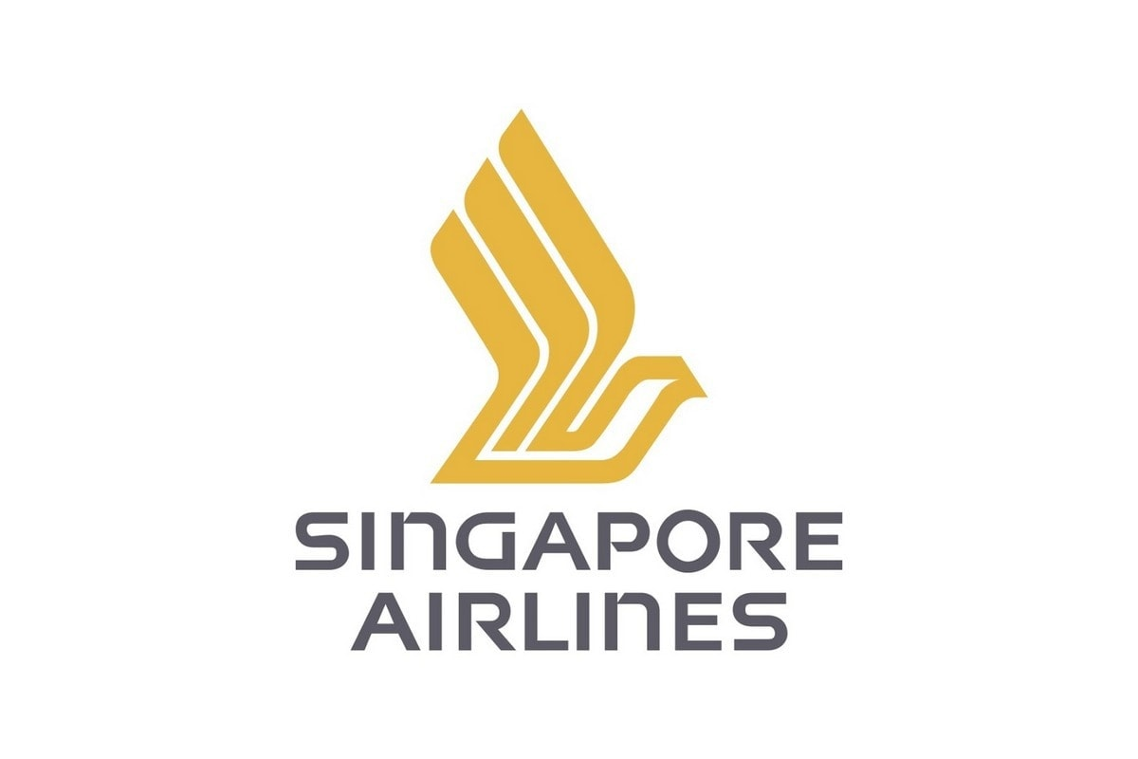
Picture 1.

1.Executive Summary:
Air tourism and air travel aren't expected to return to 2019 levels until 2024, as a result of the COVID-19 pandemic, which caused airline earnings to fall by 60% in 2020 (Craven, et al., 2022).
The airline industry, particularly Singapore Airlines, which has been largely dependent on the Chinese market, was seriously affected by the COVID-19 pandemic. The company needs to draw clients and express its commitment to providing high-quality service and value as the globe starts to open up new destinations.
Service excellence combined with price competitiveness, is the recommended strategy for the organisation, because of the improved competition and difficulty the airline industry is facing. Singapore Airlines will speak with customers more proactively and establish a platform for repeat business by expanding its online presence (Phong, 2023).

2.Introduction:
The Global Organization chosen for the current assignment is one of the most well-known and honoured airlines in the world, Singapore Airlines (SIA), which is well-known for its outstanding service, state-of-the-art fleet, and vast global route network.
Originally named Malayan Airways Limited, the airline was established in 1947 and changed its name to Singapore Airlines in 1972, following its separation from Malaysia. The airline has consistently upheld its reputation for providing excellent customer service and being a leader in aviation innovation since its founding (H.Bhasin, 2023).
The purpose of this report is to analyse and evaluate the global challenges which impacts company’s marketing functions post Covid-19 pandemic. To discuss how has the company changed in terms of developing marketing plans to benefit on the most recent developments in the industry and obtain a competitive edge. To find the organization's main stakeholders and how they affect the marketing functions of the company, and to make suggestions for marketing strategies that will fix some of the issues that have been identified.

3. Analyse and Evaluate the global challenges: which impacts company’s marketing functions post Covid-19 pandemic.

The aviation business, is one of the hardest-hit activities that have been crushed by the Coronavirus pandemic, (COVID-19), in 2020. People stayed or still are scared to fly, and there are journey restrictions in place. The global flying amount, was stacked by nation-specific restrictions on worldwide flights, long-distance journey bans, and trip abandonments, all of which have produced the aviation activity to suffer massive deficits. Governments around the world implemented a number of measures to stop the virus's spread. But the main concern is how a sector this size and significance can bounce back from this? What steps must be taken to ensure that the aviation sector emerges from this even stronger than it was before? .
The Wuhan Municipal Health Commission (WMHC) in China reported 27 cases of viral pneumonia in humans on December 12, 2019. The virus was recognised as an unfamiliar coronavirus. Established on the results of ongoing investigations and genomic sequencing performed in nearby labs, it was tentatively identified as 2019-nCoV–. Beginning in 2020, an increasing number of nations worldwide closed their borderlines and limited local travel in response to the coronavirus (COVID-19) pandemic (Shan, 2020). As a consequence, almost all departures had to be cancelled in direction to stop the infection from spreading, which had an effect on the air company business worldwide. It was announced by the International Air Transport Association (IATA), that air companies may lose $113.0 billion in sales in 2020. Compared to its estimation of the pandemic's effect, from just two weeks ago, this is nearly four times higher.
A terrifying reality surfaced within weeks as countries started to close their borders and China closed off more cities in an effort to stop the novel coronavirus from spreading. Chief Executive Director Mr. Goh, and other executives, realised that the air company that Singapore spends seven decades growing into one of the biggest and most trustworthy global carriers in the world might go out of business if they did not take decisive financial and marketing action quickly (Kamil, 2020).
Just 1.8 billion passengers took flights in the first year of the pandemic, down from 4.5 billion in 2019. This is due to a 50% decrease in passenger capacity and a 60% drop in total passenger traffic from the previous year. Due to COVID-19, airlines lost US$370 billion in revenue, along with airports and air navigation services.

Table 1. Singapore Airlines Group Passengers Carried FY2018 - FY2022 (in millions), (Statista, 2023).

3.1. Economic factors and staff shortages .
Due to the epidemic's effect on travellers' low requirement for travel, several international Singapore Airlines flights remained cancelled as a effect of different nations' block procedures. As of March 31, 2021, Singapore's annual report profits dropped by 76.1% to S$ 3.82 billion, and the nearly 98% decline in passenger numbers was not sufficiently offset by the increase in freight revenue. The capital chain of Singapore Airlines has been significantly impacted by the pandemic. To help it overcome COVID-19, SIA claims to have received up to S$19 billion (US$13 billion).
Due to extremely decreasing incomes, several air companies were constrained to lay off employees for the reason that they could not afford to pay their wages. About 4300 jobs in the Singapore Airlines have been lost as a result of various employees' and management's salary reduction measures; of these, 2400 were lost due to layoffs and 1900 were lost as a result of other measures. To support the management, senior vice presidents' salaries has been reduced by 15%, executive vice presidents' salaries by 20%, CEP salary by 25%, and board members' salaries by 30%. It is evident that the epidemic's effects have directly lowered internal management's pay scale (Statista, 2023).

3.2.Singapore Airlines green marketing.
From January 2022, Singapore Airlines has been actively involved in various sustainability initiatives and green practices such as:
- Fuel Efficiency and Fleet Modernization: Singapore Airlines has been committed to operating a fuel-efficient fleet. The airline invests in modern aircraft that are designed to be more fuel-efficient, which contributes to lower carbon emissions per passenger.
- Carbon Offset Programs: Like many other airlines, Singapore Airlines may offer carbon offset programs. Through these programmes, travellers can choose to invest in initiatives that either capture or reduce an equivalent amount of greenhouse gases, thereby offsetting the carbon emissions caused by their flights. The tool has been used on Singapore Airlines' Airbus A350 fleet since August 2022. This is after a successful test period and validation of SITA OptiClimb® results. According to (SITA, 2022) calculations, the solution will assist the carrier in reducing the annual carbon emissions from aircraft by up to 15,000 tonnes.
- Sustainable Practices: Airlines, including Singapore Airlines, often engage in sustainable practices within their operations. This can include waste reduction, recycling programs, and other initiatives aimed at minimizing their environmental impact.
- Communication and Education: Green marketing involves effective communication with consumers. Singapore Airlines often share information’s with passengers about their environmental initiatives through various channels, such as in-flight announcements, on-board literature, and social media (SIA Annual Report, 2023).
- Partnerships and Certifications: Singapore Airlines do partner with environmental organizations or seek certifications that demonstrate their commitment to sustainability. For example, they participate in programs like the International Air Transport Association's (IATA), and other industry-specific certifications.
- Innovation in Sustainable Technology: Singapore Airlines invests in research and development to explore and implement new technologies that reduce their environmental impact. This includes advancements in aircraft design, alternative fuels, and energy-efficient practices (SITA, 2022).

3.3. How Singapore Airlines Uses (AI) to Personalize Air Travel.
Airlines and hotels use technology to enhance the traveller experience by helping them on their journeys, minimising disruptions, and interesting them to their products. Singapore Airlines, for example, uses artificial intelligence (AI) to supply more individualised service through all of its routes. While no airline can guarantee the level of personalization displayed in the above example, Singapore Airlines strives to customise every passenger's travel experience. Singapore Airlines focuses on the entire customer experience, not just one aspect, in order to effectively personalise. Customised communications are provided by Singapore Airlines to its clients at every stage of the travel process, from booking to actual travel to maintaining a relationship afterward. In order to power the personalization, the airline uses Insider's Growth Management Platform, which provides customer intelligence (Rowan, 2019).
For example, if I were a customer of Singapore Airlines, I could anticipate that the airline would notify me of specific sporting events happening nearby and suggest a specific seat for me when I book a flight. This would allow me to buy tickets that earn the airline a referral fee, which boosts revenue for the airline while also improving my experience as a customer.

4.Singapore Airlines Marketing Strategies.
The flag carrier of Singapore is Singapore Airlines, a five-star airline. This is a thorough examination of Singapore Airlines' marketing mix: 7Ps (Product, Price, Place, Promotion, Process, People, and Physical Evidence) (Rahman, 2021).

4.1.Singapore Airlines Product and Services:
Suites, First Class, Business Class, Premium Economy Class, Economy Class, and the recently merged SilkAir Business Class and Economy Class are among the different cabin classes that Singapore Airlines offers. A suite's main feature is its luxury, which includes ultra-leather padded wardrobes, fine dining, a luxurious assortment of toiletries, 32" HD touchscreen monitors, and other amenities. First Class includes a private area, roomy seats, mood lighting, and in-flight entertainment in addition to other amenities. In Economy Class, they even have more personal space in their seats. These demonstrate how well Singapore Airlines' products and services align with its premium airline positioning (Rahman, 2021).

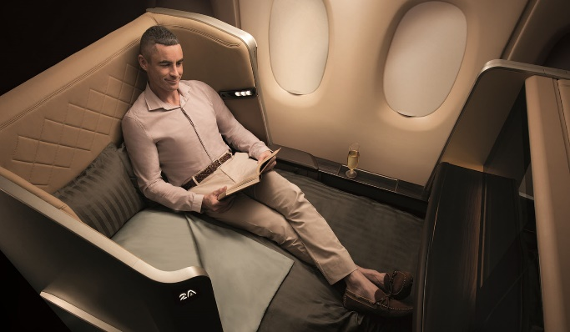

Picture 2.

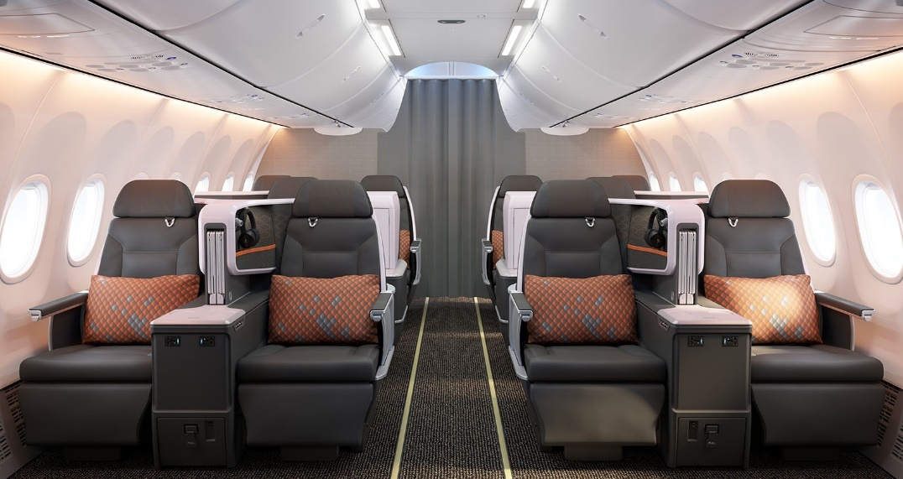
Picture 3.

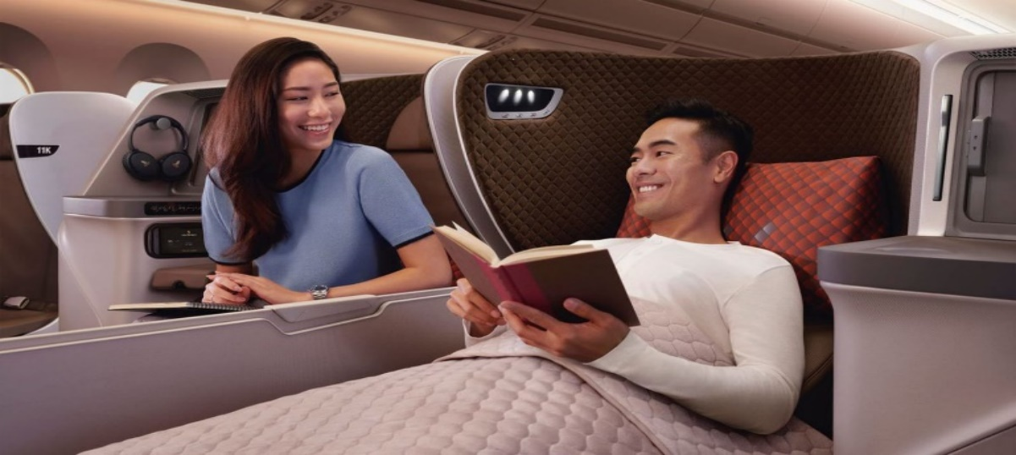
Picture 4.

4.2.Singapore Airlines Pricing Strategy:
Singapore Airlines follows a premium pricing strategy because, as was already mentioned, it is a premium airline. There is no denying the Suite services' price. However, the majority of people on the planet cannot afford it due to its high cost. For other services, the airline maintains competitive pricing policies in order to satisfy the needs of its intended market (Rahman, 2021).

4.3.Singapore Airlines Place and Distribution channels:
Singapore Airlines' main hub is located at Singapore Changi Airport. Through its subsidiaries, it serves over 130 destinations globally via air travel. Notably, the airline gave serious thought to its options prior to deciding to drop the "flights to nowhere" concept. The idea was to offer guests a three-hour sightseeing tour that would start and end at Singapore's Changi Airport. Customers who wish to travel with Singapore Airlines can buy tickets via its website. They can also do so by visiting websites like Expedia and Skyscanner, which are owned and operated by travel companies and tour operators. (Rahman, 2021).

4.4.Promotional strategies of the company:
Singapore Airlines heavily invests in its advertising campaign. It typically invests about $100 million annually in print and digital media advertising. Passengers are rewarded in numerous ways by its passenger loyalty programme, KrisFlyer:
- KrisFlyer Loyalty Program: The KrisFlyer loyalty program appears to be a valuable initiative for passengers, offering them rewards such as miles that can be used for travel and upgrades. Highlighting the benefits of the loyalty program in advertising could attract more passengers to participate.
- Social Media Presence: The Facebook page's large following suggests a strong presence on this platform, possibly due to the platform's popularity among a diverse audience. The lower follower count on Instagram and YouTube may indicate a need for the airline to tailor its content and engagement strategies to these platforms.
- Opportunities for Improvement: To enhance its social media presence, Singapore Airlines could analyse the content and engagement strategies that have been successful on Facebook and adapt them for Instagram and YouTube.
Creating platform-specific content that aligns with the preferences of each platform's user base can help attract and retain followers.
- Targeting Different Audiences: Consider the demographic differences among users on different social media platforms. Tailoring content to the preferences and behaviours of users on each platform can be crucial.
- Consistent Branding Across Platforms: While tailoring content, it's important to maintain a consistent brand image and message across all social media platforms. This helps in reinforcing the airline's identity.
- Engagement Strategies: Encouraging user-generated content, running contests, and engaging with followers through comments and messages can boost the airline's presence and encourage more people to follow and subscribe (Rahman, 2021).

4.5.Singapore Airlines People Strategies:
There are about 17,000 workers at Singapore Airlines. It should be noted, however, that it announced the elimination of about 4300 jobs, both domestically and internationally caused by the Covid-19 effect. The four-month training programme is a requirement for the amiable and well-trained Singapore Airlines cabin crew. In order to advance to more senior roles within the organisation, its pilots must also complete an intense training programme (Rahman, 2021).

4.6.Singapore Airlines Process:
Different departments of Singapore Airlines adhere to different protocols. For example, it differs from most other airlines' meal services in that its "Book the Cook" service lets users choose from a wide selection of meals (Rahman, 2021).

4.7.Singapore Airlines Physical Evidence:
Singapore Airlines operates some of the most opulent and spacious aircraft in the world, including the Airbus 1350-900, Airbus A380-800, Boeing 777-300ER, and Boeing 787-10. An incredible selection of toiletries, ultra-leather padded compartments, interiors, an excellent logo, and other details enhance the beauty of its physical surroundings (Rahman, 2021).

5.Singapore Airlines Stakeholders and their impact on the Marketing Functions of the company:
Stakeholders in Singapore Airlines are various. Customers, staff members, shareholders, the leadership group, suppliers, and pressure groups are among them. Singapore Airlines has created a thorough communication plan that facilitates effective stakeholder engagement and have a huge impact on their marketing functions. Stakeholders, some of whom are directly accountable for its success and who have strong interests in it (Park, 2022).

5.1.Singapore Airlines Internal Stakeholders:
SIA Internal Stakeholders

SIA Shareholders
SIA Employees
SIA Leadership Team

- SIA Leadership Team: The executives in the leadership team have a wealth of experience and expertise, and they oversee various departments within the company, including marketing, finance, operations, IT, and human resources. It is dedicated to giving consumers the greatest service possible and advancing the airline's prosperity. The Singapore Airlines leadership group is in charge of determining the airline's strategic course. The CEO is in charge of the group and is assisted by a number of senior and executive vice presidents.
- SIA Employees: In order to encourage and keep its staff, Singapore Airlines also offers a variety of other benefits. These include discounted travel during non-peak seasons, a free ticket to any destination on the airline's network, attractive leave policies, health insurance, and profit-sharing bonuses. Singapore Airlines' staff members are the company's public face and are in charge of giving customers excellent service. There are about 14.5 thousand workers at the airline.
- SIA Shareholders: The shareholders, who are in charge of giving Singapore Airlines the necessary funding and assisting in its expansion, are also highly significant internal stakeholders. The airline is owned by a diverse group of people and organisations (Park, 2022).

5.2.Singapore Airlines External Stakeholders:
SIA External Stakeholders

SIA Pressure Group
SIA Suppliers
SIA Customers

- SIA Customers: The success or failure of Singapore Airlines is largely determined by its customers, making them the airline's most significant external stakeholder. The company places a high priority on client satisfaction and service. The airline also makes significant investments in technologies that enhance the traveller experience. It has created an app that lets users manage their reservations, book flights, and check in online. Additionally, it provides a selection of in-flight entertainment choices for passengers to take advantage of while flying.
- SIA Suppliers: The airline and its suppliers have solid working relationships. In order to guarantee that it can offer its clients the greatest service possible, it collaborates closely with them. Singapore Airlines relies on a diverse network of suppliers to supply it with the goods and services it needs. Manufacturers of aircraft, engine suppliers, ground handling firms, caterers, and other service providers are some examples of these suppliers.
- SIA Pressure Group: The pressure groups push for change and increase public awareness of particular issues. They also keep an eye on the airline's operations to make sure they adhere to the moral and legal guidelines established by the authorities. A number of pressure groups are also interested in Singapore Airlines' operations. These groups include labour/trade unions, consumer rights organisations, environmental organisations, and other advocacy groups (Park, 2022).

6.Singapore Airlines Marketing Strategies Recommendations:
For those who think flying is a simple way to get where they're going, Singapore Airlines remains their top choice. There is strong business competition in the aviation sector. It is evident from this circumstance that less people are travelling. To maintain its position in the airline industry, a company needs to be able to generate profits and implement new marketing strategies (GSC, 2022).
At this point I can provide some general recommendations for Singapore Airlines' marketing strategies:
- Content Marketing: Develop high-quality, relevant, and informative content to engage and educate customers. Emphasize the unique features and benefits of flying with Singapore Airlines. Loyalty Programs: Strengthen and promote the airline's loyalty program to retain existing customers. Offer exclusive perks, rewards, and personalized experiences to loyal customers.
- Personalization: Implement personalized marketing strategies based on customer data and behaviour. Use data analytics to create targeted promotions and offers for specific customer segments.
- Innovative Technologies: To improve the customer experience, embrace cutting-edge technologies like artificial intelligence, virtual reality, and augmented reality. Implement innovative features in booking processes, in-flight services, and customer service.
- Pricing and Promotions: Regularly assess and adjust pricing strategies to remain competitive in the market. Launch targeted promotions during peak travel seasons or in response to market trends.
- Partnership and Alliances: Explore strategic partnerships with other airlines, travel agencies, or related businesses to expand the reach and offer joint promotions. Join global alliances to enhance connectivity and improve the overall travel experience for customers.
- Customer-Centric Approach: Prioritise comprehending and fulfilling the needs and preferences of your customers. Utilise client feedback to improve offerings and adjust marketing strategies as necessary.
- Digital Marketing: Invest in a strong online presence, which should include a distinctive mobile app and an easy-to-use website. Make use of social media channels for customer service, information sharing, and focused advertising.

7.Conclusion:
The national airline of Singapore, Singapore Airlines Ltd. (SIA), is a significant carrier in the Pacific, operating routes to North America and Europe, its famous for its unmatched client support as well, regarding its ongoing initiatives to improve its aviation and technology. The Singaporean government owns 54% of SIA, with smaller stakes held by Delta Airlines and Air France. Singapore Airlines has made numerous commitments to the arts and education as part of its vision. Controlled areas, as well as the health and well-being of the nation's population (SINGH, 2016).
Additionally, Singapore Airlines declared strongly to protect the environment and the world being ahead. The goal is to offer air travel services of the greatest calibre as well as to maximising profits for the organization's both employees and shareholders. Numerous airlines are aware of Singapore Airlines Limited and its unique brand image.
In conclusion, despite Singapore Airlines' long history of fame in the air travel segment, the COVID-19 pandemic's restraints have forced the company to put on hold the majority of its activities. Due to the risk of getting sick, some clients began to become afraid to fly, even to open destinations. Due to the pandemic's instability, Singapore Airlines must employ an advertising and marketing strategy to entice customers with the lowest rates available. SIA is committed to working with deals and offers to enable price differentiation as flight restrictions was suspended (SINGH, 2016).

8.References:
Craven, M., Liu, L., Wilson, M. & Misory, M., 2022. McKinsey&Company. [Online]
Available at: https://www.mckinsey.com/capabilities/risk-and-resilience/our-insights/covid-19-implications-for-business
[Accessed 7 11 2023].
GSC, 2022. wearecsg.com. [Online]
Available at: https://wearecsg.com/blog/aviation-marketing-strategies/
[Accessed 12 11 2023].
H.Bhasin, 2023. Marketing91. [Online]
Available at: https://www.marketing91.com/marketing-mix-singapore-airlines/#google_vignette
[Accessed 15 11 2023].
Kamil, A., 2020. Today. [Online]
Available at: https://www.todayonline.com/singapore/covid-19-sia-announces-cost-cutting-measures-affecting-10000-staff-ceo-other-bosses-take
[Accessed 15 11 2023].
Park, K., 2022. Bloomberg. [Online]
Available at: https://www.bloomberg.com/news/articles/2022-06-02/stakeholders-support-helps-singapore-airlines-come-out-ahead-from-covid?leadSource=uverify%20wall
[Accessed 12 11 2023].
Phong, M. G. C., 2023. Podcast: Singapore Airlines CEO Goh Choon Phong Interview Exclusive [Interview] (20 april 2023).
Rahman, M., 2021. Marketing mix of Singapore Airlines (7Ps of Singapore Airlines). [Online]
Available at: https://www.howandwhat.net/marketing-mix-singapore-airlines/
[Accessed 12 11 2023].
Rowan, M., 2019. @KPItarget﻿. [Online]
Available at: https://www.kpitarget.com/how-singapore-airlines-uses-ai-to-personalize-air-travel/
[Accessed 12 11 2023].
Shan, Z. J. C. &. J., 2020. 2019 Novel coronavirus: where we are and what we know. Springer Nature 2020, 48(2)(Springer-Verlag GmbH Germany, part of Springer Nature 2020), pp. 155-163.
SIA Annual Report, F., 2023. Sustainability at Singapore Airlines. [Online]
Available at: https://www.singaporeair.com/saar5/pdf/Investor-Relations/Annual-Report/sustainabilityreport2223.pdf
[Accessed 14 11 2023].
SINGH, L. S. C. &. K., 2016. Development of Singapore's Global Air Transport Hub. 50 Years of Transportation in Singapore, 1(https://doi.org/10.1142/9789814651608_0008), pp. pp. 479-546 .
SITA, 2022. SITA OptiClimb®. [Online]
Available at: https://www.sita.aero/pressroom/news-releases/singapore-airlines-deploys-sita-opticlimb-to-reduce-up-to-15000-tons-of-aircraft-carbon-emissions-per-year/
[Accessed 13 11 2023].
SITA, O., 2022. adsadvance. [Online]
Available at: https://www.adsadvance.co.uk/sita-opticlimb-selected-by-singapore-airlines-to-reduce-emissions.html
[Accessed 13 11 2023].
Statista, R. D., 2023. statista.com. [Online]
Available at: https://www.statista.com/statistics/1044692/singapore-airlines-group-passenger-numbers/
[Accessed 13 november 2023].

