PEST Analysis of Swansea City AFC


April 2018
Module Name:
Name:
Student Number:

The Global Business Environment (M4X00801)
Peter Basford
1707183

Table of Contents

1 – Executive Summary 3
2 – Introduction 4
2.1 – Report Remit 4
2.2 – Background of the Organisation 4
2.3 – The PEST Analysis 5
3 – Analysis of Influencing Factors 6
3.1 – Political Factors 6
3.2 – Economic Factors 8
3.3 – Societal Factors 10
3.4 – Technological Factors 10
4 – Conclusion 11
4.1 – Strengths and Weaknesses 11
4.2 – Recommendations 11
5 – References 12

Table of Figures

Figure 1 – Income against Expenditure (Dettmer, 2018) 8
Figure 2 – Unemployment rate, 1971 to 2018 (Office for National Statistics, 2018) 9
Figure 3 - Changes in modern betting (OddsWinner, 2014) 10

1 – Executive Summary
This report contains an application of the PEST framework to the Swansea Stadium Management Company and their owners Swansea City AFC. Following the takeover of the SSMC Swansea City have stated they are looking to explore new revenue streams for the club and stadium. An explanation of the PEST framework is given along with a brief overview of the stadium and how it came to be in its current position.
A key political factor impacting the running of the stadium is the wave of terrorist attacks throughout Europe over the last few years. This has lead to tighter security at locations that could be a target, such as the Liberty Stadium. Involved in this is the recruitment of new security staff, specialist training and drills on the topics of handling emergent threats to the public and the business as a whole. The impact of these attacks on the public willingness to attend public events is also looked at and consideration is made to counteract this phenomenon. An economic factor considered is the recent rise in the minimum wage and how this will affect both the employees of the SSMC and the spending habits of the wider public. Societal factors involve the behaviour of visiting fans and any costs the stadium is subjected to as a result of them. A new technological opportunity for the stadium would be working with the large betting companies to improve the Wi-Fi facilities of the stadium allowing for a better experience for the customers.
Recommendations arrived at are that:
- In the event of a terror attack, ticket prices can drop to ensure maximum possible attendance.
- An improved economic outlook and rising incomes present the opportunity to sustainably raise prices.
- Improvements to the stadium Wi-Fi infrastructure should be further explored.

2 – Introduction

2.1 – Report Remit
This report will examine the stadium management arm of Swansea City AFC Limited and the threats and opportunities presented to them through the medium of a PEST analysis. Having assessed these four factors, recommendations will be made as to possible avenues of future research and changes that could be made to the operation of the stadium.

2.2 – Background of the Organisation
The Liberty Stadium was built by the City and County of Swansea Council as part of the development of the Morfa Retail Park. It was built as a new home to Swansea City AFC and Ospreys Rugby, replacing the ageing Vetch Field stadium (The Stadium Guide, 2011) for Swansea City and giving the Ospreys a purpose-built home for the first time (Ospreys, 2018). The stadium is now regularly hosting international sporting events and sell-out concerts while also providing facilities for numerous events and conferences each year (Liberty Stadium, 2018). Up until recently, the stadium was run by the Swansea Stadium Management Company (SSMC), which was mutually controlled by Swansea Council, Ospreys Rugby and Swansea City AFC (Swansea Council, 2018). This agreement has now changed with Swansea City AFC taking over sole control of the SSMC. The new agreement states that instead of sharing the profits between the three controlling organisations, Swansea City will pay Swansea Council rental payments, the Ospreys will be allowed to continue using the stadium on a long-term lease and Swansea City will now be able to stay competitive with other Premier League clubs by taking full advantage of opportunities as they occur (Ibid.).

2.3 – The PEST Analysis
The use of the mnemonic PEST to assess the environmental influences upon an organisation has been around in various forms since Francis Aguilar first suggested his “ETPS” acronym for Environmental, Technical, Political and Social in his 1967 publication “Scanning the Business Environment” (Aguilar, 1967; cited in Collins, 2010). Over the intervening decades, Aguliar’s method has survived due to its simplicity and versatility, being applicable to all sectors of the business environment. It has been rearranged (PEST) and added to (PESTEL, adding Environmental and Legal) but remains a valued method of assessing the external factors impacting a business.
While it is certainly a useful tool, it is the opinion of the author that PEST has the potential to become something of a crutch for business strategic planning. Though the conclusions drawn from a PEST analysis may be valid at the time, they may rapidly become outdated in these current turbulent economic times. Managers must keep this in mind and not become focused on meeting the recommendations of a previous PEST analysis without paying attention to developing threats and opportunities.

3 – Analysis of Influencing Factors

3.1 – Political Factors
Political factors that can affect the management of the Liberty Stadium can be wide-ranging. With the ongoing Brexit negotiations and the potential for a so-called “Hard-Brexit” and the associated restrictions on movement within the EU (BBC, 2018), there is the potential for a diminished presence of European footballers in UK clubs with the potential for half of the Premier League needing some form of work permit (Slater, 2018). The effect this could have upon British football could be significant, with knock-on effects upon the stadium companies themselves as the perceived value of the Premier League would be decreased.
With the spate of recent terror attacks in Europe and the UK and terrorism-related arrests rising by 68% between June 2016 and June 2017 (Dempsey, et al., 2017) the threat of attacks is perhaps now more in the public consciousness than it has been since the height of the IRA attacks in the late 20th century. With this in mind stadium owners and event organisers need to consider the wide variety of threats they could face, from Improvised Explosive Devices (IEDs) and using a vehicle as a weapon to the so-called “active shooter” scenario and the use of more complicated Chemical, Biological and Radiological (CBR) agents such as the Anthrax campaign in the USA of 2001 or the use by a Japanese cult of the nerve agent Sarin in attacks in the 1990s (Lindstrom, 2004; NaCTSO, 2017). Updated guidance from the Home Office following the 2017 attacks now include the such things as preparing, rehearsing and carrying out search plans of the venue, actions to be taken on receipt of a bomb threat and the necessity of thorough vetting of new employees, regardless of how long they may be intending to work for the organisation (NaCTSO, 2017). These will all have an impact on the costs of running the stadium, requiring specialist training and supervision. The need for in-depth checks on prospective employees in-particular may see in increase in costs for the stadium due to the fluctuating nature of the workforce, dependant on the size of the event and the suspected volatility of the crowd.
The demands for increased security procedures placed upon stadium owners are not, however, the only impact of these acts of terrorism. Following the 2017 attacks in the UK and the 2015 Paris attacks tourist numbers dropped, not only in the cities affected but many major European cities along with attendance at events that are perceived as potential targets, such as sporting events and concerts (Statista, 2017; Hurst, 2017). This means that the company needs to remain aware that they may see a reduction in ticket sales following an attack, even if that attack was in a far-flung European capital.

3.2 – Economic Factors
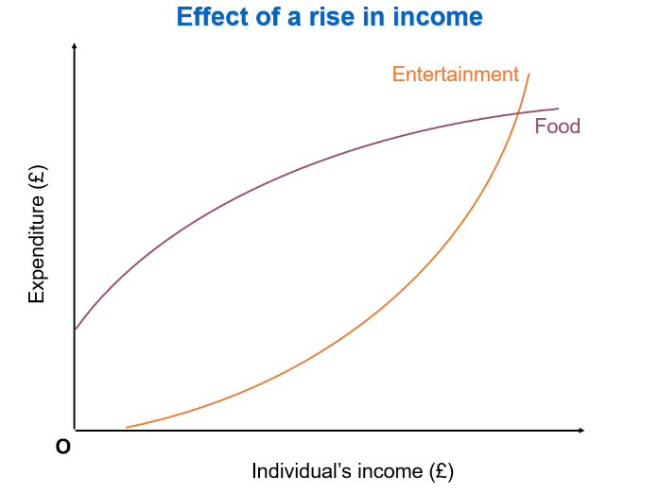
Any successful business cannot be run in a vacuum, it must react to the fluctuations of the global market and the economic environment it finds itself in. In the last few days, the National Living Wage (a rebranding of the old National Minimum Wage) has increased to £7.83, with the Chancellor reportedly planning to raise it to £9 by 2020 (O'Flynn & Burnip, 2018). The foreseeable impact of this on the SSMC is twofold. The increase will require a rise in the labour costs of the stadium with further rises with each new financial year up to 2020, with many of the stadium staff being on zero-hour contracts and the potential for them to be on the minimum wage this might have a not insignificant impact on the costs of the business. The upside of this is that with the rise in income people will become more willing to spend their money on entertainment, such as attending live sporting events (See Figure 1). In the case of a stadium, the supply of seats is fixed, with no way to increase the number beyond large construction work. Consider a graph of supply and demand, the supply curve for stadium seats will be a vertical line at the capacity of the stadium, as no increase or decrease in price can affect the number of seats available. In the case of a fixed supply, as the demand curve moves to the right, the supply curve cannot move to meet this, meaning the new equilibrium price will be higher, the more demand there is. From this, we can conclude that in times of rising wages, such as these coming years if Phillip Hammond follows through on his stated intentions, the price per ticket that the fans will tolerate can rise alongside. As figure 1 shows, the money people will spend on entertainment increases exponentially as income increases, this could allow for a large opportunity to raise ticket prices.
Figure 1 – Income against Expenditure (Dettmer, 2018)
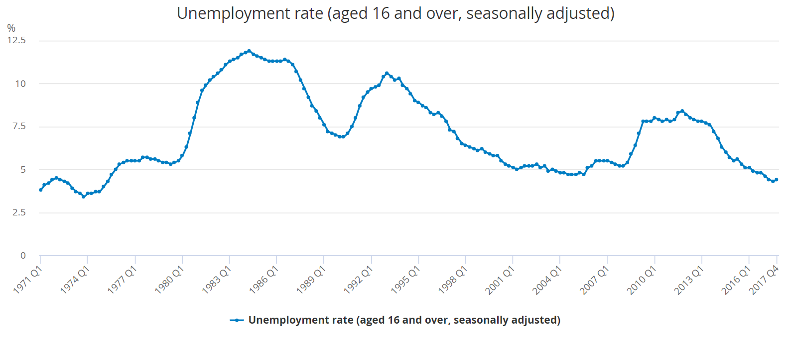
Also to be considered is the falling unemployment rate (See Figure 2). With more people in work now than in the last decade and more people able to afford tickets, there may be the potential to move to a more dynamic pricing structure, adjusting prices according to demand (Peltz, 2016). With the Ospreys regularly failing to fill even half of the stadium capacity (Howell, 2014), perhaps the prospect of cheap tickets could attract new fans to the club.
Figure 2 – Unemployment rate, 1971 to 2018 (Office for National Statistics, 2018)

3.3 – Societal Factors
The impact of society on the stadium cannot be overstated, particularly the behaviour of the more militant football fans. With matches against Cardiff being particularly vicious the cost of security for these matches is far higher than a more usual match. Not only is the cost of increased staff to be considered there is also the potential for damage to the stadium fixtures and fittings. Following a Swansea – Cardiff match in 2009 thousands of pounds of damage was done to the stadium by away fans, while the stadium was reimbursed for the repairs by Cardiff City the opportunity cost must also be considered (BBC, 2009). Any planned events after such volatile matches must take into account the possibility of some seating being unavailable due to the actions of opposing supporters. One possible knock-on effect of the more stringent anti-terrorism requirements is that the increased security and assist in controlling the rowdier fans, this could be considered a benefit that may offset some of the cost of the security measures.

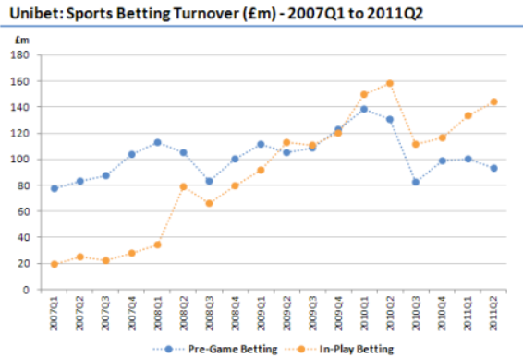
3.4 – Technological Factors
With the rapid expansion of “In-Play” betting, there is now a large demand for fast internet connections in stadiums (OddsWinner, 2014). Currently, mobile internet connections at large events have consistently been slow or non-existent, as the local networks are swamped with connections. With the Football League now approving limited Wi-Fi connections in stadiums, there is the opportunity for the Liberty Stadium to steal a march on other stadiums by approaching one of the large betting companies and working in partnership to install advanced Wi-Fi infrastructure and allow fans access to faster internet within the stadium (BBC, 2016).
Figure 3 - Changes in modern betting (OddsWinner, 2014)

4 – Conclusion

4.1 – Strengths and Weaknesses
While there are increased threats in the months and years ahead, there are also opportunities these events present. Though the political climate presents challenges, none of them are insurmountable and the company should be able to navigate its way through with sufficient care and attention paid to the Brexit process. The current economic situation could present an opportunity for the SSMC, with an improved economic outlook leading to the potential for sustainable prices rises. While a weakness of hosting Swansea City is their fans and any potential hooliganism, this seems to have been declining in recent years. The use of technology in the stadium is an area where the SSMC could develop a strength through the pioneering of new technologies.

4.2 – Recommendations

- Be prepared to reduce ticket prices in the events of further terror attacks in the UK and Europe, this would ensure that the maximum number of tickets are still being sold, regardless of a potential drop in demand.

- As personal incomes increase, ticket prices can be raised beyond the rate of increase due to the nature of people’s spending on entertainment.

- Explore partnerships with large betting companies to improve WiFi facilities within the stadium.

5 – References
BBC, 2009. Stadium damage to cost thousands. [Online]
Available at: http://news.bbc.co.uk/1/hi/wales/south_west/8352310.stm?
[Accessed 4 4 2018].
BBC, 2016. Football: English stadiums to get free wi-fi for some apps. [Online]
Available at: http://www.bbc.co.uk/news/technology-35942609
[Accessed 4 4 2018].
BBC, 2018. UK's offer to EU nationals arriving during Brexit transition. [Online]
Available at: http://www.bbc.co.uk/news/uk-politics-43230616
[Accessed 1 4 2018].
Collins, R. J., 2010. Is there a better way to analyse the business environment?, Reading: University of Reading.
Dempsey, N., Allen, G. & Politowski, B., 2017. Terrorism in Great Britain: the statistics, Commons Briefing papers CBP-7613, London: House of Commons Library.
Dettmer, S., 2018. Lecture 9 Economics [Powerpoint Presentation] M4X00801: The Global Business Environment. [Online]
Available at: https://moodle.uwtsd.ac.uk
[Accessed 4 4 2018].
Howell, A., 2014. Welsh rugby: Andy Howell asks can regions follow Leinster by competing with Cardiff City and Swansea City for crowds?. [Online]
Available at: https://www.walesonline.co.uk/sport/rugby/rugby-news/welsh-rugby-crowds-andy-howell-7754853
[Accessed 4 4 2018].
Hurst, A., 2017. European visitor numbers down after UK terror attacks. [Online]
Available at: https://www.telegraph.co.uk/business/2017/07/31/european-visitor-numbers-uk-terror-attacks/
[Accessed 3 4 2018].
Liberty Stadium, 2018. About the Stadium. [Online]
Available at: http://www.liberty-stadium.com/liberty_stadium_introduction.php
[Accessed 25 3 2018].
Lindstrom, G., 2004. Protecting the European Homeland - The CBR Dimension, Paris: European Union Institute for Security Studies.
NaCTSO, 2017. Crowded Places Guidance, London: National Counter Terrorism Security Office.
OddsWinner, 2014. Report: How the UK’s Mobile Betting Industry More than Doubled in 2014. [Online]
Available at: http://www.oddswinner.com/report-how-the-uks-mobile-betting-industry-doubled-in-2014/
[Accessed 4 4 2018].
Office for National Statistics, 2018. Unemployment rate (aged 16 and over, seasonally adjusted). [Online]
Available at: https://www.ons.gov.uk/employmentandlabourmarket/peoplenotinwork/unemployment/timeseries/mgsx/lms
[Accessed 4 4 2018].
O'Flynn, N. & Burnip, L., 2018. What is the National Living Wage 2018, when did it increase and what’s the minimum wage in the UK for 16,18 and 25 year-olds?. [Online]
Available at: https://www.thesun.co.uk/news/2085051/national-living-wage-2018-increase-date-uk-minimum-wage/
[Accessed 4 4 2018].
Ospreys, 2018. The Story. [Online]
Available at: http://www.ospreysrugby.com/Page/Content/1632
[Accessed 25 3 2018].
Peltz, J. F., 2016. Why 'dynamic' pricing based on real-time supply and demand is rapidly spreading. [Online]
Available at: http://www.latimes.com/business/la-fi-agenda-dynamic-pricing-20160314-story.html
[Accessed 4 4 2018].
Slater, M., 2018. EU referendum: Brexit could have 'big effect' on football. [Online]
Available at: http://www.bbc.co.uk/sport/football/35919247
[Accessed 1 4 2018].
Statista, 2017. Terrorism impact on the travel industry in Europe - Statistics & Facts. [Online]
Available at: https://www.statista.com/topics/3329/terrorism-impact-on-the-travel-industry-in-europe/
[Accessed 3 4 2018].
Swansea Council, 2018. Council and Swans agree lease for Liberty Stadium. [Online]
Available at: https://www.swansea.gov.uk/article/39594/Council-and-Swans-agree-lease-for-Liberty-Stadium
[Accessed 26 3 2018].
The Stadium Guide, 2011. Vetch Field. [Online]
Available at: http://www.stadiumguide.com/vetchfield/
[Accessed 25 3 2018].

