

Graduate Diploma Professional Police Practice

LEVEL 6 - 40 Credits

Workbook title: Competency Based Workbook 2 (DHEP)

(SOUTH WALES POLICE, GWENT POLICE AND UWTSD)

Learner name: ______________________________

Learner’s University Registration Number:
_______________________________

FACULTY OF BUSINESS AND MANAGEMENT
PUBLIC SERVICE PROGRAMME

Module title: Policing in the Workplace 3 (DHEP) - BMPP6001D

Workbook Guidance

Please read these notes carefully. They provide essential information. The documents you will use in developing your workbook are on the following pages.

What is the workbook for?

The purpose of this workbook is to enable learners to demonstrate and provide evidence of how they meet the learning outcomes set by the College of Policing, for the Graduate Diploma in Professional Policing Practice. You are being asked to outline your experiential learning based upon your theoretical understanding in a range of operational situations.

- Wellbeing and Resilience
- Criminal Justice
- Conducting Investigations
- Decision making and discretion
- Maintaining Professional Standards
- Leadership and Team working
- Policing the roads
- Information and Intelligence

You may wish to use the same incidents as you have outlined in the Occupational Competence Portfolio.

How should the workbook be presented?

Blank electronic copies can be found on Moodle of this workbook. You must submit this document electronically therefore it is important that you save your work regularly and upload the final typed version through Turnitin on Moodle.

Word count policy can be found in chapter 7 of the Academic Quality under section 7.7 (this applies to presenting work above and under the specified word count).
(https://www.uwtsd.ac.uk/media/uwtsd-website/content-assets/documents/academic-office/aqh-chapters/chapters---en/Chapter_07_Assessment_Taught_Programmes_Pages_72-79-UPDATED-05-11-2019.pdf)

Reflective practice is a core aspect for your workbooks and although there is a variety of useful resources on Moodle, there is one particular book that is specifically based on reflective practice in policing, here is a link to one chapter from Selina Copley’s Reflective Practice for Policing Students:
https://moodle.uwtsd.ac.uk/pluginfile.php/298870/mod_resource/content/1/Reflective%20Practice%20for%20Policing%20Students%20-%20Selina%20Copley%20Chapter5.pdf

How is the workbook assessed?

Advice and support about the completion of this workbook is available to you. Please contact Kelly Andrews’s direct using k.andrews@uwtsd.ac.uk with any questions or queries you may have.

Dates of workbook submission can be located within the General information tile within Moodle.

Once submitted your workbook will be assessed and marked independently. You will be provided with individual feedback once the work has been marked.

Confidentiality

It is important that no individual can be identified either directly or indirectly from the information in the workbook. However, you must:

- Adhere to guidance in the Candidate Handbook about confidentiality.
- Not identify individuals including witnesses, victims, or offenders by name.
- Not write information that enables any individual to be identified indirectly through the description you provide. This includes references to names, colleagues, places (including hospitals, schools, town, villages, streets) specific incidents which were high profile and could be identified due to past publicity, other professionals or any other personal information including medical or other conditions.
- Take personal responsibility for adhering to confidentiality rules.
- Not include any dates of any incidents or anything that specifically identifies an actual incident.

Please be aware that any content that is deemed to be inappropriate, disrespectful, or abusive will not be tolerated. Following review of any content of this nature the information will be shared with the employer of the student responsible.

Should any health and wellbeing concerns be raised because of disclosures made by the student within this workbook, the employer of the student will be informed.

NOTE

Your workbook will be submitted electronically via Turnitin on Moodle. Guidance on this is in the Candidate Handbook.

Remember that the workbook is YOUR responsibility you must not rely on the assessor or anyone else to pick up any confidentiality breaches as this is your work and you must accept full responsibility for confidentiality. Meeting all the confidentiality requirements is particularly important.

Dyslexia and other special circumstances

If you have any condition that you feel may affect your ability to deal with any part of the programme, please see the Candidate Handbook for further guidance. The University has a Student Services Unit that may be able to help but it is the learner’s individual responsibility to contact them.

Competency Based Workbook 2 - Learner Workbook

Guidance:

- Your workbook must contain items 1 - 5 below (in the order given).
- You should use the pro-forma to insert your text within each section.
- Note that this module has 2 components with each weighted at 50% of the overall 100% marks total.
- You should upload your completed document as a saved pdf file of this workbook; if this is not possible then a Word Doc file is acceptable. Do not send a scanned file from a photocopier, an apple.dot file, or a Microsoft publisher file as Turnitin will not be able to assess them, despite you being able to upload them.

Contents

Component 1  50% | Area of Professional Practice | Word count
Task 1 | Vulnerability and Risk  Evidence-based policing | 2000
Task 2 | CHOOSE ONLY 1 OF THESE 'ADVANCED LEARNING AREA’ OPTIONS. IT SHOULD BE ONE THAT HAS BEEN AGREED WITH THE FORCE TO STUDY IN YEAR 2. | All options are 2000 words
Task 2  Option 1  Option 2  Option 3  Option 4  Option 5 | Response Policing  Policing Communities  Road Policing  Information and Intelligence  Conducting Investigations | 2000
 | Bibliography

Task 1

Relevant areas of the National Policing Curriculum:
Vulnerability and Risk, Evidence-based policing

You must choose a policing incident in which you played a significant role with a victim of crime or anti-social behaviour and reflect on what happened.

Give a brief description of the incident including social and legislative contexts and any relevant cultural, ethnicity and language issues.

Critically evaluate the appropriateness of different approaches (by professionals and the police) in supporting or managing vulnerable people or people at risk of harm.

Explore what works in relation to tackling repeat victimisation and repeat offending. Consider the use of evidence-based policing.

2000 words (+/- 10%: include your actual word count at the end of each section)

ANSWER:

Being a police officer is a challenging and often varied role to which requires versatility and a sense of adaptability to deal with a plethora of incidents. Whilst engaging in my role as a response officer, on a day to day basis I deal with crime, which can vary in terms of risk, severity and harm. However, one thing remains a constant, there is often a victim at the heart of this.

In this essay I will endeavour to discuss and evaluate an incident whereby I feel that I played a significant role in supporting a victim of crime whilst dealing with an incident I responded to.

Before I endeavour to discuss this incident, I believe it is important to understand the definition of what a victim is and how this is reflected and interpreted in policing context. A victim has been widely accepted as the following definition “someone or something that has been hurt, damaged, or killed or has suffered, either because of the actions of someone or something else, or because of illness or chance” (Cambridge University 2022), this goes on to explain that someone can be victim to a range of things, including crime.

Whereas within the Victim’s Code outlined by the Ministry of Justice (2020) states the following in line with their definition of a victim: “a person who has suffered harm, including physical, mental, emotional harm or economic loss which was directly caused by a criminal offence” or, “a close relative or a nominated family spokesperson, of a person whose death was directly caused by a criminal offence.”
When attending incidents whereby there is a victim at the end of it, there is an emphasis on understanding that the crime - no matter the severity - may have an adverse effect on the wellbeing of that person. It is also important to realise that the quality of my conduct and the service I provide will leave a long lasting impression, and may go some way to reassure and support them.

There is also an importance in understanding that each victim of crime has a dedicated list of rights that must be honoured to support them, whether it is in regards to supporting their journey through the criminal justice route, or support in their day to day life following the impact of being a victim of crime. These dedicated rights are listed under the Code of Practice for Victims of Crime in
England and Wales November 2020. These are set out as follows:

- Right 1: To be able to understand and to be understood;
- Right 2: To have the details of the crime recorded without unjustified delay;
- Right 3: To be provided with information when reporting the crime;
- Right 4: To be referred to services that support victims and have services and support tailored to your needs;
- Right 5: To be provided with information about compensation;
- Right 6: To be provided with information about the investigation and prosecution;
- Right 7: To make a Victim Personal Statement;
- Right 8: To be given information about the trial, trial process and your role as a witness;
- Right 9: To be given information about the outcome of the case and any appeals;
- Right 10: To be paid expenses and have property returned;
- Right 11: To be given information about the offender following a conviction;
- Right 12: To make a complaint about your Rights not being met.

Crown Prosecution Service (2022)

Whilst it is important to recognise the rights that a victim has, I also have to conduct myself and execute my duties in line with the Police Standards of Professional Behaviour and the Code of Ethics. Police Officers are expected to adhere to the following standards which has been set out by the Gloucestershire Police Federation (2019), these are as follows:

- Honesty and Integrity - Police officers are honest, act with integrity and do not compromise or abuse their position.

- Authority, Respect and Courtesy - Police officers act with self-control and tolerance, treating members of the public and colleagues with respect and courtesy. Police officers do not abuse their powers or authority and respect the rights of all individuals.

- Equality and Diversity - Police officers act with fairness and impartiality. They do not discriminate unlawfully or unfairly.

- Use of Force - Police officers only use force to the extent that it is necessary, proportionate and reasonable in all the circumstances.

- Orders and Instructions - Police officers only give and carry out lawful orders and instructions. Police officers abide by police regulations, force policies and lawful orders.

- Duties and Responsibilities - Police officers are diligent in the exercise of their duties and responsibilities.

- Confidentiality - Police officers treat information with respect and access or disclose it only in the proper course of police duties.

- Fitness for Duty - Police officers when on duty or presenting themselves for duty are fit to carry out their responsibilities.

- Discreditable Conduct - Police officers behave in a manner which does not discredit the police service or undermine public confidence in it, whether on or off duty. Police officers report any action taken against them for a criminal offence, any conditions imposed on them by a court or the receipt of any penalty notice.

- Challenging and Reporting Improper Conduct - Police officers report, challenge or take action against the conduct of colleagues which has fallen below the Standards of Professional Behaviour.

I have opted to discuss the following incident whereby I feel it is relevant to discuss this in relation to the question and criteria set out. The incident in question was a report of criminal damage whereby the victim had their front windows smashed by an unknown person. However, this victim was well known to police for being a repeat victim of crime by unknown people in the community.

Upon responding to this incident, it was my first time dealing with the victim and their family who came to live in Cardiff following a decision to flee home life in Iraq due to ongoing tensions and conflicts back home. Whilst conversing with the victim, it was apparent that they struggled to speak English properly and that they were unable to explain what had happened clearly.

Realising that language could become a barrier that prevents the victim from receiving the best standards in care and service, I opted to utilise Language Line, which is an external organisation that specialises in translating a wide variety of languages. Language Line has worked in partnership with the police since the 1980s and allows a plethora of languages to be translated in quick fashion (Language Line 2022). Through using this service I was able to communicate clearly with the victim, and understand what had happened.

The victim was able to explain to me that since they had moved into the area in early 2021, they had experienced several issues, which included their front windows being smashed on more than one occasion since moving there. The victim went onto state that they believed the issues surfaced as they suspect the motivations were due to the fact they come from IRAQ and that area they live in has a very small population of migrants.

Based on this information, this incident was to be dealt with as a Hate Crime. Which meets the criteria set out in the following definition:

‘'Any criminal offence which is perceived by the victim or any other person, to be motivated by hostility or prejudice based on a person's race or perceived race; religion or perceived religion; sexual orientation or perceived sexual orientation; disability or perceived disability and any crime motivated by hostility or prejudice against a person who is transgender or perceived to be transgender.” (Metropolitan Police, 2022).

This decision was made as it was highly likely that the motivation behind committing this offence was due to the race and ethnicity of the victim, as per the victim’s concerns and experiences since moving to the area. Upon talking to the victim about the current and previous incidents, it was clear that there were no identified suspects and the matters were unable to be progressed. Upon reviewing the locality of the offence, it was established that no further witnesses or CCTV enquiries were identified, which hampered my investigation further.

My next focus was in supporting the victim, and to review and implement measures where I deemed suitable to reduce the likelihood of the victim being subject to crime, whilst enhancing the security and crime prevention methods and implements to support the victim and promote their welfare and safety. Upon reviewing their home, I could see that they did not have any CCTV or crime prevention features such as spotlights or alarms.

Whilst talking to the victim, I explained measures that could be put in place to enhance the security measures that may assist the victim in reducing the likelihood of becoming a victim to crime again. I also provided crime prevention advice which included keeping the doors and windows within the property secure, keeping belongings hidden and safe within the address in combination with the measures discussed all in the aim to reduce the likelihood of repeat victimisation.

In line with a report issued by the Scottish Government (2014) in relation to situational crime prevention, there is the theory that crime occurs where there is a ‘clustering’ of opportunity, the opportunity of a motivated offender, the opportunity to offend and the absence of a guardian or deterrent. To combat this theory of crime, it is suggested that the following measures are put in place to reduce the likelihood of crime occurring:

- Increasing formal electronic alarms or CCTV.
- Increasing surveillance/security/police patrols
- Increasing natural surveillance, minimising obstructions and increasing natural lighting
- Removing physical targets, such has visible high value goods
- Erecting or strengthening physical barriers, for example double locks or double paned glass.
(Scottish Government 2014)

It must be stressed that these measures can prevent the likelihood of crime occurring, however this isn’t always a certainty, especially if the offender(s) is highly driven to commit offences. The victim was happy and appreciative to receive this information and took on board what was said.

I also informed the victim that I would be referring them to South Wales Victim Support focus, an external partner with the initiative that focuses solely on providing support to victims of crime, whether it is support in regards to day to day life, or supporting a victim through the criminal justice process with whatever assistance they may need. In accordance with this referral I informed the victim that our local hate crime officer would be in touch to discuss the matter and to provide further support.

Upon attending this incident, it was evident to me that there was no viable lines of enquiry to identify the suspect(s) nor collect any further evidence in relation to this incident due the lack of available means to progress this. My main focus was putting in support measures to benefit the victim moving forward. Prior to leaving the address, I established the property was owned by Cardiff City Council and made efforts to arrange repair work to be conducted by their staff, this was done to reassure and help the victim with the practical aftermaths of the crime.

When leaving the victim I returned to the station to ensure that I put everything that I had explained to the victim into practise and ensuring that the relevant support mechanisms were in place. I also made sure to pass the matter onto the local Neighbourhood Policing Team, this was to ensure that they were aware of the ongoing issues the victim is experiencing, and to also set up a contingency plan in the attempt to reduce demand and the likelihood of further offences. This will involve the implementation of a patrol strategy, whereby officers would frequently patrol the locality with the aim of providing a visible deterrence, officers would also provide reassurance visits. In addition to this a referral was sent to the Target Hardening team, with would result in an officer attending the victim’s address to review and implement measures that could help reduce the likelihood of crime occurring.

Upon reflection, I would say that the service I provided to this victim was measured and respectful, given the circumstances of the incident and the historic incidents I was able to adapt and cater to the needs of the victim, through translation and hate crime support mechanisms. Although I was aware that the incident would be difficult to progress, I did my upmost to prevent the likelihood of offences happening again, by putting in support and making partners aware of the situation.

Although a short period of time has passed since this incident, no further reports from the victim has been received, which suggests that the support that has been put in place is working. However, it would be naïve to suggest that the issues have been resolved. This is something that will have to be reviewed as time goes on.
2165 words
Bibliography:

- Cambridge University 2022 - VICTIM | English meaning - Cambridge Dictionary
- Crown Prosecution Service 2022 - Victims and Witnesses: Care and Treatment | The Crown Prosecution Service (cps.gov.uk)
- Gloucestershire Police Federation 2019 – Standards of Professional Behaviour (polfed.org)
- Language Line (2022) - Language Line UK | Police & Criminal Justice
- Metropolitan Police 2022 - What is hate crime? | Metropolitan Police
- Ministry of Justice 2020 – Mojo Victims Code 2020 (publishing.service.gov.uk)
- Scottish Government (2014) – What Works to Reduce Crime?: A summary of the evidence – What Works to Reduce Reoffending: A Summary of the Evidence - gov.scot (www.gov.scot)

Task 2

This is a reminder that this TASK 2 section is an opportunity for you to answer one question which should be relevant to the “advanced learning” area that you have chosen. The advanced learning lecture that you choose to attend will assist you in answering this task.

Choose 1 of these 5 options to answer

(Note for officers who have an interest in becoming a detective and wish to specialise in this role, you MUST choose option 5)

  - Response Policing.
  - Policing Communities.
  - Road Policing.
  - Information and Intelligence.
  - Conducting Investigations.

Task 2 Option 1:

Relevant areas of the National Policing Curriculum:

Response Policing

A core part of the policing mission is to prevent crime and disorder. Domestic abuse causes both serious harm and constitutes a considerable proportion of overall crime

You should choose a domestic abuse incident that was of a complex nature, in which you played a significant role in providing a response.

Critically assess the challenges associated with a domestic abuse incident that you have attended, and the strategies developed for effective policing in such challenging situations.

2000 words (+/- 10%: include your actual word count at the end of each section)

ANSWER:

A core part of my role a response officer working in South Wales Police is managing vulnerability and risk, whilst always attempting to reduce risk. This is an ever present challenge with the way crime and society expands and becomes complex. From working on a response team, my personal experience and view is that domestic violence requires a lot of our time, and is the highest reported types of calls that we receive. This isn’t always limited to domestic related assaults, but can extend to plethora of offences and incidents, which can involve, but is not limited to theft, criminal damage, harassment, coercive and controlling behaviour and stalking.

Although the variety may differ, it must never be underestimated that the risk involved in domestic related offences could potentially result in loss of life, which is the very reason why domestic incidents need to be dealt with promptly and to the highest standard whilst balancing often complex situations. Before I endeavour to discuss a situation whereby I dealt with a complex incident, it is important to set out and identify what domestic abuse is.

Women’s Aid (2022) set out domestic abuse as “An incident or pattern of incidents of controlling, coercive, threatening, degrading and violent behaviour, including sexual violence, in the majority of cases by a partner or ex-partner, but also by a family member or carer”. It goes onto state that domestic incidents can include the following:

- Coercive control
- Psychological and/or emotional abuse
- Physical or sexual abuse
- Financial or economic abuse
- Harassment and stalking
- Online or digital abuse

Walby (2004) states that domestic violence has consequences for both the individual victim and wider society, and that domestic violence drains the resources of public and voluntary services whilst causing untold pain and suffering to victims. It was estimated that in 2001 the overall cost was £23 billion, with a table below providing the following breakdown.

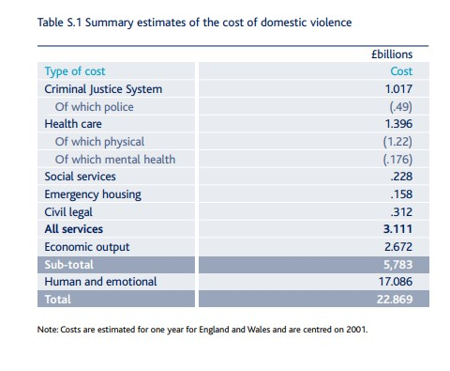

Although it is appreciated that these findings were obtained in 2001, it provides a comprehensive insight with regards to the costs and strains it places on a variety of services, not just limited to the police. Of course, it is clear that this figure will have changed in over 21 years, as demand, society and complexity will have evolved.

In a report published by Her Majesty’s Inspectorate of Constabulary in 2014, it highlighted South Wales Police’s policy in relation to dealing with Domestic Violence, which is contained within a ’10 point plan’, which documents the initial actions an officer should take and the guidance on maximising evidential opportunities. It also highlights the need to safeguard those involved and the emphasis on taking positive action where the offence allows, this can include arresting the perpetrator. It also documents that in the 12 months leading up to August 2013, in every 100 domestic abuse crimes recorder, there were 96 arrests, which highlights the emphasis on taking decisive action to safeguard and protect vulnerable people. In the same sample period, 6,370 domestic abused flagged crimes were reported in the 12 months to the end of August 2013, leading to 47% of cases resulting in a charge, 7% in a caution and 1% in an out of court disposal. HMIC (2014).

Although these statistics have been sourced from an inspection conducted in 2014, 8 years ago at the time of writing this essay, it still lends perspective and insight into the general demand of South Wales Police in regards to domestic abuse, however this is likely to have developed and increased in terms of demand and complexities.

In this essay I will endeavour to discuss about a domestic abused related situation whereby the victim I helped had reported that they were subject to a pattern of controlling and coercive behaviour whereby her now ex-partner, the perpetrator had subjected her to this behaviour for a period of over a year, which had a massively negative impact on the victim’s wellbeing and day to day life.

Coercive and controlling behaviour has no doubt been a phenomenon for many years, however, this is something that has only recently been introduced into British Law as a criminal offence. In 2015, as part of the Serious and Organised Crime Act 2015, Coercive and Controlling behaviour was acknowledged as a criminal offence under section 76 with the following definition:

“Controlling or coercive behaviour in an intimate or family relationship
(1)A person (A) commits an offence if—
(a)A repeatedly or continuously engages in behaviour towards another person (B) that is controlling or coercive,
(b) At the time of the behaviour, A and B are personally connected,
(C) The behaviour has a serious effect on B, and
(d)A knows or ought to know that the behaviour will have a serious effect on B.”

Crown (2015).

Whilst the Crown Prosecution Service (2022) provides further context to the definition to the offence which describes it as an act or a pattern of acts of assault, threats, humiliation and intimidation or other abuse that is used to harm, punish, or frighten their victim. This can be carried out in many methods which is intended to make the victim dependent on the perpetrator, or for the perpetrator to gain control over the victim’s choices or day to day life.

Whilst on duty, I received a report of a domestic related coercive and controlling behaviour whereby the victim had reported that her now ex-partner had been abusing her over a substantial period of time, of over a year. Upon receiving this report, I made contact with the victim and as per their wishes met them at the police station I work at to speak with them in an environment they felt was safe and neutral.

One of my first considerations when meeting the victim was to ensure they were safe and comfortable with talking with myself, a male officer, as they have been subject to abuse by their ex-partner, a male, I was conscious of the fact they may feel more comfortable talking to a female officer. However, they were happy to discuss the matter with myself. To ensure that the victim felt comfortable, I arranged for the meeting to be made in a neutral whereby there was comfortable seating and refreshments available. This was to ensure that they felt safe and trusted to disclose what happened.

Upon talking to the victim, they told me that they were in a relationship for over 6 years with their ex-partner to which they have one child. The victim told me that the relationship started off good, where they were treated well and had no complaints nor was there any indication that the relationship was going downhill. The victim started to notice that their partner became increasingly controlling around a year before they split. Whereby the partner began monitoring the victim’s social media, questioning her on everything she posted, the people she followed and her intentions for following these people, this quickly progressed to accusations of cheating. The partner started making threats to take the child if the victim didn’t give them access to their social media passwords to check on their activity, in the end the victim felt compelled to give them the password to keep them happy.

This then led to matters becoming worse, whereby the arguments became more and more frequent, where they led to arguments over what the victim would wear, where the victim was going, who they were going out with and why they were going out. The victim stated that this pattern kept going on for such a time that she started seeing friends and family less frequently and lost her appetite, which led to issues with her health and professional life, causing performance problems in her day job.

The victim went on to discuss that the relationship became physically volatile, whereby the partner would begin drinking, which often fuelled the arguments more. However, the victim stated that their partner would often slap and punch the victim when he became drunk. The victim stated that this happened more times than they could remember, but a number of these assaults left marks and scars to which the victim kept a secret record of these by taking photos.

The physical violence escalated to such an extent that the victim required hospitalisation whereby the partner had assaulted and grabbed the victim’s hand so hard that it fractured their wrist, this resulted in the victim having to receive medical attention which then affected her ability to work properly and carry out day to day chores. The victim stated that the physical abuse continued, but that it became so frequent they believed it was just part of a natural relationship. The victim went onto say that their partner’s drinking became progressively worse which led to him using her money also to fuel his drinking. This victim stated that this led to them being worse off financially each month due to lack of money.

The main motivation behind the victim coming forward was that she saw a friend who raised their concerns that they hadn’t seen them as often, this led to the victim breaking down and disclosing what they had been experiencing over the past year. The victim went onto tell me that she sought help from her GP to obtain counselling services to help deal with the anguish. The victim wanted the ordeal to stop and for them to live and independent life without fear or further harm.

Upon reflecting on what the victim had disclosed to me, I could see that there was a pattern of incidents, which ranged in variety and severity. Whilst considering these facts, I also referred to the following cycle which documents the cycle and stages of domestic abuse:

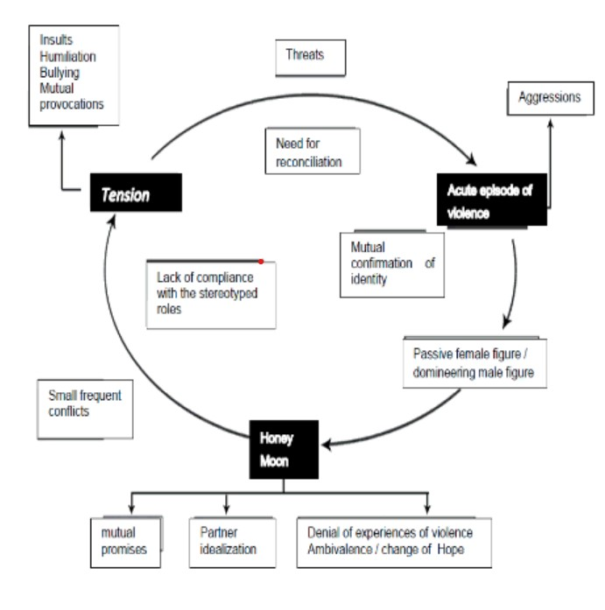

De Lucena et al (2016).

The cycle is quite self-explanatory, whereby it is has been identified through speaking to victims of domestic abuse, the stages and process they go through with their often abusive partners. Where it started over comments and arguments over to social media, to threats of taking their child away, and ultimately escalating to the victim requiring medical attention.

Whilst reflecting on the information given I used the National Decision Model to help me come to a conclusion of the best course of action to deal with this matter whilst taking consideration into the options and consequences. This is displayed with the following diagram provided by the College of Policing (2022):

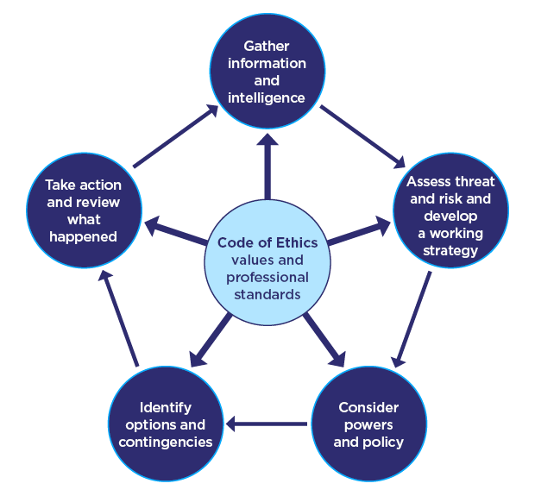

This breaks down my thought making process and I will refer to this whilst I explain my rationale in how I made a decision in dealing with this. The information received from the victim highlighted a lengthy historic of domestic abuse, which ranged from verbal abuse to physical assaults and coercive and controlling behaviour. Based on this information and the range of assaults detailed, I made a threat risk assessment which I believed to be high as the victim was still in contact with the suspect and there was further risk of violence. To add to this, the victim has a child which increases the likelihood of vulnerability, although no information to suggest the child was being abused.

In line with South Wales Police policy, I informed the victim that due to the risk and severity of the offences that her ex-partner would be arrested, I explained that this was necessary to safeguard her, and to secure the perpetrator, in the attempt to prevent further offences, and to safeguard her. The victim was understanding of this. I explained to the victim that there were two ways to move forward with this, through the means of providing a positive statement, providing evidence and supporting prosecution, whereby the victim can provide evidence, or withdraw evidence and refuse to support a prosecution. The victim opted to provide a statement, with the reasoning that have realised how serious the situation is, and the risk they face for the safety of their child and themselves.

Upon taking the statement, I took the time to take a comprehensive statement detailing the offences, capturing the images taken. I also took details of their GP and friends who were aware of what happened to captured further evidence. In addition to this, I obtained details of the victim’s employer and obtained consent forms for medical records to be obtained. In addition to this a safety plan was put in place and safeguarding referrals were submitted for safeguarding.

This matter was progressed whereby the suspect was arrested on suspicion of the offences, which led to him being charged and remanded in custody until the court date. This incident was difficult to deal with, as it was a sensitive situation with several factors to consider and risk to manage. Dealing with domestic abuse is an emotive and impactive event which often tears families apart. This incident was managed to be dealt with effectively by mitigating the risk and dealing with the perpetrator whilst the victim was appropriately supported.

2145 words.

Bibliography:

- College of Policing (2022) - National decision model | College of Policing
- Crown (2015) - Serious Crime Act 2015 (legislation.gov.uk)
- De Lucena et al (2016) - Vista do Analysis of the cycle of domestic violence against women (usp.br)
- HMIC (2014) - I am the title (justiceinspectorates.gov.uk)
- Walby (2004) - Layout 1 (lancs.ac.uk)
- Women’s Aid (2022) - What is domestic abuse? - Women’s Aid (womensaid.org.uk)

Authentication signature:

Please sign to confirm that the work submitted is your own and has not been copied from another:

Signed: C Lewis

Date:
07/11/2022
Bibliography
The bibliography should only include sources referenced within the workbook using the Harvard referencing system. Information about referencing in written assignments and how to avoid plagiarism can be found on Moodle. It is important that you are aware of the importance of ensuring that the work submitted is your original work.

