Challenges & opportunities in digital era

Student ID:2505785
Student Name: nazia khan
Date: 11/10/25
Table of Contents
Component 1 2
Source Exploration 2
Key Challenges for Students 2
Key Opportunities for Students 2
Planning Your Report 3
Component 2 4
Introduction 4
Challenges Students Face 4
Opportunities Digital Tools Provide 4
How Students can Adapt 5
Conclusion 6
Component 3 500 6

Component 1

Source Exploration
Parveen and Ramzan are the two main authors of the journal article. They published this journal article on 6 June 2024. The main findings of the source concludes that there are significant benefits and negative impact as well on the development of the student’s academic careers. It helps them to improve their learning abilities, it provides an easy access to students for downloading crucial information from internet (Parveen and Ramzan, 2024). I choose this source because it has all the important insights of data and information which is crucial for research. This source helps me with information that is important for answering all the topics covered in the report.

Key Challenges for Students
There are some major challenges associated with the digitalisation of education and learning. There is a major threat of digital distraction to students while learning through online platforms. This has led to lack of focus on their goals, poor academic performance and social behaviour of students are also affected. These issues will ultimately affect the growth factor for individual students in their academic, personal and professional career advancement. In addition, the social interaction of students is also figured as an important threat for their future behaviour towards other people. This will affect the collectivism and positivity feeling among students learning and growth. The lack of guidance to students for effectively and efficiently using AI and digital technology in education will led to poor academic performance. There is also lack of technical support and services to many of people due to their poor economic status and other reasons.

Key Opportunities for Students
The digital tools and technologies help students to improve their learning and skill development operations. It enhanced the interactivity and engagement of students with others through online learning platform. It offers a wide range of sources and information to students for their further research and skill enhancement courses. The digital era of education enables a personalised learning environment for students. This will also foster communication and collaboration of students with each other’s. This will enable worldwide access of information and educational material to students. This digital era offers students a more affordable and efficient way of learning from typical old education system. It will help students who are not economically capable to afford quality education. In addition, it acts as a bridge between the economic and social stability of students their future career development. The digital tools will help to provide a wide range of skill development and growth opportunities to students.

Planning Your Report
The report in component 2 will focus equally on both benefits and challenges of digital era because it is important to know the pros and cons of any tool and technology on the students. The Google Calendar and to do list will enable students to track and manage their schedules in learning. It will help them to follow and maintain their efficiency in learning. These tools will enable students to foster their learning and provide them a balance between their academic and personal life. The report will be structured through various topics which includes introduction, challenges, opportunities, solutions and conclusion.

Component 2

Introduction
There is a significant role of digital era in the learning of students, this will enable them a easy and flexible learning environment. This helps every student to gain higher knowledge and skills at global level from their home. This digital era in education system comes with many benefits as well as difficulties for students such as it provides vast access to information and knowledge but there are several distractions and privacy concerns. Alenezi, Wardat and Akour (2023), also states that digital revolution has facilitated unrestricted access to information at world level. This report will cover benefits and difficulties of digital era such as impact on health and potential distractions.

Challenges Students Face
There are two major challenges which are majorly faced by the students are distractions and lack of physical learning that also facilitates health concerns to students. In the view of Pérez-Juárez, González-Ortega and Aguiar-Pérez (2023), the excessive usage of technology lead to addition of digital tools and devices that has a negative impact on physical and mental health of students. The digital distraction may lead to poor academic performance and reducing focus from their studies and goals. However, there should be development of distraction-free learning platforms that are designed for students in reducing distraction (Nabung, 2024). These issues are one of the reasons behind students’ poor social behaviour. These issues will become a serious problem for students’ development and improvement in their future career aspects. These concerns should be properly mitigated within time to enhance productivity and efficiency of learning among students.

Opportunities Digital Tools Provide
The two main opportunities which are crucial and beneficial for the development of the students and their future growth are global learning opportunities and reduction in educational costs. These opportunities of digital era have helped education system to grow and foster its research abilities and development. According to Mhlongo et al. (2023), there is high adaption of digital technology in the education over the last few years. This has increased learning opportunities for students as it helps them to gain access to the global level skills and knowledge in an easy manner. Global learning opportunities of education helps students to foster their educational abilities and skills that are crucial for their future career development. In addition, it also provides access of higher, qualitative and quantitative data to students for their research and educational purpose. It helps individual student to access information worldwide from their home and devices at any time, which is a major contributor in their academic performance. The expansion of digital learning is also supported by its low and cheaper pricing as compare to traditional educational system. Cost of education is a major barrier for many students for accessing higher and quality education. This learning technology has enables students to improve and foster their skillsets and educational qualification. This will significantly contribute to the development of country and economy as well.

How Students can Adapt
The three main suggestion for students to adapt to digital learning environment are mentioned below in detail;
- Accessing Support Services: The students should attend workshops and classes to understand the importance and usage of digital technology in their academic career. It will help them to gain appropriate skills and knowledge about right use of technology. There should be proper training provided to students that will help them to gain complete access of online platforms and their potential benefits their academic career advancement.
- Critical use of AI Tools: There should be responsible training provided to students for critical use of AI tools in their academic journey. The AI tools will enable individual student to learn in a most effective and appropriate manner. This will help them to complete their research and make their tasks easy and managed.
- Time Management Strategies: The time management tools such as Google Calander and to do lists will enable students to effectively manage their time and create schedules according to them. The pomodoro techniques also helps to divide different tasks on number of intervals and break times (Ogut, 2025). It also helps students to focus on their goals with proper rest needed to their body.

Conclusion
The digital era in the education system has a significant role in the development of the academic and professional career of students. There are several benefits as well as challenges of digitalisation in the education system. There is identified that lack of physical interaction and digital distraction has a lead to poor academic and social behaviour of students. It has affected appropriate development of students in their future. However, there are some major benefits that provided vital expansion of quality education to students. It has improved the global learning opportunities and reduced cost of education. It helped many students to foster their academic journey in an effective and efficient manner. There should proper training and support to students for the critical uses of AI technology with time management strategies to gain full potential of digitalisation of education system. These suggestions help digitalisation of education and learning in a positive manner to students in their future career growth.
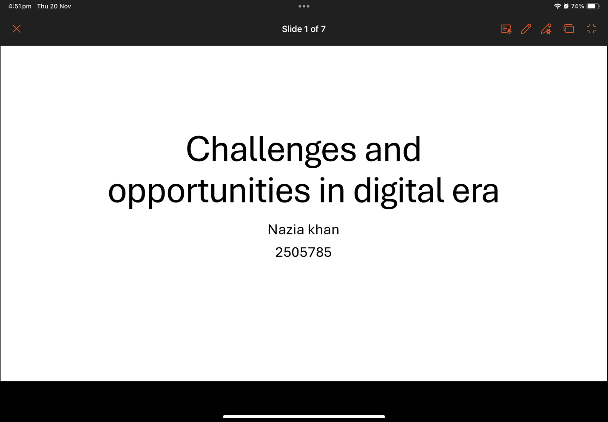
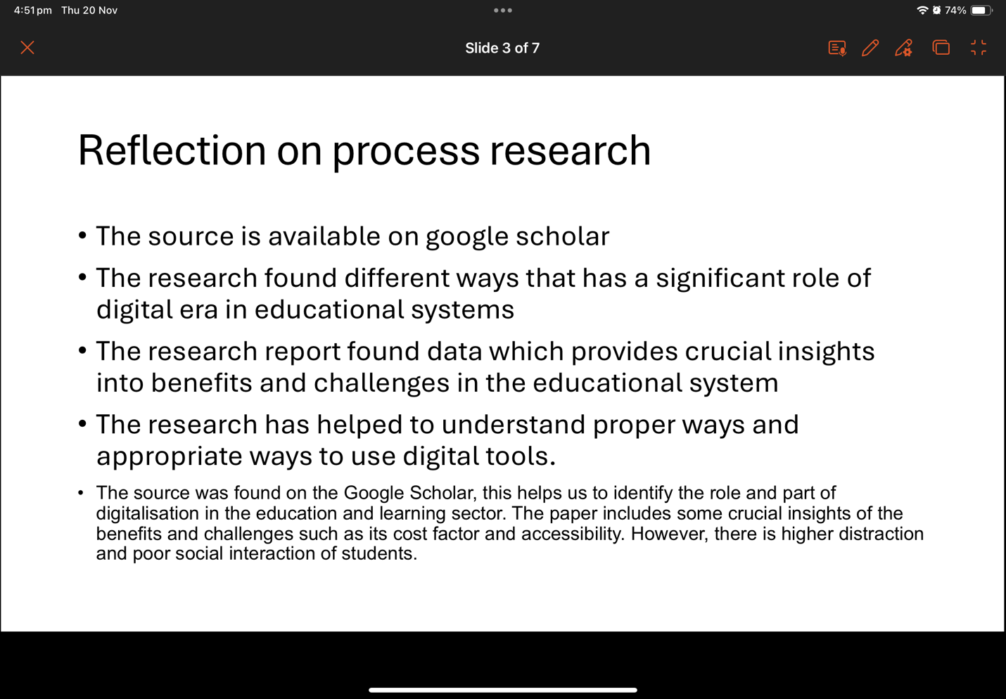
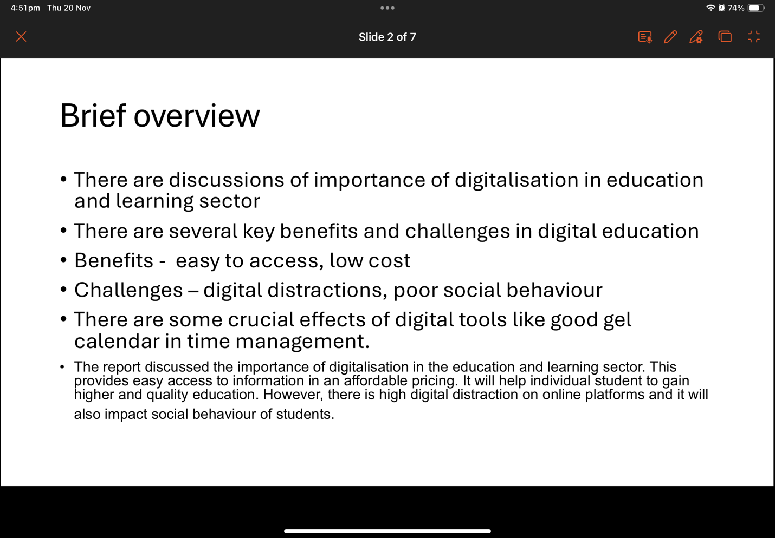
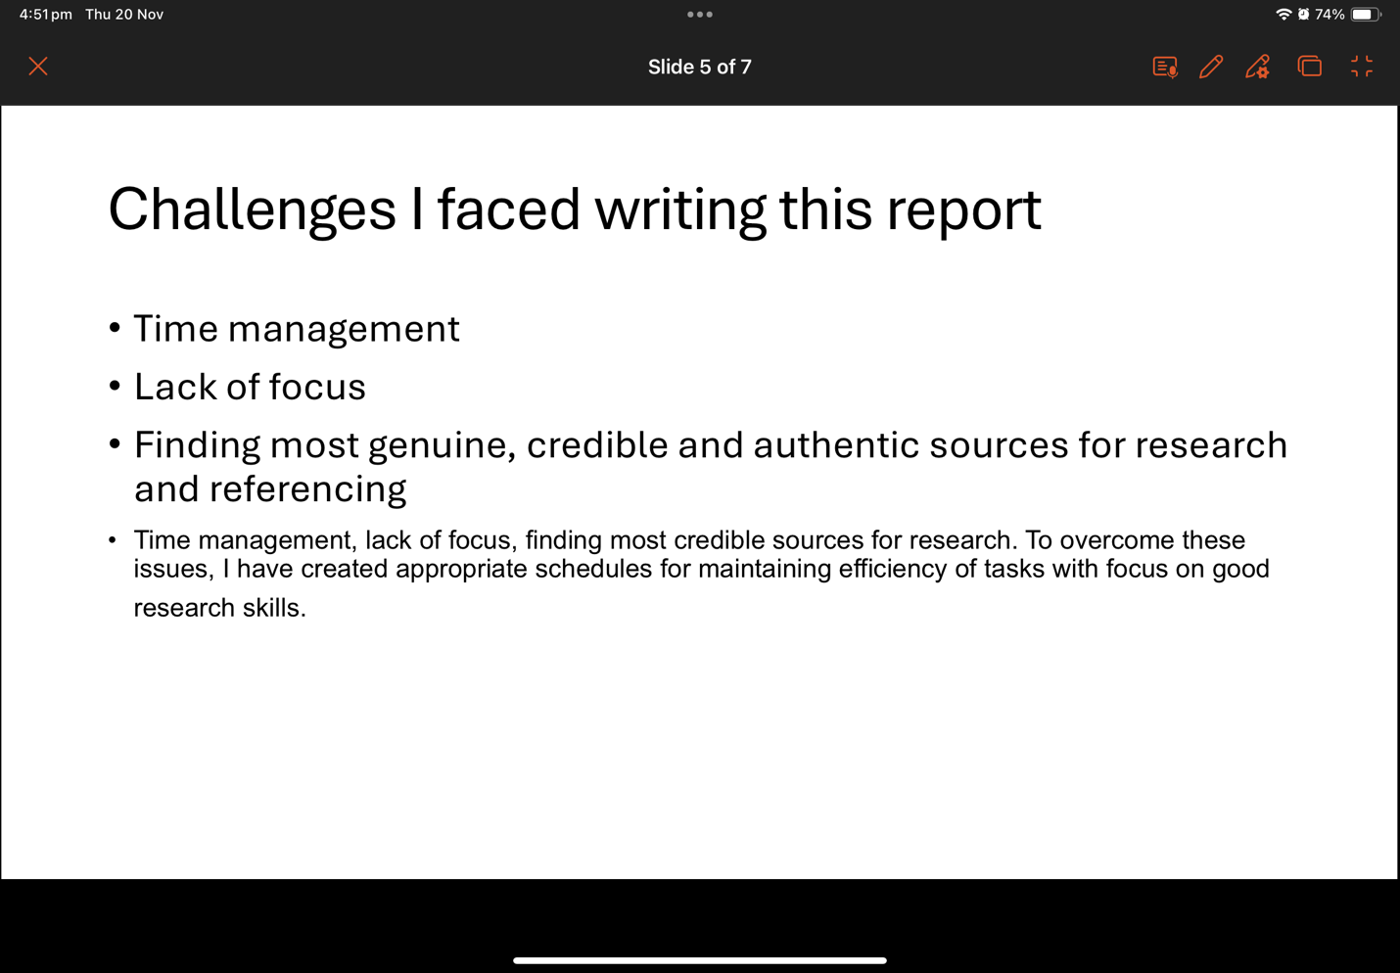
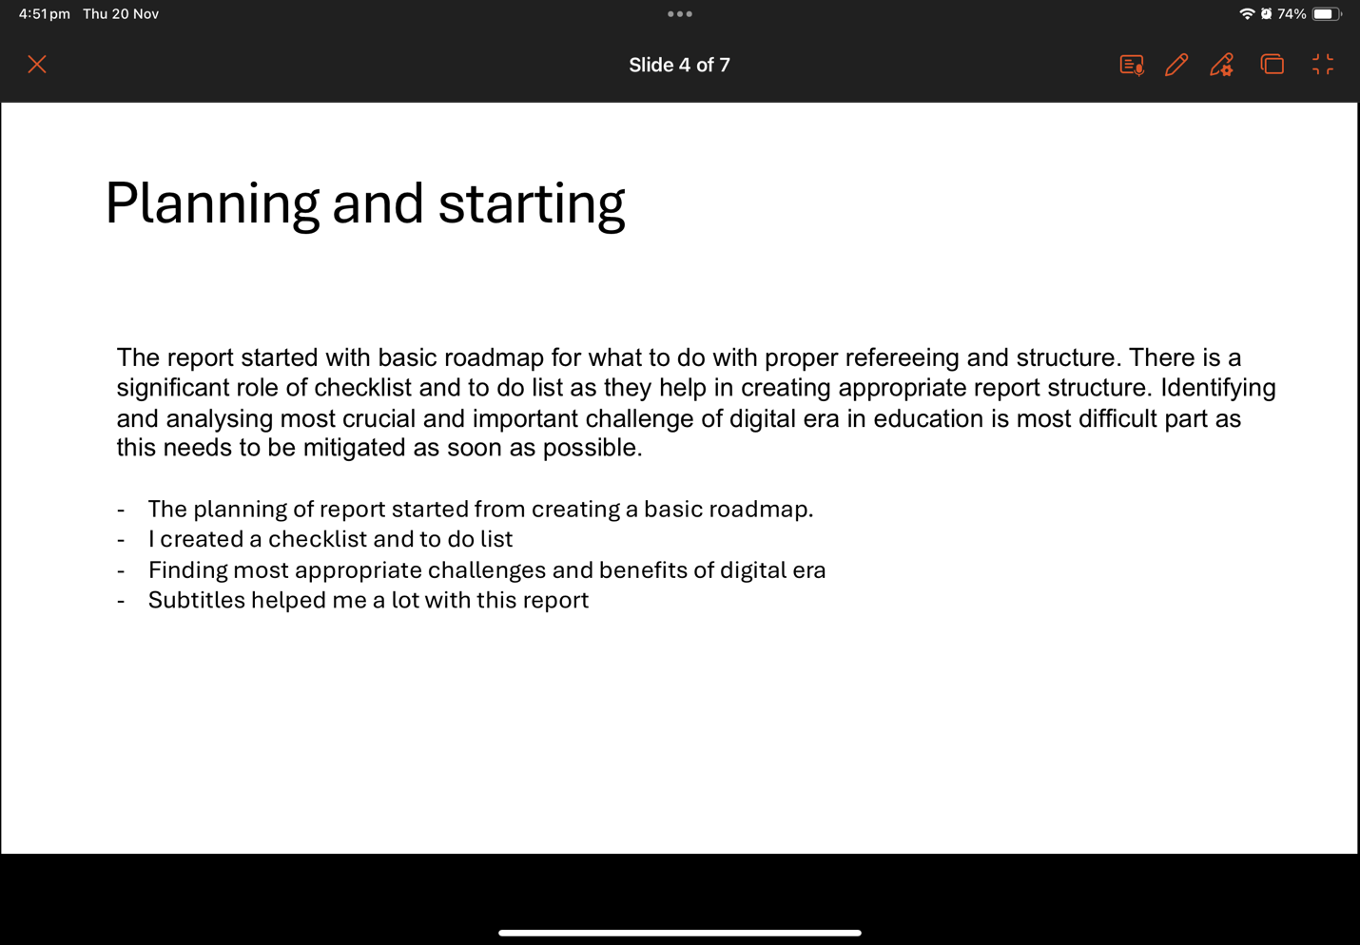
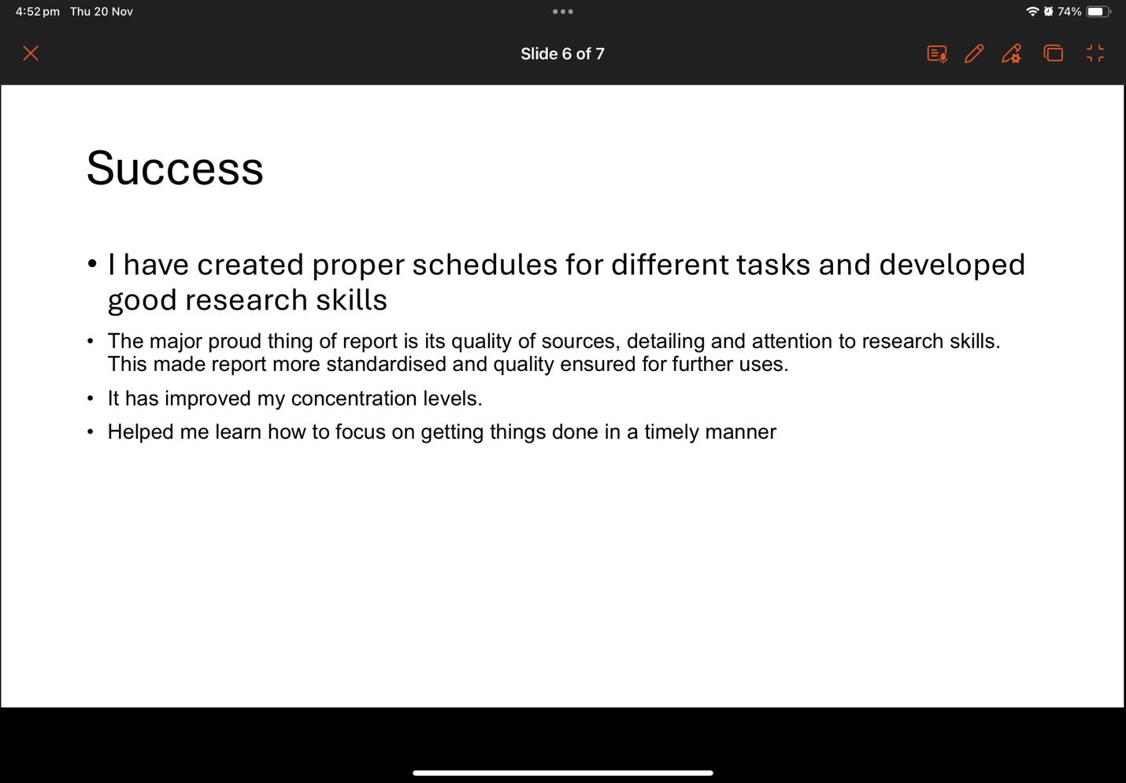
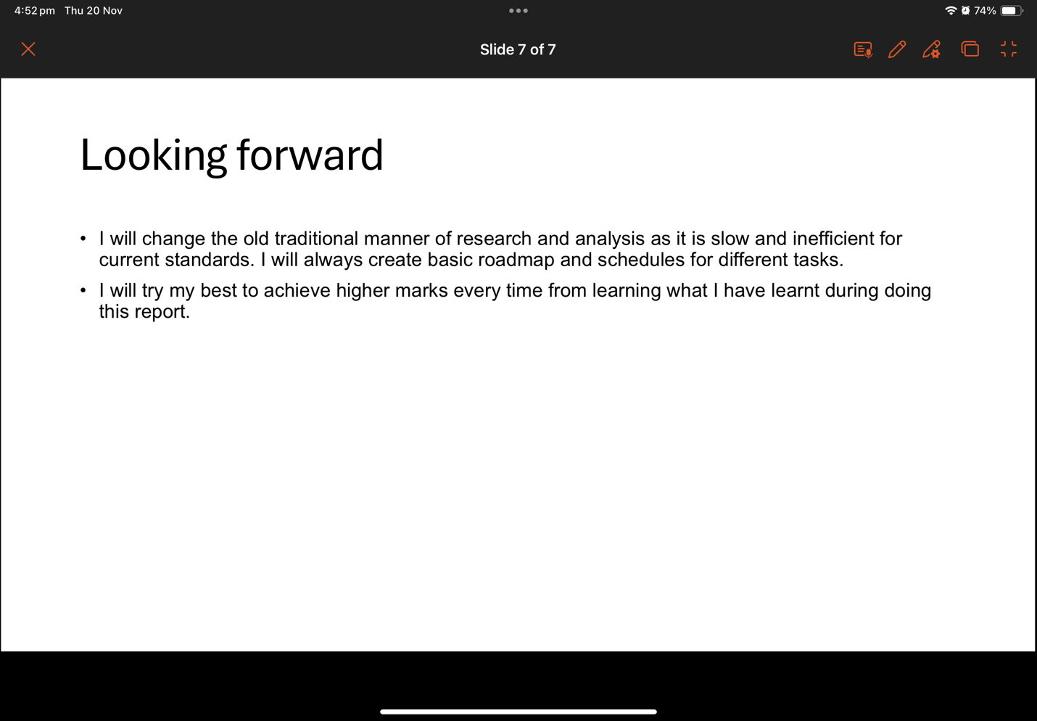

References
Alenezi, M., Wardat, S. and Akour, M., 2023. The need of integrating digital education in higher education: Challenges and opportunities. Sustainability, 15(6), p.4782. https://www.mdpi.com/2071-1050/15/6/4782
Mhlongo, S., Mbatha, K., Ramatsetse, B. and Dlamini, R., 2023. Challenges, opportunities, and prospects of adopting and using smart digital technologies in learning environments: An iterative review. Heliyon, 9(6). https://www.sciencedirect.com/science/article/pii/S2405844023035557
Nabung, A., 2024. The impact of multitasking with digital devices on classroom learning: A critical review on the future of digital distraction in education. US-China Education Review, 14(6), pp.369-383. https://www.davidpublisher.com/Public/uploads/Contribute/6684ac350c950.pdf
Ogut, E., 2025. Assessing the efficacy of the Pomodoro technique in enhancing anatomy lesson retention during study sessions: a scoping review. BMC Medical Education, 25(1), p.1440. https://link.springer.com/content/pdf/10.1186/s12909-025-08001-0.pdf
Parveen, S. and Ramzan, S.I., 2024. The role of digital technologies in education: Benefits and challenges. Int. Res. J. Adv. Eng. Manag, 2(06), pp.2029-2037. https://www.researchgate.net/profile/Shaheen-Inam-Ur-Rahim/publication/382658836_International_Research_Journal_on_Advanced_Engineering_and_Management_The_Role_of_Digital_Technologies_in_Education_Benefits_and_Challenges/links/66a8b4224433ad480e8498d2/International-Research-Journal-on-Advanced-Engineering-and-Management-The-Role-of-Digital-Technologies-in-Education-Benefits-and-Challenges.pdf
Pérez-Juárez, M.Á., González-Ortega, D. and Aguiar-Pérez, J.M., 2023. Digital distractions from the point of view of higher education students. Sustainability, 15(7), p.6044. https://www.mdpi.com/2071-1050/15/7/6044

