

Research Title: A Study on How Technology Improve the Restaurant Business Over the Pandemic: A Study on North-West London

Module Code: LCBB6000
Module Lecturer’s Name: Dr Anupam Mazumdar
Student Name: Simona Mocanu

Student ID: 1905164

Abstract
The innovative technological development and its improvement have helped the food industry or rather the restaurant operations to be secure and it attempted to make a huge difference in the updating future. The advancement of the technologies and their overcoming facts has helped in maintaining the utilization of the technology for overcoming the challenges. There is no such proper knowledge regarding the technologies and its inspiration for attracting the customers. The special appearance of robotic technology has been epic and it made a great change in the dissertation. Thus, the purpose of the qualitative, as well as the quantitative data, has been to explore the restaurant and initiate in detailed the detailed assessment during or after the Covid. The survey session has helped in making the research more effective as the stakeholders of the restaurants located in North west London have been conducted. Therefore, the results led to a conclusion and to level up more sales and production, convenience and effective safety protocols to be maintained.
Table of Contents
Chapter 1: Introduction 5
Background of study 5
Problem Statement 6
Rationale 6
Research aims and objectives 6
Research Questions 7
Research Hypothesis 7
Research Significance 7
Conclusion 8
Chapter 2: Literature Review- 9
Introduction 9
Impact of Covid-19 on the restaurant business of north west London area 9
Areas of technology used during the pandemic to normalise the restaurant business 10
Technological improvement of the Restaurant operation with dynamic prospect 12
Conceptual Framework: 13
Research Gap: 15
Chapter 3: - Research Methodology 16
Introduction 16
Research Philosophy 16
Research Approach 17
Research Design 17
Data Collection Method 18
Data Analysis Technique and Sampling Method 18
Research Ethics 19
Chapter Summary 20
Chapter 4: Data Collection 21
Primary Survey 21
Thematic Analysis 27
Chapter 5: Discussion 31
Chapter 7: Conclusion 33
Discussion on Findings 33
References 35

Chapter 1: Introduction
The importance of technology and its involvement of it in a broad way for improving the restaurant business over the pandemic. The case study generated in the North-West London initiates the situation of the financial background for standing out the restaurant business operation at its earlier pace. Thus, this dissertation executes the issue identified and initiates for the readers and other researchers to have a clear and vivid description of the research carried on. The main issue identified in the paper is that the UK, North-West London has a loss of 9.7% due to the pandemic crisis globally. Thus, the purpose of the research is to adopt the lockdown approach by the government that impeded the operation of the restaurant business. Therefore, in this particular regard, technology has played a huge role in making success to the business during the pandemic.

Background of the study
The background of the topic refers to the impactful study on the entrepreneurial approach and its relationship with the technological impact on the North-West London restaurant business. Before the outbreak of covid and its disastrous impact on the financial background of the restaurant operation in the North-West region of London. The revenue of the restaurant operation generated to be 1.012157 million GBP in 2020 and if compared to 2021, it accounts to be 5.8199028 million GBP. Thus, in response to this, Moreno (2019) has stated that the turnover in the year 2021 was five and a half times higher than the previous year. The initializing and adoption of the different tools and techniques for normalizing the business operation intends to make a great difference. Contrary to this fact, Cavusoglu (2019) has also stated that normalising the business operation and make making the impact of tools and techniques more proactive for the positive success of the restaurant operation in the high aspect.

Problem Statement
The research has focused on accomplishing the conduct of the study by intervening on the importance of technological involvement and its impact on the business operations of restaurants in London. The main issue is to dig out the impact of the technologies on the areas of the country which are adopted by the restaurants. During the pandemic, there has been a huge loss of finance and thus to stand up and mitigate the economical crunch, it is necessary to carry out the operation and to carry out the business, it is necessary to have involvement of innovative technologies (Hussain 2020).

Rationale
The sudden outbreak of coronavirus and its impact on the restaurant business operation has been huge. The research aims to shed the light on the improvement of technological intervention inside the workplace. From a survey, it has been centralized that the revenue management in the country from 2008 to 2019 was going upwards and the worth of the annual production in the restaurant was around12 million GPB which is almost 58.7% (Liu 2020). Hence, the improvement and the collaboration have been easier and it desired to make the revenue stronger by implying the highest range in the workplace. Further, the sudden outbreak of the pandemic made a huge disruption in the financial statement of the restaurant operations and thus, the various stakeholders have initiated to make greater changes in the technological improvement along with the visibility as well as the desired stage in making the entire access of analysing the focus on it.

Research aims and objectives
The main aim of the research study indicates the importance or rather identify the impact of the technology on the restaurant business the northwest London during the pandemic.
Objectives:
- To initiate the assessment of the impact of Covid 19 and its implementation on the restaurant business of the North West London area.
- To have an identification of technology used in the pandemic to have a normalization of the restaurant business.
- To have a measure of how technology can improve the restaurant over the entire pandemic.

Research Questions
- What are the basic impacts of Covid-19 on the restaurants of the Northwest London area?
- How has the technology improved the basic operations of the restaurant over the pandemic?
- How the technologies are used during the pandemic by the restaurants for normalizing the operation?

Research Hypothesis
H0- There is no significant relationship between technology and its impact on restaurant business operations.
H1- There is a significant relationship between technology and its impact on restaurant business operations.

Research Significance
This particular research can significantly implement the technological impact on the restaurant business operation. In this way, this research can help the business manufacturers to earn the maximum amount of profit by helping them to have an identification of the most appropriate leveraging of the technology and its maintenance. The impact of online delivery and suitable technology can help the business forms to reduce material costs, speed the transfers, and increase the transaction. Thus, Osorio (2021) has stated that in this way, the target firms can achieve the desired state of success and improve the business grounds with effective technology implications. This paper can be used as a reference to further investigate the impact of a pandemic on the restaurant industry

Conclusion
From the above discussion, it can be summarized that the introductory chapter states that the overall issue of the restaurant business operation has been dealt with since the pandemic outbreak. The importance of techniques and tools can mitigate the issues for helping the business organization to regain its profits after the covid impact by developing strong techniques and tools for operating the business growth.

Chapter 2: Literature Review-

Introduction
The concerned dissertation has dealt with different techniques and tools of technology and at the same time, it portrayed the impact on the performance post covid. In this particular chapter, the relevant literature discussed happens to be based upon the research aims and objectives as stated in chapter 1. Most importantly, the concerned research mainly contains two types of variables and it mainly includes the dependent variables such as tools and techniques and independent variables such as the impact of the business operations in the long run. In this particular chapter, the concept of all the research variables has been demonstrated and finally, the entire relationship between the dependent variables and the independent variables has been administered. The conceptual framework of this particular chapter has been illustrated and the relationship between the variables is more efficient and clearer.

Impact of Covid-19 on the restaurant business of north west London area
The impact of Covid 19 on the restaurant business has been severe and disastrous. In this pandemic, restaurant businesses happen to be faced with most of the vulnerable situation and some have been forced to a shutdown of business and switch to other jobs. The effect on the restaurant industry has been particular with dramatic establishments. As stated by Flynn (2020), people are ordering food from online and staying back home. The restaurants foot and online reservations became extinct during the lockdown sessions and thus, the impact of technology had a huge inclination. Concerning the facts, Ripolli (2021) has opined that the statements are quite reliable and thus people have changed what they have been ordering. It has been observed that almost 12% of the weekdays intend to make a notion on the weekdays. Thus, it can be stated from the facts that during the covid period, the financial background of the country had a huge fallout.
Furthermore, the impact of covid 19 on the restaurant business operation of the North west London area had a huge downfall. About the context, Kumar (2021) has stated firmly that preferences for firmly dining are a perceived threat and therefore, it increases the preferences for private dining during the pre or post covid situation. During the lockdown session, there was no chance of dining out or ordering food from outside. However, with time, the increase in the preferences of the perceived drinks, it has been analysed that the better solution for tackling the business and reducing the customers preferences under the pandemic situation. Concerning the facts, Gorton (2020) has stated how the hotels and restaurants happen to be gearing up the woo price conscious the customers. It intends to express the fear and the hospitability of recovering from the pandemic situation. It has been stated that ensuring safety and hygiene with affordable meals intends to help the industry within the region from losses. Thus, throughout the discussion, it can be referred to that the impact of the pandemic crisis on restaurant operations has identified four of the major themes and it proclaims the importance of the interviews conducted along with the survey. With the duration of the restrictions, and imposing due to the pandemic, it is considered to be not fixed and with effective opportunities, the redirect of the business initiates to make the importance of the internal markets.

Areas of technology used during the pandemic to normalise the restaurant business
The restaurant industry happened to be blunted hard and fast during the scenario of the Covid 19 pandemic. The leaders across the different industries intend to survive and evolve accordingly. Thus, to keep the door wide, it is necessary is open doors to technology and software for effective outcomes in the end. According to a 2020 report, the restaurant international association has stated that 81.846 million GBP was lost during the first two months of the session of lockdown and by the spring of 2021, the industry had a deficit of a huge amount. Thus, the industry saw the deficit and the pandemic has forced many of the restaurants to have a dramatical shift in the business model and with current technologies, the restaurants happen to be considered as the prime innovative location for the people around the region. In this situation, Herath (2020) has stated that take out and curbside pick is quite essential and it intends to save the restaurant industry with directive analysis and portrayal. Those who have embraced the digital side of the operation, the innovation and its innovation have helped in making extensive analysis of the existing customers. The agility has played a huge role and with the majority of the restaurant’s extensive analysis, the fully reopened traffic patterns initiate to make the challenges more appropriate and initiate full recovery.
Further, the technological invention for initiating the importance of the cloud kitchen proliferating and it intends to make the technology more worthy and trendy. Thus, in this sequence, Gurburz (2020) has stated that trends that the cloud kitchen have emerged with the pre covid world. Moreover, it is estimated that the cloud kitchen and its proliferation initiates to make the ness owners thrive in the difficult time. Concerning the facts, Jun (2021) has opined that restaurant in the North London area has adopted contact-less dining and it initiates that the social distancing, as well as the whole new level of the restaurant, happens to be likely introduced by the contact-fewer dining facilities. Thus, such technology happens to spell the end of the physical menus and on the germiest surfaces in the restaurant intends to make changes within the restaurant operations. Apart from that, one of the authors has proclaimed that the rise of clean technology in restaurant companies has intended to make a huge change and as per the zoonotic disease, the customers had a wide preference for meat consumption in the end. In the wake of the pandemic, the customers opted for the healthier option and thus, propelling the clean technology, the restaurants had keen to add cleaner to the meat rather than the menu. This initiated the importance of the topmost outbreak and hygiene with the implementation of rigorous sanitization and during the grand entry of the restaurant sector after the covid initialization.

Technological improvement of the Restaurant operation with the dynamic prospect
The technology helping the restaurant operators to survive the pandemic and beyond makes it quite safe for the restaurant operations to make its productivity by initialising the importance of the potential timelines and improving their factual understanding and management. About the context, Verevka (2020) has stated that integrating technological advancement has helped restaurant operations to make a great survive in the pandemic situation. Thus, many of the changes and its trend operators have been facing the pandemic and people have adopted it quickly. The establishment has restructured the business and it included app-based ordering, pickup options and deliberate solutions for the customers. Several of the changes has been considered in the long-term business and the tactics added a safety benefit to the offers. Concerning the facts, Ponce (2021) has argued that new technologies has been adverse and it reduced the job benefits of those employees who lack in having a keen understanding of technological advancement. According to statistics, it has been observed that 4.0992 million GBP hospitality and leisure job jobs have been lost.
Furthermore, one of the advanced improvements in the restaurant implication is the fundamental role of the information and communication technologies to facilitate the business transaction and communicate with relevant information for basic decision making. Apart from that, the model of McLean’s Information system enables identifying the relationship among the critical dimension of the IS success in system quality, service quality, and usage intention that benefits the framework of the access to the personalized, complete, relevant and live-streaming platforms in helping the potential customers to get a complete easy understanding (Matsenko 2021). Currently, the restaurant operations happen to be using live promotion with accurate, reliable, and selective information for complete, opportunities and it tends to reach the customers and sell the products during the pandemic operations in the long run. From the greater perspective, it has been centralized that to generate a meaningful upgrade of the financial performance post covid, the business operators have to focus on utilizing the technology only (Postova 2021). For example, it has been discussed earlier that the majority of the technologies were used for ensuring the health safety of the customers and measuring their health conditions. One of the basic innovative technology adverse in this area has been robotic technology and it has been used during the pandemic period during the critical operations of the restaurants by carrying out the safety protocols (Kubler 2022). Thus, the major use of the technologies has been of great help over the pandemic period.

Conceptual Framework:

Conceptual Framework
Dependent Variable
Technological Improvement in Restaurant Business Operation

Independent Variable

Customer Loyalty

Performance management

Maintaining service quality

Customer satisfaction

Figure 1: Conceptual Framework
(Source: As created by author)

Research Gap:
The literature in the study is due to the fewer data provided on the technology adopted by the restaurants in the London zone for overcoming the financial crunch. On the other sector, the gap widens the literature review by not discussing the theoretical approach adopted by the business for better improvement. Thus, the constraints in the study get gap due to less explanation of the technological implementation. It has been identified that the literature review chapter for the project is not comparative within this research. Hence, the comparison between the technological involvement with other countries could have been done in this chapter.

Chapter 3: - Research Methodology

Introduction
The chapter of the research paper has focused on the methodologies that the researchers have used to carry out the research paper. This chapter has not only described the outline of the research paper and has also focused on critically discussing the logic and reasons behind the selection of the research philosophy, design and approach. Apart from that, the selection of the methods of the data collection as well as the logic behind the selections happens to be discussed quite elaborately in this particular chapter of the research study. Thus, it has focused on the various guidelines that the researcher has maintained to carry out the particular research.

Research Philosophy
Philosophical thinking helps an individual to the encouraged formulating ideas and strategies for conducting the research paper. The selection of the data and the sources has become easier for the investigators to have a proper selection of the research philosophy. In this section, the various philosophies are there, positivism, realism, pragmatism, and interpretivism. The researcher has focused on rejecting the pragmatism philosophy, realism and positivism philosophy because the philosophies would have not helped in properly interpreting the data. Thus, for this research, interpretivism philosophy is selected as it helped in properly interpreting the data collected from authentic and reliable sources.
The main justification behind selecting this particular philosophy is that it has been quite easier to stay connected with the roots and in this case study, the technological impact on restaurant operation in London. Thus, it is quite evident that through the mean terms of the particular philosophy, it has become quite easier for the researchers to have an analysis of the topic and select the data with the proper collection method (Doina 2020). In other words, it has been stated that the major application of the research philosophy has made the researcher have an understanding of the positive as well as the negative impacts of the technological impact on restaurant operations in northwest London.

Research Approach
One of the most crucial steps that the researcher has followed in the research paper is to give the selection of a proper research approach. Thus, selecting a proper approach has made it quite easier for the researchers to properly assume the methods for conducting the research (Galanskin 2019). Thus, in this context, there are two types of approaches deductive approach and the inductive approach. The researcher has focused on discarding the deductive approach and because the research is primarily based on observations, the inductive approach made great management. It is evident that throughout the means of an inductive approach, the researcher tends to draw a proper conclusion.

Research Design
The selection of a proper design has been considered one of the most crucial steps that need to be incorporated into the research process. The different kinds of crucial steps to be incorporated state a descriptive, explanatory, experimental, and diagnostic for conducting the research paper. The major fact that means of selecting a proper research design for the research authenticity, reliability, to be ensured. Thus, in this case, study, the researcher has discarded the designs like the diagnostic, correlation, and explanatory as these would not have helped in presenting the collected data in a concrete statistical manner.
In this sequence, the exploratory research design has been adopted because the initial target happens to be exploratory research design and it enables an understanding of the impact of the information technology on function as well as performance. The fact is that through this particular research design, the collection of data and information about the research topic has been immense and it focuses on the entire research process from various perspectives (Hallock 2019).

Data Collection Method
The stage of collecting the data has been considered one of the most crucial parts of a research paper. The researchers can collect information from authentic sources that is relevant to the research paper. There are two types of data collection methods, primary and secondary (Archibald 2019). In this particular dissertation, both the data collection method has been adopted by the researcher for maintaining diversity.
The main reason behind selecting this particular research data collection method is that the researchers have provided authenticity to the entire research. Thus, in this case, the researcher has focused on surveying by providing authenticity to the paper. It has approached nearly 50 participants for collecting the minute details. The focus on the secondary sources has been previewed with journals, peer-reviewed articles, and websites. It has provided with a great opportunity in saving time as well as money.

Data Analysis Technique and Sampling Method
The analysis of the data collection method is considered one of the crucial stages of a research paper and having an understanding of the importance of the collected data and information. The focus of the researchers has been on selecting the descriptive data analysis and to give focus on the collected data and information, the researcher must have an identification of the similarities between the variable of the research paper. Apart from that, the gathering of the primary data for the research, a questionnaire was served and collecting the sample happened to be one of the crucial tasks. Therefore, in this regard, 50 samples have been collected from the stakeholders of the different restaurants and for reducing the extreme biases, a random sampling technique was adopted for strong enhancement. On the other hand, the entire interpretation of the data is collected through a critical aspect and thus the numerical data analysis technique was used to have the quantitative research in delivering the right findings. The entire research has been numerically interpreted and apart from that, an excel program has been adopted for the basic understanding (Rinjit 2020).

Research Ethics
The maintaining of research ethics and integrity is considered to be the core priority of the researchers in this research paper. Thus, in this context, the researchers have focused on maintaining a sense of professionalism and with a particular approach towards the respondents, the researchers have ensured that the entire collection of the data and information has been used for academic purposes. The researcher has also focused to collect the data and information without asking any personal questions and thus, to protect the collection of the data from leakage or breach, it had been ensured that the researcher with all guidelines and provisions of the Data Protection Act of 1998. It has helped in avoiding the interference of any other party. Further, the confidentiality and the privacy of the participants have also been secured with security and safety for better outcomes. Thus, it can be stated that through the means of maintaining ethics and integrity, the researchers have been able to provide reliability and authenticity for the entire research paper.

Chapter Summary
From the above discussion, it can be concluded that the entire means of selecting the proper philosophy, approach and design has been possible in making this research more successful. Thus, the interpretivism philosophy has made it possible for interpreting the collected data in the possible right way. Apart from that, the entire data collection process has been considered one of the most important parts of the research paper as it has helped in collecting the relevant data and its information in a proper understanding of the influence of robotic technology and its improvement in the restaurant operations in the London post covid.

Chapter 4: Data Collection

Primary Survey
Q1. How did Covid-19 affect the restaurant business during the pandemic?
a) Positively b) Negatively
Options | Total Number of Respondents | Percentage of responses
Positive | 50 | 75%
Negative | 50 | 25%

From the above discussion, it has been analyzed that every customer is important for business performance and the sudden effect of Covid had a huge impact on the restaurant business with the responses, it has been quite evident for having a concrete understanding.
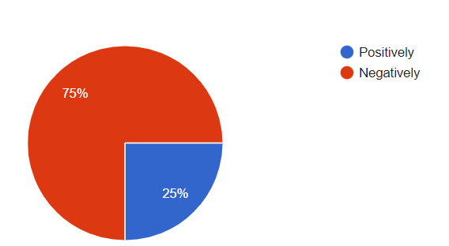
Q2. Which area of a restaurant was affected most by the pandemic?
a) Sales b) Production c) Employee availability d) Customer satisfaction

Options | Total Number of Respondents | Percentage of responses
Sales | 50 | 66.7%
Production | 50 | 0%
Employee Availability | 50 | 25%
Customer Satisfaction | 50 | 8.3%
From the above discussion, it can be overviewed that majority of the stakeholders have responded that the sales area in a restaurant has been affected the most by the pandemic. Whereas, employee availability retails to be 20% and customer satisfaction is 10%. Thus, it has been observed that the production area has no such effect.
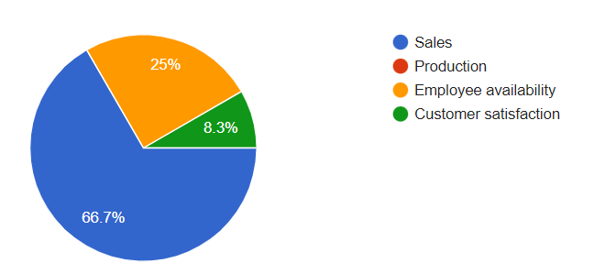
Q3. Did you get in touch with technology regarding restaurant services during the pandemic?
Options | Total Number of Respondents | Percentage of responses
Yes | 50 | 72.7%
No | 50 | 27.3%

From the above responses, it has been observed that 70% of the respondents during the technology regarding the restaurant services and 30% participated with a no as there has been no touch in the restaurant services.
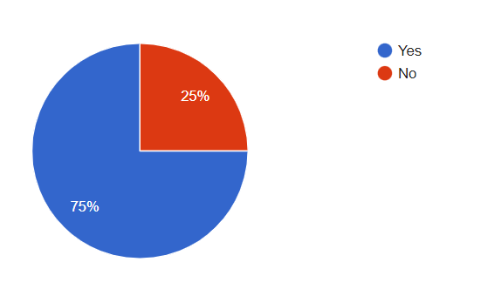
Q4. In which areas of the restaurant, technologies were used?
Options | Total Number of Respondents | Percentage of responses
Production | 50 | 9.1%
Delivery | 50 | 33.3%
Payment | 50 | 25%
Communication | 50 | 25%

From the above discussion, it has been analysed that the stakeholders have responded that delivery has been most affected by the technological intervention nearly and it has focused on the effective analysis. Thus, the responses have helped in having a concrete analysis of the technological intervention.
Q5. Did you think that the technologies bring convenience to the restaurant business during the pandemic?
Options | Total Number of Respondents | Percentage of responses
Yes | 50 | 85.7%
No | 50 | 9.5%
Maybe | 50 | null

From the above discussion, it has been observed that the entire access of the stakeholder analysis has been initiated and with the highest majority in the yes, it can be depicted that technologies have brought convenience for the restaurants during the pandemic.
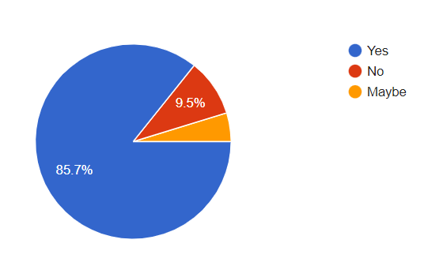
Q6. How did technology improve the restaurant business during the pandemic?
Options | Total Number of Respondents | Percentage of responses
More Sales | 50 | 17.6%
Convenient Sales | 50 | 43.1%
Effective payment sales | 50 | 39.2%

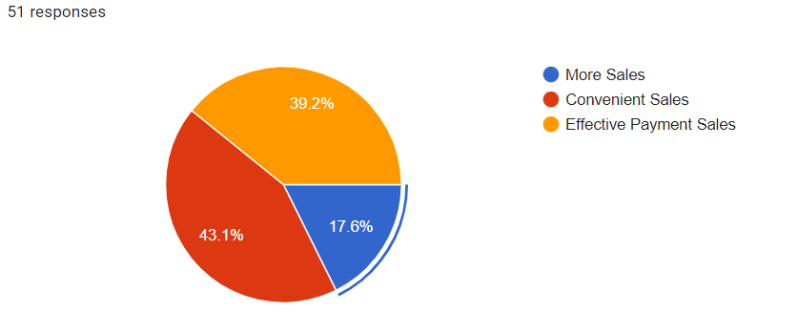
From the response, it has been analysed that the basic intervention and its access to the technological improvement have been done accordingly and it has stated that convenient sales have been more accurate and it portrayed the importance of the stakeholder responses.
Q7. How has technological usage in restaurants impacted customers?
Options | Total Number of Respondents | Percentage of responses
Health Safety | 50 | 17.6%
Safe Order | 50 | 15.7%
Convenient payment gateway | 50 | 66.7%

From the above survey analysis, the importance of the convenient payment gateway happens to be 66.7% and it portrayed that technology usage in the restaurant has a direct impact on the customers. It refers to the respondents with basic implementation to the facts and its reliability on the usage of robotic and delivery access in maintaining the financial crunch post covid.
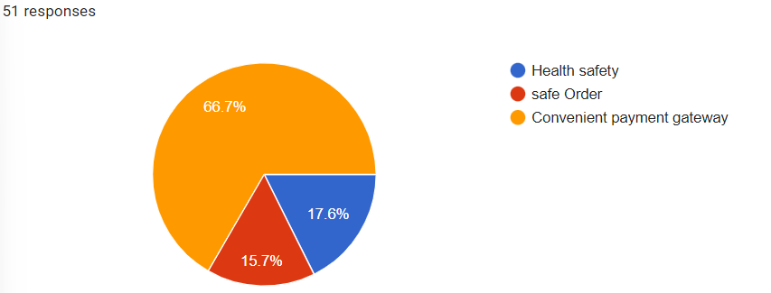

Thematic Analysis
Theme 1: Impact of Covid 19 on the restaurant operations
From the existing literature review, it can be depicted that the impact of Covid 19 on the restaurant business has been tremendous. The concerning facts and detailed arguments between the authors have focused on the major loss of the finance background and thus the study predicts the consequences in the North West area of London. Thus, throughout the discussion, it has been observed that the employment opportunities have been generated with entire loss as there has been no production due to lockdown sessions around the globe. Apart from that, the study conducted emerges to state that the supportive package initiates to make a great difference and it primarily focused on the lost revenues. Thus, from the discussion, Covid has caused a loss of 68,190,364 million GBP revenue in the year 2021 (Morganti 2021). Due to lockdown and the spread of the disease, outgoing food services were reduced and hence, a huge loss has been showcased for the restaurant operators in London. The impact was quite effective and survival was quite difficult due to the sudden implication. Thus, it can be portrayed from the discussion that the impact of the entire access of the firm has been based on better implications in the long run.
Theme 2: Technological involvement in normalizing the restaurant business
In this section for the discussion, the sudden involvement of technology has been great and it has intervened in the 4restaurant operations to provide it with stellar guest service. Thus, from the existing literature, it can be identified that the restaurant business requires a high degree of dependable performance and adherence to maintaining the quality and its standards. Therefore, in this context, Kompanents (2020) has stated once that the self-ordering kiosks happen to make in the news that let the customers in orde3ring the food from themselves and make their peace. The drastic involvement of the robotics technology and smart devices enhanced the impact to be fruitful and initiative. Thus, the convenience has been higher and it reserves to be quite prompt and it states to have involvement of the new technology. Technology has importance in making the customization in fast food painless and it attempts to control the store data with relevance to the guest preferences. Accordingly, with the help of the new tech, it has been observed that the restaurant in the relied area happens to make magic by improvising the importance of the phone and web. Continuously, there has been an argument regarding the positive and negative aptitude and thus it can be reviewed from the literature discussed, that technological improvement has been of positive advantage such as an increase in efficiency, however, it has a great disadvantage and it states that employees with no willing in greater knowledge regarding the technology and it leads to consequences. Apart from that, the consumers improvising with the new involvement of technology, the overall production of the firm tends to increase. The involvement of the safety protocols and the consumers eating out in the restaurants involves in make the dining less, yet the overall production has been quite convenient in the long run. Thus, it can be stated that the calling in for a restaurant has been decisive as the improvement in technology and robotic analytics has made a huge impact on the country after the covid. The enhancement in the customer experiences has been the major goal of the firm and it represents the technology that has benefitted the increased turnover of the table and it provided the ability to increase the sales, and the ability to make the increased turnover of the technological innovation in the end. It represents the major role of the firm or the restaurant business operations that make a great deal out of it. It relocates the importance of the takeovers and makes the changes with possible indecision and activates the economic stability for the future.
Theme 3: Areas of the country adopted technology for normalizing the business
In this sequence, as reviewed in the existing literature discussed in Chapter 2, it can be stated that the areas in the country are currently approached for a deep dive into the specific areas and it comes into line. In this context, it has been observed that the future of the restaurant has certainly reflected the modern growing dependence on consumers. Thus, the desire for personalized experiences and making it worthy for the changing roles of the employees in the long run. On the other hand, the clearly defined streamline of the operations makes it quite efficient with the customer experiences and digitally, the entire scenario of the open-mic session with the right technology. With further reference, the wait times at the restaurant have haven drastic and it cuts the servers to be turning down thetheirbile devices. Therefore, the smart devices have been used to place ahead of time with the designated in-order stations. The entire discussion has been managing the seating as well as the customer loyalty with dining preferences and it attempts to make the concept more active and fortunate. On the other hand, the technological factors include the production technique, communication and information with e-commerce logistics in the end. Further, the constant improvement in the North-west region of the country initiates streamlining the processes, maintaining the data flow and also managing the business to grow rapidly. The technological change tends to bring the entities into the new market or rather to the ground. Thus, the improvement in the areas of the country had made huge progress with a revenue increment and increased its productivity by reducing the cost and increasing the safety protocols. The increase in efficiency and making the increase in productivity and technological improvement in the technological impact of the restaurant and its showcasing involvement with the basic development on its edge. Technological improvement tends to improve productivity and its satisfaction initiates the business capabilities for better expansion. Information technology has enabled in making the business to attain a greater reach and it relies on making the operation of the restaurants in the end. Apart from that, the technology has improved with the robotic delivery and states that the future of the business has more impact on the industrial leaders anticipate the technological advancement in the following areas with the most impact on the business and it operates to be quite energetic and early administration relies on the innovative management in the long run. It enables making the entire access more initiative and accessible in the end.

Chapter 5: Discussion
From the above discussion, it can be observed the impact of technological improvement in the areas of the Northwest London restaurant operation businesses. Hence, the empirical study on the informational technological improvement post covid states the management process along with the focus on the value of technology adopted such as the robotic technologic management and its focus on the data collection method. Thus, it can be discussed that both the primary and secondary sources have helped in depicting the researcher to have prime focus. On the other hand, it can be discussed that the technology and the various steps inherited by the stakeholders improve the financial condition of the firm. Thus, throughout the entire analysis, it can be centralized that the particular form of organizational access leads to the facilitating inhibition and its role played by the performance indicates the key takeaway enhanced by the extended enterprise and its focus on the implication to maintain the streams for making the researching more valuable to the business values and its implications.
The data collection has been abided by the laws and has been inherited with the importance of the specific technical features and it leads to the importance of the restaurant operation to be operated after the implication of Covid 19. Thus, it has been generalized that the analyst has focused on the literature review with an implication to the interrelated process which helps in evaluating the basic analysis of hospitality management in the end. Thus, the driven access to the interference equipped managed to make the problem statement more reliable and prosperspectiveart from that, Chapter 1 of the introduction makes the entire access of the food industry and has been discussed briefly with the critical analysis in the end. Thus, it can be intervened that the structural framework has been based on the theoretical analysis and it also focused on the mixed method for managing the proper analysis of the interview session in the end. The information collected has been based on a particular topic that enhances to suggest that supply chain management is more effective and dynamic in the end. Further, it has been intervened that the huge support initiates the support to the group of the stakeholders in making extensive management. Further, while collecting the information from the respondents, a supportive survey has been analysed and it helped in making the supportive interview sessions and performance management. Thus, the major impact of the critical analysis stages is to be more concrete and effective in the end. The aspect of the primary sources has been based on the artefact and its development has been depicted for the better understanding of the readers. Further, the pandemic and lockdown have been measured with imposed due to the major impact on the restaurant business and its implication in London. Therefore, it has reflected the reduction in the number of customers as well as the gross earnings. Thus, through this discussion, it can be intervened that the imposed act of the business and its extent in the pandemic has been huge and despite the losses, 98% of the business has been hopeful for the revive of the business through technology adoption and its major focus in the long run.
Apart from that, the life experiences of the restaurant’s workers have been less highlighted and it focused on the financial as well as the emotional stressor that details the concern. The findings have been consistent and with the science of the occupational stressor, it can be depicted that the workload, working conditions and structure have also changed due to technological adoption. According to the recent studies, it can be centralized that the perspective factors and their initialization for the benefit of the physical stressors, its historical operation, and the structural component of the work restaurants make it quite dynamic for the effective disparities in the coming up of the scenario of the economic crunch. Further, to address the financial insecurity, it has been necessary in making an association with the participants and it can be stated that expansion of the technology and maintaining the safety measures initiated to attract the customers for effective growth in the end.

Chapter 7: Conclusion
This chapter of the research has mainly discussed the overall outcome of the entire research and the utmost discussion on the findings has been briefly reflected in this particular chapter. The implementation of the research along with the findings of the research has been based on the potential areas of the discussion and recommendation for the problem has been discussed for an effective outcome in the end.

Discussion on Findings
It has been identified from the primary demographic analysis that more than 90% of the population happens to be involved in the food industry or rather the restaurant business operation. The engagement rate of the participants has been much higher than the females and with the participants in the survey, it has been idealised that the demographic file has been more convincing with the responses. It can also be stated from the survey that technological advancement and its effectiveness in the growth of the business process have been positive. Accordingly, 33% of the people have agreed to the fact that globalization has been created with immense chances within the market. Therefore, it has been forecasted from the impact of the technological impact, that 28% of the people had agreed to immensely justify the prospect of the research implementation. Avoiding the potential risk from social media, it can be intervened that the policies and regulations maintained in the paper could have been justified to make a greater prospect in the long run.
The research can be implemented in the business process and within the food industry, the developed countries tend to have a major lack in the focus of the technologies and it can be stated with different technological improvements and effective analysis, future researchers can look into the problem statement more effectively. On the other hand, a major research gap has been identified in the paper and it states that the finding methods happen to be limited and the resources that have been used in the data collection process are not up to the point. More population could have been added or rather other employees could have been added for the survey to analyse the technological involvement. Further, it has also been identified that the viewpoint or rather the opinions of the people has been analysed and it focused on the prominent gap in between the questions asked for the research. The critical questions could have been more critical and authentic and with the mixed method research, the secondary sources could have indulged in the journals and articles. Thus, the themes that have been identified in the paper could have been more elaborated and the entire study could have been taken into such a position that a critical aspect could have been discussed.

References
Archibald, M.M., Ambagtsheer, R.C., Casey, M.G. and Lawless, M., 2019. Using zoom video conferencing for qualitative data collection: perceptions and experiences of researchers and participants. International Journal of Qualitative Methods, 18, p.1609406919874596.
Cavusoglu, M., 2019. An analysis of technology applications in the restaurant industry. Journal of Hospitality and Tourism Technology.
Doina, G., 2020. ‘POSITIVISM -FROM WEAKNESSES TO NEW OPENINGS’. Research Gate. Available at:https://www.researchgate.net/publication/342562400_POSITIVISM_-FROM_WEAKNESSES_TO_NEW_OPENINGShttps://www.researchgate.net/publication/342562400_POSITIVISM_-FROM_WEAKNESSES_TO_NEW_OPENINGS.
Flynn, D., Moloney, E., Bhattarai, N., Scott, J., Breckons, M., Avery, L. and Moy, N., 2020. COVID-19 pandemic in the United Kingdom. Health Policy and Technology, 9(4), pp.673-691.
Galanakis, C.M., 2020. The food systems in the era of the coronavirus (COVID-19) pandemic crisis. Foods, 9(4), p.523.
Gonzalez-Aguirre, J.A., Osorio-Oliveros, R., Rodríguez-Hernández, K.L., Lizárraga-Iturralde, J., Morales Menendez, R., Ramírez-Mendoza, R.A., Ramírez-Moreno, M.A. and Lozoya-Santos, J.D.J., 2021. Service robots: Trends and technology. Applied Sciences, 11(22), p.10702.
Gurbuz, I.B. and Ozkan, G., 2020. Transform or perish: Preparing the business for a post-pandemic future. IEEE Engineering Management Review, 48(3), pp.139-145.
Hallock, S., Thai, V. and Peszynski, K., 2019, October. Enablers of logistics cluster benefits: An exploratory study. In Australasian Transport Research Forum (ATRF), 41st, 2019, Canberra, ACT, Australia, pp. 2-18.
Herath, T. and Herath, H.S., 2020. Coping with the new normal imposed by the COVID-19 pandemic: Lessons for technology management and governance. Information Systems Management, 37(4), pp.277-283.
Hrynick, T. and Ripoll, S., 2021. Evidence Review: Achieving COVID-19 Vaccine Equity in Ealing and North West London.
Jun, K., Yoon, B., Lee, S. and Lee, D.S., 2021. Factors influencing customer decisions to use online food delivery services during the COVID-19 pandemic. Foods, 11(1), p.64.
Karniouchina, K., Sarangee, K., Theokary, C. and Kübler, R., 2022. The Impact of the COVID-19 Pandemic on Restaurant Resilience: Lessons, Generalizations, and Ideas for Future Research. Service Science.
Khan, S.A.R., Ponce, P., Tanveer, M., Aguirre-Padilla, N., Mahmood, H. and Shah, S.A.A., 2021. Technological innovation and circular economy practices: Business strategies to mitigate the effects of COVID-19. Sustainability, 13(15), p.8479.
Klymchuk, A., Postova, V., Moskvichova, O. and Hryhoruk, I., 2021. Crisis management of restaurant business in modern conditions. Journal of Environmental Management & Tourism, 12(4), pp.977-985.
Kompanets, K., Horodetskyy, M. and Miskа, V., STRATEGIES OF INNOVATIVE DEVELOPMENT OF HOTEL BUSINESS IN THE CONVENTION OF THE COVID PANDEMIC 19. Moderní věda, p.5.
Matsenko, O.M., Kubatko, O.V., Bardachenko, V. and Demchuk, K., 2021. Transformation of the Restaurant Business as a result of the COVID-19 Pandemic: Improving the Security of Service and Maintaining the Health of Human Capital.
Moreno, P. and Tejada, P., 2019. Reviewing the progress of information and communication technology in the restaurant industry. Journal of Hospitality and Tourism Technology.
Phillipson, J., Gorton, M., Turner, R., Shucksmith, M., Aitken-McDermott, K., Areal, F., Cowie, P., Hubbard, C., Maioli, S., McAreavey, R. and Souza-Monteiro, D., 2020. The COVID-19 pandemic and its implications for rural economies. Sustainability, 12(10), p.3973.
Piccarozzi, M., Silvestri, C. and Morganti, P., 2021. COVID-19 in management studies: a systematic literature review. Sustainability, 13(7), p.3791.
Singh, S., Kumar, R., Panchal, R. and Tiwari, M.K., 2021. Impact of COVID-19 on logistics systems and disruptions in food supply chain. International Journal of Production Research, 59(7), pp.1993-2008.
Verevka, T.V., 2020. Development of industry 4.0 in the hotel and restaurant business. IBIMA business review, 324071.

Appendix

Q1. How did Covid-19 affect the restaurant business during the pandemic?
a) Positively b) Negatively
Q2. Which area of a restaurant was affected most by the pandemic?
a) Sales b) Production c) Employee availability d) Customer satisfaction
Q3. Did you get in touch with technology regarding restaurant services during the pandemic?
- Yes b) No
Q4. In which areas of the restaurant, technologies were used?
- Production b) Delivery c) Payment d) Communication
Q5. Did you think that the technologies bring convenience to the restaurant business during the pandemic?
- Yes b) No c) Maybe
Q6. How did technology improve the restaurant business during the pandemic?
- More Sales b) Convenient Sales c) Effective Payment sales
Q7. How has technological usage in restaurants impacted customers?
- Health Safety b) Safe Order c) Convenient payment gateway

