Student Name Dan-Gheorghe Filimon

Student number 1909419

Module Teacher Tanja Nathan

Module Name

Community Engagement (LCBB4002)

Date 06/01/2020

Using Gibbs model of reflection (Gibbs, 1988), which is composed of six stages, I analyzed my experience and I reflected about the events during this semester and how I did my work for this assignment.
Description (Mantell, 2018)
It all started with an end day in August 2019 when I decided it was time for a new challenge in my life, enrolling in college -business management field.I did this after I analysed what I need to do to develop myself and what do I need to do for a better job and more possibilities. A year ago I came to London at the urging of my two brothers-in-law who had been here for two years, respectively four years. They are also students at various universities in London and they explained me how the university courses here are and how many possibilities you have if you join. I was also attracted by certain possibilities of success in a prosperous society and about the student life in a foreign country with multiple people from various cultures. I have been employed at a large American company, which gives me the possibility, after a certain period of time, to promote myself in a management position. But for this promotion it is necessary to have higher education and this course it is perfect for my needs and can help me to. My manager was very happy as well to know that I started this course and encouraged me to focus a lot on it because I have only to win from this situation. I felt that I am valued and gave me confidence in everything.
A challenge (Johns, 2009) I was willing to accept and take it to an end. I decided to take the courses of this university, because I felt the need for a professional change and for the prestige and the location where the building is located, in central London, around the different tourist attractions. Was not easy to choose this University, but due to short research I did before to join it, I had an easy decision to take when I realized how many strengths it has.
Family and friends were delighted when I informed (Jasper, 2003) them of the decision to enrol in this university and encouraged me in the decision taken. For me it is very important the support I receive from them and my morale was boosted after this.
The first contact with the University was when I supported the written test for admission. I had great emotions, because I did not know what this sample consisted of and if I could get a passing grade. The other candidates who passed this exam seemed as excited as I was. Sometimes, some of them, to relax the tense atmosphere, said different jokes, which depicted our foreheads. From the beginning I felt that this is the right place to study and I was hoping that everything to go well.

Feelings (Gibbs, 1988)

The news of passing the written exam gave me confidence that I will be able to obtain a positive result at the interview (Palmer, 1994), which I have held before with the dean of the faculty. After holding the interview I received the long awaited result: ADMITTED. I was very happy and looking forward to sharing the news with family and friends. In those moments I was very proud of myself for this success. It was a great achievement for me and for the effort I was doing.
Because many years have passed since graduating from high school, in the first week of classes I remembered with joy how it is to be a student (Pearson, 2009).Being a sociable person it was easy for me to integrate into the classroom. Some colleagues from my classroom were very sociable and others were shy, but in the end we became good friends and we always share thoughts and concerns about anything.
The fact that I returned to the school benches after a long time, I felt a little emotional (Gibbs, 1988) but obviously for me it was something I liked. Basically I was thinking about becoming a schoolboy. In the first week of classes I analysed absolutely all the colleagues and tried to know their character. The encouragement and discussions with different people, as I would be studying in a foreign country, made me become confident in my own strengths. Every person I knew and who studied at the University tried to tell me the experience they had over the years of their studies. I was very fascinated by what was being told about it.
With the passage of time, in the classroom were formed groups of close friends with whom you could discuss some personal problems, not only those at school. At first I was a little tense, because I didn't think I would be able to continue these courses, it was a new experience for me. But after several weeks of courses I began to feel more confident in my strengths that I will succeed in what I have proposed, namely the successful completion of this faculty. Being a student in London, in a foreign country, made me feel proud of myself.

Evaluation (Gibbs, 1988)

This experience for me is a beneficial one, because it helps me to develop certain qualities that I have (Pearson, 2009). Also it is a big step in my developing plan. A degree will help me to grow up in my career and will help me to get a better job according to my abilities and qualities. After completing the courses of this university, the next step will be to subscribe for a master degree if I will have the resources and to have a job who can develop myself as an individual.
This university gave me the chance to meet serious and well-trained teachers, but at the same time very friendly and communicative. They have the rights skills to identify which are my needs and what things I need to develop so I can learn easier and achieve knowledge better. The course of business and management is the ideal place to gather new knowledge and to develop you professionally, the place where you prepare for big challenges in your life.
Due to reason that I have a job where I work full time, sometimes I feel overworked and tired. The time being limited for me was very difficult but challenging in another way for me to carry out essays and to attend all the classes. Despite I work night shift, 5 days per week, my attendance is 100% in first semester and I want to keep it like this for all semesters.

Analysis (Jasper, 2003)

From the first day of university I tried to integrate into the class and I think did it successfully. The fact that English is the second language was initially an impediment (Johns, 2009), but in the following period I developed my speaking and writing skills. Prior to following the courses of this university, I had difficulty writing in English, but over time I managed to improve my writing.
Some of the colleagues tried more or less to give their interest in accumulating new knowledge. Others were more active or less active in the courses. Overall my contact with anuniversity in a foreign country and the fact that I need to study in another language than Romanian make me more confident in what I can do and what I can achieve.

Role play (Gibbs, 1988)

During the semester, I had to carry out certain projects, and in the discipline of community engagement I had to perform a role play. During the courses the teacher informed us that we will support a role play (Mantell, 2018), and the action could be at the choice of each student, which was an advantage for us. I believe that this role play has helped me in developing communication skills. The presentation took place in front of the class, and at the end of it I received feedback from a colleague chosen by the teacher. This colleague completed the feedback in a form (see attached picture). During the presentation I was a bit shy, because I have never supported such a role play ever. Supporting the role play helped me to develop my thinking, learning and problem solving skills, to improve my language and communication skills. Emotions during the presentation did not go unnoticed by colleagues (I felt very emotionally requested). Despite the emotions, I managed to finish supporting this role play. In supporting the role play, some colleagues had a good interpretation, and others less good. Some colleagues played their roles well and I understood the message they wanted to convey.
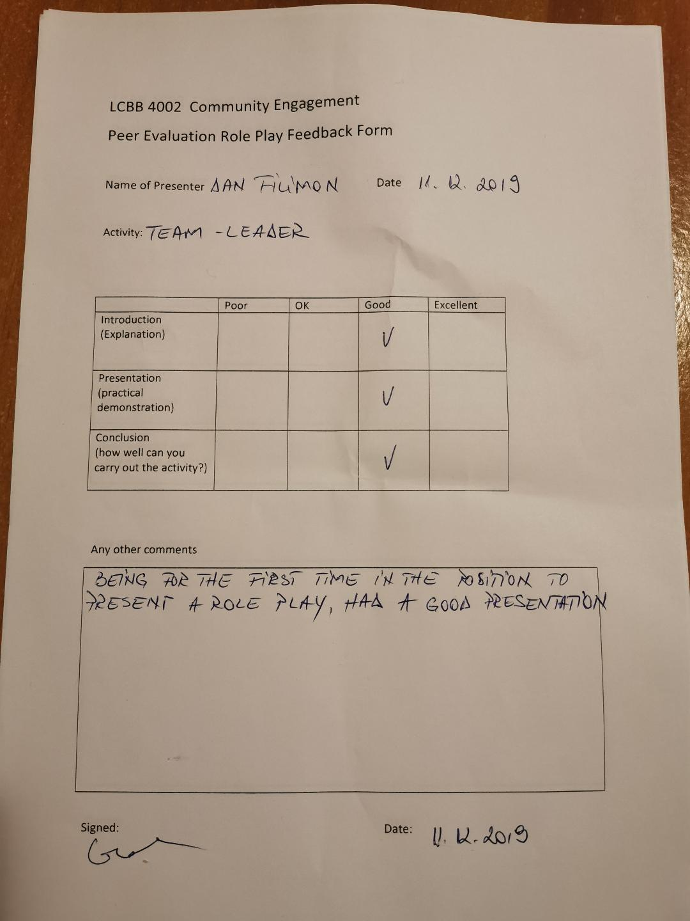

Conclusion (Jasper, 2003)

In conclusion (Mantell, 2018), I think that attending the courses of this faculty will bring me many personal and professional satisfaction. I will meet new people and connect new friends with different personalities and characters. Also the contact with people from different countries and cultures it is something new for me and something which I am happy to learn about. At university I will learn to respect and listen to those around me and to use my skills in order to interact better with different people and personalities. In the three years of college I will have the opportunity to study numerous disciplines and I will have a lot of things to sustain to professional development. After completing my studies I will have the chance to get a promotion or a new job that will bring me professional satisfaction. I believe that the experience accumulated on the university benches will help me to pass the practical tests that I will support. After the three years, I will have a greater knowledge in the field of business-management. If I need to think at what I would do different after this experience I think I would be more confident and I will trust more in my abilities.

Action plan (Gibbs, 1988)

My action plan I think was well structured and I think I am a person who is not rushing in taking fast decisions. I always analyze what I need to do and which are the steps which I need to take in order to meet my goals. Sometimes my friends tell me that I think too much before taking an important decision, but I reply to them that if I assume risk I need to know all the details before doing this. If I would need to go back and change something in my actions I don’t think I would do too many changes as the things went well during this semester and everything was almost I was planning before to start.
Like Gibbs is saying in his work (Gibbs, 1988), the cycle is ending with this action plan and next time we will need to focus on another reflective cycle.

Bibliography
Gibbs, G. (1988). Learning by doing: a guide to teaching and learning. Oxford: Further Education Unit, Oxford Polytechnic.
Jasper, M. (2003). Beginning reflective practice. Cheltenham: Nelson Thornes.
Johns, C. (2009). Becoming a reflective practitioner, 3. Oxford: Wiley Blackwell.
Mantell, A. (2018). Reflective Practice in Social Work (Transforming Social Work Practice Series). Learning Matters.
Palmer, A. (1994). reflective practice in nursing. Oxford: Blackwell Scientific Publications.
Pearson, P. (2009). A model for using reflection to enhance interprofessional education. International Journal of education .

