Title page
Tyra Watson
2008059
Certificate of higher education skills for the workplace (Health and Social Care)
Psychology for Health and Social Care
Case study report
BMHP4003_BIRM
Rebecca Kavanagh

Title page ……………………………………………………………………………………………………………1
Contents Page …………………………………………………………………………………………………….2
Introduction ……………………………………………………………………………………………………….3
Social learning theory …………………………………………………………………………………………4
Attitude ………………………………………………………………………….………………………………….5
Theory of planned behaviour …………………………………………….………………………………6
Conclusion …………………………………………………………………………………………………………7
Reference list …………………………………………………………………………………………………….8
Introduction
A local Clinical Commissioning Group (CCG) are concerned about their patients as they have been watching their patients closely and they have seen an increase in obesity especially in the semi younger patients, this has raised concerns as it puts the services and all finances under duress. The CCG would like to develop a strategic plan to help diminish the levels of obesity and increment good dieting practices, we have been asked to come up with a report to further their understanding of what the possible social and biological determinants of unhealthy eating may be.
This includes:
Social learning theory – this includes learning from others by seeing and observing
Attitudes – this includes paying attention to what somebody or something is doing and sort of mimicking their it’s/their behaviours and how these attitudes are formed direct experience, classic conditioning, and then observational learning.
Theory of planned behaviours – this includes the suggested statement that different factors shape whether our attitudes are reflected in our behaviours. The theory predicted an individual's intention to engage in a behaviour at a specific time and place. The theory was intended to explain all behaviours over which people have the ability to exert self-control.
Obesity is not getting any better but worse with the risk of obesity increasing every year and this has been happening for many years and will continue to happen if people do not fix their diet. Since 2002 obesity has been increasing and it is mainly the middle-aged people who suffer with it, and every year the number becomes higher and higher.
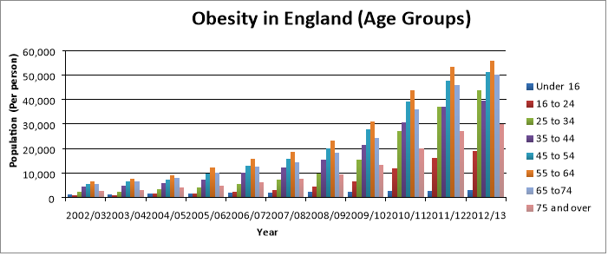

(Essaycompany, 2016)
Social learning theory
The arrangement of social models is likewise an essential method for sending and changing conduct in circumstances where blunders are probably going to deliver expensive or lethal results. In reality, if social learning continued solely based on fulfilling and rebuffing outcomes, the vast majority could never endure the socialization cycle. Indeed, even in situations where non-social improvements can be depended upon to inspire some estimation of the ideal conduct and mistakes don't bring about dangerous results, individuals are generally saved extremely monotonous and regularly random experimentation by imitating the conduct of socially able models. The basic conceptions of human nature they adopt and the causal processes they postulate require careful examination for several reasons. According to (Bandura, 1985) what theorists believe people to be determines which aspects of human functioning they explore most they investigate most altogether and which they leave unexamined. Originations of human instinct in this manner centre request around chosen measures and are thus fortified by discoveries of standards epitomizing the specific view. Social learning is learning through observation and not direct experience which is the opposite view of John Watson believing learning through association linking two stimuli together for example taking something as simple as going on your phone which is a day-to-day basis but if you got given a chocolate every time you went on your phone you would start associating your phone with chocolate and anytime you pick up your phone you would think of chocolate. Furthermore (Watson, 2017) believed people learned from direct experience behaviourism is a subject numerous theorists depict as a characteristic science that takes the entire field of human instinct. It is the matter of behaviourist brain science to anticipate and control human movement. The field has as its plan to be capable, given the boost, to anticipate the reaction, or seeing the response and to know the improvement that created it. Watson contended brain research is on par with its perceptions.
Linking unhealthy eating with Bandura’s theory suggests the theoretical concepts from social cognitive theory, recognised as an induvial who has environmental and social factors have and impact on a person meaning society around them has an effect on the decisions they make, for example someone may be eating a McDonalds and a different person sees how much they are enjoying the meal and they may not have ever tried one and this will then encourage them to purchase one to see if it is nice. Also, on the other hand society may tell someone they are too slim/skinny, and it may have a mental effect on that person, so they start overeating to match ‘societies’ needs. (Cotton and Long, 2013) One big problem the world is facing is that there is such easy access to unhealthy food like fast food restaurants that you can go in or have it delivered right to you, as people are busy working looking after their children and general life they simply do not have the time to prepare a healthy meal so they order food instead and because of this busy lifestyle they cannot go to gym either as a result they become over weight.
Attitudes

Attitude is our evaluation of a person an idea or an object and within they have three components an effective component is feelings, your thoughts which is cognitive, and action is behaviour. Characterized a disposition as a psychological or neural condition of status, coordinated through experience, applying an order or then again powerful impact on the person's reaction to all items and situations to which it is connected. A more straightforward meaning of demeanour is a mindset or an inclination to act with a specific goal in mind because of both a person's experience and disposition. Typically, when we allude to an individual's perspectives, we are attempting to clarify their conduct. Mentalities are a perplexing mix of things we will in general call character, convictions, qualities, practices, and inspirations. At the point when we discuss somebody's demeanour, we are alluding to the individual's feelings and practices. An individual's mentality toward preventive medication incorporates their perspective about the theme for instance thought how the individual feels about this theme for example feeling, just as the activities for instance the practices he or on the other hand she participates in because of demeanour to forestalling medical issues. This is why we understand the difference between someone’s positive attitude, thoughts, personality, values, and beliefs verses their negative ones. (Pickens, 2005).
Like most theoretical terms in the English language, attitude has more than one meaning. It has from one perspective the meaning of "wellness" or "adapted-ness," and like it’s by-structure aptitude connotes a subject indicates an emotional or mental state for activity. Through its utilization in the field of craftsmanship, notwithstanding, the term came to have a very independent meaning it referred to the outward or stance. The primary importance is unmistakably safeguarded in modern psychology in what are frequently alluded to as "mental perspectives" and the second which means in "motor perspectives." Since mentalistic psychology research generally goes before mentalistic research, it is natural to find mental psychologically are given acknowledgment sooner than motor mentalities (Allport, 1935).
There are three components of the attitude model easily remembered as ‘ABC’ A - for affective which is feeling, B - for behaviour which is action and C - for Cognitive which is though. These make up the different things that are the concept of attitude. Cognitive is our understanding of what we think we know about an object, food or even a person you know. A fact you think you know also can be a belief more than a fact(s). Behaviour is based on our past actions so possibly avoided something and felt negative about it or went to see someone and felt positive about it. Affective (subjective) which is to do with our emotions responding. To put it in perspective two people could have the same set of facts given to them and have a completely different reaction to it. This is based on feelings. Example people’s attitudes towards the use of cars maybe influenced by their beliefs about climate change as cars have such an impact. Another example of behaviour feelings is people believe eating meat has a negative effect on the body so someone who constantly eats at takeout restaurants like McDonalds, KFC or Chinese take out do not consider the health risks opposing to someone who is vegan who believes killing, eating or testing on animals is morally wrong because they have feelings so a vegan would never consider eating out at these types of places and this is where the difference of opinions is, some people only believe in unhealthy eating because making food is too time consuming for many reasons or it could be to save money because it is cheaper to buy a three pound chicken and chips than make it from scratch whether your only eating for one or feeding a whole family. Also, fast food restaurants are being so normalised and at such a high demand people forget how risky these types of foods are which is one of the main causes of obesity.

Theory of planned behaviour
According to (Kim, 2020) the theory of planned behaviour patterns of behaviour can be obtained through direct insight or by noticing the conduct of others. the more simpler type of learning, established in direct insight, is to a great extent represented by the fulfilling and rebuffing outcomes that follow any given activity. Individuals are over and again faced with circumstances with which they should bargain somehow. Some of the responses they try proving unsuccessful while other produce more, while others produce more good outcomes. Through this interaction of differential support, effective methods of conduct are ultimately chosen from exploratory exercises, while incapable ones are disposed of. Even though conduct can be formed into new examples partially by fulfilling and rebuffing results, learning would be extremely relentless and unsafe on the off chance that it continued exclusively on this premise. The majority of the multifaceted reactions individuals show are learned, either purposely or accidentally, through the impact of model. In reality basically all taking in wonders coming about because of direct encounters can happen on a vicarious premise through perception of different people groups conduct and its ramifications for them. A person’s ability to learn by perception empowers him to secure complex examples of conduct by watching the exhibitions of commendable additionally be created by seeing the full of feeling responses of others rebuffed for their activities, lastly, the declaration of recently educated reactions can be socially managed through the activities of compelling models. The first comments are not intended to suggest that new methods of conduct are moulded exclusively through experience, both of a direct observational sort. Organic construction draws certain lines on the kinds of forceful reactions that can be effectively idealized, and hereditary blessing impacts the rate at which learning advances. This is the idea that behaviourism is concentrated on the point that nurture is what moulds us to be who we are, so with this notion you can make someone behave in any peculiar way by manoeuvring the conditions and moulding them toward a specific method of being.
When a behaviour is carried out it can bring about unexpected positive or adverse results, this can evoke great or horrible responses from other people, and it can reveal unanticipated difficulties or facilitating factors. This input could change a person’s behavioural, normative and control beliefs this will impact future goals and/or actions. (Maio, Haddock and B Verplanken, 2019). Theory of planned behaviour and Reasoned Action are both show that attitude has effects on behaviour that indirectly shaped attitude’s purpose to act which in fact then regulates behaviour. The theory of planned behaviour recommends that behavioural control impacts conduct in two ways, first it directly affects conduct expectations and furthermore singular aims a commitment and a specific conduct which then at that point is affected by their certainty and capacity to perform the action, then the second apparent behavioural control has direct impact on conduct. This impact relies upon genuine control of the applicable activity, this is whether the conduct can, as a general rule be performed. In other words, while people might accept that they can play out the applicable conduct their insight may not be precise. As a result, perceived behaviour control may not predict their behaviour, this should lead to a better ability to predict behaviour than by only considering variables from the theory of reasoned action, which is both theory of planned behaviour and theory of reasoned action.

Conclusion

CCG could gather health and food pamphlets which would include information with great detail and sit and go through a one-on-one session or a group session with approximately 8 people of a diverse age and all obese sized but different varieties of it and once gone through they could create their own posters or leaflets to support the idea of their health being at risk as numbers in obesity rise as they would have been given the evidence to and detail to support them.
Or we could have a doctor/ nurse come in with props from the hospitals of what happens when you overeat and have a sort of workshop to make a fun sense of a serious situation like making smoothies, seeing what eating too much does also bring in other people that have suffered with obesity to go give motivational talks and to prove anyone can lose the weight no matter what they weighed.
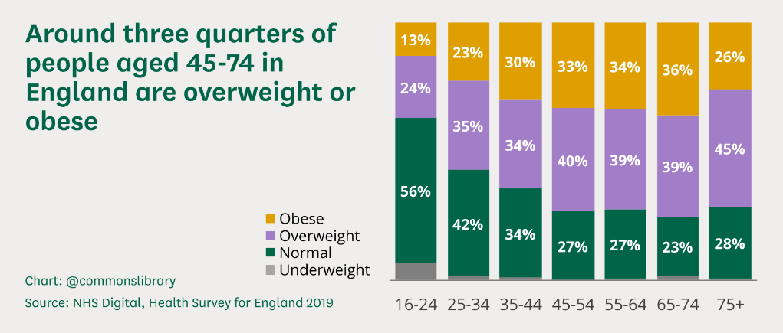
Also, there are simpler ways to lose weight like trying to skip a meal preferably not breakfast and replace it with either fruits, vegetables, smoothies, or multivitamins diet but try avoiding doing this for a long period of time.

(Baker, 2021)
Reference list

Allport, G. (1935). . Attitudes. [online] . Available at: http://aurora.upsi.edu.my/wp-content/uploads/2021/02/ALLPORT-ATTITUDES-ARTICLE.pdf.
Baker, C. (2021). Obesity Statistics. commonslibrary.parliament.uk. [online] Available at: https://commonslibrary.parliament.uk/research-briefings/sn03336/.
Bandura, A. (1985). Model of Causality in Social Learning Theory. Cognition and Psychotherapy, pp.81–99.
Cotton, M.T. and Long, J.D. (2013). Exploring Facilitators and Barriers to Healthy Eating Among Community Gardeners. sigma.nursingrepository.org. [online] Available at: https://sigma.nursingrepository.org/handle/10755/304542 [Accessed 27 Jul. 2021].
Essaycompany. (2016). essaycompany.com | Essay | Analysis of Obesity in the UK. [online] Available at: https://www.essaycompany.com/essays/statistics/obesity-in-england-statistical-report [Accessed 29 Jul. 2021].
Kim, R. (2020). WAR SYSTEM : an interdisciplinary approach. S.L.: Routledge.
Maio, G.R., Haddock, G. and B Verplanken (2019). The psychology of attitudes & attitude change. London ; Thousand Oaks, California: Sage.
Obesity Statistics - House of Commons Library (parliament.uk)
Pickens, J. (2005). Google Scholar. [online] scholar.google.co.uk. Available at: https://scholar.google.co.uk/scholar?q=attitudes+and+perceptions+jeffrey+pickens&hl=en&as_sdt=0&as_vis=1&oi=scholart.
psycnet.apa.org. (n.d.). APA PsycNet. [online] Available at: https://psycnet.apa.org/record/1999-02672-003.
Tandfonline.com. (2019). Taylor & Francis Online. [online] Available at: https://www.tandfonline.com.
Watson, J.B. (2017). Behaviorism..

