Name: Seletta Loreen Munroe
Student ID: 2332437
Programme: BSc (Hons) Health and Social Care
Module: Changemakers: Building your Personal Brand for Sustainable Employment
Module code: BMHP5015
Lecturer: Christopher Mafuva
Assignment Title: Component 1: online portfolio
Submission Deadline: 13th April 2026

I confirm that the use of AI is not used in this Assignment

Introduction
The assignment focus: Personal branding.
The main topics I will cover from unit 1:
- The steps needed to achieve my goal of becoming a social worker
- Self - awareness
- Emotional intelligence.
Aligning my brand with important values is the goal of personal branding, and self-awareness will assist me in identifying my essential beliefs. Empathy, compassion, and advocacy are just a few of the core principles of social work that are essential in the healthcare industry. When I think about my brand, self-awareness makes it easier for me to see my strengths, such as I poses excellent communication skills and I have excellent listening skills, which will contribute to social work. If I were to list a weakness, it would be to constantly strive for improvement and better time management. In social work, being able to control my emotions under pressure is crucial and something I must constantly do. When it comes to communicating, having the proper social skills is also crucial, and actively listening will support and manage any challenging conversations.
Task 1 Unit 1: Brand You
The main topics I will cover from unit 1:
- How will I achieve my goal as a social worker
- Why self-awareness is important as a social work
- Why emotional intelligence is important in social work
Developing relationships within the social work community may significantly influence my professional trajectory. attending local events, conferences, and workshops to network with seasoned professionals and gain knowledge from their perspectives. organisations for professionals, such as the British Association of Social Workers (BASW). Or looking into ways to access professional resources, job sites, and networking through Social Work England. Effective social work requires both academic understanding and practical abilities. When handling delicate and varied situations, critical thinking, interpersonal communication, and cultural competency are essential. (Social Work UK, 2015). Using social media platforms like LinkedIn and my university alumni network to inform others that I'm seeking a social work position (Smith, 2026).
Why self-awareness is important in Social Work
Social workers deal with a wide variety of individuals with different needs and backgrounds. Eventually, a social worker will deal with people, families, or even communities that differ from their own. This implies that addressing some of the potential obstacles in the client-worker interaction in social work must be on a social worker's agenda (Social work degree, 2025). When social workers are more self – aware, communication becomes more effective. Being conscious of your emotions allows you to speak more effectively. It also enhances the ability to understand and interpret the emotions of others. In this field of work, having empathy and the ability to understand a person’s feeling, and emotions are essential. (Care Learning, 2024).
How will I achieve my goal as a social worker
I should constantly strive to understand more about many languages, cultures, and belief systems as a social worker. This could be going to seminars, taking part in neighbourhood activities, or looking for mentorship from experts who have worked in ethnic settings. Setting goals for professional development and education may entail pursuing advanced degrees or focusing on clinical, educational, or child welfare social work. These reasonable objectives guarantee that I stay informed and skilled in a sector that is ever changing. participating in advocacy organisations, staying up to date on laws and regulations, or spearheading community projects that promote structural change and fight injustice. (Social work Institute, 2025).
Importance of Emotional intelligence within social work
Understanding the importance emotional intelligence is an essential ability for any social worker. Increasing our self-awareness, self-management, social awareness, and relationship management can help us better serve our clients and navigate the difficulties of our profession. As a crucial competency in social work, emotional intelligence should be fostered and cultivated for the benefit of our clients, ourselves, and the larger communities we serve. (Social work news, 2023). Emotional intelligence and communication techniques in this field, strengthening interpersonal and professional links is crucial since it enables social workers to form close bonds with both clients and colleagues. Empathic social workers can see the world from their clients' point of view. (Neuro launch, 2024).
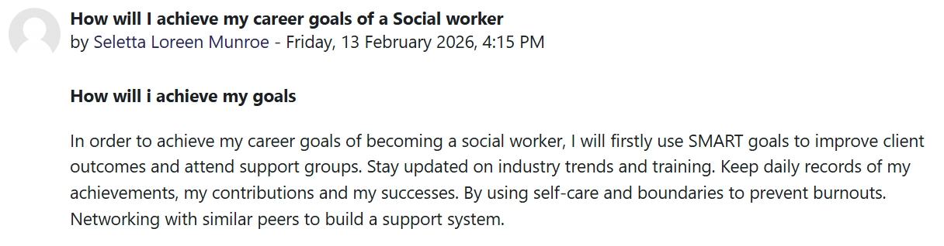
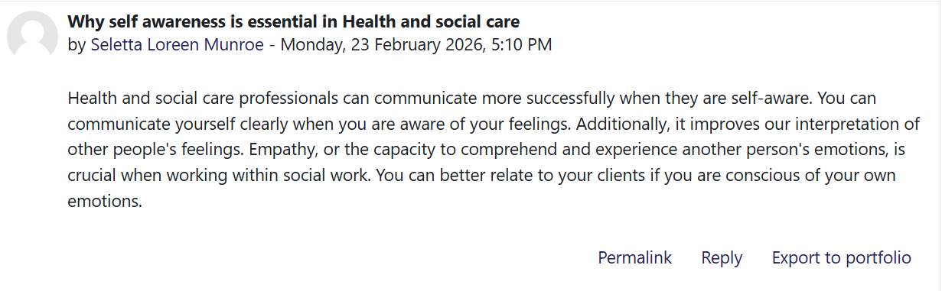
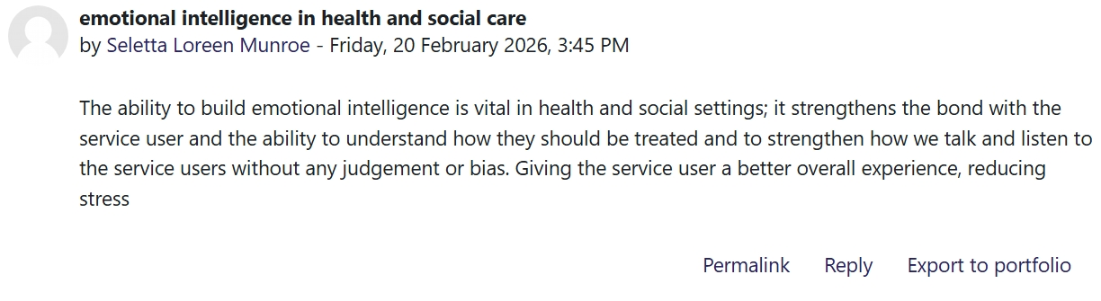

Task 2 – Reflection on unit 2: It’s a small world
The main topics I will cover from unit 2:
- The meaning of networking.
- The methods used to persuade people to get vaccinated.
Networking provides a priceless chance to establish connections with colleagues, keep informed, and promote professional development within health and social care industry, by cooperation, exchanging knowledge is crucial. Professionals can share ideas, experiences, and creative solutions through networking. Organisations may enhance service delivery, overcome obstacles, and keep current with market developments by learning from peers. (Hscpn, 2026). In fact, studies indicate that BAME groups, households with lower incomes, and lower levels of education are more likely to be hesitant to get vaccinated. In addition to adopting messaging that exploits, it is crucial to use reliable channels like church groups, charities, and community organisations. (I, Vlaev, 2021).
Meaning of networking
To create chances and support my growth and development, networking is crucial. Chatting with coworkers, going to meetings, asking a mentor for help, or even interacting with peers online are all examples. Through networking, I can get in touch with companies and employers about opportunities. Additionally, it enables me to stay current with industry trends, learn from the experiences of others, and obtain advice or insights into other career choices. Developing solid professional connections can lead to opportunities for career progress, collaboration, and mentoring that I might not have otherwise found. (Royal College of Nursing, 2026).
The methods used to persuade people to get vaccinated.
- Religious and community leaders
It has typically been seen that religious leaders' involvement in health-related activities increases their congregations' participation in these interventions, hence promoting favourable health outcomes. Uebari (2009). Religious leaders are highly respected and have the power to persuade their followers to accept or reject vaccination. (United Nations Children's Fund, 2004). Working with local communities and community organisations, translating material, delivering vaccinations to the public through mobile clinics. Providing transportation, while maintaining anonymity were all necessary to overcome the many access hurdles to vaccination uptake. (Nanyonjo et al, 2023).
- Celebrity endorsement and partnership
Using celebrities to promote the COVID-19 vaccine may seem like a creative way to engage the public. However, using celebrities to further a government cause has been a longstanding practice. Additionally, it has shown great efficacy (Du-Lieu & Grassi 2020). One of the most famous instances of celebrity-led health campaigns is Elvis Presley's polio vaccination. However, several other well-known individuals have urged people to take preventative health steps (The conversation, 2025).
Personal reflection
When I think back on my educational experience, the thing that shocked me the most was how members of faith-based groups can impact the community, particularly those from a demographic that is more vulnerable to health disparities or has trouble accessing healthcare. As a result, religious leaders may be in a good position to actively assist in addressing health issues in the communities they serve. I was also taken aback by how frequently religious leaders can connect with marginalised groups, including immigrants, who are unable to easily obtain health information through traditional channels due to language issues (NIHR, 2023).
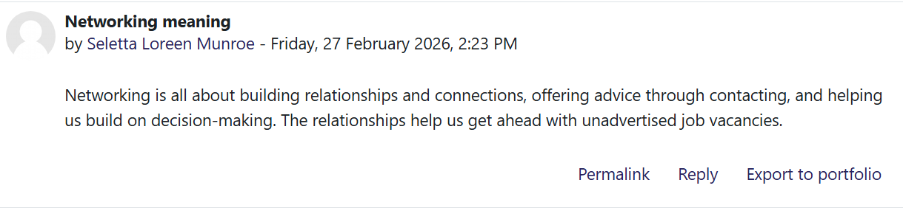
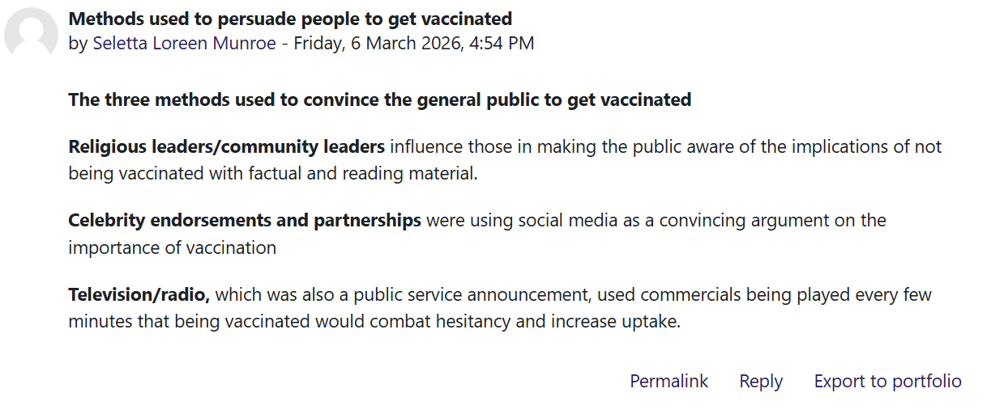

Task 3 – Reflection on Unit 3: Opportunity knocks
The main topics I will cover from unit 3 that relates to opportunities
- Serendipity mindset
- How blogging helps in health and social care
- Why professional presence online is important
I realised that my online presence is more crucial than ever thanks to the principles I gained in this class. An individual's internet profile can have a significant impact on my career by impacting networking, employment prospects, and professional development. My online presence says a lot about who I am, whether I'm maintaining a professional LinkedIn profile or constantly engaging on social media. Today's job hopefuls must keep an active and positive online presence. Online profiles are used by employers to assess a candidate's professionalism, communication abilities, and general character, all of which have an impact on hiring decisions. Employers can easily determine whether you are a good fit for a position thanks to a well-curated online reputation that serves as social proof of your qualifications (G, Valeria, (2024).
Serendipity mindset
Mentality of serendipity. It's about developing an openness to the unexpected surprises that life presents; it's not just about luck. Anyone may turn ordinary routines into amazing adventures by adopting new perspectives and embracing the unknown. Adopting a serendipity attitude is a potent instrument for creativity and personal development, not just a fun strategy. It helps people to see the chances that come from unforeseen circumstances. Adopting this way of thinking entails seeing life from a perspective that emphasises spontaneity. This viewpoint strengthens the bond between creativity and curiosity. People who adopt this approach frequently develop a feeling of amazement and find excitement in the unexpected (J, Cole 2025).
How Blogging helps in Health and Social Care
Blogging is an act of creating, publishing and the ability to update the content made on a website platform that facilitates communication between individuals, and organisations. Being a blogger allows you to share information and express your ideas through online channels. These days, a lot of people utilise popular websites like Facebook, Instagram, LinkedIn, Twitter, and Tik Tok for communication. Forums, blogs, and specialised communities and support groups are more examples. To benefit patients, communities, and healthcare professionals, social media platforms are increasingly being employed in primary care in creative ways. Social media platforms allow health professionals to represent themselves as people and practices to represent their organization (NHS, 2025).
Why is professional presence online important
Having a strong internet presence makes you more visible to people throughout the world. A well-maintained digital footprint makes it easier for clients, coworkers, and potential employers to locate you. Opportunities for networking, partnerships, and job offers that you might otherwise pass over can result from this enhanced visibility. Having an online presence contributes to my credibility. You show that you are an expert in your profession by sharing your accomplishments, experiences, and knowledge. Well-written LinkedIn profiles, interesting blog entries, and active involvement in pertinent online forums are all components of a professional online presence. This not only demonstrates your abilities but also fosters my development and positions me as a leader in my field. (Career guidance advice, n.d).
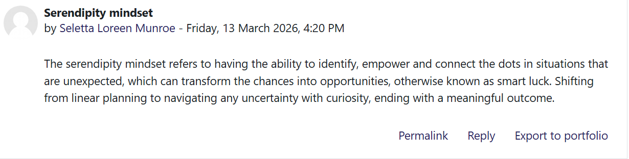
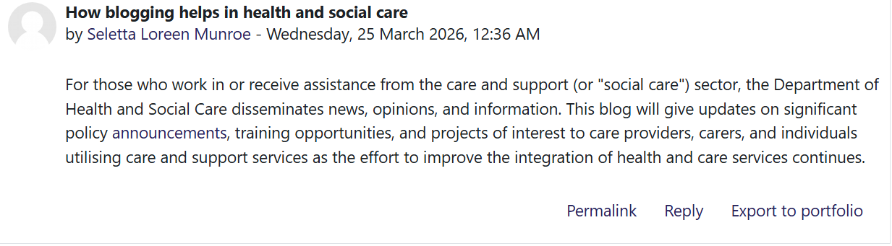
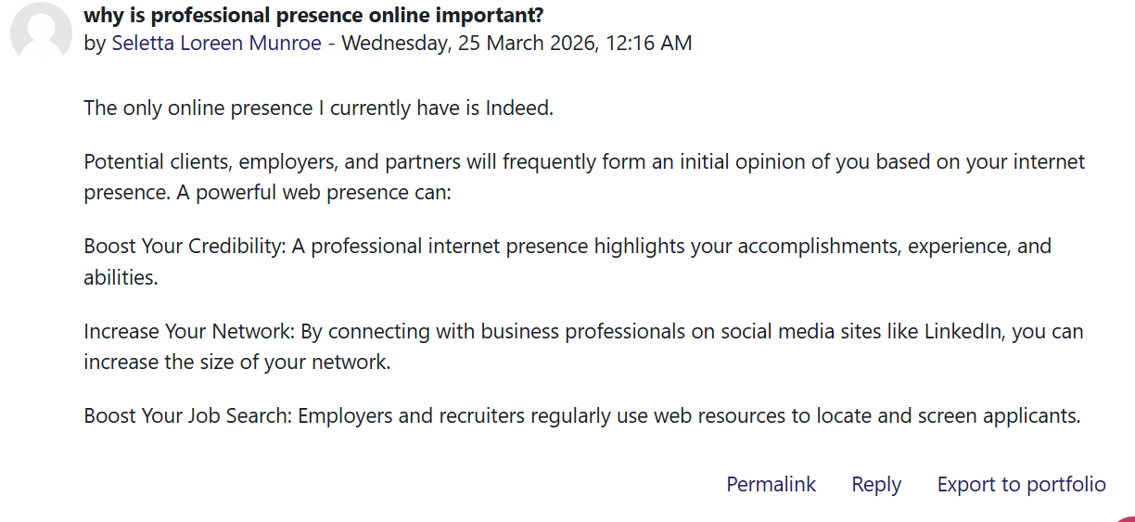

Task 4 – Reflection on unit 4: The pursuit of happiness
Positive self-talk, which entails having an internal dialogue that is mostly upbeat and cheerful, must be my overall learning experience from unit 4. These ideas and declarations are what give me strength, boost our drive, and boost our self-esteem. The way our inner voice interprets the world is known as self-talk. Everything from our motivation and relationships to our self-esteem can be impacted by the way we connect with our inner selves. This section also taught me the self-limiting phrases like, I cannot handle this, or this is impossible. Can be especially harmful since it makes us feel more stressed in every circumstance and prevent us from looking for answers (E, Scott, 2026).
The meaning of limiting belief can be defined as an opinion, state of mind, or conviction that we believe to be the truth. Having limiting belief can holds us back, in essence having limiting beliefs can be what we tell yourself to keep us in our perfect comfort zone, which can prevent us from becoming who we really want to be.
Summarising the overall impressions of the module and the knowledge and abilities I have acquired that will be helpful in the profession of social work. Positive self-talk helps you overcome limiting thoughts and changes our perspective. (E, Georgieva, 2024).
The main topics I will cover from unit 4:
- Positive self-talk comments
- Limiting beliefs
I learned from this class that limiting our beliefs is a mistake we make about ourselves that limits our possibilities. We are prevented from seizing opportunities, taking chances, or accomplishing our objectives by these self-imposed mental obstacles. It's critical to identify unconscious biases in addition to improving my self - awareness and my self- esteem.
The meaning of critical thinking is communication, and having the ability to problem solve are interrelated abilities that can greatly enhance our job in social work by improving decision-making, interpersonal relationships, and the successful resolution of complicated challenges. In the complex and quickly evolving surroundings typical of social work settings, critical thinking helps me to thoroughly examine situations, make well-informed decisions, and devise adaptable approaches to tackling obstacles (Tripathy, M. 2020).
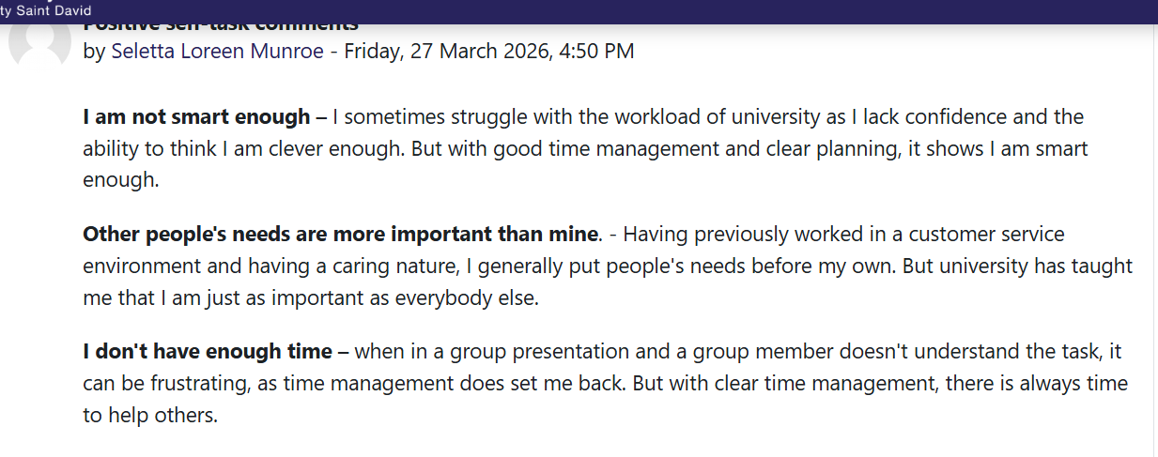
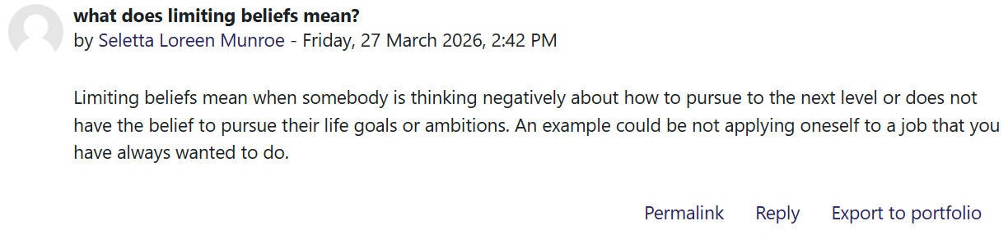
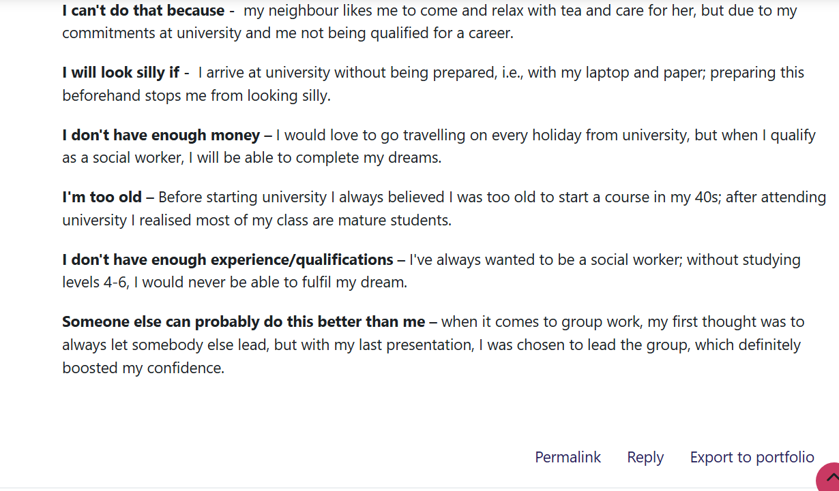

Conclusion
It would be crucial to have a strong personal brand to accomplish the objectives of social work. This would entail realising the significance of social work in general and acknowledging the value of emotional intelligence. when interacting with and helping others. Developing a strong network and adopting a serendipitous approach to communication is essential. A strong and genuine personal brand can be created by maintaining a professional online presence while encouraging positive interaction.

References
Care Learning, (2024). What is Self-Awareness in Health and Social Care; Available at: https://carelearning.org.uk/blog/skills-and-principles-blog/what-is-self-awareness-in-health-and-social-care/ Accessed 23rd February 2026
J, Cole, (2025). Serendipity Mindset: Unlocking Unexpected Opportunities for Growth and Creativity; Available at: https://laroadrunners.com/serendipity-mindset/ Accessed 25th March 2026
Dr. Badillo-Diaz, (2024). 21st Century Social Worker: Ways to Create and Build your Brand: Available at; https://www.theaisocialworker.com/blog/21st-century-social-worker-ways-to-create-and-build-your-brand/ Accessed 15th February 2026
Du-Lieu, Grassi, (2020). COVID vaccine: celebrity endorsements work – even if people don’t like it. Available at: https://www.hud.ac.uk/news/2020/december/covid-vaccine-celebrity-endorsements/ Accessed 13th March 2026
E, Georgieva, (2024). The Power of Positive Self-Talk in Overcoming Limiting Beliefs; Available at: https://emiliyageorgieva.com/the-power-of-positive-self-talk-in-overcoming-limiting-beliefs/ Accessed 2nd April 2026
Hscpn, (2026). The Power of Networking: Building Meaningful Connections in Health and Social Care. Available at: https://hscpn.org/the-power-of-networking-building-meaningful-connections-in-health-and-social-care/ Accessed 1st April 2026
Nanyonjo et al, (2023). Community efforts to promote vaccine uptake in a rural setting: a qualitative interview study. Available at: https://doi.org/10.1093/heapro/daad088 Accessed 13th March 2026
Neuro launch, (2024). Emotional Intelligence in Social Work, Enhancing Professional Practice and Client Outcomes; Available at: https://neurolaunch.com/emotional-intelligence-in-social-work/ Accessed 24th February 2026
NHS, (2025). Social media; Available at: https://www.england.nhs.uk/long-read/social-media/ Accessed 1st April 2026
NIHR, (2023). 23/149 Faith-based groups and the impacts on health and health inequalities; Available at: https://www.nihr.ac.uk/23149-faith-based-groups-and-impacts-health-and-health-inequalities/ Accessed 1st April 2026
Royal College of Nursing, (2026). Networking; Available at: https://www.rcn.org.uk/professional-development/your-career/networking/ Accessed 2nd March 2026
E, Scott, (2026). What Is Positive Self-Talk; Available at: https://www.verywellmind.com/how-to-use-positive-self-talk-for-stress-relief-3144816/ Accessed 2nd April 2026
J, Smith (2026). How to become a social worker. Available at: https://www.prospects.ac.uk/jobs-and-work-experience/job-sectors/social-care/how-to-become-a-social-worker/ Accessed 1st April 2026
Social work degree, (2025). Why Is Self-Awareness Important in Social Work? A Complete Guide; Available at: https://www.socialworkdegrees.org/why-is-self-awareness-important-in-social-work/ Accessed 23 February 2026
Social Work England, (2020). Reflecting on my values: Available at; https://www.socialworkengland.org.uk/news/reflecting-on-my-values/ Accessed 15th February 2026
Social work Institute, (2025). The Purpose of Advocacy in Social Work: Empowering the Marginalized; Available at: Accessed 15th February 2026
Social work news, (2023). How to use emotional intelligence to become a better social worker; Available at: https://www.mysocialworknews.com/article/how-to-use-emotional-intelligence-to-become-a-better-social-worker. Accessed 24th February 2026
The conversation, (2025). How celebrity endorsements can shape public health; Available at: https://www.gavi.org/vaccineswork/how-celebrity-endorsements-can-shape-public-health Accessed 13th March 2026
Toni-Uebari TK, Inusa BP. The role of religious leaders and faith organisations in haemoglobinopathies: a review. BMC Blood Discord. (2009) ; 9:6. Doi: 10.1186/1471-2326-9-6. [DOI] [PMC free article] [PubMed] Accessed 13th March 2026
Tripathy, M. (2020). Dimensions of critical thinking in workplace management & personal development: a conceptual analysis, Multidisciplinary journal for education, social and technological sciences, 7(2), pp. 1–19. Available at: https://doi.org/10.4995/muse.2020.12925. Accessed 2nd April 2026
UK social work (2015). From Student to Professional: Navigating the Transition into a Social Work Career; Available at: https://uksocialwork.co.uk/from-student-to-professional-navigating-the-transition-into-a-social-work-career/ Accessed 1st April 2026
United Nations Children's Fund. Building trust in immunization. Partnering with religious leaders and groups. New York: UNICEF; (2004). [Google Scholar] Accessed 13th March 2026
G, V. (2024). No Online Presence, Here’s Why It Could Be Hurting Your Career; Available at: https://www.netreputation.com/no-online-presence-heres-why-it-could-be-hurting-your-career/ Accessed 1st April 2026
I, Vlaev, (2021). How to persuade people to take the COVID-19 vaccine; Available at: https://www.wbs.ac.uk/news/how-to-persuade-people-to-take-the-covid-19-vaccine/ Accessed 1st April 2026
S. Kristenson, (2023). 21 limiting beliefs examples that hold you back in life; Available at: https://www.happierhuman.com/limiting-beliefs/ Accessed 10 April 2026

