Jenson Davies (2316793)
Computing (Data & Information Systems)
Introduction to web and database concepts
Website Report

Table of Contents
Introduction 2
Requirements 2
Implementation 3
Validation 5
Evaluation 7

Introduction

This report will cover a plethora of aspects that relate to the creation of my original website. The report will contain information on the requirements for the website along with its purpose. The report will also contain a demonstration of the finished website, along with descriptions of any issues that were faced when creating the website. The report will then conclude with an evaluation that discusses what website usability, accessibility, and search engine optimisation is and how the website adheres to these requirements. A list of references will also be included that highlight all the sources that were used using the IEEE referencing format.

Requirements

This website will be a descriptive website based on the application “Letterboxd”. The aim of this website is to provide a detailed analysis of the website and its features, along with who created it; this can help any potential users make an informed decision on whether they would like to sign up to the website. The app is a platform where users can share their taste in movies and as a result my website will be targeted to those who have a keen interest in cinema. The website will contain a series of pages that outline what users can do on the platform, what the platform is for, who created it and my own personal opinions on the website.

Implementation

Homepage:
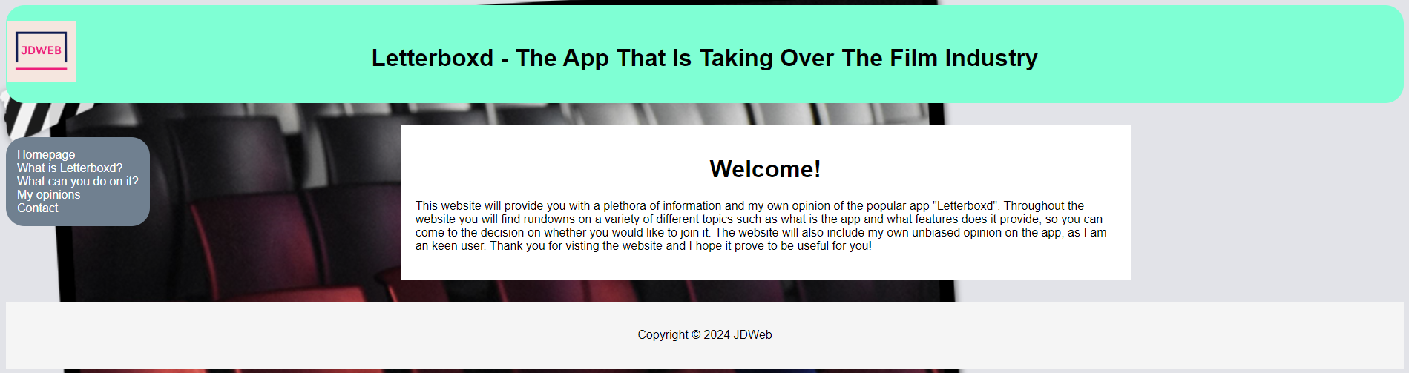
What is Letterboxd? (Page 1):
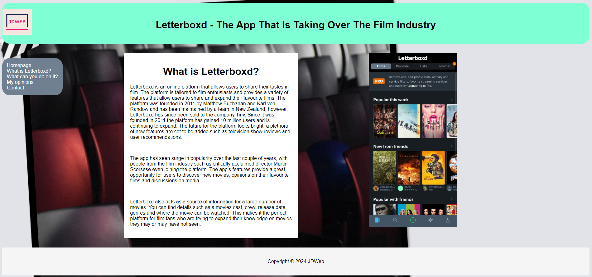
What can you do on it? (Page 2):
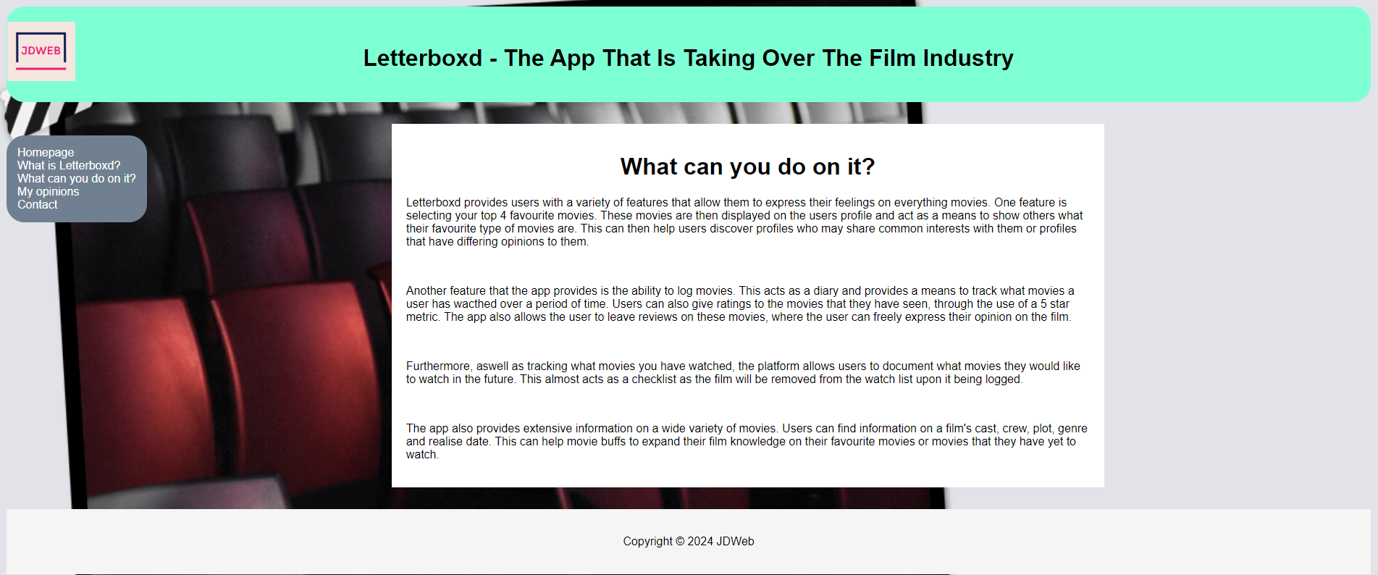

My opinions (Page 3):
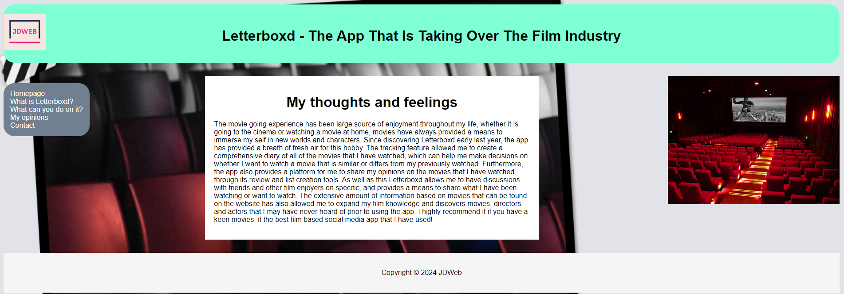
Contact Page (Page 4):
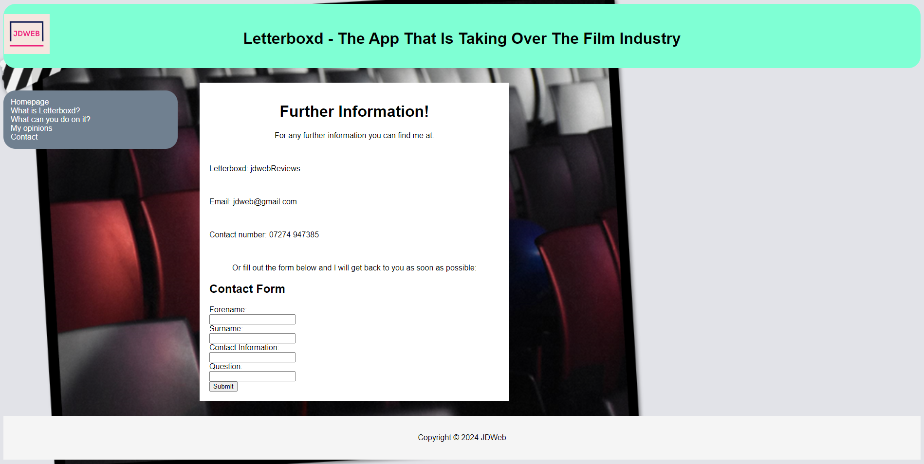

Validation

Using the https://validator.w3.org/ website I conducted a validation check on the code included within each page of my website.

Homepage:
- One error that occurred on all pages was:
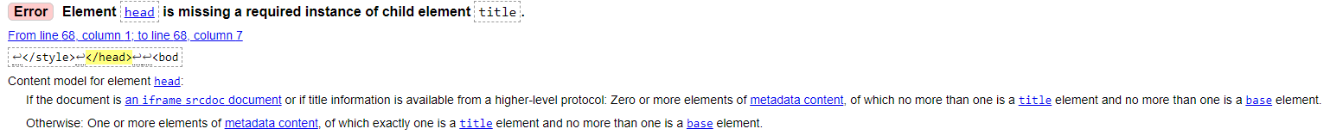
To resolve this, I included a title element on each page of the website, for example here is a screenshot from my homepage:
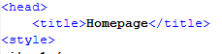
- There were multiple instances where values were flagged for spaces when referencing file names:
This occurred with multiple values on differing pages, and I was unable to correct this as replacing the spaces with a different character such as an underscore would result in a error when trying to open the pages using the navigation menu.

Contact Page:
- One error that occurred on the Contact Page was:
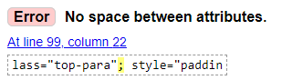
To resolve this I removed the semi colon as it was not needed.

My opinion page:
- One error that occurred was:
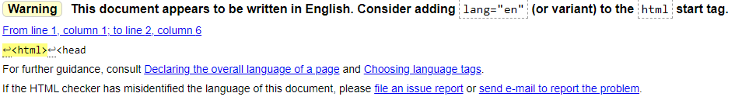
To resolve this I specific the language of the document using:
- Another issue was:
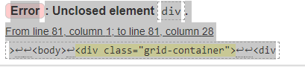
This was resolved by properly closing the div as a > was missing after the image style was specified:

Evaluation

According to a scholarly journal titled “Development of a web site usability instrument based on ISO 9241-11”, usability refers to the extent at which a product can be used by users to achieve specified goals. This means that developers should strive to create a website that enables users to fulfil their needs by providing tools and features that allow them to carry it out efficiently. The journal also discusses the importance of website usability in the context of an e-commerce website. The journal states that websites with features that help increase a website usability see positive effects such as an increase in time spent on the website, increases revisit rates and eventually an increase in online purchases through the website. It also highlights that a usable website can have benefits such as, reducing the time spent on development, cost of support and cost of maintenance. These benefits show that if the development team was to spend time ensuring their website is as suitable to the users needs as possible, then they would see a reduction in the amount of time and resources needed to be spent on the website, along with an increase in user retention and spending. However, the study also highlights the difficulty measuring usability; it states that usability is made up of a plethora of independent quality attributes such as user performance, satisfaction and learnability, and as a result makes it very hard to measure usability precisely. This means that due to the fact that the usability of website is made up of a variety of factors, it makes it hard to pinpoint and exact value when determining how usable a website it, as it may be subject to the specific person or environment as well as the tools available on the website. In order to create a usable website, a development team must consider their target demographic as well as their needs; the website must contain a variety of tools that allow the user to efficiently use the website as intended. If a team was to create a website that can be effectively used, they may see a reduced need for extra support and maintenance costs, as well as this they may see and increase in their user retention rate along with their user spending rates. [1]
Moreover, website accessibility plays a pivotal role when developing a website. According to the scholarly journal titled “Condition of Web Accessibility in Practice and Suggestions for its Improvement”, The W3C defines a website as accessible if it can be used by people who may have some kind of disability. This means that when developing a website, a developer should consider implementing tools that will aid those who may find it difficult to use the website, for example, a text reader for those who are visually impaired or voice recognition for those with cognitive disabilities. The journal also highlights a variety of other factors that should be considered in order to make a website accessible such as features that adhere to people with difficulties reading, people with slow internet connections, people who speak other languages and people who own different versions of a specific browser. In the journal 14 guidelines to creating an accessible website are provided from the Web Content Accessibility Guidelines (1999) which was published by the W3C; some of the guidelines include: “provide equivalent alternatives to auditory and visual content”, “don’t rely on colour alone”, “provide clear navigation mechanisms” and “ensure that documents are clear and simple”. In order to ensure that a website is accessible, you must implement tools that adhere to those who may struggle to view and comprehend your website normally; furthermore, your website must be easy to use and understand so that all users are able to use the website as intended. [2]
Furthermore, another factor that plays a large role in website development is search engine optimisation (SEO). According to the scholarly journal titled “Search Engine Optimisation and Automatic Classification”, search engine optimisation refers to when a website strives to be one of the top results for any specific search engine, this usually means being within the first five pages. This is a particularly important for a website as if it is optimised well, it could result in more users visiting the website. The journal discusses the importance of search engine optimisation and how to achieve it from the perspective of someone who has worked within the industry for a long period of time. One method of SEO is paying for it; in large markets organisations may have to pay an amount in order to show their website on a specific page, however, this method is expensive and once the payments have stopped there a possibility that the website will no longer be featured on that page. Another more affective method that is highlighted in the journal is regular updates and additions to your website’s content. If the website developers were to consistently add content to their website, it may encourage users to continue to use your website or it may encourage new user to move to your website. This increase in users will then help you to push your website to one of the earlier pages when users use a search engine. Another method is ensuring that the titles included within your website are short and captivating, whilst also including keywords that will help your website to be present when the user searches for the topic that is included within the website. [3]

After completing my own website, I believe that the design of it was useful. The website included a consistent homestyle, with the navigation menu on the left-hand side and the content in the middle. This was done in order to not confuse the user as a consistent house-style means that the user will be able to quickly locate specific things on the website without feeling overwhelmed or confused. Furthermore, the navigation menu included a background colour that contrasted with the webpage background so that the text within it could be read effectively; within the navigation menu I also included a feature that cause the text to change colour when the user hovers over a specific piece of text, this was done so that the user could identify which webpage they would be sent to if they were to click that specific point in the menu. Furthermore, I also included a header and footer that remained consistent throughout the website, these were used to highlight to the user the article and website that they were viewing as a logo and title were included in the header and the copyright information were included in the footer. Moreover, each piece of content had white background, this was done in order to differentiate it from the background and make the text easier to read for the user. The content included was informative, providing information on how the use the app “Letterboxd”, the history of the app, where the app may go in the future and my own opinion on the app. However, in the future I could include more images that coincide with the content, in order to provide captivating extra content as most of my information was text based.
In addition to this, I also implement some search engine optimisation techniques (SEO) to my website. For example, I included relevant titles on each page of my website so that my website my come up if the user was to search for something relevant to the topic that I was discussing. This can be seen in my “What is Letterboxd?” page where I included a title that users may be searching for if they were looking to gather more information on the platform. Furthermore, within the content of that page I also included key words such as the names of the creators of the platform and the company that currently own “Letterboxd” so that my website may also be present if you were to search for them.
Moreover, I also believe that my website is accessible. My website complies with Guideline 1.4 Distinguishable in WCAG 2.1; this is due the fact that each body of content is differentiated from the background, as contrasting background colours were used so that the content could be easily read; for example, the background image for most of my webpages is primarily gray, so I used a white background colour for my text, which as a result makes it stand out from the background. Additionally, my website also complies with Success Criterion 2.42 Page titled. This is as a result of each page including a title that highlights the purpose of the page, meaning the user can identify whether they want to view the webpage based on their needs. However, to improve my website and make it more accessible in the future I could implement alternatives to the text-based information included such as audio recordings, so that those who may struggle to read the text are able to access the information.

References

[1]
“Document unavailable - ProQuest,” www.proquest.com. https://www.proquest.com/docview/232576825?parentSessionId=u8kBKSKrmpm75aF758raIGDT7fm9XhoQBurfjnII06s%3D&pq-origsite=primo&accountid=130472&sourcetype=Scholarly%20Journals (accessed Jan. 16, 2024).

[2]
“Condition of Web Accessibility in Practice and - ProQuest,” www.proquest.com. https://www.proquest.com/docview/2616584899?pq-origsite=primo&sourcetype=Scholarly%20Journals (accessed Jan. 16, 2024).

[3]
Uwtsd.ac.uk, 2024. https://www-cambridge-org.ezproxy.uwtsd.ac.uk/core/journals/legal-information-management/article/search-engine-optimisation-and-automatic-classification/62F78CB45C8996EDDA6DBD4EC1CFFB4A (accessed Jan. 16, 2024).
‌

Appendices

Website.css:

h1 {
text-align: center;
};

.container .Rimage{
float: right;
margin-right: 15px;
max-width: 10%;
}

Homepage.html:

<!DOCTYPE html>
<html lang="en">
<head>
<meta charset="utf-8"/>
<title>Homepage</title>
<link rel="stylesheet" type="text/css" href="website.css">
<style>
.item1 {
grid-area: header;
background-color: aquamarine;
border-radius:25px;
}
.item2 { grid-area: menu; }
.item3 { grid-area: main; }
.item4 { grid-area: right; }
.item5 { grid-area: footer; background-color: whitesmoke;}

.grid-container {
display: grid;
grid-template-areas:
'header header header header header header'
'menu main main main main right'
'footer footer footer footer footer footer';
grid-gap: 10px;
background-image:url("background.png");
background-size: cover;
padding: 10px;
font-family:Arial, Helvetica, san-serif;
}

.grid-container > div {

padding: 20px 0;
font-size: 16px;
}

a{
color:white;
text-decoration: none;
}
a:hover{
color:aquamarine;
}

.item2 ul{
padding:15px;
background-color:slategrey;
list-style:none;
border-radius:25px;
}

.top-para{
background-color:#FFFFFF;
color:black;
padding:10px;
text-align:left;
}

.container{
width:60%;
margin:auto;
padding:20px;
}

.logo {
height: 10px;
padding: 1px
}
</style>
</head>

<body>
<div class="grid-container">

<div class="item1">
<div class="logo">
<img src='jdweb.png' alt='Logo'
style='width:5%;'>
</div>

<h1 style="text-align: center;">Letterboxd - The App That Is Taking Over The Film Industry</h1>
</div>

<div class="item2">
<ul>
<li><a href="Homepage.html">Homepage</a></li>
<li><a href="What is Letterboxd.html">What is Letterboxd?</a></li>
<li><a href="What can you do on it.html">What can you do on it?</a></li>
<li><a href="My opinion.html">My opinions</a></li>
<li><a href="Contact.html">Contact</a></li>
</ul>
</div>

<div class="container">
<div class="top-para" style="padding: 20px;">

<h1>Welcome!</h1>
<p>This website will provide you with a plethora of information and my own opinion of the popular app "Letterboxd". Throughout the website you will find rundowns on a variety of different topics such as what is the app and what
features does it provide, so you can come to the decision on whether you would like to join it. The website will also include my own unbiased opinion on the app, as I am an keen user.
Thank you for visting the website and I hope it prove to be useful for you!
</p>
</div>
</div>

<div class="item5">
<p style="text-align: center;"> Copyright &copy; 2024 JDWeb </p>
</div>

</div>

</body>
</html>

Contact.html:
<!DOCTYPE html>
<html lang="en">
<head>
<meta charset="utf-8"/>
<title>Contact</title>
<link rel="stylesheet" type="text/css" href="website.css">
<style>
.item1 {
grid-area: header;
background-color: aquamarine;
border-radius:25px;
}
.item2 { grid-area: menu; }
.item3 { grid-area: main; }
.item4 { grid-area: right; }
.item5 { grid-area: footer; background-color: whitesmoke;}

.grid-container {
display: grid;
grid-template-areas:
'header header header header header header'
'menu main main main main right'
'footer footer footer footer footer footer';
grid-gap: 10px;
background-image:url("background.png");
background-size: cover;
padding: 10px;
font-family:Arial, Helvetica, san-serif;
}

.grid-container > div {

padding: 20px 0;
font-size: 16px;
}

a{
color:white;
text-decoration: none;
}
a:hover{
color:aquamarine;
}

.item2 ul{
padding:15px;
background-color:slategray;
list-style:none;
border-radius:25px;
}

.top-para{
background-color:#FFFFFF;
color:black;
padding:10px;
text-align:left;
}

.container{
width:90%;
margin:auto;
padding:10px;
}

.container Rimage{
float: right;
margin-right: 15px;
max-width: 10%;
}

.logo {
height: 10px;
padding: 1px
}

</style>
</head>

<body>
<div class="grid-container">

<div class="item1">
<div class="logo">
<img src='jdweb.png' alt='Logo'
style='width:5%;'>
</div>
<h1 style="text-align: center;">Letterboxd - The App That Is Taking Over The Film Industry</h1>
</div>

<div class="item2">
<ul>
<li><a href="Homepage.html">Homepage</a></li>
<li><a href="What is Letterboxd.html">What is Letterboxd?</a></li>
<li><a href="What can you do on it.html">What can you do on it?</a></li>
<li><a href="My opinion.html">My opinions</a></li>
<li><a href="Contact.html">Contact</a></li>
</ul>
</div>

<div class="container">
<div class="top-para" style="padding: 20px;">

<!-- Main body ; -->
<h1>Further Information!</h1>
<p>
For any further information you can find me at:
</p><br>
<p>
Letterboxd: jdwebReviews
</p><br>
<p>
Email: jdweb@gmail.com
</p><br>
<p>
Contact number: 07274 947385
</p><br>
<p>
Or fill out the form below and I will get back to you as soon as possible:
</p>

<h2>Contact Form</h2>

<form>
<label for="fname">Forename:</label><br>
<input type="text" id="fname" name="fname" value=""><br>
<label for="fname">Surname:</label><br>
<input type="text" id="sname" name="sname" value=""><br>
<label for="fname">Contact Information:</label><br>
<input type="text" id="cinfo" name="cinfo" value=""><br>
<label for="fname">Question:</label><br>
<input type="text" id="question" name="question" value=""><br>
<input type="submit" value="Submit">
</form>
</div>
</div>

<div class="item5">
<p style="text-align: center;"> Copyright &copy; 2024 JDWeb </p>
</div>

</div>
</body>
</html>
My opinion.html:
<!DOCTYPE html>
<html lang="en">
<head>
<meta charset="utf-8"/>
<title>My opinion</title>
<link rel="stylesheet" type="text/css" href="website.css">
<style>
.item1 {
grid-area: header;
background-color: aquamarine;
border-radius:25px;
}
.item2 { grid-area: menu; }
.item3 { grid-area: main; }
.item4 { grid-area: right; }
.item5 { grid-area: footer; background-color: whitesmoke;}

.grid-container {
display: grid;
grid-template-areas:
'header header header header header header'
'menu main main main main right'
'footer footer footer footer footer footer';
grid-gap: 10px;
background-image:url("background.png");
background-size: cover;
padding: 10px;
font-family:Arial, Helvetica, san-serif;
}

.grid-container > div {

padding: 20px 0;
font-size: 16px;
}

a{
color:white;
text-decoration: none;
}
a:hover{
color:aquamarine;
}

.item2 ul{
padding:15px;
background-color:slategray;
list-style:none;
border-radius:25px;
}

.top-para{
background-color:#FFFFFF;
color:black;
padding:10px;
text-align:left;
}

.container{
width:60%;
margin:auto;
padding:20px;
}

.logo {
height: 10px;
padding: 1px
}

</style>
</head>

<body>
<div class="grid-container">

<div class="item1">
<div class="logo">
<img src='jdweb.png' alt='Logo'
style='width:5%;'>
</div>
<h1 style="text-align: center;">Letterboxd - The App That Is Taking Over The Film Industry</h1>
</div>

<div class="item2">
<ul>
<li><a href="Homepage.html">Homepage</a></li>
<li><a href="What is Letterboxd.html">What is Letterboxd?</a></li>
<li><a href="What can you do on it.html">What can you do on it?</a></li>
<li><a href="My opinion.html">My opinions</a></li>
<li><a href="Contact.html">Contact</a></li>
</ul>
</div>

<div class="container">
<div class="top-para" style="padding: 20px;">

<!-- Main body ; -->
<h1>My thoughts and feelings</h1>
<p>
The movie going experience has been large source of enjoyment throughout my life, whether it is going to the cinema or watching a movie at home, movies have always provided a means to immerse my self in new worlds and
characters. Since discovering Letterboxd early last year, the app has provided a breath of fresh air for this hobby. The tracking feature allowed me to create a comprehensive diary of all of the movies that I have watched,
which can help me make decisions on whether I want to watch a movie that is similar or differs from my previously watched. Furthermore, the app also provides a platform for me to share my opinions on the movies that I have
watched through its review and list creation tools. As well as this Letterboxd allows me to have discussions with friends and other film enjoyers on specific, and provides a means to share what I have been watching or want to
watch. The extensive amount of information based on movies that can be found on the website has also allowed me to expand my film knowledge and discovers movies, directors and actors that I may have never heard of prior to
using the app. I highly recommend it if you have a keen movies, it the best film based social media app that I have used!
</p>

</div>
</div>

<div class="item5">
<p style="text-align: center;"> Copyright &copy; 2024 JDWeb </p>
</div>

<div class="item4">
<img src='cinema.gif' alt='Cinema'
style='width:100%;'>
</div>
</div>

</body>
</html>

What can you do on it.html:
<!DOCTYPE html>
<html lang="en">
<head>
<meta charset="utf-8"/>
<title>My opinion</title>
<link rel="stylesheet" type="text/css" href="website.css">
<style>
.item1 {
grid-area: header;
background-color: aquamarine;
border-radius:25px;
}
.item2 { grid-area: menu; }
.item3 { grid-area: main; }
.item4 { grid-area: right; }
.item5 { grid-area: footer; background-color: whitesmoke;}

.grid-container {
display: grid;
grid-template-areas:
'header header header header header header'
'menu main main main main right'
'footer footer footer footer footer footer';
grid-gap: 10px;
background-image:url("background.png");
background-size: cover;
padding: 10px;
font-family:Arial, Helvetica, san-serif;
}

.grid-container > div {

padding: 20px 0;
font-size: 16px;
}

a{
color:white;
text-decoration: none;
}
a:hover{
color:aquamarine;
}

.item2 ul{
padding:15px;
background-color:slategray;
list-style:none;
border-radius:25px;
}

.top-para{
background-color:#FFFFFF;
color:black;
padding:10px;
text-align:left;
}

.container{
width:60%;
margin:auto;
padding:20px;
}

.logo {
height: 10px;
padding: 1px
}

</style>
</head>

<body>
<div class="grid-container">

<div class="item1">
<div class="logo">
<img src='jdweb.png' alt='Logo'
style='width:5%;'>
</div>

<h1 style="text-align: center;">Letterboxd - The App That Is Taking Over The Film Industry</h1>
</div>

<div class="item2">
<ul>
<li><a href="Homepage.html">Homepage</a></li>
<li><a href="What is Letterboxd.html">What is Letterboxd?</a></li>
<li><a href="What can you do on it.html">What can you do on it?</a></li>
<li><a href="My opinion.html">My opinions</a></li>
<li><a href="Contact.html">Contact</a></li>
</ul>
</div>

<div class="container">
<div class="top-para" style="padding: 20px ;">

<h1>What can you do on it?</h1>
<p>
Letterboxd provides users with a variety of features that allow them to express their feelings on everything movies. One feature is selecting your top 4 favourite movies. These movies are then displayed on the users profile
and act as a means to show others what their favourite type of movies are. This can then help users discover profiles who may share common interests with them or profiles that have differing opinions to them.
</p>
<br>
<p>
Another feature that the app provides is the ability to log movies. This acts as a diary and provides a means to track what movies a user has wacthed over a period of time. Users can also give ratings to the movies that they
have seen, through the use of a 5 star metric. The app also allows the user to leave reviews on these movies, where the user can freely express their opinion on the film.
</p>
<br>
<p>
Furthermore, aswell as tracking what movies you have watched, the platform allows users to document what movies they would like to watch in the future. This almost acts as a checklist as the film will be removed from the watch
list upon it being logged.
</p>
<br>
<p>
The app also provides extensive information on a wide variety of movies. Users can find information on a film's cast, crew, plot, genre and realise date. This can help movie buffs to expand their film knowledge on their
favourite movies or movies that they have yet to watch.
</p>
</div>
</div>

<div class="item5">
<p style="text-align: center;"> Copyright &copy; 2024 JDWeb </p>
</div>

</div>

</body>
</html>

What is letterboxd.html:

<!DOCTYPE html>
<html lang="en">
<head>
<meta charset="utf-8"/>
<title>My opinion</title>
<link rel="stylesheet" type="text/css" href="website.css">
<style>
.item1 {
grid-area: header;
background-color: aquamarine;
border-radius:25px;
}
.item2 { grid-area: menu; }
.item3 { grid-area: main; }
.item4 { grid-area: right; }
.item5 { grid-area: footer; background-color: whitesmoke;}

.grid-container {
display: grid;
grid-template-areas:
'header header header header header header'
'menu main main main main right'
'footer footer footer footer footer footer';
grid-gap: 10px;
background-image:url("background.png");
background-size: cover;
padding: 10px;
font-family:Arial, Helvetica, san-serif;
}

.grid-container > div {

padding: 20px 0;
font-size: 16px;
}

a{
color:white;
text-decoration: none;
}
a:hover{
color:aquamarine;
}

.item2 ul{
padding:15px;
background-color:slategray;
list-style:none;
border-radius:25px;
}

.top-para{
background-color:#FFFFFF;
color:black;
padding:10px;
text-align:left;
}

.container{
width:60%;
margin:auto;
padding:20px;
}

.container Rimage{
float: right;
margin-left: 5px;
max-width: 10%;
}

.logo {
height: 10px;
padding: 1px
}

</style>
</head>

<body>
<div class="grid-container">

<div class="item1">
<div class="logo">
<img src='jdweb.png' alt='Logo'
style='width:5%;'>
</div>

<h1 style="text-align: center;">Letterboxd - The App That Is Taking Over The Film Industry</h1>
</div>

<div class="item2">
<ul>
<li><a href="Homepage.html">Homepage</a></li>
<li><a href="What is Letterboxd.html">What is Letterboxd?</a></li>
<li><a href="What can you do on it.html">What can you do on it?</a></li>
<li><a href="My opinion.html">My opinions</a></li>
<li><a href="Contact.html">Contact</a></li>
</ul>
</div>

<div class="container">
<div class="top-para" style="padding: 20px ;">

<h1>What is Letterboxd?</h1>
<p>Letterboxd is an online platform that allows users to share their tastes in film. The platform is tailored to film enthusiasts and provides a variety of features that allow users to share and expand their favourite films.
The platform was founded in 2011 by Matthew Buchanan and Karl von Randow and has been maintained by a team in New Zealand; however, Letterboxd has since been sold to the company Tiny. Since it was founded in 2011 the platform
has gained 10 million users and is continuing to expand. The future for the platform looks bright, a plethora of new features are set to be added such as television show reviews and user recommendations.
</p>
<br>
<p>
The app has seen surge in popularity over the last couple of years, with people from the film industry such as critically acclaimed director Martin Scorsese even joining the platform. The app's features provide a great
opportunity for users to discover new movies, opinions on their favourite films and discussions on media.
</p>
<br>
<p>
Letterboxd also acts as a source of information for a large number of movies. You can find details such as a movies cast, crew, release date, genres and where the movie can be watched. This makes it the perfect platform for
film fans who are trying to expand their knowledge on movies they may or may have not seen.
</p>
</div>
</div>

<div class="item5">
<p style="text-align: center;"> Copyright &copy; 2024 JDWeb </p>
</div>

<div class="item4">
<img src='la.png' alt='Letterboxd'
style='width:40%'>
</div>

</div>

</body>
</html>

