

LOCATION: Swansea | LLEOLIAD: abertawe
LEVEL 4 | LEFEL 4
EXAMINATION PERIOD | CYFNOD ARHOLIADAU
January 2024 | 2024

MODULE CODE: ACDA4006
Electrical and Electronic Principles

TIME: 2 HOURS
Maximum Marks : 100
answer All the questions

Equipment or materials required – Calculator, Formula sheet, Graph sheet,
Adnoddau neu ddefnyddiau sydd eu hangen - Cyfrifiannell

ANSWER ALL THE QUESTIONS

Question 1 [25 Marks]
- For the circuit shown in fig1, Calculate the following
- Total resistance in the circuit [8 Marks]
- Total current in the circuit. [3 Marks]
- Current across each resistor [12 Marks]
- the voltage across $R_{7}$ resistor [2 Marks]
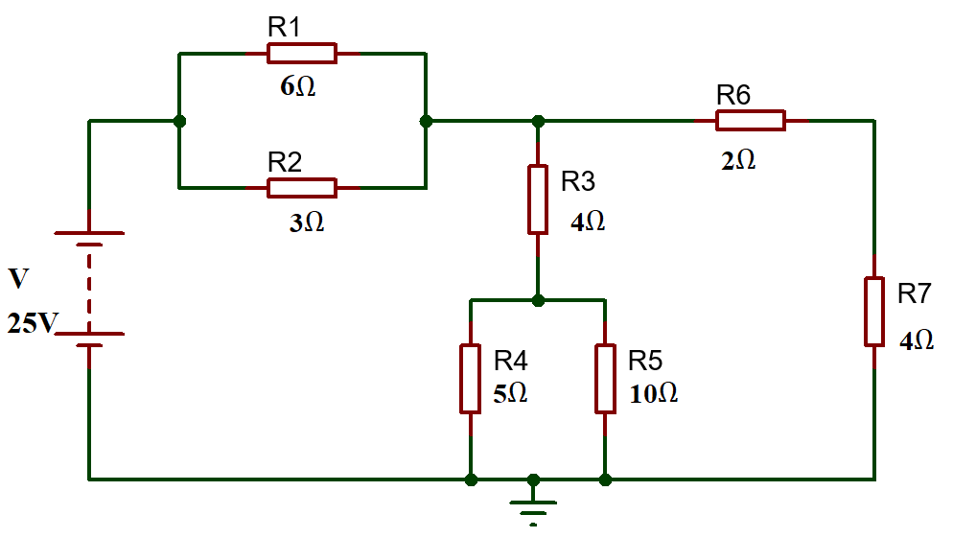
Fig: 1

Question 2 [25 Marks]
- Determine the current across each resistor in the circuit shown in fig.2, using mesh analysis (Kirchhoff’s Voltage Law) [17 Marks]
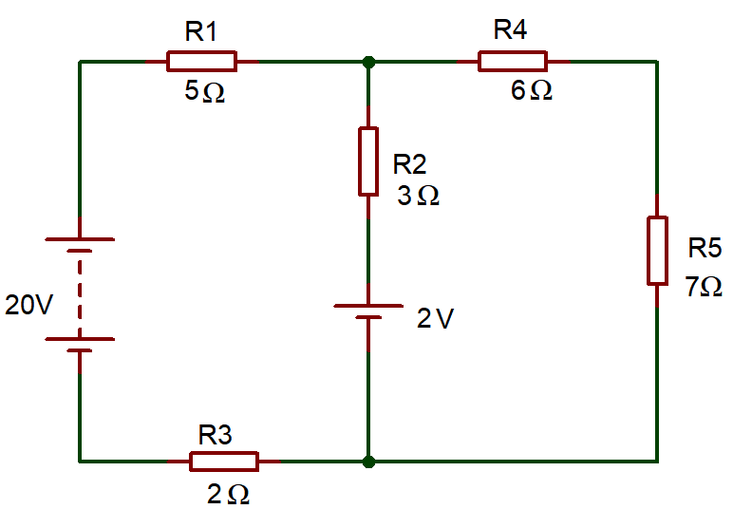
Fig.2
- Three resistors ($R_{A} R_{B} and R_{c})$are connected in series to a 200V Voltage Source. Where, $R_{c}=25Ω, V_{B}=50V and$Total current = 3A. Calculate the following
- Voltage across $R_{A}$ [2 Marks]
- Voltage across $R_{C}$ [2 Marks]
- Resistance value of $R_{A}$ and $R_{B}$ [4 Marks]
Question 3 [25 Marks]
- A power supply requires 80W of input power and produces an output power of 75W. Calculate its efficiency in percentage and the total power loss. [5 Marks]
- State Thevenin’s Theorem with the aid of Thevenin’s equivalent circuit. [5 Marks]
- The alternating current is given by $i=100 sin314t$. Determine the following
- Maximum Value of current [1 Mark]
- RMS Value of Current [2 Marks]
- Frequency [2 Marks]
- In the RL circuit shown in fig 3. Calculate the following.
- Inductive Reactance ($X_{L})$ [3 Marks]
- Impedance (Z) [3 Marks]
- Current across the circuit. [2 Marks]
- Phase angle [2 Marks]
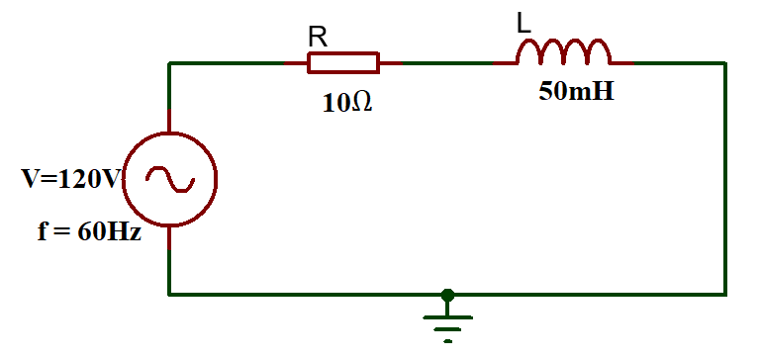
Fig. 3
Question 4 [25 Marks]
- Define the following terms
- Reactance [2 Marks]
- Impedance [2 Marks]
- Peak inverse Voltage [2 Marks]
- A sine wave is observed on a oscilloscope as shown in fig 4. The time setting is 10ms/div and voltage is 2V / div. Estimate the following.
- Peak Voltage [1 Mark]
- Peak to peak voltage [2 Marks]
- Time period of the waveform [2 Marks]
- Frequency [2 Marks]
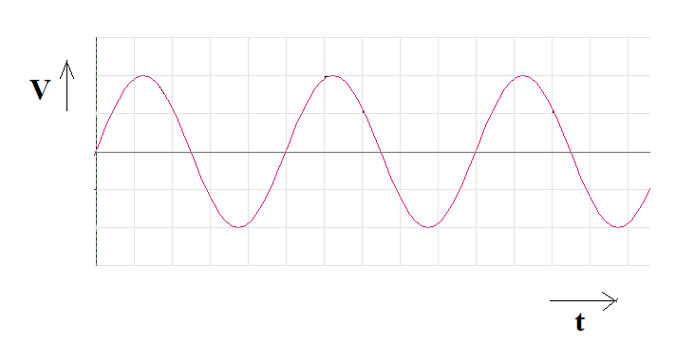
Fig.4
- A transformer steps up voltage from 110 V to 440 V. If the primary coil has 50 turns, how many turns does the secondary coil have? [4 Marks]
- List any two applications of Transistor. [2 Marks]
- What happens when a PN junction diode is forward biased? [6 Marks]

Diwedd/End

