

Module name: MANAGEMENT ACCOUNTING FOR MANAGERS
Module code: LCBB5010_LON
Module leader: Zainab Atta
Student name: Anamaria Fermesanu
Student ID nr: 1907760

TABLE OF CONTENTS

- Introduction..........................................................2
- Cost Analysis and Business Model......................3
- Budgeting and Financial Planning .....................5
- Performance Measurement and Decision-Making …………………………...…………….................7
- Sustainability and Ethical Considerations ...............................................................................10
- Conclusion and Recommendations....................11
- References ............................................................12


Figure 1. NVIDIA headquarters (2026)

1. Introduction
NVIDIA Corporation is a globally renowned technology company founded in 1993 that primarily deals with the production of graphics processing units (GPUs), artificial intelligence (AI) infrastructure, and high-performance computing solutions. Although NVIDIA Corporation primarily focused on producing gaming products, over time it has successfully rebranded itself as a leader in AI and data centre solutions that support various technologies such as cloud computing, machine learning, and autonomous systems (NVIDIA, 2026). This strategic shift has enabled NVIDIA Corporation to achieve tremendous financial results, with revenue exceeding $215 billion in fiscal year 2026 owing to the surge in AI-related products (Macrotrends, 2025; Statista, 2025).

It can be argued that management accounting assumes a critical role in enabling effective decision-making in any organisation through the provision of relevant financial and non-financial information to support effective planning, budgeting, and performance evaluation activities (Drury, 2018). However, in highly dynamic and technology-driven industries, these tools can be used to enable firms to adapt to uncertainties in the environment, optimise resource allocation, and sustain competitive advantage (Atrill & McLaney, 2019; Kaplan & Atkinson, 2015). Hence, the present report critically examines how NVIDIA uses management accounting to facilitate financial decision-making in a dynamic global environment.

2. Cost Analysis and Business Model

NVIDIA has a highly scalable and innovation-driven business model with the development and commercialization of cutting-edge semiconductor products. It has multiple segments through which it earns revenue, namely Data Centre, Gaming, Professional Visualization, and Automotive segments, with the Data Centre segment being the major revenue earner due to the rising demand for artificial intelligence and cloud computing in the global market (NVIDIA, 2026). This is a strategic shift for the company as it has transformed itself into a provider of basic infrastructure in the digital economy (Deloitte, 2024).

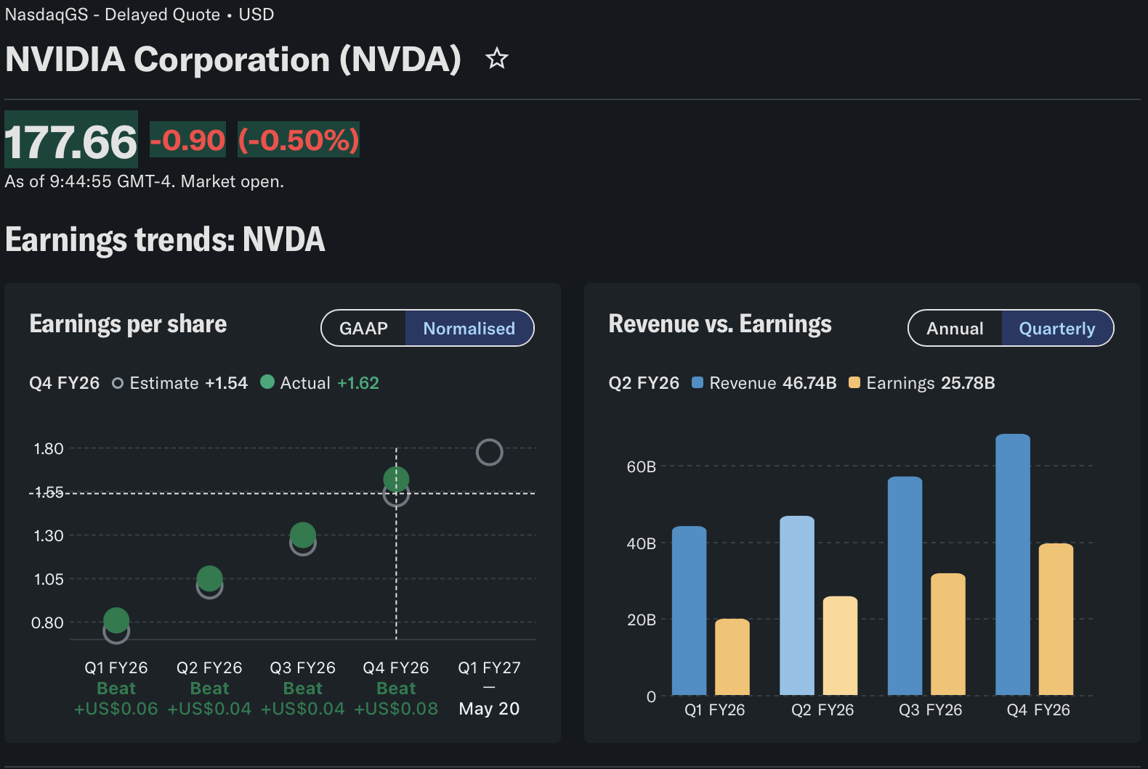

Figure 2: NVIDIA Revenue vs Earnings (2026) (Yahoo Finance 2026)

The revenue model of the company mainly depends on the sales of high-performance GPUs including the sale of the H100 and Blackwell chips, software-based solutions like CUDA enabling AI development and deployment. Besides, NVIDIA enjoys the strategic collaboration with key cloud service providers, which brings in recurring and ecosystem-based revenue streams (PwC, 2023). This revenue diversification system creates resilience and enables the company to take advantage of the new technology trends.
In terms of management accounting, it is essential to analyse the cost structure of NVIDIA to comprehend its profitability and strategic decisions. The firm has heavy fixed expenses especially concerning the research and development (R&D), employee wage and infrastructural investments. One of the reasons why NVIDIA has a high R&D investment is that it has invested in technology and ensures that it remains in the lead in a very competitive market (NVIDIA, 2026). Such expenses do not depend on the volume of production much and are the key to the long-term value creation (Kaplan and Atkinson, 2015).
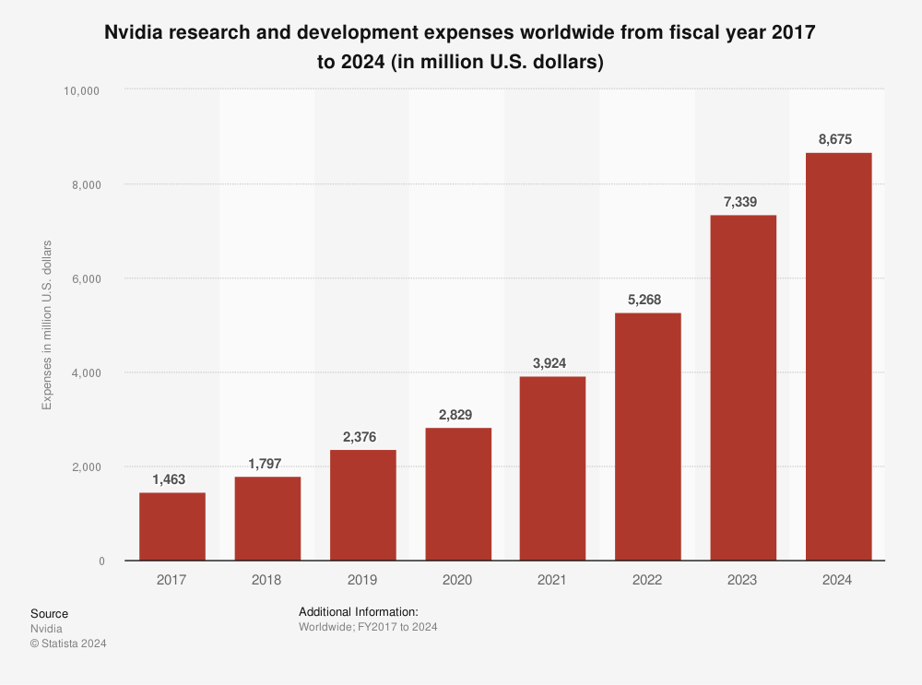 Figure 3: NVIDIA R&D Expenditure Trend (Macrotrends, 2025)

Conversely, the variable costs are directly linked to the level of production, which encompasses manufacturing costs, supplies and material costs. NVIDIA uses third-party contract manufacturers, including Taiwan Semiconductor Manufacturing Company (TSMC), which creates a cost variability according to the situation in the global supply chain (KPMG, 2023). These costs have risen because of the demand spurt of AI chips, but good pricing power and demand have enabled NVIDIA to ensure high contribution margins. The connection between variable and fixed costs is necessary to operate the cost-volume-profit (CVP) analysis, which is used to make prices, production, and investment decisions (Horngren et al., 2018). The capability of NVIDIA to utilize high fixed investment and scalable production indicates good cost control and helps in long-term profitability in the dynamic technological world.

3. Budgeting and Financial Planning
Budgeting is an essential aspect of management accounting, and it is an important tool that organisations use to plan their finances, coordinate and control their financial transactions in line with their strategic goals (Drury, 2018). Budgeting, especially in the context of NVIDIA, is important because the company is fast growing in the field of artificial intelligence (AI) and semiconductor industries, which are marked by high rates of uncertainty, technological disruption, and capital intensity. Consequently, NVIDIA is flexible and dynamic in its budgeting strategy, which allows management to react adequately to the changes in demand, innovation cycles, and changing market conditions (Atrill and McLaney, 2019).
An important purpose of budgeting is that it enables the performance analysis based on variance, i.e. comparing actual financial results with planned budgets to spot deviations and take amending managerial measures (Horngren et al., 2018). The financial performance of NVIDIA shows that operating expenses have increased significantly, with the figure increasing between 2024 and 2025 by more than 75 percent, with the operating expenses approximated to be 27.9 billion to over 49 billion (Macrotrends, 2025). This large variance demonstrates the size of the company growth and the necessity of flexible budgeting systems that will be able to keep up with a fast growth.

GAAP
($ in millions, except earnings per share) |  | Q4 FY26 |  |  | Q3 FY26 |  |  | Q4 FY25 |  |  | Q/Q |  | Y/Y
Revenue |  | $68,127 |  |  | $57,006 |  |  | $39,331 |  |  | 20 % |  | 73 %
Gross margin |  | 75.0 % |  |  | 73.4 % |  |  | 73.0 % |  |  | 1.6 pts |  | 2.0 pts
Operating expenses |  | $6,794 |  |  | $5,839 |  |  | $4,689 |  |  | 16 % |  | 45 %
Operating income |  | $44,299 |  |  | $36,010 |  |  | $24,034 |  |  | 23 % |  | 84 %
Net income |  | $42,960 |  |  | $31,910 |  |  | $22,091 |  |  | 35 % |  | 94 %
Diluted earnings per share |  | $1.76 |  |  | $1.30 |  |  | $0.89 |  |  | 35 % |  | 98 %
Non-GAAP
($ in millions, except earnings per share) |  | Q4 FY26 |  |  | Q3 FY26 |  |  | Q4 FY25 |  |  | Q/Q |  | Y/Y
Revenue |  | $68,127 |  |  | $57,006 |  |  | $39,331 |  |  | 20 % |  | 73 %
Gross margin |  | 75.2 % |  |  | 73.6 % |  |  | 73.5 % |  |  | 1.6 pts |  | 1.7 pts
Operating expenses |  | $5,102 |  |  | $4,215 |  |  | $3,378 |  |  | 21 % |  | 51 %
Operating income |  | $46,107 |  |  | $37,752 |  |  | $25,516 |  |  | 22 % |  | 81 %
Net income |  | $39,552 |  |  | $31,767 |  |  | $22,066 |  |  | 25 % |  | 79 %
Diluted earnings per share |  | $1.62 |  |  | $1.30 |  |  | $0.89 |  |  | 25 % |  | 82 %

Figure 4: NVIDIA Operating Expenses Growth (Nvidia 2026)

On an internal level, it is possible to note that the growth of operating costs can be attributed in large part to strategic managerial decisions that are geared towards maintaining long term competitive advantage. To facilitate the next generation AI technologies, NVIDIA has put in place more substantive investment in research and development (R&D), infrastructure, and human capital (NVIDIA, 2026). Specialised engineering skills, sophisticated chip design, and capacity of data centres are a strategic focus on innovation and scale. These choices are in line with the requirements of strategic budgeting, which focuses more on the creation of long-term value than short-term cost reduction (Kaplan and Atkinson, 2015).
In addition, there has been an increase in administrative and marketing expenses with the growth of NVIDIA in terms of its operational abilities such as global alliances and ecosystem building. The investments contribute to the growth of revenues and penetration of the market, which strengthens the dominance of the company in the AI industry. In management accounting terms, this proves the correspondence of budgeting processes with the organisational strategy, which guarantees that the financial resources are distributed to the areas, which yield the greatest output (Drury, 2018).
Macroeconomic and industry specific influences have also contributed greatly towards the cost structure of NVIDIA, externally. The volume of demand on AI technologies in the world has increased competition in the semiconductor manufacturing capacity, especially among semiconductor foundries like TSMC, which resulted in higher production costs (PwC, 2023). Also, supply chain issues, geopolitical unrest, and inflationary forces have also impacted the escalating prices in the technology industry (Deloitte, 2024; KPMG, 2023). Such external uncertainties enhance the need to embrace flexible and adapting budgetary structures. Compared to the fixed budgeting, flexible budgeting helps organisations to be able to change the financial plans according to the changes in the level of activities and external condition, thus enhancing the effectiveness of the performance evaluation and decision-making (Atrill and McLaney, 2019). The successful implementation of this strategy in NVIDIA is evidenced by its capability to keep revising forecasts and redistribute resources. Through a combination of financial and non-financial information in the budgeting procedure, the firm would be able to ensure high profitability as well as controlling cost increase in a turbulent environment. The NVIDIA budgeting and financial planning, in general, is evidence of an advanced and highly integrated process, which entails an internal focus on investment priorities and an external analysis of the market. This helps the organisation to counteract the speedy technological change, maximize the distribution of resources, and maintain sustainable competitive advantage in the global semiconductor market (Horngren et al., 2018).

4. Performance Measurement and Decision-Making
Management accounting's performance measurement function allows organisations to assess operational, financial and strategic performance through key performance indicators (KPIs) (Merchant and Van der Stede, 2017). In the high-tech sectors such as semiconductors and artificial intelligence (AI), performance measurement systems need to incorporate both financial and non-financial indicators to offer a comprehensive assessment of performance (Simons, 2000). NVIDIA employs this type of approach, utilising a range of KPIs to enable data-driven decision making and sustain its competitive edge. A critical financial KPI for NVIDIA is revenue growth, which is influenced by its capacity to leverage the growing market for AI and data centre products. Financial reports show that NVIDIA has enjoyed significant revenue growth over the past few years, largely due to its AI-centric product offerings (Financial Times, 2026). This key performance indicator guides decisions about market growth and infrastructure investments. Net profit margin is another key financial KPI that measures the overall profitability of the business after deducting all costs. NVIDIA's high margins reflect its capacity to create value with its high-end products and cost management (Morningstar, 2026).

NVIDIA CORPORATION
CONDENSED CONSOLIDATED STATEMENTS OF INCOME
(In millions, except per share data)
(Unaudited)
 |  |  | Three Months Ended |  |  |  |  |  |  |  | Twelve Months Ended
 |  |  | January 25, |  |  |  | January 26, |  |  |  | January 25, |  |  |  | January 26,
 |  |  |  | 2026 |  |  |  | 2025 |  |  |  | 2026 |  |  |  | 2025
Revenue |  |  | $ | 68,127 |  |  | $ | 39,331 |  |  | $ | 215,938 |  |  | $ | 130,497
Cost of revenue |  |  |  | 17,034 |  |  |  | 10,608 |  |  |  | 62,475 |  |  |  | 32,639
Gross profit |  |  |  | 51,093 |  |  |  | 28,723 |  |  |  | 153,463 |  |  |  | 97,858
Operating expenses
 | Research and development |  |  | 5,512 |  |  |  | 3,714 |  |  |  | 18,497 |  |  |  | 12,914
 | Sales, general and administrative |  |  | 1,282 |  |  |  | 975 |  |  |  | 4,579 |  |  |  | 3,491
 |  | Total operating expenses |  | 6,794 |  |  |  | 4,689 |  |  |  | 23,076 |  |  |  | 16,405
Operating income |  |  |  | 44,299 |  |  |  | 24,034 |  |  |  | 130,387 |  |  |  | 81,453
 | Interest income |  |  | 568 |  |  |  | 511 |  |  |  | 2,300 |  |  |  | 1,786
 | Interest expense |  |  | (74 | ) |  |  | (61 | ) |  |  | (259 | ) |  |  | (247 | )
 | Other income, net |  |  | 5,604 |  |  |  | 733 |  |  |  | 9,022 |  |  |  | 1,034
 |  | Total other income, net |  | 6,098 |  |  |  | 1,183 |  |  |  | 11,063 |  |  |  | 2,573
Income before income tax |  |  |  | 50,397 |  |  |  | 25,217 |  |  |  | 141,450 |  |  |  | 84,026
Income tax expense |  |  |  | 7,437 |  |  |  | 3,126 |  |  |  | 21,383 |  |  |  | 11,146
Net income |  |  | $ | 42,960 |  |  | $ | 22,091 |  |  | $ | 120,067 |  |  | $ | 72,880
Net income per share:
 | Basic |  | $ | 1.77 |  |  | $ | 0.90 |  |  | $ | 4.93 |  |  | $ | 2.97
 | Diluted |  | $ | 1.76 |  |  | $ | 0.89 |  |  | $ | 4.90 |  |  | $ | 2.94
Weighted average shares used in per share computation:
 | Basic |  |  | 24,304 |  |  |  | 24,489 |  |  |  | 24,359 |  |  |  | 24,555
 | Diluted |  |  | 24,432 |  |  |  | 24,706 |  |  |  | 24,514 |  |  |  | 24,804

Another important KPI is return on invested capital (ROIC), which assesses the company's efficiency in using its capital to make profits. A high ROIC reflects sound investment strategies and facilitates value creation over time (Damodaran, 2012). This is especially important for NVIDIA, which invests heavily in research and development and in capital-intensive facilities. Furthermore, cash flow from operations is a vital financial KPI that measures the company's capacity to generate cash to support operations and future growth (Penman, 2013).
Beyond financial metrics, NVIDIA uses non-financial KPIs to evaluate its business strategy. A primary measure is innovation metrics, such as the creation of new chip architectures and advances in AI technologies. Innovation allows NVIDIA to stay ahead in a fiercely competitive environment (Schilling, 2020). Another significant non-financial KPI is ecosystem and customer growth, especially with collaborations with cloud companies, enabling long-term growth and market expansion (Financial Times, 2026).
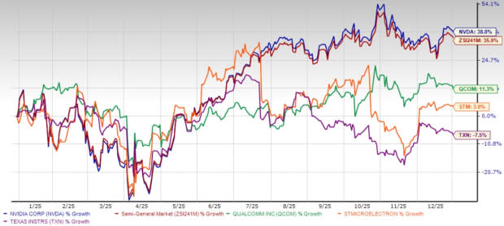
Figure 5: NVIDIA Stock Price Performance (Yahoo Finance, 2026)
The stock price performance in Figure 5 is an indicator of investor confidence, and an external success factor for the organisation, as it is a measure of the market's view of NVIDIA's performance (Morningstar, 2026).
These KPIs guide NVIDIA's strategic planning. For instance, the company has been emboldened to invest in its AI strategy and invest in new technologies by its strong revenue growth and returns on capital. Likewise, profitability has allowed for higher pricing, enabling NVIDIA to extract value while remaining competitive. Also, cash flow has allowed the company to invest in research and development and expand worldwide.
From a management accounting viewpoint, NVIDIA's combination of financial and non-financial KPIs demonstrates a holistic and integrated view of performance management. This ensures that financial performance in the short term is aligned with the company's long-term success, allowing it to continue to grow and adapt to the ever-changing technological environment (Simons, 2000).

5. Sustainability and Ethical Considerations

Sustainability has emerged as a critical factor in financial decision-making, especially in technology-driven sectors with high energy demands and globalised supply chains. NVIDIA incorporates sustainability into its financial decision-making through environmental, social and governance (ESG) factors, which impact investment and operations (Eccles and Klimenko, 2019). NVIDIA prioritises energy-efficient solutions, specifically GPUs that offer superior computational capability at lower energy costs, leading to cost efficiency and sustainability (NVIDIA, 2026).

In terms of management accounting, sustainability is integrated using non-financial performance measures, allowing organisations to consider environmental sustainability alongside financial performance (Burritt and Schaltegger, 2014). NVIDIA's commitment to energy-efficient data centre technologies not only aligns with sustainability goals but also drives cost savings over time, reflecting the link between environmental strategies and cost management. Moreover, the incorporation of ESG metrics into financial planning reflects a transition towards sustainable value creation, in which companies prioritise long-term stakeholder interests over short-term profits (Unerman et al., 2018). But there are ethical implications in cost management and pricing. NVIDIA's high-end pricing strategy, especially for its cutting-edge AI chips, has resulted in remarkably high profit margins. While economically rational due to innovation and market competitiveness, such pricing strategies could potentially limit accessibility and fairness for smaller businesses and less developed markets (Stiglitz, 2019). This raises questions about profit motive versus ethical considerations in concentrated technology markets.

Furthermore, NVIDIA's use of outsourcing raises ethical concerns around transparency and working conditions. The semiconductor industry has intricated global supply chains, which may pose ethical risks such as poor labour practices or environmental degradation (Gereffi, 2018). Consequently, NVIDIA needs to ensure that its suppliers comply with rigorous ethical and environmental standards to avoid reputational and financial risks. In conclusion, NVIDIA is committed to incorporating sustainability into its financial strategies, especially through energy-efficient product development and ESG strategies. But there are ethical considerations around pricing and supply chains that need to be addressed. Striking a balance between profits and purpose is crucial for long-term stakeholder engagement and ensuring a sustainable competitive edge in the global technology sector (Eccles and Klimenko, 2019).

6. Conclusion and Recommendations
In conclusion, this report has demonstrated how NVIDIA effectively uses management accounting techniques and procedures to guide financial decision-making in a quickly evolving, technology-focused sector. The paper has shown how the company's business strategy, which is centred on AI and data centre solutions, is supported by a cost structure that consists of low variable manufacturing costs and high fixed expenses for research and development. Furthermore, it has been shown that financial planning and budgeting play a crucial part in managing growth, and flexible budgets enable the business to respond to both internal and external market demands. Adopting both financial and non-financial Key Performance Indicators (KPIs) makes decision-making easier by enabling the integration of long-term strategic objectives with operational goals.
Considering these observations, it is recommended that NVIDIA keep refining its flexible budgeting strategies to address market unpredictability in AI. To promote value generation, the business should keep integrating sustainability indicators into its management accounting system. Lastly, to gain a sustained competitive advantage, increasing the transparency of its global supply chain would promote good governance and foster stakeholder confidence.

7.References

Atrill, P. and McLaney, E. (2019) Accounting and finance for non-specialists. 11th edn. Harlow: Pearson.
Burritt, R. and Schaltegger, S. (2014) ‘Sustainability accounting and reporting: fad or trend?’, Accounting, Auditing & Accountability Journal, 27(2), pp. 195–215.
Deloitte (2024) Technology industry outlook 2024: Navigating growth and innovation in the digital era. Available at: https://www2.deloitte.com (Accessed: 19 March 2026).
Drury, C. (2018) Management and cost accounting. 10th edn. Andover: Cengage Learning.
Eccles, R.G. and Klimenko, S. (2019) ‘The investor revolution’, Harvard Business Review, 97(3), pp. 106–116.
Financial Times (2026) NVIDIA financial performance and market growth. Available at: https://www.ft.com(Accessed: 19 March 2026).
Gereffi, G. (2018) Global value chains and development: Redefining the contours of 21st century capitalism. Cambridge: Cambridge University Press.
Horngren, C.T., Datar, S.M. and Rajan, M.V. (2018) Cost accounting: A managerial emphasis. 16th edn. Harlow: Pearson.
Kaplan, R.S. and Atkinson, A.A. (2015) Advanced management accounting. 3rd edn. Harlow: Pearson.
KPMG (2023) AI and business strategy: The future of artificial intelligence in global markets. Available at: https://home.kpmg (Accessed: 19 March 2026).
Macrotrends (2025a) NVIDIA revenue 2010–2026. Available at: https://www.macrotrends.net/stocks/charts/NVDA/nvidia/revenue (Accessed: 19 March 2026).
Macrotrends (2025b) NVIDIA operating expenses 2010–2026. Available at: https://www.macrotrends.net/stocks/charts/NVDA/nvidia/operating-expenses (Accessed: 19 March 2026).
Merchant, K.A. and Van der Stede, W.A. (2017) Management control systems. 4th edn. Harlow: Pearson.
Morningstar (2026) NVIDIA financial data and stock performance. Available at: https://www.morningstar.com(Accessed: 19 March 2026).
NVIDIA (2026a) NVIDIA announces financial results for fourth quarter and fiscal 2026. Available at: https://nvidianews.nvidia.com (Accessed: 19 March 2026).
NVIDIA (2026b) NVIDIA annual report 2026. Available at: https://www.nvidia.com/en-us/investor-relations/(Accessed: 19 March 2026).
NVIDIA (2026c) Corporate sustainability report. Available at: https://www.nvidia.com/en-us/about-nvidia/corporate-responsibility/ (Accessed: 19 March 2026).
Penman, S.H. (2013) Financial statement analysis and security valuation. 5th edn. New York: McGraw-Hill.
PwC (2023) Global semiconductor industry outlook. Available at: https://www.pwc.com (Accessed: 19 March 2026).
Schilling, M.A. (2020) Strategic management of technological innovation. 6th edn. New York: McGraw-Hill.
Simons, R. (2000) Performance measurement and control systems for implementing strategy. Upper Saddle River: Prentice Hall.
Statista (2025) NVIDIA revenue by segment and market data. Available at: https://www.statista.com (Accessed: 19 March 2026).
StockAnalysis (2026) NVIDIA revenue breakdown by segment. Available at: https://stockanalysis.com/stocks/nvda/revenue/ (Accessed: 19 March 2026).
Yahoo Finance (2026) NVIDIA Corporation (NVDA) financial data. Available at: https://finance.yahoo.com/quote/NVDA/ (Accessed: 19 March 2026).

