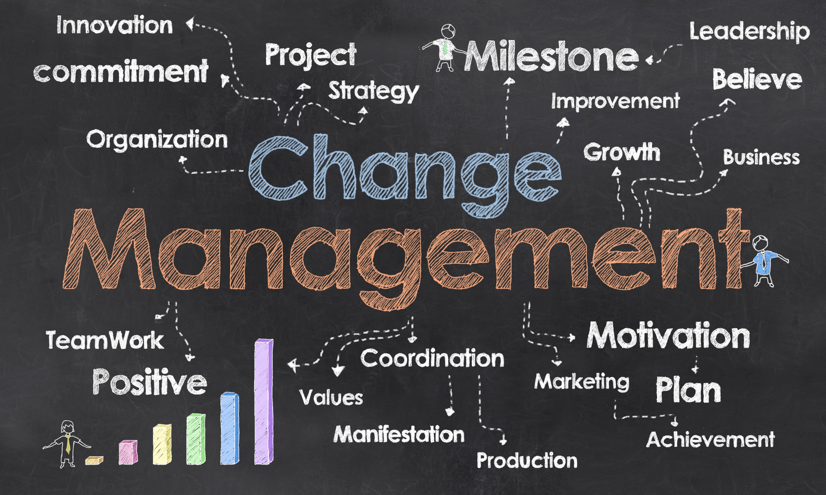  The change management within Nestle organisation | Cristina-Andreea Grasu (1814440)  BMSW 6103 Leading and implementing workplace change

Executive summary

The purpose of the report was to identify how companies implement and develop changes within their workplace. The writer decides to talk about Nestle which is considered one of the largest companies of food and beverages. The report is divided in different section where the writer critically analysed an examinate how Nestle is implementing the change , what type of change the organization is major focus on and what is the purpose of it. In fact ,Nestle based on the main findings of the writer , is major focusing the attention on the digitalization of the company with the purpose to obtain more information and data about customers values , beliefs and attitudes. The company has an inclusive culture type where everyone is treated with equality , motivation, and training to implement the change with success. Overall, as it will be possible to identify in the main findings , every change implemented by the company in the past and in the last two years had an efficient success by further help the business expand itself and growth it profits. On the other side ,behind the implementation of the change are the leaders of Nestle that are looking for strategies and plans in order to ensure employees that before implementing any changes they have the opportunity to provide feedback regarding their thought about the changes and based on the results , Nestle will then try to make their employees understand and have a clear picture of the aim and the necessity of that change. Moreover , the report include different types of models such as Lewin Model of Change , Charles Handy Model of Culture , such as definition of change and leadership. The report will end with conclusion and an overview around the organization as well as further recommendation made by the writer with the purpose to provide ideas for the company that they may need to adopt.

Contents Page

Executive summary 1
Contents Page 2
1.0 Introduction 3
2.0 2.0 Procedure 2.1 Background information on the organization 4
2.2 Reason of implementing change inside the organisation 6
2.3 Change Models used by the organisation 9
2.4 Leadership 10
2.5 Change Agents 12
2.6 Culture 13
3.0 Conclusion …………………………….. …………………………………………14 4.0 Recommendation………………………………….…………………………………..14
5.0 Appendix 15
6.0 Reference List 15

Introduction
The purpose of the report was to identify how Nestle is implementing changes around the organization and what strategies and plans are the leaders of the company using to succeed in this process.
The writer found out that Nestle is considered one of the largest company of food and beverages worldwide and their purpose is to always look after innovation and opportunities that can be implemented within organization with the purpose to further help with the growth and profit of the company. In the first part of the report will be possible to discover the reason of digital change around the company and the need of it to be implemented. In fact the writer sustains that the purpose of the change was to help the company to further customize customer needs in order to meet their expectation around what type of products they are looking for.
The writer used different tool to identify how Nestle implement the change inside the company in fact the major change that the company is looking at the moment is the digitalization of the IT system and to identify the way they implemented this change the writer used the Lewin three steps of change process and she found out that to further help employees to adapt themselves to the new changes the company has a team called DAT which is a group of people with the right skills and knowledge that has the responsibilities to further train other people inside the company to understand the need of change. Also, the writer identified the culture that the company is using, and she used the Charles Handy model of culture and discovered that Nestle has an inclusive type of culture which shows that the company values employees and motivate them by offering the opportunity of growth and self-development through training. Further in the last part of the report there is the conclusion and few recommendations provided by the writer which had the purpose to highlight the importance of the change that Nestle made within the company and further she suggested few recommendations that the company should be aware of when implementing new changes.

2.0 Procedure
2.1 Background information on the organization
The history of Nestlé organization begins in 1866 with the foundation of the Anglo-Swiss Condensed Milk Company when actually ,the cofounder of the company Henri Nestlé developed a new formula of infant food and together with Anglo-Swiss ,today it is recognised as Nestle Group. The company purpose for over 150 years was to build a Nutrition , Health and Wellness with the aim of helping people living a healthier life. All the company objectives cover many internal and external changes in terms of managing and implementing transformations within the organization. (Nestle History ,2020 )According to the 2019 Forbes Global 2000 list Nestlé is the world’s largest food company being on top seat of the industry with its frozen staples sales such as Hot Pockets, Stouffer’s and DiGiorno along with coffee brands ,and water sector ,products that made Nestle having a profit of almost $13 billion in 2019. (Sorvino, 2020)
Based on researcher of literature undertake by the write Nestle company stands behind its approach of managing and implementing changes , methods and decision taken by its leaders regarding the change management strategies to be put in place with the aspiration of making people’s life healthier. A few changes that have taken place over the years and have benefited the organization according to the writer research are: when the family that controlled the French cosmetic L’Oréal invited Nestle in 1974 to take an indirect holding in the firm, change that in 2004 made Nestle having 30% of L’ Oreal’s shares directly. (Economist, 2009) Also , Nestle acquired Alcon pharmaceutical laboratories in 1977 for USD 280 million and over the years Nestle supported the Alcon’s R&D drive and international expansion , fact that bring to the company noticeable profit as Nestle took into account the three steps of the gradual divestment of Alcon such as IPO of 23.2% in 2002 , sales 24.8% in 2008 and the sale of Nestle’s remaining Alcon shares to Novartis for $11 billion , a deal made by Nestle with the purpose of growing its core business. (Nestle Global , 2010). Being consider one of the largest foods and beverages company Nestle had many changes during its administration. The most recent and still in expansion is the IT sector from were the company based on the data and information provide good food quality to customers and stakeholders to meet Nestle principle which is make people to life a healthier life. From where the digitalization of the company that permit to the business to compete with its rivals from the food market.
According to Christoph M. and Luca B. Nestle in 2018 planned to re-organize parts of its IT activities to benefits from its current technology hub in different countries and locations. This change aim has been to accelerate Nestle’s digital transformation with the purpose to act more quickly to fast-paced technological changes that are very competitive worldwide. These plans , before taking place are, first part of discussion with company employees that can share their thoughts and concerns through comments and feedback , process that happened every time a change needs to take place and , based on the feedback the change will happen with mitigation and support to make employees understand and see the need of change inside the company. Because Peter V, head of HR member of Nestle Executive Board says that Nestle commitment is to treat everyone with respect and appreciation. (Meier and Borlini, 2018 ) In fact , according to Nestle annual report (2019) digitalization is vital for business evaluation because covers business aspects with regarding the way they operate internally and external also helping the company to create values that will generate business growth and opportunities as well as customers satisfaction.(Nestle Global , 2019) Despite all this changes around the company regarding the digitalization , Nestle profit did not stop to grow in fact in 2020 despite the pandemic the company reached 2.8% organic growth with internal growth of 2.6% and pricing of 0.2%. Earnings per share increased by 22,2% ,free cash flow decreased by 19.1% to CHF 3.3 billion due to a delayed payment from an associate company and lower reported sales but even though , the company completed the sale of a 60% stake in the Herta charcuterie business to Casa Tarradellas. According to the writer during the pandemic the company has developed solutions to meet increased demand for at home consumption based on product that support health and boost the immune system as well as affordable offerings. At the same time, during COVID 19 the company accelerated the development of its digital capabilities and expanded e-commerce and online communication. In fact, the e-commerce sales grew but 48.9% reaching 12.4% of total Group sales and the net profit and earning per share grew by 18.3% to CHF 5.9 billion.(Nestle report, 2020)

2.2 Reason of implementing change inside the organisation
According to the writer , the reason of implementing change inside the organization conceals many positive aspects that will provide the company more opportunities and growth in the market also will inspire innovation ,improve skills and developing employees. On the other side implementing changes can generate negative aspects as when a change needs to take place will remove everyone internal and external from their comfort zones such as attitudes ,beliefs and values that they already been used to. Further, to make a change successful business needs to look after strategies and way of communicating the change and being transparent in transmit exactly the purpose of the change and why it is necessary to be done. (McCullough, 2019)
According to Markus Wanner: “Change management is an organized, systematic application of the knowledge, tools, and resources of change that provides organizations with a key process to achieve their business strategy.” (Wanner,2013)
Based on the writer researches the reasons of developing and implementing changes such as service ecosystem, network of e-content studios and digital platforms and programmatic media buying platforms around digitalization area inside Nestle is based on many principles and objectives. As Nestle aim is to create products that are right for the customers, the company is looking for solutions that can be accessed on demand and effortlessly integrate into customers lives because nowadays people are pressed for time , digitally engaged and health-conscious and their expectation is to receive communication with recommendation around “fit-for-me” products. To succeed in this area Nestle is focusing its efforts into the digitalization of the company and the reasons behind it are to better understand and engage ,create value with consumers and customers , scaling growth in e-commerce , transparency and traceability along their supply chains ,decide freely when and how to develop new abilities and changes in order to meet public expectations, understanding the efficiency of each brand interaction by improving resource allocation and capture information and data that can be used to optimize channel strategies in real time.(Nestle digitalization ,2020) In fact in 2019 because of this changes that Nestle has been working through different years and is still in progress , the e-commerce sales grew by 18.5% to account for 8.5% of total sales which established Nestle at the leading edge of the food and beverage industry thanks to the fact that the company communications are connected with consumers in a relevant and personalized way. At the same time, the company is also renovating operation by further digitalizing its supply chain and manufacturing and the goal is to create a competitive advantage through data , artificial intelligence automation and predictive analytics. For example, at the end of 2019 , 100 of Nestle factories were equipped with “collaborative robots” that interact with humans working safely in proximity. (Investigate.co.uk ,2020)
The digital transformation inside a company is a process of transition undergone by administrative management and corporations in which they rely on a work paradigm based only on digital techniques. The purpose of implementing changes around the digital sectors of a business, in this case Nestle, is the need of innovation of services and products to establish new channels , increasing the commercial value of the products and the elevation of the shopping patterns by creating an electronic network between customers and suppliers with the aim to have a better understating of the external expectation of consumers and clients. (Yassine, Diab and Hadad, 2021)
The type of change that the company is using is called transformational change. The transformational change “leads to alterations in certain areas which is cause due to an interaction with the environmental factors and create a need for new behaviours or changes in the behaviours of the organizational employees.”(Management guide ,n.d) According to the writer this change brings advantages and disadvantages around the organization such as :
ADVANTAGES OF TRANSFORMATIONAL CHANGE | DISADVANTAGES OF TRANFORMATIONAL CHANGES
- keeps the company open , honest, and ethical ;  -it reduces turnover costs;  -it encourages change ;  - motivate and help employees to further develop their skills and capabilities;  help he business to keep its changes up to date and match the external expectation ;  help the company to keep its position on the market by being able to compete with other companies; | - too much focus on the bigger picture and forgot about the other changes that must be implemented of areas of the business that requires change;  -it can be risky and disruptive because if the change is not implemented with efficiency can have a negative impact on employees’ life;  -it can increase pressure on team members ;  - it needs a continual communication ;

To better understand the advantages and disadvantages of the digital change inside Nestle the writer conduct a SWOT and PESTLE analysis.
According to the writer the changes that Nestle is undertaking regarding the IT area of the company can be categorized as a strength because will help the company to build a strong relationship with the customers by understanding exactly their expectation and implementing and manage the change into that area to satisfy their needs and at the same time will be an advantage on the business profit plan. On the other side being focused and implementing changes around one area only such as the digital transformation can affect other sectors of the company. For example, being concentrated in implementing the artificial intelligence around supply chain and manufacturing it can be a weakness because machines and robots are programmed by humans and their capacity in doing their job is based on the settings made by people and therefore is better to train employees to develop their knowledge to implement the changes and make it successful.(Marr, 2020) Further, the opportunities that the digital transformation is giving to a business is the data and information of people’s values , beliefs and attitudes aspects that will help a company to focus its sales on that kind of products knowing that the major sales and profit will rise and will help with the growth of the business. Moreover , with the PESTLE analysis the writer will highlight how this changes inside Nestle can be affected by political , economic ,social , legal environments. Being one of the largest company that operates in different countries worldwide ,with employees , suppliers and stakeholders that have different cultures beliefs values and attitudes , the digitalization in certain countries can be affected by the laws and the way that each state is relating with its citizens in advertising certain products. At the same time , economically and technological the implementation of the digitalization around Nestle’s stores worldwide can have different costs that it may be hire that the profits. On the other side with the legal and environmental factors , Nestle needs to be aware of the data protection , policies and practices and implementing its changes aligned with each country regulations in order to ensure its profits and avoid scandals.

2.3 Change Models used by the organisation
According to the write a change inside an organisation needs to be implemented by steps to avoid the resistance of accepting the needs of it. It is important for the leaders and managers understand the requirement of implementing changes and build up strategies to further communicate and transmit and implement the change with success around employees , customers, and suppliers. (Johnston, Lefort and Tesvic, 2017)Creating a company as Nestle that is based on the latest technologies it is a difficult process that needs effort and methods that will help implemented the change around the organization with success. There are different change models that can help with the implementation of change and one of these is the Lewin Three step change process.
According to Lewin to implement a change successful it needs time to make people accept that change and understand the requirement of it. In fact, Lewin is saying that if change is implemented by force and people are feeling pushed to change ,this will increase the tension and if this rises beyond a certain level will result in an aggressiveness that will affect communication and relationship. His change model is based on three steps: unfreezing which involves the awareness of why a change needs to take please , moving which is the second phase where people will start changing their behaviour regarding the new changes that needs to take place and will start adjusting attitudes and beliefs, and the last step which is refreezing implicates the reinforcement of the new behaviours to maintain the new levels of performance and avoid regression. (Hayes, 2018)To prepare its employees to embrace the need of digitalization inside the company and understating the benefit of those changes , Nestle created a digital acceleration team called DAT to encourage a culture of social networking within the company. This team was created with the purpose to provide to Nestle’s employees and adequate training to acknowledge them with the right skills to handle the digital change of the company. (Morphy, 2018) The second purpose of the team is to experiment with exciting digital trendsetter to find new approaches. This team has twelve members that always set in front of the screens that showcase current data trends , factors that will make the company to be ready around new changes and help employees and customers to embrace that new change. To further transmit this change to the customers , the company incorporate QR codes on candy bars as way of mixing the new approach with the old , to determinate when to go with traditional vs digital media by observing the approach and customer behaviours regarding the change. But in the same time the company knows that mixing the traditional world with the digital transformation will keep its older customers and will create a new generation registering profit from both sides. (Centricdigital.com. 2016.)

2.4 Leadership – Management of Complex Areas
To implement changes around an organisation , the leadership style of a company plays an important role into getting this process applicable with success. According to the writer , “Leadership is that process in which one person sets the purpose or direction for one or more other persons and get them to move along together with him or her and with each other in that direction with competence and full commitment” Jacques and Clement ,(1994) According to the former CEO and current chair of Nestle, Paul Bulcke says that “There is no single type of leadership. How someone leads will be personal to them. It will be shaped by the company and by the role they are in.” Paul Bulcke (2020) The leader role that he is using around Nestle company is comprehensive leadership style because he thinks that it is essential to trust the people inside the company and build a capable team that can be trustable and capable to effectively lead every little change which is required into the organisation. Leadership around Nestle is based on inspiration ,motivation , action, and energy. To implement the changes successful inside Nestle and make everyone embrace it positively Nestle has his approach based on three principles: (Bulcke, 2020)
Safety first – secure the safety of its people first.
Maintaining activity – regional team trained to adapt and implement the changes that match the local situation of a country.
Solidarity with the local community – which is one of the core values of the company that includes everyone internal and external. (Bulcke, 2020)
On the other side , even if the company has a comprehensive leadership style , the leaders to well implement the changes around different areas of the organization are always trying to improve communication processes and training to ensure the devotion to the Nestle Corporate Business Principles and to correct the gaps whenever necessary with zero tolerance for cases of non-compliance because the company expect that trade partners and employees adhere to business principles and if there is anything that they do not agree with , they should have a transparent way of communicate those issues. Internal the company is trying to inspire ,innovate be transparent and work in an open environment to make everyone feel respected and free to express themselves to help them further understand and resolve their queries to ensure the continuous evolution. External, the purpose of Nestle is to unlock the power of quality of life for everyone ,and to carry out responsible stakeholder engagement to bring relevant collaboration and knowledge sharing. Base of the writer research , even of Nestle try to implement changes around the IT system of the business the organisation will avoid using data and technology in ways that are unethical or could lead to discrimination among its employees and stakeholders. (Corporate Business Principles, 2020)
According to Aga Swiatowa the responsible for time management IT systems at Nestle she says that to further implement a digital change inside the organised there is the need of a sustainment strategy to implement the change with success. In fact, to adapt to these digital changes Nestle has a big transformation program behind HR space because their teams need first to understand the future changes that are taking place in the world to then be able to support business evolution. (Sexton-Brown, 2018) Also, the company is offering a self-service mode where they can communicate and share information about the business, and at the same time they are putting more feature on mobile such as the employee central app and success factors of the company. In other words , the digitalization in the hiring process provides a great deal because when employees are hired the database has already their CV and it takes details from their CV filled in, into pre-set forms by the company and employees can fill the rest of it making their life easier thank to the use of digitalization. (Pratt, 2019)

2.5 Change Agents
When is about change every organization requires one or more change agents , a change agent are those people that have the skills and power to stimulate , facilitate and coordinate change effort. Those agents can be external or internal such as managers, employees, or consultants. According to Fred C. Lunenburg usually organization then to hire external agents because they are not influenced by the culture , values, and beliefs of the company and therefore they will be able to implement the change with success. At the same time having external agents can be a disadvantage as they may have a lack an understanding the company history and operating methods. (Lunenburg ,2010)
According to the writer , even if Nestle is trying to make changes around the digital area of the company , the purpose of it is to help the business growth because Nestle objectives are based on people , products and brand and what they are trying do to with the digitalization inside the company is to serve customer better ,to understand them and what change they need to make inside the company in order to supply them with their preferences and meet their expectations ,and the only why to do it right is to implement changes around the digital system of the company in order to gather as much data as possible. (Wetlaufer, 2001) As it possible to identify to support the change, leaders, and managers of Nestle created a team called DAT with people trained to support employees around the digitalization of the company. Because what is important when changes around digitalization occur is to further invest in new capabilities and make sure that employees develop the right skills and knowledge by understanding the need of it and have a clear picture of what will improve when they get there. Furthermore , digital transformation for many employees involves moving out of the comfort zone but to embrace it successfully it is important to give employees the changes to get involved in using it to understand exactly how it works and it is exactly what the team of Nestle DAT does. (Newman, 2017) Usually change agents are internal and external , what Nestle does is to train his own people and place them in a group to create a team to further transmit the change with successful to the rest of the employees of the company. In this case Nestle is using internal agents ,where internal change agents are continuously involved in the change process because the team called DAT of the company have the role to introduce the changes need step by step and motivate employees to avoid their resistance. (Change Agent,n.d.)

2.6 Culture
Nestle culture is based on diversity and inclusion and is one of the ways through which they bring purpose and values to customers life. Nestle values are, respect to ourselves , for each other , respect for diversity and respect for the future. Their aim is to implement diversity and inclusion across everything they do , focusing on three core areas, culture , innovation, and society. According to the writer , Nestle is trying to build an inclusive culture that values the different talents and experiences of their employees. In fact, when Nestle is hiring new workers they are looking for employees with the right knowledge that can ensure leaders that they will further respect the company values and accept it ,and if new employees show respect and commitment to the business values and beliefs the company will further motivate them providing equal opportunities for their development. (Nestle Digital, 2021) To encourage a culture of common values across their diverse company Nestle is using the cutting-edge technology which is based on automated tools that centralized reporting on mandatory training courses , compliance maturity and results from CARE ,their compliance audit program. (Nestle Global , 2021)
There are different models that explain the culture of an organization one of the is Charles Handy model. According to Charles Handy’s model there are four types of culture which an organization follow and those are , power ,task culture , person culture and role culture. Moreover, using this model to understand Nestle culture it is possible to understand that the organization leaders and managers have the power to take decision in fact they created a team to facilitate the implementation of digital change around the company and make all employees adapt their values and believes with the company strategy. Regarding the task culture is possible to identify that Nestle create the DAT digital team with the purpose to further transmit the right knowledge and skills to other employees to train and help them adapting their principles and ideas with those of the company to make the implementation of digital transformation more successful. Further with the personal culture is possible to identify how actually Nestle is trying to make everyone feeling integrated within the company culture by offering the same train to everyone without making any discrimination around their employees. To arrive to the role of culture , Nestle step by step wants to make their employees embrace the company vision , regarding their needs of change around the digitalization of IT system of the company ,and to facilitate the implementation of change the company is training their employees to further helping them gaining new skills and develop themselves around technology and digitalization with the purpose to delegate the same roles and reasonability’s which leads to the type of Nestle’s inclusive culture. (Juneja, n.d.)

3.0 Conclusion
Based on the findings of the writer is possible to identify that Nestle company embrace change without problems because before implementing any change the leader of the company is looking for strategies that can help their employees to embrace the need of it without difficulties. In fact, Nestle with his own DAT team is not looking just at implementing the digital change but every change that the company needs to made , their own team , will further train employees and transmit the change to the customers within small steps in order to facilitate and offering the time needed by the employees , customers and stakeholders to adapt themselves at the changes that will be implemented within the business structure , policy and process. According to the writer , being considered one of the largest companies of food and beverages worldwide ,it is a proof that the change model that the company is using to implement and develop the needs of change within the workplace was and is still a success because is helping the company to further expand its branches and increase profit. Moreover, is viable that the change agents of the company are trying to build an peaceful workplace environment , build relationship based on transparent and authentic communication and honest feedback in order to show their employees that their voice matter and that they are free to communicate without barriers because with this strategy leaders and managers will know how to easy implement the change and make everyone adapt their behaviour by making the change acceptable and efficient without affecting and influence in a negative way their life style.
4.0 Recommendations
According to the writer , the company should not only focus on the digitalization part of the IT system because there are many other sectors that also need attention to identify the gaps and implement change where needed. Because implementing change in only one part of the company will make loses in other sectors, and it is important to maintain and equilibrium and daily checking and asking for feedback from each department and sector of the business to understand and identify if there is any problems or issues that requires change. In fact , Nestle should adopt together with the inclusive culture the type of digital culture because as long as they are implementing changes around this area of the IT system , the company needs to have a digital culture. An organisation should embrace the digital culture for various reasons because will enable organisations to foster a workplace that encourages employees by trying new thinks and learn new skills and knowledge also will attract new capacities and will rise employee engagement authorising them to bring their voice of ideas and create an impression. ( GDS group, 2021)
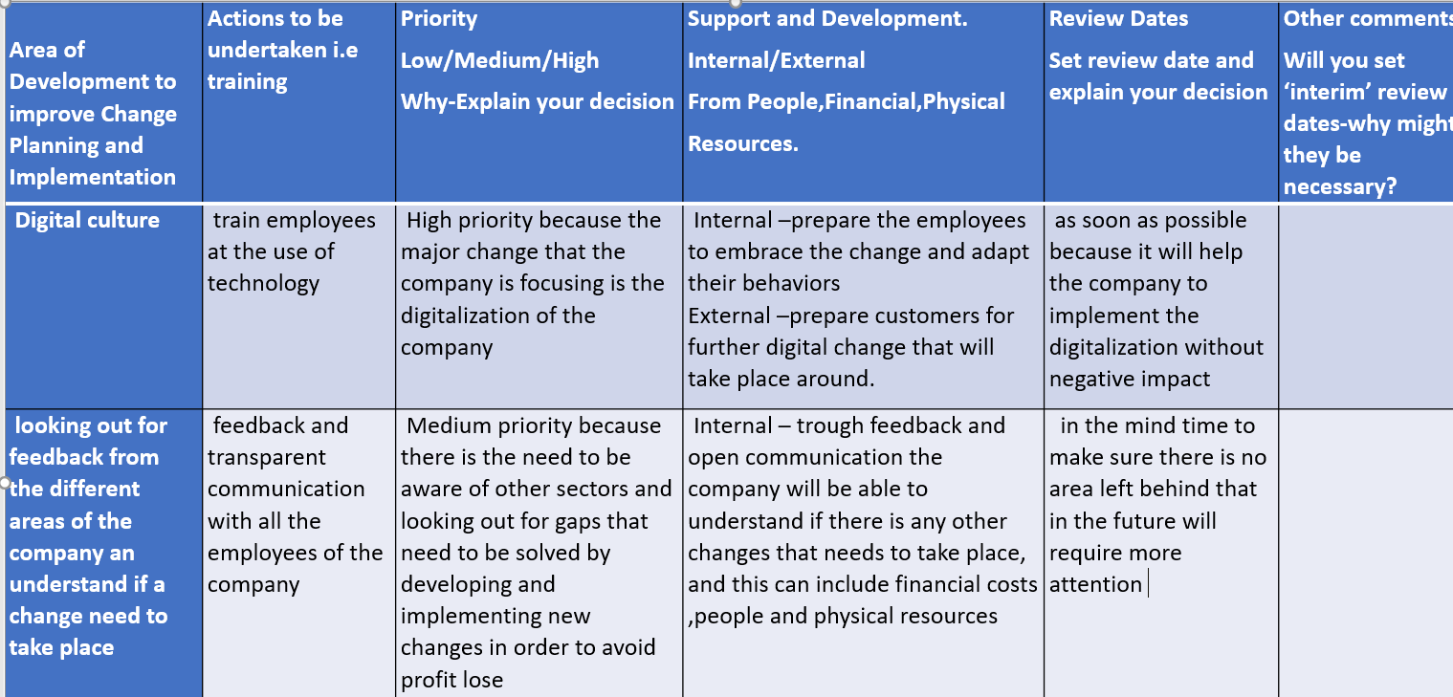

5.0 Appendix

SWOT ANALYSIS OF THE DIGITALIZATION CHANGE
STRENGHTS  -better relationship with employees because of the raining and communication provided  - better understanding of customers and stakeholder’s expectation  - better engagement with people requirements  - paper less  - facilitate the fast communication  - stock over the year of data and information | WEAKNESSES  - the digitalization should never take the place of humans  - costs  - the lack of attention on other sectors that will require further change
OPPORTUNITIES  - profit growth  - further expansion of Nestle branches in different countries  - new ways of innovation and ideas of future development | THREATS  - the continuous change around digital market  - competitors on the market with a better management of the implementation of digitalization

6.0 Reference List

- Nestlé Global. 2021. History. [online] Available at: <https://www.nestle.com/aboutus/history> [Accessed 30 May 2021].
- Sorvino, C., 2020. The World's Largest Food And Restaurant Companies In 2019. [online] Forbes. Available at: <https://www.forbes.com/sites/chloesorvino/2019/05/15/worlds-largest-food-restaurant-companies-2019/> [Accessed 30 May 2021].
- The Economist, 2009. [online] Available at: <https://www.economist.com/business/2009/01/22/in-pursuit-of-beauty> [Accessed 30 May 2021].
- Nestlé Global. 2010. Nestlé completes sale of Alcon to Novartis. [online] Available at: <https://www.nestle.com/media/pressreleases/allpressreleases/nestle-completes-sale-of-alcon-to-novartis> [Accessed 30 May 2021].
- Meier, C. and Borlini, L., 2018. Nestlé Announces Re-Organization of its Global Information Technology Activities. [online] Nestle.com. Available at: <https://www.nestle.com/sites/default/files/asset-library/documents/media/press-release/2018-may/nestle-reorganization-global-information-technology-activities-en.pdf> [Accessed 31 May 2021].

- Nestle Global., 2019. Nestlé highlights innovation, digitalization and sustainability in 2019 Annual Report. [online] Nestlé Global. Available at: <https://www.nestle.com/media/pressreleases/allpressreleases/nestle-annual-report-2019> [Accessed 31 May 2021].
7. Nestlé Global. 2020. Nestlé reports half-year results for 2020. [online] Available at: <https://www.nestle.com/media/pressreleases/allpressreleases/half-year-results-2020> [Accessed 14 June 2021].
8. McCullough, K., 2019. Why Change In the Workplace is Good! – Karen McCullough. [online] Karen McCullough. Available at: <https://www.karenmccullough.com/change-in-the-workplace-a-guide-for-companies/> [Accessed 14 June 2021].
9. Wanner, M. F. (2013). Integrated change management. Paper presented at PMI® Global Congress 2013—North America, New Orleans, LA. Newtown Square, PA: Project Management Institute.
10. Nestlé Global. 2020. Connecting through digitalization | Nestlé Annual Report. [online] Available at: <https://www.nestle.com/investors/annual-report/digitalization> [Accessed 14 June 2021].
11. Investegate.co.uk. 2020. Investegate |Nestle SA Announcements | Nestle SA: Statement re (Nestl� Annual Report 2019). [online] Available at: <https://www.investegate.co.uk/nestle-sa/rns/statement-re--nestl--annual-report-2019-/202003240700013413H/> [Accessed 14 June 2021].

12. Yassine, M., Diab, P. and Hadad, D., 2021. The Impact of Digital Transformation on Innovation and Performance in Companies—Nestle Lebanon Case Study. Research in Economics and Management, 6(1), p.p112.
13. Bernard Marr. 2020. What Are The Negative Impacts Of Artificial Intelligence (AI)?. [online] Available at: <https://bernardmarr.com/default.asp?contentID=1827> [Accessed 14 June 2021].
14. Johnston, A., Lefort, F. and Tesvic, J., 2017. Secrets of successful change implementation. [online] Mckinsey & Company. Available at: <https://www.mckinsey.com/business-functions/operations/our-insights/secrets-of-successful-change-implementation> [Accessed 15 June 2021].
15. Hayes, J., 2018. The Theory and Practice of Change Management. 5th ed. London: Macmillan publisher limited, pp.20,21.

16. Morphy, E., 2018. Nestlé takes the digital challenge. [online] Fdiintelligence.com. Available at: <https://www.fdiintelligence.com/article/72984> [Accessed 15 June 2021].
17. Centricdigital.com. 2016. How Nestle's Digital Transformation Made the Brand a Major Player in Today's Marketplace - Technology - Webflow Ecommerce Website Template. [online] Available at: <https://www.centricdigital.com/blog/how-nestles-digital-transformation-made-the-brand> [Accessed 15 June 2021].
18. Jaques E. & Clement, S.D ‘Executive Leadership: a practical guide to managing complexity’ Cambridge, MA: Carson-Hall & Co. Publisher (1994) p.4
19. Bulcke, P., 2020. “There is no single type of leadership”. [online] EU Blog » Learning From Leaders ». Available at: <https://www.euruni.edu/blog/paul-bulcke-nestle/> [Accessed 15 June 2021].
20. Nestle.com. 2020. Corporate Business Principles. [online] Available at: <https://www.nestle.com/sites/default/files/asset-library/documents/library/documents/corporate_governance/corporate-business-principles-en.pdf> [Accessed 15 June 2021].
21. Pratt, L., 2019. Adapting to the future of work with Nestle. [online] HRD. Available at: <https://www.hrdconnect.com/2019/03/04/adapting-to-the-future-of-work-with-nestle/> [Accessed 15 June 2021].
22. -Brown, E., 2018. Adapting to the future of work with Nestle. [online] HRD. Available at: <https://www.hrdconnect.com/2019/03/04/adapting-to-the-future-of-work-with-nestle/> [Accessed 15 June 2021].
23. Lunenburg, F.C. ,2010 . Managing Change : The Role of the Change Agent , International Journal of Management ,Business ,and Administration , Vol 1 ,No 1.
24.Wetlaufer, S., 2001. The Business Case Against Revolution. [online] Harvard Business Review. Available at: <https://hbr.org/2001/02/the-business-case-against-revolution> [Accessed 17 June 2021].
25. Newman, D., 2017. Helping Your Employees Adapt to Digital Transformation - Future Of Work. [online] Future Of Work. Available at: <https://fowmedia.com/helping-your-employees-adapt-to-digital-transformation/> [Accessed 17 June 2021].
26. Change Agent: Meaning and Role | Organisation. n.d [online] Available at: <https://www.businessmanagementideas.com/notes/management-notes/organisational-change/change-agent-meaning-and-role-organisation/5299> [Accessed 20 June 2021].
27 .Nestlé Global. 2021. Our culture of business ethics and integrity. [online] Available at: <https://www.nestle.com/csv/impact/respecting-human-rights/ethical-conduct> [Accessed 20 June 2021].

28. Juneja, P., n.d. Charles Handy Model of Organization Culture. [online] Managementstudyguide.com. Available at: <https://www.managementstudyguide.com/charles-handy-model.htm> [Accessed 20 June 2021].
29. GDS Group ., 2021. What is Digital Culture? – Everything You Need to Know. [online] GDS Group. Available at: <https://gdsgroup.com/insights/technology/what-is-digital-culture/> [Accessed 23 June 2021].
30. Management Guide , n.d. Transformational Change and Change Management. [online] Managementstudyguide.com. Available at: <https://www.managementstudyguide.com/transformational-change-and-change-management.htm> [Accessed 23 June 2021].

