

RESULT

ASSIGNMENT DETAILS AND FEEDBACK
SOUTH WEST WALES CENTRE FOR TEACHER EDUCATION
Sections marked with * should be completed by module lead
Student name: | Johanne Defay | Student P number: | 1704610
Programme: * | Secondary Post Graduate Certificate in Education
Module: * | Curriculum Development and Enhancement | Module Level (6 or 7): | Level 7
Module code: * | ECSP7002 | Contribution to Overall  Module Assessment (%): * | 100
Module Lead:* | Jan Barnes
Assignment Title:* | Reflections on Teaching and Learning | Assignment No (x of x): | 1
Start date:* |  | Submission deadline:* | 14th May 2018 –full submission
Return date of provisional marks & written feedback:* | 11th June 2018

Referencing: | In the main body of your submission you must give credit to authors on whose research your work is based. Append to your submission a reference list that indicates the books, articles, etc. that you have read or quoted in order to complete this assignment (e.g. for books: surname of author and initials, year of publication, title of book, edition, publisher: place of publication).
Submission: | All assignments must be submitted to Turnitin unless otherwise instructed by the Lecturer.  Note: the Turnitin version is the primary submission and acts as a receipt for the student. Late submission of the electronic version of the assignment will result in a late penalty. Penalties for late submission: Up to one week late, maximum grade D. Over one week late, Refer. Only the Extenuating Circumstances Panel may grant an extension. | Date: | 14/05/18

Module lead to tick to indicate if a hard copy version of the assignment must be submitted.* | YES
 | NO | √

Introduction
Following the BERA guidelines, the school in which this research has been undertaken will be anonymised as school x (BERA, 2011). School x is a comprehensive secondary school, welcoming pupils from year 7 to year 11 for a total of 705 pupils, amongst which 38.1% are eligible to Free School Meal - identified as significantly above the national average (Welsh Government, 2017a; Estyn 2015). However, despite 60% of its pupils living in the 20% most deprived areas in the country, school x is perceived as highly successful in its pupils’ achievements due to excellent support and teaching (Estyn, 2015).
The class chosen for the research intervention is a year 7 set two class of 31 pupils, who had previously demonstrated interest in understanding French pronunciation. Moreover, it was believed that it would be more beneficial to introduce them to French pronunciation at this stage as it could be defined as a critical stage for their learning for pronunciation (Kissling, 2013). Indeed, Pinter (2006) discussed the Critical Period Hypothesis (Lenneberg, 1967, cited in Pinter, 2006) and argued that younger learners seem to be more receptive and sensitive to the phonological systems of foreign languages.
Furthermore, I had interest in researching further into pronunciation instruction since that despite the complexity of French pronunciation and its necessity to the pupils’ language skills development, research on the matter appears to be rather limited. Indeed, despite several researches on explicit phonetics instruction (Kissling, 2013; Sturm, 2013; Kissling, 2015), it could be noted that those covering phonics instruction in second language teaching are insufficient, considering its benefits and its wide use in first language reading (Braibant & Gerard, 1996; Hatcher et al., 2004; Bald, 2007). Thus, the research questions are:
- Can the explicit instruction of identified phonics improve their pronunciation in the short and long term?
- Does it allow them to pronounce words they haven’t encountered before without being heavily accentuated?

Literature review
In the 1920s, pronunciation was at the centre of foreign language teaching with the introduction of the audiolingual method (Harmer, 2015). The focus was on pronunciation accuracy and in order to achieve it, teachers were drilling sentences that pupils were merely repeating. Thus, it could be argued that even though pupils were attaining a certain degree of accuracy, their knowledge of French phonology was limited to that of their teacher, being mere recipients of knowledge. Consequently, as the audiolingual method’s benefits in language learning was becoming questionable due to the lack of genuine communication (Harmer, 2015), it was abandoned and the teaching of pronunciation witnessed an important decrease (Sturm, 2013). Moreover, following the Critical Period Hypothesis (Lenneberg, 1967, cited in Pinter, 2006), it was believed that it would be impossible for a learner to reach native-like pronunciation in a foreign language if they started after puberty, resulting in a lack of interest in teaching pronunciation (Sturm, 2013). Furthermore, despite the recognition of the significance of pronunciation instruction in language learning due to its close relation to learner’s intelligibility and thus in their ability to be understood while interacting (Derwing & Munro, 2009, cited in Sturm, 2013), Sturm (2013) noted that pronunciation still appeared to be omitted from the schemes of work. On the other, an increase in effective pronunciation instruction research was observed (Sturm, 2013). Overall, despite a lack of inclusion within schemes of work, it could be argued that when pronunciation is indeed included within a languages course, the amount of time dedicated to it conveys the significance it has in language learning (Kissling, 2013).
However, effective pronunciation instruction appeared to be strongly associated with the teaching of phonetics as it could be noted from the several studies investigating explicit phonetics instruction (Kissling, 2013; Sturm, 2013; Kissling, 2015). Furthermore, it could be noted that these explicit phonetics instruction studies were all undertaken in university context, where a module on pronunciation was offered for an entire semester, as opposed to secondary schools where pronunciation would have to be included in the scheme of work. The results in Sturm’s (2013) research conveyed the positive effect explicit phonetics instruction had on the students when they were compared to those of students who did not experience any form of phonetics instructions. Thus, it was suggested that this proved to be successful with “advanced undergraduate learners of L2 French” (Sturm, 2013, p.658). However, as noted by Sturm (2013), this research did not investigate which method of explicit phonetics instruction was more beneficial to the learners and it is thus complex to define which supported their improvement, since the students in the research undertook a wide variety of exercises and tasks during a whole semester, including a grapheme-phoneme correspondence and the learning of the IPA. Consequently, as the aim of this research is to investigate whether the instruction of grapheme-phoneme correspondence would improve pupils’ pronunciation of targeted phonemes, the presumption that this element was the one that made a difference in Sturm’s (2013) should not be dismissed. Along the same lines, in the case of Kissling’s (2013) study, the phonetics instructions did not seem to be more effective on pupils’ pronunciation than other components of pronunciation instruction. Thus, it could be argued that due to the complexity of phonetics instruction and its questionable benefit to pupils’ pronunciation, it might be more beneficial to learners to make use of different strategies to enhance their pronunciation. On the other hand in Sturm’s (2013) research, a more holistic approach to pronunciation was employed, in the sense that students’ pronunciation was judged on the reading of a text according to different factors - such as liaison, intonation, consonant sounds, vowel sounds, and nasal sounds – and through a percentage of correctly pronounced syllables. Consequently, it could be argued that the results were left to the subjectivity of the French native speaker assessing them, since they did not make use of a scale in order to consider the correctness of their pronunciation. In addition, the results could not convey in which area students had made improvement and if it was a consistent feature across the sample students. As opposed to Sturm’s (2013) research, Kissling (2013) undertook a phonemic approach to the explicit teaching of pronunciation; these phonemes were selected due to being identified as problematic to English speakers learning Spanish. This aspect led me to design a test that would focus on one specific area of French pronunciation in order to measure whether the intervention was effective in that aspect, following Kissling’s (2013) model.
Furthermore, it appears that even though the study of pronunciation can be dedicated an entire module in higher education - where explicit phonetics instruction would be studied for a semester on average (Kissling, 2013) – it appears to be rather neglected in second language learning in secondary education. It could be observed consequently, that this omission conveys the complexity of phonetics as they would only be introduced in higher education for the first time. Moreover, it was acknowledged that despite the majority of studies implementing explicit phonetics instruction during semester-long courses, learners could not reach a native-like pronunciation (Kissling, 2015).
Therefore, even though the International Phonetic Alphabet (IPA) has been identified as valuable in terms of accuracy when recognising and producing sounds, it has been acknowledged as limited in terms of pedagogical practicality and benefits (Churchman, 1928). Indeed, despite defining one of its main functions as a more reliable transcription of the way words sound than their normal spelling, Churchman (1928) admits the controversy of such a statement. In fact, due to the claim of several studies on the benefits of explicit phonetics instruction in second language learning (Sturm 2013), it could be assumed that employing it within the French classroom would benefit learners. However, as mentioned previously, for the case of Sturm’s (2013) study, both grapheme-phoneme correspondences and IPA were taught, leading to question which of these two elements contributed to the improvement of students’ pronunciation. However, it could be argued that one of the determining factors in effective pronunciation output would be the amount of time dedicated to the phonemes (Kissling, 2013). Furthermore, Kissling (2013) observed that both instructional setting failed to instil a long-term retention of pronunciation rules. Regarding this aspect, this suggests that time and recycling could be the main factors in improving pupils’ pronunciation, as Chung (2008) commented that an insufficient time dedicated to pronunciation instruction would lead to less significant benefits to pupils’ pronunciation. Thus, as the real benefits of explicit phonetics instructions could be questioned, it could be added that as Kissling (2013; 2015) investigated its use within Spanish courses, its transferability might not apply to French courses. Indeed Spanish, having a consistent grapheme-phoneme correspondence (Goswami, 2005) as well as a coherent correspondence with the phonetic alphabet, the risk of confusion during the introduction of the IPA would be reduced. Therefore, as Kissling (2013) summarises and questions the case of studies promoting explicit phonetics instruction in Spanish, it could be argued that due to their focus on Spanish phonemes and more particularly on consonantal segments such as ‘p’, ‘r’, ‘t’, a phonetics approach to pronunciation was more relevant. Indeed, due to the emphasis on these single letters, resulting in a correspondence of one grapheme for one phoneme, it could have been more manageable for learners, and thus easier for them to improve their pronunciation. Along the same lines, due to the simplicity of the alphabet used for these phonemes, /p/ for the letter ‘p’ for instance, it could be argued that employing the phonetics approach might not lead to further confusion with Spanish. However, it has been acknowledged that the inconsistencies of the phonetic alphabet with the spelling of French could confuse learners in their pronunciation of words with sounds such as ‘u’ in French transcribed as /y/ (Churchman, 1928). Along the same lines, it can be argued that a certain number of symbols seem to render the IPA unpractical and less valuable as a teaching tool for pronunciation, due to the contradictions and confusions it induces. Thus, due to the drawbacks of the IPA as a pedagogical too, Churchman (1928) suggested the use of exercises in order to acquire the underlying rules of French pronunciation such as the way to pronounce the letter combinations ‘im’, ‘in’ or ‘gn’ for instance. Indeed, this seems to agree with the view that learners would need to learn some rules at some point and could not rely on visual support indefinitely. Moreover, in that respect, Churchman (1928), while acknowledging the limitations of using the IPA in the teaching of French pronunciation, relates the pedagogical benefits at loss if the concept of pronunciation instruction was to be abandoned.
Similarly, as Jaffré and Fayol (2006, cited in Sturm, 2013) defined French pronunciation as rather predictable from its spelling, it was noted that, granted that the pronunciation rules of letter combinations in French were to be mastered, it could be sufficient for learners to reach an intelligible pronunciation of French. As a result, the introduction of phonetics instruction to the class of year 7 for this research was questioned, due to its complexity and to the time it required, and a more accessible approach was preferred for the intervention. The phonics approach is mainly used at early stages of life when pupils learn how to read. It consists in identifying ‘relationships between sounds and letters and the patterns that can occur’ (p.37), which falls in the category of grapheme-phoneme correspondence, being the focus of this research (Conway, 2015). It is argued to be more effective than its counterpart, the whole language method, in enabling learners to read (Hattie, 2008, cited in Conway, 2015). Moreover, even though the phonics approach is mainly employed in the first language, it could be argued that it is how learners approach the reading of new vocabulary; in that respect, Conway’s (2015) argument to provide learners with the necessary phonological tools in order to transfer this knowledge to the reading and pronunciation of new words in the target language could be beneficial to them. Similarly, it has been suggested that the phonics approach to teaching pronunciation could improve pupils’ confidence and ability in French pronunciation (Green, 2014).
Along the same lines, despite a number of studies focusing on explicit phonetics instruction in second language pronunciation, it has been acknowledged that learners tend to use a phonemic approach instead, transferring their first language knowledge of the correspondence grapheme-phoneme to fill the gaps in their second language knowledge (Kissling, 2015). Thus, it could be argued that mispronunciation would not only be due to a lack of phonetics understanding, but would rather be due to a correspondence grapheme-phoneme too heavily influenced by their first language. Thus, it was believed that providing the pronunciation rules of certain letter combinations could be more beneficial to the learners rather than the IPA since it would render them more independent in their reading of French, while still being accessible. Furthermore, phonological discrimination was found to be an important factor in correct pronunciation production, based on the belief that if learners could not differentiate the correct from the incorrect pronunciation, the chances of being accurate when producing the phoneme would be rather low (Kissling, 2015). As a result, it was believed that designing a discrimination activity followed by a pronunciation drill would benefit their discrimination skills and would therefore increase their accuracy in pronouncing the targeted phonemes.
As a consequence, due to the time restraint experienced for this research, as well as to the experience of pronunciation pupils already had during the year, it was decided that a phonetics approach would not be beneficial to them, as it might bring more confusion. Along the same lines, the French teacher of this class had already implemented a system to support their pronunciation, employing a similar concept to a phonetics approach, but using English as a basis. As a result, since it appeared that introducing another phonetic alphabet to this class of year 7 would be overwhelming and time consuming, while they were restricted by time, the phonetics approach was dismissed. Moreover, concerning the stage in foreign language learning in which learners should be taught pronunciation explicitly, Higgs and Clifford (1982, cited in Kissling, 2013) defined that the early and advanced stages of second language acquisition appear to be crucial in terms of pronunciation uptake. In that respect, the combining of both phonics and phonetics approach could be suggested, the former at the early stage of second language acquisition and the latter at its advanced stage. As a result, the class of year 7 chosen for the intervention were introduced with the grapheme-phoneme correspondences of what were seen to be the most misconceived French phonemes, as it was their first year of French, and could thus be defined as the early stage of their second language acquisition.

School Policy and Practice
Since the focus of this research was pronunciation and French misconceived phonemes in particular, it was too specific to the French subject to be part of a whole school policy. However, the French department had demonstrated interest and involvement in developing a methodology in order to support learners in pronouncing French words. Thus, this strategy consists in employing a green colour coding system to represent how the word would be spelt in English to sound like the French word, when introducing and drilling new vocabulary. For instance, when presenting the French word “passe-temps” to learners, “/pastah/” would be placed underneath the French spelling of the word, in a green colour. Thus, even though this does not transcribe as the French pronunciation of the sound /ɑ̃/ for the combination of letters ‘em’, it could be argued that during the drilling, pupils would have a chance to repeat the sound /ɑ̃/ that they are hearing from the teacher while not being distracted and tempted to pronounce the silent letters ‘p’ and ‘s’. Consequently, this technique appeared to be successful in supporting learners in their pronunciation of new words, as long as the green spelling was placed underneath the vocabulary. Moreover, this technique seems to satisfy the needs of pupils and it proved to be even more effective when they took responsibility for their own pronunciation improvement when they wrote them down in their exercise books. Thus, besides being in accordance with pupils’ needs, this approach appears to be in accordance with Churchman’s (1928) view on the matter, following the belief than an accurate phonetic transcription might not benefit learners significantly. Indeed, this approach seems to be a continuation of Churchman’s (1928) argument according to which the use of the IPA would be beneficial to the teaching of pronunciation if it was simplified, since the French department employs letters and sounds learners are familiar with in order to support their pronunciation. However, it diverges from Churchman’s (1928) view in the sense that learners are not provided with rules in order to later become independent in their reading of French words but are rather provided visual support when a misconception in pronunciation is anticipated. Thus, despite the French department’s accessible approach to French pronunciation, it differs from the researches reviewed previously since it would be more qualified as an implicit approach to pronunciation instruction, opposing those of Sturm (2013) and Kissling (2013; 2015) explicit approaches which followed the belief that learners would internalise these rules in order to achieve accurate pronunciation in the future. As a result, since this research attempted to measure the benefits of explicitly teaching the grapheme-phoneme correspondences of identified phonemes, it could inform as well the French department whether it would be worth their time.

Methodology and ethics
Reflective practise as well as research within the classroom have been defined as valuable attributes for teachers to implement in their teaching (Donaldson, 2015; Welsh Government, 2015). Indeed, since reflective practice is one of the 55 Qualified Teacher Status standards (Welsh Government, 2009), and that research is part of the new standards introduced (Welsh Government, 2017b) their benefits and necessity to teaching are evidently acknowledged. Along the same lines, as identified within the Welsh educational action plan (Welsh Government, 2017c), teachers will need to be engaged with research in order to provide the most suitable teaching experience to learners’ needs. Accordingly, action research follows a cyclical pattern, used by teachers in order to reflect on their own practice. Thus, when an action research is undertaken, teachers will plan an intervention, implement it, observe its results, and reflect upon them in order to inform further planning if necessary (Costello, 2003). As a result, the use of action research within the classroom is extremely valuable to teachers as the action undertaken and the reflections ensuing from it will be adapted to the context of the class and will further support suitable improvements when necessary. Therefore, for the purpose of this assignment, an action research was undertaken as it appeared to be the most appropriate approach, since it was to be implemented on a rather short period of time and aimed at improving my practice through a small-scale study (Welsh Government, 2015).
Moreover, it attempted to investigate an effective approach to the teaching of pronunciation, answering the two following research questions:
- Can the explicit instruction of identified phonics improve their pronunciation in the short and long term?
- Does it allow them to pronounce words they haven’t encountered before without being heavily accentuated?
Consequently, the intervention occurred over the course of three lessons over three successive days. It comprised a pretest and a posttest, both a day before and after the intervention, which consisted of a single one-hour lesson on pronunciation. During the intervention lesson, the class was introduced to a phonics chart, a drilling of each phoneme, a discrimination task, a predicting task, a recognition task and a practice task. The discrimination task and the recognition task were informed by Kissling’s (2015) study on second language phonetics perception, as it was believed that it would support and improve their pronunciation.

Data collection
According to Mills (1999) both qualitative and quantitative data could be argued to be the best approach to data collection, depending on your research question, which led me to consider the use of both a qualitative data for the data collection, due to the nature of the research. Indeed, as quantitative data is used for the collection of numerical data, it could be argued that the collection of recordings was closer to qualitative data (Johnson & Christensen, 2004). However, prior to the collection of data, pupils were introduced with the reasons of the pronunciation project and its implications, being that the data collected from them – recordings - would be used to draw conclusions as to the effectiveness of the pronunciation intervention, in an essay. Thus, after pupils had been presented with the project, they were also presented with consent forms which they had to sign in order to take part in the research. Furthermore, pupils were also reminded that should they wish to withdraw from the research, they could do so at any time, as participating in the research was not compulsory, even though the intervention was. The 14 participants of this research were part of a year 7 class, and were the first 14 to be recorded in the class. In fact, in order to be as objective as possible, the order in which pupils were recorded was randomised to obtain the most impartial sample of the class as possible. Indeed, due to time constraint, two hours were dedicated to both the pretest and posttest recordings. Furthermore, in accordance with the BERA guidelines (BERA, 2011), the pupils that accepted to take part in the research were attributed a random number from 1 to 31, unknown from the researcher, in order to anonymise their data. Moreover, in order to allow them to withdraw from the research, they gave their number at the beginning of their audio recording so they could be identified in the future if necessary. Thus, in an attempt to answer the research questions mentioned above, pupils were recorded reading a list of 15 selected words aimed at assessing the grapheme-phoneme correspondences acquisition, a day before and a day after the intervention. However, due to time constraint, the long-term effect could not be measured.

Data analysis
Concerning data analysis, a quantitative approach was adopted. Indeed, due to the subjectivity that could result from analysing data on correct pronunciation of French, it was believed that relying on a quantitative approach would result in a more objective and guaranteed analysis of the results as the research question attempted to measure improvement in pronunciation (Johnson & Christensen ,2004). Moreover, among the studies that investigated pronunciation uptake after explicit instruction, the quantitative approach to data analysis was employed (Sturm, 2013; Kissling, 2013, 2015) and was consequently believed to be the most appropriate for this research. Indeed, when attempting to compare the impact pronunciation instruction had on learners, being able to use figures appears to be necessary in order for the study to be of any value in future research. As a result, a similar method to Kissling’s (2013) study was adopted, grading the pronunciation of each phoneme between 1 and 3, 1 standing for an English-accented pronunciation, 2 being a mix of English-accented and French-accented pronunciation and 3 being French-accented pronunciation of the phoneme, and thus its mastery. Thus, in order to answer the first research question, each pupil was given an average score for the reading task, pretest and posttest, in order to compare the overall improvement; the proportion of 1, 2 and 3 in the pretest and posttest were compared in order to investigate whether the amount of heavily English-accented phones diminished after the intervention. Furthermore, a similar approach was adopted to answer the second research question, since the list of words used for the research included words that had not been taught explicitly to the pupils.

Evaluation
While similar studies conducted their research throughout a semester-long course (Sturm, 2013; Kissling, 2013, 2015), this research was limited to a rather short period of time, due to the lack of flexibility of the French department curriculum in school x. Consequently, the intervention consisted of a single one-hour lesson on pronunciation, preceded by a pretest and followed by a posttest. Thus, it could be argued that as opposed to similar studies, the impact the pronunciation intervention would have on pupils’ pronunciation uptake was bound to be limited. Indeed, Conway (2015) argued in favour of a more consistent approach to its teaching, by incorporating pronunciation instruction to each lesson. Consequently, the value of this research could be defined as limited to this class setting, and would request another action research within which pronunciation would be introduced on a more regular basis. Furthermore, due to the omission of a delayed posttest, the long-term effect of this intervention could not be measured.
During this lesson, pupils were first introduced with a phonics chart, gathering the most misconceived phonemes of French pronunciation - /y/, /ɛ̃/, /ɔ̃/, /ɑ̃/, /ɔ / (Walz, 1980; Sturm, 2013) - as well as phonemes that had been identified as commonly mispronounced within this class such as ‘tion’, ‘gn’, ‘qu’ and ‘ou’. On the phonics chart, the identified phonemes were written according to their normal spelling, and were associated with a visual support, being a picture of the word it was included in (see Appendix A). For instance, for the phoneme ‘in/im’, there was a picture of a rabbit with its French equivalent “lapin”.
Furthermore, the intervention started with the introduction and drilling of these nine phonemes in the first instance, then each phoneme was modelled in details, by explaining the way it was produced in the mouth, with the support of a picture, as well as by demonstrating it myself. Indeed, the inclusion of a practical version of places of articulation was informed by Kissling’s (2013) study, which incorporated the places and manners of articulation among explicit phonetics instruction, since it was believed that instructing pupils how to produce the sounds they were trying to reproduce would enhance their pronunciation accuracy. Following the articulation demonstration, the phoneme was drilled with pupils until a satisfying version of it would be produced by the class; once the phoneme was considered as mastered, it was drilled once again within words that contained the phoneme (see Appendix B). Thus, once a phoneme was believed to be acquired by the class, the next phoneme would be introduced. However, it could be argued that this activity could have been more effective if I had ensured that the words containing the targeted phoneme that had been displayed for further practice, were known by the pupils.
Afterwards, as it was observed that leading learners to notice the different phonological features proved to be more effective than when they were expected to discover them implicitly (Kissling, 2015), pupils were then presented with a discrimination task, where they had to choose which phoneme they thought they were hearing in the word that was pronounced, between three options (see Appendix C) . Thus, it could have been defined as beneficial to pupils’ pronunciation uptake, since it supported them in differentiating the nasal sounds of the ‘in/im’, ‘an/en’ and ‘on’ letter combinations; however as three phonemes could not be included in the discrimination task due to the lack of similarity between each other, pupils were not provided with enough exposure to these phonemes in order to internalise their pronunciation.
Following the discrimination task, pupils were asked to undertake a pronunciation prediction task, in which they had to guess the correct pronunciation of a word, between several options. In order to proceed, pupils were shown a French word containing one of the phonemes previously studied, and they had to choose the correct pronunciation transcribed with an English spelling. For instance, when they were given the word ‘quart’, they had to choose between the following options: “/kar/”, “/kwar/” and “kart” (see Appendix D). Similarly to the previous activity, the pronunciation prediction task was informed by Kissling’s (2015) claim about the significance of discriminating sounds in order to acquire them. Moreover, the needs and habits of the class were considered as well, since English transcriptions of the French words were used as they were familiar with this system, implemented by their French teacher. Nevertheless, it could be argued that introducing the English spelling to teach the French pronunciation in that task, could have brought some confusion to their understanding of French pronunciation as distinctive to the English pronunciation.
The final activity of the pronunciation intervention was a snakes and ladders game, designed to practise producing the targeted phonemes within French words. However, while reflecting on the effectiveness of this activity, it could be noted that it could have been introduced too early in the lesson, considering that they did not have a significant amount of practice before attempting this rather independent task. Along the same lines, as some activities could not be incorporated during the lesson due to a time constraint, it could be suggested that the secret signal activity should have been exchanged with the snakes and ladders game for pupils to benefit more from the pronunciation intervention. Indeed, the secret signal activity (see Appendix E) would have drilled in an engaging way, the targeted phonemes of this research.
Besides, concerning data collection, it was in accordance with Kissling’s (2013) study, since pupils were presented with a list of words to read aloud (see Appendix F), as opposed to a short text including the phones being assessed (Sturm, 2013). The reason for using the list of words containing the phones instead of a short text was due to the current level of the pupils, being in their first year of French language learning. Indeed, it was believed that a short text to read would be overwhelming and would prevent them from focusing on the correct pronunciation of the targeted phonemes (Kissling, 2013).

Results
The average pronunciation score of pupils in the pretest and posttest was calculated in an attempt to investigate the overall improvement in French pronunciation the pupils experienced. Thus, in the pretest, the mean average of pupils’ pronunciation on the list of words was of 18,26 out of a maximal potential score of 45, if they had managed to get rid of their English-accented pronunciation of the phonemes. As for the posttest, the mean average reached 23,71. Thus, it could be noted that the improvement in terms of phonemic pronunciation was rather negligible, with an uptake average of 5,45 over 15 phonemes. Nevertheless, it appeared that when looking at the mean average between the pretest and posttest of individual phonemes – in bold in the French words (see figure 1) - some of them such as, ‘tion’ of “information” and “libération”, and ‘aux’ in “travaux”, were already scoring rather high in the pretest, considering that no instruction had been performed. Furthermore, the results in the posttest demonstrated that the acquisition of grapheme-phoneme correspondences was not homogeneous between the different phonemes, as for instance the phonemes ‘au’ and ‘tion’ appeared to be rather comprehended and pupils seemed to incorporate French phonological rules slightly more than with other phonemes. Along the same lines, these results convey the idea that some phonemes might need more instruction than others, for instance, it appeared that ‘qu’ was one of the phonemes that was not acquired as there was either no improvement in its pronunciation, or an insignificant one (Kissling, 2013).

Figure 1: Mean average of the score on each phoneme in both the pretest and posttest
 | Important | mince | intelligent | château | beau | travaux | quitter | question | quarante | montagne | cagnotte | gagner | information | nation | libération
Mean average pretest | 1,07 | 1,07 | 1 | 1,36 | 1 | 1,5 | 1 | 1 | 1,21 | 1,29 | 1,14 | 1,43 | 1,43 | 1,36 | 1,43
Mean average posttest | 1,43 | 1,5 | 1,64 | 2,14 | 1,43 | 2 | 1,36 | 1,14 | 1,21 | 1,43 | 1,29 | 1,71 | 1,64 | 1,93 | 1,79

However, despite an overall idea of how effective this pronunciation intervention was, the results displayed in figure 1 would need to be further developed in order to reach an understanding of the actual improvements that had been achieved in the pronunciation of these phonemes. Consequently, the proportion of 1, 2 and 3 gradings of the phonemes’ pronunciation were turned into percentages, as shown in figure 2, and converted into a bar graph for both the pretest (figure 3) and the posttest (figure 4). As a result, it can be observed that despite the original belief according to which the pronunciation intervention had a rather negligible impact on pupils’ pronunciation, it did however diminish rather significantly the amount of 1 grades, implying then that the intervention impacted on the English-accentedness of pupils’ pronunciation of the phones (see figure 3 and 4). Indeed, it appears that if pupils cannot produce phonemes that are not English-accented, they are able on the other hand to incorporate a few features of French phonology when pronouncing these phonemes. For instance, it was noted that despite what could be perceived as rather misunderstood and mispronounced, the ‘im/in’ phoneme was often perfectly incorporation the French / ɛ̃ / but was impinged by the addition of an extra /n/ sound, due to the influence of English. Along the same lines, it could be argued that the percentage of 2 grades between the pretest and the posttest increased substantially as it doubles or even triples for the case of some phonemes such as ‘in/im’ in “important” and “intelligent”, ‘eau/au’ in “château” and ‘tion’ in “information” and “libération”. Moreover, a grade 2 in this study could be considered as rather positive, since a 3 would exclude any English-accentedness; in that respect, it is believed that taking into account the time pupils were given to process these grapheme-phoneme correspondences while associating them with the correct sound, a grade 2 would be rather acceptable. Along the same lines, even though the proportion of 3 grades does not appear to be striking, considering that in most of the phonemes in the pretest, there was a 0% proportion of grades 3, whereas it reached 15% on average in the posttest, with the highest score in the phoneme ‘au’ in both “château” and “travaux”. Therefore, in answering the first research question, it could be argued that despite what could be perceived as a negligible positive impact on learners’ pronunciation in the short-term, it appears that for some phonemes in particular, pupils managed to employ some French phonological features while pronouncing them. Thus, even though this research was a smaller-scale research and occurred in a shorter period of time, its results, although positive, do not convey such a significant impact of pronunciation instruction on pupils’ pronunciation improvement when compare to similar researches (Sturm, 2013; Kissling, 2015).
Figure 2: Table of the proportions of 1, 2 and 3 grades in the pretest and the posttest
 | % of 1 pretest | % of 1 posttest | % of 2 pretest | % of 2 posttest | % of 3 pretest | % of 3 posttest
Important | 93 | 64 | 7 | 29 | 0 | 7
mince | 93 | 64 | 7 | 21 | 0 | 14
intelligent | 100 | 57 | 0 | 21 | 0 | 21
château | 71 | 21 | 21 | 43 | 7 | 36
beau | 100 | 71 | 0 | 14 | 0 | 14
travaux | 57 | 36 | 36 | 29 | 7 | 36
quitter | 100 | 71 | 0 | 14 | 0 | 14
question | 100 | 93 | 0 | 0 | 0 | 7
quarante | 86 | 86 | 7 | 7 | 7 | 7
montagne | 71 | 64 | 29 | 29 | 0 | 7
cagnotte | 93 | 79 | 0 | 14 | 7 | 7
gagner | 71 | 57 | 14 | 14 | 14 | 29
information | 64 | 43 | 29 | 50 | 7 | 7
nation | 64 | 29 | 36 | 50 | 0 | 21
libération | 64 | 29 | 29 | 64 | 7 | 7

Figure 3: Bar graph of the proportion of 1, 2 and 3 grades in the pretest

Figure 4: Bar graph of the proportion of 1, 2 and 3 grades in the posttest

Concerning the second research question, it attempted to investigate whether the intervention would enable pupils to pronounce words they didn’t know, in other words if they would employ the grapheme-phoneme correspondences to decipher unknown words and pronounce the targeted phonemes correctly. Thus, in order to do so, the list of words pupils was asked to read for their recording on, was constituted of words that had not been explicitly instructed before, even though some were cognates with English. The reason for the inclusion of English cognates was to measure whether the instruction of grapheme-phoneme correspondences would overcome the English pronunciation. Thus, as it can be noted from figure 2 and 4, the phoneme ‘tion’ found in “information”, “nation” and “libération”, was the only phoneme with English cognates that obtained no more than 43% of 1 grades, whereas the other English cognates were still heavily influencing pupils’ pronunciation with a minimum of 57% with “intelligent” and a maximum of 93% with “question”. However, when pupils had to decipher new words, that were not English cognates, it appeared to be particularly successful with the phoneme ‘au/eau’, but not so effective with the phonemes ‘qu’ and ‘gn’ that seemed to be the most challenging ones to acquire. Thus, in that respect, the discrepancy between phonemic acquisition is in agreement with the previous argument according to which each phoneme needs different amount of instruction to be processed (Kissling, 2013). Consequently, the main factor in pronunciation accuracy acquisition might not be the manner in which it is instructed, but rather the amount of time dedicated to its learning (Chung, 2008).

Conclusion
Despite an increasing interest of researches in investigating whether the explicit instruction of pronunciation would be more beneficial to improve learners’ pronunciation, the number of researches on the subject still appear to be rather limited considering how important it is to be intelligible and thus to be understood in another language (Derwing & Munro, 2009, cited in Sturm, 2013). Since Higgs and Clifford (1982, cited in Kissling, 2013) claimed that the early stage and the advanced stage of second language acquisition were critical for pronunciation acquisition, there has been some research within higher education (Sturm, 2013; Kissling, 2013, 2015). However, there seems to be a lack of research on the matter at the secondary school level, considering that both the early stage criticality belief as mentioned before, and the Critical Period Hypothesis (Lenneberg, 1967, cited in Pinter, 2006) appear to convey the necessity for young language learners to be exposed to pronunciation instruction. Consequently, it was believed that investigating this topic with an able class of year 7, would bring an interesting and different view on the matter. Indeed, it followed the belief that despite what other researches reviewed on the matter, the implementation of explicit phonetics teaching (Sturm, 2013; Kissling, 2013, 2015) would not be appropriate to the context of secondary school pupils in their first year of French. In fact, this view was shared, as the use of the IPA within French pronunciation instruction, was qualified as unpractical, confusing and unadvised as a pedagogical tool (Churchman, 1928).
Thus, for the purpose of this research, another approach was considered, that of the phonics approach to the teaching of pronunciation (Bald, 2007; Conway, 2015). The main focus of this approach was the teaching of grapheme-phoneme correspondences as well as their phonological features in order to enable pupils to decipher the written foreign language and become more independent. As a result, a pronunciation intervention was planned aiming at investigating the benefits of the phonics approach on pupils’ pronunciation of phonemes identified as problematic to English language speakers (Walz, 1980; Sturm, 2013).
Therefore, in order to measure the potential improvements on the pronunciation of these phonemes, a pretest and a posttest were undertaken and data was collected from the pupils that participated in the research; they were recorded reading a list of words incorporating the assessed phonemes (Kissling, 2013). As for the effectiveness of the pronunciation intervention, it could be defined as rather limited and negligible due to a number of factors.
Indeed, since the intervention consisted in an hour-long lesson, the scope of the research in that respect was insufficient in order to provide pupils with enough exposure to enable them to process and acquire all the phonemes they had been introduced to. However, despite the lack of time dedicated to pronunciation instruction, the phonics approach appeared to be rather successful with phonemes such as ‘au/eau’ and ‘tion’ which the pupils seemed to have acquired some of their phonological features since a small proportion of these phonemes were English-accented. Thus, although these results were relatively insignificant, considering the amount of time spent on pronunciation, pupils’ improvement in pronouncing these phonemes could be perceived as rather positive. Nevertheless, as some phonemes happened to be rather evident to pupils, others were found to be obscure and did not seem to be acquired at all, such as ‘qu’, which witnessed the lowest improvement in pronunciation. This finding happened to convey Kissling’s (2013) argument according to which different phonemes will require different times of instruction. Thus, it might be worth investigating in future research which phonemes appear to be acquired in more time and design a curriculum accordingly. As for the findings of this research on the matter, it could be hypothesised that the ‘qu’ phoneme might be the one requiring the most time, but it might be due to the intervention design.
Furthermore, it has been raised that these results might also be the consequence of an excessive number of phonemes introduced within the intervention, which might have impacted on the results as distractors. Thus, if this research was to be replicated, it would be advised to spread the pronunciation intervention over several lessons, in order to increase the opportunities of practising the phonemes (Chung, 2008), focusing on a particular phoneme each lesson in order to avoid confusion.

Limitations and future development
Nevertheless, one of the main limitations of this research was that it was a small-scale research, and as such, the results obtained from it could give an indication for further development within the French department of school x, but could not be extended in a broader context, as these results were likely to reflect the performance of this class and the pupils sampled in particular. Along the same lines, the results might not have been as reliable since their analysis relied on the use of mean and average, which require a higher number of participants in order to obtain more reliable results. Consequently, further research would attempt to replicate a similar study, within modern language secondary school education, with several classes. Similarly, if the research was to include a larger number of pupils, it could be worth having a control group to measure whether the critical element of pronunciation instruction is time and practise, or the grapheme-phoneme correspondences as well as their pronunciation.
Similarly, another limitation of this research was, as in Chung’s (2008) study, as well, the time spent on the practice of pronunciation and the way it was spread in time. Indeed, the research took place in three days following each other and pronunciation instruction only occurred for the hour-long lesson of the intervention. The reason for that setting was due to the timetable of the class with which the research was undertaken, since they had French three times within the same week and none the following week. Moreover, due to the format of the data collection - being recordings of the pupils reading a list of words – as well as the time constraint, it was decided to spend three lessons in a row to perform the intervention and collect data. Indeed, two entire lessons had to be spent recording pupils preceding and following the intervention, and no more lessons could be dedicated to pronunciation instruction because of the curriculum. For future research, it would be advised to plan an action research and attempt to divide and spread the pronunciation intervention a bit more in time.
Along the same lines, in addition to being a small-scale research, the intervention was limited to an hour long lesson, where research would rather suggest a more spread amount of pronunciation instruction over the course of the semester (Sturm, 2013; Kissling, 2013, 2015; Conway, 2015). However, for the case of Sturm (2013) and Kissling (2013, 2015), pronunciation was dedicated an entire module for students to study it, rendering the research more valuable in terms of data and results, as students were given the time to process and internalise the phonological features targeted, whereas it could be argued that the results found within this research rather tested pupils’ short-term memory since the setting of the pretest-intervention-posttest could not enable pupils to process and integrate the phonological features of the phonemes. Thus, if a similar research was to be undertaken, it would be advised to consider the teaching of pronunciation as an important element of modern foreign language teaching (Conway, 2015) and incorporate it to the scheme of work.
Furthermore, one of the reasons that prevented pupils from acquiring these phonological features more effectively is believed to be the number of phonemes that were introduced during the lesson. Indeed, it was believed in the first instance that it would support pupils in pronouncing a more important number of words. However, it appeared to be overwhelming for pupils as they had to understand and process the phonological features of 9 phonemes that were already identified as problematic to English speakers of French. As a consequence, it would be understandable for pupils to only retain and reproduce a small amount of the phonemes to which they were introduced. Along the same lines, even though nine phonemes were introduced during the lesson intervention, pupils were assessed on only five of them, without being warned it would be only these five phonemes, resulting in negligible positive results (Kissling, 2013). In the first instance, it was believed that it would be beneficial to an accurate measurement of their pronunciation ability, as it would have only assessed the effectiveness of the pronunciation intervention as opposed to the pupils’ pronunciation acquisition ability. However, for further research, it would be advised to reduce the number of phonemes introduced to the class and assess them on all of which have been introduced.
Finally, one of the most important limitations to this research was the list of words that had been selected for the recordings. In fact, while attempting to reproduce a similar approach to data collection as Kissling’s (2013) study, it differed from it since the words selected in this word list, were purposefully words that pupils would have not been explicitly introduced to, so that their potential knowledge of the pronunciation of the word would not affect the results of this study. However, this appeared to result in confusion on the part of the pupils, especially as the word list also included some English cognates on which they relied heavily in order to pronounce the French words. As a consequence, in an attempt to measure whether the grapheme-phoneme correspondences would be prioritised when English cognates in French, it resulted in an inconclusive learning of the former. In future research, it might be of interest to record pupils on two lists of words, a list with the words they would know and a list with unknown words in order to investigate the second research question, inquiring to which phonological features pupils would employ in each situation.

REFERENCES

Altrichter, H., Posh, P. & Somekh, B. (1993) Teachers Investigate their Work. London: Routledge.
Bald, J. (2007) Using Phonics to Teach Reading and Spelling. London: SAGE Publications.
BERA (2011) Ethical Guidelines for Educational Research [www] https://www.bera.ac.uk/wp- content/uploads/2014/02/BERA-Ethical-Guidelines-2011.pdf?noredirect=1 (date accessed: 31 March 2018)
Braibant, J. & Gerard, F. (1996) “Savoir lire : une question de méthode? ”, Bulletin de psychologie scolaire et d’orientation, 1, 7-45.
Brook, D. (1999) Approaches to Teaching Phonics. Derby: University of Derby.
Chung, W. L. (2008) “The effectiveness of explicit, implicit, and noticing instruction: Mandarin speakers’ perceptions and production of English sentence stress”, Proquest Dissertations and Theses.
Conway, E. (2015) “Demystifying phonics: all your questions answered”, Modern English Teacher, 24, 3, 37-39
Costello, P. J. (2003) Action Research. London: Continuum.
Donaldson, G. (2015) Successful futures. Independent Review of Curriculum and Assessment Arrangements in Wales. Cardiff: Welsh Government.
Estyn (2015) A report on school x [www] https://www.estyn.gov.wales/sites/default/files/documents/Cefn%20Hengoed%20Community%20Sc hool.pdf (date accessed: 31 March 2018)
Goswami, U. (2005) “Synthetic Phonics and Learning to Read: A Cross-language Perspective”, Educational Psychology in Practice, 21, 273-282.
Green, S. (2014) “Making the foreign familiar”, The Times Educational Supplement, (5110).
Harmer, J. (2015) “Popular methodology”, The Practise of English Language Teaching. Harlow: Pearson Education Limited.
Hatcher, P. J., Hulme, C. & Snowling, M. J. (2004) “Explicit phoneme training combined with phonic reading instruction helps young children at risk of reading failure”, Journal of Child Psychology and Psychiatry, 45, 2, 338-358.
Johnson, B. & Christensen, L. (2004) Educational Research: Quantitative, Qualitative and Mixed Approaches. Boston: Allyn and Bacon.
Kissling, E. M. (2013) “Is Explicit Phonetics Instruction Beneficial for FL Learners?”, The Modern Language Journal., 97, 3, 720-744.
Kissling, E. .M (2015) “Phonetics instruction improves learners’ perception of L2 sounds”, Language Teaching Research, 19, 3, 254-275.
Mills, G. (1999) Action Research: A Guide for the Teacher Researcher
Pinter, A (2006) Teaching Young Language Learners. Oxford: Oxford University Press.
Sturm, J. L. (2013) “Explicit phonetics instruction in L2 French: A global analysis of improvement”, System., 41, (3), 654-662.
Walz, J. (1980) “An Empirical Study of Pronunciation Errors in French”, The French Review, 53, 3, 424- 432.
Welsh Government (2009) Becoming a Qualified Teacher. [www] https://gov.wales/docs/dcells/publications/090915becomingateacheren.pdf#page=25 (date accessed: 2 May: 2018)
Welsh Government (2015) Effective use of data and research evidence. [www] http://learning.gov.wales/docs/learningwales/publications/150814-effective-use-of-data-en.pdf (date accessed: 2 May 2018)
Welsh Government (2017a) My Local School [www] http://mylocalschool.wales.gov.uk/School/6704031?lang=en (date accessed 31 March 2018)

Welsh Government, (2017b) Professional Standards for Teaching and Leadership. [www] http://learning.gov.wales/docs/learningwales/publications/170901-professional-standards-for- teaching-and-leadership-en.pdf (date accessed: 2 May 2018)
Welsh Government (2017c) Education in Wales: Our national mission. [www] https://gov.wales/docs/dcells/publications/170926-education-in-wales-en.pdf (date accessed: 2 May: 2018)

Appendices
Appendix A: The phonics chart used to introduce the different phonemes
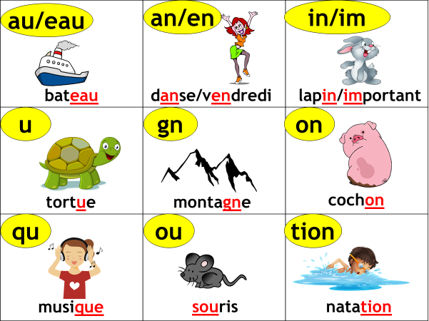

Appendix B : Slide used for the instruction of the French phoneme ‘au/eau’

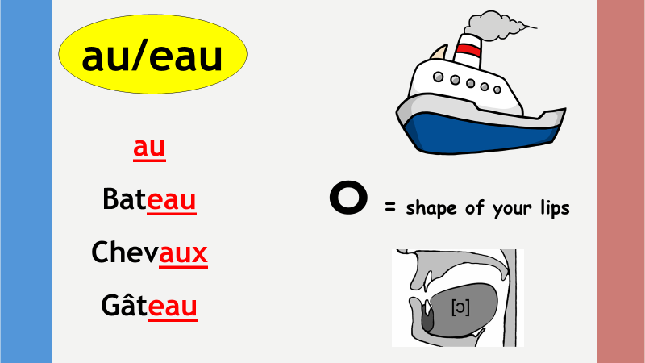

Appendix C: An example of the discrimination task

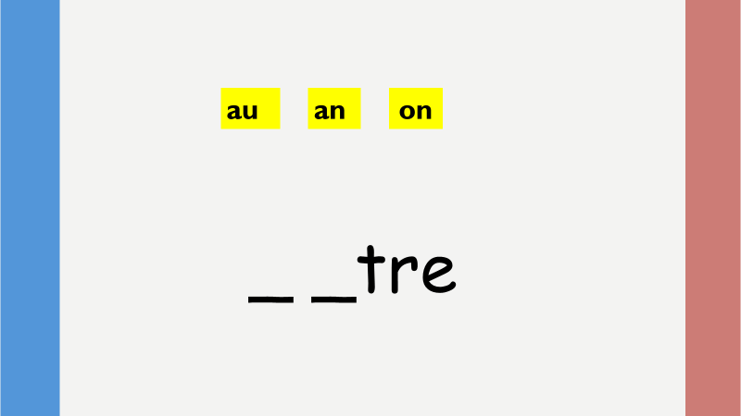

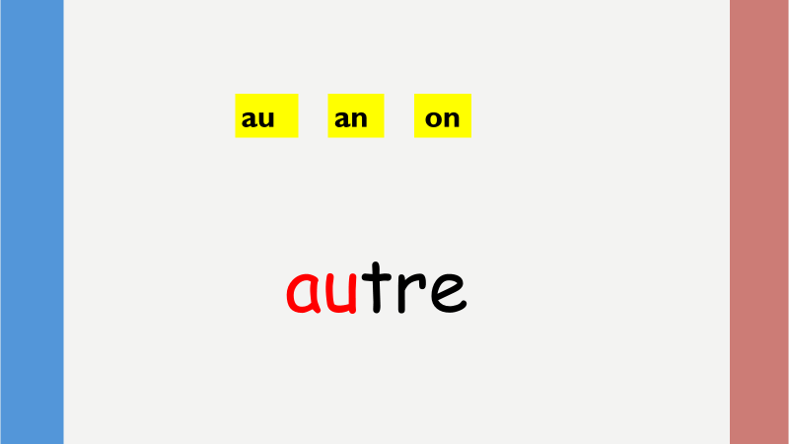

Appendix D: Pronunciation prediction task

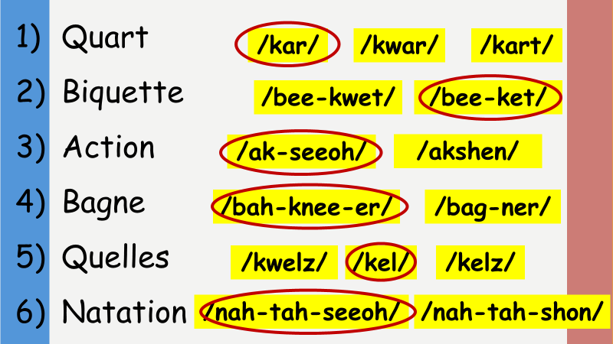

Appendix E: Slide of the secret signal activity

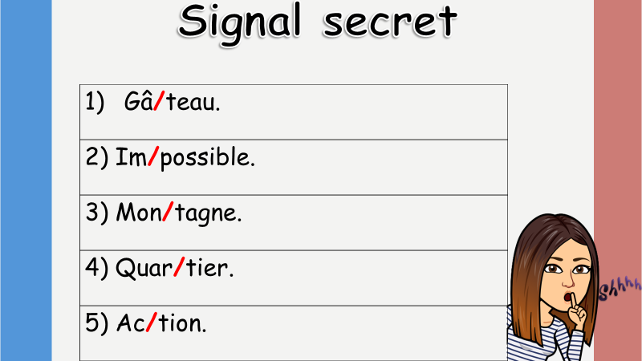

Appendix F: List of words to be recorded

1. Important
2. Libération
3. Quitter
4. Château
5. Mince
6. Montagne
7. Intelligent
8. Nation
9. Beau
10. Question
11. Gagner
12. Travaux
13. Information
14. Cagnotte
15. Quarante

