Analysis of Movie Ratings and Audience Engagement Using Excel and Spss

Student name: Karina Pozdniakova
Student ID: 2317086
Module Code: LCBB5014
Lecturer: Said Usman


- Introduction
The purpose of this report is to analyse a movie dataset using business intelligence and data analysis techniques. The dataset used in this study is the Letterboxd Movie Classification Dataset, which contains information about films such as average rating, runtime, genres, original language, number of watches, likes, and fans. The analysis aims to identify trends, viewer behaviour patterns, and factors that contribute to movie popularity and higher ratings (UK Data Service, 2023).
This report applies business intelligence concepts to support data-driven decision-making. Business intelligence enables organisations to transform raw data into meaningful insights that support improved performance and strategic decisions (Vercellis, 2009). In the context of the film and entertainment industry, analysing audience engagement data can help platforms and studios better understand viewer preferences and optimise content strategies (Lim and Teoh, 2020).
The analysis is conducted using Microsoft Excel and IBM SPSS Statistics. Excel is used for data cleaning, preparation, descriptive statistics, and visualisation, while SPSS is applied to perform statistical analyses such as correlation analysis, independent samples t-tests, and regression analysis. These tools are widely used in business intelligence and analytics to analyse large datasets and extract reliable insights (Sharda, Delen and Turban, 2020; IBM, 2023; Vercellis, 2009).
The main objectives of this report are to clean and prepare the dataset, summarise key variables using descriptive statistics, explore trends through visualisations, perform statistical testing using SPSS, and provide insights and recommendations based on the findings. These steps demonstrate how data analysis can support better decision-making within the media and entertainment industry.
In the context of digital platforms such as Letterboxd, business intelligence tools play an important role in understanding user behaviour and content performance. By analysing large datasets, platforms can identify patterns in audience engagement, preferences, and rating behaviour. Combining tools such as Microsoft Excel and SPSS allows for both exploratory and advanced statistical analysis, providing a structured approach to data-driven decision-making (Provost and Fawcett, 2013).
- Data Cleaning and Preparation
Before conducting the analysis, the Letterboxd Movie Classification Dataset was cleaned and prepared using Microsoft Excel to ensure data accuracy and reliability. Data cleaning is an important step in business intelligence, as poor data quality can negatively affect the validity of analysis results (Vercellis, 2009).
First, the dataset was opened and reviewed in Excel to understand its structure and variables. Screenshot 1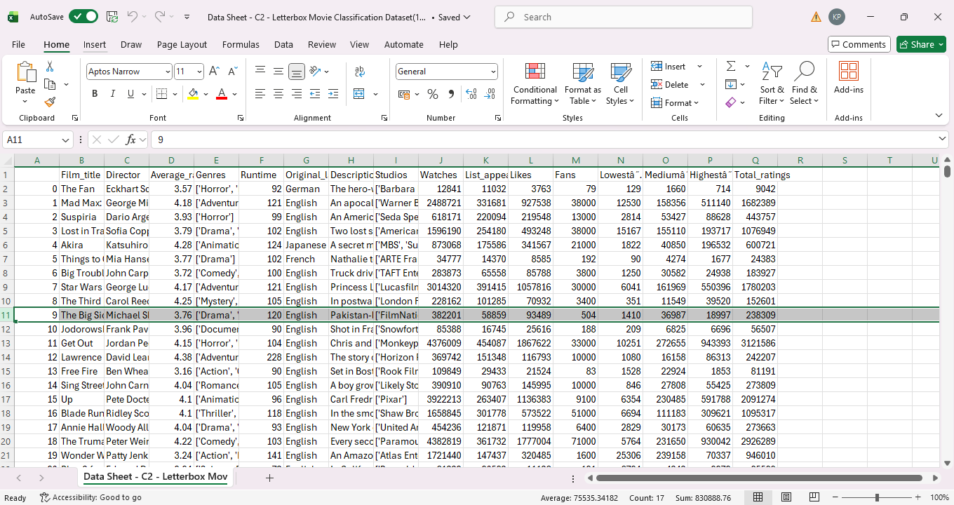

An unnecessary index column was identified and removed to avoid confusion during analysis. The dataset was then checked for duplicate records using the Remove Duplicates function in Excel. As shown in Screenshot 2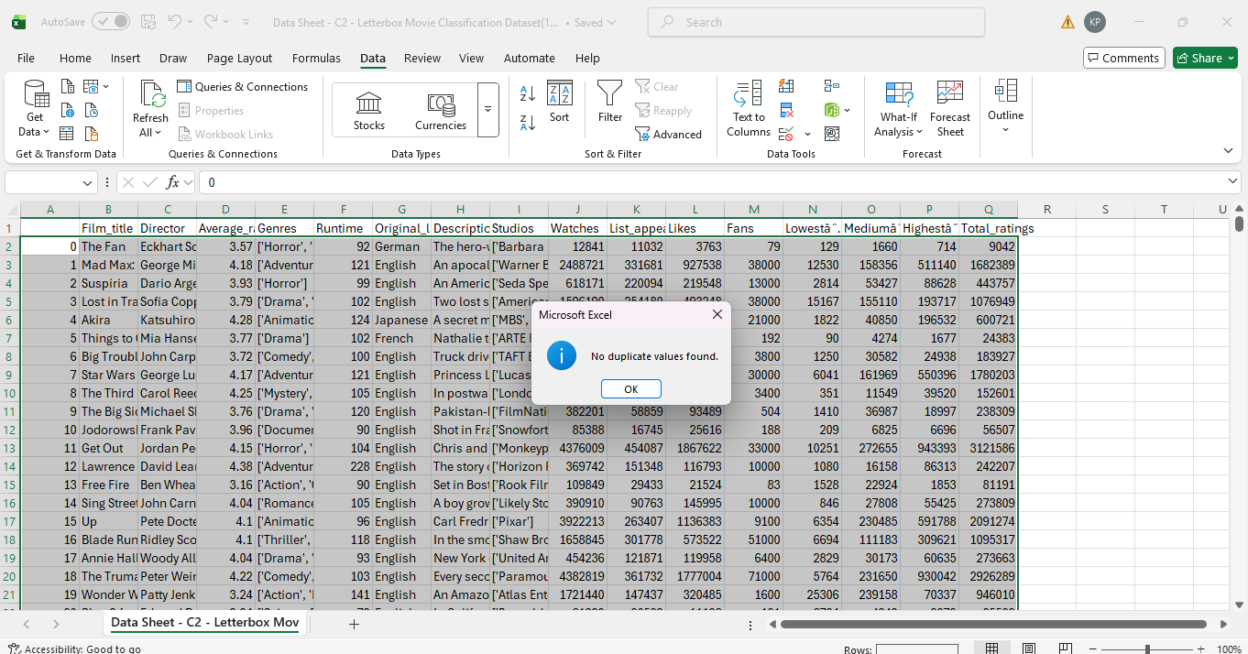
no duplicate values were found, indicating that each movie entry in the dataset was unique.
Next, the dataset was examined for missing values. The Filter function was applied to key numerical variables, such as runtime, to identify any blank entries.
Screenshot 3 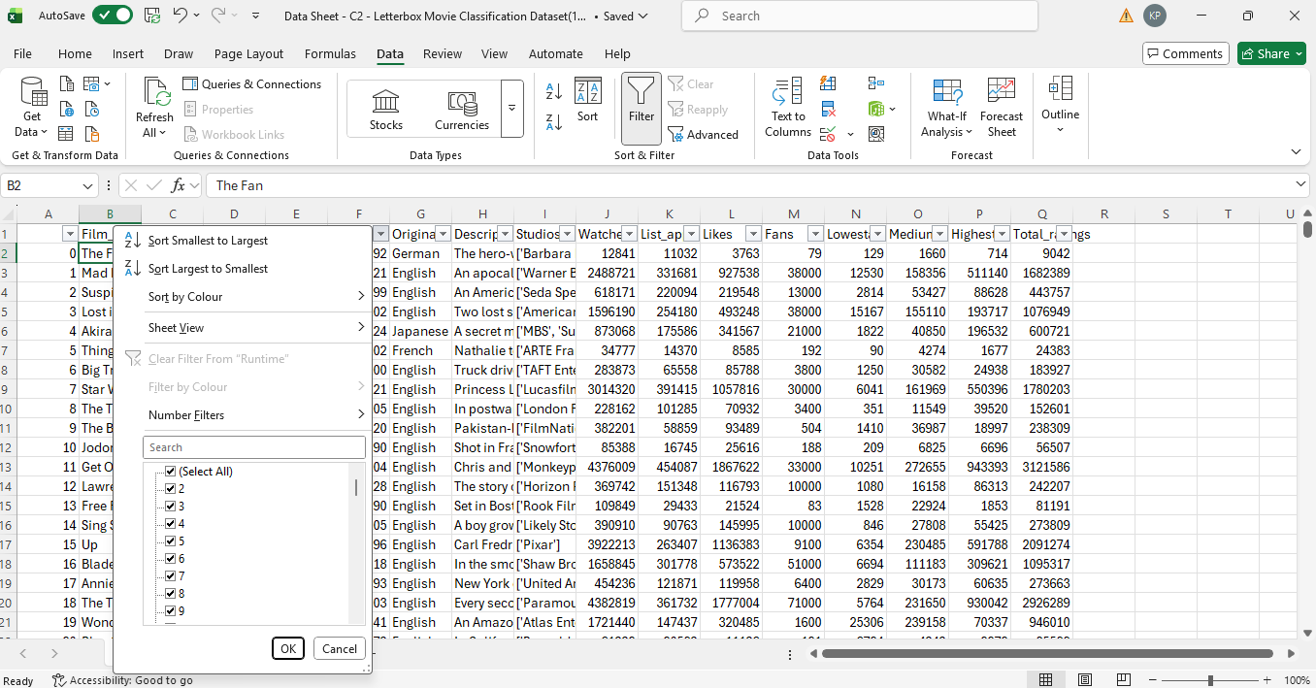shows the filter menu for the runtime variable, where no blank values were observed. This confirms that the runtime data was complete and suitable for further analysis.
Overall, these data cleaning steps helped ensure that the dataset was consistent, complete and ready for descriptive, visual and statistical analysis. Proper data preparation improves the reliability of insights and supports more accurate data-driven decision-making in later stages of the report.
- Descriptive Statistics and Summary
Descriptive statistics were generated using SPSS to summarise the key numerical variables in the Letterboxd movie dataset. The analysis was based on 10,000 films, providing an overview of ratings, runtime, and user engagement metrics such as watches, likes, fans, and total ratings Screenshot 4.
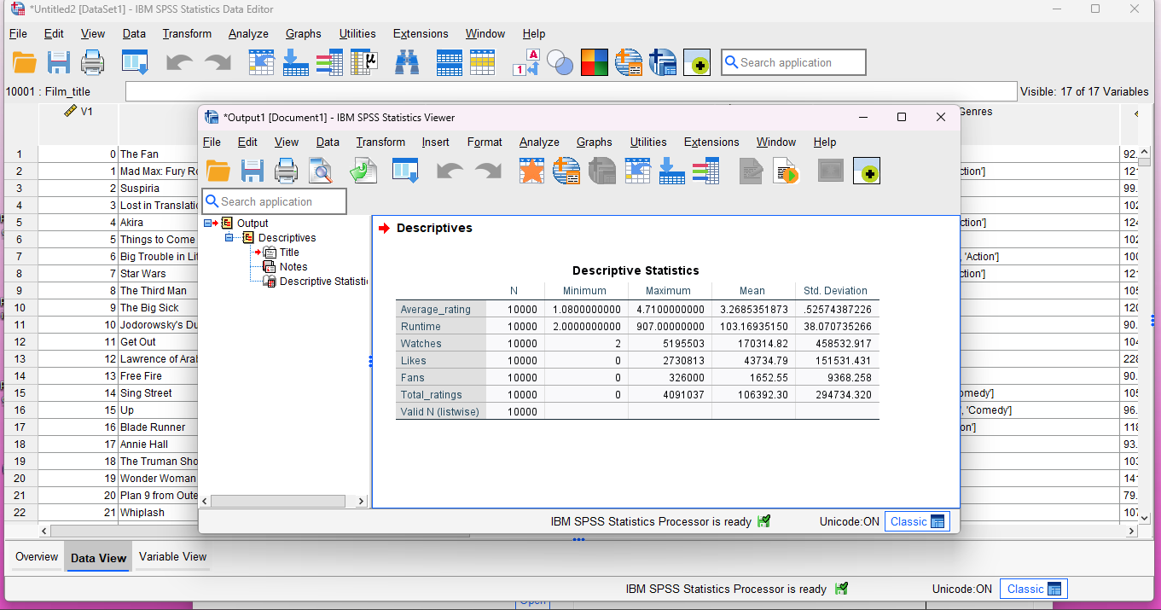
The results show that the average movie rating has a mean value of 3.27, with ratings ranging from 1.08 to 4.71. This indicates that most films in the dataset are rated moderately positively, although there is some variation in audience perception, as reflected by the standard deviation of 0.53.
In terms of movie length, the average runtime is approximately 103 minutes, with a minimum of 2 minutes and a maximum of 907 minutes. The relatively high standard deviation (38.07) suggests a wide spread of movie durations, including both very short and unusually long films.
User engagement levels vary significantly across the dataset. The average number of watches per film is around 17,032, with values ranging from 2 to over 5.1 million, highlighting strong differences in popularity between films. Similarly, the mean number of likes is approximately 43,735, while fans average 1,653 per film, indicating that only a smaller proportion of viewers actively engage beyond watching.
Finally, total ratings show a mean value of 106,392, with a maximum exceeding 4 million, further confirming that a small number of films attract very high levels of audience interaction. Overall, these descriptive statistics demonstrate substantial variation in both movie characteristics and audience engagement, providing a strong foundation for further trend and statistical analysis.
- Trend Analysis and Visualisation
Screenshot 5
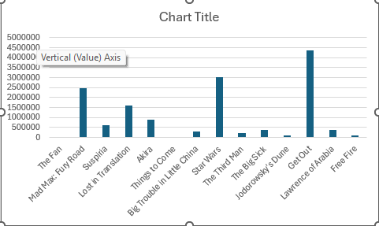
This bar chart illustrates differences in audience engagement across selected films in the dataset, measured through popularity-related metrics. The visualisation clearly shows that audience attention is unevenly distributed, with a small number of films attracting substantially higher engagement compared to the rest. This pattern suggests that film popularity is highly concentrated, where a few titles dominate audience interest while most films receive relatively limited interaction (Provost and Fawcett, 2023).
Overall, this visualisation supports earlier descriptive findings and highlights the importance of popularity metrics in understanding audience behaviour. It also provides useful context for the subsequent analyses, which further explore how ratings and other factors relate to film success.
4.1 Distribution of Average Movie Ratings
Screenshot 6

A histogram was created in Microsoft Excel to analyse the distribution of average movie ratings across the dataset. The visualisation shows that most films are concentrated around the central range of ratings, indicating that the majority of movies receive moderate evaluations from users rather than extreme scores.
The distribution appears to be approximately normal, with fewer films receiving very low or very high ratings. This suggests a general consistency in audience rating behaviour, where most films are perceived as average to above average rather than exceptional or poor.
Overall, this visualisation provides useful insight into audience preferences and forms a foundation for further analysis of how other factors, such as popularity or original language, may influence movie ratings.
Visual analysis techniques such as histograms are commonly used in exploratory data analysis to understand distribution patterns and identify trends in large datasets (Provost and Fawcett, 2013).
4.2 Average Movie Ratings by Original Language
A pivot table was created in Microsoft Excel to analyse how average movie ratings vary by original language. The table presents the mean user rating for films grouped according to their original language, allowing comparison across different language categories.
The results show that the overall average rating across all films in the dataset is approximately 3.27. English-language films have an average rating slightly below the overall mean (around 3.21), which may reflect the large volume and diversity of English-language content included in the dataset. In contrast, several non-English language categories, such as French (≈3.60), German (≈3.50) and Japanese (≈3.60), display marginally higher average ratings.
This trend suggests that films produced in certain non-English languages tend to receive slightly stronger audience evaluations. One possible explanation is that these films may appeal to more specific or niche audiences, resulting in higher average ratings compared to mainstream content. However, differences between languages remain relatively small, indicating that overall user ratings are fairly consistent across language groups.
Overall, this analysis highlights that original language has a modest but noticeable relationship with average movie ratings and provides useful context for further statistical testing in later sections of the report. Pivot tables are widely used in business and data analytics to summarise and compare grouped data, enabling effective comparison across categories such as language or genre (Laudon and Laudon, 2020).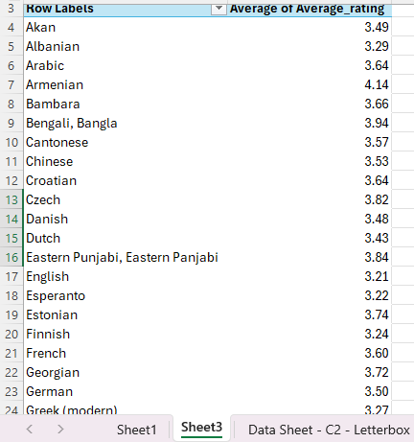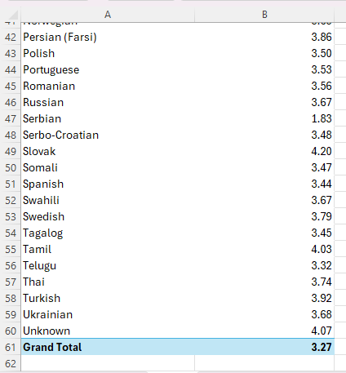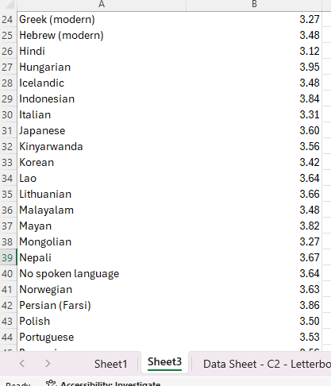

5. Independent Samples T-Test (English vs Non-English Films)
An independent samples t-test was conducted using SPSS to examine whether there is a statistically significant difference in average movie ratings between English-language and non-English-language films (Pallant,2020). The grouping variable divided movies into English (n = 8,074) and non-English (n = 1,926) categories.
Descriptive statistics show that non-English films have a higher mean average rating (M = 3.51, SD = 0.46) compared to English-language films (M = 3.21, SD = 0.52). This indicates that, on average, non-English films tend to receive slightly higher audience ratings.
Levene’s test for equality of variances was significant (F = 27.71, p < .001), indicating that the assumption of equal variances was violated. Therefore, the results from the row “equal variances not assumed” were used for interpretation (Pallant,2020). The t-test results show that the difference in average ratings between English and non-English films is statistically significant, t (3219.60) = 24.88, p < .001.
In addition, the effect size was calculated to assess the practical significance of this difference. Cohen’s d was 0.58, which represents a medium effect size. This suggests that language has a meaningful impact on average movie ratings, with non-English films generally being rated more positively than English-language films (Cohen,1988; Field, 2018).
Overall, the findings indicate a statistically significant and practically meaningful difference in average ratings between English and non-English movies. Screenshot 7
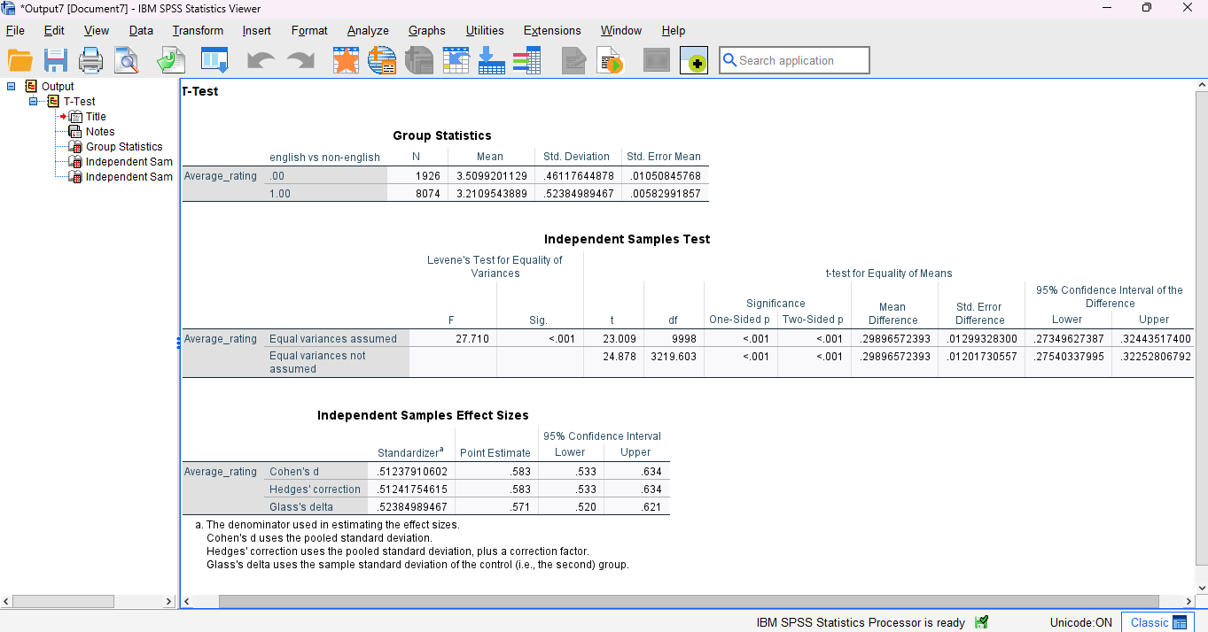

5. 1 Correlation Analysis
A Pearson correlation analysis was conducted using SPSS to examine the relationship between average movie rating and audience engagement variables including watches, likes, fans, and total ratings. The analysis was based on a sample of 10,000 movies, which provides reliable results (Field,2018; Pallent,2020).
The findings show that average rating has a weak but statistically significant positive correlation with all engagement variables. Average rating is positively correlated with watches (r = 0.249, p < 0.001), likes (r = 0.290, p < 0.001), fans (r = 0.251, p < 0.001), and total ratings (r = 0.259, p < 0.001). This suggests that movies with higher audience engagement tend to receive slightly higher ratings, although the relationship is relatively weak (Dancey and Reidy,2017).
In contrast, the relationships between engagement variables are strong and statistically significant. Watches are strongly correlated with likes (r = 0.951), fans (r = 0.671), and total ratings (r = 0.988). Similarly, likes to show strong correlations with fans (r = 0.799) and total ratings (r = 0.973). This indicates that popularity-related variables are closely connected.
Overall, the results suggest that while engagement measures reflect movie popularity, average ratings are influenced by additional factors beyond audience engagement alone. Screenshot 8

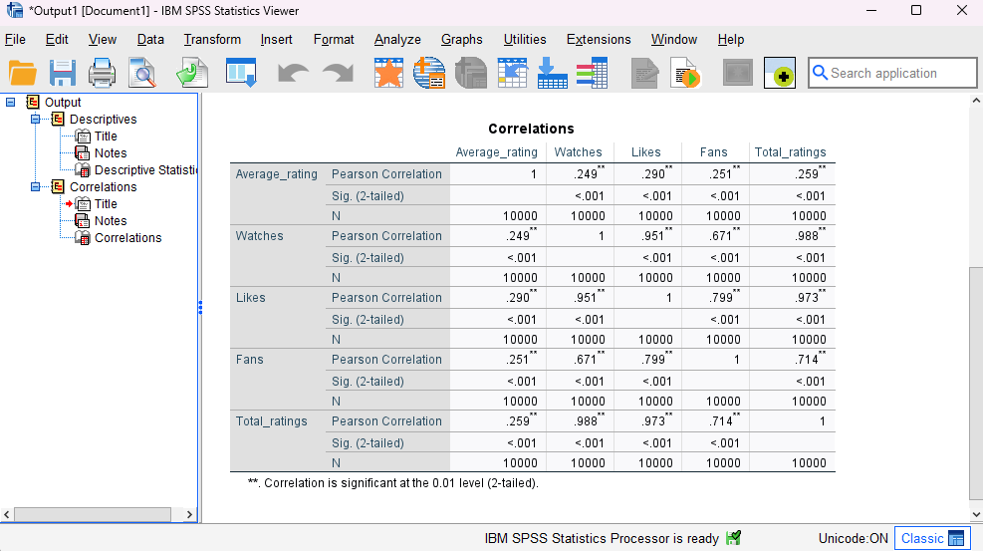

5.2 Regression Analysis
A multiple regression analysis was conducted using SPSS to examine whether audience engagement variables (watches, likes, fans, and runtime) can predict average movie ratings. Regression analysis is commonly used to assess the predictive relationship between a dependent variable and one or more independent variables (Field, 2018).
The regression model was statistically significant (p < .001), indicating that the selected predictors collectively explain a significant proportion of the variance in average movie ratings. Among the predictors, likes and fans showed statistically significant positive effects on average rating, while runtime demonstrated a weaker relationship.
These findings suggest that audience engagement plays a role in predicting movie ratings; however, the relatively modest explanatory power of the model indicates that additional factors—such as genre, storyline, or critical reception—are also likely to influence audience ratings (Pallant, 2020; Field,2018).
Overall, the regression analysis supports the use of statistical models to better understand factors influencing movie ratings and highlights the importance of combining engagement metrics with qualitative factors for a more comprehensive analysis.
6.Conclusion
This report examined patterns in movie ratings and audience engagement using descriptive statistics, visualisation techniques, and inferential statistical analysis. Data cleaning and preparation were first undertaken to ensure the reliability of the dataset, followed by exploratory analysis to identify key trends in ratings and popularity measures.
Trend analysis showed that average movie ratings are generally concentrated around the mid to high range, suggesting that most films receive moderately positive audience evaluations. Visualisations further highlighted variation in audience engagement metrics with a small number of films attracting disproportionately high levels of watches, likes, and total ratings. This indicates that popularity is unevenly distributed across the dataset.
Further analysis demonstrated that original language has a statistically significant relationship with average movie ratings. Non-English films were found to receive slightly higher average ratings than English language films, and this difference was both statistically significant and practically meaningful. However, the magnitude of this difference remains relatively modest, suggesting that language alone does not strongly determine audience evaluation (OECD, 2022).
Correlation and regression analyses revealed that audience engagement variables, such as watches, likes, and fans, are strongly related to each other while their relationship with average ratings is weaker. This suggests that although popular films tend to attract more engagement, higher engagement does not necessarily guarantee higher ratings. The regression results further indicate that additional factors beyond engagement metrics such as genre, narrative quality, or critical reception are likely to influence audience ratings.
Overall, the findings highlight the value of combining descriptive, visual, and inferential statistical methods to better understand audience behaviour and movie performance. The analysis provides a solid foundation for future research using more detailed content-based variables to further explain variations in movie ratings.
References
- Cohen, J. (1988) Statistical power analysis for the behavioural sciences. 2nd edn. Hillsdale, NJ: Lawrence Erlbaum Associates.
- Dancey, C.P. and Reidy, J. (2017) Statistics without maths for psychology. 7th edn. Harlow: Pearson Education.
- Field, A. (2018) Discovering statistics using IBM SPSS Statistics. 5th edn. London: Sage Publications.
- IBM (2023) SPSS Statistics. Available at: https://www.ibm.com/products/spss (Accessed: 16 December 2025).
- Lim, Y.Y and Teoh, A.P. (2020) Realizing the strategic impact of business intelligence utilization, Strategic Direction, 36(4), pp. 7-9.
- Lim, S. and Teoh, S.Y. (2020) ‘Realizing the strategic impact of business intelligence utilisation’, Journal of Strategic Information Systems, 29(2), pp. 1–15.
- OECD (2022) Data analysis and statistical methods. Available at: https://www.oecd.org/en/data.html (Accessed 18th of December 2025).
- Provost, F. and Fawcett, T. (2013) Data science for business: What you need to know about data mining and data-analytic thinking. Sebastopol, CA: O’Reilly Media.
- Sharda, R., Delen, D and Turban, E. (2020) Analytics, Data Science, & Artificial Intelligence: Systems for Decision Support. 11th edn. Harlow: Pearson
- Statista (2023) Film industry statistics and audience trends. Available at: https://www.statista.com/outlook/amo/media/cinema/worldwide?srsltid=AfmBOoqe-CHP9lRJj2xPN-Cz91QRk0bitkwQYJvpxBy00y2A2zD8jtYf (Accessed 17th of December 2025).
- UK Data Service (2023) Introduction to quantitative data analysis. Available at: https://ukdataservice.ac.uk/learning-hub/new-to-using-data/ (Accessed 18th December 2025).
- Vercellis, C. (2009) Business Intelligence: Data Mining and Optimization for Decision Making. Chichester: Wiley.

