Izabela Pietrzyk 2221179

BMHN4001

Physical activity and the distribution of health and disease in the UK populations.
When it comes to enjoying life, health is most important measure. It influences individuals mental and physical wellbeing. In order to understand the importance of leading a healthy lifestyle, this essay will define health and wellbeing of individuals and populations. It will briefly describe how factors such as genetic, environmental or behaviour influence health outcomes. Moreover, it is going to explain why various components such as cardiorespiratory fitness or muscular fitness are important elements of health-related fitness. Furthermore, this essay examines how some of the most important health measures in UK as life-expectancy is related to socio-economic status. Second part of this essay will define and explain the term physical activity. It will investigate the association between levels of physical activity in deprivation.

Epidemiological research measures the connection between different exposures and outcomes and separates them into two categories. Having a negative health condition or leading an unhealthy lifestyle can result in both hard and soft outcomes. Furthermore, Kaplan (1985) describes the hard outcome as mortality or morbidity measures of disease states and conditions that have not reached a mortal endpoint. Likewise, soft outcome is a risk factor or exposure such as high blood pressure, stress or inactivity that can increase the chance of an individual having a hard outcome in a future (Kaplan, 1985). Positive health is accompanying a capacity of enjoying life and it is a crucial component of wellbeing and holistic concept of an individual, whereas negative health is linked with hard or soft outcomes such as morbidity measures, or worst of all, can lead to mortality relating to death before the sex-related average (Bouchard, Malina, Perusse, 1997). Additionally, according to Taylor (2018, p. 3) health and well-being is established as a balance between physical, mental, and social well-being. Rowe and Mitchel (2013, p. 88) explains that health contains various elements, some of which individuals can control and others that they have reduced or no control over. Wellbeing is a difficult concept to define as it varies from one individual to another, and it is measured to be a changing process depending on persons condition (Rowe and Mitchell, 2013).
Health status of an individual is defined by multiple different factors. Health behaviour, alongside health habits has a major impact on health condition. Taylor (2018, p. 39) describes that to be able to enjoy positive health, it is necessary for the individual to develop a program of good health habits, such as exercising, not smoking, not snacking between meals, maintaining a healthy weight, having at least 7 hours of sleep, and limiting alcohol consumption. However, anyone who leads an abnormal lifestyle and is physically inactive, smokes, is heavily overweight or consumes large amounts of processed foods may experience adverse health effects such as heart disease, cancer, stroke, or chronic lung disease (Taylor, 2018).
Another crucial factor influencing health is the environment people live in. Pollutants, availability of food and drinking water, sanitation and hygiene, climate change or opportunities for physical activity is all linked to numerous outcomes in health and well-being (Faculty of Public Health, 2016). According to Graham (2007, p. 61), socio-economic deprivation plays a vital role in relation to the environment factor and people who live in a more deprived area are more susceptible to the effects of pollution and therefore have poorer health outcomes than those living in affluent regions.
Not only behaviour or environment are considered essential elements of health outcomes, but also the inheritance of susceptibility to various diseases. Moreover, interesting information provided by Taylor (2018, p. 29) explains that identical twins are more likely to share their genetic characteristics due to the same genetic makeup, compared to fraternal twins, whose genomic sequence only partially overlaps.

Figure 1 presents Dahlgren and Whitehead rainbow model, showing that personal characteristics, behaviours of an individual, social and community networks, living and working conditions and general socioeconomic, cultural and environmental conditions determine the quality of health. The model has been published by the Public Health England (Public Health England, 2017, fig. 1) to support the governments explanatory message about the health inequalities and the result in poor impact on both mental and physical health.

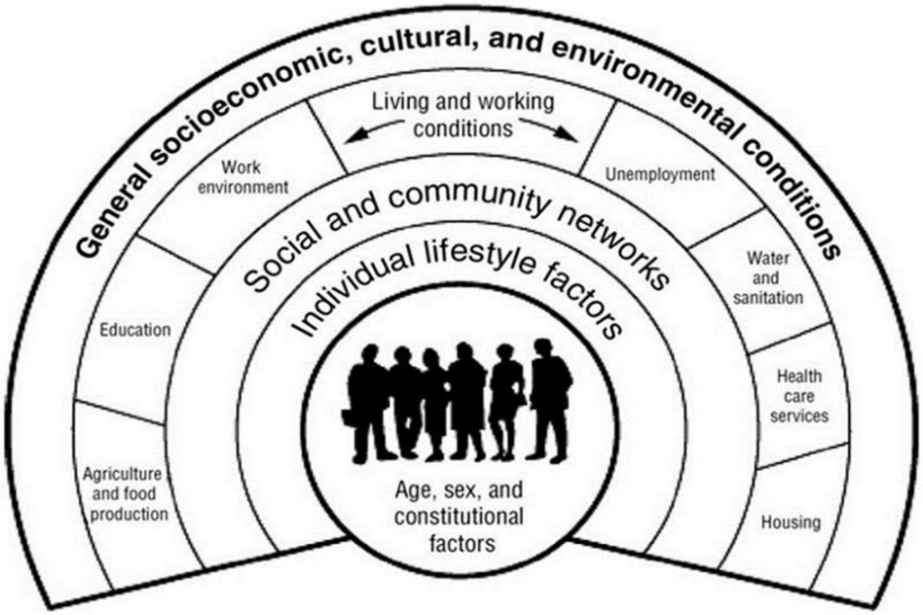

Figure 1: The main determinants of health composed by Dahlgren and Whitehead in 1991 (Public Health England, 2017, fig. 1)

Moreover, when it comes to describing health, health related fitness comes in different forms of fitness components including cardiorespiratory component or muscular component which is related to health status of a person (Bouchard, Malina, Perusse, 1997). Similarly, Liguori (2017, p.1) explains that physical fitness and health related physical fitness have a connection with good health outcomes and correspond with exercise and physical activity, resulting with performing daily activities with vigour and without fatigue. Bayles and Swank (2018, p. 58) clarify that cardiorespiratory fitness is a key component of health-related fitness, and it is characterized by the ability of an individual to complete any intensity exercise in an energetic and continuous approach. It is highlighted that high levels of cardiorespiratory fitness are related to higher level of physical activity and links to health advantages (Bayles and Swank, 2018).
Furthermore, to be able to continue the level of physical activity, people should consider the cardiovascular and respiratory system. Cardiovascular disorders can be considered as both genetic and behavioural factor, including infections or defects present at birth, as well as smoking, lack of exercise, stress, or poor diet (Taylor, 2018). Moreover, Taylor (2018, p. 24) explains that respiratory system is extremely important for the correct functioning of the body and is responsible for inhaling oxygen, excreting carbon dioxide, and regulating blood composition. Interference with its proper functioning can be caused by behaviour or environment factors, such as smoking or living in industrialized urban areas, which can result in severe allergic reaction, for instance asthma (Taylor, 2018).
In addition, Kell (2012) describes that another important component of positive health is related to musculoskeletal fitness, which is associated with reduced risk of osteoporosis and coronary heart disease, increased and improved bone mineral density, greater health benefits with age and better performance of daily activities. Moreover, musculoskeletal fitness is made up of various elements including muscular strength, endurance and flexibility and is defined as the maximum force a muscle can produce to perform an action, the ability to perform repetitive contractions and the dynamic movement of a joint (Kell, Bell, Quinney, 2012).

The UK government measures the health of the population by investigating whether socio-economic status influences the overall wellbeing. The next following lines of the paragraph explain Marmot et al. (2010) review, describing strong difference in life and health expectancy measurements in England, related to most deprived and least disadvantaged areas. Furthermore, relating to social circumstances such as social position and income, people living in the worst-off areas of England, on average, die seven years earlier and spend 17 years more living with a disability that people living in the richest areas of England (Marmot, 2010). Moreover, it is examined that life expectancy is similar for both men and women all over the country and it is a total of 88 years in the wealthiest parts and 71 years in the poorest (Marmot, 2010). Additionally, the report shows that life expectancy in the poorest neighbourhoods of England equals 67 years, similar to national average in countries such as Thailand or Egypt where access to health service is unavailable and lack of clean water, sanitation or shelter appears in some extreme poverty areas resulting in high levels of infant mortality. However, Marmot et al. (2010) explains that the contribution to bad health and reduced years of life of those living in deprived regions of England are not associated with absolute poverty, but variety of different diseases related to drugs, alcohol, smoking or poor nutrition, cancers, or obesity.
In addition, Marmot et al. (2020) recent review reveals changes in inequalities in life expectancy and health over the last decade. The review describes that life expectancy has decreased since 2010 and is especially lower in the most deprived 10% of neighbourhoods in the Northeast of England and higher in the least deprived 10% of neighbourhoods in London (Marmot, 2020). Furthermore, the new report explains that mortality rates linked to suicide, drugs or alcohol abuse have increased in men and women aged 45-49. The conditions people live in are responsible for health inequalities. With this in mind, inequalities in income are associated to peoples life chances. The better the individuals income status, the better the options related to healthy living.

Health is defined in variety of different ways and physical activity is believed to be one of the influences on a positive health outcome. Physical activity is a behaviour, and it is defined as any bodily movement performed by skeletal muscles that requires energy expenditure and can be carried out by different ways including walking, cycling, running or other forms of active entertainment such as yoga or dance (WHO, 2018). Moreover, physical activity is an important component of preventing health risks such as type 2 diabetes, stroke, breast or colon cancer and it hugely benefits health outcomes in both children and adults resulting in improved all-cause mortality, improved cardiorespiratory and muscular fitness, improved sleep, and reduced symptoms of mental health issues (WHO, 2020). According to the World Health Organization (2020) it is recommended that children and adolescence do at least 60 minutes of moderate to vigorous intensity aerobic activity, at least 3 days a week, combining it with some strengthening muscle and bone exercises. Similarly, adults should incorporate at least 150 to 300 minutes of moderate intensity activity, or 75 to 150 minutes of vigorous intensity throughout the week with the addition of muscle strengthening activities on at least 2 days a week (WHO, 2020). In addition, sedentary behaviour or not meeting recommended amounts of physical activity can result in adverse health outcomes and should be avoided by all groups of people (Bayles and Swank, 2018).
Rutter et al. (2019) explains that diseases caused by inactivity are responsible for more than 41 million deaths per year. Furthermore, the government action on improving populations level of physical activity have been insufficient, therefore a system map based on scientific evidence has been developed in hope to examine the factors attributing to physical activity and the relations between these factors (Rutter et al., 2019, p. 163, fig. 1). In addition, a system map gives a better understanding of physical activity determinants for policymakers and practitioners.
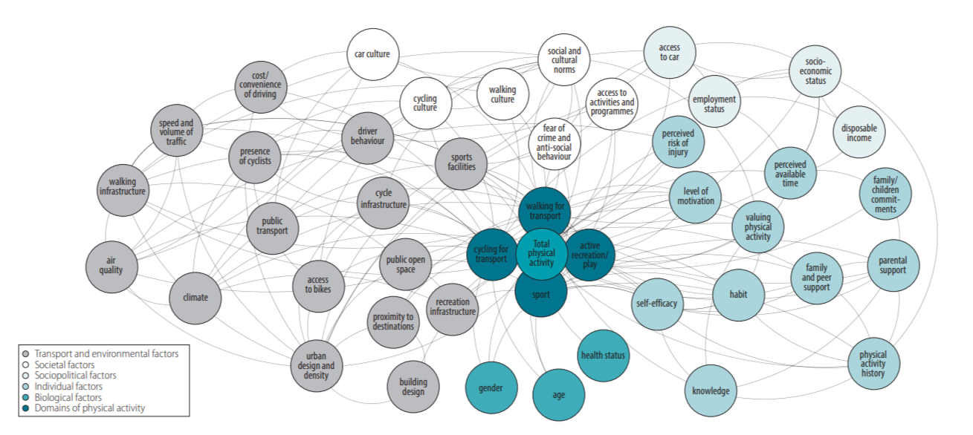

Figure 2: An initial Physical activity system map (Rutter et al., 2019, p. 163, fig. 1)

According to Craike et al. (2018) umbrella review, health outcomes related to physical activity vary between socioeconomic status and people from socioeconomically disadvantaged groups, low income or low education are less likely to be physically active and more prone to adverse health outcomes. Moreover, a cohort study obtaining 6821 respondents written by Jones (2009), describes that people living in most deprived areas have shorter distance to the nearest greenspace by 139m compared to most affluent. However, most deprived areas are considered to be over three times the percentage more difficult to access compared to most affluent. Furthermore, most deprived regions are considered to be more than twice unsafe than affluent areas. Summarising, study written by Jones (2009) explains that deprived areas are surrounded with more greenspace, but people living in those neighbourhoods choose to visit greenspaces less and are unable to achieve physical activity guidelines because of perceived accessibility and safety.

In conclusion, health is characterized by different factors including genetic, behaviour and environment. Those factors can contribute to individuals health outcomes and can result in either positive or negative health. Moreover, it is discovered that peoples position in life influences their health outcome. The more deprived the area is, the more adverse health effect an individual will experience. The government describes that the social-economic status plays a vital role in influencing peoples life expectancy, and people living in most poor areas of England die sever years earlier than individuals living in less deprived areas. It is believed that physical activity has a huge impact on the populations health. However, people living in the most disadvantaged neighbourhoods are less likely to be active therefore have a higher chance of developing a disease, compared to people living in less deprived areas.

Word count – 2053
References
Bayles, M.P. and Swank, A.M. (2018) Exercise testing and prescription. Philadelphia: Wolters Kluwer.

Bouchard, C., Malina, R.M. and Perusse, L. (1997) Genetics of fitness and physical performance. Champaign, IL: Human Kinetics.

Craike, M., Wiesner, G., Hilland, T. A., Bengoechea, E. G. (2018) ‘Interventions to improve physical activity among socioeconomically disadvantaged groups: an umbrella review’, International Journal of Behavioral Nutrition and Physical Activity, 15(43), pp. 1-11. Available at: https://doi.org/10.1186/s12966-018-0676-2

Faculty of Public Health (2016) Environmental determinants of disease. Available at: https://www.healthknowledge.org.uk/public-health-textbook/disease-causation-diagnostic/2f-environment/environmental-determinants-disease (Accessed: 13 November 2022).

Graham, H. (2007) Unequal lives: health and socio-economic inequalities. Maidenhead: Open University Press.

Jones, A., Hillsdon, M. and Coombes, E. (2009) ‘Greenspace access, use, and physical activity: Understanding the effects of area deprivation’, Preventive Medicine, 49(6), pp. 500-505. Available at: https://doi.org/10.1016/j.ypmed.2009.10.012

Kaplan, R.M. (1985) ‘Quantification of health outcomes for policy studies in behavioural epidemiology’, Behavioural Epidemiology and Disease Prevention, 84, pp. 31-54. Available at: https://doi.org/10.1007/978-1-4684-7929-4_3

Kell, R. T., Bell, G. and Quinney, A. (2012) ‘Musculoskeletal fitness, health outcomes and quality of life’, Sports Medicine, 31(12), pp. 863-873. Available at: https://doi-org.ezproxy.uwtsd.ac.uk/10.2165/00007256-200131120-00003

Ligouri, G. (2017) ACSM’s health-related physical fitness assessment manual. 5th edn. Philadelphia, PA: Lippincott Williams & Wilkins.

Marmot, M., Allen, J., Goldblatt, P., Boyce, T., McNeish, D., Grady, M. and Geddes, I. (2010) The marmot review: Fair society, healthy lives. London: The Marmot Review. Available at: https://www.parliament.uk/globalassets/documents/fair-society-healthy-lives-full-report.pdf (Accessed: 2 December 2022).

Marmot, M., Allen, J., Boyce, T., Goldblatt, P. and Morrison, J. (2020) Health equity in England: the marmot review 10 years on. London: Institute of health equity. Available at: https://www.instituteofhealthequity.org/resources-reports/marmot-review-10-years-on/the-marmot-review-10-years-on-full-report.pdf (Accessed: 2 December 2022).

Public Health England (2017) Chapter 6: social determinants of health. Available at: https://www.gov.uk/government/publications/health-profile-for-england/chapter-6-social-determinants-of-health (Accessed: 16 November 2022).

Rowe, J. and Mitchell, A. (2013) Key concepts in health and social care. London: Collins.

Rutter, H., Cavill. N., Bauman, A. and Bull. F. (2019) ‘Systems approaches to global and national physical activity plans’, Bull World Health Organ, 97, pp. 162-165. Available at: http://dx.doi.org/10.2471/BLT.18.220533

Taylor, S.H. (2018) Health psychology. 10th edn. New York: McGraw-Hill Education.

World Health Organization (2018) More active people for a healthier world. Available at: https://moodle.uwtsd.ac.uk/pluginfile.php/637320/mod_resource/content/1/WHO%20Global%20Action%20Plan%20on%20Physical%20Activity%2C%202018-30.pdf (Accessed: 21 November 2022).

World Health Organization (2020) Physical activity and sedentary behaviour. Available at: https://moodle.uwtsd.ac.uk/pluginfile.php/525180/mod_resource/content/1/9789240015128-eng-2.pdf (Accessed: 21 November 2022).

