Foreign Languages & Cultural Awareness

MODULE: BMIH5003
Lecturer: Giulia Chifari
ID: 2235127
Marian Cristian Avram

Table of Contents
Introduction: 3
Key differences & Cultural aspects: 3
Religion: 3
Gender: 3
Race: 3
Customs: 3
Cultural & Leadership Comparison: GLOBE’s Project 3
Performance Orientation 3
Assertiveness: 4
Future Orientation 4
Humane Orientation 4
Institutional Collectivism 4
In-group Collectivism 4
Gender Egalitarianism 4
Power Distance 5
Uncertainty Avoidance 5
Leadership Styles: 6
Challenges of Intercultural Leadership: 6
Example 1: 6
Example 2: 7
Potential areas of conflict in the hotel: 7
Performance Reviews and Feedback 7
Work-Life Balance 7
Recommendations: 7
Conclusion: 7
References: 8

Introduction:
I have been appointed as a General Manager and need to visit Portugal branch of our esteemed hotel chain to get firsthand information about the execution of the organisation’s mandate and to get acquainted with the brand standards of the entity. This initiative is especially relevant as several employees will transfer to our London branch effective July 2024 (Nedelko & Brzozowski, 2020). This report is focused on giving detailed descriptions of the culture and leadership prominent during the visit, which are essential for guaranteeing successful integration into the setting and retaining the quality of our brand.

Differences & Cultural aspects:
The people of the UK and Portugal are quite different in their behaviours and attitudes.
Customs: According to the analysis, Portuguese manners remain more formal and conventional and are more focused on family-centred values than British ones, which are more individualistic and informal.
Gender: Gender roles are highlighted more in Portugal than in the UK since the latter has an English woman as its prime minister.
Race: The UK's racially diverse population is attributed to its immigration history and colonial conquest. At the same time, Portugal has a relatively more homogenous population than the UK but is less diverse (Martin, 2016).
Religion: Portugal's religion is majorly Catholic, while the UK's religious background is more diversified, with Anglicans and others (Sam, 2023).

Cultural & Leadership Comparison: GLOBE’s Project

Power Distance
The study found that PD scores for the UK are lower, signifying that the UK is characterised by a low level of hierarchy and a comparatively low degree of centralisation. Power distance is seen as low in Portuguese society in terms of how participants respect authority and obey the chain of command (Mukhtorov, et al., 2023).

Assertiveness:
The level of assertiveness in the UK can be considered high, and employees can share their views or communicate directly with others. Conversely, employees from Portugal are less likely to be aggressive or pushy when it comes to enforcing their position.

Future Orientation
UK workers tend to be highly future-oriented. They are willing to plan for the future, be creative when developing strategies, and look forward to achieving these goals (German & Ismael, 2023). Portugal's score is also high, as Portuguese employees balance short-term and long-term needs while considering future implications.

Performance Orientation
Therefore, UK employees generally have a performance-oriented organisational culture that focuses on achievement and accountability over results. It is evident that unlike the employees of Portugal, who highly regard performance, the Portuguese employees consider the relational coordinates together with the organisational coordination with success (Ren, et al., 2023).

Humane Orientation
While UK employees may implement these values more systematically than organisations through tangible social responsibility programs, Portuguese employees earn high scores in humane orientation, which reveals their desire and predisposition to help and be generous due to cultural factors, as analysed by the research.

Institutional Collectivism
Employees in the UK have low scores in institutional collectivism and high scores in individualism. The scores in the chart below state that employees of Portuguese culture have slightly higher institutional collectivism, indicating the group’s allegiance and organisational goals.

In-group Collectivism
The concept of collectivism is significantly stronger in the case of Portuguese employees, as they value interpersonal relationships, as stated by the analysis. Portugal appreciates the importance of teamwork on a high level; they are considerably more in-group.

Gender Egalitarianism
UK culture strongly values gender egalitarianism, which advocates for equal rights for both genders (JungYun, 2019 ). Portugal can be seen as scoring relatively high on gender equality; however, there may be noticeable tendencies toward more traditional roles in specific social and occupational domains.

Uncertainty Avoidance
The UK employees are more open-minded and eager to cope with uncertainty, and they are less oppressive to experimentation in their solution-finding strategies. As predicted by the study, employees in Portugal tend to avoid uncertainty more, which means that they prefer stable circumstances, well-defined rules, and structured arrangements.
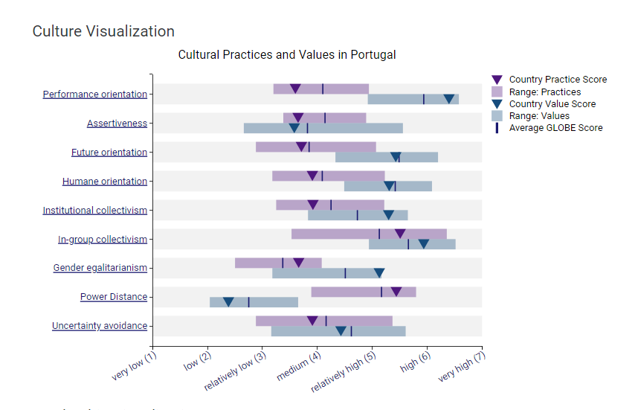 (Globe, 2020)

Leadership Styles:
Humane-oriented leadership in the UK is more formal and supports humane organisations structurally. It increases professional empathy, whereas, in Portugal, humane-oriented leadership is more communal and has no impact.
Autonomy in the UK entails independent decision-making and risk-taking in leadership, thus leading to self-reliance and trustworthy conduct. On the contrary, Portuguese leaders stress equality and collective decision-making and work as a team rather than as separate individuals, as predicted by the study.
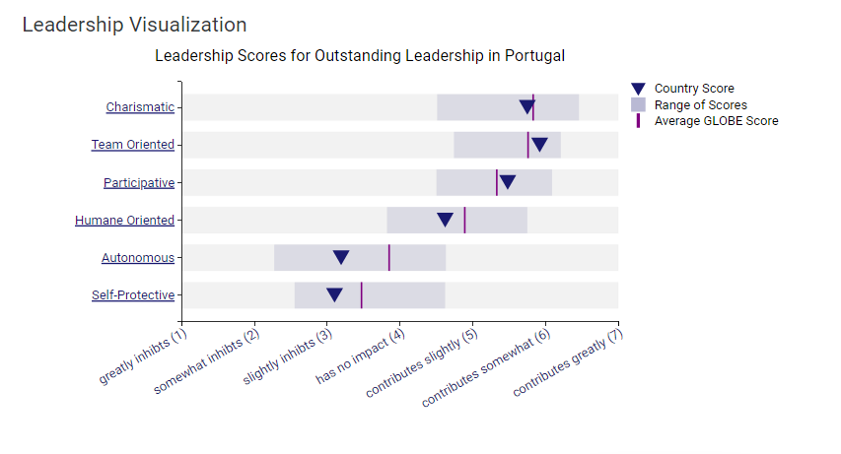
(Globe, 2020)

Challenges of Intercultural Leadership:
This paper analyses how leadership expectations differ from one cultural context to another (Lu & Wan, 2019).
Example 1: While employees in the UK might demand a more engaged and equal approach to management, those in Portugal may be more inclined to accept a strict top-down format.
Example 2: In the case of the hotel, this may foster discord. On the one hand, UK staff might be bothered by the idea that they are being directed, while on the other hand, Portuguese staff will be uncomfortable, given that they are not offered much direction.

Potential areas of conflict in the hotel:

Performance Reviews and Feedback
Honest interpersonal communication is popular in the UK, where it is regarded as an effective method of communication. However, it is important to understand that feedback may be delivered relatively softly in Portugal because of politeness.

Work-Life Balance
Employees in the UK might follow a strict working-for-pay timetable and maintain appropriate professional conduct. Portuguese may be more informal and thereby may not have as formal a boundary between their work and that of others.

Recommendations:
- Cultural Sensitivity Training: The hotel needs to incorporate cultural sensitivity training to promote cultural sensitivity and diplomacy among its employees.
- Flexible Leadership Approaches: The hotel should promote cultural values and help leaders transform cultures to be flexible for workers, regardless of cultural differences.
- Inclusive Decision-Making: Support ‘voice’, enabling employees to raise concerns and coordinate agendas.

Conclusion:
The study concludes that various cultural differences exist in the world, and it was crucial for the hotel to understand them as it embarked on planning and implementing intercultural leadership (Lu, 2019). The following discussion outlined how the hotel can address these challenges to effectively capitalise on the ever-diverse team and improve overall performance and customer satisfaction.

References:
German, G. & Ismael, P., 2023. Diversity and inclusion in hospitality and tourism. International Journal of Contemporary Hospitality Management, Volume 36.
Globe, 2020. Globe 2020\. [Online]
Available at: https://globeproject.com/results/countries/PRT%3Fmenu=list.html#list
JungYun, H. S. J., 2019 . Is consumer forgiveness possible? Examining rumination and distraction in hotel service failures. International Journal of Contemporary Hospitality Management.
Lu, Z. & Wan, Y., 2019. Consumers’ responses to invitations to write online reviews: The impact of message framing, power and need for status. International Journal of Contemporary Hospitality Management.
Lu, Z. W. Y., 2019. Consumers’ responses to invitations to write online reviews: The impact of message framing, power and need for status. International Journal of Contemporary Hospitality Management.
Martin, o., 2016. Culture and Dialogue. s.l.:Brill.
Mukhtorov, Botir & Murodjon, E., 2023. METHODS OF EFFECTIVE HUMAN RESOURCE MANAGEMENT. International Journal Of Management And Economics Fundamental, p. 76–80.
Nedelko, Z. & Brzozowski, M., 2020. Recent advances in the roles of cultural and personal values in organizational behavior’ Advances in Human Resources Management and Organizational Development Book Series. Hershey: IGI Global.
Ren, Y., Choe, Y. & Song, H., 2023. Antecedents and consequences of brand equity: Evidence from Starbucks coffee brand.. Int. J. Hosp.Manag, p. 103351.
Sam, 2023. Guest room cleaning procedure.pptx. [Online]
Available at: https://www.slideshare.net/samkeliso/guest-room-cleaning-procedurepptx

