

LEVEL 4 ASSESSMENT SPECIFICATION
Student name: |  | Student ID number:
Programme: | CertHE Computing Skills for Workplace
Module: | Introduction to Web and Database Concepts
Module code: | ACCA4023 | Contribution to Overall Module Assessment (%): | 50%
Lecturer: | Sadhana Jha, Shah Room | Internal Verifier: | Abida Perveen
Assignment Title: | HTML & CSS Web Development | Word count (or equivalent): | 2000

Table of Contents
1. Introduction 3
2. Project Aims and Objectives 4
3. Website Planning and Design 4
4. Technologies Used and Website Development 6
4.1 HTML5 6
4.2 CSS3 6
4.3 Bootstrap 6
4.4 Visual Studio Code 7
5. Website Features, Testing and Evaluation 7
6. Challenges Encountered 11
7. Recommendations for Future Improvements 11
8. Conclusion 12
9. References 13

DriveEasy Car Rental Website Report

Introduction
The advancement of digital technology has made the website an important channel that businesses can use to market their products or services. The availability of websites for car rental businesses enables them to show their inventory, conduct reservations, provide customer support and build their brands. A good website increases customer satisfaction through easy navigation, great design and accessibility of information. As explained by Krug (2014), websites ought to be simple, efficient and user-friendly to make it easy for people visiting them to find relevant information. Responsive web design is another crucial feature of a modern website since clients access websites using different devices.
In this project, I have designed and developed an adaptive website for a hypothetical car rental firm known as DriveEasy. The design and development of this website took place using HTML5, CSS3, Bootstrap 5, and Visual Studio Code. In choosing Bootstrap, its responsive grid system makes sure that the website adjusts effectively to desktop, tablet, and mobile devices (Bootstrap, 2025). Four webpages were developed namely: Home page, Cars page, about page, and Contact page.
The site has features including responsive navigation menu, hero section, booking form, about page, contact form, and Google Maps. The features are a representation of how front-end web development techniques have been used for practical purposes.
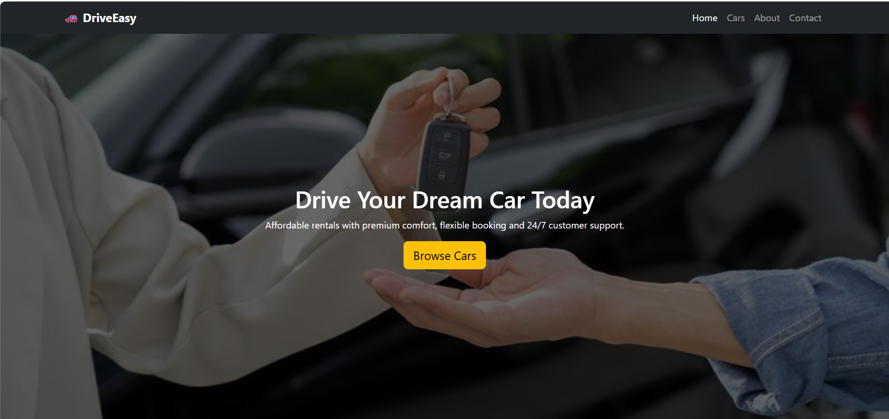
Figure 1: Homepage of the DriveEasy Car Rental Website:

Project Aims and Objectives
The first goal of this project was to create the website for a pretend car hiring company DriveEasy that is professionally designed and convenient to use. The site makes it possible to look at the list of the rental vehicles, learn about the company, and contact the firm using a contact form. In accordance with the principles of good web design, the website focuses on functionality, aesthetically appealing nature, and ease of navigation (Duckett, 2021).
The main goals were the creation of the responsive website based on Bootstrap 5 which would work well on desktops, tablets, and mobile devices (Marcotte, 2014), provision of the intuitive navigation system which will increase usability (Nielsen, 2024), the presentation of rental cars via Bootstrap cards with photos, prices, and descriptions (Krug, 2014), provision of the information about the company via the informative About page, and creation of the Contact page with the contact form and integrated Google Map (Garrett, 2011). These objectives collectively helped ensure that the website satisfied all current usability, accessibility, and responsive design standards.
Figure 2: Website Navigation Structure

Website Planning and Design
Website planning and design is a vital process for the creation of the DriveEasy Car Rental website, as it sets the foundation for the future layout and functions of the website. Proper planning helps to avoid mistakes during the development process and make sure the website will satisfy the user's needs. As stated by Garrett (2011), successful websites start from good planning of user's needs, information architecture and interface design. That is why the website was created in order to create an easy-to-use website with a nice user interface.
The site has four pages that are related: Home, Cars, About, and Contact. In the Home page, there is a hero banner of the firm, featured cars, testimonials of customers, and the booking form. On the Cars page, there are various cards of available vehicles with images, descriptions, and the rental prices. About page highlights the firm's vision, mission, and values while in the Contact page there is the contact form, business contacts and the Google map. It makes it easy for users to find the information since it is separated into different pages (Krug, 2014).
The colours in the modern scheme were used for the design of the site to give a professional look. Dark grey and black colours were applied on the navigation bar and the footer respectively. White background colors have been used to enhance readability. Yellow call-to-action buttons have been included to highlight the features on the site. Colour contrast and visual hierarchy will aid in the usability of the web design since the viewer’s eyes will be directed to important elements (Lidwell, Holden and Butler, 2010).
For readability purposes, sans-serif fonts, standard headings, and adequate white spaces were employed (Williams, 2015). The navigation bar is present in all pages where it collapses into a more user-friendly mobile menu through the Bootstrap responsive navigation feature (Marcotte, 2014).
The Bootstrap grid system, cards, forms, and buttons were employed for the development of an organized and responsive structure to reduce time taken to develop the website while making it look professional (Bootstrap, 2025). In summary, the planning and designing process was effective in balancing functionality, usability, and aesthetics of the web page to form a basis for the implementation of the website.
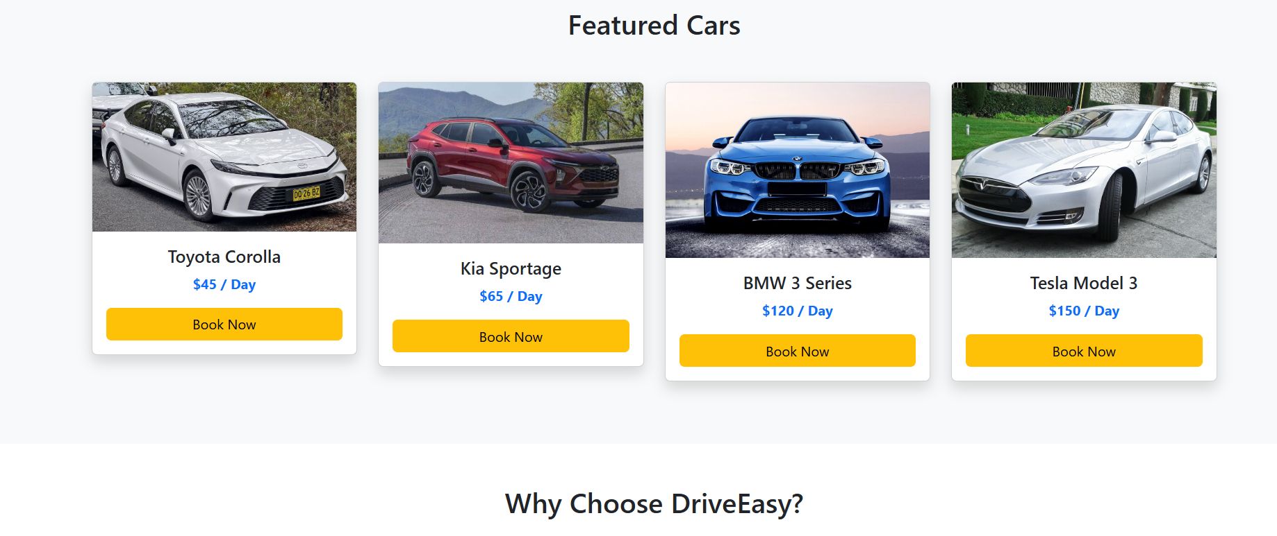
Figure 3: Website Design Layout

Technologies Used and Website Development

The construction of the DriveEasy Car Rental website involved the application of HTML5, CSS3, Bootstrap 5, and Visual Studio Code. Each of these technologies contributes to developing an appealing site while achieving some target functions, including responsiveness as well as making the site easy to handle by users (Duckett, 2021).

4.1 HTML5
HTML5 is the basis of the future website. The use of semantic tags like <header>, <nav>, <section>, <footer>, and <form> and is responsible for structuring information and facilitating accessibility and SEO (MDN Web Docs, 2025). With the help of HTML5, four pages were designed: the Home, Cars, About, and Contact sections. All these pages were interconnected with the help of the navigation menu, along with HTML forms that collected information about customers, such as names, emails, messages. Moreover, HTML5 validation performed the function of checking the used input (Freeman, 2018).

4.2 CSS3
CSS3 is the technology that established the aspect of the website by regulating its colors, fonts, spacing, layout and images. A particular style.css file was used for unifying style on all site pages. For instance, the hero section involved the usage of a large-width background picture along with overlays for text (Lidwell, Holden and Butler, 2010). In addition, some features of cars were provided with hover effects and transition effects.

4.3 Bootstrap
The website was constructed using Boostrap 5. Bootstrap ensures that the navigation bar changes size according to available screen size. It uses the 12-column grid system to display everything elegantly on the desktop, tablets, and mobile phones (Bootstrap, 2025). Various elements that Bootstrap is offering such as cards, buttons, forms, and spacing utilities, contributed to easy creation of professional-looking website without spending large amounts of time on development.

4.4 Visual Studio Code
Visual Studio Code (VS Code) served as the development environment, thanks to its quality of offering syntax highlighting and code completion (Microsoft, 2025). The usage of the Live Server extension made it possible to view any changes in the browser immediately. Therefore, there was no need to include too much time in testing of the code and making corrections. Thus, these technologies helped to create a modern website that meets all the current standards and requirements and helped to lay a strong foundation for future improvements.
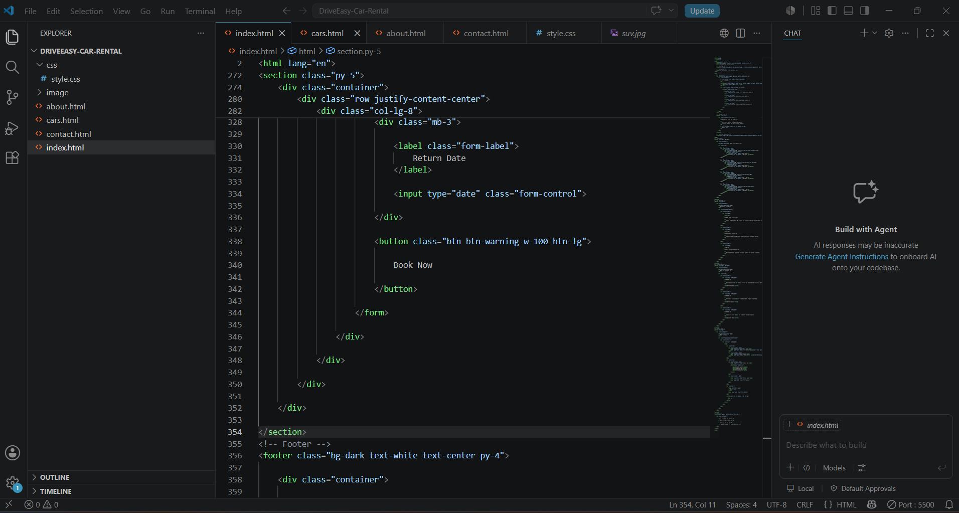
Figure 4:Home Page Developed Using visual studio code

Website Features, Testing and Evaluation
The objective of DriveEasy Car Rental website was to create a user-friendly, responsive, and attractive site that customers would enjoy using while looking for rental cars and exploring information about the company. The principal aim of the site is to provide the visitors with usability, accessibility, and responsive design in order to offer improved experience. Businesses with clear navigation and simple structure have more chances to satisfy customers (Nielsen, 2024).
One of the distinctive features of the site is its navigation bar that is consistent in Home, Cars, About, and Contact sections. The navigation bar is equipped with the Bootstrap system and so it turns into a mobile-friendly version when accessed from smaller devices (Marcotte, 2014). The home page has a banner saying “hero”; there are information about the different rental vehicles there as well as reviews from other customers and booking form designed to increase engagement level of the customers.
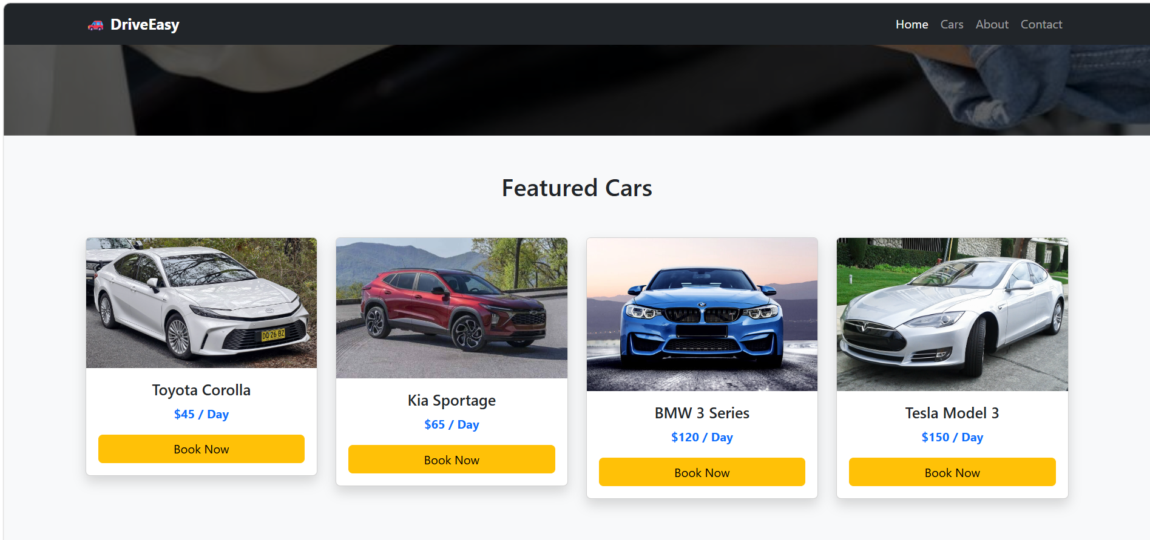
Figure 5: Home page
The Cars page contains car rental information due to the use of Bootstrap cards that include images, descriptions, prices, and booking reference buttons (Lidwell, Holden, and Butler, 2010).
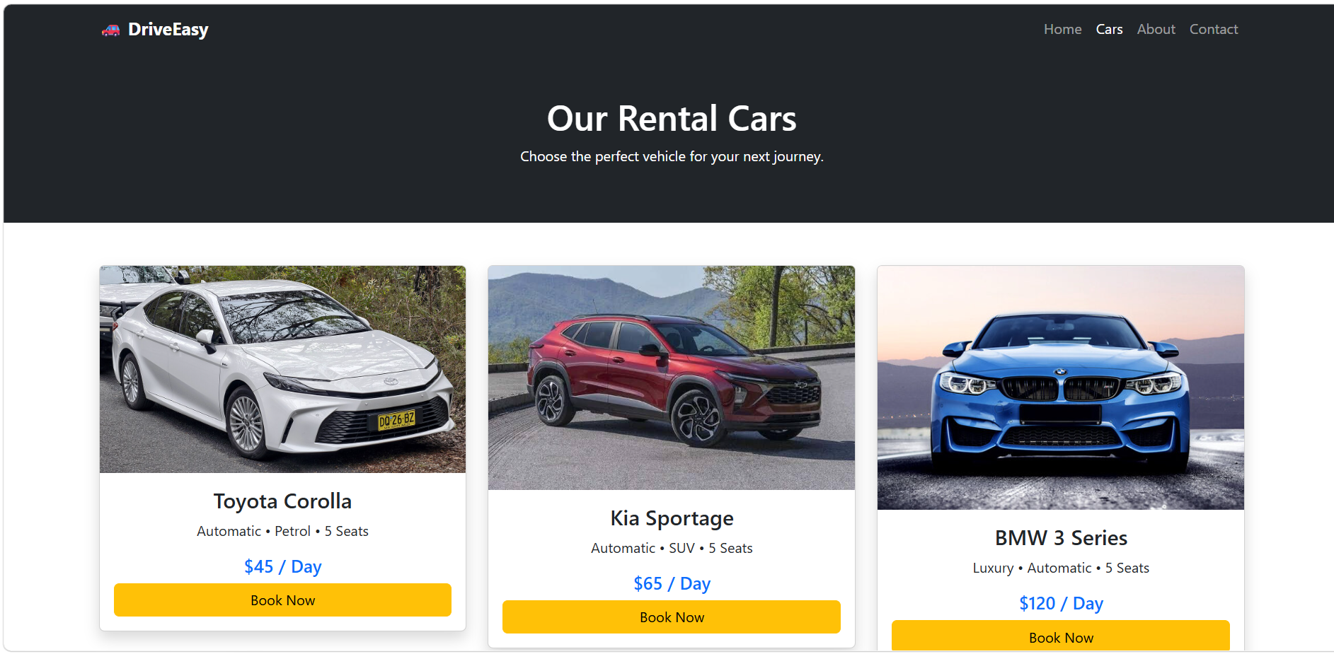
Figure 6: Car page
The About page of the company features information about its mission, vision, and values (Garrett, 2011).
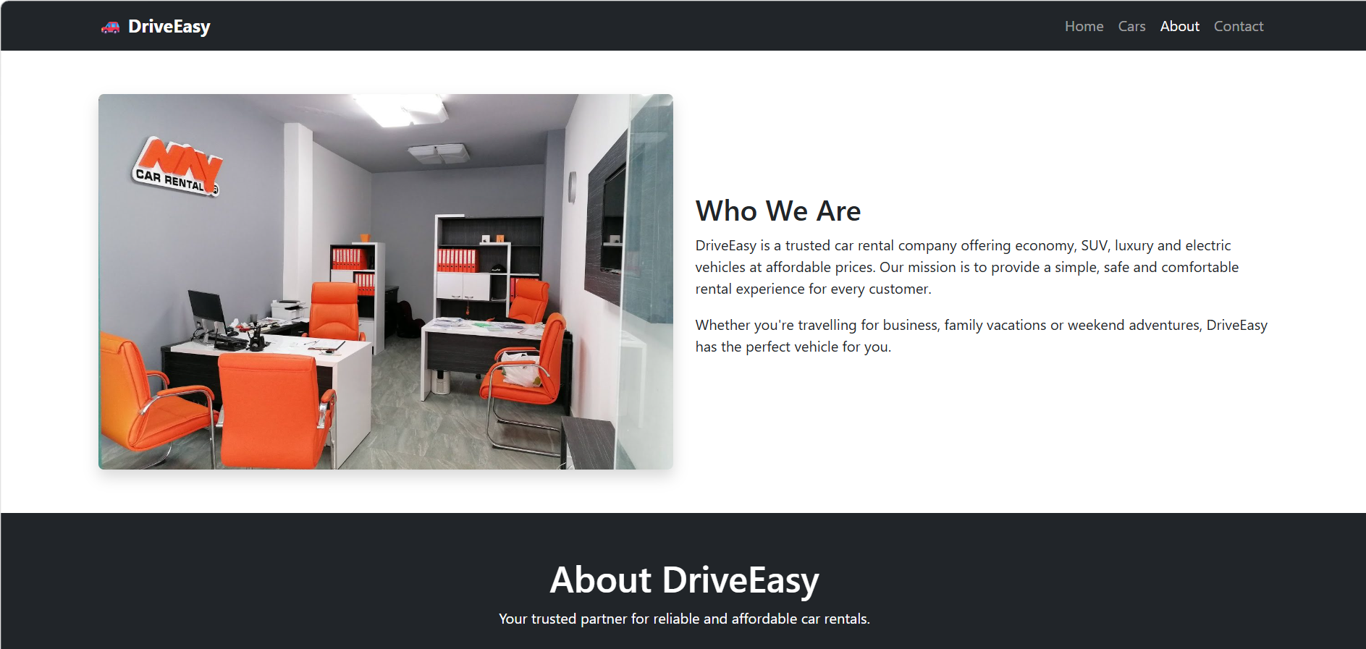
Figure 7: About page
Finally, the Contact page provides information for contacting the company, office location, and includes contact form for a visitor to fill in.
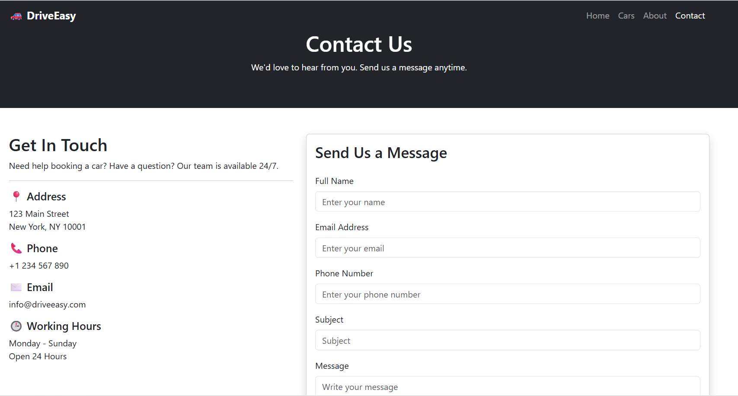
Figure 8: Contact page
Website testing ensured that it functions properly and responds adequately. The testing of various hyperlinks, forms, images, in addition to the testing of Bootstrap elements has been conducted to ensure the high quality of the site. The creation process involved the identification and correction of errors pertaining to image links and missing Bootstrap components because of which, tools such as Visual Studio Code and a Live Server extension were utilized for conducting real-time testing of the website as described in (Microsoft, 2025).
In general, the website performed well since it satisfied its requirements because it was built with a responsive design and had good navigability, usability and visually appealing representing interface. Although the future implementing of functionalities such as the ability for users to make an online payment or use a database could further improve the effectiveness of the website, it has already revealed that front-end development and the principles of responsive design were properly applied.

Table 1: Website Testing Results
Test Performed | Expected Result | Outcome
Navigation Links | All pages open correctly | Passed
Hero Image | Background image displays correctly | Passed
Featured Car Images | Images load without errors | Passed
Bootstrap Components | Navbar, cards and forms display correctly | Passed
Responsive Layout | Website adapts to desktop, tablet and mobile screens | Passed
Contact Form | Form fields display and accept input | Passed
Footer Links | Footer displayed consistently on all pages | Passed

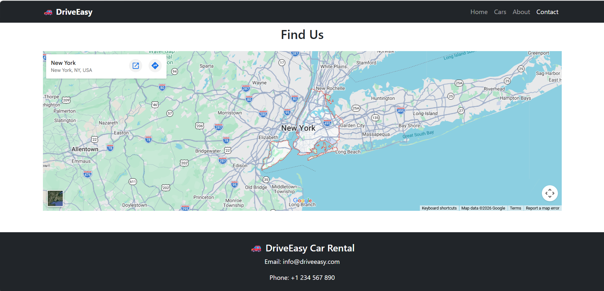
Figure 9: Contact Page Google Map

Challenges Encountered
Many technical and design issues were met while creating the DriveEasy Car Rental website. One of the major issues involved the correct structure of the HTML5 document. Some websites did not include some required elements, like DOCTYPEhtml>, <head>, and <body> tags that can make the Bootstrap components work incorrectly. Once the fixing code had been finished, the necessary elements were added so that the pages were correctly rendered. The next issue involved linking the external sources, as incorrect file path was preventing CSS and images from loading (MDNWebDocs, 2025).
This situation was eliminated due to careful organization of project folders and the paths correction. Responsive design required making some changes as well. Although the website is working correctly on the desktop computer, some of its sections are misaligned when opened on tablets and smartphones. In order to make Bootstrap's responsive grid system and utility classes react adequately and adjust all design elements correctly (Bootstrap, 2025). Large image files made the loading slow because images had to be resized and optimized making the website run smoothly with a good quality (Google, 2024). Consistency of color, text type, spacing, and the navigation throughout all pages was another task, but the issue was solved with the help of common stylesheet and usage of Bootstrap items (Garrett, 2011).

Recommendations for Future Improvements
Though the website succeeded in achieving the tasks set and designed for the website, there are still things that can make it even better. For instance, linking the MySQL database will allow booking processing and keeping records of the customers. One potential aspect of enhancing the customer experience is developing a reliable authentication system so that users can register, manage their reservations and review their past bookings. Payment integration through trusted third parties like PayPal or Stripe will provide users with an opportunity to pay online, thus making the process more secure and convenient.
Furthermore, users would appreciate additional features like searching for cars and filtering them based on the requirements pertaining to type, price, number of people, etc. Other tools such as live chat support, booking confirmation emails, and customer feedback mechanisms will considerably contribute to customer experience. It is also essential to ensure that users with disabilities find the site comfortable to use by following WCAG recommendations as confirmed by W3C (2023).

Conclusion
The DriveEasy Car Rental website accomplishes its goal by creating a responsive and user-friendly website with HTML5, CSS3, Bootstrap 5, and Visual Studio Code. The project showed how to apply modern front-end web development techniques in practice and was an opportunity to improve skills in planning, coding, testing, and debugging. Thus, the newly developed website creates a nice interface to see cars and contact the company and can also serve as a great base for further improvements, including a database, online booking, securing payment, etc.

References
Bootstrap. (2025). Introduction . https://getbootstrap.com/docs/4.1/getting-started/introduction/
Duckett, J. (2021). HTML and CSS: Design and build websites (2nd ed.). Wiley.
Garrett, J. J. (2011). The elements of user experience: User-centered design for the web and beyond (2nd ed.). New Riders.
Google. (2024). PageSpeed Insights. https://developers.google.com/speed/pagespeed/insights_extensions
Krug, S. (2014). Don't make me think, revisited: A common sense approach to web usability (3rd ed.). New Riders.
Lidwell, W., Holden, K., & Butler, J. (2010). Universal principles of design (2nd ed.). Rockport Publishers.
Marcotte, E. (2014). Responsive web design. (2nd ed.), A Book Apart, LLC., New York, 153.
MDN Web Docs. (2025). HTML: HyperText Markup Language. https://developer.mozilla.org/en-US/docs/Web/HTML
Microsoft. (2025). Visual Studio documentation. https://learn.microsoft.com/en-us/visualstudio/windows/?view=visualstudio
Nielsen, J. (2024). Usability heuristics for user interface design. Nielsen Norman Group. https://www.nngroup.com/articles/ten-usability-heuristics/
W3C. (2023). Web Content Accessibility Guidelines (WCAG) 2.2. https://www.w3.org/TR/WCAG22/
Williams, R. (2015). Non-designer's design book (4th ed.). Peachpit Press.

