Task 1 2
Task 2B:Create a mind map of contemporary software applications that are used to support day-to-to-to-today 5
business/ Organisation operations. 5
Task 3 6
Task 4 16
Bibliography 20

Full name: Daud Mohammed Jama
Student ID number: 2442748
the program of study: CertHE Computing Skills for Workplace
module name: Software Solutions for Business
module code: ACCA4026
Lecturer’s name: Rajeev Nath
date of submission: Monday [15-12-2025] 14:00 (2PM)
the university name with relevant campus name: University of Wales Trinity St David

Table of Contents

Task 1. e-Commerce Website builders/software solutions (Approx. 500 words) Give a description of two contemporary e-Commerce website builders/software solutions (approx. 2/3 sources).
E-commerce website builders have changed how businesses establish an online presence, offer accessible, scalable, and cost-effective tools which allows you to create and manage digital stores much more efficiently. This task showcases two leading e-commerce website builders while examining their features, advantages, and limitations.

Shopify
Shopify is one of the most popularly used e-commerce platforms globally, with over 3.7 million online stores running through there platform[ [1]It is a cloud-based platform meaning that it allows users to design, launch, and manage an online shop from the comfort of your home or wherever they are while also it not being too complicated. Shopify provides the foundation for you to start your website through a library of customisable templates, allowing businesses to create professional storefronts efficiently
building, payment processing, and marketing tools into one. The platform supports multiple payment methods such as Shopify Payments, PayPal, and credit cards, while offering analytics A main strength of Shopify is its all-in-one approach. The platform includes website and social media marketing. The Shopify App Store provides over 13,000 apps for efficiency, such as inventory management, email marketing, and drop shipping [ [2]

Fig 1: Website developed using Shopify features
One of the main advantages of Shopify is its ease of use and strong customer support. It is more suitable for small to medium-sized businesses seeking an efficient and reliable method to build an online presence for there businesses. However, Shopify has some negatives. This is due to restricted design flexibility beyond its available templates, but it also has the opportunity for a wider variety of templates for an increased cost due to
BigCommerce
BigCommerce is another major Software e-commerce platform that primarily focuses premium app subscriptions and third-party transaction fees.on flexibility and efficiency. the platform is designed to help develop both small businesses and large ones. They offer efficient tools for managing difficult catalogues and sales.
BigCommerce provides multiple e-commerce tools. It supports multiple businesses under a single account, making it easy for companies to manage different brands . The platform also includes B2B features such as custom pricing and bulk ordering,
One of BigCommerce’s main advantages is its efficiency and marketing tools that are not complex to use . The platform displays analytics and multi-currency options. Another of its main advantages is BigCommerce does not charge transaction fees, which is very beneficial for high-volume sellers [3]
BigCommerce is great for fast-growing businesses that also require flexibility and global reach.The platform supports high-traffic stores and large product catalogues. The platform offers more design freedom and performance capability highlighting the benefits of using BigCommerce.On the other hand , BigCommerce can be difficult for beginners compared to Shopify, as its advanced tools may require more technical knowledge due to its complexity. The number of free templates is limited, and plans can be costly for smaller/new businesses.

Task 2. Mind-map of contemporary software applications (Approx. 500 words). a. Describe mind mapping and explain the benefits of using mind mapping in business operations (approx. 2/3 sources).

Mind mapping is using diagrams to portray information in a hierarchical structure-the central theme is at the core and related concepts branch out from it. Mind mapping differs from traditional note taking in the way the graph is flexible despite it’s innate structure, mind mapping uses keywords and symbols to show the connection and relationships between ideas[ [4]Regarding modern software applications, mind mapping can categorise diverse types of software applications in a way that people can understand. The visual representation of these softwares and their functions provide clarity on how digital tools support various organisations.
Mind mapping offers numerous benefits in business operations such as the improved understanding when dealing with complex information. Modern businesses are reliant on multiple software applications to cover a variety of roles including managing operations, financesand customers. Mind mapping allows these businesses to visualise how exactly these applications interact with and support their goals, making it easier to comprehend systems, and reducing information overload by helping individuals quickly identify key components and relationships within business operations[ [5]
Further benefits of mind mapping include its ability to boost creativity and innovation by encouraging free association and idea generation, allowing the exploration of multiple possibilities. Employees can use mind maps during brainstorming sessions to come up withideas for new software, efficiency improvementor digital strategy. This approach supposes innovative thinking forcing organisations to adapt to changing technological environments.
Mind mapping is also vital for planning decision-making and problem solving particularly in business operations where decisions often involve many costly factors such as price, time, resources and risk. Mind maps reduce the chances of making a wrong decision as they help visually compare options which helps businesses to evaluate strengths and weaknesses as well as identify challenges. For example, if a software application were to be adopted, mind maps could lay out the steps needed as well as training, benefits and risks increasing the information had before making the decision.
Additionally, communication and collaboration within organisations is improved by mind mapping making it easier for collaboration within a company. Visual information is easier to comprehend than text, making it simpler for teams to share ideas and come to an understanding. Mind maps are especially useful during meetings as well as presentations as they clarify talking points and provide a concise overview enhancing teamwork and reducing misunderstandings.
In conclusion, mind mapping is effective for organisation and providing clarity for modern softwares and business operations. Due to the way it simplifies information, it supports creativity, planning and decision making, improving communication. Integrating mind mapping into daily operations can improve business’ productivity, efficiency and strategic thinking and to integrate mind mapping into training, product management would further improve these things by creating an adaptable but structured way of thinking which helps businesses to remain responsive to change in a way that still honours their original principles by maintaining clarity, alignment and focus in an increasingly digital environment. Overall, mind mapping strengthens organisational learning, supports continuous improvement, and helps businesses align technology, people and processes more effectively.

Task 2B:Create a mind map of contemporary software applications that are used to support day-to-to-to-today

business/ Organisation operations.

Software Applications Mind map :

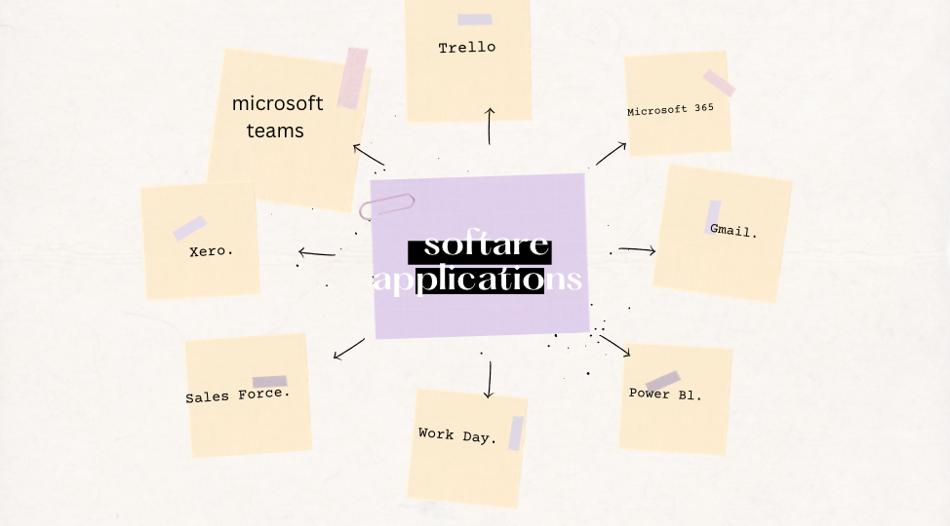

Task 3. Office Applications for creating, storing, presenting, and analysing information/data
(Approx. 2000 words).

Four office applications for creating sorting presenting and analysing information/data
Digital tools are indispensable due to their support of communication, documentation, analysis, and decision-making all of which are vital for modern organisations [5]The most widely used of these tools are office productivity applications-particularly the cores of the Microsoft Office Suite. Microsoft Word, Microsoft PowerPoint, Microsoft Excel, and Microsoft Access have all become essential to business operations partly due to the fact that the diversity of the collection allows for different organisational needs to be met while seamlessly integrating to create an efficient workflow [6]. Having a thorough understanding of the major features, benefits, and limitations of these four applications is vital for recognising the way in which they boost professional efficiency, data management, and organisational productivity and analysing how it isn’t hindered by each application being designed for one purpose as they cohesively create, store, present and analyse information in ways that support strategic and operational goals. This essay will go into depth about each application and provide a comprehensive analysis of its role within contemporary business environments.

Microsoft word

The most widely used word-processing application is undeniably Microsoft Word-it is used across all industries mainly because it fulfills the need to create formal documents that are vital for everyday inter organisational communication [7]No matter if it is the developing of reports, the preparing of meeting minutes, the producing of letters, the writing of proposals or the drafting of policies Microsoft Word provides a place for the creation of professional and structured written communication. A highly favoured feature of Word is the variety of formatting options with users being able to alter font styles, align paragraphs, create tables and even insert page borders
increasing the ways in which organisations can reflect their branding and communication style [8]Templates are readily available-which further enhances the efficiency as employees can parse between pre-made layouts for documents-helping maintainconsistency across departments and reducing the time required to create professional content from scratch.

What sets Microsoft Word apart from the competition is its deceptively simple review and editing tools. Features such as Track Changes, Comments and Compare Documents which all allow multiple team members to collaborate on a single document without overriding each others' contributions may seem par for the course but are essential for effective teamwork, particularly in environments where documents need approval or require revisions from managers-common in corporate sectors [9]Word also offers integrated spelling and grammar tools that support endeavours to remain professional in communication. Advanced features such as style sets, referencing tools, and the generation of an automatic table of contents all support academic writing and corporate reports while OneDrive provides Cloud integration enhancing the collaboration efforts by enabling real time co-authoring providing a space for employees to work in different office locations and simultaneously contribute [10]


However, Microsoft Word is not without its limitations. Instability is prevalent resulting in bugs and slowness particularly with large documents-particularly if they hold multiple images or complex formatting. Additionally, formatting inconsistencies are not uncommon when transferring content to other versions of the software or to different applications. Furthermore, training is required for some of Word’s advanced features-mail merge, macros and developer tools- which can be intimidating for inexperienced users creating barriers for beginners. Despite these flaws, Word remains a paragon of office operations mainly due to its flexibility, friendliness to beginners and innovative document creation abilities

Microsoft Power Point

On the other hand, Microsoft PowerPoint is a visual portrayal of information a stark contrast to the conveyance of information in Microsoft Word. It is a common tool for presentations both within and outside the workplace and is highly successful-mostly due to the way it stimulates the audience's attention with the text, images, diagrams, animations, videos and audio that can be integrated into the slides providing informations in ways it can’t be provided in writing[ [11]]. The diversity of the professionally designed templates allows those who are beginners in design to create appealing presentations that are logical and aid the comprehension of the audience by providing a clear outlook.

PowerPoints effectiveness in explaining complex ideas is in part due to its ability to seamlessly incorporate multimedia elements such as videos, charts, flow diagrams and interactive elements all of which simplify information that would be difficulty to verbally explain. Exclusive features such as SmartArt provide visual representation of processes and relationships, providing presenters with a way to convey organisational structures, workflows and conceptual frameworks with ease. Engagement is further enhanced by the compelling animation and transitions that sets the presenter in control of the pace at which the information is portrayed.



Another feature of PowerPoint is Presenter View which allows presenters to view notes, slide previews and a timer on their personal screen leaving the audience unaware as they are only able to see the contents of the presentation supporting seamless delivery by aiding presenters stay on track without hindering their audience engagement. A recent addition to PowerPoint are features with integrated Artificial Intelligence for example PowerPoint designer- a feature that automatically suggests improvement to the layout of the slides based on the content added- reducing the time required for adjusting visual elements and helping create a more professional-looking presentation.

However, PowerPoint has flaws-without strategic use, which is unlikely for beginners, the tool is not helpful at all due to the fact that a poorly designed presentation can be overwhelming or even boring to audience particularly if overloaded with animation or text respectively. Slow performance or compatibility issues are par for the course particularly when concerning large presentations with videos or high-resolution images. Irrespective of this, PowerPoint stays essential due to the way it provides a way to convey information in an engaging form that is still professional enough for meetings and public speaking environments.
Conversely, Microsoft Excel offers a more mathematical perspective in comparison to its counterparts (Microsoft Word with its written communication and documentation while PowerPoint has its on visual and oral communication) with its focus on numerical analysis and quantitative data organisation. Excels primary use is in finance sectors but it is used industry wide in spaces such as marketing, sales Human Resources and many others. It’sability to automate complex calculations through formulas and functions is highly coveted due to the hundreds of built in functions- which need to cover areas such as maths, statistics, logic and finance- which are needed for it. Organisations can more than half the time previously spent on the processes for budgets, forecasts, payroll calculations etc. Formulas such as SUM, AVERAGE, IF and VLOOKUP allow users to control large datasets without manually performing calculations, reducing the risk of human error and massively improving efficiency.

Microsoft Excel

Excels advanced analytical tools set it apart from many other spreadsheet applications and websites. Features such as PivotTables and PivotCharts allow users to summarise, filter and reorganise datasets on a whim in order toproduce insightful improvements for business decision making. For example, a sales manager can quickly analyse revenue by specific parameters such as area, worker, product category and time period while leaving the original dataset unchanged. This is a particularly useful feature in environments where routine reports are required to judge performance, analyse and identify trends as well as support organisational planning. Excel also features a wide variety of tools used to visualise data such as bar charts, line graphs, scatterplots, histograms, conditional formatting and heat maps-all of which aid users in identifying trends, outliers and relationships between variables opening the path to data analysis by making it accessible and understandable.

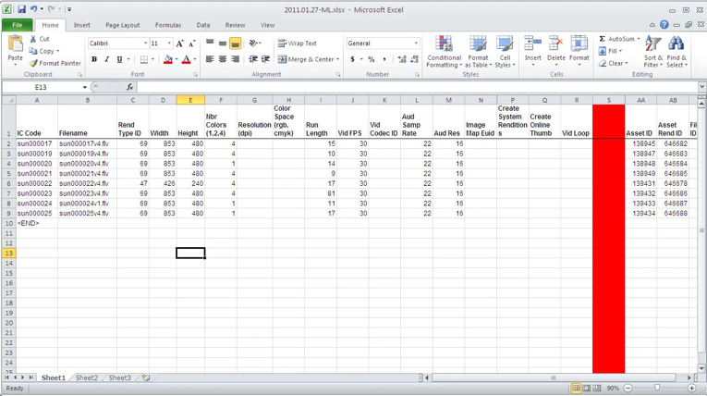

What-If Analysis tools are another powerful component of Excel, encouraging users to explore what potential outcomes could be achieved as the result of a range of different business scenarios. The required input to achieve a specific target-such as calculating the sales volume needed to reach a desired profit- can be determined using Goal Seek. Users are enabled to compare multiple possible outcomeswith Scenario Manager while Solver supports optimisation tasks. Strategic planning and forecasting are made infinitely easier with these tools as they play a vital role in it. These paired with Excels top of the market data cleaning abilities (which can remove duplicates, validatedata entry, split text and transform data sets) makes it incredibly useful for businesses.
However, Excel is not perfect and does have a weakness. Spreadsheets can become overwhelming and difficult to manage when there’s excessive formulas or lacklustre organisation of data. Additionally, formula errors can negatively impact the accuracy of the results and heavily disrupt the structure of the business by undermining organisational decisions. Excel is also less than ideal for extremely large datasets or for environments with more than one user where real time contributions to the data management Is required. Therefore, users may need to use other database systems that can cater to their needs. Despite this, Excel stays crucial mostly due to its analytical power and ease of use.
Unlike its analytical counterpart, Microsoft Access is a structured system that manages large sets of information that is related. As Access is a relational database management system, organisations can store, organise, and retrieve date efficiently through interconnected tables which are linked using primary and foreign keys which reduce duplication and improving the integrity of data. In contrast to its counterparts which are used no matter the size of the organisation-Access is particularly useful for small to medium sized businesses that need to manage customer records as well as inventory, employee data, bookings and project information. Users are helped with defining field types, validation rules and relationships between records by the table design tools.

Data can be filtered by users due to Access’ support of powerful querying tools additionally calculations can be performed, and specific information can be extracted. SQL or the intuitive query design interface can build queries. Access also includes forms that simply data entry by providing users with a controlled interface for adding and editing records leading to a reduction in data entry errors and improving the usability of the database. Access provides structured formats that can be used to prime or share with stakeholders. It also supports automation through macros which encourages users to streamline repetitive tasks therefore increasing efficiency.
However, more robust systems such as SQL server or cloud-based databases may be usedover Microsoft Access due to their affinity for enterprise level data solutions that larger organisations typically need which Microsoft Access is not suitable for- largely due to the performance issues that it experiences when many users access the database simultaneously. It’s also not entirely beginner friendly due to the fact that an understanding of database theory is needed to design an efficient version of a rational database which isn’t an easy thing to pick up, Regardless, Access is an affordable and valuable tool for organisations that require a way of managing structured data.

In conclusion, the core four under the Microsoft Office suite-Microsoft Word, Microsoft PowerPoint, Microsoft Excel and Microsoft Access are all indispensable in the business operations of not just a contemporary British society but modern international society. Word is a paragon of written communication and documentation while PowerPoint focuses more on visual and oral communication, Excel accommodates numerical analysis and encourages data driven decision making while Access conveys organisational information using structured data management. While each individual tool has features that improve efficiency and productivity. They are best used as a collective due to their cohesive integration creating a powerful productivity system that covers all relevant organisational tasks from documents to presentations to analysing data and managing complex information systems. They have minimal limitations and despite them, these digital tools are indispensable in a modern workplace for a variety of reasons but most importantly, their flexibility, ease of use and ability to encourage and support teamwork and collaboration in a highly technological and data driven environment. Furthermore, Microsoft 365 is continually updated and provided with cloud-based updates meaning that these applications evolve as the needs of organisations do. They are also accessible across platforms allowing employees to transfer work between devices promoting mobility and remote collaboration. Overall, these applications provide a reliable foundation for portraying information correct.

Task 3B: Explain four office software solutions for business operations (MS Word, MS PowerPoint, MS Excel,
and MS Access), highlighting their major features, benefits, and limitations (if there are any). You can use
some images in addition to text

IF Function Section:

Before implementing formula
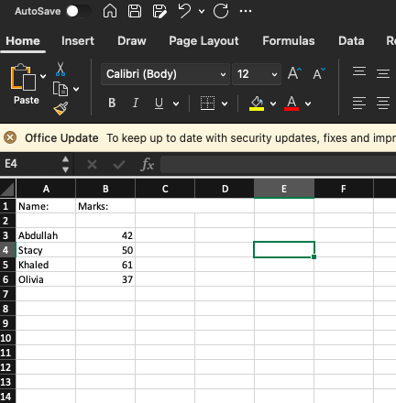

After implementing formula

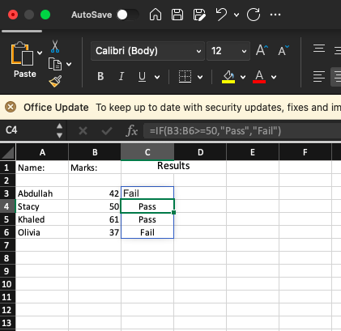

Description:
I have used the IF function to clearly show if whether a student has passed or been unsuccessful. The IF Formula determines the result of the test by checking if the score is higher than 50. Anything under 50 is a fail.

Pivot table section:

Original data table
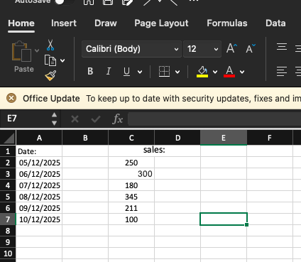

Pivot table creation menu
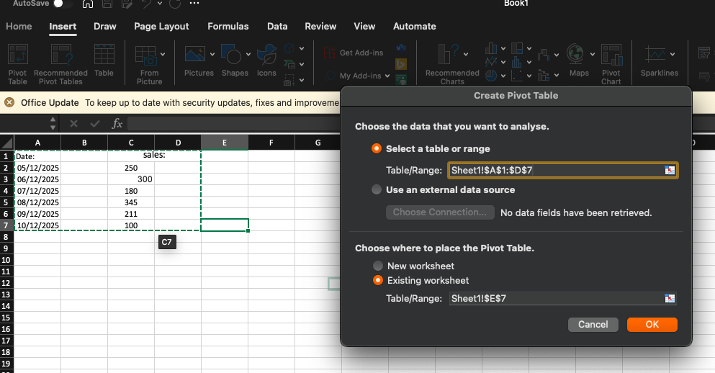

Pivot table:

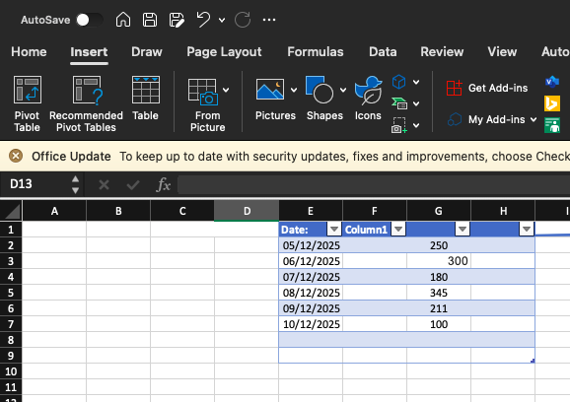

Description:
This pivot table demonstrates and displays daily sales automatically.This is due to the fact that excel summarises and calculates the total amount of sales each day. This is a quick and simple form of data analysis without the need for complicated formulas.

Task 4. Communication and Collaboration applications (Approx. 1000 words).
Technology has rapidly advanced over the years and in a world where remote work and global teams are becoming increasingly prevalent, digital communication and collaboration tools have seen a rise in usage particularly in modern business environments which have evolved in how they operate. Businesses rely on technology to streamline interactions and manage projects with applications such as Microsoft Teams and Trello becoming the main contributors to supporting a smooth workflow. Microsoft Teams primary use is communication while Trello focuses on online collaboration and project management. They work in tandem to reflect how digital platforms support productivity, teamwork and organisational efficiency. A crucial part of appreciating their role in contemporary business operations is understanding their features and influence on workplace practices.
Microsoft Teams is a primary example of rapid growth in the way it’s become one of the most widely used communication platforms in professional settings. It’s one of the cores of the Microsoft 365 suite and so it seamlessly integrates with the other four widely used cores (Microsoft Word, Excel, PowerPoint, Outlook and OneDrive) allowing Teams to act as a central hub where employees can do a variety of things including communicating, scheduling meetings, sharing documents and real-time collaboration [12]A key feature of Teams is its messaging interface which is instant enabling quick and direct communication between employees. On the contrary, emails can be stiffly formal which discourages more natural conversations. Teams provides channels for users to organise their conversations into channels-dedicated spaces for specific topics- helping employees locate information easily and reducing confusion by keeping discussion relevant to the task at hand.

Another strength of Microsoft Teams is the capability of its video conferencing system. Remote and hybrid work are becoming more and more common in today’s era meaning video meetings are essential for establishing a relationship between coworkers via maintaining communication and supporting teamwork. Teams system includes a multitude of useful virtual meeting features including but not limited to high quality video and audio, the sharing of screens, the ability to record and the inclusion of live captions [13]]. These help replicate many aspects of face to face meetings negating the idea that effective communication cannot be upheld due to physical distance. Additionally, the ability to join from multiple types of devices adds flexibility for employees who may have multiple workspaces. Teams also supports voice calls, making it a possibility for situations that may be either formal or informal.
Significant components of the application also include file sharing and real time collaboration. The integration of OneDrive and SharePoint into the programme means documents stored in them can be directly accessed from the platform, enabling employees to work on files without constantly switching between countless applications. Changes appear instantly on all versions of a document when several people are editing it at the same time eliminating conflicts between versions and repeated file uploads [14]It also cuts down on the time it takes to make decisions as teams can collaborate on documents during meetings or while having discussions-therefore combining communication and collaboration in a way that supports efficient workflow by reducing the need for separate platforms
On the other hand, Trello focuses primarily on project management and is an online collaboration tool. Based on boards, lists and cards, it’s a simple visual system that is structured in a way that’s easy to understand while providing teams with clarity regarding their work. A project is represented by a board, a stage of said project is represented by a list and each card represents an individual task[ [15]For example, a board may hold lists that are labelled “To-Do,” “In Progress” and “Completed.” Team members can adjust the cards in accordance with their status as work progresses helping others to understand the state of the project. The visual method employed prioritises organisation and workplace transparency.
Trello continues to support real time collaboration by allowing simultaneous editing of boards. Task related communication is also centralised as each card can hold a wide range of information, such as checklists, deadline, attachment, labels and comments, thus minimising the need for separate emails and deadlines. Ensuring that everyone knows all relative information. Commenting on cards is also enabled meaning members can discuss tasks directly with the board while Trello sends notifications regarding changes, encouraging team members to stay informed.
A feature that makes Trello stand out is Butler-it’s automation system- a tool that automates repetitive tasks. For example, moving cards when a checklist is completed or sending reminders when deadlines approach, saving time and maintaining a consistent workflow- particularly in larger projects that involve many parts [16]Trello also has access to a wide range of popular external tools like Google Drive, Slack, Teams and Dropbox due to its support of integrations known as Power-Ups. These allow Trello to adapt to different organisational needs by making it compatible with other programs typically used.
Irrespective of their different purposes, both Teams and Trello both aim to reduce the amount of workplace inefficiency. Despite Teams focus on communication-containing messaging, meeting and file sharing features- and Trellos focus on collaboration and project management they can be used together cohesively in a business. Whether it’s a team using Teams to discuss project detail, while simultaneously using Trello to organise workflow, or a team using Teams to hold meetings as Trello is being used to track the progress of tasks it’s clear that the combination is ideal for clear communication and structured work [17]The embedding of both tools in contemporary businesses is an indicator of a trend where organisations prioritise productivity as well as dynamic work practices.
These digital collaboration and communication tools have had a significant impact on the business environments of today. Remote and hybrid work arrangements have become infinitely easier due to their support and they also encourage global teamwork by connecting employees from different regions. Furthermore, these tools heavily simplify communication reducing the strain on administration by centralising information and automating tasks. Platforms like Microsoft Teams and Trello have had a qualitative effect on businesses’ organisation, decision-making and teamwork.
In conclusion, it’s undeniable that these types of digital tools are vital in today’s world due to the leading role technology is starting to play in connecting employees and supporting organisational processes. Microsoft Teams is an exemplary demonstration on how to effectively merge messaging, virtual meetings and productivity software into a formal application. Trello is an ideal visual project management tool for collaboration and task structure. Both platforms are crucial for a connected, efficient workplace in the digital age that is transforming modern businesses.

Task 4B: Test one feature of a freely available Communication (1) and one feature of a Collaboration (1)
application and document several screenshots with brief accompanying description to provide evidence of
practical use
Communication feature:

This communication feature is crucial in modern day society as it allows us to have instant communication with colleagues or anyone we want. This enables a process of fast sharing information due to the fact that Messages can be delivered instantly and efficiently.
Collaboration feature:

This collaboration feature is grea due to the fact that it allows multiple people to work on the same document instantly. This also improves teamwork and reduces errors on multiple different versions.

Bibliography

[1] | s. Inc, “About shopify,” shopify, [Online]. Available: https://www.shopify.com/uk/case-studies/how-soeur-quadrupled-online-orders-with-shopify. [Accessed 15 December 2025].
[2] | S. Inc, “Shopify App Store,” Shopify Inc., [Online]. Available: https://apps.shopify.com/. [Accessed 15 December 2025].
[3] | BigCommerce, “Essential Pricing - No Transaction Fees,” BigCommerce, [Online]. Available: https://www.bigcommerce.com/essentials/pricing. [Accessed 15 December 2025].
[4] | T. Burzan, “What Is a Mind Map?,” Tony Burzan Group, [Online]. Available: https://buzan.com.au/what-is-mind-mapping/. [Accessed 15 December 2025].
[5] | Microsoft, “Digital Tansformation with microsoft 365,” Microsoft corporation, [Online]. Available: https://www.microsoft.com/microsoft-365. [Accessed 15 Decmeber 2025].
[6] | Microsoft, “Microsoft 365 for business overview,” Microsoft Corporation, [Online]. Available: https://www.microsoft.com/en-gb/microsoft-365/business. [Accessed 15 December 2025].
[7] | Microsoft, “word documentation,” Microsoft Corporation, [Online]. Available: https://support.microsoft.com/word . [Accessed 15 December 2025 ].
[8] | Microsoft, “Create and format documents in word,” Microsoft corporation, [Online]. Available: https://learn.microsoft.com/en-us/office/troubleshoot/word. [Accessed 15 December 2025].
[9] | Microsoft, “Track changes in Word,” Microsoft Corporation. [Online]. [Accessed 15 December 2025].
[10] | Microsoft, “Colloborate on Word documents with OneDrive,” Microsoft Corporartions, [Online]. Available: https://support.microsoft.com/en-us/office/collaborate-in-word . [Accessed 15 December 2025].
[11] | Microsoft, “Powerpoint Overview,” Microsoft corporation, [Online]. Available: https://www.microsoft.com/powerpoint . [Accessed 15 December 2025].
[12] | Microsoft, “Microsoft Teams Collaboration,” Microsoft Corporation, [Online]. Available: https://www.microsoft.com/en-gb/microsoft-teams/collaboration. [Accessed 15 December 2025].
[13] | Microsoft, “Microsft Teams File Sharing,” Microsoft Corporation, [Online]. Available: https://www.microsoft.com/en-gb/microsoft-teams/file-sharing. [Accessed 15 December 2025].
[14] | Microsoft, “Microsoft Teams Collaboration,” Microsoft Collaboration, [Online]. Available: https://www.microsoft.com/en-gb/microsoft-teams/collaboration. [Accessed 15 December 2025].
[15] | Trello/Atlassian, “Trello Tour,” Atlassian Pty Ltd, [Online]. Available: https://trello.com/tour. [Accessed 15 December 2025].
[16] | Atlassian, “Butler Power-Up: Trello Automation,” Atlassian Pty Ltd, [Online]. Available: https://www.atlassian.com/blog/trello/butler-power-up-trello-automation. [Accessed 15 December 2025].
[17] | A. support, “The Trello App for Microsoft Teams,” Atlassian Pty Ltd, [Online]. Available: https://support.atlassian.com/trello/docs/the-trello-app-for-microsoft-teams/. [Accessed 15 December 2025].

