Sinead James (1910154)

Economics of sustainability
BMSP6007

Contents:
- Introduction
- Overview of industry
- How does the alcohol industry affect third parties?
- How was the market previously failing?
- Current solutions for a previously failing market
- Recommendations for further improvement
- Conclusion
- Reference list

Introduction:
The intention for this paper is to identify how the alcohol industry affects third parties by identifying any negative externalities present within the data. Examples of existing market failures regarding the alcohol industry will be evidenced with government legislation. Micro-economics will take effect within the demand and supply curves present throughout this paper that allow for the existence of negative externalities to be visually evidenced. This paper also intends to discover any existing solutions put in place to reduce the effect the negative externalities are having on third parties, whether these existing solutions have healed any externalities will also be analysed. Also, within this paper, recommendations for further improvement to diminish current negative externalities will be suggested.

Overview of industry:
The perception of alcohol can be misjudged by society due to the affects it has on the consumers, with over 50% of brits consuming alcohol weekly, 602,391 of which are alcohol dependent and 24% consuming over the recommended unit amount (alcohol change, 2018) and crime relating to alcohol proceeding towards 1.2 million violent incidents annually throughout England and Wales, approximately 116,000 being toward NHS staff (Faculty of public health, 2005). It can come as no surprise that the 50% of non-consumers or those who consume responsibly, have an initial response of the alcohol industry having only negative effects on society.
There are, however, positive aspects of the alcohol industry, those being the positive impact it has on an adult’s social wellbeing when consumed responsibly, these positive aspects include improved social cohesion, engagement and contentment within a local surrounding that provides a sense of community (University of Oxford, 2017). Other positive factors of the alcohol industry include the employment it provides within the hospitality sector and according to Dufoil et al (1997) moderate alcohol consumption, especially with women, provide increased cognitive abilities that allow the consumer to develop skills regarding reasoning, remembering and thinking and apply them to their daily lives. The main positive impact that the alcohol industry has on the economy, is the £10.5 billion of funds it provides the UK economy each year to aid with factors such as the public services. These funds are extracted via alcohol duty and excise tax on alcohol consumers (HMRC, 2016).

How does the alcohol industry affect third parties?
Those who must deal with the misuse of alcohol are usually those nearest and dearest to the consumer who is drinking irresponsibly, it is evidenced that the families of an individual who is alcohol dependent suffer greatly in terms of mental wellbeing as there is more chance of conflict, emotional detachment and lack of independence for the family members that must deal with alcoholism (NIdirect, 2022). According to the American addiction centre for alcohol (2020), those who are in a relationship with an alcohol dependent individual are more likely to suffer with lack of social interaction than normal resulting is self-isolation, this is due to the individual feeling the need to make excuses for not attending social situations in fear this would cause conflict within the relationship, as families support one another and family members rely heavily on this comfort, with the misuse of alcohol over time this support fades as the dependent becomes incapable of meeting the needs of their family, specifically emotional support, as their priorities shift more toward their addiction this can have an extreme negative impact on the partners, children, parents and close friends of the alcoholic.
According to the London police and crime committee (2022), alcohol consumption plays a vital role in the night-time economy, NTE, with growth worth approximately £66 billion for the UK. However, with London having the highest crime rate regarding alcohol consumption and its affects with just over 50% (approximately 704,000) of crimes being alcohol related, where 75% of these crimes take place on a weekend with a staggering 83% between 10pm and midnight. The first impression of these crimes paints an image of pub and street brawls; however, this is not the case, these crimes include domestic violence to family members which takes the situation to a deeper level, these family members are innocent and just a target for over-consumption. The police and crime committee also declare that half of a police person’s time is spent dealing with alcohol-related problems across the UK, with 75% of police workers bearing the brunt of the violence resulting in injuries when dealing with a drunken member of the public
The national health service has also been strongly affected by the misuse of alcohol, with 2% of the UK population being admitted to hospital due to alcohol-related incidents each week, 1% of these patients being the victim of an alcohol-related crime, this is having a very negative effect on the workload of the NHS, with costs accounting for £3.5 billion annually to our national health service (LAPE, 2022). According to the HMRC’s alcohol strategy (2016), 13% of UK adults binge drink with 21.5% of those numbers drinking above the recommended unit amount on each occasion, this has a significant effect on our NHS regarding liver disease, seeing a 25% increase in liver disease between 2001-2009, 37% of these statistics being alcohol-induced, it comes as no surprise as to why the costs to the NHS has increased to £3.5 billion in 2022 from £1 billion in 2015. Regarding the previous third parties that are affected by the misuse of alcohol, it is evident that there are negative externalities of consumption present, the below supply and demand curve presents the welfare/ dead-weight loss (yellow triangle) to society:

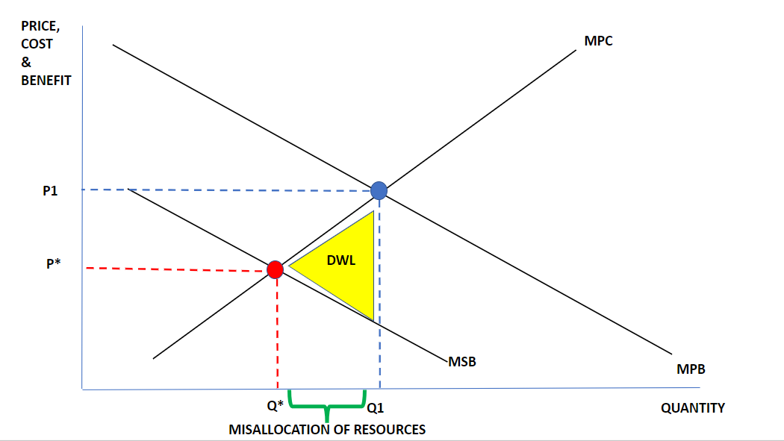

Another third party which is greatly affected by the misuse of alcohol is the businesses that operate legitimately, with over-consumption amongst employees resulting in under-productivity, absenteeism, workplace accidents and overall workplace dissatisfaction. In the united states, 8.7% of those in full time employment misuse alcohol during and after shifts, with 16.5% of those figures being those in construction and 11.8% within the hospitality sectors, it is assumed that workplace alcoholism stems from historical office drinking culture when the workforce were paid in brandy, the media also has a negative impact on the use of alcohol within a workplace setting as it portrays an image of alcohol in the workplace resulting in creativity (Okhifun, 2022), if there were more opportunities to provide knowledge to employees about how to cope with stress and success other than with the use of alcohol, such as mindfulness-based stressed reduction, it is assumed these statistics may decrease. Mindfulness-based stress reduction takes a more holistic approach to aiding the workforce with coping-mechanisms, this form of education can aid employees with gaining long-term knowledge on how to deal with the stress of daily problems to take a different approach that will lead to future growth, this method of mindfulness is evidenced to boost self-esteem, creativity, positive workplace relationships, decision making and productivity (National library of medicine, 2018).
The final third party evidenced to be negatively affected by the alcohol industry is the environment, with anthropogenic pollutants regarding the ingredients, manufacturing, packaging, and transportation of alcohol waste creating environmental externalities and resulting in 1.5% of the UK’s greenhouse gas emissions. According to Callan and Thomas (2012), an environmental externality is anything that causes damage to our atmosphere, air, water, natural resources and overall quality of life. A micro-brewery can produce approximately 3,000 pints a year whereas larger organisations produce an average of 19 million pints during the festive season alone, the emissions are also created upon consumption of the alcohol, as a locally brewed cask-ale will produce approximately 300g of CO2 emissions and a single bottle purchased from a shop is responsible for an average of 900g of CO2 emissions due to the manufacturing and transportation of the product to local stores and supermarkets (Morris, 2022). This causes a market failure within the alcohol industry as there is a spill over of social costs compared to private costs which result in a welfare loss to society. An example of negative externalities of production can be viewed in the table below:
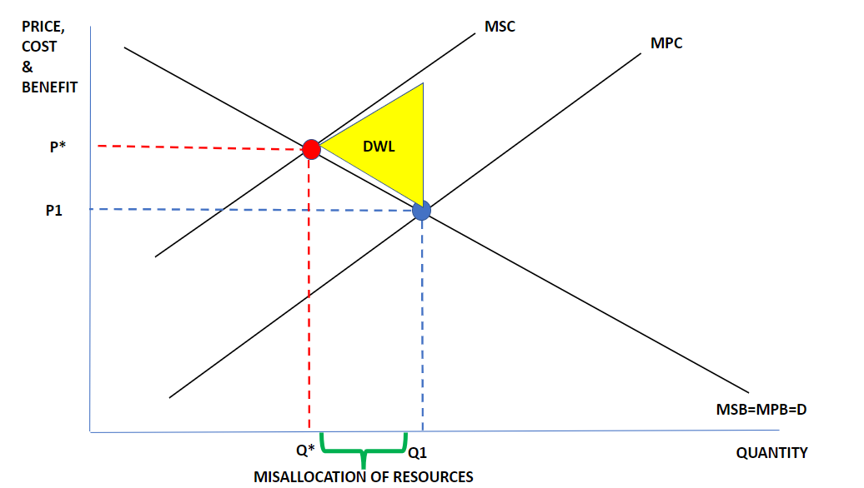
The effect alcohol has on third parties cause negative externalities within the demand and supply curve. The private benefits that the demand and supply curve regard in the diagrams, is the satisfaction consumers get after consumption of a product, in this case the alcohol is represented as a demerit good, it is the hope for demerit goods that the law of diminishing marginal utility takes place to result in consumers not willing to pay the market price for a product as satisfaction decreases after one unit or more is already consumed. A marginal private benefit is the consumption of one more unit of said product, what the demand and supply curve takes into consideration is the spill over affect the consumption of one more unit has on third parties as shown in the yellow dead-weight loss triangles within the above images, thus is why the marginal social benefit is lower than the marginal private benefit within the diagram representing the negative externalities of consumption (EconplusDal, 2016). Within the diagram that shows the negative externalities of production however, the private costs evidence the costs to organisations to produce a product or service, the marginal private costs are the costs of producing one more unit of such goods for the organisation, the marginal social costs are considered within the diagram as the costs to third parties due to the production of the goods or services, this is why in the demand and supply curve that represents the negative externalities of production, the marginal social cost curve is higher than the marginal private cost curve as factors such as pollution are considered (APMicroeconmoics, 2022). When social costs are not considered throughout the production and consumption phase, this results in an affect to third parties and is the reason why solutions need innovating to correct this negative externality and recreate the demand and supply curve to meet the point of allocative efficiency, solutions come in the form of ameliorative intent for the short-term fixture of the negative externalities or the preventative intent to take a more long-term approach to solving the issue (Lecture 1, 2022).
The allocative efficiency point is when the social optimum is considered and is an economical state as to which the production of a demerit goods meets the consumer needs and preferences, the point of allocative efficiency is when the social costs meet the social benefits on a demand and supply curve resulting in a broken market being fixed and the elimination of negative externalities (APmicro-economics, 2022) and can be viewed when the equilibrium meets P*=Q* (social optimum) from their original private optimum of P1 and Q1 within the above images regarding the negative externality of production, this is when the solution to meet the allocative efficiency point creates a price increase yet the quantity decreases. Within a negative externality of consumption, the allocative efficiency point is where the social costs are reduced by ensuring the marginal social benefit is increased to a point that meets the marginal private benefits, again this would result in a price increase and quantity decrease to remove any misallocations of resources. Regarding the law of demand, a price increase means a quantity consumed or produced is decreased (APmicroeconomics, 2022). The law of supply evidence a direct relationship between price and quantity, however, it is easier to implement a price increase to expect a quantity decrease, but then excludability of consumers will become inevitable as the substitution effect takes place and consumers continue to purchase the demerit good with a cheaper alternative. Excludability is present with demerit goods because of factors such as addiction, individuals that become alcohol dependent will assumingly pay any excess increase in price due to feeding their addiction. It will not therefor, drastically reduce the quantity sold even though it may discourage some consumers from purchasing the demerit goods.

How was the market failing before?
Research into how the alcohol industry was failing before shows that between the 1950’s and the 1970’s, the concerns about alcohol related illness increased, the 1950’s saw an increase in alcohol consumption followed by a surge of alcohol related issues in the 1960’s such as drink driving and alcohol related illnesses such as cirrhosis of the liver, the 1970’s evidenced an increase in deaths relating to cirrhosis of the liver and alcohol consumption by more than 40 million since the 1950’s (Royal college of physicians, 1987). The 1980’s viewed concerns for the preservation of social order as concerns about social matters had risen and by the 1990’s the term ‘binge drinking’, meaning the increased consumption of alcohol by youths in public became a growing concern (Berridge et al, 2009).

Current solutions for a previously failing market:
With the evidence that discovered an increase in alcohol consumption during the 1950’s, the year 1962 marked a new era for alcohol related treatments. Alcoholism was viewed to be a symptom of an underlying issue such as anxiety, depression or psychopathy, therefor in 1962 the ministry of health issued a memorandum that marked the opening of specialised treatment units within hospitals, where alcohol psychosis treatments were the focal point for service users (Thom, Berridge, 1995). In 1981, the book “Drinking sensibly”, was published by the HMSO and defined the meaning of the term ‘alcohol misuse’, three years later, a command-and-control approach regarding alcohol limitations was introduced by the health education council within their pamphlet; That’s the limit (1984) in the form of recommended weekly unit allowances, it was advised that men do not exceed 18 alcoholic units and women 9. By the year 1987, the recommended unit limitations that had been previously released, were revised and changed to 21 units per week for a man and 14 for a woman with added advise that anything over 36 units per week for a man and 22 units per week for a woman were too much, by 1995, the recommended unit allowance was once again reviewed and changed from a weekly allowance to a daily allowance of 3-4 units for a man and 2-3 units for a woman, with a suggested 48 hour gap before consuming alcohol again (House of commons, 2012). A market solution for the misuse of alcohol comes in the form of excise tax, excise tax on alcohol consumption within the UK is currently 17.5% which is approximately 0.4p per £1 of revenue, this duty-tax is paid by the consumer on importation to the UK and aids in generating approximately £10.5 billion annually to fund public services, with duty fraud deducting approximately £1.2 billion in unpaid excise tax annually (HMRC, 2016). Below is an image of a timeline that visually presents how the market was previously failing and when solutions were put into place:
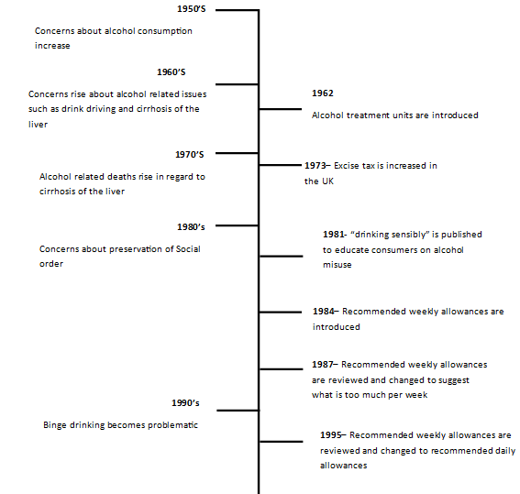
Recommendations for further improvement:
To further improve the progress made regarding the misuse of alcohol, a command-and-control approach could be used that considers the banning of advertising alcohol. Norway has already taken this approach and put a full ban on advertising alcohol and France has put a complete ban on the advertisement of alcohol on television, this resulted in Norway reducing alcohol sales by 7.4% (Rossow, 2011) and France by 11% (EUCAM, 2022). A market approach could be a licensing tax that shops, pubs and restaurants would pay annually to aid in maintaining social order, to exclude responsible business owners from the payments the tax could be reimbursed to those on the basis that there have been no altercations that involved the premises providing alcohol irresponsibly. Below is a demand and supply curve that provides a new allocative efficiency point (red point) with the implementation of the licensing tax to solve the negative externality of consumption:
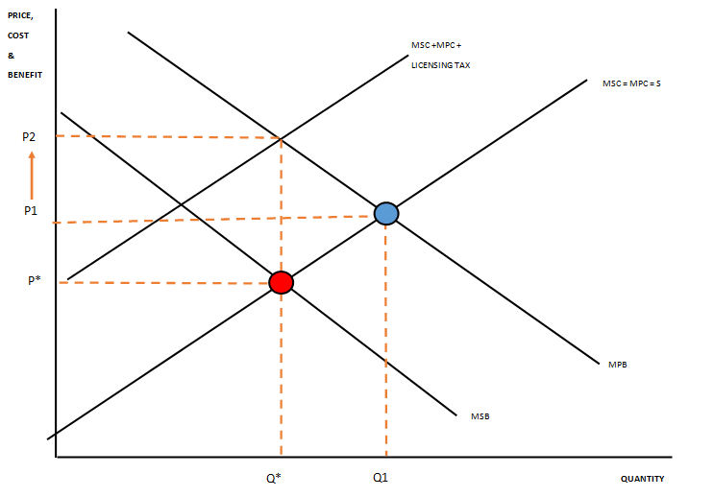

Conclusion:
It has been evidenced that solutions have been put into place to correct the negative externalities of consumption over time, however, the negative externalities of the consumption of alcohol have also changed with the times. Beginning in the 1950’s as a concern of the amount consumed and developing into concerns about social order by the 1990’s. With the concerns the negative externalities have had on various aspects over time, there has always been one factor of the externality present, and that is the affect it has on third parties. The implementations of solutions have clearly aided the negative factors present within different timeframes and it can be assumed that if the recommendations of banning advertisement and the licensing tax that will be reimbursed if responsible sale and consumption is present, then this will further improve the current factors of the negative externalities present today. Alcohol consumption can be assumed to always have negative factors associated with it, so solutions will always need to be adapted and put into place to amend the externalities in the future.

Reference list:
American addiction centre for alcohol, (2020). Effects of alcoholism on families and close friends, Retrieved from: Effects of Alcoholism on Families & Close Relationships [Sourced on: 30/03/22]
APmicro-economics, (2022). 4.1 externalities; externalities of production and consumption, Retrieved from: Externalities - AP Microeconomics - AP MICROECONOMICS (microeconomicsap.com) [Sourced on: 31/03/22]
Berridge, V. Herring, R. Thom, B. (2009). A confused concept and its contemporary history, social history of medicine, p597-607 [Sourced on: 05/04/22]
Callan, S, J. & Thomas, J, M. (2012). Environmental economics and management; Theory, policy and applications, p62, 6th edition, Southwestern, CENGAGE learning [Sourced on: 12/04/22]
Dufoil, C. Ducimetiere, P. Alperovitch, A. (1997). Sex differences in the association between alcohol consumption and cognitive performance, p405-412, EVA study, American journal of epidemiology [Sourced on: 30/03/22]
EconplusDal, (2016). Negative externalities in consumption (Demerit good), Retrieved from: https://www.youtube.com/watch?v=sYTQ3... [Sourced on: 12/04/22]
EUCAM, (2022). The European centre for monitoring alcohol marketing; France, Retrieved from: France – EUCAM [Sourced on: 05/04/22]
Faculty of public health, (2005). Alcohol and violence; Briefing statement, Retrieved from: . New Document (ias.org.uk) [Sourced on: 30/03/22]
Health education council, (1984). That’s the limit! A guide to sensible drinking, Retrieved from: That's the limit (1984 edition) | Open Library [Sourced on: 05/04/22]
HMRC, (2016). The HMRC alcohol strategy; Modernising alcohol taxes to tackle fraud and reduce burdens on alcohol businesses, Retrieved from: The HMRC Alcohol Strategy (publishing.service.gov.uk) [Sourced on: 30/03/22]
HMSO, (1981). Drinking sensibly; A discussion document, Retrieved from: Drinking sensibly (1981 edition) | Open Library [Sourced on: 05/04/22]
House of commons, (2012). History of alcohol guidelines, Retrieved from: House of Commons - Alcohol Guidelines - Science and Technology Committee (parliament.uk) [Sourced on: 05/04/22]
LAPE, (2022). The cost of alcohol on the NHS, Retrieved from: The Cost of Alcohol on the NHS | LAPE.org.uk [Sourced on: 31/03/22]
Lecture 1, (2022). Setting the time horizon; management strategies and pollution prevention, Slide 21, Retrieved from: https://moodle.uwtsd.ac.uk/pluginfile.php/576297/mod_resource/content/3/lecture%20-%201%20%286%29.pptx [Sourced on: 12/04/22]
London police and crime committee, (2022). The impact of alcohol on policing London’s night-time economy, Retrieved from: 1 (london.gov.uk) [Sourced on: 31/03/22]
Morris, A. (2022). Alcohol problem: the environmental impacts of beer, Retrieved from: Alcohol problem: the environmental impacts of beer - Isonomia [Sourced on: 31/03/22]
National library of medicine, (2018). Effect of mindfulness-based stress reduction therapy on work stress and mental health of psychiatric nurses, Retrieved from: Effect of Mindfulness-Based Stress Reduction Therapy on Work Stress and Mental Health of Psychiatric Nurses - PubMed (nih.gov) [Sourced on: 31/03/22]
NIdirect, (2022). When alcohol affects family life, Retrieved from: When alcohol affects family life | nidirect [Sourced on: 30/03/22]
Okhifan, G. (2022). Signs of alcoholism at work: Can one get fired?, Retrieved from: Drinking At Workplace: Work Alcoholism Signs, Dangers, And Prevention (alcorehab.org) [Sourced on: 31/03/22]
Rossow, I. (2011). The alcohol advertising ban in Norway; effects on recorded alcohol sales, Retrieved from: The alcohol advertising ban in Norway: Effects on recorded alcohol sales - PubMed (nih.gov) [Sourced on: 05/04/22]
Royal college of physicians, (1987). A great and growing evil; the medical consequences of alcohol abuse, p.24, London, UK: Tavestock, [Sourced on: 05/04/22]
Thom, B. Berridge, V. (1995). Specialist units for common problems; The birth of alcohol treatment units in England, p70, Oxford press journal, [Sourced on: 05/04/22]
University of Oxford, (2017). Your health! The benefits of social drinking, Retrieved from: Your health! The benefits of social drinking | University of Oxford [Sourced on: 30/03/22]

