ervins podgaiskis
2232217@student.uwtsd.ac.uk
Computer System Component Specifications
Module name: CertHE in Digital Skills
Program name: Computer System Fundamentals
Student name: Ervins Podgaiskis
Student I.D: 2232217

Introduction.

This coursework is about my knowledges which I learn on Moodle computer system fundamentals, more specific is about computer components. As we know computer is overly complicated device and takes time to learn about their parts and how it works. This course work is divided in two tasks. Task one is about sensible specification for use case scenario and task two is about depth analysis of my laptop which I own. So, let us begin!

Task one

Helping elderly relative to buy a low-cost PC.

As I help elderly person to buy a PC part and build computer, I need make sure it works properly and my relative will be happy. To build computer we will need buy necessary parts:
- CPU (Central Processing Unit) and Motherboard
- Ram (Random Access Memory)
- Storage or HDD (Hard Drive Disk)
- Input/ output features/ports
- Graphic Card
- Case and power supply
- Display or monitor
- Keyboard
- Network connectivity
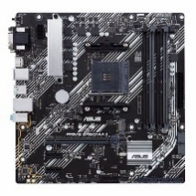
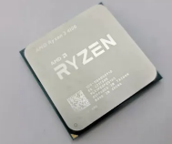
- Operating system and Software’s

Central Processing Unit and Motherboard

As low-cost motherboard I choose Asus Prime B450M – A 2. It is micro ATX motherboard (mid-size). Maximum memory amount 128 GB, maximum RAM speed 2666MHz, DDR memory version DDR 4, memory slots four. It supports with wide range of Ryzen processors and high memory capacity. It promises durability and performance. It is cheap motherboard and competitive with other motherboards in market. Compare with other motherboards it offers solid foundation for mid-range PC without breaking a bank. Motherboard impresses with its array of connectivity and options and user-friendly BIOS features [1].

Processor is computer brain of computer and major components are arithmetic logic unit (ALU), control unit (CU), registers and memory. I did some research and found that processor AMD Ryzen 3 4100 4 Core 8 Thread 3.8 GHz would be compatible with ASUS prime B450M-A2 motherboard. AMD comes with bundled wraith stealth coolers, and it is very affordable. Its performance has advantage over Intel Core i3 because it allows to overclocking lower end SKU’s. These processors are not for gaming that is why I think is more suitable for office tasks [2].
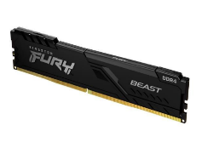

Random Access Memory

Ram is short term memory. It is small and mounted on motherboard. It is saving data while you work on file, because it is shorter way to store data than on HDD. When PC is turned off, all data is lost. Simplest and lowest RAM which would be compatible with my motherboard is Kingston Fury Beast 8 GB (1x8 GB) DDR 4 3600 MHz It have low profile heat spreader and it is have lifetime warranty.
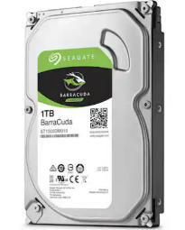

Storage or Hard Drive Disk

HDD is hardware which is not mounted on motherboard and its secondary memory where we store large amount of data, like videos, game, movies, music etc. As elderly people do not play games and not store movies but instead maybe some photos and MS office file, they do not really need high-capacity hard drive. I choose B Grade Barracuda 1TB 7200rpm SATA 6Gb/s 64 Mb Cache because SATA hard drives compatible with ASUS Prime motherboards. Compared to Hitachi hard drives, Seagate have higher data density and it helps to maintain a consistent lead in transfer rate [3], [4].

Input/ Output features/ port

External ports are:
- BIOS Flashback Button (Allows update motherboard without using CPU, Memory, or Graphic Card)
- D-Sub (D-Sub miniature port allows to connect with external devices)
- DVI-D (Digital Visual Interface is for connecting with monitor)
- HDMI (High-Definition Media Interface)
- PS/2 (6 pin mini–DIN Connector to connect a keyboard and mouse)
- There are several USB ports (external and internal, it allows to connect mouse, keyboard printer etc)
- 3 x Audio Jacks (It allow connect audio devices such as headphones or speakers) [5].
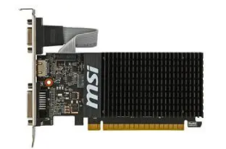

Graphic Card

It is computer hardware that gives graphic output to display. I think NVIDIA GeForce GT710 2GB PCI-Ex graphic card would be great for this computer. It is compatible with motherboard. It would be necessary to install right drivers to work properly. It is physically smaller than other GT graphic cards. It has excellent quality heatsink that keeps graphic card cool. It is faster than GT 620 card. Also, it can manage 4k resolution [6], [7].
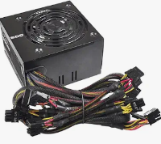
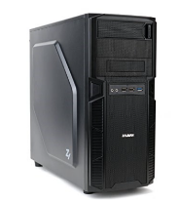

Case and Power supply

One of the best low-cost cases options is Zalman Z1 ATX Mid Tower with Evga 500 W1, 80+White 500W power supply which are good same as cx series corsair. [8],[9]. This power supply has negative feedback, but reviewer have positive experience with it. It is one of cheapest and used you can obtain even for 10- 15 £. Power case comes with two system fans, PSU cooling, front interface, Front mesh ventilator structure.
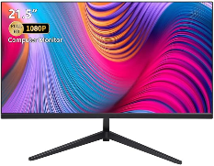

Display or Monitor

As elderly people often have bad eyesight the best would be anti-glare screen monitors to protect eyes. As person have bad eyesight, I think it would be better choosing around twenty-four inches. The good option is Maxesla 24 Inch monitor 75 Hz Full HD. It would be enough work with MS Word document, talk with relatives through video chat.
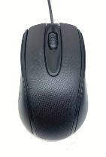
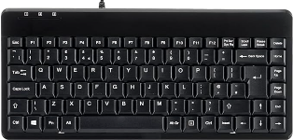

Keyboard and Mouse

Small factor but full-size keyboard would be great perix Periboard – 409U wired USB. It is cheap and simple coloured keyboard no extras. As mouse I would offer is USB wired computer mouse.

Network Connectivity

In our scenario elderly man wants to watch YouTube videos which is 500Kbps and skype video call is about 1.2 Mbps, but some providers recommend 3Mbps connection to improve experience. For general Web browsing and email is 1Mbps. Average speed for one person should be 10 Mbps as download speed and 1 Mbps upload speed [10].

Operating System and Software’s

As operating system would be Windows 11. Web browser can be Microsoft Bing because it comes together with windows eleven. For video calls there would be necessary to download Skype application and to watch YouTube videos either it can be done through web browser or also can be downloaded an application. These two applications can be downloaded and used for free. To write a document most common and popular is MS Word but it is necessary to install MS Suite or MS Office. It can be bought or used free online. For email services would need to create an account on www.gmail.com . As person wants to join courses to learn more about using Microsoft Windows I would recommend private lesson, because it would be hard learn online not knowing how to work with windows and what exactly look for internet. Every PC need to protection from viruses and cyber-attacks and one of anti-virus programs is Norton. Norton offers many features, like: Device security, Anti track which is blocking trackers from following online, password manager and lots of more.

Price list for parts and total price for this PC.

Components | Name of part | Price £
CPU | AMD Ryzen 3 4100 4 Core 8 Thread 3.8 GHz | 56.50
Motherboard | Asus Prime B450M – A 2 | 69.49
RAM Storage | Kingston Fury Beast 8 GB (1x8 GB) DDR 4 3600 MHz | 23.47
HDD Storage | B Grade Barracuda 1TB 7200rpm SATA 6Gb/s 64 Mb Cache | 23.99
Graphic Card | NVIDIA GeForce GT710 2GB PCI-Ex | 39.98
Case | Zalman Z1 ATX Mid Tower | 23.00
Power Supply | Evga 500 W1, 80+White 500W | 38.98
Monitor | Maxesla 24 Inch monitor 75 Hz Full HD | 79.39
Keyboard | perix Periboard – 409U wired USB | 19.99
Mouse | USB Wired mouse | 2.98
Total Price | 377.77

Task two

My Device and Analysis of Components

I own laptop for studies of university. Also, I watch movies on it and watch ice hockey online. I have installed some of video games to play in free time, but I have not played because of studies and working on nights. Also, I am writing documents, work with spreadsheet (MS Excel), using email services, and make presentation on MS PowerPoint. I am only who is using this laptop so there is one user. My laptop model is Lenovo 82 RN x64 Based-PC and in this task, I will analyse following parts of my laptop:
- CPU
- RAM
- Storage capacities and types
- The Input/Output Devices
- Operating System
- Installed applications.
- Internet connectivity

Central Processor Unit (CPU)

This Laptop CPU is AMD Ryzen 5 5625U with Radeon Graphics. It is good for a gaming and can expect mediocre game performance. CPU characteristics and their relevance based on graphics:
- 16Mb of L3 Cache is mediocre for performance.
- Six cores allow a satisfactory performance.
- 2.3 GHz based frequency
- 4.3 GHz single core max boost frequency
- Max stock DDR4 speed of 3200 MHz
- Lack of overclocking support cannot benefit performance.
- PCie 3.0support can be deficient performance [11]
It is good for working with MS office and applications for documents, creating presentations. It is not gaming processor but still it is good for lower performance games.

Random Access Memory

I have 8 GB Ram (5.85 Gb usable) which manufacturer is Hynix. Product is a 288-pin DIMM and has CL22 latency. It is unbuffered and NON-ECC. Through the system option I could not found that information, but I got through Command Prompt by run as an Administrator and then write following command: wmic memorychip get devicelocator, manufacturer. See the screenshot below:
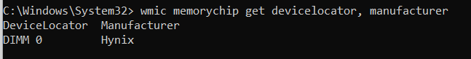

Storage Capacities and Types

My storage capacity is 236.25 Gb and have Disk 0 partition 1 with 260Mb capacity and Disk 0 partition 4 with 1.95Gb capacity. Partition one is booting sector and partition four is recovery sector for factory reset performs. SE screenshot below:
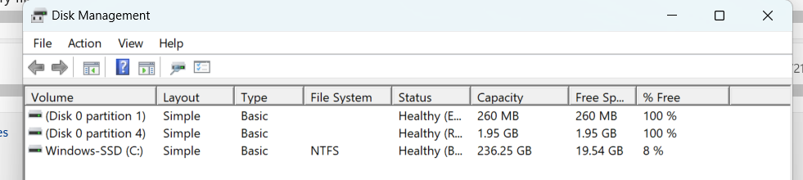

To get this information I did following steps: Windows+R keys to open run window, type diskmgmt.msc and enter.
Through Device manager I found out that my disk drive type is Samsung MZALQ256HBJD-00BL2. This drive has M.2 Form factor and a PCie 3.0 x 4 interface. Reading speed 3100 Mbps and writing speed 1300 Mbps.

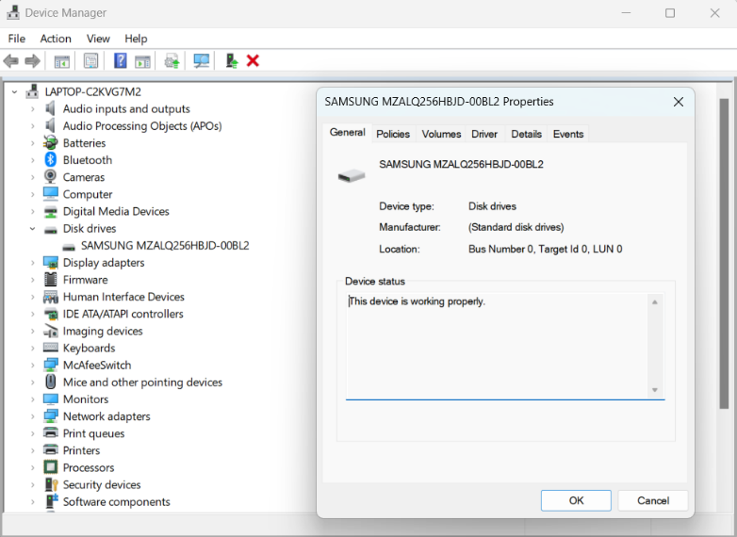

The Various Input/ Output devices.

My laptops’ input devices are Logitech wireless 2.4 Ghz which connected through Bluetooth, standard PS/2 inbuild keyboard, trackpad, or touchpad, integrated Realtek webcam, Realtek® microphone. Output devices are integrated PnP monitor AMD Radeon TM Graphics, integrated Realtek ® Audio speakers. All this general information can be found through device manager. Sometimes I use my old headphone Beats Mixer as output device when I want blast my ears out.

Operating System

My operating system is Windows 11 Home, version 22H2, Build 22621.3007 . It have redesigned Start Menu, widgets panel on start menu, tiled sets of windows new gaming technologies. From last version of windows this version introduce ne productivity features: new Start Menu, focus assist and the Taskbar, new Voice Access Availability, better OneDrive integration with File Explorer etc [12].

Installed Applications

When I begin study university, I bought this laptop and I have it 1 year. I have been used a lot. I have install many applications but I will mention several which I use mostly. I use two web browsers one is Microsoft Edge which I use to look all research for my assignments and coursework for university and other is Mozilla Firefox which I use for emails, movie, and sport streams. I obtain MS Office for studying. AS Antivirus I have Norton 360 with Anti Track feature. Of course, there is input/output device applications and drivers installed.

Internet Connectivity

We have Realtek Semiconductor PlusNet internet. It has 5Gh network band, thirty-six network channels, link speed (receive/transmit) 866/866 Mbps. WPA2-personal security type.

Analysis/ Benchmark Data

First tested my laptop’s CPU speed and it is 123H/s which gives 40115 points, and it is quite low rank as it can be seen in screenshot. CPU speed can be tested on Website: https://cpux.net. Which I add in my reference list [13].
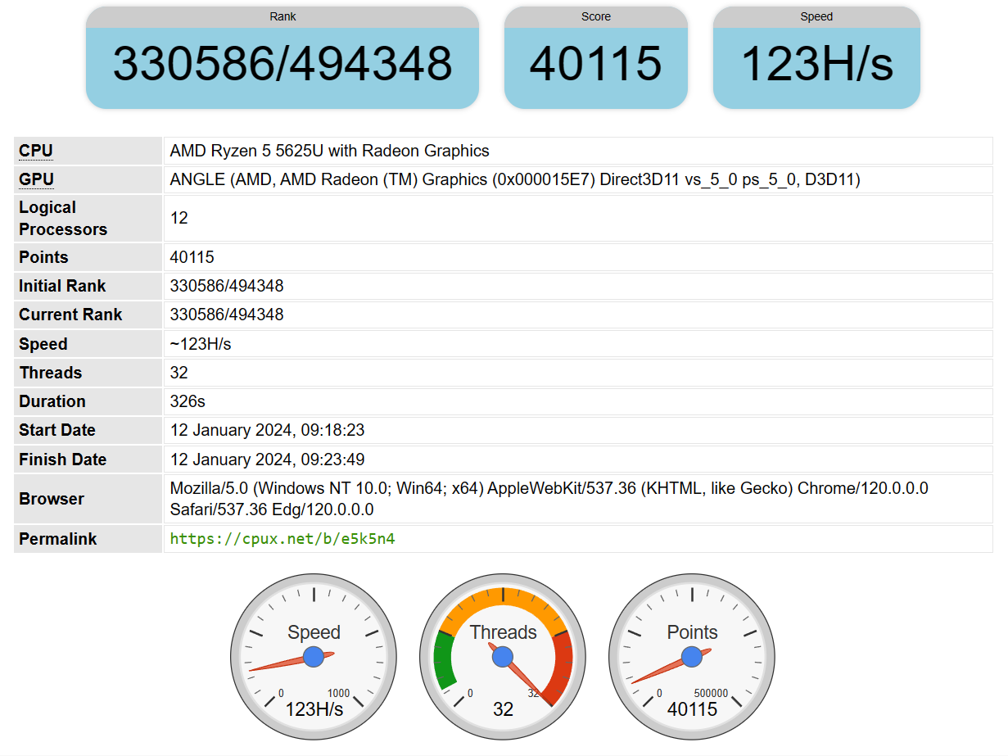

Next, I did Hard Drive Disk Transfer speed benchmark test. To do this test I install application “ATTO Disk Benchmark 4.00.0f2” This application can be downloaded from website https://www.atto.com [14]. See screenshot below.
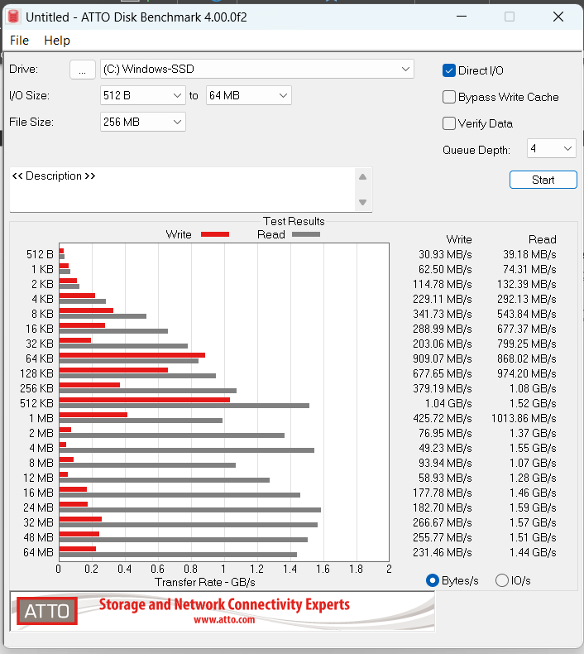

For graphic card performance I used superposition benchmark application because it is for free. It can be downloaded from website [15]. In screenshot can be seen that graphic cards performance is low. Average frames per second is ten and satisfactory performance is in range 30 – 120 depends on monitor.
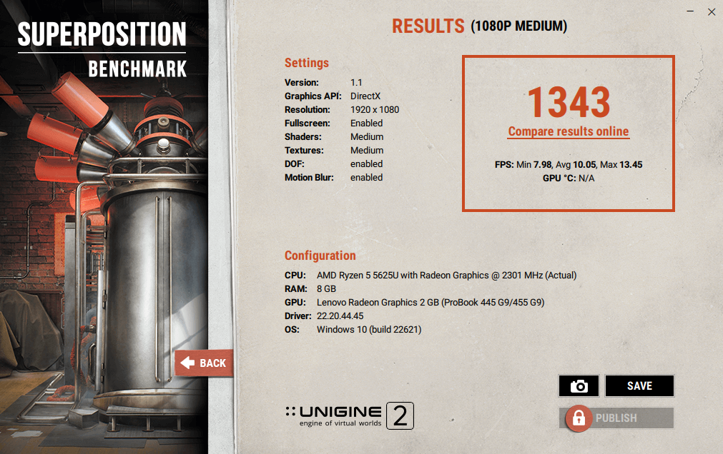

Last, I test my internet connection speed. Most popular website is speedtest.net [16].

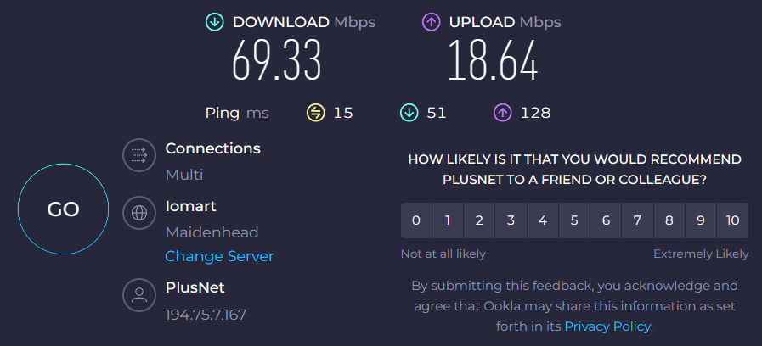

Conclusion

In this coursework I was look for low-cost computer part and analyse my laptop. I can tell that I spent hours for research in internet because computer is complicated, and parts need choose carefully that PC would work properly. When I analyse my own laptop couple of things was easy to find but finding RAM manufacturer was bit challenging. I learned a lot of new things and understood that there is new world about computers to learn in future. It was difficult in beginning but at end of it I want more to know. Thank you!

References
[1] P. Hill, “ASUS Prime B450M-A II AMD AM4 Motherboard Review,” motherboardfor.com, Dec. 15, 2023. https://motherboardfor.com/amd/review/asus-prime-b450m-a-ii-amd-am4-motherboard-review/ (accessed Jan. 10, 2024).
[2] P. A. published, “AMD Ryzen 3 4100 and Ryzen 5 4500 Review: The Budget CPU Showdown,” Tom’s Hardware, Sep. 18, 2022. https://www.tomshardware.com/reviews/amd-ryzen-4-4500-ryzen-3-4100-cpu-review (accessed Jan. 10, 2024).
[3] “B Grade Seagate BarraCuda 1TB 7200RPM SATA 6Gb/s 64MB Cache HDD - OEM (ST10,” www.overclockers.co.uk. https://www.overclockers.co.uk/b-grade-seagate-barracuda-1tb-7200rpm-sata-6gb-s-64mb-cache-hdd-oem-st10-bg-13e-se.html (accessed Jan. 10, 2024).
[4] “Seagate Barracuda 7200.11 1 Terabyte Hard Drive,” Trusted Reviews, Dec. 17, 2007. https://www.trustedreviews.com/reviews/seagate-barracuda-7200-11-1-terabyte-hard-drive (accessed Jan. 10, 2024).
[5] “PRIME B450M-A II｜Motherboards｜ASUS United Kingdom,” ASUS United Kingdom. https://www.asus.com/uk/motherboards-components/motherboards/prime/prime-b450m-a-ii/ (accessed Jan. 11, 2024).
[6] “NVIDIA GeForce GT710 2GB PCI-Ex Graphics Card,” Farnell.com, 2023. https://cpc.farnell.com/msi/gt710-2gd3h-lp/graphics-card-gef-gt710-2gb-lp/dp/CS33680?mckv=VEYl5XSq_dc (accessed Jan. 11, 2024).
[7] “GeForce GT 710 Review 2GB From Gigabyte,” www.youtube.com. https://www.youtube.com/watch?v=QsiQJRJseDc (accessed Jan. 11, 2024).
[8] “zalman | PSU, Cases, CPU Coolers,” www.zalman.com. https://www.zalman.com/EN/Product/ProductDetail.do?productSeq=1193 (accessed Jan. 11, 2024).
[9] “EVGA W1 500W power supply. Not as bad as people make it out to be. 1 year review,” Linus Tech Tips, Sep. 08, 2020. https://linustechtips.com/topic/1244363-evga-w1-500w-power-supply-not-as-bad-as-people-make-it-out-to-be-1-year-review/ (accessed Jan. 11, 2024).
[10] “What Internet Speed do you Need for Video Conferencing?” MegaMeeting, Jan. 29, 2021. https://www.megameeting.com/news/what-internet-speed-for-video-conferencing/#:~:text=Video%20conferencing%20typically%20requires%20around%201.5%20to%202
[11] “Is the Ryzen 5 5625U CPU Good for Gaming?” TechReviewer. https://www.techreviewer.com/tech-specs/amd-mobile-5625u-for-gaming/ (accessed Jan. 11, 2024).
[12] Z. B. last updated, “Windows 11 version 22H2 review: Refined, but still not perfect,” Windows Central, Sep. 20, 2022. https://www.windowscentral.com/software-apps/windows-11/windows-11-version-22h2-review#Windows%2011%20Version%2022H2:%20Taskbar%20&%20Action%20Center (accessed Jan. 11, 2024).
[13] “CPU Expert,” cpux.net. https://cpux.net/ (accessed Jan. 12, 2024).
[14] “Disk Benchmark for Windows Software | ATTO,” ATTO Technology. https://www.atto.com/disk-benchmark/
[15] “UNIGINE Benchmarks,” Unigine.com, 2017. https://benchmark.unigine.com/superposition
[16] “Speedtest by Ookla - The Global Broadband Speed Test,” Speedtest.net, 2019. https://www.speedtest.net/

