Planning and Delivering an International Event

International Conference on Sustainable
Tourism Development (ICSTD)

International Meetings Management BMIH6007
Student: Roxana Elena Belu (2120013)
Tutor: Philippa Fitzgerald

Table of Contents

Introduction…………………………………………………………………………………………………..3
- The event Cycle …………………………………….…………………………………………….4
  - The event concept…………………………………………………………………………….4
  - Event Aims and Objectives…………………………………………………………………4

- Operational strategy of the event………………………………………………………….6

- Bouget of the event…….……………………………………………………………………….7

- Industry trends and impacts………………………………………………………………..9

- Cultural and situational considerations……………..……………………………….10
  - PESTEL analysis ………………………………………………………………………..….10
  - Risk Management - SWOT analysis……..………………….………………………..13

References…………………………………………………..………………………………………..15
Appendices ……………………………………………..……………………………………………17
Appendix A…………………………………………………………………………………..………..17
Appendix B……………………………………………………………………………………..……..18
Appendix C…………………………………………………………………………………………….19

Introduction:

According to Singh (2009, cited in Quick, 2020, p. 9), the planning phase of an event is its longest and, maybe, most crucial stage because it will ultimately determine its result. When pre-event preparation is done carefully, the delivery phase, often referred to as on-site management can be executed more easily (Quick, 2020, p.11). Even with meticulous pre-planning, however, some aspects of the concept will inevitably change on-site. For this reason, managers must be ready for anything unexpected and give considerable thought to contingency planning well in advance. Muller (2017, p. 237) says that all events are affected by six paradoxes. According to Duignan, Parent, and McGillivray, 2023, 150) These paradoxes are philosophical and use a high-level perspective from social science regarding the administration and results of significant events.
The professional management company Ratters on a contract basis for The United Kingdom Government in association with the Institute of Travel and Meetings will organize in London the International Conference on Sustainable Tourism Development (ICSTD) (Bowdin et al. 2024, p. 37 – 38). Conway Main Hall a landmark and prominent ethical society and humanist centre located at 25 Red Lion Square, Holborn, WC1R 4RL, in the centre of London was chased to be the venue of the event. (Cavendis Venues,2024). Because of its central location, it is easily accessible by public transport and has good connections to other areas of the city. Conway Hall (2024) is an adaptable space that can accommodate a variety of events, such as weddings, seminars, conferences, concerts, and community get-togethers. It is especially well-known for its dedication to advancing discussions on ethics, humanism, and culture. The venue was founded in 1929 and has a long history based on ethical and humanist values. It was constructed to act as a centre for moral and cultural gatherings, representing ideas like freedom of opinion, secularism, and reasoned investigation. The building itself has unique architectural details that combine Arts & Crafts and Georgian design elements. Classical motifs define the façade, while the internal areas are intended to host a range of activities. Conway Hall's main hall, which has a gallery, a stage, and seating areas, is its focal point and the place where the International Conference on Sustainable Tourism will take place. Large crowds can be accommodated for lectures, performances, and conferences in this flexible and roomy venue.

- The Event Cycle:
Future-focused, according to Getz and Page (2020, p. 358) rational planning always starts with a vision, sets goals, considers potential outcomes of alternative courses of action, formulates, and implements strategies and actions to achieve goals, and continuously evaluates and solicits feedback to improve the system. The notion of "event cycle" describes the sequence of steps and procedures that an event goes through from inception to completion.

  - Event Concept
The International Conference on Sustainable Tourism Development (ICSTD) is a global gathering focused on the sustainability of the tourism and hospitality industries. The conference is planned to take place on 29 -30 July 2024 in London and will cover two days of sessions, attended by over 400 executives from travel and hospitality industries. The conference's agenda is driven by research and centres on important problems and the creative growth of the industry by putting forth ground-breaking fixes for the real concerns that the sector is facing. Some important names from the industry will be invited to speak and entertain the audience, between them we can name Richard Richardson Chef Executive of Institute of Hospitality and Joan Smith head of operations on the Institute of Hospitality (Institute of Hospitality, 2024). Dominic Paul, Whitbread Chief Executive is also invited to attend at the conference (Whitbread, 2024). The same is Anjana Raza, Head of Social Responsibility of Sustainable Alliance (Sustainable Hospitality Alliance, 2024).

  - The event aims and objectives

'Together we can build a better tomorrow' is the event mission statement and will guide management throw the overall objectives of the event (Marketing mission statement, 2021). The data provided by the World Tourism Organisation shows huge growth trends for tourism and hospitality so increasing awareness about the urgent need for responsible development and sustainable hospitality is number one objective of The International Conference on Sustainable Tourism Development (ICSTD) (Edgell, 2020, p.258). As the mission statement makes clear, establishing a good atmosphere, fostering trust, and establishing partnerships and collaborations within the hospitality and tourism sector for a better tomorrow is another important objective. To improve understanding of sustainable tourism concepts, provide a forum for education and knowledge exchange among stakeholders, such as travel industry experts, legislators, academics, and local communities and encourage the creation and use of laws that support ethical and sustainable travel practices by facilitating conversations about laws and regulations pertaining to sustainable tourism is also a goal same as encouraging the active involvement and empowerment of local communities in tourism decision-making processes to ensure that tourism benefits are distributed equitably or emphasize the importance of preserving cultural heritage and promoting cultural sensitivity in tourism activities to avoid negative cultural impacts.
Examine the resilience of tourist locations, considering variables including global crises, economic difficulties, and climate change, and investigate strategies for creating robust tourism economies same as examine how sustainable technologies and green infrastructure can be combined to create eco-friendly lodging, renewable energy sources, and waste minimization strategies in tourism initiatives are also on the International Conference on Sustainable Tourism Development objectives list. Producing revenue through ticket sales or advertising is also important for the event, even if is a public-private partnership and is sponsored in part by the government.

- Operational strategy of the event
Following the implementation of strategic plans, operational planning occurs once the event manager has created an idea, evaluated its viability, selected a location, and created a strategy project plan, which includes a series of plans for all significant event management tasks (Bladen, 2023, p.79).

Event owner

International Conference on Sustainable Tourism Development Event owner Rutter Events, empowered by its partners, The United Kingdom Government in association with the Institute of Travel and Meeting will be enrolled with the duty of care and will schedule the logistics of the entire event. The owner will be responsible for contracting the venue and suppliers, obtaining the necessary documentation required by law and ensuring the event insurance.

Event staff

The event staff will be chosen from the event owner's employees and will be responsible for the smooth running of the event and for checking contractors to respect the schedule. The cleaning service is outsourced from Cleanology, a leader in providing eco-friendly cleaning services (Cleanology, 2024). Security is assured by the venue for an extra cost and stipulated in the venue rental contract.

Event contractors

Charles Kendall Logistics a specialised logistic company will be the one assuring the event logistics and everything related to the technical side of the event (Charles Kendall, 2024).
Eden Caterers, one of the most sustainable caterers in the United Kingdom will be responsible for providing the soft drinks open bar and buffet for the event on both days during lunchtime between 11:30 and 12:30. The menu will be chosen on a diverse base including organic and vegan food.

Venu Setup

The conference set-up plan is available in Appendix A
The buffet set-up and traffic flow is available in Appendix B
The lunch area set-up plan is available in Appendix C
- Bouget of the event

Expenditure | Unit cost | Unit No. | Total Cost
Fixed costs
Venue rent | £8000.00 | 2 Days | £16000.00
Insurance | £ 450.00 | 1 | £ 450
Logistic equipment rent
Microphone | £ 60.00 | 3 | £180.00
Audio System | £ 250.00 | 1 | £250.00
Led Video Walls | £200.00 | 1 | £200.00
Laser | £120.00 | 1 | £120.00
Stage screens | £450.00 | 2 | £900.00
Staff Cost
Staff members | 12h x £26.00 | 9 | £ 2808.00
Management | 12h x £32.00 | 2 | £768.00
Cleaning (outsourced) | £1300.00 | 1 | £1300.00
Speakers | £3000.00 | 23 | £4600.00
Marketing budget | £2000.00 | 1 | £2000.00
Variable costs
Food and Beverage | £16.00 | Max. 500 | £8000.00
Uniforms T-shirt | £5.00 | 9 | £45.00
Pens and paper | - | - | £200.00
Banners | £65.00 | 7 | £455.00
Gas and Transport | - | - | £1400.00
TOTAL EXPENDITURE |  |  | £39676.00
Income
Fixed Income
Government Sponsorship | - | - | £ 25000.00
Variable Income
Ticket Sales | £46.00 | 500 | £23000.00
Advertising place | £400.00 | 12 | £4800.00
TOTAL INCOME |  |  | £52800.00
Expected Profit | £ 13124.00

- Industry trends and impacts

Alderton (2011) states that the new trends presented during IMEX America Convention 2020 by the convention lead Rodhit Talwar are shorter sessions that are repeated more often, 15 or 20 minute keynotes, and breakout sessions with the speakers for more in-depth conversation or one-to-one meetings with the real scientists, engineers, and designers of innovative goods and services.

Conferences, meetings, and get-togethers that combine virtual and in-person elements and enable attendees to participate in person or virtually which are referred to as hybrid events are also a new trend in the meeting events industry. This approach has become increasingly popular, particularly in reaction to the way that events are evolving due to variables like the COVID-19 pandemic and the growing usage of digital technologies. Conferences can reach a wider audience by hosting hybrid events, which cater to a worldwide audience and offer those who would want to participate remotely or have travel restrictions to participate virtually. An example of this topic is the Annual Spring Meeting of International Centre of Diffraction Data members which took place last year in March and was conducted as a hybrid, with half of the participants participating online via the Zoom platform and the other half travelling to the ICDD Headquarters in Newtown Square, Pennsylvania, United States of America (Zulli, 2023).

- Cultural and situational considerations

Without an awareness of the larger social, cultural, and political context, Spracklen and Lamound (2016, cited in Werner and Ding, p.22) stated,that is impossible to investigate and comprehend events.

  - PESTEL analysis

Political Factors

Emergencies in public health such as pandemics or other infectious disease outbreaks can cause travel restrictions, cancellations of conference attendees, and general disruptions and affect the event participation. Modifications to local or international legislation concerning events, transport, or environmental standards may affect the conference, same as travel restrictions, visa issues, or geopolitical tensions between the United Kingdom and other countries which may hinder tourism, business travel and international participation to the conference (Asgill, 2023). Political unrest or notable events, such as protests or rallies, may have an influence on conference guests' safety and security as well as the feasibility of holding the event in general. The overall cost of organising and attending the conference may change in response to financial actions taken by the government, such as modifications to tax laws or spending plans.

Economic factors

The success of a tourism conference in London can be greatly impacted by economic aspects in the preparation, implementation, and outcome. The United Kingdom economy has an uncertain future. Although growth in the economy is anticipated in the upcoming years, it will not surpass pre-pandemic rates (Selfin, 2024). The overall status of the world economy can have an impact on corporate budgets, sponsorship opportunities, and companies' willingness to invest in attending or supporting the conference. Exchange rate fluctuations can also have an impact on the costs associated with attending the conference for participants from other countries, affecting travel and lodging costs as well as the overall affordability of the event.

Social Factors

Recognising the age, gender, and professional background trends of prospective attendees in order to adjust conference activities and information appropriately is important. United Kingdom is facing an increased population of elderly citizens with more than 18.6% of the United Kingdom’s population 65 years old or above (UK Parliament, 2023). The country's daily immigration leads to increased diversity and a greater crime rate (Somerville and Walsh, 2021).

Technological Factors

The impact of social media on personal connections is essential to the event's success. In the United Kingdom about 98% of people have access to the internet according to the Office of National Statistics (2018), therefore encouraging and facilitating social media involvement could expand the conference's audience and provide more networking opportunities.

Environmental Factors

The United Kingdom environment is affected the same as all the globe by climate change and an increased number of natural disasters in the last years (British Red Cross, 2023). Because of London's dedication to lowering carbon emissions, it's critical to think about eco-friendly travel alternatives for guests, promote the use of public transit, walking, bicycling, or electric automobiles, and advise them to book eco-friendly lodging.

Legal Factors

Legal factors are crucial considerations for organizing a conference in London, ensuring compliance with local regulations, and contributing to the overall success of the event. Contracts, including those with suppliers and venues, licences, and permits, must comply with all legal requirements. Similar to policies for general data protection, equality and discrimination, intellectual property, health and safety, employment, taxation, competition and so on which are regulated by law.
  - Risk Management – SWOT analysis.
According to Moylan (2018, p. 2), failing to comply with the growing demands of hazard and risk management planning is a breach of the duty of care. According to Aven (2016) three main approaches are frequently employed in risk management: risk-aware, preventive, and persuasive techniques. Three main approaches are frequently employed in risk management: risk-aware, cautious, preventive, and persuasive techniques. The first one is a robustness and resilience strategy, the second one describes how risk is handled using either an absolute or relative risk assessment method for risk avoidance, reduction, transfer, and retention and the third one emphasises features such as containment, the creation of alternatives, safety considerations and redundancy in the design of safety devices. Most of the time, a combination of these three tactics would be the best course of action. SWOT analysis will help management identify the risks and threats of the event.

Straights

London, the town where the conference will take place has several green programmes dedicated to sustainability and provides a wide variety of tourism activities, including cultural attractions and historical sites (London Government United Kingdom, 2024). The outstanding location can accommodate environmentally conscious events and help the management organise a conference by green standards.
The conference is run by a team with a wealth of knowledge in organising and managing events, guaranteeing effective coordination and administration. Carefully planned networking events and activities that foster deep connections between attendees, as well as the incorporation of contemporary technologies like virtual participation choices and interactive tools to improve the overall experience of attendees are strong straight on the event list. In addition to having well-known and reputable speakers who can draw in a varied and attentive audience, the event has well-defined goals and objectives that give the conference a focused direction. The adequate financial backing and sponsorship ensuring the availability of necessary resources is also a straight next to a carefully thought-out and implemented marketing plan to draw in a large audience and increase visibility.

Weaknesses

Budgetary restrictions make it more difficult to provide particular features or bring in more speakers and the selected location only holds a certain number of guests, and this limits the quantity and affects accessibility. The excessive dependence on contractors which could be dangerous in the event of unforeseen absences or changes is maybe one of the biggest weaknesses of the event. The unanticipated technical issues during virtual components of the conference may disrupt sessions and negatively impact the attendee experience and the insufficient accommodations for participants with special needs may compromise inclusivity and limit accessibility.

Opportunities

The conference can reach a global audience by utilising virtual participation options and online platforms and can incorporate new platforms or technology to improve conference involvement and experience. The event has possibilities to highlight creative solutions and profit from new trends in the sector, and also to attract more financial help through sponsorship. The event may foster collaboration between the tourism industry and technology startups, exploring innovative solutions and applications that enhance the overall tourism experience and may also explore the significance of training and education programmes for the tourist industry, focusing on the abilities and information required for environmentally friendly travel. The use of contractor’s employees’ skills in logistics or catering is also an opportunity and can bring benefits to the event.

Threats

Outbreaks of infectious diseases or global health crises, such as pandemics, can lead to travel restrictions, attendee cancellations, and overall disruption of the conference such as the change of visa regulation which can affect the international participant's access are some of the biggest threats affecting the event. Competition from concurrent conferences or events could cause a possible dispersion of the crowd and can also threaten the event as the potential logistical challenges that could have an impact on the meeting's effectiveness include transportation concerns, technological problems, and internet connection problems.

References:
Alderton, M. (2011) IMEX America reveals meeting trends: future events will have shorter sessions and more interaction with presenters, Successful meetings. NorthStar Travel Group, LLC, pp. 12–12. Available at: https://librarysearch.uwtsd.ac.uk/permalink/44WHELF_UWTSD/1ir6fgh/cdi_gale_infotracgeneralonefile_A281901912 (accessed: 25.02.2024)

Asgill, O. (2023) 'New 2024 UK visit visa rules /Work in the UK without a work permit'. Premius Solicitors 18th Dec. Available at: https:// primussolicitors.com/2024-uk-visit-visa-rules/ (accessed: 04.02.2023)

Aven, T. (2016) 'Risk assessment and risk management: Review of recent advances on their foundation'. European Journal of Operational Research, 253(1), 1-13. Available at: https:// doi.org/10.1016/j.ejor.2015.12.023

Bladen, C. et al. (2023) Events management: an introduction. Third edition. London;

Routledge, Taylor & Francis Group. Bowdin, G.A.J. et al. (2024) Event Management, 4th ed. London: Routledge

British Red Cross (2023) What you need to know about floods in UK. Available at: https://www.redcross.org.uk/stories/disasters-and-emergencies/uk/what-are-floods#:~:text=Climate%20change%2C%20a%20growing%20population,been%20since%20the%20year%202000. (accessed: 04.02.2024)

Cavendish Venues (2024) Conway Hall Available at: https://www.cavendishvenues.co.uk/conway-hall/location/ (accessed: 24.02.2024)

Charles Kendall (2024) Event Logistics. Available at: https://www.charleskendall.com/services/logistics/event-logistics. (accessed: 05.02.2024)

Cleanology (2024)'Award winning experts in cleaning & Facilities'. Available at: https:// cleanology.com (accessed:20.02.2024)

Conway Hall (2024) What’s on Duignan. Available at: https:// www.conwayhall.org.uk/whats-on/ (accessed: 24.02.2024)

Duignan, M.B., Parent, M.M. and McGillivray, D. (2023) 'ACCOMMODATING (GLOBAL-GLOCAL) PARADOXES ACROSS EVENT PLANNING,' Event management, 27(1), pp. 149–154. Available at: https://doi.org/10.3727/152599522X16419948694991.

Edgell, D.L. (2020) Managing Sustainable tourism – A Legacy for the future. 3rd Ed. London: Routledge.

Getz, D. and Page, S.G. (2020) Event Studies. Theory, Research and policy for Planned Events, 4th ed. London: Routledge

Institute of Hospitality (2024) 'Out team'. Available at: https://www.instituteofhospitality.org/about-us/meet-our-team/ (accessed: 04.02.2024)

London Government United Kingdom [London GovUK] (2024) Urban Greening. Available at: https:// www.london.gov.uk/programmes-strategies/environment-and-climate-change/parks-green-spaces-and-biodiversity/urban-greening#:~:text=About%20urban%20greening&text=Roofs%20and%20walls%20covered%20in,and%20keep%20the%20city%20cool. (accessed: 25.02.2024)

Marketing mission statement. (2021) Place of publication not identified: Business Professor. Available at: https:// librarysearch.uwtsd.ac.uk/permalink/44WHELF_UWTSD/11c0l68/alma99100418076002421 (accessed:23.02.2024).

Müller, M. (2017) 'Approaching paradox'. Tourism Management, 63, 234–241. Available at: https://doi.org/10.1016/j.tourman. 2017.06.003

Office of National Statistic [ONS] (2020) Internet access – households and individuals Great Britain: 2020. 7th Aug. Available at: https://www.ons.gov.uk/peoplepopulationandcommunity/householdcharacteristics/homeinternetandsocialmediausage/bulletins/internetaccesshouseholdsandindividuals/2020 (accessed: 03.02.2024)

Quick, L. (2020) Managing events : real challenges, real outcomes. London: Sage.

Selfin, Y. (2024) 'Economic Outlook'. KPMG . Available at: https://kpmg.com/uk/en/home/insights/2018/09/uk-economic-outlook.html#:~:text=Economists%20are%20now%20forecasting%20growth,below%20its%20pre-pandemic%20level.(accessed: 03.02.2024)

Somerville, W. and Walsh, P. W. (2021) 'United Kingdom Decades Long Immigration Shift Interrupted by Brexit and the Pandemic'. MPI Migration Policy Institute, 19 Aug. Available at: https://www.migrationpolicy.org/article/united-kingdom-shift-immigration-interrupted-brexit-pandemic. (accessed: 07.02.2024)

Sustainable Hospitality Alliance (2024) Our Team. Available at: https:// sustainablehospitalityalliance.org/about-us/our-team/ (accessed: 25.02.2024)

UK Parliament (2023) New Inquiry. The rights of older people. 20th Dec. Available at: https://ommittees.parliament.uk/committee/328/women-and-equalities-committee/news/197544/new-inquiry-the-rights-of-older-people/#:~:text=The%202021%20census%20confirmed%20that,from%2016.4%25%20a%20decade%20earlie. (accessed: 03.02.2024)

Zulli, D. (2023) “2023 ICDD® Annual Spring Meetings – A Hybrid Event 20–24 March 2023,” Powder diffraction, pp. 1–6. Available at: https://doi.org/10.1017/S0885715623000313

Werner, K. and Ye, D. (2020). Events-Future, Trends, Perspectives: an international approach. München: UTB.

Whitbread (2024) Management. Available at: https://www.whitbread.co.uk/about-us/management/#executive-committee (accessed: 04.02.2024)

Wynn-Moylan, P. (2018) Risk and hazard management for festivals and events. Abingdon, Oxon ; Routledge.

Appendices

Appendix A - Conference set up.
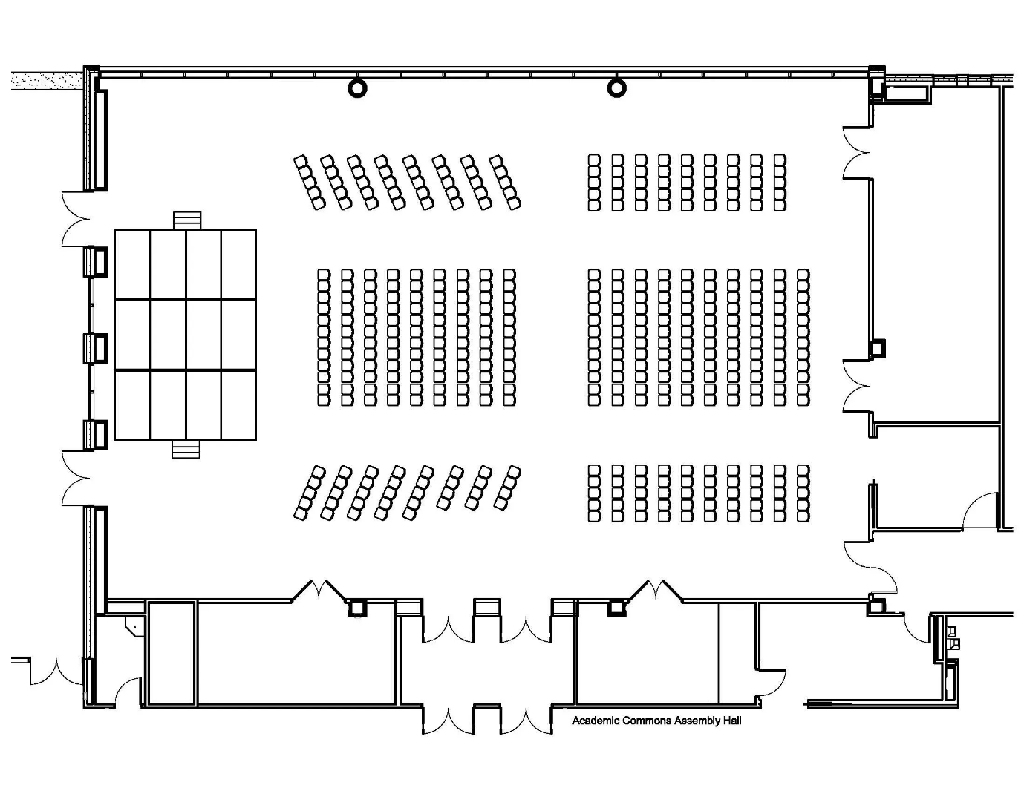

Appendix B



Appendix C - Lunch setup area plan


