Restaurant concept and Menu design

Student Name: Alexandra Anghel
Module name: Food & Beverage Operations
Tutor name: Ffion Cumberpatch
Word count: 413 words

Part 1

Restaurant concept
A 4-star luxury Hotel Trinity is going to open in Manchester, in the coming autumn. The future grand Trinity Hotel, will offers personalised offers for dishes and will offer international and traditional British cuisines. The restaurant will ensure customer satisfaction strategies by offering specific menu, including for special dietary, that shows the concern and importance about the honourable guests of restaurant. Additionally, the feedback will be analysed from guests which will be effective for future improvement.
Manchester is a modern cultured city where cultural diversity is taking place that generates diversity in foods and hospitability highly which supports the restaurant concept (Potivin 2021).

Target consumer
The GDP ( Gross Domestic Product) rate is 82661million GBP in 2020 which represents a high purchasing power of the citizen which can be favourable for restaurant (Clark 2023). Therefore, the restaurant will offer innovative foods for all age groups including families, travers, reputed business personalities, who are willing test something different in this luxurious hospitable atmosphere (Peng 2020).
Reason for the Menu
The increasing number of customers in the city develops the demand for innovative foods and luxurious hospitability (Nozawa et al. 2022). The honourable guests of a restaurant are looking for ambiance, hospitability and innovative foods with fascinating and innovative taste including personalised foods that is the key reason behind the menu (Martin-Rios et al. 2020). Creation of a signature reputation by its luxurious hospitability is also a fundamental reason of the menu.
Sustainability

Sustainability is the modern trend of the nation which execute global reputation and high standard (UN.org. 2023). Regarding this, active actions will be incorporated to develop sustainable development goals. The restaurant is ensuring to use clean energy, and will maintain heath wellbeing for each valuable customer (Lo, King, and Mackenzie 2020).

Challenges

There are more than 650 restaurants in Manchester which can create competitiveness which may impact the cost structure of the Trinity Hotel (Restaurantsofmanchester. 2023). Additionally, skilled chef recruitment also can be an issue for the restaurant which may impact the food quality and the hotel’s image.

Recommendations and Alternation Strategies

The innovative food service by fusion and customization strategy will attract the new customers which will break the marketing competition (Filimonau et al. 2020). Additionally, serving authentic and international food will ensure customer loyalty and trust. Regarding this, training the staff about hospitability, serving style, and maintaining strategy about the food quality and offering attractive offers in special occasion and festival are major recommended strategy for the restaurant.

Part 2


Trinity Hotel

Figure: Restaurant Logo

Pricing strategy
The pricing strategy of the Trinity Hotel will show the dishes are less costly which will also secure higher revenue (Zhong and Moon 2020). The competitive prices for food and combo offers is the fundamental strategy of the restaurants to attract the customers. Regarding this, the price range will be 29 GBP to 509 GBP in the future restaurant in Manchester, UK.
This strategy will attract international and the British citizen of the city. Most of the international and British citizen are fond of culture and art which will be offered authentically through the authentic and fusion foods in the restaurant.

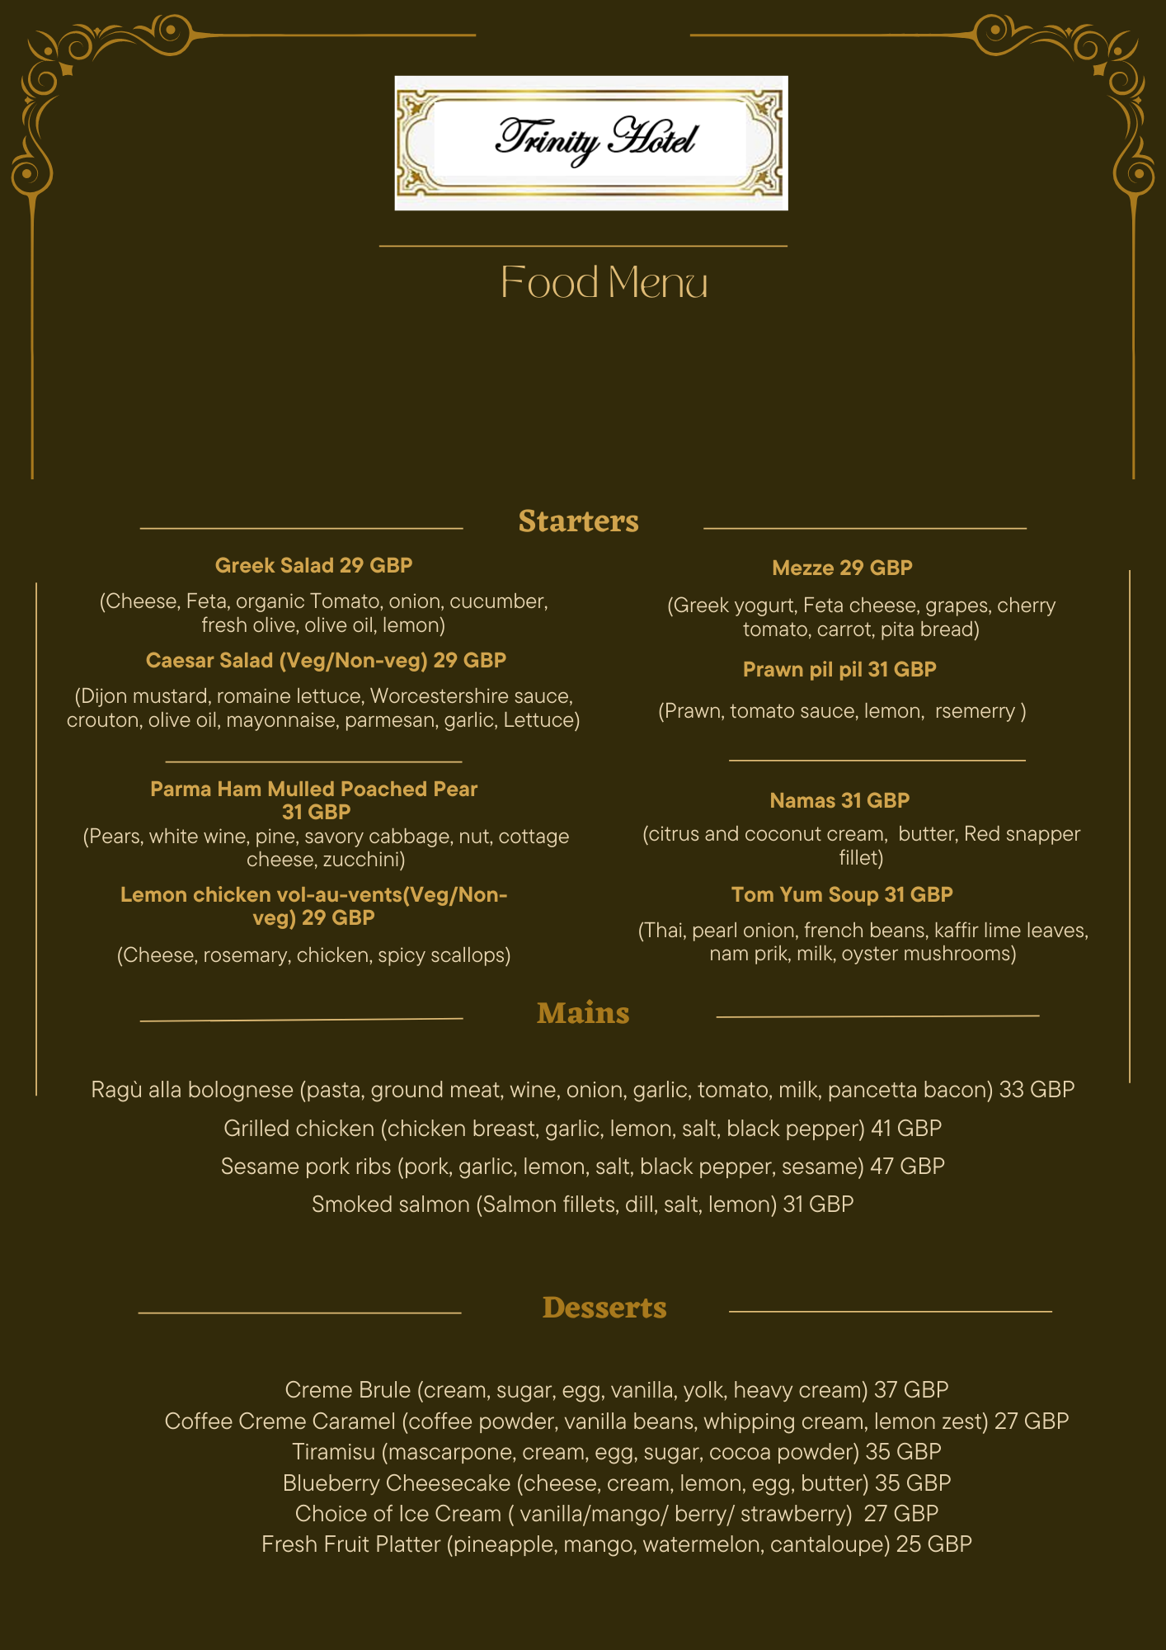
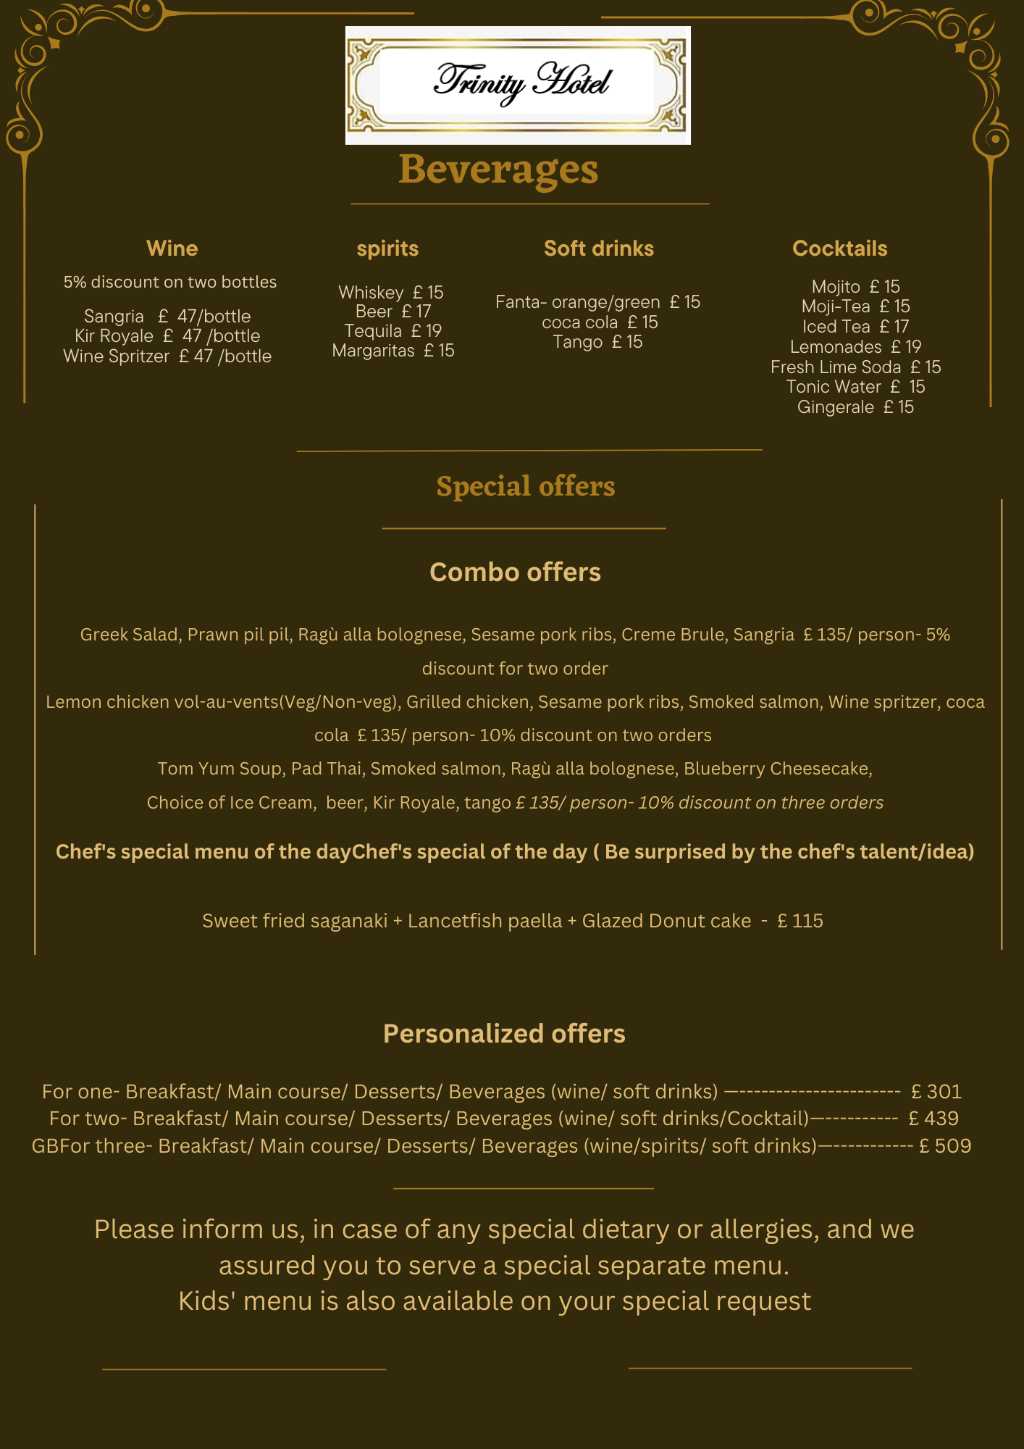

References

Clark. D., 2023. Gross domestic product of Greater Manchester from 1998 to 2021. Available at:https://www.statista.com/statistics/1289267/gdp-of-manchester/(accessed on: 6.6.2023)
Filimonau, V., Todorova, E., Mzembe, A., Sauer, L. and Yankholmes, A., 2020. A comparative study of food waste management in full service restaurants of the United Kingdom and the Netherlands. Journal of Cleaner Production, 258, p.120775.
Lo, A., King, B. and Mackenzie, M., 2020. Segmenting Chinese millennial restaurant customers: A lifestyle and health and environmental consciousness approach. Journal of China Tourism Research, 16(2), pp.183-213.
Martin-Rios, C., Zizka, L., Varga, P. and Pasamar, S., 2020. KITRO: Technology solutions to reduce food waste in Asia-Pacific hospitality and restaurants. Asia Pacific Journal of Tourism Research, 25(10), pp.1128-1135.
Nozawa, C., Togawa, T., Velasco, C. and Motoki, K., 2022. Consumer responses to the use of artificial intelligence in luxury and non-luxury restaurants. Food Quality and Preference, 96, p.104436.
Peng, N., 2020. Luxury restaurants’ risks when implementing new environmentally friendly programs–evidence from luxury restaurants in Taiwan. International Journal of Contemporary Hospitality Management, 32(7), pp.2409-2427.
Potvin, J., 2021. Bachelors of a Different Sort: Queer Aesthetics, Material Culture and the Modern Interior in Britain. Bachelors of a different sort, pp.1-336.
Restaurantsofmanchester. 2023. Manchester restaurant. Available at: https://www.restaurantsofmanchester.com/#:~:text=Manchester%20Restaurants&text=Welcome%20to%20Restaurants%20Of%20Manchester,according%20to%20our%20secret%20inspections (accessed on: 6.6.2023)

UN.org. 2023. #Envision2030: 17 goals to transform the world for persons with disabilities. Available at: https://www.un.org/development/desa/disabilities/envision2030.html (accessed on: 6.6.2023)
Zhong, Y. and Moon, H.C., 2020. What drives customer satisfaction, loyalty, and happiness in fast-food restaurants in China? Perceived price, service quality, food quality, physical environment quality, and the moderating role of gender. Foods, 9(4), p.460.

