Assessment 1
Module: Data Handling and & Business Intelligence

Module code: LCBB500 Lecturer: Gasso Mwaluseke

Individual Report

' 5 Current BI Trends'

Simona Filipova Vasileva
University of Wales Trinity Saint David, London Campus,
BA Business and Management, London, United Kingdom
2030587@student.uwtsd.ac.uk

Contents
What is BI 3
Trend 1 (BI and AI) 4
Trend 2 (Mobile BI) 5
Trend 3 (Analytics in real - time) 6
Trend 4 (Data Security) 7
Trend 5 (Data Governance) 8
Conclusion 9
References 10

What is BI
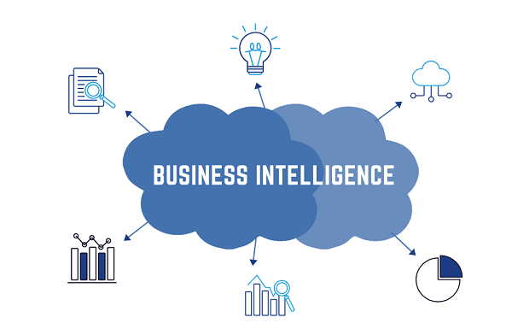
Picture: Innovation Junction

The procedural and technological framework that gathers, saves, and analyzes the data generated by a company's operations is known as business intelligence (BI) (FRANKENFIELD, 2022).
Descriptive analytics, performance benchmarking, process analysis, and data mining are all components of business intelligence (BI), which is a broad term. The term "business intelligence" refers to the process of arranging the copious amounts of information that are produced by an organization into easily digestible reports, performance measures, and trends(FRANKENFIELD, 2022). Business intelligence is descriptive, outlining both the current situation and the events that led up to it. On the other hand, business analytics is a catch-all word encompassing methods of predictive data analysis (Pratt, 2019). Academic and professional communities have paid close attention to business intelligence (BI) technology, and the newly developing discipline of business analytics (BA) is starting to produce academic research (Gregory Richards, 2019).
There are many different types of BI software and solutions like Data mining tolls, Data visualization software, Spreadsheets, Reporting software and etc.
Better business decisions can be made, reporting and analysis can be done more quickly and accurately, data quality can be improved, employee satisfaction can be increased, costs can be reduced, and revenue can be increased if a company implements BI into its business model. These are just some of the many benefits that can accrue to a company after it implements BI (FRANKENFIELD, 2022).

Trend 1 (BI and AI)

Picture: Global Data 365

Corporate intelligence has not been immune to the wave of adoption that artificial intelligence (AI) has brought to every other facet of the business world. The enormous potential of this technology holds the promise of enhancing human intellect by radically altering the ways in which we engage with data and analytics pertaining to commercial enterprises (Anthony, 2022).
There is broad consensus that AI can process vast volumes of data faster than humans. Additionally, the technology provides a unique perspective on corporate intelligence and facilitates the discovery of previously ignored ideas. Additionally, the opportunity to properly define the value of informative pieces and appreciate how data changes into genuine business decisions looks too appealing to pass up. As a result, businesses are hurrying to use the combination of BI and AI. Nobody enjoys having to make up for missed time (Anthony, 2022).

Trend 2 (Mobile BI)
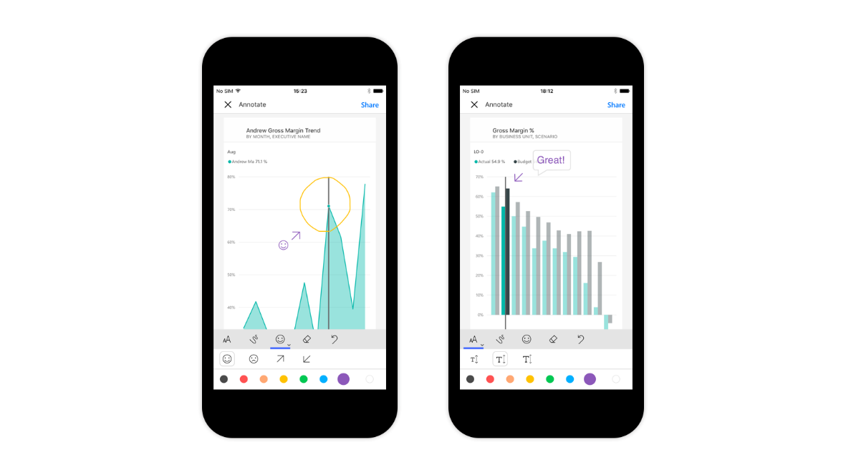
Picture: Microsoft Power BI
Users of business intelligence software are no longer need to be chained to a desk whenever they require insights. Every user at your organization possesses a mobile phone, which allows them to do business even when they are not physically present at the office. You could even have users in today's modern corporate environment who perform some or all of their job away from the office. This is not an uncommon occurrence (Leake, 2022).
According to Mordor Intelligence, the market for mobile BI tools is anticipated to post a compound annual growth rate (CAGR) of 22.43% between the years 2021 and 2026. These tools are designed to fulfill the requirements of modern enterprises. Users are able to pull up dashboards and obtain reports on their phones if they are equipped with the appropriate tools. An employee who is going to attend to a meeting and requires a certain data point or insight can have it readily available on an app to view before they leave (Leake, 2022).

Trend 3 (Analytics in real - time)
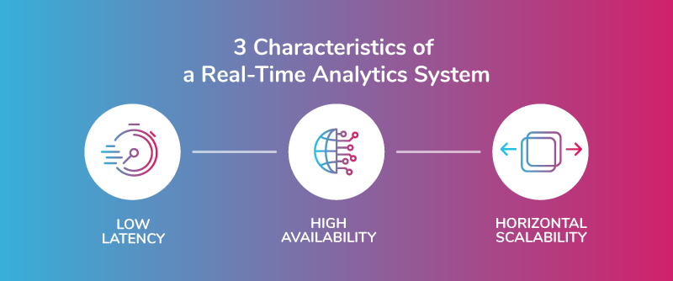
Picture: Striim
Real-time data has become increasingly important, and as one of the data analytics trends, it will do so in 2022 as well. Since the outbreak of the pandemic, we have seen that timely and accurate information is crucial for developing efficient defenses. While corporations strived to secure their survival in these ominous times, some governments used data to make the best decisions they could (Eliaçık, 2022).
Real-time data access is no longer just available to enterprises; it is now available to everyone. Press conferences may be filled to the brim with the most recent data, graphs, and figures that have influenced antiviral strategies. However, creating ad hoc analyses has also enabled businesses to keep up with developments and adapt to key issues (Eliaçık, 2022).
Predicting and alerts are becoming increasingly crucial in both personal and professional life for developing suitable firm reactions and strategies for the future initiatives with more factors to take into account. Additionally, adopting live dashboards will let firms obtain up-to-date data about their processes and respond right away if any possible issues occur. Some firms are able to continue operating while others are unable to do so because to the overdrive for data access that is becoming the norm (Eliaçık, 2022).

Trend 4 (Data Security)

Picture: Softbenz Infosys
We have often brought up the value that data can have for a company. More than only improved decision-making, accurate, comprehensive, and intelligible data has several advantages. Nevertheless, if data is left ignored, all these advantages may be diminished, and you may wind up accumulating losses (Anthony, 2022).
In 2018, organizations like Facebook had serious data security breaches. The hackers revealed thousands of their users and put these firms through the dirt. Additionally, the firms' market value decreased, their resources were depleted, and customers' faith was impacted by the bad press. Millions of cybercriminals are waiting for an opening to strike in the current day. The worst part is that they target both large and small businesses. For businesses that have not put in place impenetrable security layers, successful assaults are always a possibility (Anthony, 2022).
The trend toward data security accelerated in 2019, and we anticipate that organizations will keep looking for further secure solutions in 2021. The importance of personal information is now fully understood by consumers, who are wary about revealing it online. Businesses will continue to close any security gaps in an effort to foster confidence and gather the data they require (Anthony, 2022).

Trend 5 (Data Governance)
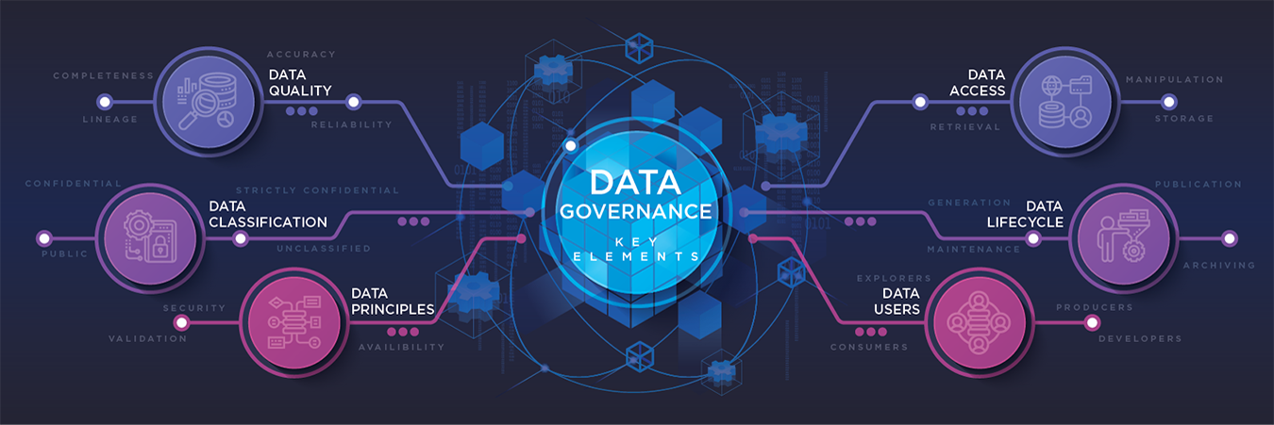
Picture: Office of Information and Communications Technology
Data governance is the next item on our list of developing business intelligence trends. This idea refers to a collection of procedures, guidelines, and job descriptions that guarantee proper assessment, production, consumption, and management of corporate data at the tactical, strategic, and operational levels. To provide a safe and effective data management process, it specifies roles and duties regarding who may change the data, under what circumstances, and using what tools and techniques (Calzon, 2022).
All types of businesses are vulnerable to attacks and breaches, as you can see from our data security trend, leaving vast amounts of sensitive data from clients, suppliers, workers, and others susceptible to exploitation. In this regard, putting into practice a carefully prepared governance strategy can assist firms in maintaining compliance with legal requirements while creating the ideal atmosphere for utilizing excellent data and accomplishing their objectives (Calzon, 2022).
Data governance has become a required practice in today's fiercely competitive corporate world, where the quantity of information being gathered keeps increasing every second. In addition to helping firms stay legal, a well-implemented governance structure also helps them save expenses, increase internal and external communication, and achieve their strategic objectives (Calzon, 2022).

Conclusion
As conventional business intelligence (BI) solutions are being eclipsed by cloud computing, the focus of vendors is shifting to supplying post variety of technological with customization possibilities. Even if knowledge in data science is becoming more commonplace, self-service business intelligence is becoming increasingly popular. The business intelligence (BI) and analytics processes will continue to be driven by automation, freeing you up to focus on other responsibilities. The way we access information has been transformed as a result of embedding, which will also continue to have an effect on the development of BI software and business insight (Kaur, 2022).
Governance of data is the wild boar that everyone wishes to tame. Mobile insight is a sizeable portion of business intelligence and has an impact on the way in which businesses collect data (Kaur, 2022). Businesses around the globe are fast understanding that investing in business intelligence (BI) and analytics is crucial given the ongoing need to examine data. To develop a plan that is equipped for the future, it is necessary to monitor the market and understand the most recent developments. While adopting corporate data and analytics or evaluating service providers, these patterns may serve as a standard. (Rozario, 2022).

References
Anthony, J., 2022. 11 Business Intelligence Trends for 2022: Latest Predictions You Should Be Thinking About. [Online]
Available at: https://financesonline.com/business-intelligence-trends/
[Accessed 15 December 2022].
Calzon, B., 2022. Top 10 Analytics And Business Intelligence Trends For 2023. [Online]
Available at: https://www.datapine.com/blog/business-intelligence-trends/#data-governance
[Accessed 15 December 2022].
Eliaçık, E., 2022. Explore the latest business trends and join the data-driven revolution. [Online]
Available at: https://dataconomy.com/2022/04/12-business-intelligence-trends-2022/#Modern_data_warehouses
[Accessed 15 December 2022].
FRANKENFIELD, J., 2022. What Is Business Intelligence (BI)? Types, Benefits, and Examples. [Online]
Available at: https://www.investopedia.com/terms/b/business-intelligence-bi.asp
[Accessed 15 December 2022].
Gregory Richards, W. Y. A. Y. L. C. A. P., 2019. Business Intelligence Effectiveness and Corporate Performance Management: An Empirical Analysis. Journal of Computer Information Systems, 59(2), pp. Pages 188-196.
Kaur, R., 2022. Business Intelligence Trends in 2023: Future of BI. [Online]
Available at: https://www.selecthub.com/business-intelligence/business-intelligence-trends/
[Accessed 15 December 2022].
Leake, K., 2022. Four Emerging Business Intelligence Trends For 2022. [Online]
Available at: https://www.forbes.com/sites/forbestechcouncil/2022/02/25/four-emerging-business-intelligence-trends-for-2022/?sh=5b56b5bd3759
[Accessed 15 December 2022].
Pratt, J. F. a. M. K., 2019. What is business intelligence? Transforming data into business insights. [Online]
Available at: https://www.cio.com/article/272364/business-intelligence-definition-and-solutions.html
[Accessed 15 December 2022].
Rozario, C., 2022. 7 Business Intelligence Trends to Watch Out For in 2022. [Online]
Available at: https://www.analyticsinsight.net/7-business-intelligence-trends-to-watch-out-for-in-2022/
[Accessed 15 December 2022].

